ODOR ASSESSMENT

Lunenburg High School
Kitchen Area
1079 Massachusetts Avenue
Lunenburg, MA

Prepared by:
Massachusetts Department of Public Health
Bureau of Environmental Health
Indoor Air Quality Program
May 2019

Background

Building: | Lunenburg High School (LHS)
Address: | 1079 Massachusetts Avenue, Lunenburg, MA
Assessment Requested by: | John Londa, Lunenburg public schools
Reason for Request: | Odors affecting kitchen staff
Date of Assessment: | April 5, 2019
Massachusetts Department of Public Health/Bureau of Environmental Health (MDPH/BEH) Staff Conducting Assessment: | Michael Feeney, Director, IAQ Program
Building Description: | The LHS kitchen is located in a wing of the LHS adjacent to the cafeteria, which connects to the main building by a hallway
Windows: | No openable windows in the kitchen

IAQ Testing Results
Please refer to the IAQ Manual for methods, sampling procedures, and interpretation of results (MDPH, 2015). The following is a summary of indoor air testing results (Table 1).
- Carbon dioxide levels were below the MDPH guideline of 800 parts per million (ppm) in all areas tested except for areas D156 and D157.
- Temperature was within the MDPH recommended range of 70°F to 78°F the day of the assessment.
- Relative humidity was below the MDPH recommended range of 40 to 60% in all areas the day of assessment as is typical during the heating season.
- Carbon monoxide levels were non-detectable (ND) in all areas tested.
- Fine particulate matter (PM2.5) concentrations measured were below the National Ambient Air Quality (NAAQS) limit of 35 μg/m³ in all areas tested.

Ventilation
A heating, ventilating and air conditioning (HVAC) system has several functions. First it provides heating and, if equipped, cooling. Second, it is a source of fresh air. Finally, an HVAC system will dilute and remove normally occurring indoor environmental pollutants by not only introducing fresh air, but by filtering the airstream and ejecting stale air to the outdoors via exhaust ventilation. Even if an HVAC system is operating as designed, point sources of respiratory irritation may exist and cause symptoms in sensitive individuals.
Fresh air is provided by ceiling-mounted fresh air supplies. Air is also drawn into the kitchen via the kitchen hood from the cafeteria.

Other IAQ Evaluations
Of note was the existence of a floor drain in front of the refrigerator (Picture 1) which likely has a dry drain trap. In addition a second floor drain exists beneath an unused steamer (Picture 2) The purpose of a drain trap is to inhibit the draw of sewer gas, odors and other pollutants from the drain system. With an operating kitchen hood, pollutants from the drain system can be drawn into the kitchen.

Conclusions/Recommendations
The following recommendations are made to assist in improving IAQ:
- Ensure that floor drains in the kitchen are wetted with a sufficient amount of water daily.
- For buildings in New England, periods of low relative humidity during the winter are often unavoidable. Therefore, scrupulous cleaning practices should be adopted to minimize common indoor air contaminants whose irritant effects can be enhanced when the relative humidity is low. To control dusts, a high efficiency particulate arrestance (HEPA) filter equipped vacuum cleaner in conjunction with wet wiping of all surfaces is recommended. Avoid the use of feather dusters. Drinking water during the day can help ease some symptoms associated with a dry environment (throat and sinus irritations).
- Consider adopting the US EPA (2000) document, “Tools for Schools”, as an instrument for maintaining a good IAQ environment in the building available at: http://www.epa.gov/iaq/schools/index.html
- Refer to resource manual and other related IAQ documents located on the MDPH’s website for further building-wide evaluations and advice on maintaining public buildings. These documents are available at: http://mass.gov/dph/iaq.

References
MDPH. 2015. Massachusetts Department of Public Health. “Indoor Air Quality Manual: Chapters I-III”. Available at: http://www.mass.gov/eohhs/gov/departments/dph/programs/environmental-health/exposure-topics/iaq/iaq-manual/.
US EPA. 2000. Tools for Schools. Office of Air and Radiation, Office of Radiation and Indoor Air, Indoor Environments Division (6609J). EPA 402-K-95-001, Second Edition. http://www.epa.gov/iaq/schools/index.html.

Picture 1
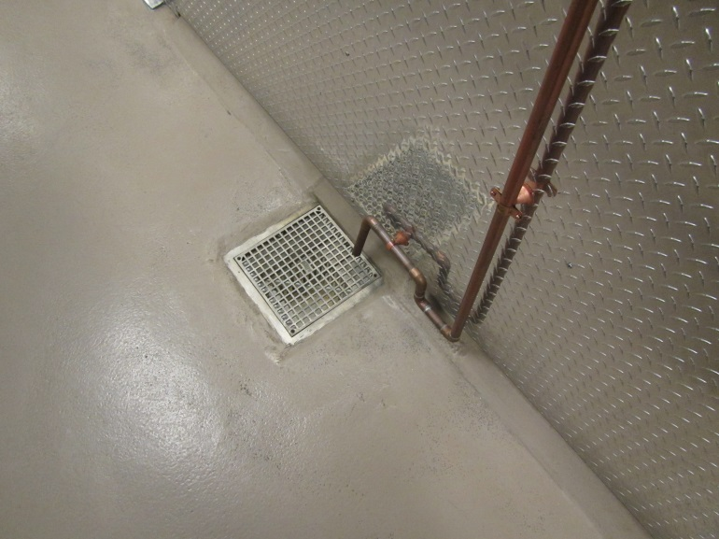
Floor drain in front of refrigerators
Picture 2
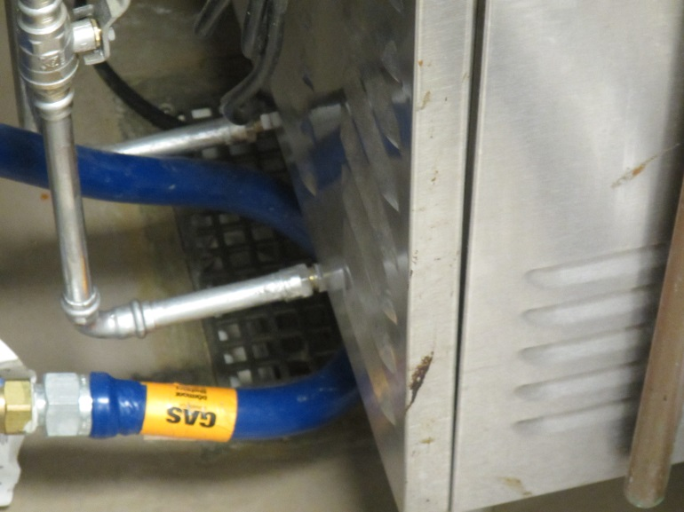
Floor drain beneath steamer
Location | Carbon  Dioxide  (ppm) | Carbon Monoxide  (ppm) | Temp  (°F) | Relative  Humidity  (%) | PM2.5  (µg/m3) | Occupants  in Room | Windows  Openable | Ventilation |  | Remarks
 |  |  |  |  |  |  |  | Supply | Exhaust
Background (outside) | 306 | ND | 47 | 13 | 2
Main hallway B wing | 730 | ND | 72 | 13 | 1 | 0 | Y | Y | Y
Main hallway D wing | 620 | ND | 71 | 12 | 1 | 0 | Y | Y | Y
Cafeteria | 852 | ND | 73 | 15 | 1 | 100+ | Y | Y | Y
Serving | 646 | ND | 72 | 11 | 0 | 2 | N | N | Y
Store room | 603 | ND | 72 | 11 | 0 | 0 | N | N | N
Salad bar | 552 | ND | 72 | 9 | 1 | 0 | N | N | Y
Stoves | 521 | ND | 73 | 7 | 0 | 0 | N | N | Y
Refrigerator | 734 | ND | 75 | 9 | 0 | 0 | N | N | Y
Dish washer | 607 | ND | 74 | 20 | 0 | 0 | N | N | Y
Mgr. office | 767 | ND | 74 | 12 | 0 | 1 | N | Y | Y
Rear storage | 632 | ND | 74 | 12 |  | 0 | N | N | Y
D156 | 821 | ND | 71 | 12 | 0 | 0 | N | N | Y
D157 | 828 | ND | 71 | 12 | 0 | 0 | N |  | Y

