INDOOR AIR QUALITY ASSESSMENT

Lunenburg Public Library
1023 Massachusetts Avenue
Lunenburg, Massachusetts

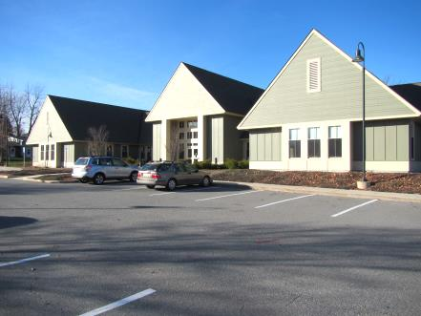

Prepared by:
Massachusetts Department of Public Health
Bureau of Environmental Health
Indoor Air Quality Program
February 2017

Background
Building: | Lunenburg Public Library (LPL)
Address: | 1023 Massachusetts Avenue, Lunenburg, MA
Assessment Requested by: | Martha Moore, LPL Director
Reason for Request: | General indoor air quality (IAQ) assessment and employee concerns
Date of Assessment: | November 23, 2016
Massachusetts Department of Public Health/Bureau of Environmental Health (MDPH/BEH) Staff Conducting Assessment: | Michael Feeney, Director, IAQ Program
Date of Building Construction: | 2005
Building Description: | Two-story wooden building
Windows: | Openable

Methods
Please refer to the IAQ Manual and appendices for methods, sampling procedures, and interpretation of results (MDPH, 2015).

Results and Discussion
The following is a summary of indoor air testing results (Table 1).
- Carbon dioxide measurements were below the MDPH recommended level of 800 parts per million (ppm) in all areas surveyed.
- Temperature was within the MDPH recommended range of 70°F to 78°F at the time of assessment in all areas.
- Relative humidity was below the MDPH recommended range of 40 to 60% in all areas tested.
- Carbon monoxide levels were non-detectable (ND) in all areas tested.
- Particulate matter (PM2.5) concentrations measured were below the National Ambient Air Quality (NAAQS) level of 35 μg/m³ in all areas tested.

Ventilation
A heating, ventilating, and air conditioning (HVAC) system has several functions. First it provides heating and, if equipped, cooling. Second, it is a source of fresh air. Finally, an HVAC system will dilute and remove normally occurring indoor environmental pollutants by not only introducing fresh air, but also filtering the airstream and ejecting stale air to the outdoors via exhaust ventilation. The act of cooling is two-fold; the system chills the air via cooling coils while also typically removing moisture from the air. The HVAC system consists of air handling units (AHUs) that mix supply and return air from the room, filter, heat/cool (as needed) and deliver back to the room via ductwork.
Of note is the low relative humidity in the LPL. The HVAC system has a desiccant wheel installed on each AHU (Picture 1). A desiccant wheel is a device that is designed to recover energy and to exchange heat between a fresh air supply and return vent. As this system operates, the desiccant wheel can also serve to reduce relative humidity. Low relative humidity (<20%) can be a source of eye, nose and respiratory irritation for sensitive individuals. LPL staff reported that some individuals experienced eye, nose and respiratory irritation while working around the main desk of the library. Of note is a dust pattern around the fresh air supply immediately above the main desk (Picture 2). This type of dust pattern may be indicative of an air leak from the ductwork above the main desk. If an air leak exists, debris within the ceiling plenum may become disturbed and aerosolized. The dust pattern indicates the airflow from the ceiling plenum is directed downwards behind a banner above the main desk (Picture 3).

Microbial/Moisture Concerns
The LPL experienced a flood that resulted in water damage to some areas of gypsum wallboard (GW). Any water-damaged porous materials (e.g., GW, carpeting, ceiling tiles) not dried within 48 hours should be discarded and replaced to avoid microbial colonization. Typically, carpeting is not recommended in below grade space. Mold resistant carpet tiles should be considered when replacing carpeting in below grade spaces.
Plants were observed in several areas, including on porous surfaces (e.g., carpet). Plants can be a source of pollen and mold, which are respiratory irritants to some individuals. Plants should be properly maintained and equipped with drip pans to prevent water damage to porous materials. Plants should also be located away from air diffusers to prevent the aerosolization of dirt, pollen, and mold.

Other Conditions
Other conditions that can affect IAQ were observed during the assessment. The Institute of Inspection, Cleaning, and Restoration Certification (IICRC) recommends that carpeting be cleaned annually (or semi-annually in soiled high traffic areas) (IICRC, 2012). Regular vacuuming with a high efficiency particulate air (HEPA) filtered vacuum in combination with an annual cleaning will help to reduce accumulation and potential aerosolization of materials from carpeting. Since the average lifespan of carpeting is approximately eleven years (Bishop, 2002), consideration should be given to the installation of new flooring.

Conclusions and Recommendations
In view of the findings at the time of the visit, the following recommendations are made:
- Remove the banner above main desk.
- Repair any breaches in the ductwork above the main desk.
- Consider resetting the desiccant wheels in the HVAC system to raise the relative humidity in the LPL as needed. Consideration should be given to alter the desiccant wheel setting to increase the removal of moisture in warm spring/summer months and decreasing reduction of relative humidity in fall/winter months.
- Any water-damaged porous materials (e.g., carpeting, acoustic ceiling tiles) not dried within 48 hours should be discarded and replaced to avoid microbial colonization.
- Plants should be properly maintained and equipped with drip pans to prevent water damage to porous materials. Plants should also be located away from air diffusers to prevent the aerosolization of dirt, pollen, and mold.
- Continue to clean carpeting annually or semi-annually in soiled high traffic areas as per the recommendations of the Institute of Inspection, Cleaning and Restoration Certification (IICRC, 2012).
- For buildings in New England, periods of low relative humidity during the winter are often unavoidable. Therefore, scrupulous cleaning practices should be adopted to minimize common indoor air contaminants whose irritant effects can be enhanced when the relative humidity is low. To control for dusts, a high efficiency particulate arrestance (HEPA) filter equipped vacuum cleaner in conjunction with wet wiping of all surfaces is recommended. Avoid the use of feather dusters. Drinking water during the day can help ease some symptoms associated with a dry environment (throat and sinus irritation).
- Refer to resource manual and other related indoor air quality documents located on the MDPH’s website for further building-wide evaluations and advice on maintaining public buildings. These documents are available at http://mass.gov/dph/iaq.

REFERENCES
Bishop, J. & Institute of Inspection, Cleaning and Restoration Certification. A Life Cycle Cost Analysis for Floor Coverings in School Facilities. 2002.
Institute of Inspection, Cleaning and Restoration Certification (IICRC). 2012. Carpet Cleaning: FAQ. Retrieved from http://www.iicrc.org/consumers/care/carpet-cleaning.
Massachusetts Department of Public Health (MDPH). 2015. Indoor Air Quality Manual: Chapters I-III. Available at: http://www.mass.gov/eohhs/gov/departments/dph/programs/environmental-health/exposure-topics/iaq/iaq-manual/.
Picture 1
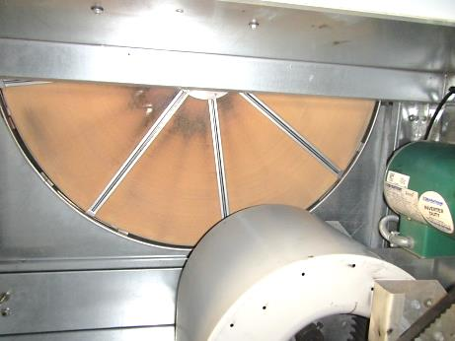
Desiccant wheel in HVAC system
Picture 2
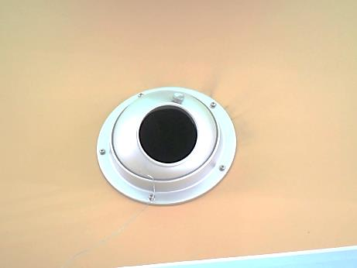
Fresh air supply vent above main desk, note dust pattern indicating air leakage
Picture 3
Banner above main desk

Location | Carbon  Dioxide  (ppm) | Carbon Monoxide  (ppm) | Temp  (°F) | Relative  Humidity  (%) | PM2.5  (µg/m³) | Occupants  in Room | Windows  Openable | Ventilation |  | Remarks
 |  |  |  |  |  |  |  | Supply | Exhaust
Background (outdoors) | 460 | ND | 41 | 33 | 27
117 | 508 | ND | 73 | 17 | 2 | 0 | Y | Y | Y
133 | 544 | ND | 73 | 16 | 3 | 0 | Y | Y | Y | Stained flooring
138 | 522 | ND | 73 | 17 | 8 | 0 | Y | Y | Y
139 | 523 | ND | 73 | 17 | 2 | 0 | Y | Y | Y
141 | 494 | ND | 72 | 17 | 2 | 0 | Y | Y | Y | Plant
142 | 507 | ND | 72 | 18 | 3 | 0 | N | Y | Y
Magazines | 512 | ND | 71 | 17 | 2 | 1 | Y | Y | Y
Media | 489 | ND | 72 | 17 | 2 | 0 | Y | Y | Y
Main desk | 529 | ND | 72 | 18 | 2 | 8 | Y | Y | Y | Tile floor
Fiction | 509 | ND | 72 | 17 | 2 | 1 | Y | Y | Y | Water damage to wall
Non-fiction | 499 | ND | 72 | 17 | 2 | 0 | Y | Y | Y
Center of main room | 538 | ND | 72 | 19 | 2 | 6 | Y | Y | Y | Plant
Tech center | 545 | ND | 73 | 18 | 2 | 1 | Y | Y | Y
Children’s main desk | 570 | ND | 73 | 17 | 3 | 9 | Y | Y | Y
Children’s north stack | 547 | ND | 73 | 17 | 2 | 0 | Y | Y | Y | Window-mounted air conditioner
Children’s south stack | 654 | ND | 73 | 19 | 2 | 9 | Y | Y | Y
Office | 573 | ND | 73 | 18 | 2 | 0 | N | Y | Y
Catalog | 548 | ND | 73 | 18 | 2 | 8 | Y | Y | Y
Staff room | 552 | ND | 73 | 17 | 2 | 2 | N | Y | Y | Refrigerator

