INDOOR AIR QUALITY ASSESSMENT

Lunenburg Town Hall
17 Main Street
Lunenburg, Massachusetts

Prepared by:
Massachusetts Department of Public Health
Bureau of Environmental Health Assessment
Emergency Response/Indoor Air Quality Program
January 2003

Background/Introduction
At the request of John Londa, Director of Facilities and Grounds for the Lunenburg School Department, the Massachusetts Department of Public Health (MDPH), Bureau of Environmental Health Assessment (BEHA) provided assistance and consultation regarding indoor air quality at the Lunenburg Town Hall (LTH), 17 Main Street, Lunenburg, Massachusetts. Concerns about mold in the basement prompted the request. On September 4, 2002, a visit was made to this building by Michael Feeney, Director of Emergency Response/Indoor Air Quality (ER/IAQ), BEHA, to conduct an indoor air quality assessment.
The LTH is a two-story, clapboard-sided, wood frame structure. The building was originally constructed as a school 1867. A new roof and second floor heating, ventilating and air-conditioning (HVAC) system were added to the building 2002. The second floor contains town offices and an auditorium. The first floor currently houses town offices. An attic with bell tower exists above the second floor. The basement is partially dirt floor. Areas in the basement on cement are used for storage (see Picture 1) and for the furnace/first floor HVAC unit. Windows are openable throughout the building. Windows appear to be original wooden sash windows.

Methods

Air tests for carbon dioxide, temperature and relative humidity were taken with the TSI, Q-Trak, IAQ Monitor Model 8551.

Results

The LTH has an employee population of 20 and is visited by approximately 25 to 30 people daily. Tests were taken during normal operations and results appear in Tables 1-2.

Discussion

Ventilation
It can be seen from the tables that carbon dioxide levels were below 800 parts per million of air (ppm) in all occupied offices, except the town clerks office. Please note that rooms with carbon dioxide levels below 800 ppm were unoccupied. Carbon dioxide levels in the building would be expected to be higher during winter months.
Air is supplied to the second floor by an air handling unit (AHU) located in the attic. The attic AHU provides conditioned air to offices and the auditorium by a combination of ceiling and wall-mounted air diffusers connected via ductwork (see Picture 2). Air returns to the AHU through wall-mounted exhaust grilles via ductwork. The first floor is provided with ventilation from an AHU located in the basement. The attic AHU does not appear to be designed to have mechanical ventilation that will exhaust air from the second floor. This system appears to recirculate air within the LTH second floor. With the lack of exhaust ventilation, pollutants that exist in the interior space will not be diluted and will build up and remain inside the office. Air is supplied to the first floor by an air handling unit (AHU) located in the basement. The basement AHU provides conditioned air to offices by a combination of ceiling and wall-mounted fresh air diffusers connected via ductwork. Air returns to the AHU through wall-mounted exhaust grilles via ductwork. This AHU appeared to be deactivated during the assessment. The basement AHU also does not appear to be designed to have mechanical ventilation that will provide fresh air or to exhaust air from this office space. A duct appears to draw air from another duct located behind file cabinets (see Picture 3). With the lack of a fresh air supply, pollutants that exist in the interior space will not be diluted and will build up and remain inside the office. In addition, pollutants from the basement may be captured by this AHU and distributed into occupied areas.
Exhaust ventilation ductwork was identified in the attic, which appear to be connected to a turbine vent on the roof of the LTH (see Picture 4). These ducts are likely connected to wall mounted grilles on the first floor. A louver located inside the duct controls airflow. A heating element is usually located above the louver that creates airflow via rising heat called “the stack effect”. Under these circumstances, it appears that the building does not have a functioning exhaust ventilation system. Without exhaust ventilation, normally occurring environmental pollutants can build up and lead to air quality/comfort complaints.
To maximize air exchange, the BEHA recommends that both supply and exhaust ventilation operate continuously during periods of school occupancy. In order to have proper ventilation with a mechanical supply and exhaust system, the systems must be balanced to provide an adequate amount of fresh air to the interior of a room while removing stale air from the room. The date of the last servicing and balancing was not available at the time of the assessment. It is recommended that existing ventilation systems be re-balanced every five years to ensure adequate air systems function (SMACNA, 1994). Please note that the LTH ventilation system in its condition at the time of the assessment cannot be balanced.
The Massachusetts Building Code requires a minimum ventilation rate of 20 cubic feet per minute (cfm) per occupant of fresh outside air or have openable windows in each room (SBBRS, 1997; BOCA, 1993). The ventilation must be on at all times that the room is occupied. Providing adequate fresh air ventilation with open windows and maintaining the temperature in the comfort range during the cold weather season is impractical. Mechanical ventilation is usually required to provide adequate fresh air ventilation.
Carbon dioxide is not a problem in and of itself. It is used as an indicator of the adequacy of the fresh air ventilation. As carbon dioxide levels rise, it indicates that the ventilating system is malfunctioning or the design occupancy of the room is being exceeded. When this happens a buildup of common indoor air pollutants can occur, leading to discomfort or health complaints. The Occupational Safety and Health Administration (OSHA) standard for carbon dioxide is 5,000 parts per million parts of air (ppm). Workers may be exposed to this level for 40 hours/week, based on a time weighted average (OSHA, 1997).
The Department of Public Health uses a guideline of 800 ppm for publicly occupied buildings. A guideline of 600 ppm or less is preferred in schools due to the fact that the majority of occupants are young and considered to be a more sensitive population in the evaluation of environmental health status. Inadequate ventilation and/or elevated temperatures are major causes of complaints such as respiratory, eye, nose and throat irritation, lethargy and headaches. For more information concerning carbon dioxide, please see Appendix A.
Temperature readings ranged from 73° F to 84° F, which were above the BEHA recommended comfort guidelines in a number of areas. The BEHA recommends that indoor air temperatures be maintained in a range of 70°F to 78°F in order to provide for the comfort of building occupants. In many cases concerning indoor air quality, fluctuations of temperature in occupied spaces are typically experienced, even in a building with an adequate fresh air supply. Temperature control is difficult in an old building without a functioning ventilation system.
The relative humidity ranged from 43 to 48 percent in occupied areas, which was within the BEHA recommended comfort range. The BEHA recommends a comfort range of 40 to 60 percent for indoor air relative humidity. It is important to note however, that relative humidity measured in the basement and the second floor exceeded outdoor measurements (range +6 to 10 percent). This increase in relative humidity can indicate that the exhaust system is not operating sufficiently to remove normal indoor air pollutants (e.g., water vapor from respiration). Moisture removal is important since the sensation of heat increases as relative humidity increases (the relationship between temperature and relative humidity is called the heat index). As indoor temperatures rise, the addition of more relative humidity will make occupants feel hotter. If moisture is removed, the comfort of the individuals is increased. Removal of moisture from the air, however, can have some negative effects. Please note relative humidity in the building would be expected to drop during the winter months due to heating. The sensation of dryness and irritation is common in a low relative humidity environment. Low relative humidity is a common problem during the heating season in the northeast part of the United States.

Microbial/Moisture Concerns
During the spring and summer of 2002, New England experienced a stretch of excessively humid weather during three periods in May, July and August. As an example, outdoor relative humidity at various times ranged from 73 percent to 100 percent without precipitation from July 4, 2002 through July 12, 2002 (The Weather Underground, 2002).
According to the American Society of Heating, Refrigerating and Air-conditioning Engineers (ASHRAE), if relative humidity exceeds 70 percent, mold growth may occur due to wetting of building materials (ASHRAE, 1989).
The basement is used for storage of large amounts of materials, including cardboard and paper products. If these materials are subjected to high relative humidity conditions without drying for several days, these materials can become colonized by fungi (mold). Some materials were stored in cardboard boxes that were placed on the dirt
floor. This method of storage resulted in mold contamination of the boxes (see Picture 1) and most likely, the stored contents. As noted previously, relative humidity measurements in the basement were 24 percent higher than the relative humidity measured outdoors (49%). Increased temperature indoors, as measured in this building, would be expected to have lower relative humidity compared to outdoors. The increase in relative humidity may indicate that a moisture source exists in the building. Several possibilities were examined:
- One possible source of increased relative humidity is occupants in a building without adequate air exchange. This possibility was ruled out since the basement was unoccupied.
- No means exists for venting the basement to remove water vapor. If water penetrates through the foundation, moisture may accumulate in the basement. In an effort to improve energy efficiency, fiberglass insulation was affixed to the foundation walls, sealed within a wall material (See Picture 5, note the large water stain on the base of the wall). It appears the purpose of the insulation is to prevent air penetration and heat loss through the foundation. The paper on the insulation can support mold growth if wetted. The installation of insulation also prevents natural ventilation of the crawlspace that can lead to the accumulation of water vapor.
- An unsealed opening in the foundation exists at sidewalk level (see Picture 6), which is likely an abandoned coal chute opening. The cellar showed signs of repeated water penetration (see Picture 7). It is likely that wet weather systems with an easterly wind will drive water against the foundation and through this opening.
- Enhancing water pooling is the addition to the south wall of the LTH (see Picture 8). The vault has a peaked roof. No gutter or downspout system exists on the edge of this peaked roof. Rainwater runs off the roof onto the ground at the base of the building. This runoff has created a trench parallel to the base of the front wall of the vault, which allows rainwater and melting snow to pool against the foundation and the exterior wall of this wing. Excessive exposure to water can result in water penetration into the cellar along the addition slab.
- Shrubbery exists in close proximity to the foundation walls (see Picture 8). The growth of roots against the exterior walls can bring moisture in contact with wall brick and eventually lead to cracks and/or fissures in the foundation below ground level. Over time, this process can undermine the integrity of the building envelope and provide a means of water entry into the building through capillary action through foundation concrete and masonry (Lstiburek, J. & Brennan, T.;2001).
- A condensation drain for the building empties onto the foundation wall (see Picture 9). This configuration moistens masonry, which may then penetrate through the wall into the basement.
- A former gutter downspout pipe was identified in the slab of the addition. It could not be determined where this pipes is connected. Several open-ended pipes exist in the basement (see Pictures 10 and 11). The purpose of these pipes could not be determined, nor whether each is connected to a former rainwater drainage system.
Each of these conditions, in combination with high ambient temperatures during the summer, increased relative humidity and possible water sources within the basement, may contribute to moistening of porous materials. The American Conference of Governmental Industrial Hygienists (ACGIH) recommends that porous materials (e.g., carpet) be dried with fans and heating within 24 hours of becoming wet (US EPA, 2001, ACGIH, 1989). If porous materials are not dried within this time frame, mold growth may occur.
In order to explain how mold and associated odors/particulates in the basement can migrate into occupied areas, the following concepts must be understood:
- Heated air (from radiators) will create upward air movement (called the stack
- effect).
- Cold air moves to hot air, which creates drafts.
- As the heated air rises, negative pressure is created, which draws cold air to
- the heat source.
- Airflow created by the stack effect, drafts or mechanical ventilation can draw
- airborne particulates into the air stream (i.e. from the basement).
- Spaces in the frame of the door to the basement can provide a pathway for air
- to travel from the basement to the upper floors.
Each of these concepts has an influence on the movement of basement odors or other particulates up the stairwell. Without an active exhaust ventilation system, pollutants can accumulate. In addition, a number of penetrations through the basement ceiling/office floors for pipes can serve as pathways for basement air to migrate into occupied spaces. In order to control possible mold growth, water penetration into the basement area must be minimized/eliminated.

Other Concerns

Bird Waste
As reported by Mr. Londa, the attic became a pigeon roost, resulting in a large deposition of bird waste. Efforts were made to clean this area, however significant amounts of bird waste residue exists on beams (see Picture 12), plaster lathe (see Picture
13) and other surfaces (see Picture 14). Birds in a building raise concerns over diseases that may be caused by exposure to bird wastes. These conditions warrant clean up of bird waste and appropriate disinfection. Certain molds (Histoplasma capsulatum) are associated with bird waste (CDC, 2001; NIOSH, 1997) and are of concern for immune compromised individuals. Diseases of the respiratory tract may also result from exposure to bird waste. Exposure to bird wastes is thought to be associated with the development of hypersensitivity pneumonitis in some individuals. Psittacosis (bird fancier's disease) is another condition closely associated with exposure to bird wastes in bird raising and other occupational settings. While immune compromised individuals have an increased risk of health impacts following exposure to the materials in bird wastes, these impacts may also occur in healthy individuals exposed to these materials.
The methods to be employed in clean up of a bird waste problem depends on the amount of waste and the types of materials contaminated. The MDPH has been involved in several indoor air investigations where bird waste has accumulated within ventilation ductwork. Accumulation of bird wastes have required clean up of such buildings by a professional cleaning contractor. In less severe cases, the cleaning of the contaminated material with a solution of sodium hypochlorite has been an effective disinfectant (CDC,
1998). Disinfection of non-porous materials can be readily accomplished with this material. Porous materials contaminated with bird waste should be examined by a professional restoration contractor to determine if the material is salvageable. Where a porous material has been colonized with mold, it is recommended that the material be discarded (ACGIH, 1989).
The protection of both the cleaner and other occupants present in the building must be considered as part of the overall remedial plan. Where cleaning solutions are to be used, the “cleaner” is required to be trained in the use of personal protective methods and equipment (to prevent either the spread of disease from the bird wastes and/or exposure to cleaning chemicals). In addition, the method used to clean up bird waste may result in the aerosolization of particulates that can spread to occupied areas via openings (doors, etc.) or by the ventilation system. Methods to prevent the spread of bird waste particulates to occupied areas or into ventilation ducts must be employed. In these instances, the result can be similar to the spread of renovation-generated dusts and odors in occupied areas. To prevent this, the cleaner should employ the methods listed in the SMACNA Guidelines for Containment of Renovation in Occupied Buildings (SMACNA, 1995).
Finally, AHUs are equipped with filters that strain particulates from airflow. It appears that filters were installed that were larger than the filter frame for each AHU. Filters were found cut (see Picture 15) to fit into each rack in attic AHUs. Cutting of frames and filter medium creates space by which air drawn into the AHU can by-pass the filter, resulting in the potential distribution of pollutants into occupied areas. In addition, filters installed in AHUs appear to be of a type that will provide minimal filtration of respirable particles In order to decrease aerosolized particulates, disposable filters with an increased dust spot efficiency can be installed. The dust spot efficiency is the ability of a filter to remove particulates of a certain diameter from air passing through the filter. Filters that have been determined by ASHRAE to meet its standard for a dust spot efficiency of a minimum of 40 percent would be sufficient to reduce airborne particulates (Thornburg, D., 2000; MEHRC, 1997; ASHRAE, 1992). Note that increased filtration can reduce airflow produced by the unit by increased resistance (called pressure drop). Prior to any increase of filtration, each AHU should be evaluated by a ventilation engineer to ascertain whether they can maintain function with more efficient filters. The age and function of AHU may preclude any attempt to increase filter efficiency.

Conclusions/Recommendations
In order to address the conditions listed, the recommendations made to improve indoor air quality in the building are divided into short-term and long-term corrective measures. The short-term recommendations can be implemented as soon as practicable. Long-term solution measures are more complex and will require planning and resources to adequately address the overall indoor air quality concerns.

Short Term Recommendations
- Seal the vent to the basement AHU. Consider installing fresh air supply ductwork for this AHU.
- Seal all spaces around utility pipes.
- Do not store porous materials on the dirt floor of the cellar.
- Keep the door to the basement closed. Install weather stripping and a door sweep on this door to create an airtight barrier.
- Seal the former coal chute to prevent further water damage.
- Have bird waste cleaned from attic in a manner consistent with that described in the Other Concerns section of this report.
- Install properly sized filters for all AHUs. Examine the feasibility of increasing the efficiency of AHU filters. Prior to any increase of filtration, each piece of air handling equipment should be evaluated by a ventilation engineer as to whether it can maintain function with more efficient filters.
- To prevent moisture penetration into the basement, the following actions should be considered:
  - Move foliage to no less than five feet from the foundation.
  - Improve the grading of the ground away from the foundation at a rate of 6 inches per every 10 feet (Lstiburek, J. & Brennan, T.; 2001).
  - Install a water impermeable layer on ground surface (clay cap) to prevent water saturation of ground near foundation (Lstiburek, J. & Brennan, T.; 2001).
- Consider removing the stained wall material and fiberglass insulation along foundation. Remove this material a manner consistent with US EPA recommendations for mold remediation (US EPA, 2001).
- Seal the former gutter drain hole in the addition slab.
- During a rainstorm, determine if rainwater drains from the pipes shown in Pictures 10 and 11. If these pipes drain rainwater, a system of water collection and pumping from the cellar should be considered. If these pipes do not drain rainwater, seal/cap these and all other drain pipes in the basement.
- Remove mold colonized materials stored from the basement where practical.
- Disinfect non-porous surfaces with an appropriate antimicrobial.
- For buildings in New England, periods of low relative humidity during the winter are often unavoidable. Therefore, scrupulous cleaning practices should be adopted to minimize common indoor air contaminants whose irritant effects can be enhanced when the relative humidity is low. To control for dusts, a high efficiency particulate arrestance (HEPA) filter equipped vacuum cleaner in conjunction with wet wiping of all surfaces is recommended. Avoid the use of feather dusters. Drinking water during the day can help ease some symptoms associated with a dry environment (throat and sinus irritations).

Long Term Recommendations
- Consideration should be given to repairing the original exhaust ventilation system for the first floor. Consult a ventilation engineer to determine whether existing ductwork can be restored.
- Consider installing a gutter/downspout system on the edge of the peaked roofs of the addition to direct water away from the base of the building.

References
ACGIH. 1989. Guidelines for the Assessment of Bioaerosols in the Indoor Environment. American Conference of Governmental Industrial Hygienists, Cincinnati, OH.
ASHRAE. 1992. Gravimetric and Dust-Spot Procedures for Testing Air-Cleaning Devices Used in General Ventilation for Removing Particulate Matter. American Society of Heating, Refrigeration and Air Conditioning Engineers. ANSI/ASHRAE 52.1-1992.
ASHRAE. 1989. Ventilation for Acceptable Indoor Air Quality. American Society of Heating, Refrigeration and Air Conditioning Engineers. ANSI/ASHRAE 62-1989.
BOCA. 1993. The BOCA National Mechanical Code-1993. 8th ed. Building Officials & Code Administrators International, Inc., Country Club Hills, IL. M-308.
CDC. 2001. Histoplasmosis. CDC Website. Centers for Disease Control and Prevention, National Center for Infectious Diseases, Division of Bacterial and Mycotic Diseases, Atlanta, GA. http://www.cdc.gov/ncidod/dbmd/diseaseinfo/histoplasmosis_g.htm
CDC. 1998. Compendium of Measures to Control Chlamydia psittaci Infection Among Human (Psittacosis and Pet Bats (Avian Chlamydiosis), 1998. MMWR 47:RR-10. July 10, 1998.
Lstiburek, J. & Brennan, T. 2001. Read This Before You Design, Build or Renovate. Building Science Corporation, Westford, MA. U.S. Department of Housing and Urban Development, Region I, Boston, MA
MEHRC. 1997. Indoor Air Quality for HVAC Operators & Contractors Workbook. MidAtlantic Environmental Hygiene Resource Center, Philadelphia, PA.
NIOSH. 1997. Histoplasmosis: Protecting Workers At Risk. National Institute for Occupational Safety and Health, National Center for Infectious Diseases, Cincinnati, OH. DHHS (NIOSH) Publication. No. 97-146 September 1997. http://www.cdc.gov/niosh/97-146.html
OSHA. 1997. Limits for Air Contaminants. Occupational Safety and Health Administration. Code of Federal Regulations. 29 C.F.R. 1910.1000 Table Z-1-A.
SBBRS. 1997. Mechanical Ventilation. State Board of Building Regulations and Standards. Code of Massachusetts Regulations. 780 CMR 1209.
Schmidt Etkin, D. 1992. Office Furnishings/Equipment & IAQ Health Impacts, Prevention & Mitigation. Cutter Information Corporation, Indoor Air Quality Update, Arlington, MA.
SMACNA. 1995. IAQ Guidelines for Occupied Buildings Under Construction. 1st ed. Sheet Metal and Air Conditioning Contractors’ National Association, Inc., Chantilly, VA.
SMACNA. 1994. HVAC Systems Commissioning Manual. 1st ed. Sheet Metal and Air Conditioning Contractors’ National Association, Inc., Chantilly, VA.
Thornburg, D. 2000. Filter Selection: a Standard Solution. Engineering Systems 17:6 pp. 74-80.
US EPA. 2001. Mold Remediation in Schools and Commercial Buildings. US Environmental Protection Agency, Office of Air and Radiation, Indoor Environments Division, Washington, D.C. EPA 402-K-01-001. March 2001. https://www.epa.gov/mold/mold-remediation-schools-and-commercial-buildings-guide.
US EPA. 1992. Indoor Biological Pollutants. US Environmental Protection Agency, Environmental Criteria and Assessment Office, Office of Health and Environmental Assessment, Research Triangle Park, NC. ECAO-R-0315. January 1992.

The Weather Underground. 2002. Weather History for Westfield, Massachusetts, July 4,
2002 through July 12, 2002.
http://www.wunderground.com/history/airport/KBAF/2002/7/4/DailyHistory.html
http://www.wunderground.com/history/airport/KBAF/2002/7/5/DailyHistory.html
http://www.wunderground.com/history/airport/KBAF/2002/7/6/DailyHistory.html
http://www.wunderground.com/history/airport/KBAF/2002/7/7/DailyHistory.html
http://www.wunderground.com/history/airport/KBAF/2002/7/8/DailyHistory.html
http://www.wunderground.com/history/airport/KBAF/2002/7/9/DailyHistory.html
http://www.wunderground.com/history/airport/KBAF/2002/7/10/DailyHistory.html
http://www.wunderground.com/history/airport/KBAF/2002/7/11/DailyHistory.html
http://www.wunderground.com/history/airport/KBAF/2002/7/12/DailyHistory.html
Picture 1

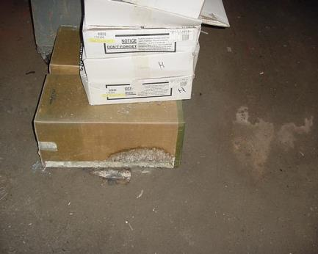

Basement with Dirt Floor, Note Mold Colony on Box

Picture 2

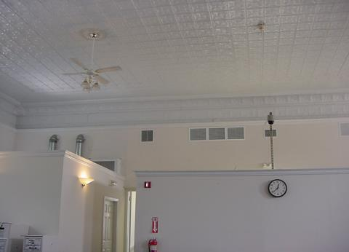

Second Floor Fresh Air Supply Vents

Picture 3

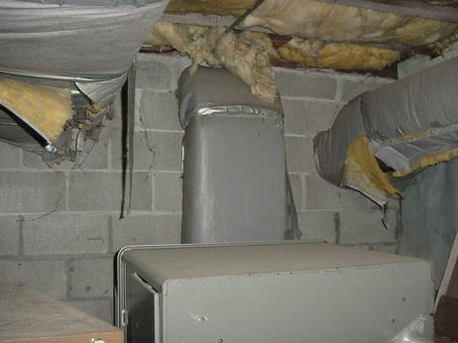

Air Intake for Basement AHU Located behind File Cabinet in Basement

Picture 4

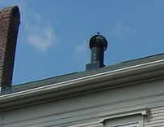

Turbine Exhaust Vent On Roof

Picture 5

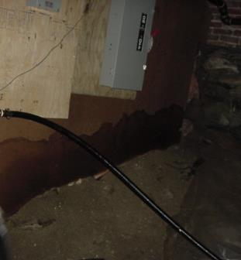

Wall Material Enclosing Fiberglass Insulation on Foundation, Note Size of Water Stain

Picture 6

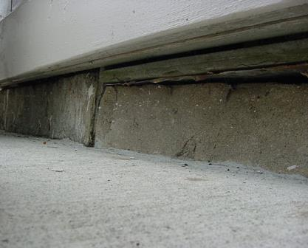

Opening In Foundation along Sidewalk

Picture 7

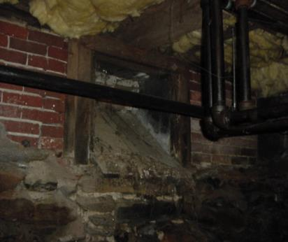

Interior View of Former Coal Chute, Note Heavy Water Damage

Picture 8

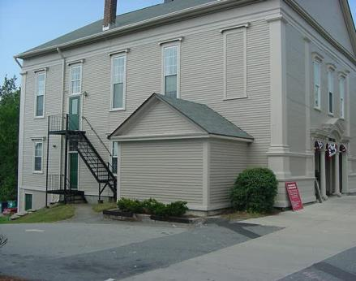

The Addition, Note Shrubbery and Lack of Gutters/Downspout of Roof Edge

Picture 9

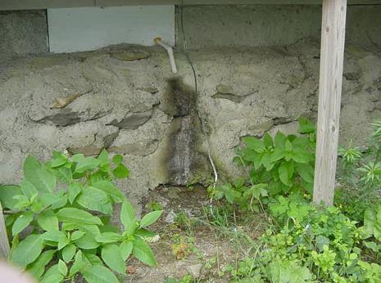

Condensation Drain That Empties onto Foundation

Picture 10

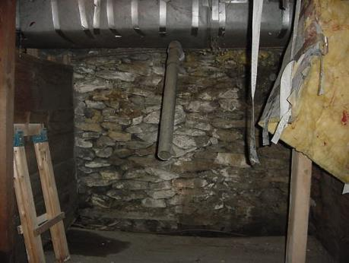

Open Pipe in Basement

Picture 11

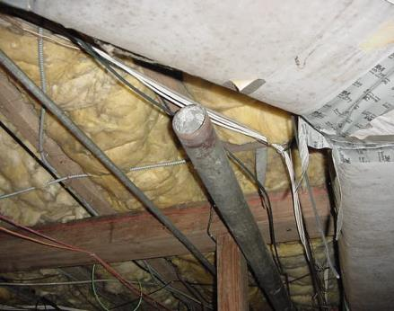

Another Open Pipe in the Basement

Picture 12

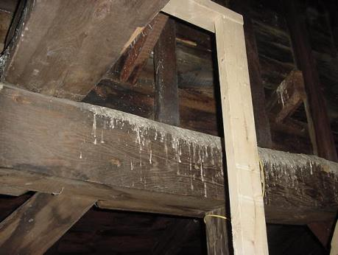

Bird Waste on Beams in Attic

Picture 13

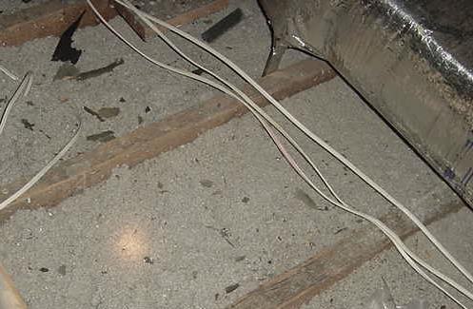

Bird Waste on Insulation in Attic

Picture 14

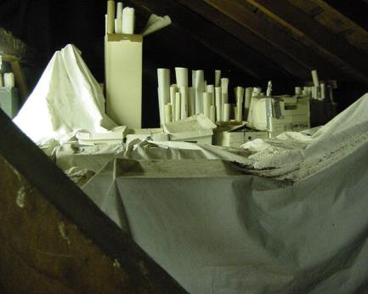

Bird Waste on Sheets in Attic

Picture 15

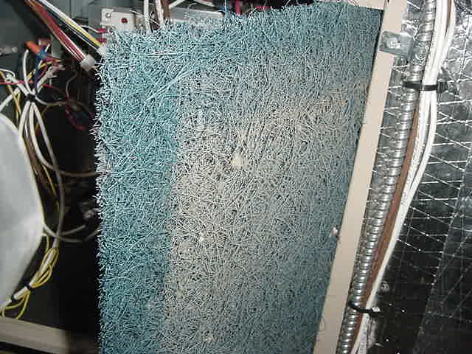

Cut Filters in Attic AHU

Location | Carbon | Temp. | Relative | Occupants | Windows | Ventilation |  | Remarks
 | Dioxide  *ppm | °F | Humidity  % | in Room | Openable | Intake | Exhaust
Outside  (Background) | 325 | 79 | 59
2nd Meeting Hall | 574 | 75 | 50 | 0 | Y | Y | Y | Door open  C fans
Building Inspector Office | 578 | 74 | 51 | 1 | Y | Y | Y | Door open, abandoned vent
Public Health Office | 582 | 74 | 52 | 2 | Y | Y | Y | Photocopier, door to attic  Door open
Records | 576 | 74 | 52 | 0 | Y | Y | Y
Computer Room
Foyer | 614 | 74 | 53 | 1 | Y | Y | Y
Board of Assessors | 972 | 76 | 57 | 2 | N | Y | Y | Univent – no filter  Door open, --photocopier
Restroom |  |  |  |  |  |  |  | Exhaust vent on light switch
 | 854 | 75 | 44 | 3 | Y | Y | Y | Windows open, window AC
Town Clerk | 904 | 75 | 47 | 1 | Y | N | N | Door open
Finance Office | 741 | 74 | 47 | 2 | Y | N | N | Door open
Board of Selectmen | 727 | 74 | 50 | 3 | Y | Y | N | Door open
CAP O | 730 | 74 | 51 | 0 | Y | N | N
Photocopier Room | 698 | 75 | 51 | 0 | N | N | N | Photocopier  Door open
Basement | 444 | 68 | 71

