Lyme Disease Surveillance in Massachusetts, 2010
Massachusetts Department of Public Health
2010 Surveillance Highlights

- 2,593 confirmed Lyme disease cases were reported in Massachusetts in 2010, representing a 35.6% decrease statewide over the number of cases reported in 2009 (4,028). Last summer’s unusually hot, dry weather was not favorable for ticks. These weather conditions also may have prevented people from spending as much time outside, resulting in fewer people being exposed to Lyme disease.

- Incidence rates of Lyme disease in 2010 were dramatically lower for many counties, compared with 2009. This was especially true in Nantucket County, where the incidence rate dropped from 452 per 100,000 in 2009 to 265 per 100,000 in 2010.

- The majority of confirmed cases had onsets in June, July and August.

- The highest incidence rates were among children aged 5-9 years and adults aged 65-69 years.

- 64% of confirmed cases reported an erythema migrans (“bulls-eye”) rash.

The map below illustrates Lyme disease incidence rates per 100,000 by city and town in Massachusetts from 2006-2010. The darker the shading, the higher the incidence. Lyme disease is considered endemic in all of Massachusetts.

Areas of high incidence include much of the eastern half of the state outside of the greater Boston area. Regions of particularly high incidence include Cape Cod and the Islands, as well as some areas in Norfolk, Middlesex, Essex, and southern Berkshire Counties. More isolated areas of high incidence were in Franklin, Hampshire, and Hampden Counties.

County* | 2010 Confirmed Cases (#) | 2010 Incidence Rate (per 100,000)
Barnstable | 117 | 54
Berkshire | 93 | 71
Bristol | 141 | 26
Dukes | 25 | 151
Essex | 184 | 25
Franklin | 42 | 59
Hampden | 130 | 28
Hampshire | 80 | 51
Middlesex | 414 | 28
Nantucket | 27 | 265
Norfolk | 267 | 40
Plymouth | 230 | 47
Suffolk | 34 | 5
Worcester | 252 | 32
State Total | 2593 | 40
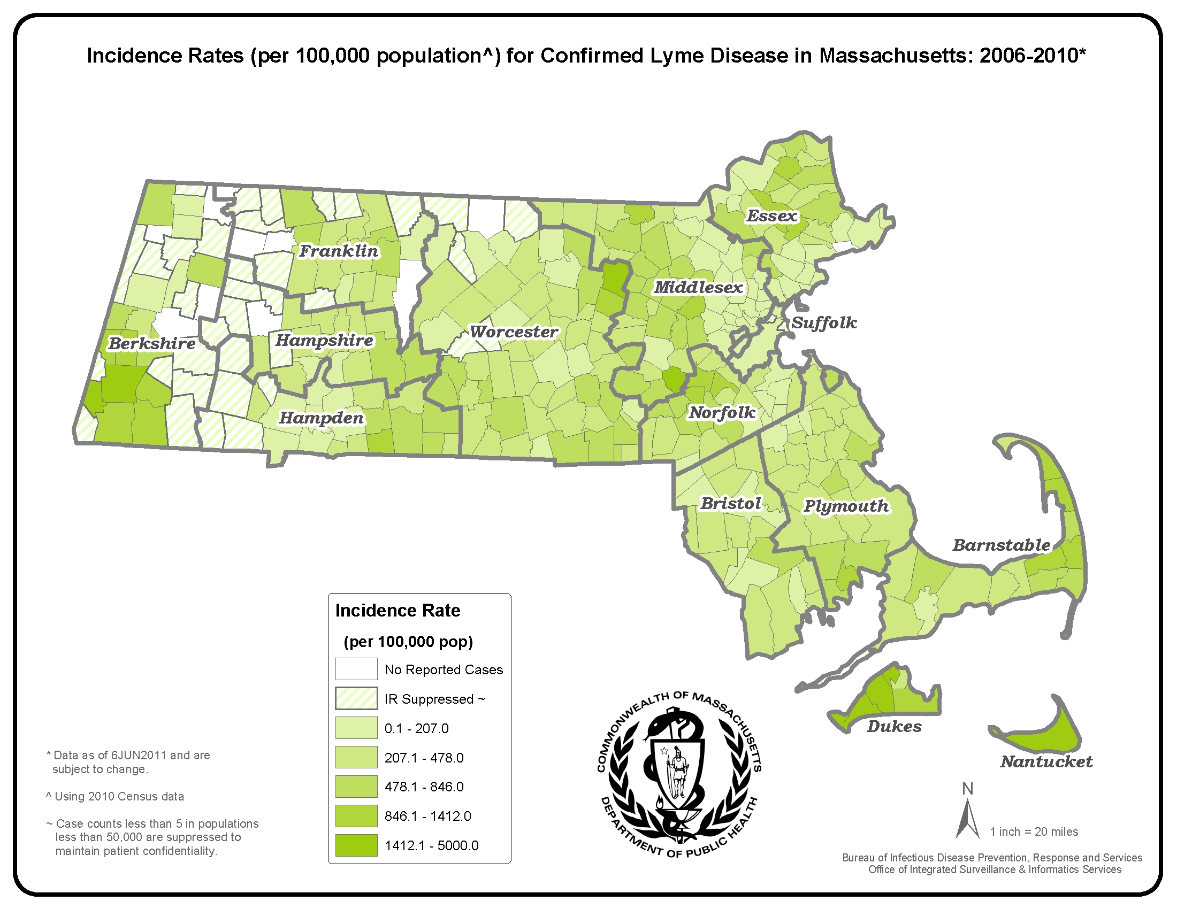
*County was unknown for 557 cases

Figure 1

Figure 2

