Lyme Disease Surveillance in Massachusetts, 2012
Massachusetts Department of Public Health
2012 Surveillance Highlights

- 3,342 confirmed and 1,708 probable Lyme disease cases were reported in Massachusetts in 2012, representing a 19% increase over the number of probable and confirmed cases reported in 2011.

- Incidence rates of confirmed Lyme disease in 2012 were higher for most counties, compared with 2011. Exceptions included Berkshire County, where the incidence rate decreased from 92 to 45 per 100,000, and Suffolk County, which remained at 8 per 100,000 from 2011 to 2012. The chart below shows the combined incidence rates for all confirmed and probable cases, by county.

- The highest incidence rates were among children aged 5-9 years and adults aged 65-69 years.

- The majority of cases had onsets in June, July, and August.

- 68% of confirmed cases reported an erythema migrans (“bulls-eye”) rash.

- MDPH was unable to classify approximately 20% of all cases reported during 2012 due to insufficient clinical information.

The map illustrates Lyme disease incidence rates per 100,000 by city and town in Massachusetts from 2008-2012; the darker the shading, the higher the incidence. Lyme disease is endemic in all of Massachusetts.

Areas of highest incidence include much of the eastern half of the state. Regions of particularly high incidence include Plymouth, Cape Cod and the Islands, and parts of Middlesex, Essex, and southern Berkshire Counties. More isolated areas of high incidence are reported from Franklin, Hampshire, and Worcester Counties.

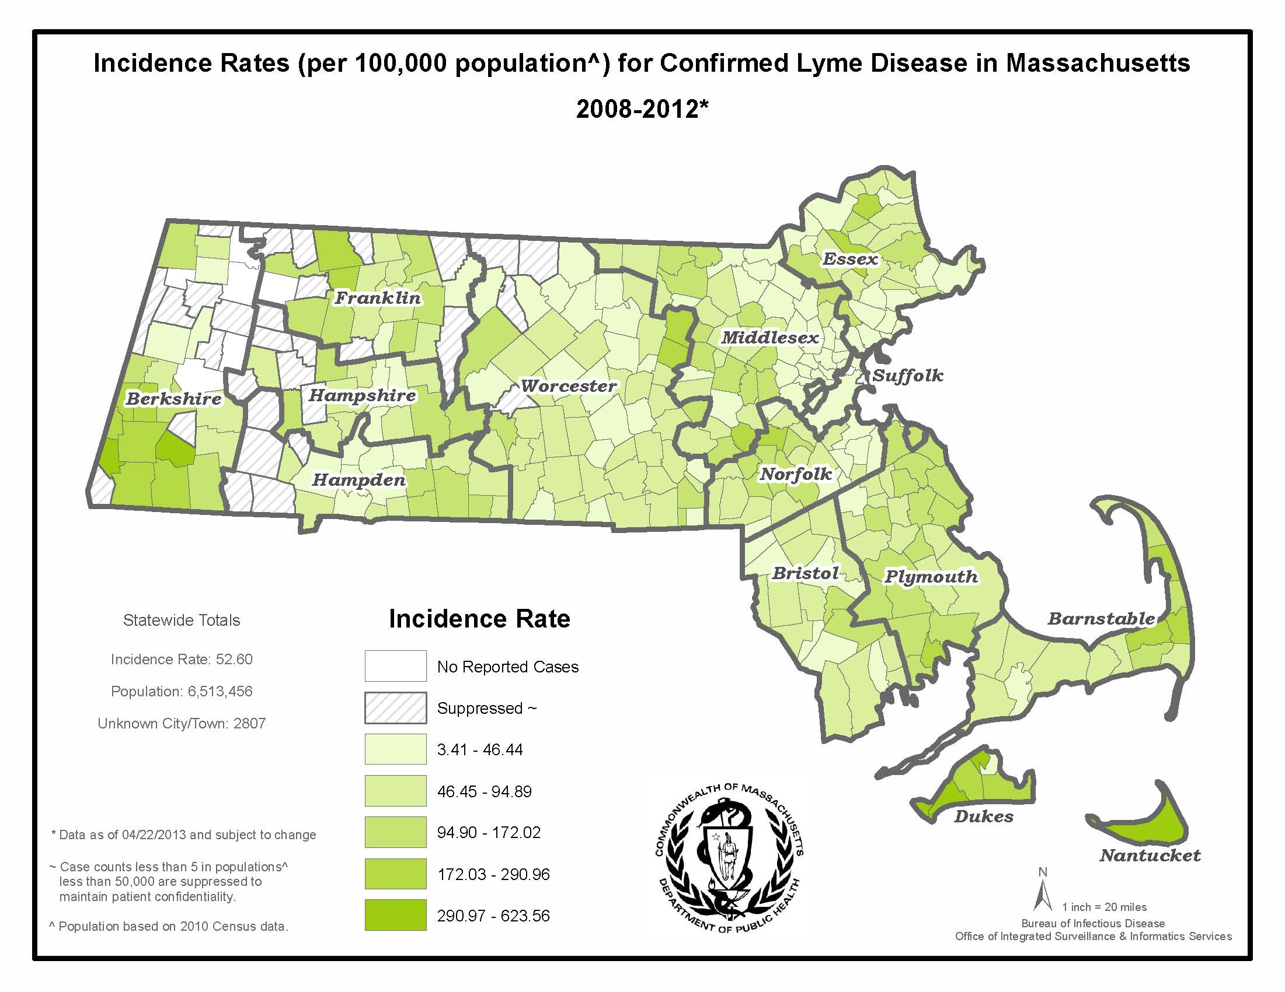
County | 2012 Confirmed Cases (#) | 2012 Probable Cases (#) | Incidence of Confirmed and Probable Cases  (per 100,000)
Barnstable | 183 | 107 | 134
Berkshire | 59 | 29 | 67
Bristol | 351 | 161 | 93
Dukes | 46 | 37 | 502
Essex | 311 | 194 | 68
Franklin | 45 | 19 | 90
Hampden | 104 | 67 | 37
Hampshire | 74 | 50 | 78
Middlesex | 485 | 289 | 51
Nantucket | 44 | 21 | 639
Norfolk | 371 | 167 | 80
Plymouth | 496 | 189 | 138
Suffolk | 61 | 56 | 16
Worcester | 290 | 149 | 55
Unknown | 422 | 173 | -
State Total | 3,342 | 1,708 | 77

Figure 1
Figure 2
Figure 3

