Lyme Disease and Babesiosis Co-Infection*:2009-2013
Massachusetts Department of Public Health
*Co-infection = patient with confirmed/probable Lyme disease + laboratory evidence of B. microti infection.
Symptomatic co-infection = patient with confirmed/probable case status for both Lyme disease and babesiosis

2009-2013 Surveillance Highlights
- Between 2009 and 2013, there were 24,687 confirmed and probable cases of Lyme disease, and 1,084 confirmed and probable cases of babesiosis reported in Massachusetts.
- There were 294 Borrelia burgdorferi/Babesia microti co-infections identified in Massachusetts; 171 of these patients met the case definition for both diseases (symptomatic co-infection).
- The highest incidence rates of B. burgdorferi/B. microti co-infection occurred in Dukes and Nantucket counties (67 and 197 per 100,000 residents). Some risk of co-infection exists throughout Massachusetts.
- The majority of B. burgdorferi/B. microti co-infections occurred in June, July and August.
- Patients with Lyme disease and babesiosis symptomatic co-infection were more likely to be reported with joint pain, muscle pain, headache and cardiac manifestations than patients with either Lyme disease or babesiosis alone.
- 36% of patients with Lyme disease and babesiosis symptomatic co-infection were hospitalized, which is similar to 39% of patients with babesiosis alone.
- 35% of reported babesiosis cases in children less than 10 years old had Lyme disease symptomatic co-infection.
- 45% of B. burgdorferi/B. microti co-infections occurred in 50 - 69 year olds.
- 15% of patients 50 years and older with confirmed or probable babesiosis had Lyme disease symptomatic co-infection; 1% of patients in this age group with confirmed or probable Lyme disease had babesiosis symptomatic co-infection.

MAP: Reported babesiosis cases overlaid on reported Lyme disease cases to demonstrate areas with higher risk of co-infection. (NOTE: these cases are reported by city/town
of residence, not necessarily place of exposure).
County | B. burgdorferi/ B. microti  co-infection (N=294) | Co-infection 5 year incidence rate (per 100,000)
Barnstable | 65 | 30
Berkshire | 1 | 1
Bristol | 20 | 4
Dukes | 11 | 67
Essex | 34 | 5
Franklin | 1 | 1
Hampden | 12 | 3
Hampshire | 3 | 2
Middlesex | 45 | 3
Nantucket | 20 | 197
Norfolk | 23 | 3
Plymouth | 48 | 10
Suffolk | 5 | 1
Worcester | 6 | 1
TABLE: Actual counts and incidence rates of patients with confirmed or probable Lyme disease and laboratory evidence of B. microti infection.
COMPARE TO

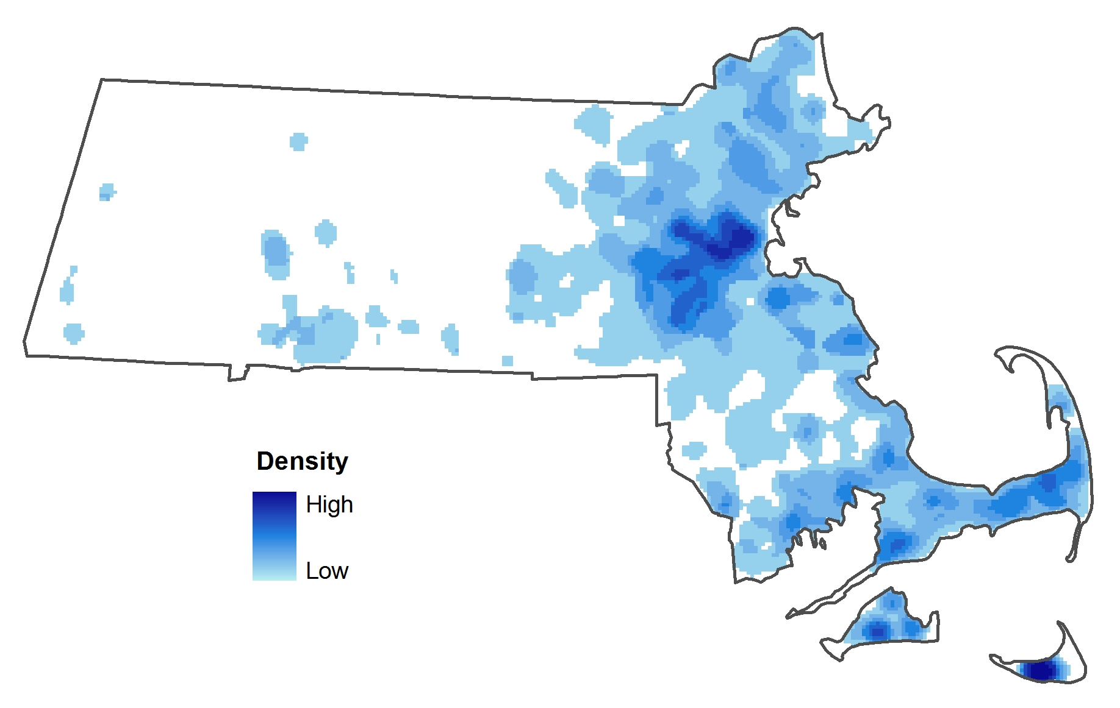

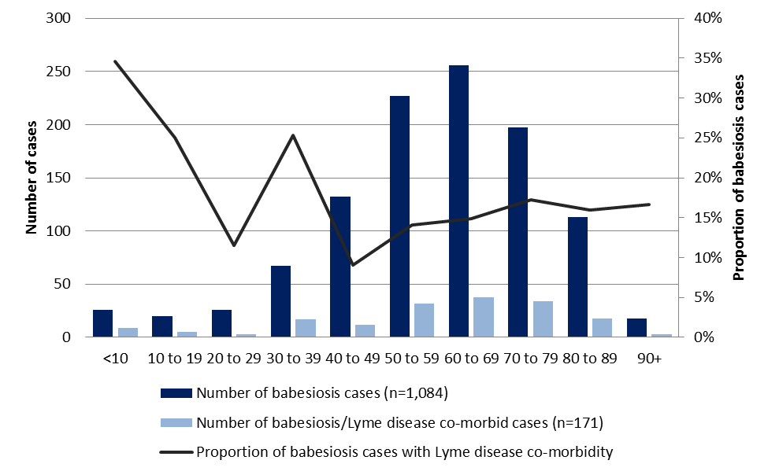
Figure 2: Number of confirmed and probable cases of babesiosis and cases of babesiosis with Lyme disease symptomatic co-infection in Massachusetts by age: 2009-2013
- The greatest proportion of babesiosis cases with Lyme disease symptomatic co-infection occurred in children less than 10 years of age (35%).
- A large number of the symptomatic co-infection cases occurred in the 50 - 79 year age range.
- 15% of patients 50 years and older, with confirmed or probable babesiosis had Lyme disease symptomatic co-infection. Only 1% of patients in this age group, with confirmed or probable Lyme disease had babesiosis symptomatic co-infection.

Table 3: Percent of particular reported signs and symptoms among probable and confirmed cases of Lyme disease, babesiosis, and Lyme disease/babesiosis symptomatic co-infection reported in Massachusetts: 2009-2013
Sign or Symptom | Lyme  (n=24,687) | Babesiosis (n=1,084) | Lyme/Babesiosis Symptomatic co-infection (n=171)
 | Percent | Percent | Percent
Rheumatologic | 55 | 47 | 75
Arthritis | 23 | 0 | 12
Joint pain | 43 | 46 | 58
Neck pain | 14 | 2 | 12
Cardiac | 2 | 0 | 5
Fatigue | 36 | 79 | 82
Fever | 34 | 83 | 85
Gastrointestinal | 1 | 44 | 37
Muscle Pain | 42 | 50 | 58
Headache | 25 | 50 | 59
Neurological | 14 | 1 | 14
Cognitive impairment | 5 | 0 | 8
Erythema migrans | 49 | 1 | 39

- Reported signs and symptoms of Lyme disease include arthritis; cardiac abnormalities such as arrhythmia, AV block and palpitations; neurological (auditory impairment, Bell’s palsy, lymphocytic meningitis, paresthesia, radiculoneuropathy, and visual and cognitive impairment); rash (including erythema migrans); and headache.
- Reported signs and symptoms of babesiosis include joint pain and muscle ache; fatigue and malaise; fever (fever, chills and sweats); headache; and gastrointestinal symptoms (anorexia and nausea).
- Reported cases with Lyme disease and babesiosis symptomatic co-infection were more likely to experience joint pain, muscle pain, headache and cardiac manifestations than patients with either Lyme disease or babesiosis alone (p<0.05 for each of these signs or symptoms).

