Anaplasmosis (HGA) and Lyme Disease Co-infection*:2009-2013
Massachusetts Department of Public Health
*Co-infection = patient with confirmed/probable Lyme disease + laboratory evidence of A. phagocytophilum infection.
Symptomatic co-infection = patient with confirmed/probable case status for both Lyme disease and anaplasmosis

2009-2013 Surveillance Highlights
- Between 2009 and 2013, there were 24,687 confirmed and probable cases of Lyme disease and 1,170 confirmed and probable cases of HGA reported in Massachusetts.
- There were 226 Borrelia burgdorferi/Anaplasma phagocytophilum co-infections identified in Massachusetts; 70 of these met the case definition for both diseases (symptomatic co-infection).
- The highest incidence rates of B. burgdorferi/A. phagocytophilum co-infection occurred in Dukes and Nantucket counties (22 per 100,000 residents) and Berkshire County (11 per 100,000 residents).
- A majority of B. burgdorferi/A. phagocytophilum co-infections occurred in June and July.
- Patients with Lyme disease and HGA symptomatic co-infection were more likely to be reported with joint pain, palpitations, fatigue, chills and/or sweats, abdominal pain, and paresthesias and/or cognitive impairment than patients with either Lyme disease or HGA alone.
- Patients with Lyme disease and HGA symptomatic co-infection were not more likely to be hospitalized than patients with HGA alone.
- 13% of HGA cases in children less than 10 years old, and 11% of adults over 80 years old with HGA had Lyme disease symptomatic co-infection.
- 72% of B. burgdorferi/A. phagocytophilum co-infections occurred in 40 - 79 year olds.
- 5% of cases 40 years and older with confirmed or probable HGA had Lyme disease symptomatic co-infection; 0.5% of cases in this age group with confirmed or probable Lyme disease had HGA symptomatic co-infection.

MAP: Reported anaplsmosis cases overlaid on reported Lyme disease cases to demonstrate areas with higher risk of co-infection. (NOTE: these cases are reported by city/town
of residence, not necessarily place of exposure).
TABLE: Actual counts and incidence rates of patients with confirmed or probable Lyme disease and laboratory evidence of A. phagocytophilum infection.
COMPARE TO

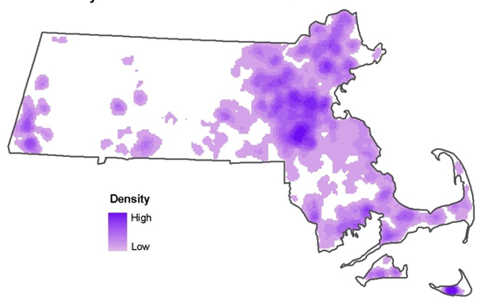
County | B. burgdorferi/ A. phagocytophilum  co-infection (N=220) | Co-Infection 5 year incidence rate (per 100,000)
Barnstable | 8 | 4
Berkshire | 15 | 11
Bristol | 35 | 6
Dukes and Nantucket | 6 | 22
Essex | 44 | 6
Franklin | 5 | 7
Hampden | 6 | 1
Hampshire | 1 | 1
Middlesex | 46 | 3
Norfolk | 18 | 3
Plymouth | 17 | 3
Suffolk | 8 | 1
Worcester | 11 | 1

Figure 2: Number of confirmed and probable cases of HGA and cases of Lyme disease and symptomatic co-infection in Massachusetts by age: 2009-2013
- The greatest proportion of HGA cases with Lyme disease symptomatic co-infection occurred in children less than 10 years (13%) and adults over 80 years (11%).
- A large number of B. burgdorferi/A. phagocytophilum symptomatic co-infection cases occurred in the 40-79 year age range.
- 6% of patients 40 years and older with confirmed or probable HGA had Lyme disease symptomatic co-infection. Only 0.5% of patients in this age group with confirmed or probable Lyme disease had HGA symptomatic co-infection.

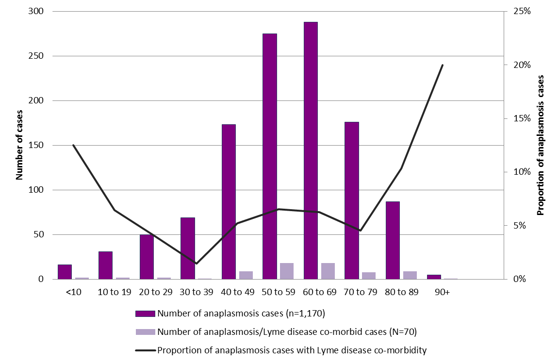

Table 3: Percent of particular reported signs and symptoms among probable and confirmed cases of Lyme disease, HGA, and Lyme disease/HGA symptomatic co-infection reported in Massachusetts: 2009-2013
 | Lyme (n=24,687) | HGA  (n=1,170) | Lyme/HGA Symptomatic co-infection (N=70)
Sign or Symptom | Percent | Percent | Percent
Rheumatologic | 55 | 57 | 89
Arthritis | 23 | 0 | 14
Joint pain | 43 | 55 | 69
Neck pain | 14 | 3 | 10
Cardiac | 2 | 0 | 9
Palpitations | 1 | 0 | 7
Fatigue | 36 | 8 | 64
Fever | 29 | 96 | 91
Chills | 19 | 20 | 54
Sweats | 11 | 6 | 29
Headache | 25 | 52 | 71
Abdominal pain | 0 | 0 | 21
Neurological | 14 | 0 | 21
Paresthesia | 5 | 0 | 14
Cognitive Impairment | 5 | 0 | 13
Rash | 59 | 4 | 36

- Reported signs and symptoms of Lyme disease include arthritis; cardiac abnormalities such as arrhythmia, AV block and palpitations; neurological (auditory impairment, Bell’s palsy, lymphocytic meningitis, paresthesia, radiculoneuropathy, and visual and cognitive impairment); rash (including erythema migrans); and headache.
- Reported signs and symptoms of HGA include gastrointestinal illness, headache, fatigue, fever, joint pain, and muscle aches.
- Reported cases with Lyme disease and HGA symptomatic co-infection were more likely to report joint pain, palpitations, fatigue, chills and/or sweats, abdominal pain, paresthesia and cognitive impairment than patients with either Lyme disease or HGA alone (p<0.05 for each of these signs or symptoms).

