INDOOR AIR QUALITY
POST-OCCUPANCY ASSESSMENT

Health and Human Services Center
330 Lynnway
Lynn, MA

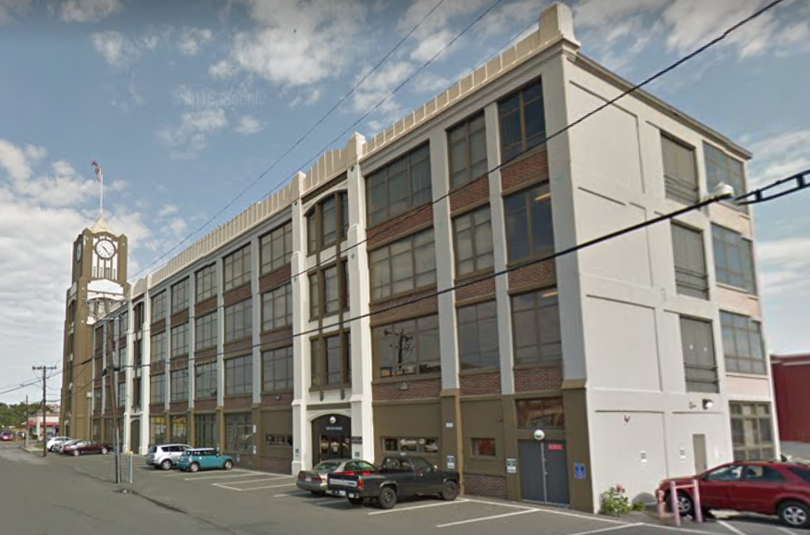

Prepared by:
Massachusetts Department of Public Health
Bureau of Environmental Health
Indoor Air Quality Program
March 2022

BACKGROUND
Building: | Executive Office of Health and Human Services (EOHHS) Center
Address: | 330 Lynnway, Lynn, Massachusetts
Assessment Requested by: | Pedro Batista, Project Coordinator, EOHHS
Reason for Request: | General IAQ issues and rodents
Date of Assessment: | March 4, 2022
Massachusetts Department of Public Health/Bureau of Environmental Health (MDPH/BEH) Staff Conducting Assessment: | Mike Feeney, Director, Indoor Air Quality (IAQ) Program
Building Description: | The EOHHS Center is located in the Clocktower Business Center, which is a 4-story brick building with a flat roof originally constructed in 1925 as a lightbulb factory. In 1995 the building was completely remodeled into offices. The EOHHS Center occupies space on the second floor, including offices, workstations, storage, and meeting rooms. Other retail and office businesses are located in the building.
Windows: | Not openable

METHODS
Please refer to the IAQ Manual for methods, sampling procedures, and interpretation of results (MDPH, 2015).

RESULTS AND DISCUSSION
The following is a summary of indoor air testing results (Table 1).
- Carbon dioxide levels were below 800 parts per million (ppm) in most areas assessed, with the remaining areas close to 800 ppm, indicating adequate fresh air in the space. Some areas tested were lightly occupied; carbon dioxide levels may be higher with higher occupancy.
- Temperature was within the recommended range of 70°F to 78°F in all areas assessed.
- Relative humidity was below the MDPH recommended range of 40 to 60% in all occupied areas. Outdoor relative humidity was measured at 19% the day of assessment. A sensation of dryness and irritation is common in a low relative humidity environment. Low relative humidity is a very common problem during the heating season in the northeast part of the United States.
- Carbon monoxide levels ranged from 6-10 ppm in the areas surveyed. Outdoor measurements upwind from the EOHHS Center were 7 ppm in the afternoon. It is likely the products of combustion from adjacent buildings and vehicle traffic were held in place low to the ground by temperature inversion (EB, unknown), which was drawn into the building by the rooftop air handling units. This unusual condition would only be present during temperature inversion events and certain wind conditions.
- Fine particulate matter (PM2.5) concentrations measured were below the National Ambient Air Quality Standard (NAAQS) level of 35 μg/m³ in all areas assessed.

Ventilation
Fresh air is provided by rooftop air-handling units (AHUs). Fresh air is drawn into the AHUs through a bank of filters, heated or cooled, and delivered to occupied areas via ducted supply diffusers. Return air is drawn into ceiling-mounted vents and ducted back to the rooftop AHUs. Some offices are designed to have supply vents and passive exhaust vents; the positive pressure created by supply ventilation aids in the removal of stale air from these areas.
AHUs for these areas are controlled by thermostats, which have fan settings of “on” and “auto”. The automatic setting on the thermostat activates the system at a preset temperature. Once a preset temperature is measured by the thermostat, the HVAC system is deactivated. Therefore, no mechanical ventilation is provided until the thermostat re-activates the system. Without adequate thermostat control of the HVAC system, naturally occurring pollutants (i.e. waste heat and odors) can accumulate.
In order to have proper ventilation with a mechanical supply and exhaust system, the systems must be balanced to provide an adequate amount of fresh air to the interior of a room while removing stale air from the room. It is recommended that HVAC systems be re-balanced every five years to ensure adequate air systems function (SMACNA, 1994). It was reported that the system was balanced prior to occupancy in 2011.

Microbial/Moisture Concerns
Water damage was noted on a windowsill in the kitchen (Table 1). No other signs of water damage or water infiltration were noted during the visit.

Other Conditions
Signs of rodents were noted in the kitchen area. In the experience of the IAQ Program, rodents and other pests tend to increase in spaces due to:
- an abundance of unsecured food,
- locations for rodents to hide and nest (harborages),
- occupant traffic/occupancy is reduced for extended periods of time.
IAQ staff noted a number of attractants for rodents, including:
- poorly cleaned microwaves and toaster ovens in the kitchen,
- food residue in workstations from occupants eating at their desks,
- presence of materials that may use glues containing fatty material, such as cardboard boxes and bound books.
- the likely presence of food stored inside desks in non-airtight containers.
Rodent harborages were noted throughout the occupied space (Picture 1). Harborages can include paper piles, cardboard boxes, and other materials. In order to reduce rodents in a building, the elimination of harborages including materials stored on floors and on other flat surfaces is necessary.
Rodent infestation can result in IAQ-related symptoms due to materials in their wastes. Mouse urine contains a protein that is a known sensitizer (US EPA, 1992). A sensitizer is a material that can produce symptoms (e.g., running nose or skin rashes) in sensitive individuals after repeated exposure. To eliminate exposure to allergens, rodents must be removed from the building. Please note that removal, even after cleaning, may not provide immediate relief since allergens can exist in the interior for several months after rodents are eliminated (Burge, 1995). Once the infestation is eliminated, a combination of cleaning and increased ventilation and filtration should serve to reduce allergens associated with rodents.

CONCLUSIONS AND RECOMMENDATIONS
In view of the findings at the time of the visit, the following recommendations are provided:

Ventilation recommendations
- Ensure thermostats are set to have the fan on continuously during occupancy.
- Consider adopting a balancing schedule of every 5 years for all mechanical ventilation systems, as recommended by ventilation industrial standards (SMACNA, 1994).
- Change filters for AHUs in accordance with the manufacturer’s instructions or more frequently if needed.
- For buildings in New England, periods of low relative humidity during the winter are often unavoidable. Therefore, scrupulous cleaning practices should be adopted to minimize common indoor air contaminants whose irritant effects can be enhanced when the relative humidity is low. To control for dusts, a high efficiency particulate arrestance (HEPA) filter equipped vacuum cleaner in conjunction with wet wiping of all surfaces is recommended. Avoid the use of feather dusters. Drinking water during the day can help ease symptoms associated with a dry environment (throat and sinus irritations).

Water damage recommendations
- Maintain indoor plants and avoid overwatering. Ensure that plants are placed in waterproof drip pans that are cleaned frequently to prevent odors.

Other recommendations
- Remove materials stored on walls and in cubicles.
- Do not store boxes on the floor.
- Obtain storage shelves, cabinets, or pest-proof totes that are configured to reduce rodent hiding spaces/harborages.
- Routinely clean the kitchens including food residues from toasters, microwave ovens, coffee makers, or any other appliances used to prepare or heat food.
- Eliminate any unwashed food dishes and utensils.
- Do not store food in or on employee desks, cubicles, or other work surfaces apart from the kitchen, and only in pest-proof air-tight containers made of hard plastic, glass, or metal.
- Consumption of food should occur in the kitchen area to limit the locations of food residues.
- Remove all empty food containers daily. Do not reuse food containers for other uses.
- Install door sweeps on all hallway doors.
- For additional recommendations, please use methods of integrated pest management IPM in this workplace described in the IPM guide: https://www.mass.gov/doc/ipm-integrated-pest-management-kit-for-building-managers/download
- Refer to resource manual and other related IAQ documents located on the MDPH’s website for further building-wide evaluations and advice on maintaining public buildings. These documents are available at: http://mass.gov/dph/iaq.

REFERENCES
Burge, H.A. 1995. Bioaerosols. CRC Publishing, Boca Raton, FL. P. 110.
EB. Unknown. Temperature Inversion. https://www.britannica.com/science/temperature-inversion Encyclopedia Britannica.
MDPH. 2015. Massachusetts Department of Public Health. Indoor Air Quality Manual: Chapters I-III. Available at: https://www.mass.gov/lists/indoor-air-quality-manual-and-appendices
SMACNA. 1994. HVAC Systems Commissioning Manual. 1st ed. Sheet Metal and Air Conditioning Contractors’ National Association, Inc., Chantilly, VA.
US EPA. 1992. Indoor Biological Pollutants. US Environmental Protection Agency, Environmental Criteria and Assessment Office, Office of Health and Environmental Assessment, research Triangle Park, NC. EPA 600/8-91/202. January 1992.

Picture 1
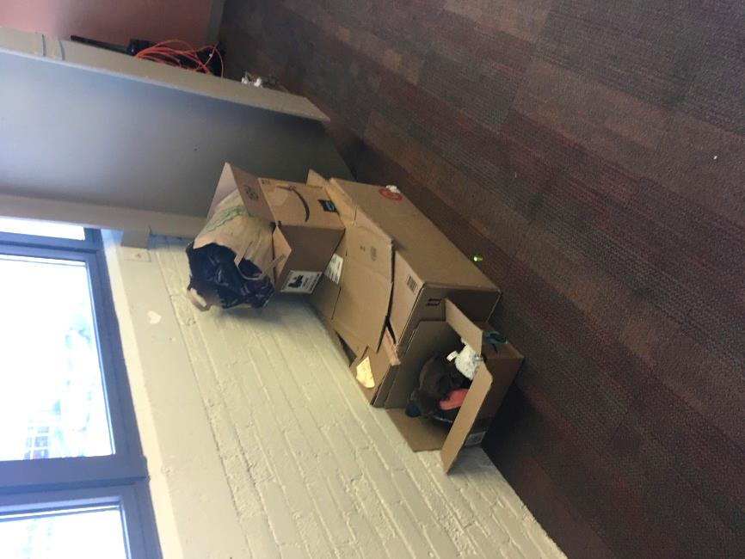
Boxed materials forming a rodent harborage

Location | Carbon  Dioxide  (ppm) | Carbon Monoxide  (ppm) | Temp  (°F) | Relative  Humidity  (%) | PM2.5  (µg/m³) | Occupants  in Room | Windows  Openable | Ventilation |  | Remarks
 |  |  |  |  |  |  |  | Supply | Exhaust
Background | 344 | 7 | 41 | 19 | 15
2004 | 733 | 7 | 71 | 18 | ND | 0 | N | Y | Y
2005 | 714 | 8 | 71 | 17 | ND | 0 | N | Y | Y
2007 | 700 | 8 | 71 | 17 | ND | 0 | N | Y | Y
2014 | 837 | 7 | 76 | 19 | ND | 1 | N | Y | Y
2017 | 865 | 7 | 76 | 20 | ND | 1 | N | Y | Y
2020 | 896 | 6 | 76 | 20 | ND | 2 | N | Y | Y
2023 | 846 | 6 | 77 | 20 | ND | 0 | N | Y | Y
2026 | 832 | 6 | 74 | 20 | ND | 0 | N | Y | Y
2028 | 883 | 7 | 76 | 20 | ND | 0 | N | Y | Y
2043 | 633 | 9 | 73 | 15 | ND | 0 | N | Y | Y
2045 | 678 | 9 | 74 | 14 | ND | 0 | N | Y | Y
2052 | 498 | 9 | 73 | 12 | ND | 0 | N | Y | Y
2059 | 503 | 9 | 72 | 12 | ND | 0 | N | Y | Y
2073 | 505 | 9 | 72 | 12 | ND | 0 | N | Y | Y
2075 | 487 | 9 | 72 | 12 | ND | 1 | N | Y | Y
2083 | 496 | 9 | 73 | 12 | ND | 0 | N | Y | Y
2085 | 503 | 9 | 73 | 13 | ND | 0 | N | Y | Y
2089 | 518 | 9 | 72 | 13 | ND | 0 | N | Y | Y
2090 | 525 | 10 | 72 | 13 | ND | 0 | N | Y | Y
2090 | 503 | 9 | 73 | 12 | ND | 0 | N | Y | Y
2096 | 545 | 9 | 72 | 13 | ND | 0 | N | Y | Y
2099 | 531 | 9 | 72 | 14 | ND | 0 | N | Y | Y
2102 | 495 | 9 | 72 | 12 | ND | 0 | N | Y | Y
2112 | 556 | 10 | 72 | 12 | ND | 1 | N | Y | Y
2122 | 516 | 9 | 72 | 13 | 1 | 1 | N | Y | Y
2124 | 572 | 9 | 72 | 12 | ND | 1 | N | Y | Y
2133 | 534 | 9 | 72 | 14 | ND | 1 | N | Y | Y
2133 | 492 | 9 | 72 | 11 | ND | 2 | N | Y | Y
2136 | 537 | 9 | 73 | 12 | ND | 0 | N | Y | Y
2148 | 508 | 9 | 72 | 12 | ND | 0 | N | Y | Y
2157 | 486 | 9 | 70 | 12 | ND | 0 | N | Y | Y
2167 | 495 | 10 | 72 | 12 | ND | 0 | N | Y | Y
2169 | 500 | 9 | 72 | 12 | ND | 0 | N | Y | Y
2170 | 487 | 9 | 71 | 12 | ND | 0 | N | Y | Y
2172 | 503 | 9 | 71 | 13 | ND | 1 | N | Y | Y
2177 | 558 | 8 | 72 | 14 | 1 | 0 | N | Y | Y
2186 | 502 | 9 | 72 | 12 | ND | 0 | N | Y | Y
Car seat room | 529 | 9 | 72 | 13 | ND | 0 | N | Y | Y | Car seats
Kitchen | 730 | 9 | 73 | 16 | ND | 1 | N | Y | Y | Toaster oven crumbs, mouse droppings, water-damaged windowsill, plants
Reception | 345 | 9 | 73 | 15 | ND | 1 | N | Y | Y
Reception | 823 | 7 | 76 | 19 | ND | 0 | N | Y | Y
Situation room | 597 | 8 | 71 | 20 | ND | 0 | N | Y | Y
Waiting room | 899 | 7 | 77 | 16 | ND | 0 | N | Y | Y | Large space beneath hallway door without door sweep

