INDOOR AIR QUALITY ASSESSMENT

Lynnfield High School
275 Essex Street
Lynnfield, Massachusetts 01940

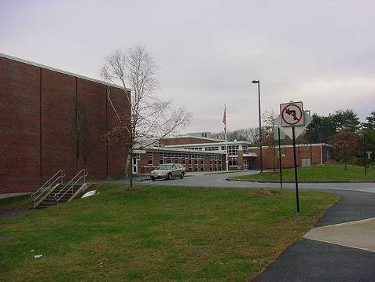

Prepared by:
Massachusetts Department of Public Health
Center for Environmental Health
Emergency Response/Indoor Air Quality Program
February 2007

Background/Introduction
At the request of a parent and the Lynnfield Public School Department, the Massachusetts Department of Public Health (MDPH), Center for Environmental Health (CEH) provided assistance and consultation regarding indoor air quality at each of Lynnfield’s public schools. These assessments were jointly coordinated through Patti Fabbri, Parent/IAQ Representative, Thom Forbes, Facilities Manager, Lynnfield Department of Public Works and Jim Nugent, Director, Lynnfield Health Department.
On December 11, 2006, a visit to conduct an assessment of the Lynnfield High School (LHS) was made by Cory Holmes, an Environmental Analyst in the CEH’s Emergency Response/Indoor Air Quality (ER/IAQ) Program. Mr. Holmes was accompanied for portions of the assessment by Ms. Fabbri.
The school is a red brick building that consists of a ground floor, main floor and second floor that was originally built in 1964. In 2001 an addition was built and the existing building was renovated. The second floor is made up of general classrooms, science labs, a teacher’s room and offices. The main floor contains general classrooms, science labs, kitchen, cafeteria, library, gymnasium locker rooms, auditorium, music rooms, art rooms, computer rooms and office space. The ground floor contains classrooms, locker rooms and a weight room. Windows are openable throughout the building.

Methods
Air tests for carbon dioxide, temperature and relative humidity were taken with the TSI, Q-Trak, IAQ Monitor, Model 8551. Screening for total volatile organic compounds (TVOCs) was conducted in the gymnasium using a Hnu, Model 102 Snap-on Photo Ionization Detector (PID). CEH staff also performed a visual inspection of building materials for water damage and/or microbial growth.

Results
The school houses approximately 630 students in grades 9-12 and approximately 75 staff members. Tests were taken under normal operating conditions. Test results appear in Table 1.

Discussion
Ventilation
It can be seen from the Table 1 that carbon dioxide levels were above 800 parts per million (ppm) in twenty-four of fifty-two areas surveyed, indicating poor air exchange in almost half of the areas surveyed, mainly due to mechanical ventilation components being deactivated at the time of the assessment. Without a continuous source of fresh outside air indoor environmental pollutants can build-up and lead to indoor air quality/comfort complaints. Please note that five areas (103, 209, 223, 228 and 312,) had carbon dioxide levels in excess of 2,000 ppm; 223 and 228 had carbon dioxide levels in excess of 3,000 ppm, which is of particular concern. Rooms 101-A and 208-A exceeded 800 ppm and were unoccupied at the time of the assessment. It is also important to note that a number of areas with carbon dioxide levels below 800 ppm were sparsely populated or unoccupied, which can greatly reduce carbon dioxide levels. Carbon dioxide levels would be expected to be higher with full occupancy.
Fresh air in classrooms is supplied by a unit ventilator (univent) system (Picture 1). A univent draws air from the outdoors through a fresh air intake located on the exterior wall of the building (Picture 2) and returns air through an air intake located at the base of the unit. Fresh and return air are mixed, filtered, heated and provided to classrooms through an air diffuser located in the top of the unit. Adjustable louvers control the ratio of outside to recirculated air (Figure 1). Univents were found deactivated in a number of areas (Table 1). Obstructions to airflow, such as items stored on or in front of univents were seen in some areas. In order for univents to provide fresh air as designed, units must be activated while rooms are occupied and air diffusers should remain free of obstructions.
Exhaust ventilation in classrooms is provided by unit exhaust ventilators (Picture 3). These exhaust ventilators were not operating in some of the areas surveyed at the time of the assessment. As with the univents, in order for exhaust ventilation to function as designed, unit exhaust ventilators must be activated. Without sufficient supply and exhaust ventilation, environmental pollutants can build up and lead to indoor air quality/comfort complaints.
Mechanical ventilation in common areas and interior rooms (e.g., gym, cafeteria, media center) is provided by air handling units (AHUs) located on the roof (Picture 4). Outside air is heated or cooled and distributed to occupied areas via ceiling-mounted air diffusers (Picture 5) and exhausted out of the building via ceiling or wall-mounted vents powered by rooftop motors (Picture 6). Mechanical ventilation did not appear to be operating in a number of common areas such as locker rooms, the athletic storage room and science prep rooms during the assessment (Table 1). Slight chemical odors were detected in prep room 101-A and musty odors were detected in the athletic storage room, most likely due to the mechanical ventilation system not operating.
To maximize air exchange, the MDPH recommends that both supply and exhaust ventilation operate continuously during periods of school occupancy. In order to have proper ventilation with a mechanical supply and exhaust system, the systems must be balanced to provide an adequate amount of fresh air to the interior of a room while removing stale air from the room. It is recommended that existing ventilation systems be re-balanced every five years to ensure adequate air systems function (SMACNA, 1994). The date of the last balancing of these systems was not available at the time of the assessment, but should have occurred at some point after construction/renovation in 2001.
The Massachusetts Building Code requires a minimum ventilation rate of 15 cubic feet per minute (cfm) per occupant of fresh outside air or have openable windows in each room (SBBRS, 1997; BOCA, 1993). The ventilation must be on at all times that the room is occupied. Providing adequate fresh air ventilation with open windows and maintaining the temperature in the comfort range during the cold weather season is impractical. Mechanical ventilation is usually required to provide adequate fresh air ventilation.
Carbon dioxide is not a problem in and of itself. It is used as an indicator of the adequacy of the fresh air ventilation. As carbon dioxide levels rise, it indicates that the ventilating system is malfunctioning or the design occupancy of the room is being exceeded. When this happens a buildup of common indoor air pollutants can occur, leading to discomfort or health complaints. The Occupational Safety and Health Administration (OSHA) standard for carbon dioxide is 5,000 parts per million parts of air (ppm). Workers may be exposed to this level for 40 hours/week based on a time weighted average (OSHA, 1997).
The MDPH uses a guideline of 800 ppm for publicly occupied buildings. A guideline of 600 ppm or less is preferred in schools due to the fact that the majority of occupants are young and considered to be a more sensitive population in the evaluation of environmental health status. Inadequate ventilation and/or elevated temperatures are major causes of complaints such as respiratory, eye, nose and throat irritation, lethargy and headaches. For more information concerning carbon dioxide, please see Appendix A.
Temperature measurements ranged from 65º F to 73º F, which were below the MDPH recommended comfort guidelines in several areas the day of the assessment. The MDPH recommends that indoor air temperatures be maintained in a range of 70 º F to 78 º F in order to provide for the comfort of building occupants. In many cases concerning indoor air quality, fluctuations of temperature in occupied spaces are typically experienced, even in a building with an adequate fresh air supply. It is also difficult to maintain comfort without operating the mechanical ventilation system as designed (e.g., univents/exhaust vents/AHUs not operating/obstructed).
The relative humidity ranged from 26 to 44 percent, which was below the MDPH recommended comfort range in the majority of areas surveyed during the assessment. The MDPH recommends that indoor air relative humidity is comfortable in a range of 40 to 60 percent. During the heating season, relative humidity levels would be expected to drop below the recommended comfort range. The sensation of dryness and irritation is common in a low relative humidity environment. For buildings in New England, periods of low relative humidity during the winter are often unavoidable.

Microbial/Moisture Concerns
Plants were noted in several classrooms. Plants can be a source of pollen and mold, which can be respiratory irritants for some individuals. Plants should be properly maintained and equipped with drip pans. Plants should also be located away from ventilation sources (e.g., air intakes, univent diffusers) to prevent the entrainment and/or aerosolization of dirt, pollen or mold.

Other Concerns
Indoor air quality can also be negatively influenced by the presence of materials containing volatile organic compounds (VOCs). Concerns were raised regarding potential VOCs emanating from the gymnasium floor, which was refinished within the last year. In an effort to determine whether VOCs were present, air monitoring for TVOCs was conducted in the gymnasium. An outdoor air sample was taken for comparison. Outdoor TVOC concentrations were ND. TVOC concentrations in the gymnasium were also ND (Table 1). VOCs are carbon-containing substances that have the ability to evaporate at room temperature. Frequently, exposure to low levels of total VOCs (TVOCs) may produce eye, nose, throat and/or respiratory irritation in some sensitive individuals. For example, chemicals evaporating from a paint can stored at room temperature would most likely contain VOCs.
Please note, TVOC air measurements are only reflective of the indoor air concentrations present at the time of sampling. Indoor air concentrations can be greatly impacted by the use of TVOC containing products. In an effort to identify materials that can potentially increase indoor TVOC concentrations, MDPH staff examined classrooms for products containing these respiratory irritants. Several classrooms contained dry erase boards and dry erase board markers. Materials such as dry erase markers and dry erase board cleaners may contain VOCs, such as methyl isobutyl ketone, n-butyl acetate and butyl-cellusolve (Sanford, 1999), which can be irritating to the eyes, nose and throat.
Several other conditions that can affect indoor air quality were noted during the assessment. CEH staff inspected the AHU in the loft in the custodial closet near the TV studio and found that the unit had holes in the sheet-metal housing (Picture 6). This is important to note because the location of the breaches were post-filter. As air is forced through the AHU it becomes depressurized, and can draw in unfiltered air, dirt, dust and debris into the unit through these breaches, which can then be distributed throughout the building via the ventilation system.
In some classrooms items were observed on windowsills, tabletops, counters, bookcases and desks. The large number of items stored in classrooms provides a source for dusts to accumulate. These items, (e.g., papers, folders, boxes) make it difficult for custodial staff to clean. Items should be relocated and/or be cleaned periodically to avoid excessive dust build up.
A number of vents and personal fans had accumulated dust (Pictures 7 and 8). If vents are not functioning, backdrafting can occur, which can re-aerosolize dust particles and reduce the efficiency of the vent to draw air. In addition, these materials can accumulate on flat surfaces (e.g., desktops, shelving and carpets) in occupied areas and subsequently be re-aerosolized causing further irritation.
Finally periodic sewer gas odors were reported in the lower level coach’s room, which contained a floor drain. Drains are usually designed with traps in order to prevent sewer odors/gases from penetrating into occupied spaces. When water enters a drain, the trap fills and forms a watertight seal. Without a periodic input of water (e.g., every other day), traps can dry, breaking the watertight seal. Without a watertight seal, odors or other material can travel up the drain and enter the occupied space.

Conclusions/Recommendations
In view of the findings at the time of the assessment, the following recommendations are made:
- Operate all ventilation systems throughout the building (e.g., gym/locker rooms, auditorium, classrooms) continuously during periods of school occupancy independent of thermostat control to maximize air exchange. To increase airflow in classrooms, set univent controls to “high”. This is of particular importance given the high carbon dioxide measurements taken in a number of areas in the school.
- Examine univent in rooms 203 and 301 due to excess heat reports and in room 103 due to noise.
- Inspect exhaust motors and belts for proper function, particularly in chemical prep rooms. Repair and replace as necessary.
- Work with town/school officials to develop a preventative maintenance program for all HVAC equipment system-wide.
- Remove all blockages from univents to ensure adequate airflow.
- Use openable windows in conjunction with classroom univents and exhaust vents to increase air exchange. Care should be taken to ensure windows are properly closed at night and weekends to avoid the freezing of pipes and potential flooding.
- Consider adopting a balancing schedule of every 5 years for mechanical ventilation systems, as recommended by ventilation industrial standards (SMACNA, 1994).
- Change filters for air-handling equipment as per the manufacturer’s instructions or more frequently if needed. Vacuum interior of units prior to activation to prevent the aerosolization of dirt, dust and particulates. Ensure filters fit flush in their racks with no spaces in between allowing bypass of unfiltered air into the unit.
- For buildings in New England, periods of low relative humidity during the winter are often unavoidable. Therefore, scrupulous cleaning practices should be adopted to minimize common indoor air contaminants whose irritant effects can be enhanced when the relative humidity is low. To control for dusts, a high efficiency particulate arrestance (HEPA) filter equipped vacuum cleaner in conjunction with wet wiping of all surfaces is recommended. Drinking water during the day can help ease some symptoms associated with a dry environment (e.g., throat and sinus irritations).
- Ensure all plants are equipped with drip pans. Examine drip pans for mold growth and disinfect areas of water leaks with an appropriate antimicrobial where necessary. Move plants away from air intakes and univent air diffusers in classrooms.
- Seal holes in AHU in loft above custodial closet near TV studio. Inspect other AHUs for similar breaches and seal as needed.
- Relocate or consider reducing the amount of materials stored in classrooms to allow for more thorough cleaning. Clean items regularly with a wet cloth or sponge to prevent excessive dust build-up.
- Clean fans blades, exhaust and supply vents periodically to prevent excessive dust build-up.
- Ensure water is poured into the drain in the coaches room every other day (or as needed) to maintain the integrity of the traps. Consider sealing if not needed.
- Consider adopting the US EPA (2000b) document, “Tools for Schools”, to maintain a good indoor air quality environment on the building. This document can be downloaded from the Internet at: http://www.epa.gov/iaq/schools/index.html.
- Refer to resource manuals and other related indoor air quality documents for further building-wide evaluations and advice on maintaining public buildings. These materials are located on the MDPH’s website: http://mass.gov/dph/indoor_air.
References
ACGIH. 1989. Guidelines for the Assessment of Bioaerosols in the Indoor Environment. American Conference of Governmental Industrial Hygienists, Cincinnati, OH.
BOCA. 1993. The BOCA National Mechanical Code-1993. 8th ed. Building Officials & Code Administrators International, Inc., Country Club Hills, IL.
OSHA. 1997. Limits for Air Contaminants. Occupational Safety and Health Administration. Code of Federal Regulations. 29 C.F.R 1910.1000 Table Z-1-A.
Sanford. 1999. Material Safety Data Sheet (MSDS No: 198-17). Expo® Dry Erase Markers Bullet, Chisel, and Ultra Fine Tip. Sanford Corporation. Bellwood, IL.
SBBRS. 1997. Mechanical Ventilation. State Board of Building Regulations and Standards. Code of Massachusetts Regulations. 780 CMR 1209.0
SMACNA. 1994. HVAC Systems Commissioning Manual. 1st ed. Sheet Metal and Air Conditioning Contractors’ National Association, Inc., Chantilly, VA.
US EPA. 2000. Tools for Schools. Office of Air and Radiation, Office of Radiation and Indoor Air, Indoor Environments Division (6609J). EPA 402-K-95-001, Second Edition. http://www.epa.gov/iaq/schools/tools4s2.html

US EPA. 2001. Mold Remediation in Schools and Commercial Buildings. US Environmental Protection Agency, Office of Air and Radiation, Indoor Environments Division, Washington, DC. EPA 402-K-01-001. March 2001.

Picture 1

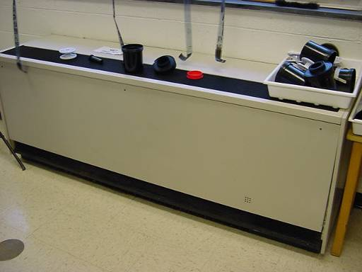

Classroom Univent

Picture 2

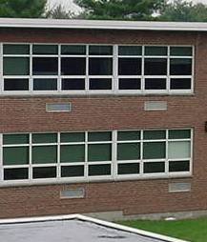

Supply and Exhaust Vents for Univents and Unit Exhaust Ventilators

Picture 3

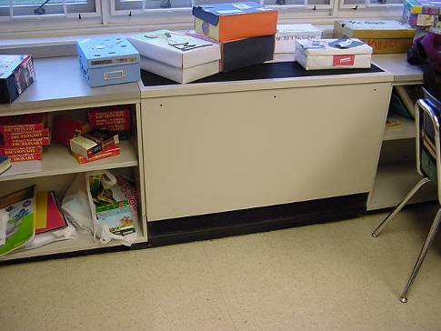

Unit Exhaust Ventilator

Picture 4

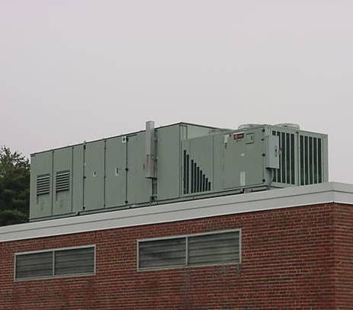

Rooftop AHU
Picture 5

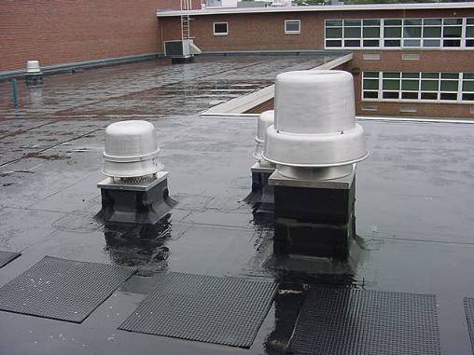

Rooftop Exhaust Motors

Picture 6

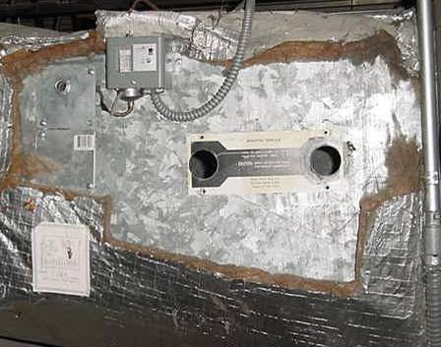

Open Holes in HVAC Ductwork (Custodial Closet Loft next to TV Studio)
Picture 7

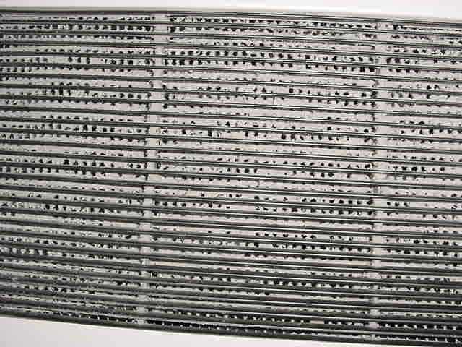

Vent Clogged With Dust/Debris

Picture 8

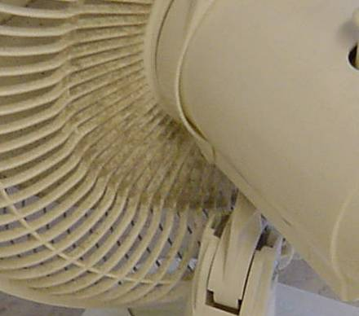

Accumulated Dust/Debris on Fan
Location | Carbon  Dioxide  (*ppm) | Temp  (°F) | Relative  Humidity  (%) | Occupants  in Room | Windows  Openable | Ventilation |  | Remarks
 |  |  |  |  |  | Supply | Exhaust | Remarks
Background | 396 | 52 | 98 |  |  |  |  | Light rain
234 | 688 | 68 | 31 | 4 | Y | Y | Y | Exhaust-off, DO
235 | 586 | 70 | 29 | 9 | Y | Y | Y | Exhaust-off, DO
233 | 649 | 70 | 28 | 14 | Y | Y | Y | DEM, DO
Music Room | 612 | 69 | 26 | 0 | N | Y | Y
253 A | 660 | 68 | 26 | 1 | N | Y | Y | DO
254 E | 521 | 70 | 27 | 0 | N | Y | Y
Art | 554 | 70 | 26 | 1 | Y | Y | Y | Return grill on univent-detached, occupants gone 50 mins.
230 | 669 | 70 | 26 | 3 | Y | Y | Y
223 | 3418 | 71 | 39 | 17 | Y | Y | Y | Univent and exhaust-off
225 | 1171 | 72 | 29 | 9 | Y | Y | Y | Exhaust-off
228 | 3498 | 68 | 39 | 21 | Y | Y | Y | Univent-off/obstructed by items on top, exhaust-off, DEM
229 | 1357 | 72 | 31 | 7 | Y | Y | Y | DEM
311 | 1710 | 71 | 32 | 21 | Y | Y | Y | DEM, DO
312 | 2108 | 73 | 33 | 21 | Y | Y | Y | Univent/exhaust-off, DEM
309 | 1642 | 74 | 32 | 15 | Y | Y | Y | Exhaust-off, DEM
310 A | 1421 | 73 | 28 | 4 | Y | N | Y | Plants
306 | 853 | 72 | 28 | 2 | Y | Y | N
304 | 560 | 70 | 26 | 0 | Y | Y | Y | DEM, MT
301 | 897 | 73 | 27 | 1 | N | Y | Y | Heat issues reported, photocopier, passive exhaust vent
Auditorium | 510 | 72 | 27 | 20 | N | Y | Y
Cafeteria | 767 | 72 | 28 | 75 | Y | Y | Y
TV Studio | 674 | 73 | 27 | 2 | N | Y | Y
Custodian Closet |  |  |  |  | N | N | Y | Holes in AHU (Loft) “mounting template”, local exhaust-off
Media Center (circ. desk) | 599 | 70 | 27 | 1 | N | Y | Y
Media Center  (lower level) | 612 | 67 | 26 | 10 | Y | Y | Y
Media Center  (workroom) | 605 | 68 | 27 | 0 | N | Y | N | Laminator
Teacher’s Room | 729 | 68 | 29 | 8 | Y | Y | Y | Dusty exhaust vent
Nurse/Clinic | 620 | 70 | 31 | 4 | Y | Y | Y
Gym | 546 | 71 | 29 | 0 | N | Y | Y
Atheltic Storage | 438 | 68 | 26 | 0 | N | N | Y | Stagnant air/musty odors-sports equipment, mechanical ventilation-off
Coaches Office | 501 | 70 | 29 | 0 | N | Y | Y | Mechanical ventilation-off, dry trap-occasional odors reported
Girl’s Locker Room | 471 | 71 | 28 | 0 | N | Y | Y | Mechanical ventilation-off
Weight Room | 483 | 70 | 35 | 0 | N | Y | Y
Trainer | 495 | 71 | 34 | 0 | N | Y | Y
Health/Wellness | 460 | 68 | 32 | 0 | N | Y | Y
105 | 1523 | 70 | 35 | 13 | Y | Y | Y | Exhaust off in prep room and in classroom
103 | 2117 | 70 | 37 | 25 | Y | Y | Y | Univent-noise
101 A Prep RM | 1237 | 70 | 32 | 0 | Y | N | Y | Chemical odors, local exhaust-off
102 | 1561 | 69 | 35 | 22 | Y | Y | Y | Univent-off, exhaust-off/obstructed
104 | 1535 | 70 | 36 | 21 | Y | Y | Y
208 A | 880 | 69 | 30 | 0 | N | N | Y | DO
209 | 2219 | 70 | 36 | 13 | Y | Y | Y | Univent-off, exhaust-off, DEM
206 | 1200 | 70 | 34 | 19 | Y | Y | Y | DEM
204 | 1040 | 69 | 33 | 7 | Y | Y | Y | DEM
203 | 1485 | 71 | 37 | 25 | Y | Y | Y | Heat control issues reported, PF
202 | 866 | 71 | 30 | 4 | Y | Y | Y | DEM
200 | 718 | 71 | 30 | 0 | Y | Y | Y
201 A | 838 | 71 | 29 | 1 | N | N | Y | Photocopier under exhaust, exhaust-off/dusty
201 | 1021 | 71 | 30 | 4 | Y | Y | Y | Univent-off, exhaust-off
Guidance | 932 | 70 | 32 | 2 | Y | Y | Y
Main Office | 610 | 69 | 39 | 6 | N | Y | Y
Assistant Principal | 590 | 65 | 44 | 0 | Y | Y | Y
Principal’s Office | 502 | 66 | 42 | 0 | Y | Y | Y

