INDOOR AIR QUALITY ASSESSMENT

Lynnfield Pre-School
525 Salem Street
Lynnfield, MA 01940

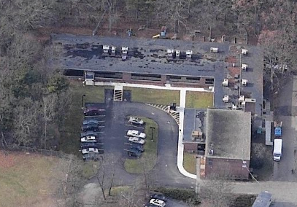

Prepared by:
Massachusetts Department of Public Health
Center for Environmental Health
Emergency Response/Indoor Air Quality Program
April 2007

Background/Introduction
At the request of a parent and the Lynnfield Public School Department, the Massachusetts Department of Public Health (MDPH), Center for Environmental Health (CEH) provided assistance and consultation regarding indoor air quality at each of Lynnfield’s public schools. These assessments were jointly coordinated through Patti Fabbri, Parent/IAQ Representative and Jim Nugent, Director, Lynnfield Health Department. On December 18, 2006, a visit to conduct an assessment at the Lynnfield Pre-School was made by Sharon Lee, an Environmental Analyst in CEH’s Emergency Response/Indoor Air Quality (ER/IAQ) Program. Ms. Lee was accompanied by Ms. Fabbri during the assessment.
The pre-school is located in a red brick building that was constructed circa 1960 and renovated in 2004. Although the majority of renovations were completed in 2004, other renovation-related activities are on-going. Over the summer of 2006, new carpet tiles were reportedly installed. The pre-school shares the building with the Lynnfield Senior Center. Windows are not openable in the building.

Methods
Air tests for carbon monoxide, carbon dioxide, temperature and relative humidity were taken with the TSI, Q-Trak, IAQ Monitor, Model 8551. Air tests for airborne particle matter with a diameter less than 2.5 micrometers were taken with the TSI, DUSTTRAK™ Aerosol Monitor Model 8520. Screening for total volatile organic compounds (TVOCs) was conducted using a Hnu, Model 102 Snap-on Photo Ionization Detector (PID). CEH staff also performed a visual inspection of building materials for water damage and/or microbial growth.

Results
The school houses approximately 70 students ranging from 2.5 to 6 years old with approximately 15 staff members. Tests were taken under normal operating conditions. Test results appear in Table 1.

Discussion
Ventilation
It can be seen from Table 1 that carbon dioxide levels were above 800 parts per million (ppm) in five of seven areas surveyed, indicating poor air exchange in these areas. Mechanical ventilation is provided by rooftop air handling units (AHUs) (Picture 1). Fresh air is distributed via ductwork connected to ceiling-mounted air diffusers (Picture 2). Air is returned to the AHUs through ceiling-mounted return vents (Picture 3). Each of the AHUs is controlled by a thermostat, which has settings of “occupied” and “unoccupied”. Thermostats were set to the “occupied” setting in a number of classrooms. The thermostat activates the AHU system at a preset temperature. Once the preset temperature is reached, the AHU continues to maintain the temperature by recirculating air. Therefore, no fresh air is provided until the thermostat re-activates the system.
The speech room does not have any means for mechanical or natural ventilation. Consideration should be given to ducting ceiling mounted supply and return vents for this area. Until this can be achieved, the hallway door should remain open as much as possible to circulate air. Consideration should also be given to undercutting the door or installing a passive vent to provide passive ventilation when the door is closed.
Exhaust fans in both the girls’ and boys’ restrooms were not operating at the time of the assessment. Exhaust ventilation is necessary in restrooms to remove moisture and to prevent restroom odors from penetrating into adjacent areas.
To maximize air exchange, the MDPH recommends that both supply and exhaust ventilation operate continuously during periods of school occupancy. In order to have proper ventilation with a mechanical supply and exhaust system, the systems must be balanced to provide an adequate amount of fresh air to the interior of a room while removing stale air from the room. It is recommended that existing ventilation systems be re-balanced every five years to ensure adequate air systems function (SMACNA, 1994). The date of the last balancing of these systems was not available at the time of the assessment, but should have occurred at some point after renovation in 2004.
The Massachusetts Building Code requires a minimum ventilation rate of 15 cubic feet per minute (cfm) per occupant of fresh outside air or openable windows in each room (SBBRS, 1997; BOCA, 1993). The ventilation must be on at all times that the room is occupied. Providing adequate fresh air ventilation with open windows and maintaining the temperature in the comfort range during the cold weather season is impractical. Mechanical ventilation is usually required to provide adequate fresh air ventilation.
Carbon dioxide is not a problem in and of itself. It is used as an indicator of the adequacy of the fresh air ventilation. As carbon dioxide levels rise, it indicates that the ventilating system is malfunctioning or the design occupancy of the room is being exceeded. When this happens a buildup of common indoor air pollutants can occur, leading to discomfort or health complaints. The Occupational Safety and Health Administration (OSHA) standard for carbon dioxide is 5,000 parts per million parts of air (ppm). Workers may be exposed to this level for 40 hours/week based on a time weighted average (OSHA, 1997).
The MDPH uses a guideline of 800 ppm for publicly occupied buildings. A guideline of 600 ppm or less is preferred in schools due to the fact that the majority of occupants are young and considered to be a more sensitive population in the evaluation of environmental health status. Inadequate ventilation and/or elevated temperatures are major causes of complaints such as respiratory, eye, nose and throat irritation, lethargy and headaches. For more information concerning carbon dioxide, please see Appendix A.
Temperature measurements ranged from 69º F to 72º F, which were within or slightly below the lower range of the MDPH recommended comfort guidelines. The MDPH recommends that indoor air temperatures be maintained in a range of 70 º F to 78 º F in order to provide for the comfort of building occupants. A number of occupants expressed problems with the building being too warm. In many cases concerning indoor air quality, fluctuations of temperature in occupied spaces are typically experienced, even in a building with an adequate fresh air supply.
The relative humidity ranged from 38 to 59 percent, which was within or close to the MDPH recommended comfort range in all areas surveyed during the assessment. The MDPH recommends that indoor air relative humidity is comfortable in a range of 40 to 60 percent. During the heating season, relative humidity levels would be expected to drop below the recommended comfort range. The sensation of dryness and irritation is common in a low relative humidity environment. For buildings in New England, periods of low relative humidity during the winter are often unavoidable.

Moisture Concerns

While no signs of microbial growth were observed at the pre-school, several moisture-related issues were observed, including the following:
- Water-damaged (WD) ceiling tiles: WD ceiling tiles are an indication of leaks from the roof or plumbing system. WD ceiling tiles can serve as a medium for mold and should be replaced after a water leak is discovered and repaired.
- Plants: Plants can be a source of pollen and mold, which can be respiratory irritants for some individuals. Plants should be properly maintained and equipped with drip pans. Plants should also be located away from ventilation sources (e.g., air intakes, diffusers) to prevent the entrainment and/or aerosolization of dirt, pollen or mold.
- Breach between sink countertop and backsplash: Spaces between the sink countertop and backsplash were noted in several classrooms. Improper drainage or sink overflow can lead to water penetration of countertop wood, the cabinet interior and areas behind cabinets. Like other porous materials, if these materials become wet repeatedly they can provide a medium for mold growth.
- Water infiltration from exterior doors: Staff should ensure exterior doors are closed properly to prevent water infiltration and subsequent damage to carpeting.

The American Conference of Governmental Industrial Hygienists (ACGIH) and the US Environmental Protection Agency (US EPA) recommends that porous materials be dried with fans and heating within 24 to 48 hours of becoming wet (ACGIH, 1989; US EPA, 2001). If porous materials are not dried within this time frame, mold growth may occur. Cleaning cannot adequately remove mold growth from water-damaged porous materials. The application of a mildewcide to moldy porous materials (e.g., ceiling tiles, carpeting) is not recommended.

Other IAQ Evaluations
Indoor air quality can be negatively influenced by the presence of respiratory irritants, such as products of combustion. The process of combustion produces a number of pollutants. Common combustion emissions include carbon monoxide, carbon dioxide, water vapor and smoke (fine airborne particle material). Of these materials, exposure to carbon monoxide and particulate matter with a diameter of 2.5 micrometers (μm) or less (PM2.5) can produce immediate, acute health effects upon exposure. To determine whether combustion products were present in the school environment, MDPH staff obtained measurements for carbon monoxide and PM2.5.
Carbon monoxide is a by-product of incomplete combustion of organic matter (e.g., gasoline, wood and tobacco). Exposure to carbon monoxide can produce immediate and acute health affects. Several air quality standards have been established to address carbon monoxide and prevent symptoms from exposure to these substances. The MDPH established a corrective action level concerning carbon monoxide in ice skating rinks that use fossil-fueled ice resurfacing equipment. If an operator of an indoor ice rink measures a carbon monoxide level over 30 ppm, taken 20 minutes after resurfacing within a rink, that operator must take actions to reduce carbon monoxide levels (MDPH, 1997).
The American Society of Heating Refrigeration and Air-Conditioning Engineers (ASHRAE) has adopted the National Ambient Air Quality Standards (NAAQS) as one set of criteria for assessing indoor air quality and monitoring of fresh air introduced by HVAC systems (ASHRAE, 1989). The NAAQS are standards established by the US EPA to protect the public health from six criteria pollutants, including carbon monoxide and particulate matter (US EPA, 2006). As recommended by ASHRAE, pollutant levels of fresh air introduced to a building should not exceed the NAAQS levels (ASHRAE, 1989). The NAAQS were adopted by reference in the Building Officials & Code Administrators (BOCA) National Mechanical Code of 1993 (BOCA, 1993), which is now an HVAC standard included in the Massachusetts State Building Code (SBBRS, 1997). According to the NAAQS, carbon monoxide levels in outdoor air should not exceed 9 ppm in an eight-hour average (US EPA, 2006).
Carbon monoxide should not be present in a typical, indoor environment. If it is present, indoor carbon monoxide levels should be less than or equal to outdoor levels. On the day of assessment, outdoor carbon monoxide concentrations were non-detect (ND). Carbon monoxide levels measured in the school were also ND (Table 1).
The US EPA has established NAAQS limits for exposure to particulate matter. Particulate matter is airborne solids that can be irritating to the eyes, nose and throat. The NAAQS originally established exposure limits to particulate matter with a diameter of 10 μm or less (PM10). According to the NAAQS, PM10 levels should not exceed 150 microgram per cubic meter (μg/m³) in a 24-hour average (US EPA, 2006). These standards were adopted by both ASHRAE and BOCA. Since the issuance of the ASHRAE standard and BOCA Code, US EPA proposed a more protective standard for fine airborne particles. This more stringent PM2.5 standard requires outdoor air particle levels be maintained below 35 μg/m³ over a 24-hour average (US EPA, 2006). Although both the ASHRAE standard and BOCA Code adopted the PM10 standard for evaluating air quality, MDPH uses the more protective proposed PM2.5 standard for evaluating airborne particulate matter concentrations in the indoor environment.
Outdoor PM2.5 concentrations were measured at 22 μg/m³ (Table 1). PM2.5 levels measured in the school ranged from 12 to 19 μg/m³, which were below the NAAQS of 35 μg/m³ (Table 1). Frequently, indoor air levels of particulates can be at higher levels than those measured outdoors. A number of mechanical devices and/or activities that occur in schools can generate particulates during normal operation. Sources of indoor airborne particulate may include but are not limited to particles generated during the operation of fan belts in the HVAC system, cooking in the cafeteria stoves and microwave ovens; use of photocopiers, fax machines and computer printing devices, operating an ordinary vacuum cleaner and heavy foot traffic indoors.
Indoor air quality can also be negatively influenced by the presence of materials containing volatile organic compounds (VOCs). VOCs are carbon-containing substances that have the ability to evaporate at room temperature. Frequently, exposure to low levels of total VOCs (TVOCs) may produce eye, nose, throat and/or respiratory irritation in some sensitive individuals. For example, chemicals evaporating from a paint can stored at room temperature would most likely contain VOCs. In an effort to determine whether VOCs were present in the building, air monitoring for TVOCs was conducted. An outdoor air sample was taken for comparison. Outdoor TVOC concentrations were ND. Indoor TVOC concentrations were also ND (Table 1).
Please note, TVOC air measurements are only reflective of the indoor air concentrations present at the time of sampling. Indoor air concentrations can be greatly impacted by the use of TVOC containing products. In an effort to identify materials that can potentially increase indoor TVOC concentrations, MDPH staff examined classrooms for products containing these respiratory irritants. Spray cleaning products were observed on tabletops in classrooms (Picture 4). Cleaning products contain VOCs and other chemicals, which can be irritating to the eyes, nose and throat and should be stored properly and kept out of reach of students. Many of these products may have been brought in without the knowledge of school personnel who maintain material data safety sheets (MSDS) for chemicals used in the school. Therefore it is unlikely that MSDS’ for these materials are available on site. Staff indicated that EpiPens™, which are auto-injectors of epinephrine (i.e., adrenaline), used to treat anaphylactic shock are located in a classroom sink/countertop drawer. These drawers are approximate 3.5 feet high. Consideration should be given to relocating EpiPens™ or installing childproof locks to prevent child access.
Lastly, a missing ceiling tile was observed in one classroom. Missing/ajar ceiling tiles can provide a pathway for materials (e.g., odors, dust, particulates) to migrate into occupied areas. Ceiling tiles should be flush with ceiling system to prevent such movement. Similarly, occupants should refrain from hanging items from the ceiling tile systems to prevent potential pathways for materials into occupied areas.

Conclusions/Recommendations
In view of the findings at the time of the visit, the following recommendations are made:
- Contact the school’s HVAC engineer regarding increasing fresh air supply by operating AHUs independently of thermostat settings by providing continuous air circulation.
- In order to improve thermal comfort/temperature control it is highly recommended that school staff work in conjunction with building management and their HVAC vendor to identify problem areas to make adjustments to the HVAC system.
- Consider having the ventilation system balanced by an HVAC engineer every five years (SMACNA, 1994).
- For buildings in New England, periods of low relative humidity during the winter are often unavoidable. Therefore, scrupulous cleaning practices should be adopted to minimize common indoor air contaminants whose irritant effects can be enhanced when the relative humidity is low. To control for dusts, a high efficiency particulate arrestance (HEPA) filter equipped vacuum cleaner in conjunction with wet wiping of all surfaces is recommended. Drinking water during the day can help ease some symptoms associated with a dry environment (throat and sinus irritations).
- Identify and repair source of leaks staining ceiling tiles. Once repairs are made replace water-stained ceiling tiles. Examine the area above and beneath these tiles for mold growth. Disinfect areas of water leaks with an appropriate antimicrobial.
- Store cleaning products properly and out of reach of students. Consider storing cleaning products in cabinets with childproof locks.
- Consider storing EpiPens™ and similar supplies in a drawer/cabinet with childproof locks.
- Replace missing ceiling tiles, and ensure all ceiling tiles are flush with suspended system.
- Consider adopting the US EPA (2000) document, “Tools for Schools”, to maintain a good indoor air quality environment in the building. This document can be downloaded from the Internet at http://www.epa.gov/iaq/schools/index.html.
- Refer to resource manuals and other related indoor air quality documents for additional building-wide evaluations and advice on maintaining public buildings. These materials are located on the MDPH’s website: http://mass.gov/dph/indoor_air.

Renovations
For future renovations projects, consider the following steps in order to reduce the migration of construction-generated pollutants into occupied areas and their potential impact on indoor air quality:
- Comply with MSBA regulations that require that schools receiving funds under the program for construction or renovation projects must confer with the most current edition of the "IAQ Guidelines for Occupied Buildings Under Construction" published by the Sheet Metal and Air Conditioning Contractors National Association, Inc. (SMACNA) 963 CMR 2.04(2)(c),(d).
- Properly seal construction barriers with polyethylene plastic sheeting and duct tape. Consider creating duel barriers by installing polyethylene on both sides of the barrier. Seal holes created by missing tiles in ceilings. Inspect these areas regularly (e.g., daily) for integrity as remediation efforts progress.
- Establish communications between all parties involved with building renovations to prevent potential IAQ problems. Develop a forum for occupants to express concerns about renovations as well as a program to resolve IAQ issues.
- Develop a notification system for building occupants immediately adjacent to construction activities to report construction/renovation related odors and/or dusts problems to the building administrator. Have these concerns relayed to the contractor in a manner to allow for a timely remediation of the problem.
- Schedule projects which produce large amounts of dusts, odors and emissions during unoccupied periods or periods of low occupancy, when possible.
- Cover dirt/debris piles with tarps or wet down to decrease aerosolization of particulates, when possible.
- Notify faculty of construction activities, as renovations may be conducted in close proximity to their classrooms. In certain cases, classrooms adjacent to construction activities may need to have their HVAC equipment deactivated and windows closed periodically to prevent unfiltered air and vehicle exhaust from entering the building. For this reason, prior notification(s) should be made.
- Disseminate scheduling itinerary to all affected parties via meetings, newsletters or weekly bulletins.
- Obtain Material Safety Data Sheets (MSDS) for all construction materials used during renovations and keep them in an area that is accessible to all individuals during periods of building operations as required by the Massachusetts Right-To-Know Act (MGL, 1983).
- Consult MSDS’ for any material applied to the effected area during construction including any sealant, adhesives, tile mastic, flooring and/or roofing materials. Provide proper ventilation and allow sufficient curing time as per the manufacturer’s instructions concerning these materials.
- Relocate susceptible persons and those with pre-existing medical conditions (e.g., hypersensitivity, asthma) away from areas of construction/renovations, if possible.
- Implement prudent housekeeping and work site practices to minimize exposure to renovation pollutants. Consider increasing manpower or work hours (e.g., before school) to accommodate increase in dirt, dust accumulation due to construction activities. To control for dusts, a high efficiency particulate air filter (HEPA) equipped vacuum cleaner in conjunction with wet wiping/mopping of all surfaces is recommended.
- Consider mounting a filter medium on the exterior of univent air intakes to minimize entrainment of construction generated dust and debris. Continue to change HVAC filters more regularly in areas impacted by renovation activities.

References
ASHRAE. 1989. Ventilation for Acceptable Indoor Air Quality. American Society of Heating, Refrigeration and Air Conditioning Engineers. ANSI/ASHRAE 62-1989
BOCA. 1993. The BOCA National Mechanical Code/1993. 8th ed. Building Officials and Code Administrators International, Inc., Country Club Hill, IL.
MDOE. 1999. School Construction, General Requirements: Capital Construction 603 CMR 38.03(13). Massachusetts Department of Education, Malden, MA.
MDPH. 1997. Requirements to Maintain Air Quality in Indoor Skating Rinks (State Sanitary Code, Chapter XI). 105 CMR 675.000. Massachusetts Department of Public Health, Boston, MA.
MGL. 1983. Hazardous Substances Disclosure by Employers. Massachusetts General Laws. M.G.L. c. 111F.
OSHA. 1997. Limits for Air Contaminants. Occupational Safety and Health Administration. Code of Federal Regulations. 29 C.F.R 1910.1000 Table Z-1-A.
SBBRS. 1997. Mechanical Ventilation. State Board of Building Regulations and Standards. Code of Massachusetts Regulations. 780 CMR 1209.0.
SMACNA. 1994. HVAC Systems Commissioning Manual. 1st ed. Sheet Metal and Air Conditioning Contractors’ National Association, Inc., Chantilly, VA.
SMACNA. 1995. IAQ Guidelines for Occupied Buildings Under Construction. 1st ed. Sheet Metal and Air Conditioning Contractors’ National Association, Inc., Chantilly, VA.
US EPA. 2000. Tools for Schools. Office of Air and Radiation, Office of Radiation and Indoor Air, Indoor Environments Division (6609J). EPA 402-K-95-001, Second Edition. http://www.epa.gov/iaq/schools/tools4s2.html
US EPA. 2001. “Mold Remediation in Schools and Commercial Buildings”. Office of Air and Radiation, Indoor Environments Division, Washington, DC. EPA 402-K-01-001. March 2001. Available at: http://www.epa.gov/iaq/molds/mold_remediation.html
US EPA. 2006. National Ambient Air Quality Standards (NAAQS). US Environmental Protection Agency, Office of Air Quality Planning and Standards, Washington, DC. http://www.epa.gov/air/criteria.html.
Picture 1

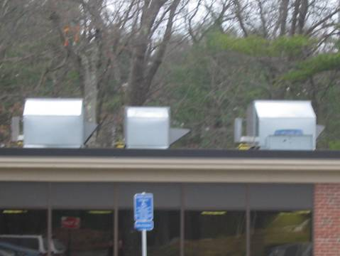

Rooftop AHUs

Picture 2

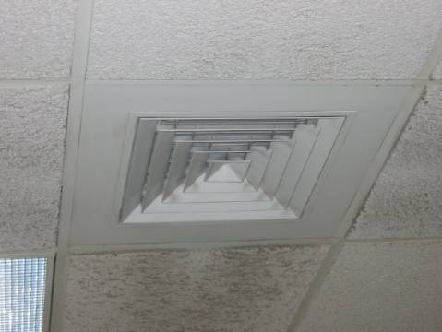

Ceiling-mounted supply diffuser
Picture 3

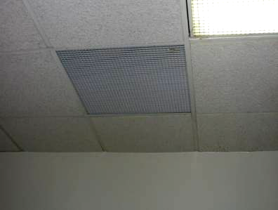

Ceiling-mounted return vent

Picture 4

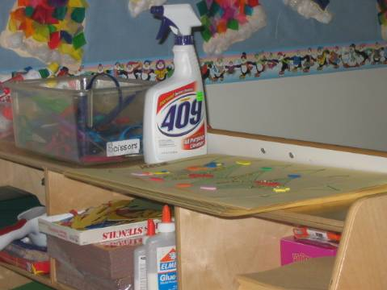

Cleaner on classroom tabletop
Location/ Room | Occupants  in Room | Temp  (°F) | Relative  Humidity  (%) | Carbon  Dioxide  (ppm) | Carbon Monoxide  (ppm) | TVOCs  (ppm) | PM2.5  (µg/m3) | Windows  Openable | Ventilation |  | Remarks
 |  |  |  |  |  |  |  |  | Supply | Exhaust | Remarks
background |  | 61 | 43 | 443 | ND | ND | 22
Ms Jill’s Room | 11 | 71 | 38 | 785 | ND | ND | 14 | N | Y  ceiling | Y  ceiling  VL | Hallway DO, cleaners, epipens in drawer
Speech Room | 4 | 71 | 38 | 1040 | ND | ND | 14 | N | N | N
Ms Maria’s Room | 10 | 72 | 59 | 966 | ND | ND | 14 | N | Y  ceiling | Y  ceiling | 1 MT/AT, items hanging from CT
Ms. Donna’s Room | 12 | 69 | 49 | 874 | ND | ND | 12 | N | Y  ceiling | Y  ceiling | Cleaners, items hanging from CT
Motor Room | 4 | 70 | 46 | 1005 | ND | ND | 17 | N | Y  ceiling | Y  ceiling | Hallway DO
Ms Jenn’s Room | 4 | 71 | 40 | 990 | ND | ND | 19 | N | Y  ceiling | Y  ceiling
Common space | 3 | 72 | 38 | 765 | ND | ND | 12 | N | Y  ceiling | Y  ceiling
Boys’ Room |  |  |  |  |  |  |  |  |  | Y  Ceiling  off | Boys’ Room
Girls’ Room |  |  |  |  |  |  |  |  |  | Y  Ceiling  off | Girls’ Room

