INDOOR AIR QUALITY ASSESSMENT

**Lynnfield Public Library**

**18 Summer Street**

**Lynnfield**

**July 2024**

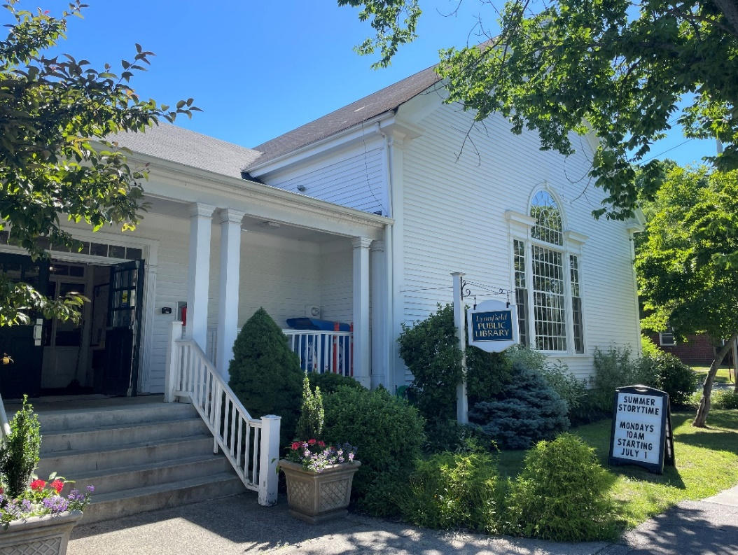

Prepared by:

Massachusetts Department of Public Health

Bureau of Climate and Environmental Health

Indoor Air Quality Program

Contents

EXECUTIVE SUMMARY 3

BACKGROUND 4

RESULTS AND DISCUSSION 4

Ventilation 5

HVAC System Maintenance 5

Water Damage and Moisture Concerns 6

Building Envelope Issues 8

Roofline/Gutters 8

Trees/Plants 8

Other Related Issues 9

Sources of Respiratory Irritants/Possible Asthma Triggers 9

[CONCLUSIONS AND RECOMMENDATIONS 10](https://massgov-my.sharepoint.com/personal/ruth_alfasso_mass_gov/Documents/Desktop/work%202020/reports%20since%20lockdown/lynnfield%20library%20recovered%20file.docx#_Toc172622174)

REFERENCES 14

PICTURES 15

Table 1 25

Table 2A 27

Table 2B 28

Table 2C 29

Table 3 30

Table 4 32

# EXECUTIVE SUMMARY

The Massachusetts Department of Public Health’s Indoor Air Quality Program (MDPH IAQ) conducted an IAQ assessment of the Lynnfield Public Library (LPL), located at 18 Summer St, Lynnfield, MA on June 28, 2024. This assessment was requested by the Library Director for the Town of Lynnfield.

Any building can have IAQ issues. These issues can be made worse through conditions common to marginalized communities (Environmental Justice communities or EJ) such as inequitable exposure to outdoor air pollution and a greater likelihood of poor building conditions leading to deterioration of IAQ resulting in higher asthma rates. While LPL is not within an EJ community, the library provides services to EJ community individuals.

**METHODS**

The assessment was conducted by evaluating several key elements within the building; a visual inspection of the heating, cooling, and ventilating (HVAC) systems, water/microbial damage, cleanliness, point sources of respiratory irritants such as chemicals, and electronic measurement of carbon dioxide (CO2), carbon monoxide (CO), temperature, relative humidity (RH), and small particulate matter (PM2.5) all taken with a Qtrak XP monitor. Data is collected in this manner to identify potential asthma triggers, allergens, and other environmental factors that can cause indoor air quality symptoms. Please refer to the [Indoor Air Quality Manual](https://www.mass.gov/lists/indoor-air-quality-manual-and-appendices#indoor-air-quality-manual-) on the MDPH website for methods, sampling procedures, and interpretation of results.

Please note: this report contains a series of recommendations that should serve as Best Practices that apply to most public buildings across the Commonwealth and should be shared amongst other buildings in Lynnfield.

# BACKGROUND

|  |  |
| --- | --- |
| Building: | Lynnfield Public Library (LPL) |
| Address: | 18 Summer Street, Lynnfield, MA |
| Coordinated Via: | Library Director Abigail Porter |
| Reason for Request: | General IAQ |
| Date of Assessment: | June 28, 2024 |
| Massachusetts Department of Public Health/Bureau of Climate and Environmental Health (MDPH/BCEH) Staff Conducting Assessment: | Jennifer Lajoie, Inspector, IAQ Program |
| Building Description: | Lynnfield Public Library is a two-story wooden building with an occupied basement. It was originally built in 1856 as a schoolhouse. Additions were constructed in the 1950s and 1960s. The last renovation was in 1991. While various upgrades to the building have occurred, they are limited by the age and design of the building. |
| Windows: | Most windows in the building are openable. |

# RESULTS AND DISCUSSION

The following is a summary of indoor air testing results (Table 1)

|  |  |  |
| --- | --- | --- |
| * ***Carbon dioxide (CO2)*** | *a measure of the adequacy of ventilation* | Levels were below the MDPH guideline of 800 parts per million (ppm) in the areas surveyed. |
| * ***Temperature*** | *a measure of comfort* | Was within the MDPH recommended range of 70°F to 78°F in most occupied areas. |
| * ***Relative humidity*** | *a measure of comfort and, when in excess for an extended period, a way to reflect the potential for mold and fungal growth* | Was within the MDPH recommended range of 40 to 60% in all areas tested. This is reflective of outdoor conditions. Relative humidity would be expected to be lower with cold outdoor temperatures and indoor heating, and higher during hot, humid weather. |
| * ***Carbon monoxide (CO)*** | *a product of combustion that can result in acute and long term cardiovascular, respiratory, and neurological symptoms* | No carbon monoxide was detected during the assessment. |
| * ***Particulate matter (PM2.5)*** | *a way to measure inhalable particle distribution in the air* | Concentrations were below the National Ambient Air Quality Standard (NAAQS) of 35 micrograms per cubic meter (μg/m3) in all areas tested. |

## Ventilation

Ventilation refers to both the supply of fresh air and the removal of stale air from a room. The introduction of fresh air into an occupied space will dilute normally occurring pollutants that are generated by occupancy and other activities. In addition, a heating, ventilating and air-conditioning (HVAC) system will remove pollutants from a building if operating appropriately. All ventilation systems throughout the building should operate continuously during periods of occupancy.

When originally constructed in the 1800s as a schoolhouse, the oldest part of the building was likely unoccupied during summer months. The building was originally equipped with openable windows to provide cross ventilation during warm weather. Windows in the LPL currently are able to be opened but are kept closed.

The LPL uses a mechanical HVAC system to provide a continuous air supply to the building. Fresh air is supplied through supply vents (Picture 1) and is returned to the system through return vents (Picture 2). The LPL reports that the system is maintained through networked thermostats (Picture 3) that are controlled remotely by the Lynnfield Department of Public Works (LDPW).

The main air handling unit (AHU) is located in the basement (Picture 4) and provides heating, cooling and fresh air to the common areas. This is supplemented by univents around perimeter areas (Picture 5).

(Table 2B).

The various types of ventilation components as well as devices that can move/redirect airflow are listed in Table 2A, Table 2B and Table 2C.

### HVAC System Maintenance

**Balancing**

To have proper ventilation with a mechanical supply and exhaust system, a system must be balanced to provide an adequate amount of fresh air to the interior of a room while also removing stale air from the room. It is recommended that HVAC systems be re-balanced every five years to ensure adequate air systems function (SMACNA, 1994).

HVAC Types and Specific Conditions

(see HVAC pictures)

* **A subterranean fresh air intake for the AHUs is located at the rear of the building.** Plants are growing near the intake (Picture 6).
* **AHUs were equipped with filters with a minimum efficiency reporting value (MERV) of 13.** The MDPH IAQ program recommends that filters be changed 2-4 times a year (or in accordance with the manufactures recommendations) and be of at least MERV 8, or higher if the equipment can handle them, without a degradation in airflow, as these are adequate to filter out pollen, mold, and similar particulates (ASHRAE, 2012).
* **LPL cannot determine the date of the last balancing of the HVAC.**

## Water Damage and Moisture Concerns

Please note that the IAQ Program does not recommend conducting mold testing in a typical water damage remediation. For details, please consult [Guidance Regarding Testing for Mold in Water-Damaged Public Buildings](https://www.mass.gov/info-details/guidance-regarding-testing-for-mold-in-water-damaged-public-buildings) | Mass.gov

The application of a mildewcide to moldy porous materials is not recommended.

Molds are found naturally in our environment both indoors and outdoors. Inside, mold growth may occur when items, particularly porous products such as paper or gypsum wallboard, are exposed to moisture. Typical water sources include leaks, floods, and condensation. To avoid mold growth, dry all water-damaged items and affected areas within 24-48 hours and reduce indoor humidity. Some people with chronic respiratory conditions, such as asthma, are more likely to experience health symptoms associated with molds, including allergic reactions and respiratory irritation. Controlling moisture is the key to preventing mold growth and potential health symptoms.

Hot humid summers are becoming more frequent due to climate change. Massachusetts has experienced hot, humid, and rainy summers in 2018, 2021, and 2023. July of 2021 was the wettest ever recorded in Massachusetts, and the three-month period from June through August, known as the meteorological summer, was the fourth wettest on record, according to the National Oceanic and Atmospheric Administration’s (NOAA) Centers for Environmental Information (NOAA, 2021). The summer of 2023 was also hot, and wet, being measured as the second rainiest on record (WBUR, 2023). These conditions are challenging for buildings, particularly those without air conditioning.

During these hot and wet summers, extended periods of outdoor relative humidity above 70% occurred. Under these weather periods, public buildings experienced extended periods of water vapor exposure from high relative humidity. When exposed to these conditions, porous materials such as gypsum wallboard, cardboard, and other materials may become prone to developing mold colonization, particularly if located in areas that are prone to developing condensation on floors and walls (e.g., below grade space). In addition, high relative humidity will cause paper to absorb moisture, which in turn cause paper jams in photocopiers and computer printers (Fisher, N., 2024).

Of particular note is moisture and water damage associated with increased rainfall. The LPL has reported issues with water infiltrating the Fiction room which is located in the basement area of the building. An exterior cement staircase is located outside the back door to the Fiction area which, reported by the LPL, floods in heavy rains (Picture 7; Table 1). There is also evidence in the Fiction room of humidity and/or water damage. This includes rust on metal book shelves (Picture 8), rust spots on the vent (Picture 9), and damage to coving at the base of the wall (Picture 9). This area of the building is also carpeted, as is the entire LPL. It is also important to note that wall-to-wall carpeting in below grade space is generally not recommended if that space is subject to chronic dampness due to water leaks or condensation accumulation (US EPA, 2008).

* **Water-damaged ceiling tiles were found (Picture 10; Table 1),** which can indicate current/historic roof/plumbing leaks or other water infiltration. Water-damaged ceiling tiles can provide a source of mold and should be replaced after a water leak is discovered and repaired.
* **Numerous water leaks throughout the years have been reported by the LPL.** These include roof leaks, sewer backups, exterior flooding, sprinkler system leaks and plumbing failures. Leaks have been reported outside the bathrooms, the basement, the genealogy room and the boiler room.
* **The LPL reports rain infiltrates the Youth Services office when water flows off the overhang outside youth services office (Picture 11).**
* **Sinks and refrigerators were also located over carpet (Picture 12; Table 1).** These appliances can spill or leak and moisten carpet. Carpet that is repeatedly or chronically moistened can become mold colonized.
* **A hole was noted in the wall under a sink (Picture 13).** This hole can allow moisture, dust, and pests into the room from behind the wall.
* **Food and food preparation equipment were noted in several areas, including sinks (Table 1).** Food preparation equipment should be kept clean to avoid cooking odors and/or smoke that can adhere to ceiling and wall surfaces since these areas do not have exhaust ventilation. Crumbs and food residue should be cleaned regularly to prevent pests, and all food should be stored in pest-proof containers. Sinks should be well maintained to avoid leaks and odors.
* **The area under sinks is a moist environment** so porous items should not be stored there. Sink backsplashes were also coming loose from the wall, creating a potential for water to damage the wall behind. (Table 1)

A list of water damage issues identified inside and outside the building is included as Table 3.

(see Water Damage and Moisture Concern Pictures)

**Mold Growth**

Porous materials (e.g., gypsum wallboard, ceiling tiles and carpeting) can be dried with fans and heating within 24 to 48 hours of becoming wet (US EPA, 2008).

If porous materials are not dried within this time frame, mold growth may occur.

## 

## Building Envelope Issues

### Roofline/Gutters

The LPL has undergone a few additions to the original 1856 schoolhouse design:

* **The additions, which were completed in 1959 and 1967, added various rooflines to the LPL, some sections with gutters (Picture 14).**
* **Each time an addition was added, the potential for areas where water can leak into the building can occur.** Where different materials meet, if the area is not appropriately sealed including flashing (metal material added to direct water at joints), water infiltration can occur, particularly as portions of the building settle or weather differently from each other.
* **Flashing around chimneys also adds a potential for water infiltration (Picture 15).**

### Trees/Plants

The presence of large trees (Picture 16) can enhance water retention and affect drainage; trees also overhang the roof. These trees pose several hazards to the LPL:

* **Leaves and other debris accumulate around roof drains, which inhibits rainwater drainage from the roof.** Ineffective drains can lead to water running off the roof to moisten exterior walls.
* **Trees prevent sunlight from drying building walls and soil (Picture 17).**
* **Trees in close proximity of building may pose a possible danger to the LPL due to the distance from exterior walls:** The recommended safe distance that any tree should be planted is the minimum of the expected maximum growth height of the species from the exterior of a building (BI, 2015).
* **Soil subsidence may also be caused by tree roots, which can undermine the structure of a building to cause wall and floor cracking and related damage.** To prevent subsidence, a sufficient distance appropriate for the tree species is recommended (Williams, 2006).
* **Severe weather may result in the tree falling onto the LPL or the tree roots damaging the foundation.** Due to the height of the trees, each is likely located closer than recommended distances.
* **In general, a tree root system will spread out in all directions from its trunk.** In some cases, tree roots can extend for over 100 feet from its trunk. Any structure disrupting the root structure may make the tree unstable if subjected to high winds from a certain direction. Based on the location, the foundation walls likely disrupt the roots of several trees.
* **The Federal Emergency Management Agency (FEMA) provides several recommendations in order to prepare for severe thunderstorms.** Of note FEMA recommends “Cut down or trim trees that may be in danger of falling on your [building]” (FEMA, 2018). Given the proximity to the LPL exterior walls, removal of trees should be strongly considered.
* **Plants were observed in contact with and near the foundation (Pictures 16 and 17).** Plants near the building can cause water damage to brickwork and mortar. In addition, plants shading exterior walls can slow drying. Water can eventually penetrate the brick, subsequently freezing and thawing during the winter. This freezing/thawing action can weaken and damage bricks and mortar.

### Other Related Issues

**A creek runs behind the LPL (Picture 18).** The LPL reports that, in times of heavy rainfall, the creek can overrun the banks and debris gets stuck in the storm grate causing more overflow into the parking lot located behind the LPL.

## Sources of Respiratory Irritants/Possible Asthma Triggers

Asthma is a lung disease that can make breathing difficult. Without careful management of asthma, some people can have symptoms, like a tight feeling in the chest, shortness of breath, coughing, or wheezing. Although there is no cure for asthma, people with asthma can live healthy, active lives. A safe and healthy environment helps to reduce asthma symptoms.

* **Personal products, particularly those with volatile organic compounds (VOCs) including scents, can also be a source of respiratory irritation.** VOCs are carbon-containing substances that have the ability to evaporate at room temperature. Frequently, exposure to low levels of total VOCs (TVOCs) may produce eye, nose, throat and/or respiratory irritation in some sensitive individuals. Products noted were cleaners and sanitizers (Picture 19).
* **Plants were noted in some areas.** Plants can be a source of pollen or mold especially if overwatered or not well maintained. Plants should also not be placed in the airstream of univents to prevent the aerosolization of pollen and mold. Plants should also not be overwatered to prevent mold growth and should be placed on waterproof drip pans.
* **Dust, a common respiratory and eye irritant, can collect on surfaces and items.** Although janitorial and maintenance staff perform routine cleaning, they may not be able to clean as effectively if items are not picked up or surfaces are cluttered.
* Even with a properly functioning ventilation system, it is necessary to reduce the use of materials that can be a source of respiratory irritants to prevent symptoms in individuals who have sensitivity to such pollutants.

Possible asthma triggers and/or airborne pollutants exist in the building. These are listed below as well as in (Table 4).

(see Sources of Respiratory Irritant Pictures)

* **All rooms in the LPL are carpeted**, **some with additional area rugs** (Table 1). Some carpets appeared to be beyond the service life of 10-11 years, (IICRC, 2002). Carpeting that is beyond its service life becomes increasingly difficult to clean and may release fibers which can be irritating if airborne. Carpets should be vacuumed regularly with a high efficiency particulate arrestance (HEPA) filter equipped vacuum cleaner and cleaned annually (or semi-annually in soiled/high traffic areas) in accordance with Institute of Inspection, Cleaning and Restoration Certification (IICRC) recommendations (IICRC, 2012).
* **A humidifier was noted (Table 1).** Humidifiers should be cleaned regularly, and distilled water should be used to eliminate distributing particulates and water treatment odors from tap water.
* **Items were found hanging from ceiling (Table 1)** Hanging items can collect dust and are difficult to clean. In addition, the process of hanging items from the ceiling can expose occupants to dust and debris from above the ceiling tile system.

# CONCLUSIONS AND RECOMMENDATIONS

Please note: this report contains a series of recommendations that should serve as *Best Practices* that apply to many public buildings across the Commonwealth and should be shared amongst other buildings operated by the Town of Lynnfield.

Issues typical to many public buildings were found in this building. Issues described can be mitigated with repairs or modifications to the exterior building components, and with changes to occupant behaviors to reduce blockages of supply/exhaust vents and exposure to VOC-generating products and items.

**Short-term recommendations** can be implemented as soon as practicable, however **long-term measures** are more complex and will require planning and resources to adequately address overall indoor air quality issues within the building.

|  |  |  |
| --- | --- | --- |
| **Short-term Recommendations** | | |
| **HVAC System** | | **Helpful Links** |
| 1. | Ensure the HVAC system is balanced every 5 years. Research the age of the HVAC system. |  |
| 2. | Ensure windows are closed tightly at the end of the day. |  |
| 3. | Remove carpeting around univents and replace with a non-porous flooring material |  |
| 4. | Air handling units that serve those rooms with mechanical ventilation should have filters changed at least twice a year using the best Minimum Efficiency Rating Value (MERV) that can work with current equipment. | [ANSI/ASHRAE Standard 52.2-2017](https://www.ashrae.org/File%20Library/Technical%20Resources/COVID-19/52_2_2017_COVID-19_20200401.pdf) |
| 5. | During filter changes, clean dust and debris from the inside of HVAC system cabinets. |  |
| 6. | Replace components beyond service life. |  |
| 7. | Clean interior of univents with compressed air or use a HEPA vacuum to remove dust from the interior including the fins/coils. |  |
| 8. | Ensure univents have proper drainage and humidity control. |  |
| 9. | Remove plants around the fresh air intake at the rear of property |  |
| **Water Damage Sources** | | |
| 10. | Examine sources of water infiltration into the LPL including around different rooflines, chimney flashing and the overhang outside the youth services office |  |
| 11. | Replace water-damaged ceiling tiles. Repeated water damage to ceiling tiles indicates leaks from the roof or plumbing/HVAC system which should be repaired. | <http://www.epa.gov/mold/mold-remediation-schools-and-commercial-buildings-guide> |
| 12. | Until carpet can be replaced, clean in accordance with IICRC recommendations annually (or semi-annually in soiled/high traffic areas) | (IICRC, 2012) |
| 13. | Do not store cardboard or other porous items directly on ground-level floors to prevent mold growth due to condensation on cool surfaces, Elevate items with pallets or store on shelving. |  |
| 14. | Seal spaces around exterior doors and pipes with weatherstripping, to prevent drafts, moisture, and pest entry. |  |
| 15. | Properly maintain plants to avoid mold and odors. Keep plants away from airflow. |  |
| 16. | Seal areas under sinks to prevent entry of dust and pests from interior wall spaces. |  |
| 17. | Place rubber or water-resistant mats under refrigerators and sinks |  |
| 18. | Use these guidelines to control for moisture and increase comfort in a minimally air-conditioned building especially during heatwaves. | * Mold Growth Prevention During Hot, Humid Weather <https://www.mass.gov/service-details/preventing-mold-growth-in-massachusetts-schools-during-hot-humid-weather> * Remediation and Prevention of Mold Growth and Water Damage in Public Schools <https://www.mass.gov/service-details/remediation-and-prevention-of-mold-growth-and-water-damage-in-public-schools-and> * Methods for Increasing Comfort in Non-air-conditioned Schools <https://www.mass.gov/doc/methods-for-increasing-comfort-in-non-air-conditioned-schools/download> |
| 19. | Remove clinging plants from the exterior of the building and trim other plants and trees at least 5 feet away from the building. |  |
| 20. | Remove trees that overhang or are close to the building |  |
| 21. | Clear out storm drain closest to the creek during heavy rainfalls |  |
| **Respiratory Irritants/Possible Asthma Triggers** | | |
| 22. | Clean dust from surfaces, frequently using methods that do not aerosolize the dust, including HEPA-equipped vacuuming or wet wiping. Avoid using feather dusters or sweeping dust into the air. |  |
| 23. | Reduce use of products and equipment that create irritating volatile organic compounds (VOCs) and only use in well-ventilated areas. Minimize the use of air fresheners (e.g., plug-ins), deodorizers and scented products. | <https://www.mass.gov/cleaner-greener-healthier-schools>  [Clean Air Is Odor Free](https://www.mass.gov/doc/clean-air-is-odor-free-removing-fragrances-to-improve-indoor-air-quality-in-schools-and-offices-0/download) |
| 24. | Ensure copiers and laminators are used in well-ventilated rooms. |  |
| 25. | Develop procedures to sort and store paper and related items to prevent a buildup of large quantities of paper. Store remaining items neatly and off the floor. Where rooms have a history of moisture issues, consider storing items in waterproof totes |  |
| 26. | Clean carpeting regularly using a HEPA-equipped vacuum cleaner, and deep clean periodically as recommended by the manufacturer. |  |
| **Long-term Recommendations** | | |
| 27. | Replace carpeting beyond its service life |  |
| 28. | Regrade the parking lot, elevate or create a berm at the back top exterior step of the staircase leading to the Fiction room to prevent rainwater flowing down the staircase |  |

# REFERENCES

ASHRAE. 2012. American Society of Heating, Refrigeration and Air Conditioning Engineers (ASHRAE) Standard 52.2-2012 -- Method of Testing General Ventilation Air-Cleaning Devices for Removal Efficiency by Particle Size (ANSI Approved).

FEMA. 2018. How to Stay Safe When a Thunderstorm Threatens. Federal Emergency Management Agency, Washington, DC. FEMA V-1009/May 2018. <https://www.ready.gov/sites/default/files/2020-03/thunderstorm-information-sheet.pdf>

Fisher, N. 2024. How Humidity Affects Your Copier and Paper Quality. Cobb Technologies, Richmond, VA. <https://www.cobbtechnologies.com/blog/how-humidity-affects-your-copier-and-paper-quality>.

IICRC. 2002. Institute of Inspection, Cleaning and Restoration Certification. A Life-Cycle Cost Analysis for Floor Coverings in School Facilities.

NOAA. 2021. Summer 2021 neck and neck with Dust Bowl summer for hottest on record. National Oceanic and Atmospheric Administration, 1401 Constitution Avenue NW, Room 5128, Washington, DC 20230 <https://www.noaa.gov/news/summer-2021-neck-and-neck-with-dust-bowl-summer-for-hottest-on-record>

SMACNA. 1994. HVAC Systems Commissioning Manual. 1st ed. Sheet Metal and Air Conditioning Contractors’ National Association, Inc., Chantilly, VA.

US EPA. 2008. Mold Remediation in Schools and Commercial Buildings. US Environmental Protection Agency, Office of Air and Radiation, Indoor Environments Division, Washington, D.C. EPA 402-K-01-001. <http://www.epa.gov/mold/mold-remediation-schools-and-commercial-buildings-guide>.

WBUR. 2023. “It's been a summer of rain and flooding misery in Mass.” WBUR local news. September 12, 2023. <https://www.wbur.org/news/2023/09/12/summer-flooding-rain-massachusetts>

Williams, A. 2006. The Distance at Which Trees Can Affect a Building is Quite Significant. The Architects’ Journal. <https://www.architectsjournal.co.uk/home/the-distance-at-which-trees-can-affect-a-building-is-quite-significant/130858.article>

(Click to link back to report)

# PICTURES

Ventilation pictures

**Picture 1**

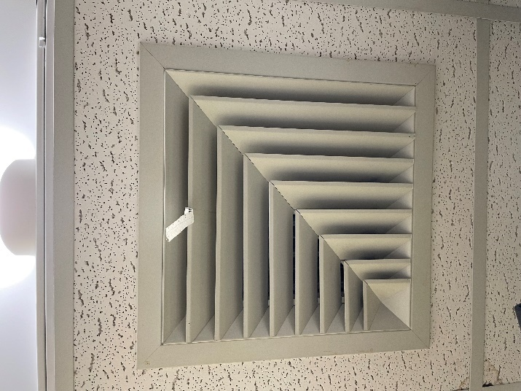

**Supply vent**

**Picture 2**

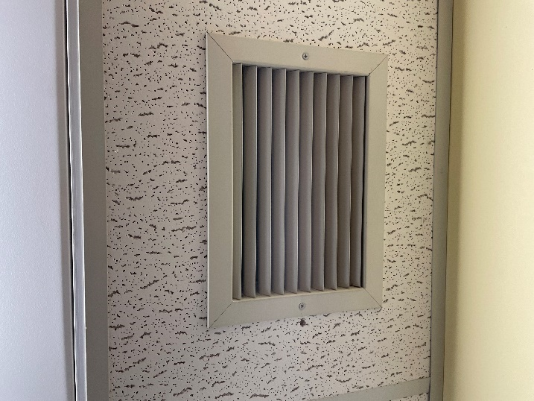

**Exhaust/return vent**

**Picture 3**

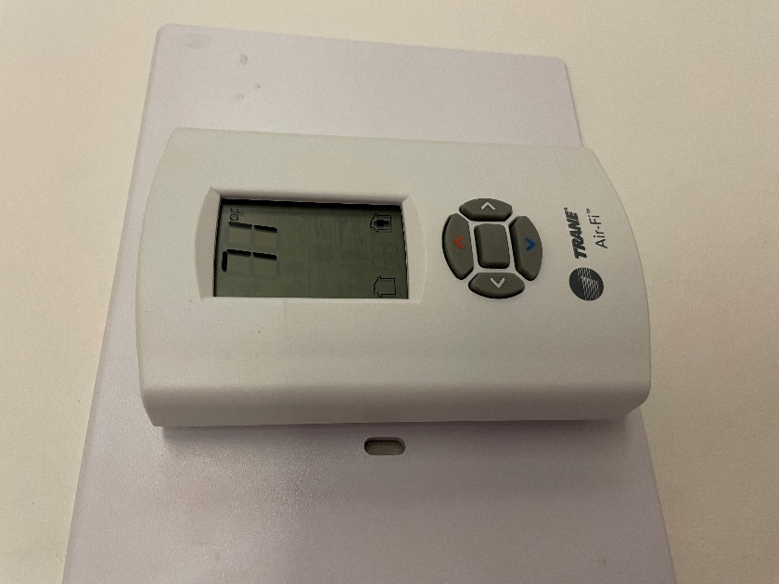

**Computer controlled thermostat**

**Picture 4**

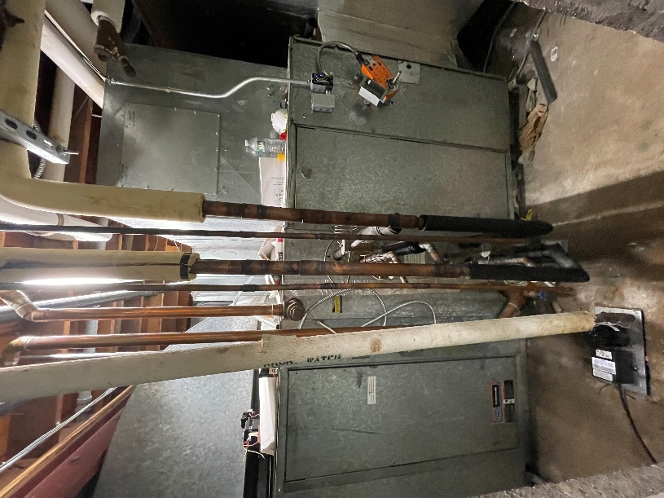

**AHU in basement**

**Picture 5**

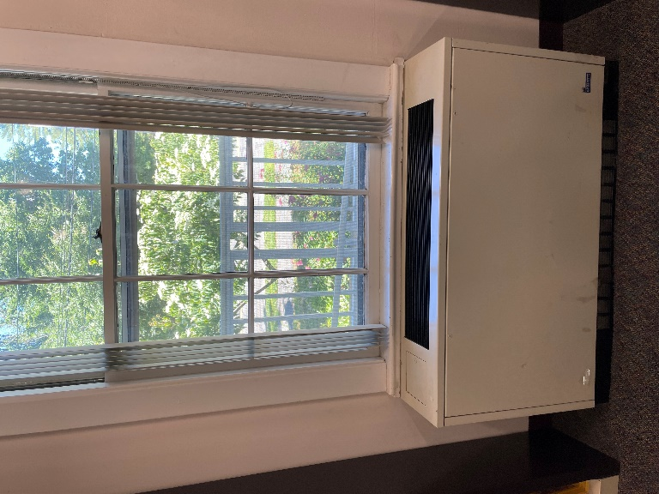

**Univent along exterior wall**

**Picture 6**

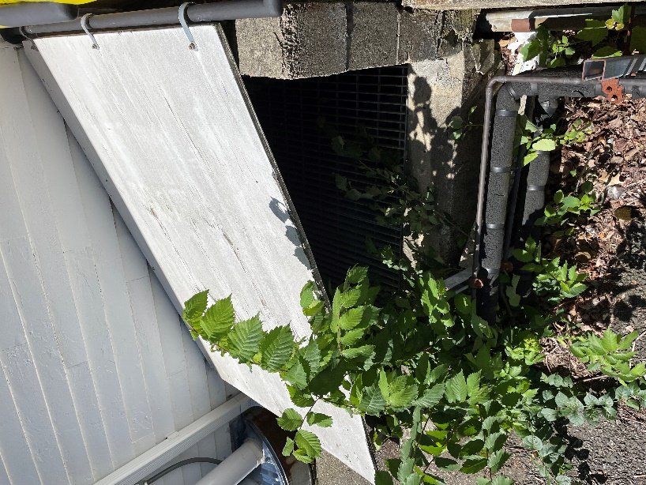

**Subterranean air intake**

Water Damage pictures

**Picture 7**

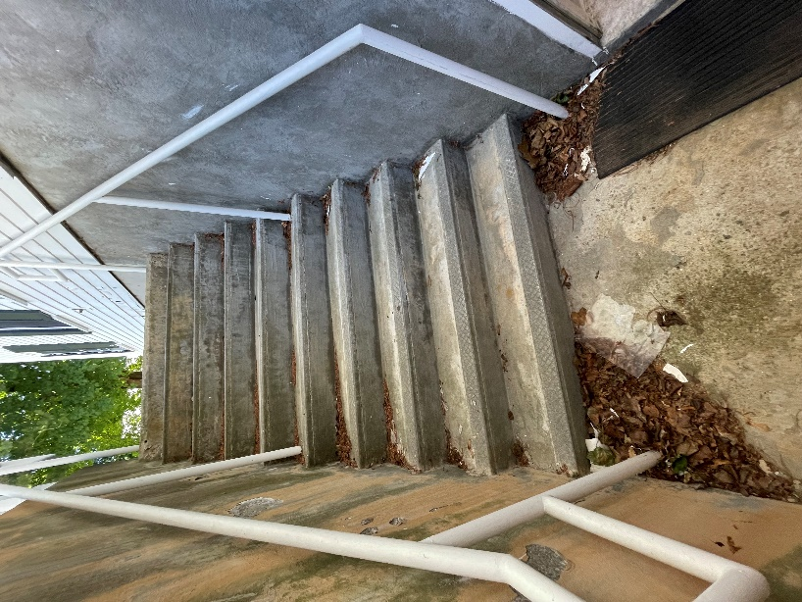

**Exterior staircase outside the basement Fiction room**

**Picture 8**

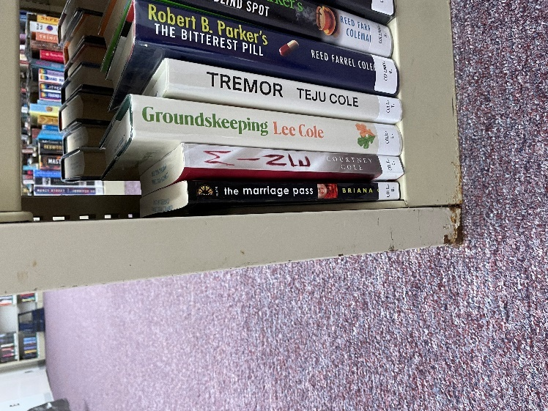

**Rust on metal bookshelves in basement**

**Picture 9**

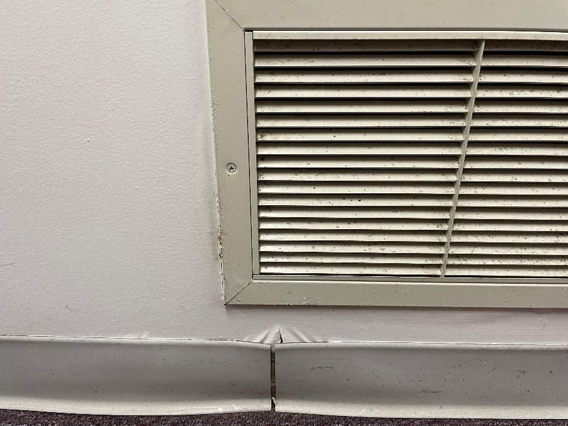

**Rust/water-damage around return vent in basement and lifting coving**

**Picture 10**

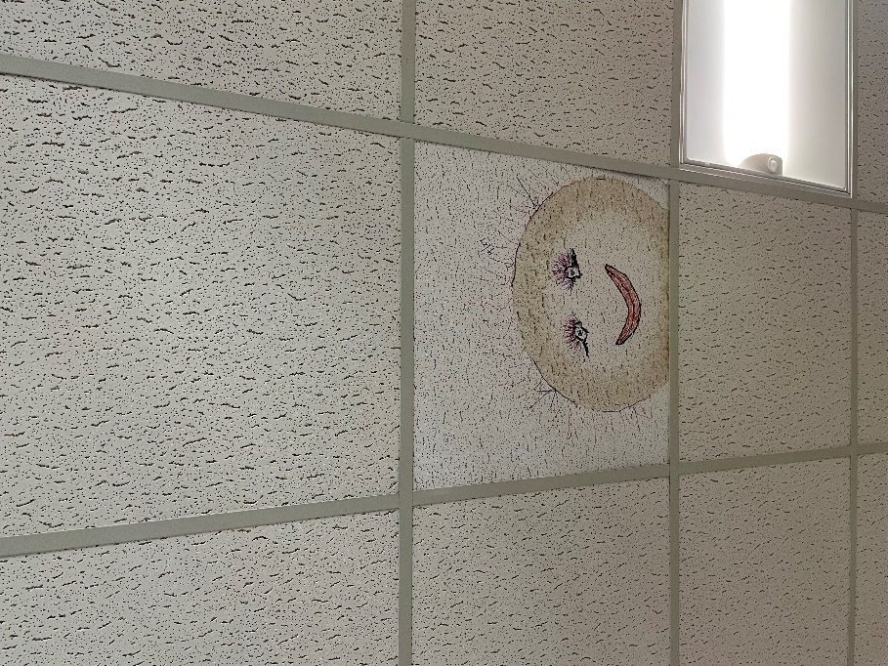

**Water-damaged ceiling tile**

**Picture 11**

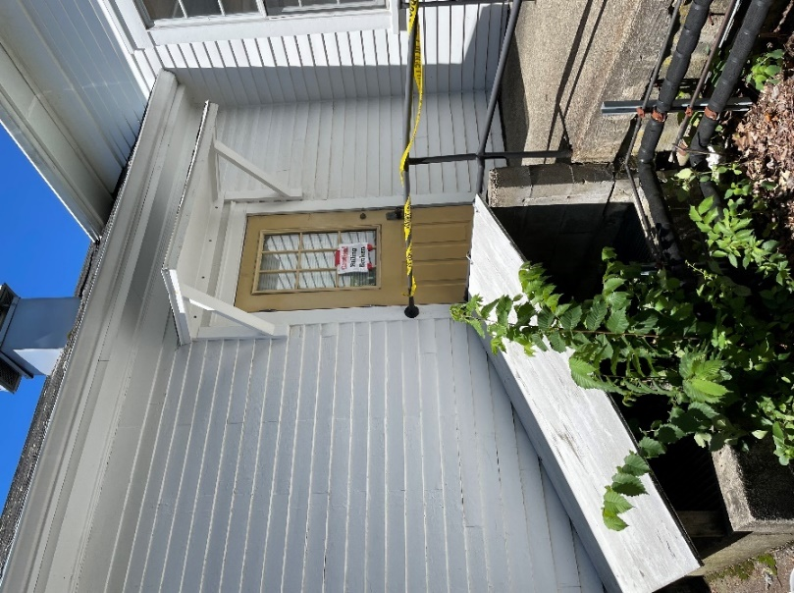

**Overhang outside office**

**Picture 12**

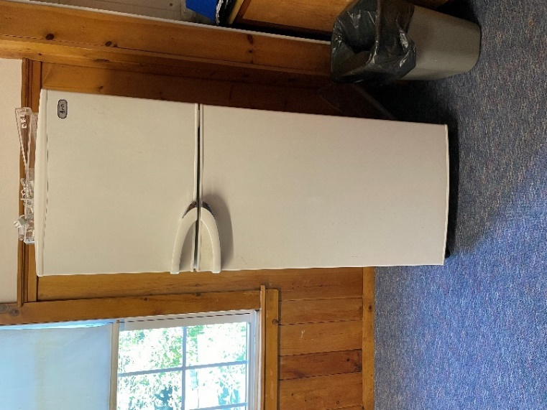

**Refrigerator on carpet**

**Picture 13**

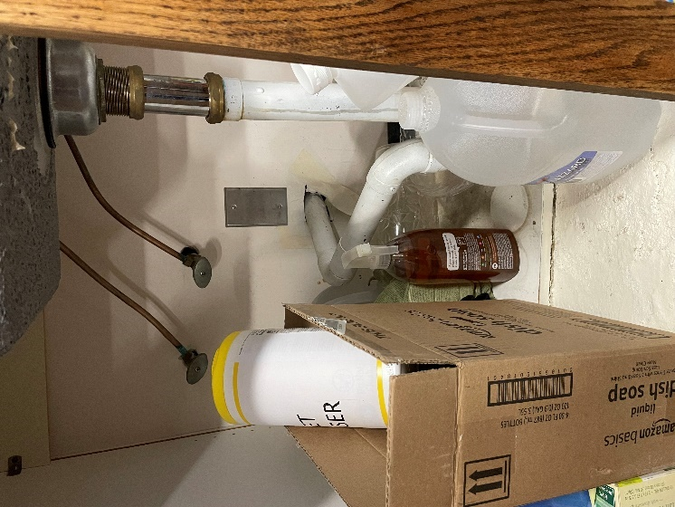

**Hole around piping under sink**

**Picture 14**

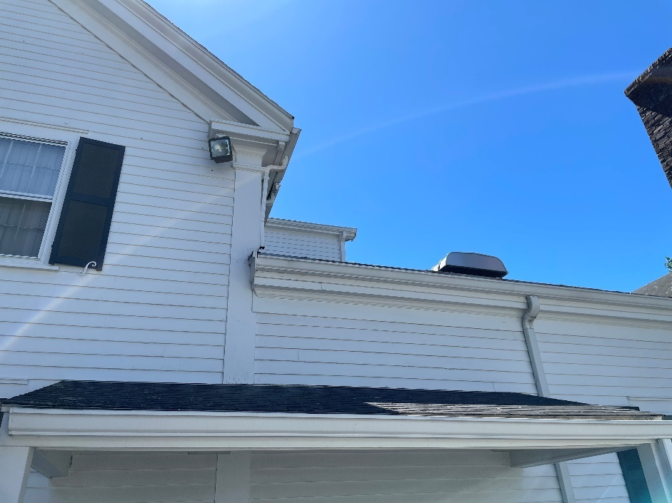

**Rooflines of the LPL**

**Picture 15**

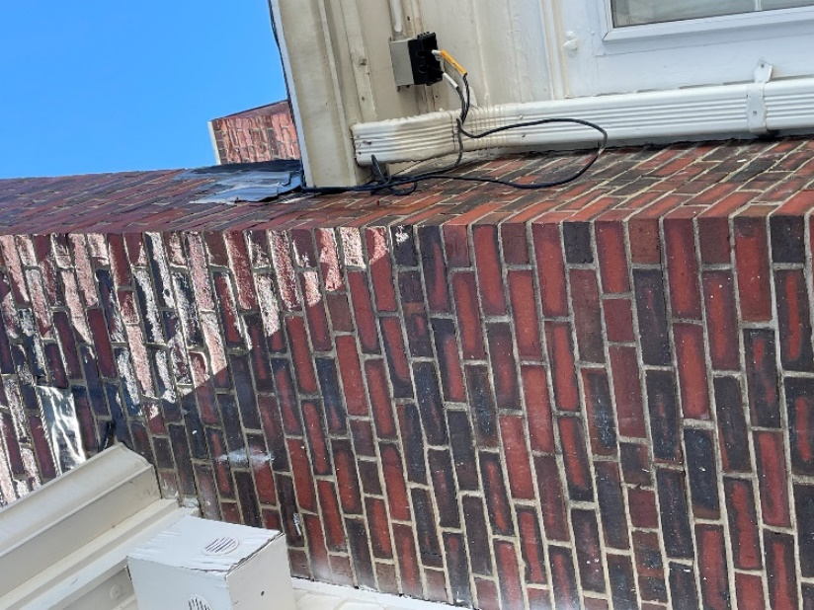

**Flashing around chimney**

**Picture 16**

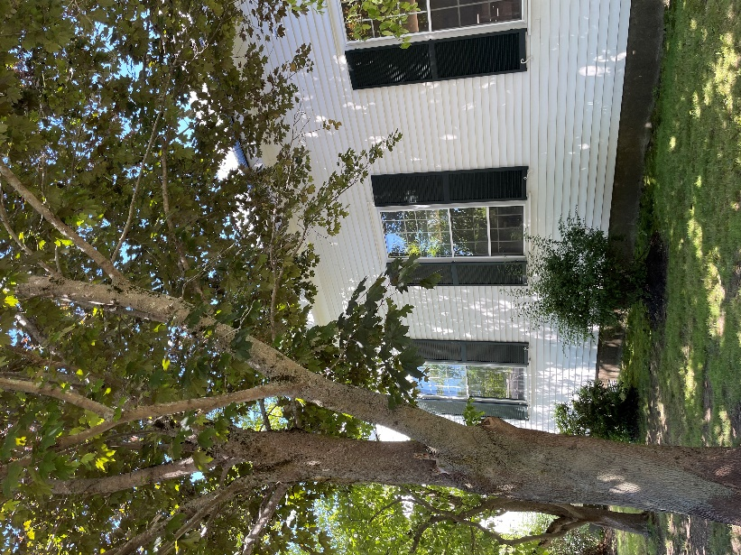

**Trees close to the building**

**Picture 17**

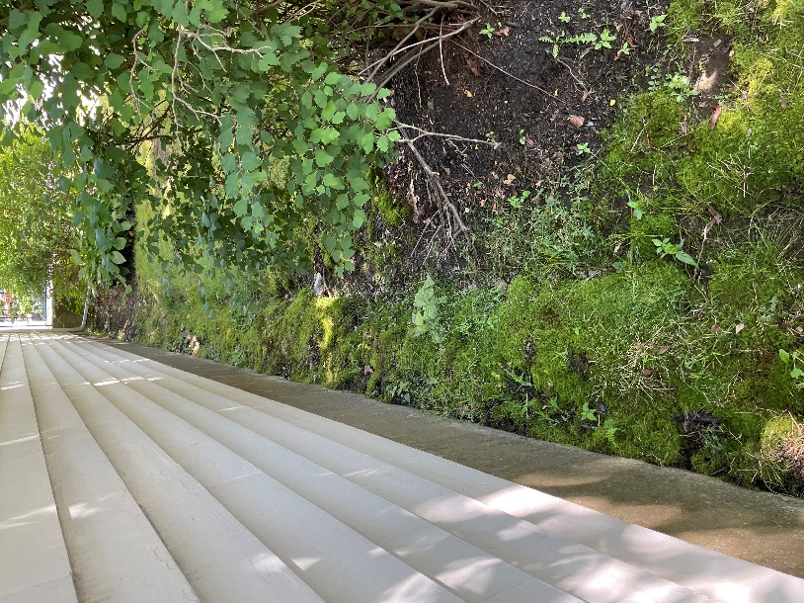

**Divot from water runoff from roof in addition to moss from saturated soil**

**Picture 18**

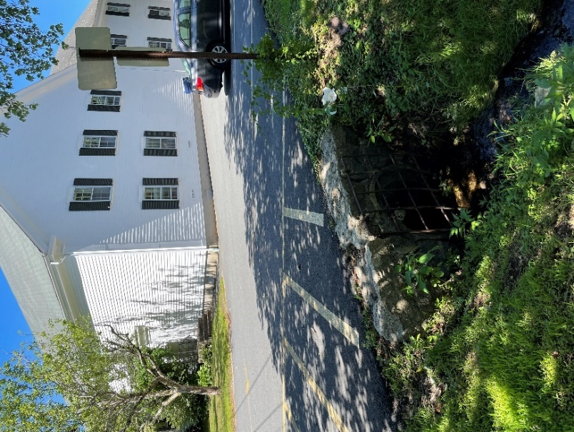

**Creek very close to the rear of the building**

**Picture 19**

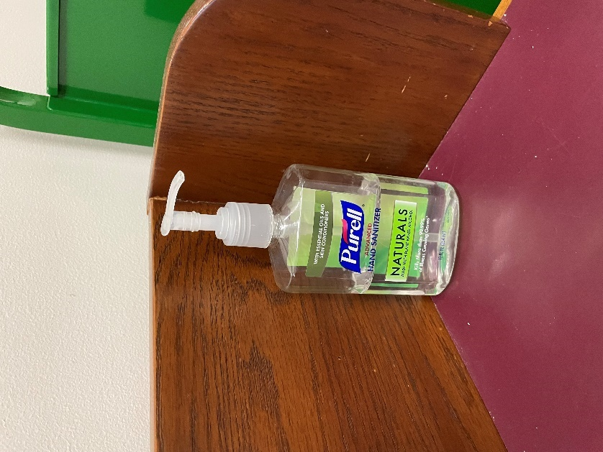

**Sanitizer**

Click to link back to report

# Table 1

| Location | **Carbon**  **Dioxide**  **(ppm)** | **Carbon Monoxide**  **(ppm)** | **Temp**  **(°F)** | **Relative**  **Humidity**  **(%)** | **PM2.5**  **(µg/m3)** | **Occupants**  **in Room** | **Windows**  **Openable** | **Ventilation** | | **Remarks** |
| --- | --- | --- | --- | --- | --- | --- | --- | --- | --- | --- |
| **Supply** | **Exhaust** |
| Background (outside) | 473 | ND | 72 | 50 | 1 |  |  |  |  | Sunny, clear, breezy |
| Circulation Office | 590 | ND | 72 | 52 | ND | 3 | Y | Y | Y | Carpet |
| Checkout area | 552 | ND | 72 | 52 | ND | 3 | Y | Y | Y | Carpet |
| Catalogue area | 536 | ND | 71 | 54 | ND | 6 | Y | Y | Y | Carpet |
| Genealogy Room | 537 | ND | 71 | 55 | ND | 1 | Y | Y | Y | Carpet |
| Mezzanine | 572 | ND | 71 | 54 | ND | 0 | Y | Y | Y | Univent, carpet |
| Tech Services | 631 | ND | 71 | 54 | ND | 3 | Y | Y | Y | Carpet, sink and fridge on carpet, sink backsplash coming loose from wall, WD CTs |
| Directors Office | 549 | ND | 73 | 54 | ND | 3 | Y | Y | Y | Carpet, plants, humidifier, fridge on carpet |
| Fiction Room (Basement) | 548 | ND | 69 | 57 | ND | 0 | Y | Y | Y | Carpet, sump pump room. Reports of rainfall coming down exterior staircase into basement area during heavy rainfall |
| Head circulation office | 594 | ND | 69 | 56 | ND | 1 | Y | Y | Y | Carpet |
| Young Adult area | 555 | ND | 71 | 54 | ND | 3 | Y | Y | Y | Carpet, area rug, WD CTs |
| Youth Services Office | 667 | ND | 70 | 54 | ND | 4 | Y | Y | Y | Carpet, WD CTs, WD door to outside |
| Children’s Room | 562 | ND | 70 | 53 | ND | 10 | Y | Y | Y | Carpet, area rug, univents |
| Break room/Green Room | 512 | ND | 70 | 53 | ND | 0 | Y | Y | Y | Carpet, fridge and sink on carpet, uninvent |

(Click to link back to report)

# Table 2A

|  |  |  |  |  |  |
| --- | --- | --- | --- | --- | --- |
| **Equipment Present in Building**  **(X = Yes)** | **Type of Heating/Cooling Ventilation**  **Equipment** | **Fresh**  **Air**  **Supply**  **(X = Yes)** | **Type of Location(s)** | **Air Filters Installed**  **MERV Rating**  **(1-15, U*)**  **(X = Yes)** | **Comments** |
| X | Univents | X | Most offices/ rooms | X |  |
|  | Roof top Air Handling Units |  |  |  |  |
|  | Outdoor, Ground-Installed Air Handling Units |  |  |  |  |
|  | Attic/Crawlspace Air Handling Units |  |  |  |  |
|  | Ceiling-Mounted Air Handling Units (including inside plenum) |  |  |  |  |
| X | Basement/Crawlspace-Installed Air Handling Units | X |  | X |  |
|  | Mechanical Room-installed Air Handling Units |  |  |  |  |
|  | Fan Coil Units |  |  |  |  |
|  | Window-Mounted Air Conditioners |  |  |  |  |
|  | Wall Louver-Controlled Gravity Air Supply |  |  |  |  |
| X | Windows |  | Most rooms |  |  |
|  | Fan in window (blowing in) |  |  |  |  |
|  | Built in wall fan (switched) |  |  |  |  |
|  | Heat recovery ventilator unit |  |  |  |  |
|  | Energy recovery ventilator unit |  |  |  |  |
|  | Chilled Beam |  |  |  |  |
|  | Passive combustion supply vent in basement/boiler room |  |  |  |  |

*U = Filter Rating underdetermined due to inaccessibility during building visit

(Click to link back to report)

# Table 2B

|  |  |  |  |  |
| --- | --- | --- | --- | --- |
| **Equipment Present in Building**  **(X = Yes)** | **Type of Exhaust Ventilation**  **Equipment** | **Ducted**  **To Outdoors**  **(X = Yes)** | **Type of Location(s)** | **Comments** |
|  | Rooftop Motors/Fans |  |  |  |
|  | Unit Exhaust |  |  |  |
| X | Ceiling Return Vent |  |  |  |
|  | Ceiling Return Vent, Plenum |  |  |  |
| X | Wall Return Vent |  |  |  |
|  | Kitchen Stove Hood |  |  |  |
| X | Restroom Exhaust Vent | X | Restrooms |  |
|  | Photocopier Exhaust Vent |  |  |  |
|  | Garage |  |  |  |
|  | Chemical Hood(s) |  |  |  |
|  | Locker Rooms |  |  |  |
|  | Showers |  |  |  |
|  | Clothes Dryers |  |  |  |
| X | Gas Water Heaters |  |  |  |
| X | Furnace-Flue to Chimney |  |  |  |
|  | Furnace/Boiler direct vent or power vent (no combustion air supply) |  |  |  |
|  | Kiln, Pottery |  |  |  |
|  | Dark Room |  |  |  |
|  | Generator Room |  |  |  |
|  | Wood Shop Dust Collector |  |  |  |
|  | Spray Paint Booths |  |  |  |
|  | Fan in window (blowing out) |  |  |  |

# Table 2C

|  |  |  |  |
| --- | --- | --- | --- |
| **Equipment Present in Building**  **(X = Yes)** | **Type of Equipment** | **Type of Location(s)** | **Comments** |
|  | Floor Fans, pedestal |  |  |
|  | Floor Fans, portable |  |  |
|  | Air Purifier (HEPA, other) |  |  |
|  | Floor heaters, portable |  |  |
| X | Refrigerators, Cold Beverage Vending Machines | Break rooms/offices | All over carpet |
|  | Radiator, wall-mounted |  |  |
|  | Radiator, floor-mounted |  |  |
|  | Passive Vents (Wall/Door) |  |  |

(Click to link back to report)

# Table 3

| **Found in Building**  **X = Yes** | **Water-Damaged Materials, Building Components or Stored Materials** | **Location** | **Visible Microbial Growth?**  **X = Yes** | **Musty odor detected?**  **X = Yes** | **Comments** |
| --- | --- | --- | --- | --- | --- |
| X | Books-other bound materials | All rooms |  |  |  |
|  | Brick walls – broken, missing mortar |  |  |  |  |
|  | Brick walls – blocked weep holes |  |  |  |  |
| X | Cardboard boxes | Basement storage |  |  |  |
|  | Carpet tiles |  |  |  |  |
| X | Carpet - Area rugs | Some rooms |  |  |  |
| X | Carpet wall-to-wall | All of the LPL |  |  |  |
|  | Ceiling tiles - affixed directly to ceiling surface |  |  |  |  |
|  | Ceiling tiles - bowing-in suspended ceiling |  |  |  |  |
|  | Ceiling tiles - water-stained in splined ceiling |  |  |  |  |
| X | Ceiling tiles - water-stained in suspended ceiling | A few areas | No | No |  |
|  | Chairs - laminated |  |  |  |  |
|  | Cloth |  |  |  |  |
| X | Countertops (around sinks) | Break room/office |  |  |  |
|  | Curtains |  |  |  |  |
|  | Dust/debris within AHU, uninvent, HVAC, chilled beam units, etc. (WD through condensation, humidity, or leaks) |  |  |  |  |
|  | Efflorescence (i.e., mineral deposits) |  |  |  |  |
|  | Engineered woods - particleboard, plywood, Masonite |  |  |  |  |
|  | Flooring – loosened tiles |  |  |  |  |
|  | Flooring - wooden |  |  |  |  |
|  | Furniture - laminated |  |  |  |  |
| X | Furniture - upholstered | Some rooms |  |  |  |
|  | Gypsum wallboard - ceiling |  |  |  |  |
|  | Gypsum wallboard - restroom wall |  |  |  |  |
|  | Gypsum wallboard - interior wall |  |  |  |  |
|  | Gypsum wallboard – located on exterior wall |  |  |  |  |
|  | HVAC drain pan – lack of draining |  |  |  |  |
|  | HVAC filters |  |  |  |  |
|  | Insulation- attic (paper-backed) |  |  |  |  |
|  | Insulation - inside air handling unit |  |  |  |  |
|  | Insulation - on pipe(s) fiberglass |  |  |  |  |
| X | Insulation - on pipe(s) other/plaster-like material | Mechanical room |  |  |  |
|  | Insulation - wall cavity |  |  |  |  |
|  | Insulation – ceiling plenum |  |  |  |  |
|  | Modular furniture – walls/cloth partitions |  |  |  |  |
|  | Musical instrument cases |  |  |  |  |
|  | Plaster ceilings |  |  |  |  |
|  | Records/files |  |  |  |  |
|  | Refrigerator - door gasket |  |  |  |  |
|  | Refrigerator - drip pan |  |  |  |  |
|  | Refrigerator - Interior surfaces |  |  |  |  |
|  | Room divider - ceiling-mounted, sliding |  |  |  |  |
| X | Sink backsplash | Breakroom/office |  |  |  |
|  | Tables – laminated |  |  |  |  |
|  | Wallpaper |  |  |  |  |
|  | Wood - attic/roof materials |  |  |  |  |
|  | Wood - floor joists in basement ceiling |  |  |  |  |
|  | Wood - wall framing |  |  |  |  |
|  | Wood - window sills |  |  |  |  |
|  | Wood - window-mounted air conditioner framing |  |  |  |  |
|  | OTHER |  |  |  |  |

WHAT ARE ENVIRONMENTAL ASTHMA TRIGGERS?

Asthma triggers are any chemical, pollutant, or allergen that can make your asthma worse. Asthma triggers can also be strong chemical smells, dust, or pets. Your asthma triggers may be different from those of other people. Not all asthma triggers affect people the same way. Environmental asthma triggers are found both indoors and outdoors. DPH link: [Asthma and Your Environment (mass.gov)](https://www.mass.gov/doc/asthma-and-your-environment-english/download)

(click to link back to report)

# Table 4

| **Condition Present**  **X = Yes** | **Possible asthma symptom-inducing environmental pollutant** | **Recommendation to reduce or eliminate the pollutant** |
| --- | --- | --- |
| X | Water Damage and/or Mold  (allergen) | Identify water source and repair to eliminate.  Clean non-porous materials.  Remove and replace porous materials susceptible to mold growth.  Perform regular water damage assessments as a tool to ensure timely mitigation as needed.  Use NIOSH water damage assessment protocol as a guide: [NIOSH water damage assessment guideline](https://www.cdc.gov/niosh/docs/2019-115/pdfs/2019-115.pdf?id=10.26616/NIOSHPUB2019115&inf_contact_key=241b5c2ed98c27d94b530dedc36f1623f651f238aa2edbb9c8b7cff03e0b16a0). |
|  | Moistening of building components during hot, humid weather (>2 days in length) (mold, allergen) | Remove materials not dried in <2 days in a manner consistent with [US EPA Mold Removal in Commercial Buildings guideline](https://www.epa.gov/mold/pdf-version-checklist-mold-remediation-mold-remediation-schools-and-commercial-buildings).  Use dehumidification in occupied basement areas and other areas with chronic dampness. |
| X | Vegetation against exterior of building (water damage-mold) | Remove all vegetation preventing building exterior drying.  Remove all vegetation capable of falling onto a building or depositing debris onto the roof. |
| X | Personal humidifiers (lack of proper maintenance)  (pollutant and allergen) | Clean and maintain properly.  Use distilled water to eliminate metal and water treatment odors.  Maintain hydration by increasing water consumption. |
|  | Drains: Floor drains, Sink drains (abandoned use)  Water bubblers (abandoned use) | If in use, pour water into drain at least twice a week.  If not in use, seal the drain with an appropriate material in accordance with Massachusetts Plumbing Code (248 CMR 10.00). |
|  | Live Animals (turtles, gerbils, birds, rabbits, etc.) | Ensure cleanliness or remove animals from the location. |
|  | Improperly maintained aquariums and terrariums (allergen) | Maintain such equipment properly to eliminate odor.  Discontinue use. |
| X | Plants and flowers  (allergen and mold) | Keep indoor plants well maintained and not overwatered. Monitor for signs of mold and pests.  Ensure water for cut flowers does not become stagnant.  Ensure dried plant material is free of odors, mold, and pests and handled carefully  If asthma risks are high, eliminate plants and flowers. |
|  | HVAC system moisture issues  (mold, allergen) | Consult ASHRAE’s minimum standards for HVAC maintenance and inspection of commercial HVAC systems (<https://www.ashrae.org/technical-resources/bookstore/standards-180-and-211>). |
|  | HVAC system contaminant issues (allergen) | Consult ASHRAE’s minimum standards for HVAC maintenance and inspection of commercial HVAC systems (<https://www.ashrae.org/technical-resources/bookstore/standards-180-and-211>). |
|  | Indoor swimming pool odors outside of swimming pool (mold, chemical) | Maintain and operate pool HVAC systems to vent odors from building.  Ensure locker room exhaust vents are operating during building hours.  All doors leading to pool should be rendered airtight and be closed. |
|  | Pollen (allergen) | Recommend installation of MERV 8 or better filters if HVAC engineer confirms HVAC system can be so equipped without adversely affecting function.  Cut grass after hours.  Cut grass in a pattern to direct clippings away from exterior wall.  Remove trees and shrubs from in front of windows and air intakes. |
|  | Dry air | Maintain hydration.  Avoid overheating of air. |
|  | Dust mites  (allergen) | Recommendation to remove non-official upholstered furniture, area rugs, pillows, cushions, etc.  Cleaning with use of HEPA-filtered vacuum cleaner.  Eliminating clutter, storing items in dust and moisture-proof containers, and regularly removing dust through wet wiping. |
|  | Pests, including rodents and cockroaches  (allergen) | Use of integrated pest management guidelines, including:   * Proper disposal of food containers * Proper storage of food products in airtight containers * Elimination of use of food as art projects * Remove pest harborages/clutter * Regular monitoring for pests   [EPA IPM guideline link](https://www.epa.gov/ipm/introduction-integrated-pest-management) |
|  | Latex-containing materials | Remove tennis balls from furniture legs. |
|  | Fragrances  (chemical) | Eliminate point sources, such as:   * Plug-in air fresheners * Aroma/oil reed diffusers * Scented sprays * Discontinue use of other scented materials * Consult DPH fragrance guideline: [*Clean air is odor-free*](https://www.mass.gov/doc/clean-air-is-odor-free-removing-fragrances-to-improve-indoor-air-quality-in-schools-and-0/download) |
|  | Strong smells from /use of Chemicals (such as cleaning products)  (chemical) | Use building-issued cleaning products.  Use products in accordance with manufacturer’s instructions including dilution, application, and ventilation.  Avoid using products that are stronger than needed for the situation. |
|  | Strong odors from new building materials (carpeting/furniture)  (chemical) | Use low VOC-emitting materials.  Air out materials (outside or in unoccupied area) prior to installation. |
|  | Tobacco smoke  Secondhand Smoke  (pollutant) | Eliminate tobacco smoking.  Seal all shared wall penetrations. |
| X | Products with a strong odor such as paint, perfume, hairspray, air fresheners, bug-spray, laminators, candles, wax melters, dry erase markers and other VOC-containing products  (chemical) | If essential:   * Provide proper exhaust ventilation to eject aerosolized product directly outdoors. * Avoid/reduce use during occupied hours.   If not necessary, remove and eliminate. |
|  | Vehicle exhaust  (pollutant) | Enforce anti-idling regulations and post signs to give notice.  Relocate vehicles away from fresh air intakes.  Require cars to park face-in at building walls.  [MA anti-idling law FAQs](https://www.mass.gov/files/documents/2018/02/20/idling-faq.pdf#:~:text=The%20Massachusetts%20Anti-Idling%20Law%20The%20goal%20of%20the,sometime%20wonder%20when%20idling%20might%20be%20considered%20necessary.) |
|  | Vapors and or fumes from gas, oil, or kerosene stoves  (pollutant) | Operate stove hood when stove in use.  Install stove hood if not present.  Ensure equipment is in good working order. |
|  | Ozone (pollutant) | Eliminate use of ozone generating equipment. |
|  | Window Air Conditioners (if not properly maintained) (allergen) | Equip with proper filter and clean periodically.  Clean drip pans.  Install in window with weathertight, non-mold-growth sustaining material. |
|  | Pottery (pollutant) | Do not operate kiln during occupied hours.  Operate kiln with exhaust system activated.  Seal all seams and holes in kiln vent.  Ensure kiln exhaust discharge terminates outdoors. |
| X | Carpeting (allergen) | Clean carpeting in a manner consistent with IICRC standards, including regular vacuuming with a high efficiency particulate air (HEPA) filtered vacuum in combination with annual cleaning or semi-annual cleaning in soiled high traffic areas. |
|  | Sweeping/dusting vs HEPA vacuuming/wet wiping  (allergen or pollutant) | Refrain from using feather dusters or brooms.  Utilize HEPA vacuums and wet wiping to minimize aerosolizing particulate matter. |
|  | Lack of adequate air exchange/mechanical ventilation | Make repairs as necessary and ensure all HVAC system components are operating continuously when building is occupied. |
|  | Lack of local exhaust at source of pollution (vocational shop activities, kitchen exhaust hood) (all) | Recommend installation of exhaust ventilation to direct pollutants directly outdoors. |
|  | Renovating buildings while occupied  (chemical) | Use all SMACNA guidelines for Renovation While Buildings Are Occupied. For information, visit <https://www.mass.gov/service-details/construction-and-renovation-generated-pollutants-in-occupied-buildings>. |
|  | Chemistry program chemical storage  (chemical) | Repair (if needed) and operate chemical storeroom vents appropriately.  Reduce or eliminate unneeded or overstocked chemicals.  Store all chemicals in a manner to separate incompatible chemicals.  Keep chemical storerooms clean. |
| X | Photocopiers/duplicating machines | All machines should have dedicated exhaust vents. |