INDOOR AIR QUALITY REASSESSMENT

Lynnhurst Elementary School
443 Walnut Street
Saugus, Massachusetts

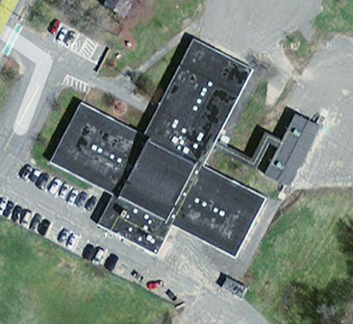

Prepared by:
Massachusetts Department of Public Health
Bureau of Environmental Health
Indoor Air Quality Program
June 2010

Background/Introduction
At the request of Frank Giacalone, Director of Public Health, Saugus Health Department, and some concerned parents, the Massachusetts Department of Public Health (MDPH), Bureau of Environmental Health (BEH) conducted an indoor air quality reassessment at the Lynnhurst Elementary School (LES), 443 Walnut Street, Saugus, Massachusetts. The LES was previously visited by MDPH’s Indoor Air Quality (IAQ) Program, and reports detailing conditions found in the building at the time of the assessments along recommendations for improvement were issued (MDPH, 2003; MDPH, 2006). Concern relative to conditions in a classroom and reported mold growth on walls of the cafeteria/gymnasium prompted the most recent request for an IAQ assessment. On March 5, 2010, Michael Feeney, Director of BEH’s IAQ Program visited the school to conduct a reassessment. Mr. Feeney was accompanied by Mr. Giacalone during the assessment.
The school is a one-story, multiple wing brick building constructed in 1965 (Picture 1). A set of three modular classrooms were added to the building in the 1990s. The school contains general classrooms, cafeteria/gymnasium, library, health suite and main office. The cafeteria/gymnasium is a two-story structure with a roof in the shape of an asymmetrical trough (Picture 2), which drains water onto the flat roof below its valley (Picture 3). Windows are openable throughout the building.

Summary of Historical Environmental Testing
As previously mentioned BEH staff has conducted several IAQ assessments of the LES. These reports demonstrate that the LES has a history of concerns related to IAQ issues. While the Saugus Public Schools (SPS) have made attempts to address air quality issues in response to these assessments, some actions will require financial resources to fully implement MDPH recommendations.
The MDPH IAQ Program conducted its first assessment of the LES in 2003. One major finding of this assessment was that the HVAC system was found to be in disrepair with many units inoperable, which minimized the amount of air circulation in the building. A number of short-term and long-term recommendations were made to improve conditions in the building, including the following:
- Continue to work with HVAC engineer to repair the ventilation control system. Have engineer survey classrooms for univent function to ascertain if an adequate air supply exists for each room. Consider having univent fresh air control dampers calibrated school-wide.
- Inspect rooftop exhaust motors and belts for proper function, repair and replace as necessary.
- Remove all blockages from univents and exhaust vents. Clean out interiors of univents regularly (e.g. with filter changes).
- To maximize air exchange, the BEH recommends that both supply and exhaust ventilation operate continuously during periods of school occupancy independent of classroom thermostat control.
- Once both the fresh air supply and exhaust ventilation are functioning, the ventilation system should be balanced.
- Adopt scrupulous cleaning practices to minimize common indoor air contaminants whose irritant effects can be enhanced when the relative humidity is low.
- Continue working with roofing contractor to eliminate leaks in the gym/cafeteria. Replace any water stained ceiling tiles and building materials. Examine the area above and around these areas for mold growth. Disinfect areas of water leaks with an appropriate antimicrobial.
- Seal areas around sinks to prevent water damage to the interior of cabinets and adjacent wallboard. Inspect wallboard for water damage and mold/mildew growth, repair/replace as necessary. Consider replacing with one-piece, molded countertops.
- Based on the age, physical deterioration and availability of parts of the HVAC system, the BEHA strongly recommends that an HVAC engineering firm fully evaluate the ventilation system and its control system (e.g. pneumatic controls, air intake louvers, thermostats).
- Consider consulting a building engineer about possible options to eliminate water pooling on roof.
- Repair/replace missing or damaged window caulking building-wide to prevent water penetration through window frames. Examine the feasibility of full window replacement.
Subsequent to the MDPH 2003 assessment, friable asbestos containing material (ACM) was found in the form of uncovered insulation in inaccessible areas above ceilings and damaged pipe insulation in the kitchen by an environmental consultant, FLI, Inc. FLI recommended that the damaged/exposed material be sealed with an encapsulant or removed (FLI, 2003). Repair work was performed at the LES in July of 2005. All asbestos clearance samples were below the Massachusetts airborne fiber limit of 0.01 fibers per cubic centimeter (f/cc) for post abatement reoccupancy (FLI, 2005). The school was reportedly reoccupied after the completion of the asbestos abatement.
In 2006, the LES was reassessed by the MDPH IAQ Program. A number of additional recommendations to improve the indoor environment were made, particulary related to improving air circulation due to elevated carbon dioxide levels (MDPH, 2006):
- Improve air exchange in certain classrooms. An increase in the percentage of fresh air supply is paramount. Contact an HVAC engineering firm to determine if univents can be modified to run continuously to provide an ongoing source of fresh air.
- Consider relocating the nurse’s office. If not feasible, make provisions to install mechanical ventilation or openable windows to provide air exchange.
- Continue with plans to install ducted exhaust grills to the face of coat closets to improve air exchange.
- Open windows to supplement the introduction of outside air from univents and improve air exchange/comfort in classrooms. Care should be taken to ensure windows are properly closed at night and weekends during the heating season to avoid the freezing of pipes and potential flooding.
- Continue with window replacement project.
- Seal utility holes in boiler room and replace missing ceiling tiles in other areas of the building to prevent the migration of odors and/or particulates.
- Change filters for air-handling equipment (e.g., univents, AHUs and ACs) as per the manufacturer’s instructions or more frequently if needed. Vacuum interior of units prior to activation to prevent the aerosolization of dirt, dust and particulates. Ensure filters fit flush in their racks with no spaces in between allowing bypass of unfiltered air into the unit.
- Keep all doors to the kitchen and nurses office shut.
- Contact an HVAC engineering firm to inspect the local exhaust hood in the kitchen for proper function and develop a preventative maintenance program for this equipment.
Based upon all assessment conducted to date, it is clear that the HVAC system at the LES warrants improvements and/or replacement.

Methods
Air tests for carbon monoxide, carbon dioxide, temperature and relative humidity were conducted with the TSI, Q-Trak, IAQ Monitor, Model 7565. Air tests for airborne particle matter with a diameter less than 2.5 micrometers were taken with the TSI, DUSTTRAK™ Aerosol Monitor Model 8520. BEH staff also performed visual inspection of building materials for water damage and/or microbial growth.

Results
This school has a student population of approximately 260 and a staff of approximately 20. The tests were taken under normal operating conditions. Test results appear in Table 1.

Discussion

Ventilation
It can be seen from the Table 1 that carbon dioxide levels were above 800 parts per million (ppm) in 9 of 15 areas surveyed, indicating a lack of adequate air exchange in these areas. It is important to note that the heating, ventilating and air conditioning (HVAC) system was deactivated in the modular classrooms, therefore there was no mechanical means to provide fresh, outside air at the time of the assessment.
Ventilation for modular classrooms is provided by air-handling units (AHUs) located on the roof. Fresh air is distributed to classrooms via ductwork connected to ceiling-mounted air diffusers. Return vents draw air back to the units through wall or ceiling-mounted grilles. Thermostats control each heating, ventilating and air conditioning (HVAC) system. In modular classrooms, thermostats have fan settings of “on” and “automatic”. Thermostats were set to the “automatic” setting in both of the modular rooms surveyed during the assessment. The automatic setting on the thermostat activates the HVAC system at a preset temperature. Once a preset temperature is measured by the thermostat, the HVAC system is deactivated. Therefore, no mechanical ventilation is provided until the thermostat re-activates the system. Due to tight building envelope construction, outdoor air infiltration through window frames and other unintentional sources is minimized; therefore little air exchange occurs when the AHUs are deactivated by the thermostats. Of note is the location of one thermostat in the hallway above a shelf (Picture 4). Since heated air cannot circulate properly through this thermostat, little temperature control can be achieved in this configuration. AHUs should be operating continuously to provide fresh air when the modular classrooms are occupied.
Fresh air in general classrooms is supplied by unit ventilator (univent) systems (Figure 1). A univent draws air from the outdoors through a fresh air intake located on the exterior wall of the building and returns air through an air intake located at the base of the unit. Fresh and return air are mixed, filtered, heated and provided to classrooms through an air diffuser located in the top of the unit. Adjustable louvers control the ratio of outside to recirculated air.
Hallway ventilation appears to be designed to use the kitchen oven hood as an exhaust vent. The kitchen is open to the hallways via a large counter which draws air from the hallways. When the kitchen hood is not activated, cooking odors are readily detected throughout most of the school. In order to prevent cooking odors and associated particulates from migrating into occupied areas, the kitchen hood should be activated during school hours. This in turn will also increase air circulation in the hallways.
To maximize air exchange, the MDPH recommends that both supply and exhaust ventilation operate continuously during periods of school occupancy. In order to have proper ventilation with a mechanical supply and exhaust system, the systems must be balanced to provide an adequate amount of fresh air to the interior of a room while removing stale air from the room. It is recommended that HVAC systems be re-balanced every five years to ensure adequate air systems function (SMACNA, 1994). The system was reportedly balanced in 2008.
The univents were installed when the building was originally constructed in 1965. According to the American Society of Heating, Refrigeration and Air-Conditioning Engineering (ASHRAE), the service life for a unit heater, hot water or steam is 20 years, assuming routine maintenance of the equipment (ASHRAE, 1991). Despite attempts to maintain the univents (i.e., cleaning univents and changing filters over vacations), the operational lifespan of this equipment has been exceeded. Maintaining the balance of fresh air to exhaust air will be difficult with univents and exhaust vent motors/equipment of this vintage.
The Massachusetts Building Code requires that each room have a minimum ventilation rate of 15 cubic feet per minute (cfm) per occupant of fresh outside air or openable windows (SBBRS, 1997; BOCA, 1993). The ventilation must be on at all times that the room is occupied. Providing adequate fresh air ventilation with open windows and maintaining the temperature in the comfort range during the cold weather season is impractical. Mechanical ventilation is usually required to provide adequate fresh air ventilation.
Carbon dioxide is not a problem in and of itself. It is used as an indicator of the adequacy of the fresh air ventilation. As carbon dioxide levels rise, it indicates that the ventilating system is malfunctioning or the design occupancy of the room is being exceeded. When this happens, a buildup of common indoor air pollutants can occur, leading to discomfort or health complaints. The Occupational Safety and Health Administration (OSHA) standard for carbon dioxide is 5,000 parts per million parts of air (ppm). Workers may be exposed to this level for 40 hours/week, based on a time-weighted average (OSHA, 1997).
The MDPH uses a guideline of 800 ppm for publicly occupied buildings. A guideline of 600 ppm or less is preferred in schools due to the fact that the majority of occupants are young and considered to be a more sensitive population in the evaluation of environmental health status. Inadequate ventilation and/or elevated temperatures are major causes of complaints such as respiratory, eye, nose and throat irritation, lethargy and headaches. For more information concerning carbon dioxide, consult Appendix A.
Indoor temperature measurements ranged from 68º F to 74º F, which were below the MDPH recommended comfort guidelines in several areas the day of the assessment (Table 1). The MDPH recommends that indoor air temperatures be maintained in a range of 70° F to 78° F in order to provide for the comfort of building occupants. In many cases concerning indoor air quality, fluctuations of temperature in occupied spaces are typically experienced, even in a building with an adequate fresh air supply.
The relative humidity measured in the building ranged from 15 to 32 percent, which was below the MDPH recommended comfort range in all areas surveyed during the assessment (Table 1). The MDPH recommends a comfort range of 40 to 60 percent for indoor air relative humidity. Relative humidity levels in the building would be expected to drop during the winter months due to heating. The sensation of dryness and irritation is common in a low relative humidity environment. Low relative humidity is a very common problem during the heating season in the northeast part of the United States. Outdoor relative humidity was 16 percent. In general, indoor relative humidity would be expected to be equal to or lower than outdoor. However, in this case, relative humidity measured indoors exceeded outdoor measurements (range 1 to 16 percent), which would be indicative of lack of air exchange in the building. Relative humidity levels within a building space that exceed outdoor relative humidity generally indicates that exhaust ventilation is not adequate.

Microbial/Moisture Concerns
In order for building materials to support mold growth, a source of water exposure is necessary (e.g., roof/plumbing leaks). BEH staff examined each area within the LES for water sources/water damage to building materials. A number of structural conditions have created pathways that allow for moisture to penetrate the building interior. Of note is the configuration of the univent fresh air intakes (UFAIs). In most buildings assessed by BEH staff, the exterior grills of the UFAIs are installed with the louvers parallel to the ground (see Picture 5 as an example). These louvers are also usually beveled in a manner for rainwater to pour away from the univent opening, similar to a peaked roof on a house. The UFAI louvers at the LES are perpendicular to the ground (Picture 6). This configuration can allow for driving rain to penetrate into the fresh air intake and accumulate in the floor of the univent instead of rolling off the louver and away from the univent.
Also of note is the presence of pebbles accumulated in the bottom of the louver frame (Picture 7). The source of the pebbles is likely from sand used during winter months in the parking lot. When plows move snow against the building, such debris remains once snow is thawed. Depositing snow in this manner during the winter months would also limit the intake of fresh air. In addition, the presence of pebbles in the UFAI frame may indicate that water is being introduced into the univent duct from melting snow. Further, just prior to this assessment, New England had been subjected to a series of rainstorms with a driving wind. Moist weather tends to travel in a northeasterly track up the Atlantic Coast towards New England (Trewartha, 1943). Wet weather systems generally produce south/southwesterly winds, which can impact on westerly and southerly facing UFAIs. UFAIs are also prone to accumulating outdoor debris, dirt and other materials that can serve as mold growth media. With repeated water penetration, these accumulated materials can become moistened, resulting in potential mold growth, particularly within several days after rainstorms.
As noted previously, the roof and upper wall of the cafeteria/gymnasium are of an unusual design. Instead of being peaked or flat, the roof in this area forms a trough which then directs water to pour onto the lower flat roofs of the building (Picture 2). The cafeteria/gymnasium has two large window frames which provide natural light. In and around the edges of the south window, a white, powdery coating was identified and suspected to be mold growth. This white coating is not mold colonization, but rather efflorescence (Picture 8). Efflorescence is a characteristic sign of water damage to brick and mortar, but it is not mold growth. As moisture penetrates and works its way through mortar, brick or plaster, water soluble compounds dissolve, creating a solution. As the solution moves to the surface of the material, the water evaporates, leaving behind white, powdery mineral deposits. Efflorescence in the cafeteria/gymnasium is on brick and mortar which is not a material that typically can serve as a mold growth medium. Numerous efforts to stem water penetration through the brick/window frame area have been attempted as evidenced by the discoloration of exterior wall brick from repeated coating with water proofing material (Picture 9).
The design of the roof system will tend to accumulate water on the flat roof sections of the building. In addition, areas directly beneath the trough of the cafeteria/gymnasium roof will tend to become eroded which will then lead to water leaks, as evidenced by water-damaged ceiling tiles. Another source of moisture inside the building is water penetration through exterior door frames (Picture 10).
The US Environmental Protection Agency (US EPA) and the American Conference of Governmental Industrial Hygienists (ACGIH) recommend that porous materials be dried with fans and heating within 24 to 48 hours of becoming wet (US EPA, 2001; ACGIH, 1989). If not dried within this time frame, mold growth may occur. Once mold has colonized porous materials, they are difficult to clean and should be removed and discarded.

Other IAQ Evaluations
Indoor air quality can be negatively influenced by the presence of respiratory irritants, such as products of combustion. The process of combustion produces a number of pollutants. Common combustion emissions include carbon monoxide, carbon dioxide, water vapor, and smoke (fine airborne particle material). Of these materials, exposure to carbon monoxide and particulate matter with a diameter of 2.5 micrometers (μm) or less (PM2.5) can produce immediate, acute health effects upon exposure. To determine whether combustion products were present in the indoor environment, BEH staff obtained measurements for carbon monoxide and PM2.5.

Carbon Monoxide
Carbon monoxide is a by-product of incomplete combustion of organic matter (e.g., gasoline, wood and tobacco). Exposure to carbon monoxide can produce immediate and acute health effects. Several air quality standards have been established to address carbon monoxide and prevent symptoms from exposure to these substances. The MDPH established a corrective action level concerning carbon monoxide in ice skating rinks that use fossil-fueled ice resurfacing equipment. If an operator of an indoor ice rink measures a carbon monoxide level over 30 ppm, taken 20 minutes after resurfacing within a rink, that operator must take actions to reduce carbon monoxide levels (MDPH, 1997).
The American Society of Heating Refrigeration and Air-Conditioning Engineers (ASHRAE) has adopted the National Ambient Air Quality Standards (NAAQS) as one set of criteria for assessing indoor air quality and monitoring of fresh air introduced by HVAC systems (ASHRAE, 1989). The NAAQS are standards established by the US EPA to protect the public health from six criteria pollutants, including carbon monoxide and particulate matter (US EPA, 2006). As recommended by ASHRAE, pollutant levels of fresh air introduced to a building should not exceed the NAAQS levels (ASHRAE, 1989). The NAAQS were adopted by reference in the Building Officials & Code Administrators (BOCA) National Mechanical Code of 1993 (BOCA, 1993), which is now an HVAC standard included in the Massachusetts State Building Code (SBBRS, 1997). According to the NAAQS, carbon monoxide levels in outdoor air should not exceed 9 ppm in an eight-hour average (US EPA, 2006).
Carbon monoxide should not be present in a typical, indoor environment. If it is present, indoor carbon monoxide levels should be less than or equal to outdoor levels. Outdoor carbon monoxide concentrations were non-detect (ND) the day of the assessment (Table 1). No measureable levels of carbon monoxide were detected in the building during the assessment (Table 1).

Particulate Matter
The US EPA has established NAAQS limits for exposure to particulate matter. Particulate matter is airborne solids that can be irritating to the eyes, nose and throat. The NAAQS originally established exposure limits to particulate matter with a diameter of 10 μm or less (PM10). According to the NAAQS, PM10 levels should not exceed 150 microgram per cubic meter (μg/m³) in a 24-hour average (US EPA, 2006). These standards were adopted by both ASHRAE and BOCA. Since the issuance of the ASHRAE standard and BOCA Code, US EPA established a more protective standard for fine airborne particles. This more stringent PM2.5 standard requires outdoor air particle levels be maintained below 35 μg/m³ over a 24-hour average (US EPA, 2006). Although both the ASHRAE standard and BOCA Code adopted the PM10 standard for evaluating air quality, MDPH uses the more protective PM2.5 standard for evaluating airborne particulate matter concentrations in the indoor environment.
Outdoor PM2.5 concentrations were measured at 4 μg/m³ (Table 1). PM2.5 levels measured indoors ranged from 1 to 10 μg/m³ (Table 1), which were below the NAAQS PM2.5 level of 35 μg/m³ (Table 1). Frequently, indoor air levels of particulates (including PM2.5) can be at higher levels than those measured outdoors. A number of mechanical devices and/or activities that occur indoors can generate particulate during normal operations. Sources of indoor airborne particulates may include but are not limited to particles generated during the operation of fan belts in the HVAC system, cooking in the cafeteria stoves and microwave ovens; use of photocopiers, fax machines and computer printing devices; operation of an ordinary vacuum cleaner and heavy foot traffic indoors.

Other Conditions
A number of conditions were observed during the assessment related to unit ventilators. The interior wall of the unit ventilators in classrooms has holes that are located between the filter and fans (Picture 11). As the unit ventilators operate, air is drawn through these holes instead of through the filter, which allows for particulates in the cabinet to become aerosolized. This condition was noted in room 5. A hole was also observed in the rear of the unit ventilator which appears to open into the wall cavity (Picture 12). Under these conditions, it is possible for the unit ventilator to draw unfiltered air from the exterior wall cavity which would then be distributed into the air of rooms with this configuration. The unit ventilator cabinet walls (where the filter and fan exist) should be airtight in order to draw air into the filter to remove particulates.
MDPH staff also observed that the filter in this unit ventilator did not fit flush with its rack, creating spaces through which air may bypass the filter. Univents should be equipped with filters that strain particulates from airflow. In order to decrease aerosolized particulates, disposable filters with an increased dust spot efficiency can be installed in univents. The dust spot efficiency is the ability of a filter to remove particulates of a certain diameter from air passing through the filter. Filters that have been determined by the American Society of Heating, Refrigeration and Air-Conditioning Engineers (ASHRAE) to meet its standard for a dust spot efficiency of a minimum of 40 percent would be sufficient to reduce airborne particulates (Thornburg, 2000; MEHRC, 1997; ASHRAE, 1992). Note that increased filtration can reduce airflow as a result of increased resistance, a condition known as pressure drop. Prior to any increase of filtration, univents should be evaluated by a ventilation engineer to ascertain whether they can maintain function with more efficient filters.
Of note was the use of food containers and storage of bird seed in classroom areas (Pictures 13 and 14). Exposed food products and reuse of food containers can attract a variety of pests. The presence of pests inside a building can produce conditions that can degrade indoor air quality. For example, rodent infestation can result in indoor air quality related symptoms due to materials in their wastes. Mouse urine is known to contain a protein that is a known sensitizer (US EPA, 1992). A sensitizer is a material that can produce symptoms in exposed individuals, including nasal and skin irritation/rashes. Pest attractants should be reduced/eliminated. Proper food storage is an integral component in maintaining indoor air quality. Food should be properly stored and clearly labeled. Reuse of food containers (e.g., for art projects) is not recommended since food residue adhering to the container surface may serve to attract pests.

Conclusions/Recommendations
SPS officials, working in conjunction with the Saugus Building Department, private contractors, LES administration, faculty members and school maintenance staff, have made some improvements to building conditions based upon in previous MDPH reports recommendations (MDPH, 2003; MDPH, 2006). To date, reports issued by the MDPH have documented a number of issues related to the functionality of the aging ventilation equipment. The SPS Facilities Department have made a number of improvements and continue to maintain existing mechanical ventilation equipment; however, the capacity of such vintage equipment to provide adequate fresh air to classrooms is limited, as illustrated by assessments which repeatedly show inadequate fresh air provision (i.e., carbon dioxide levels above 800 ppm) to classrooms. In view of the findings at the time of this visit, the following additional recommendations are made to further improve indoor air quality:
- Seal all holes in the walls of the univent air handling cabinets to limit filter bypass. Double sided, foil faced insulation with adhesive or aluminum insulation tape can be applied in a manner to create an airtight seal.
- All holes inside the univent cabinet (e.g., should also be sealed to prevent draw of air from the exterior wall cavity.
- Univent fresh air intake grilles should be replaced with a design that prevents water penetration (e.g., louvers should be oriented parallel to the ground, sloped downward to prevent water penetration), particularly in rooms with south and west facing exterior walls. In the interim UFAIs should be cleaned on a regular schedule.
- Set the thermostat for modular classrooms to the fan “on” position to operate the ventilation system continuously during the school day.
- Remove shelving or relocate thermostats for modular classrooms to facilitate airflow/temperature regulation.
- Operate the kitchen hood during school hours continuously.
- Operate all functional ventilation systems throughout the building (e.g., gym, cafeteria, classrooms) continuously during periods of school occupancy and independent of thermostat control. To increase airflow in classrooms, set univent controls to “high”.
- Inspect exhaust motors and belts for proper function. Repair and replace as necessary.
- Contact an HVAC engineering firm for a full building-wide ventilation systems assessment. Based on historical issues with air exchange/indoor air quality complaints, age, physical deterioration and availability of parts for ventilation components, such an evaluation is necessary to determine the operability and feasibility of replacing the equipment.
- Consider adopting a balancing schedule of every 5 years for all mechanical ventilation systems, as recommended by ventilation industrial standards (SMACNA, 1994).
- Use openable windows in conjunction with classroom univents and exhaust vents to facilitate air exchange. Care should be taken to ensure windows are properly closed at night and weekends to avoid the freezing of pipes and potential flooding.
- Consideration should be given to installing gutters/downspouts at the ends of the cafeteria/gymnasium roof trough to reduce water impact on the school’s lower flat roof. This system should be designed in a manner to accommodate the capacity of water that can drain from this trough roof system.
- Periodically clean/vacuum efflorescence and loose debris from walls in areas of leaks.
- It is highly recommended that the principles of integrated pest management (IPM) be used to rid the building of pests. A copy of the IPM recommendations can be obtained from the Massachusetts Department of Food and Agriculture (MDFA) website at the following website: http://www.state.ma.us/dfa/pesticides/publications/IPM_kit_for_bldg_mgrs.pdf. Activities that can be used to eliminate pest infestation may include the following activities.
  - Do not use food as components in student artwork.
  - Rinse out recycled food containers. Seal recycled containers in a tight fitting lid to prevent rodent access.
  - Store foods in tight fitting containers.
  - Avoid eating at workstations. In areas were food is consumed, periodic vacuuming to remove crumbs are recommended.
  - Regularly clean crumbs and other food residues from ovens, toasters, toaster ovens, microwave ovens coffee pots and other food preparation equipment;
  - Holes as small as ¼” are enough space for rodents to enter an area. Examine each room and the exterior walls of the building for means of rodent egress and seal. If doors do not seal at the bottom, install a weather strip as a barrier to rodents. Reduce harborages (cardboard boxes) where rodents may reside (MDFA, 1996).
- For buildings in New England, periods of low relative humidity during the winter are often unavoidable. Therefore, scrupulous cleaning practices should be adopted to minimize common indoor air contaminants whose irritant effects can be enhanced when the relative humidity is low. To control dusts, a high efficiency particulate arrestance (HEPA) filter equipped vacuum cleaner in conjunction with wet wiping of all surfaces is recommended. Avoid the use of feather dusters. Drinking water during the day can help ease some symptoms associated with a dry environment (throat and sinus irritations).
- Continue to remove/replace water-damaged ceiling tiles.
- Consider adopting the US EPA (2000) document, “Tools for Schools”, as an instrument for maintaining a good indoor air quality environment in the building. This document is available at: http://www.epa.gov/iaq/schools/index.html.
- Refer to resource manual and other related indoor air quality documents located on the MDPH’s website for further building-wide evaluations and advice on maintaining public buildings. These documents are available at: http://mass.gov/dph/iaq.

References
ACGIH. 1989. Guidelines for the Assessment of Bioaerosols in the Indoor Environment. American Conference of Governmental Industrial Hygienists, Cincinnati, OH.
ASHRAE. 1989. Ventilation for Acceptable Indoor Air Quality. American Society of Heating, Refrigeration and Air Conditioning Engineers. ANSI/ASHRAE 62-1989.
ASHRAE. 1991. ASHRAE Applications Handbook, Chapter 33 “Owning and Operating Costs”. American Society of Heating, Refrigeration and Air Conditioning Engineers, Atlanta, GA.
ASHRAE. 1992. Gravimetric and Dust-Spot Procedures for Testing Air-Cleaning Devices Used in General Ventilation for Removing Particulate Matter. American Society of Heating, Refrigeration and Air Conditioning Engineers. ANSI/ASHRAE 52.1-1992.
BOCA. 1993. The BOCA National Mechanical Code/1993. 8th ed. Building Officials & Code Administrators International, Inc., Country Club Hills, IL.
FLI. 2003. FLI, Inc. Three-Year AHERA Re-Inspection Report (Project #03-479), dated November 28, 2003.

FLI. 2005. FLI, Inc. Asbestos Abatement Air Monitoring Summary Report (Project #05-572), dated August 24, 2005.

MDFA. 1996. Integrated Pest Management Kit for Building Managers. Massachusetts Department of Food and Agriculture, Pesticide Bureau, Boston, MA.
MDPH. 1997. Requirements to Maintain Air Quality in Indoor Skating Rinks (State Sanitary Code, Chapter XI). 105 CMR 675.000. Massachusetts Department of Public Health, Boston, MA.
MDPH. 2003. Indoor Air Quality Assessment Lynnhurst Elementary School, Saugus, MA. Massachusetts Department of Public Health, Bureau of Environmental Health Assessment, Boston, MA. January 2003.

MDPH. 2006. Indoor Air Quality Reassessment Lynnhurst Elementary School, Saugus, MA. Massachusetts Department of Public Health, Center for Environmental Health, Boston, MA. June 2006.

MEHRC. 1997. Indoor Air Quality for HVAC Operators & Contractors Workbook. MidAtlantic Environmental Hygiene Resource Center, Philadelphia, PA.
OSHA. 1997. Limits for Air Contaminants. Occupational Safety and Health Administration. Code of Federal Regulations. 29 C.F.R 1910.1000 Table Z-1-A.
SBBRS. 1997. Mechanical Ventilation. State Board of Building Regulations and Standards. Code of Massachusetts Regulations. 780 CMR 1209.0.
SMACNA. 1994. HVAC Systems Commissioning Manual. 1st ed. Sheet Metal and Air Conditioning Contractors’ National Association, Inc., Chantilly, VA.
Thornburg, D. 2000. Filter Selection: a Standard Solution. Engineering Systems 17:6 pp. 74-80.
Trewartha, G.T. 1943. An Introduction to Weather and Climate. McGraw-Hill Book Company, New York, NY.
US EPA. 1992. Indoor Biological Pollutants. US Environmental Protection Agency, Environmental Criteria and Assessment Office, Office of Health and Environmental Assessment, research Triangle Park, NC. EPA 600/8-91/202 January 1992.
US EPA. 2000. Tools for Schools. Office of Air and Radiation, Office of Radiation and Indoor Air, Indoor Environments Division (6609J). EPA 402-K-95-001, Second Edition. http://www.epa.gov/iaq/schools/tools4s2.html
US EPA. 2001. “Mold Remediation in Schools and Commercial Buildings”. Office of Air and Radiation, Indoor Environments Division, Washington, DC. EPA 402-K-01-001. March 2001. Available at: http://www.epa.gov/iaq/molds/mold_remediation.html
US EPA. 2006. National Ambient Air Quality Standards (NAAQS). US Environmental Protection Agency, Office of Air Quality Planning and Standards, Washington, DC. http://www.epa.gov/air/criteria.html
Picture 1

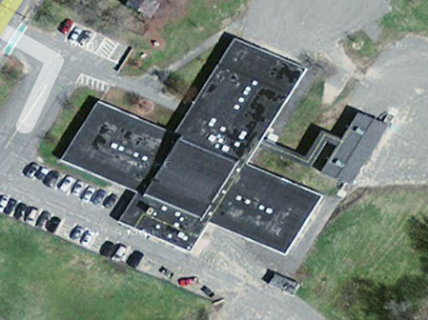

Aerial View, Arrow Denotes Auditorium/Cafeteria Trough

Picture 2
Scupper
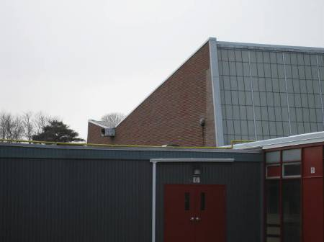

Asymmetrical Auditorium/Cafeteria Roof, Note Large Scupper That Drains Water onto Flat Roof
Picture 3

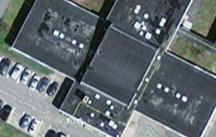

Arrow Notes Water Flow off Trough Roof, Grey Discolorization on Lower Roofs Indicate Water Accumulation

Picture 4

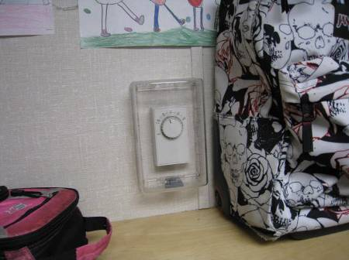

Modular Wing Thermostat over Shelf
Picture 5

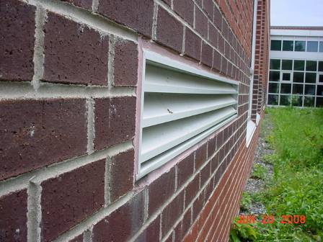

Example of a Typical Fresh Air Intake Installation with Louvers Parallel to Ground That Drain Water Out

Picture 6

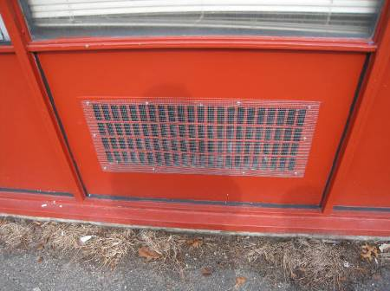

Fresh Air Intake Louvers Installed Perpendicular to Ground
Picture 7

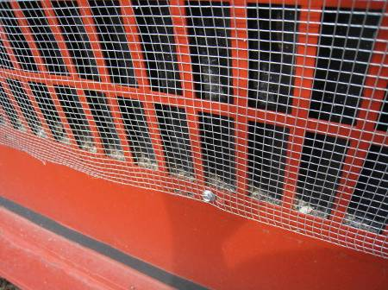

Pebbles Accumulated in Base of Fresh Air Intake Vent Shown in Picture 6

Picture 8

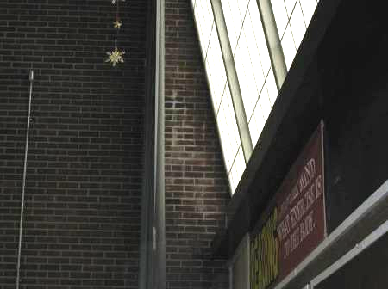

Efflorescence on Auditorium/Cafeteria Wall
Picture 9

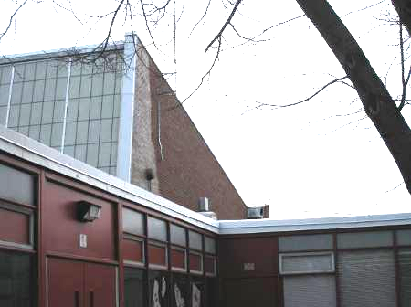

Exterior Wall Brick Discolored from Repeated Coating
with Water Proofing Material

Picture 10

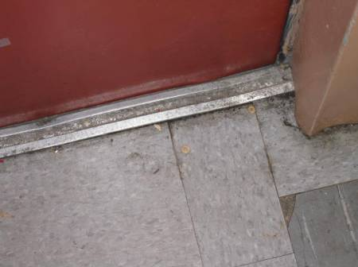

Space in Exterior Wall Door Frame
Picture 11

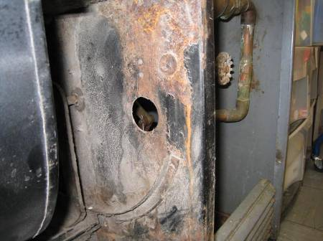

Hole in Univent Wall, Post Filter

Picture 12

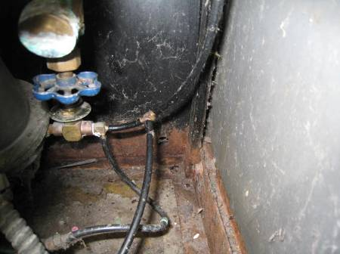

Hole in Univent Cabinet to Exterior Wall
Picture 13

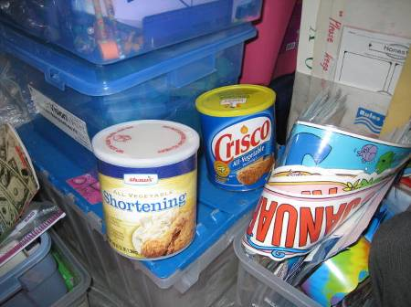

Food Containers

Picture 14

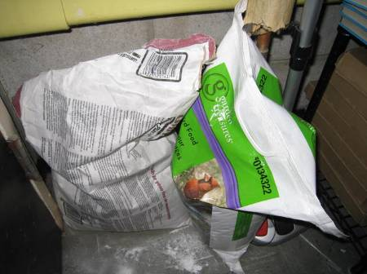

Bag of Bird Seed in Storage Closet
Location | Occupants  in Room | Temp  (°F) | Relative  Humidity  (%) | Carbon  Dioxide  (ppm) | Carbon Monoxide  (ppm) | PM2.5 (ug/m3) | Windows  Openable | Ventilation |  | Remarks
 |  |  |  |  |  |  |  | Supply | Exhaust | Remarks
Outside  (Background) |  | 52 | 16 | 371 | ND | 4
1 | 20 | 69 | 20 | 776 | ND | 2 | Y | Y | Y | Window open, door open
2 | 19 | 68 | 19 | 771 | ND | 2 | Y | Y | Y | Water damage around exterior door, windows open
3 | 17 | 71 | 19 | 773 | ND | 2 | Y | Y | Y
4 | 15 | 71 | 17 | 699 | ND | 1 | Y | Y | Y
5 | 21 | 71 | 18 | 784 | ND | 4 | Y | Y | Y | Door open
6 | 22 | 74 | 22 | 1167 | ND | 5 | Y | Y | Y | Storage closet containing bird food, shortening
7 | 25 | 71 | 24 | 1665 | ND | 7 | Y | Y | Y | Food containers, door open
8 | 24 | 72 | 21 | 1105 | ND | 5 | Y | Y | Y | Door open
Cafeteria | 30+ | 69 | 25 | 989 | ND | 5 | N | Y | Y | Efflorescence on brick walls  door open
9 | 16 | 73 | 17 | 810 | ND | 4 | Y | Y | Y | Corn starch boxes, windows open
11 | 19 | 73 | 15 | 872 | ND | 3 | Y | Y | Y | Door open
12 | 23 | 73 | 18 | 866 | ND | 2 | Y | Y | Y | 10+ water damaged ceiling tiles, windows open
10 | 1 | 72 | 17 | 725 | ND | 3 | Y | Y | Y
Modular classroom left | 27 | 73 | 32 | 2470 | ND | 9 | Y | Y | Y | Fresh air supply off, return vent off, door open, thermostat above shelf
Modular classroom right | 25 | 72 | 30 | 2147 | ND | 10 | Y | Y | Y | Fresh air supply off, return vent off, door open, thermostat above shelf
Kitchen |  |  |  |  |  |  |  |  |  | Kitchen hood off

The service life is the median time during which a particular system or component of …[an HVAC]… system remains in its original service application and then is replaced. Replacement may occur for any reason, including, but not limited to, failure, general obsolescence, reduced reliability, excessive maintenance cost, and changed system requirements due to such influences as building characteristics or energy prices (ASHRAE, 1991).

