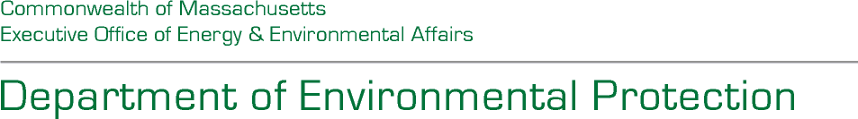


Maura T. Healey, Governor Kimberley Driscoll, Lieutenant Governor
Rebecca L. Tepper Secretary Bonnie Heiple, Commissioner

M36 Water Audit Program

Notice of Intent: Request for Interest
  - Statewide Water Management Act Permit and Registration Holders Water Audit
  - RFI # BWR 2026-AWWA-M36-Water Audits

Summary
The Commonwealth of Massachusetts Department of Environmental Protection (MassDEP) is soliciting interest from Water Management Act (WMA) registrants and permit holders to receive a free American Water Works Association (AWWA) M36 “Top-Down” Audit from a private consulting firm, which MassDEP will hire through a public procurement process at a later date. For certain facilities that meet the outlined data criteria, a “Bottom-Up Component Analysis” can also be done as part of the Audit. It is anticipated the RFI will be posted to COMMBUYS and MassDEP’s Water Management Act website on September 30, 2025. Once selected, the WMA public water suppliers (PWSs) are required to participate in the AWWA M36 Audit; however, the consulting firm hired by MassDEP will guide the Audit and provide a report to each PWS and MassDEP following completion of the Audit process.
Based upon the response to this Request for Interest (RFI), a list of WMA PWSs approved for the completion of a “Top-Down” M36 Audit, or a “Top-Down M36 Audit with a Bottom-Up Component Analysis” will be included in a competitive procurement solicitation for the services of a consulting firm, to be released by MassDEP later this year. The purpose of that procurement will be to select the consulting firm that will conduct the AWWA M36 Audits. A final list of WMA PWSs that will receive an AWWA M36 Audit will not be available until after a consulting firm is selected by MassDEP, given that time and funding constraints may limit the number of AWWA M36 Audits that can be conducted.
Funding for this program is contingent upon appropriation by the Massachusetts legislature.

Eligibility Criteria
Any Massachusetts public water supplier or municipality with a valid Water Management Act permit or registration is eligible to submit a Response to this RFI. Public water suppliers must be able to commit significant personnel time as an in-kind match and work with MassDEP’s consultant in order to produce accurate audit results and validation.

MBTA Communities Act:
Please note participation in the M36 program will be limited to Public Water Suppliers that are located within communities that are either not subject to, or in compliance with M.G.L. CH.40A §3A, the MBTA Communities Act Law. For more information, visit MBTA Communities Act Compliance Resources on Mass.gov.

RFI Application Process
RFI Applications are reviewed and recommended by a screening committee at MassDEP.

RFI Evaluation Criteria
Special consideration will be given to public water suppliers that have had a consistently high MassDEP- accepted Unaccounted for Water (UAW) percentage or have been unable to receive a final water needs forecast from the Department of Conservation and Recreation because of high UAW or other accounting issues. Please see Public Water Supply Tools, Resources & Performance Standards Mass.gov for a current list of public water suppliers and their MassDEP-approved UAW values. For a full description of the RFI Evaluation Criteria, please see the RFI, which is posted on MassDEP’s website at the link below.

Disadvantaged Communities
MassDEP is committed to advancing Disadvantaged Communities through its public investments. To that end, preference will be given to projects that provide direct benefit to Disadvantaged Communities. Information on how communities are classified as Disadvantaged Communities and which communities they are can be found at The Disadvantaged Community Loan Forgiveness Program website on Mass.gov.

Additional Information
Please see the Water Management Act website for the RFI document, and for details on how to respond to this RFI.

This information is available in alternate format. Contact Glynis Bugg at 617-348-4040.
TTY# MassRelay Service 1-800-439-2370
MassDEP Website: www.mass.gov/dep

