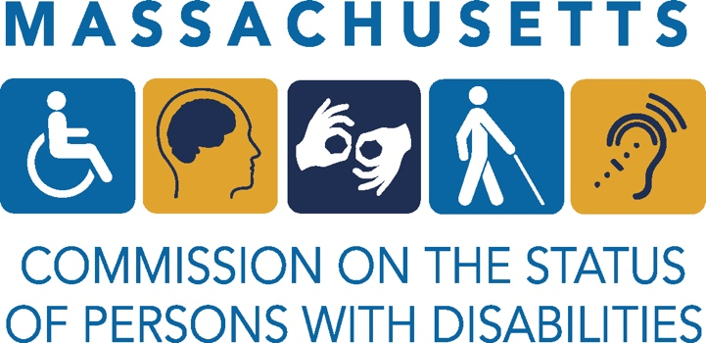
Permanent Commission on the Status of Persons with Disabilities
Nomination Form
PLEASE ANSWER ALL 13 QUESTIONS AND EMAIL BACK BY AUGUST 4, 2023 TO IMENE.BOUZIANESAIDI@MASS.GOV

Organization Name:

Nature of your organization:

Organization mission statement:

Point of Contact Name, phone number and email:

Size of your organization:
_ 0-250 employees _ 250-500 employees
_ up to 1,000 employees _ 1,000 and above

Does your organization contract with the State and/or Federal government?

CULTURE
- Does your organization incorporate disability in your Diversity, Equity and Inclusion efforts? If so, how?

- What has your organization done to create an inclusive environment for your employees, customers and/or vendors with disabilities? Provide specific examples.

LEADERSHIP

- How do your senior executives demonstrate their commitment to disability inclusion? Examples may include serving on Boards of Directors for an external disability-focused organization or working group, philanthropy, and/or in their communications?

EMPLOYMENT PRACTICES

- What are your organizational-wide hiring goals for people with disabilities and how do you measure progress toward that goal? If applicable, share your hiring and/or employment data of employees with disabilities.

- What training or programming on disability employment related to hiring, onboarding, technical assistance and ongoing support have you offered your staff?

- Does your organization display non-discrimination and/or equal opportunity policy language that specifically mentions disability on your intranet and/or external public-facing website and/or recruitment/career page?

- Does your company offer job candidates and employees opportunities to self-identify as a person with a disability? If yes, please explain.

- Does your organization have a formal/written reasonable accommodation policy and procedure? If yes, is the policy available so employees can access it on their own?

- Do you support or promote mentoring opportunities for students or job seekers with disabilities? If yes, please provide specific examples.

- Do you have partnerships with public or private vocational rehabilitation organizations that can provide access to job candidates with disabilities? If yes, please provide specifics.

COMMUNITY ENGAGEMENT
- How do you work to engage the disability community? Please explain.

- Is your organization’s digital footprint accessible? If not, how is your organization going to address digital access?

SUPPLIER DIVERSITY

- Do you have a supplier diversity program to include Disability-Owned Business Enterprises (DOBE®)? If not, do you have plans to include Disability-Owned Business Enterprises in the future?

The above questions were inspired by the Disability Equality Index

