** 2025 Massachusetts**

**Arbor Day**

**Poster Contest**

**_______________________________________**

**Trees Around the World**

**Contest Instructions and Activities**

**Table of Contents**

**Welcome Letter 2**

**Activities Overview 3**

**Contest Process 4**

**Poster Contest Rules—Please read!!! 5**

**School Winner Report Form 6**

**Celebrate Arbor Day 7**

**Arbor Day Foundation Classroom Activities Booklet 8**



**2025 Massachusetts Arbor Day Poster Contest**

*Sponsored by*

Massachusetts Department of Conservation and Recreation

United States Department of Agriculture Forest Service

Massachusetts Tree Wardens’ and Foresters’ Association

Dear Educator,

You are invited to join third, fourth, and fifth-grade teachers across Massachusetts in the 2025 Arbor Day Poster Contest sponsored by the Department of Conservation and Recreation, the U.S. Forest Service, and the Massachusetts Tree Wardens’ and Foresters’ Association. This year’s theme, “**Trees Around the World**” is intended to increase students’ understanding of trees and the importance of trees in our communities.

Trees can be found in so many parts of our daily lives. Whether we are in a city or small community, the urban and community forest is so ubiquitous that we often don’t stop to think that we are actually part of a forest community and have a complex relationship with its ecosystem. Increasing students’ understanding of their relationship with the urban forest and the trees around them is an important step toward appreciation of trees and of the environmental benefits they provide.

For participation in the contest, the use of part or all the activities in this guide is encouraged, but not mandatory. You may adapt, alter, or supplement these activities to meet the needs of your students. **Follow the contest rules as they appear on page 5**. The DCR can accept one poster from each eligible grade (3rd, 4th, and 5th) per school. Not every eligible grade needs to participate in each school. Home schooled or non-participating school students may submit their posters and enter the contest individually. Make sure your school’s poster is signed with the student’s first name and last initial and that the school winner report form (page 6) is completed and affixed to the back.

**The deadline for the Poster Contest is** **March 15, 2025.**

Visit our site at [**https://www.mass.gov/guides/annual-arbor-day-poster-contest**](https://www.mass.gov/guides/annual-arbor-day-poster-contest)and view past state winners.

Julie Coop, the DCR Urban & Community Forester, will announce the state winners.

Contact Julie Coop, Julie.coop@mass.govor 617-797-3392 for more information.

**Activities Overview**

**____________________________________**

1. **Discovering Community Trees**

**Student Learning Objectives**

**3rd Grade:** Identify and discuss benefits of trees.

**4th Grade:** Identify how trees have internal and external structures that support their survival, growth, behavior, and reproduction.

**5th Grade:**

* Estimate the economic value of urban trees to individuals and to a community.
* Describe several ways trees enhance human environments and natural ecosystems.

**Basic Activities**

**https://www.arborday.org/kids/**

* Online and Printed activities available from Arbor Day Foundation.

**Extension Activity**

* Students select one or more trees to measure and calculate benefits using MyTree: [https://mytree.itreetools.org](https://mytree.itreetools.org/)

View how to measure a tree’s diameter here: <https://www.portlandoregon.gov/trees/article/424017>

1. **Create a Poster:**

**Student Learning Objective:**

* Students create a poster that reflects their understanding of trees and the importance of trees in urban and community forests.

**Activity:**

* Ask each student to create a poster around the theme **“Trees Around the World”** that reflects their understanding of trees and the importance of trees in urban and community forests.
* The poster may relate to the theme of trees in our communities and how they protect (and are a part of) our natural resources. Students are encouraged to be creative with the theme. The theme is intended to invite a variety of interpretations related to the importance of trees in our neighborhoods. If you have other lessons related to trees that you would like to use, please feel free to do so.
* Project Learning Tree ([www.plt.org](http://www.plt.org)) is another source for lesson plan ideas.

# Contest Process

1. **Create a Poster**

Ask each student to create a poster around the theme “**Trees Around the World”** that reflects their understanding of trees and the importance of trees in communities.

Students should follow the poster contest rules by using the **checklist on page 5**.

1. **Hold a School Poster Contest**

You may select the winner or have a judging panel for the classroom and school contest. The contest may be in person or online. Judges could include other students, garden club members, tree board members, nursery personnel, arborists, the tree warden, teachers, PTA members, or individuals with an interest in trees who are willing to volunteer. Home-schooled and non-participating school students may submit their posters individually.

1. **Submit your Winning Poster to DCR**

Submit your winning poster(s) to DCR postmarked on or by **March 15, 2025**.

The DCR can accept one poster from each eligible grade (3rd, 4th, and 5th) per school. Not every eligible grade needs to participate in each school.

1. **Winners will be announced in late April**

**Poster Contest Prizes**

**First Place – 5th Grade**

* A tree is planted on the grounds of the winner’s school
  + Art & science supplies and many other prizes

**First Place – 3rd & 4th Grades**

* + Recognition Award
  + Art & science supplies and many other prizes

**Second Place, Third Place, and Honorable Mention Winners** receive art and science supplies and many other prizes.

# Poster Contest Rules

**Use this checklist to make certain all entries are eligible for judging. *Entries not meeting these guidelines may be disqualified.***

1. All entries must be **original artwork** created by an individual student who is **currently in the third, fourth, or fifth grade**. A student may enter the contest only once.
2. The student’s **first name** and **last initial** must be **written** in the lower right-hand corner on the front of the poster. Do not include the last name on the front of the poster.
3. **CONTENT:** The poster must be related to the contest theme in some way. The theme “**Trees Around the World” must be on the poster**. All words must be spelled correctly and be written clearly.
4. **ENTRY MEDIA**
   1. Entries may be done in marker, crayon, paint pens, watercolor, ink, acrylic, colored pencil, and/or tempera paint.
   2. Collages are not acceptable. (Do not glue anything on your poster.)
   3. Computer or photo-generated art and/or printing is not acceptable.
   4. Entries should not display the names of commercial products, companies, or organizations.
5. **SIZE:** Entries must be **no smaller than 8.5 x 11”** and **no larger than 14 x 18.**” **Over-sized or under-sized submissions will not be accepted.**
6. **PAPER:** Entries must be done on paper that will allow for duplication and display.
7. Entries should not be matted, mounted, laminated, framed, or folded.
8. Submit your school’s entry by **March 15, 2025** (postmark date) to DCR’s Urban and Community Forestry Coordinator, Julie Coop, as described on the “**School Winner Report Form**” on the next page. Affix School Winner Report Form to the back of the school’s winning poster.

# School Winner Report Form

**2025 Massachusetts Arbor Day Poster Contest**

**_____________________________________________________________________________________________________________________**

**All information should be complete to expedite notification of winners.**

**All artwork becomes the property of contest sponsors.**

**After selecting a winning poster for the school, copy and complete this form, attach to the back of the winning poster, and send to:**

*Julie Coop, DCR Urban & Community Forester*

*66 Mill Street*

*Belmont, MA 02478*

**(*Address Information is for mailing prizes to participants, it will not be shared*)**

Winner’s Name and Grade___________________________________________________

Winner’s Home Address ______________________________________________________

City, State, ZIP________________________________________________________________

Winner’s parent or guardian name ____________________________________________

Winner’s parent or guardian e-mail address ___________________________________

Teacher’s Name _____________________________________________________________

Teacher’s e-mail address _____________________________________________________

School Name ________________________________________________________________

School Address ______________________________________________________________

City, State, ZIP _______________________________________________________

School Phone (____) _____ - ________

**Important—School Tally:**

**How many students participated in your poster contest? _____**

**How many teachers participated in your poster contest? ________**

**Celebrate Arbor Day**

**Friday, April 25, 2025**

Since 1872, Arbor Day has been celebrated throughout the United States, and Arbor Day celebrations in schools have always played an important role. An Arbor Day celebration can be:

**•Simple** – Plant a tree in honor of your school poster contest winner or to recognize an outstanding volunteer.

**•Inspiring** – Have your graduating class plant a tree with the younger students. This is a tradition that honors the students leaving and gives new students something to enjoy throughout their years!

**•Entertaining** – Students compose poems or songs about trees or perform an Arbor Day play. (A sample play is available at [**www.arborday.org/arbordayplay**](http://www.arborday.org/arbordayplay).) This could be performed for fellow students, families, or senior citizens. Whatever you choose for your celebration, go outside and enjoy the trees and environment that surround you!

**Get your students outside and celebrate Arbor Day!**

*For ideas on celebrating Arbor Day, go to* [***www.arborday.org/celebrate/***](http://www.arborday.org/celebrate/)

*For ways to integrate Arbor Day into the classroom, go to* [***www.arborday.org/celebrate/educational-resources.cfm***](http://www.arborday.org/celebrate/educational-resources.cfm)

*or contact the* [***DCR Urban and Community Forestry Program***](https://www.mass.gov/service-details/urban-and-community-forestry)*.*

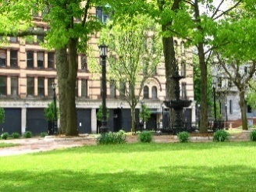

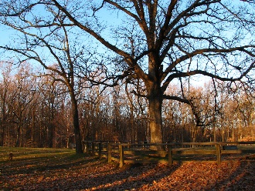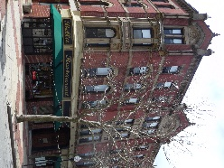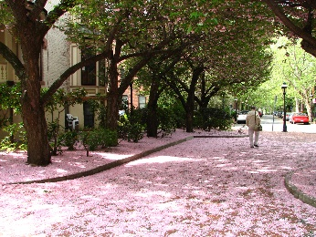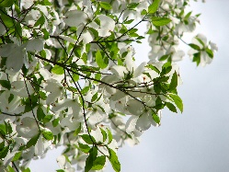

The Massachusetts Department of Conservation and Recreation prohibits discrimination in employment on the basis of race, color, creed, religion, national origin, ethnicity, gender, gender identity or expression, age, sexual orientation, Vietnam Era Veteran status, or disability.