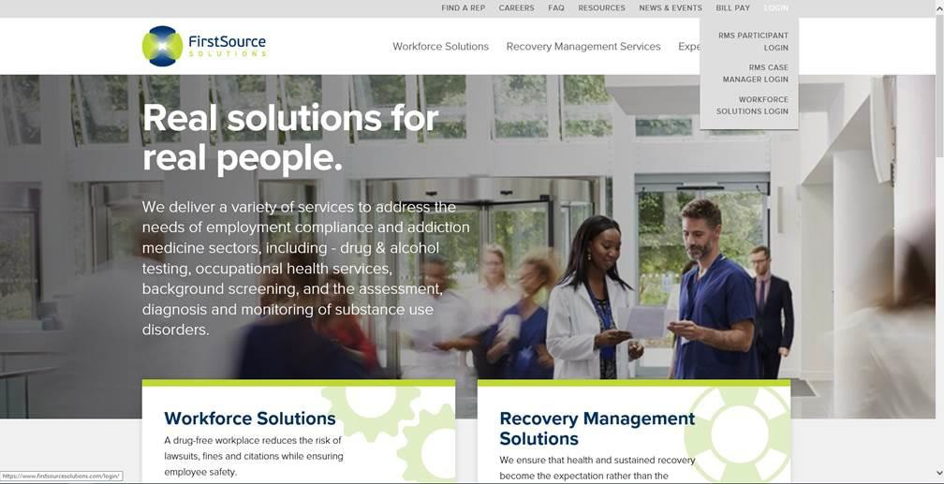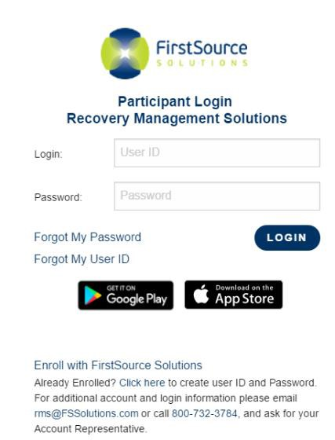

Click below to Enroll Click below to Enroll

Enrollment Instructions

MASSACHUSETTES INDIVIDUALS – SARP EVALUATIONS

You are required to enroll in FSSolutions’ Recovery Management Solutions (RMS) testing program under the MA Individuals SARP Evaluations. Please follow the instructions outlined below to ensure timely enrollment and compliance.

Once enrolled, you will NOT be required to perform daily check-ins to the notification system. A supply of Chain of Custody forms will be ordered by FSSolutions through the lab of analysis, Quest Diagnostics and sent to the address you provide during online enrollment. You will receive them within 5-7 business days after enrollment. You will use these forms to submit the required direct observed Option 5 urine drug screen(s).

Your signed release of information will allow FSSolutions to provide copies of the test result to the SARP program.
- Go to www.fssolutions.com.
  - Note: Please do not use a mobile phone device. A desktop or laptop should be used for enrollment as you will need to read and print the agreement.
- Click on the “LOGIN” drop down in top right corner.
- Click on “RMS Participant Login”

- Click on “Enroll with FirstSource Solutions”
  - *Do not attempt log in until you have completed enrollment*

100 Highpoint Drive, Suite 102, Chalfont, PA 18914-3926 ~ 833-476-1173~ www.fssolutions.com

After clicking “Enroll with FirstSource Solutions”, you will be brought to another page:

- 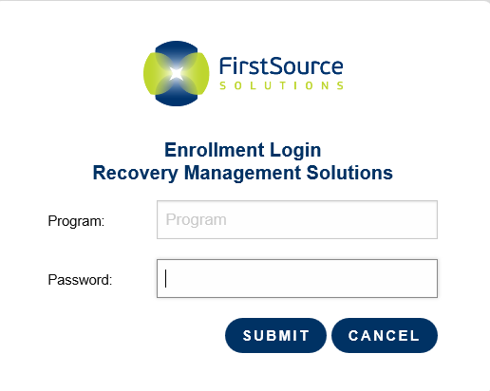Enter your Program and Password:
Program: MASS
Password: enroll

- Click the “Submit” button

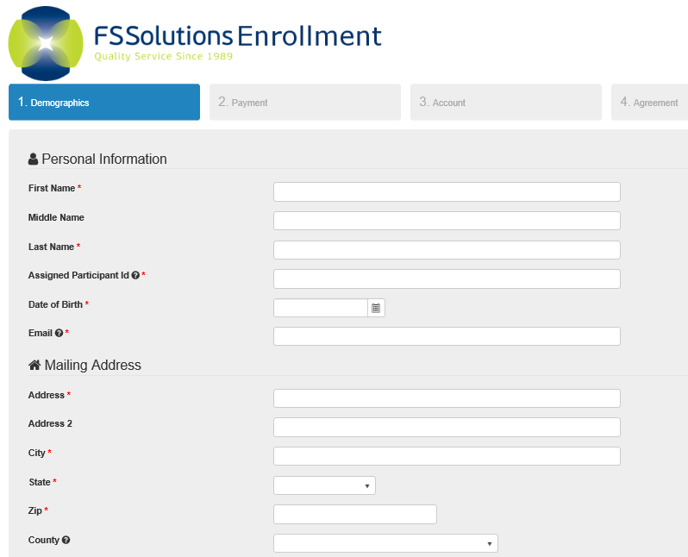Begin your Enrollment:

- Fill in all of the required fields indicated with an *.
- You are required to fill in your Assigned participant ID as:
28000 xxxx
(xxxx = last 4 of your SSN)
- Read and electronically sign the Agreement. Then click “Submit”.

*If you need assistance with Enrollment, please contact the RMS Team at FSSolutions 833-476-1173*

