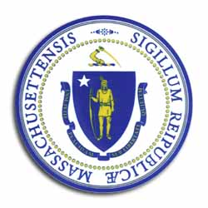
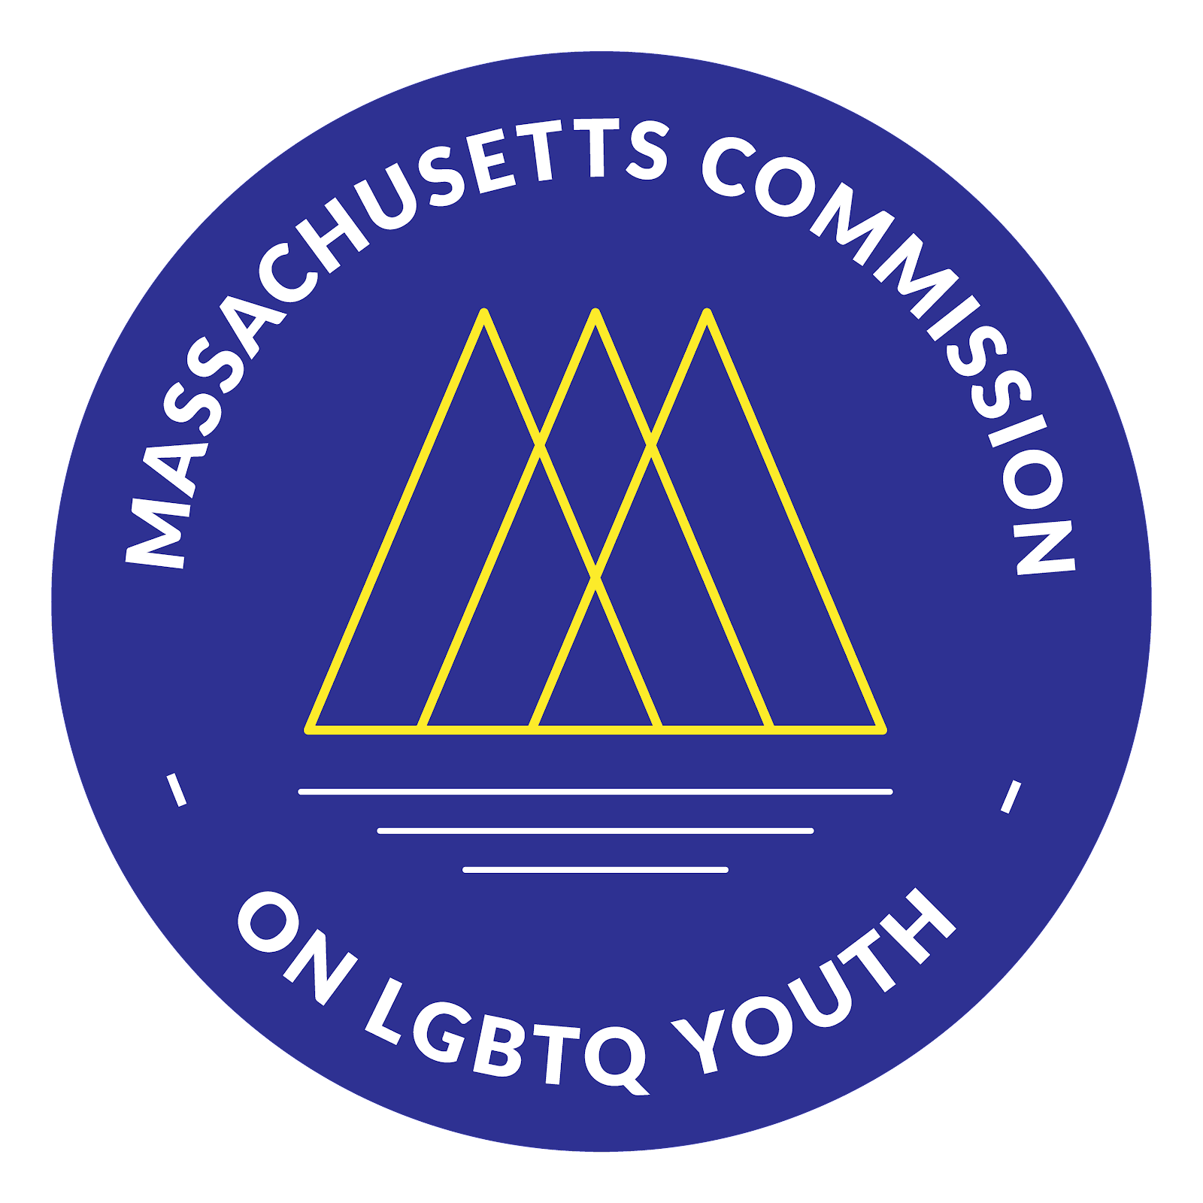
Massachusetts Commission

on LGBTQ Youth

“Working for a Commonwealth where all youth thrive”

AGENDA
Executive Committee Meeting
Monday, March 23, 2026, @ 6:00 pm
Massachusetts Commission Mass.Gov Website

Pursuant to Chapter 20 of the Acts of 2021, this meeting will be conducted via remote participation.
Join Zoom Link

Welcome and Approval of Minutes by Braxton
- Check-In
- Land Acknowledgment
- Public Comment
- Approval of the Minutes (February 2026)

Executive Director Update-Shaplaie

Old Business

Committee Updates
  - Legislative
  - Racial Justice
  - Membership
  - Safe Schools
  - Governance
  - Trans Youth

Next Steps & Closing

Upcoming Dates
- Executive Committee - Every Fourth Monday of the Month, 6 - 8 p.m.
  - Next Meeting: April 27, 2026

- Full Commission Dates
  - June 1, 2026
  - September 14, 2026
  - December 14, 2026

All meetings, with the exception of Special Meetings for Executive Sessions, are open to the public.
The items listed are those reasonably anticipated by the Chair to be discussed at the meeting. Not all items may, in fact, be discussed, and other items not listed may also be brought up for discussion to the extent permitted by law. Meetings may be recorded for live streaming and/or future posting to our website.

