

September 10, 2015

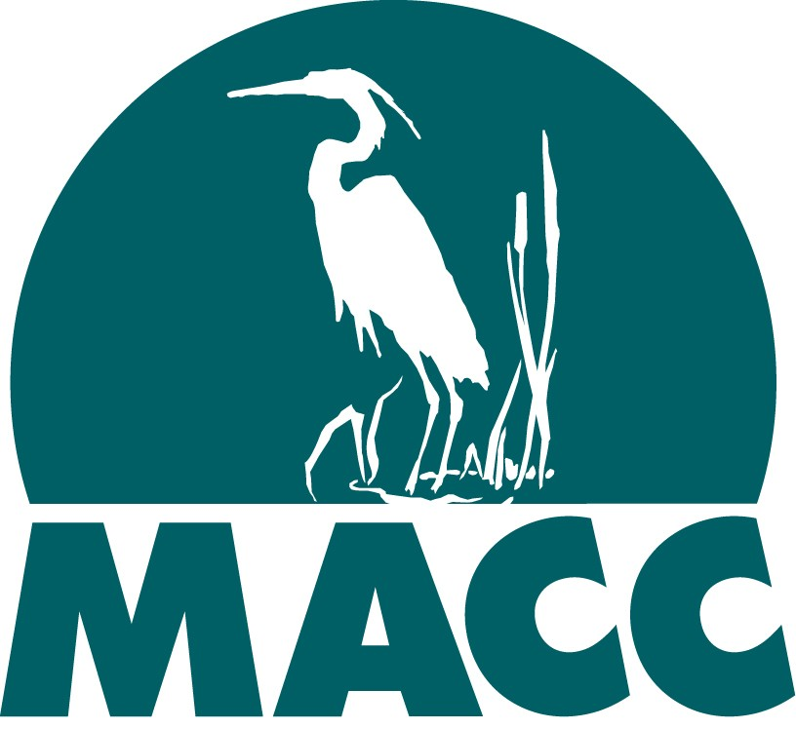

Rachel Madden, Undersecretary

Executive Office of Administration & Finance

State House, Room 373

Boston, MA 02133

Dear Secretary Madden:

The Massachusetts Rivers Alliance, the Massachusetts Association of Conservation Commissions, and the Massachusetts Land Trust Coalition appreciate your reaching out to environmental stakeholders for input on the effectiveness of environmental regulations, as a preliminary step in the regulatory review process initiated under Executive Order 562.

The Massachusetts Rivers Alliance has 58 member organizations, the Massachusetts Association of Conservation Commissions has 331 member municipal conservation commissions, the Massachusetts Land Trust Coalition has 130 land trusts and conservation members, and all three of our memberships include individuals, families, and businesses. As statewide advocates for the state’s land, wetland, and water resources, together we represent a very large constituency of people who care about land and water protection. Our member organizations, in turn, have several hundred thousand members.

In general, with so many pressing problems facing our state environmental agencies, and recent reductions in state staffing, we think devoting scarce staff resources to yet another regulatory review potentially encompassing all existing state regulations is not the best use of staff time or taxpayer money. That said, our goal is to ensure that any review of environmental regulations is fair and balanced, taking into account not just the financial costs to regulated entities, but the long-term public interests served by safeguarding the state’s outstanding environmental resources for current and future generations.

We appreciate staff reassurances that the Executive Office of Energy and Environmental Affairs (EOEEA) and its agencies plan to focus on new initiatives such as assisting municipalities to comply with environmental requirements, rolling out the new Water Management Act permitting program, and improving outdoor recreational opportunities rather than devoting significant staff time to reviewing regulations. Although we are as yet unsure of which regulations will be targeted for review, we would like to highlight

MA Rivers/MLTC/MACC

1 9/8/15

several regulations whose weakening would jeopardize the Commonwealth’s ability to protect its land and water.

**1. Water Management Act (M.G.L. Chapter 21G) regulations: 310 CMR 36.00**

As you know, the Water Management Act regulations were recently revised, the result of an intensive EOEEA-led process (the Sustainable Water Management Initiative, or “SWMI”) that lasted from 2010-1014. While litigation provided the impetus for the revisions, the reason for the change (and for the litigation) was that without any regulatory curb on water allocations, some streams in Massachusetts were running dry due to excessive water use. To insure water sustainability, the state had to rethink its system of water allocation to better balance human and environmental water needs. According to MassDEP’s website:

The purpose of SWMI was to reevaluate the way the Commonwealth manages water so that there is enough water for the many and sometimes competing long-term needs of our communities and our aquatic ecosystems. A SWMI Framework, based on extensive scientific analyses and an active stakeholder process that included 15

Advisory Committee meetings, 18 Technical Subcommittee meetings, and numerous

workgroup meetings, was released in November of 2012.

As stakeholders representing environmental interests during the process, we were dismayed by the number of significant compromises made during the development of the new regulations and guidance to assuage water suppliers’ or agency concerns. These compromises resulted in weaker protection for river flows than we would like to see, and we remain very concerned about the long-term consequences of these policy decisions for

the state’s rivers.1 Commissioner Suuberg and his staff are well aware of our concerns. We hope that in the future, the regulations and Guidance can be strengthened to better

protect the sustainability of our waterways.

However, this is a brand-new program, and a regulatory review seems premature. MassDEP has not yet issued any permits since the changes were promulgated, and is still making adjustments to the permitting process and Guidance. It is difficult to see the value of a regulatory review for regulations that have not yet been implemented.

Recommendation: We suggest the agency wait to review the regulations until after MassDEP has had a few years to implement the new program, and can review actual permit outcomes to evaluate both their environmental benefits and added costs, if any, to the communities.

**2. Interbasin Transfer Act (M.G.L. Ch. 21 §§8B-8D) regulations: 313 CMR 4.00**

The Interbasin Transfer Act was passed in 1984 to protect river flow (and water supplies)

1 These include but are not limited to: the choice of large basin-scale, annual safe yields instead of subbasin seasonal safe yields; the decision to omit improvement goals for severely depleted subbasins; and the inclusion of mitigation credit for retroactive improvements and activities, such as the establishment of various funding mechanisms and bylaws, that do not in themselves improve streamflow.

MA Rivers/MLTC/MACC 2

9/8/15

in “donor” basins, and more broadly, to prevent the excessive transfer of water from one part of the state to another. Its regulations require a review by the Water Resources Commission of water transfers, and a careful consideration of each request before approval. A 2003 WRC Guide to the Interbasin Transfer Act and Regulations states that:

The purpose of the Act is to assure that any transfer of water or wastewater from a river basin is done in a way that protects the water dependent resources of the donor basin. Many rivers and streams in the Commonwealth experience chronic low flows which can potentially degrade fisheries, wetlands, waterbased

recreation and other water-dependent resources. There are various causes of low

flows including the transfer of water out of the basin. Any water transferred out of a river basin, either for water supply or wastewater treatment purposes, is no longer available to replenish the donor basin’s rivers, aquifers, lakes or wetlands. This can also impact the availability and viability of water supplies.

As with many other regulations, in our view, this one could be stronger. To our knowledge, only two interbasin transfer requests have been turned down in the Act’s 31- year history. However, the law requires communities to implement demand management and other best management practices before a major water transfer is approved, and make sure there are no viable sources in their own watersheds for withdrawals and discharges. In addition, the Interbasin Transfer Act provides important opportunities for both donor and recipient communities to become involved, through MEPA, and the Water Resource Commission’s public review processes. We think these safeguards are important, as interbasin transfer decisions are permanent.

Recommendation: The IBTA serves a very important purpose and its regulations should not be weakened.

In addition, in view of continuing stream flow problems in some areas, and a changing climate, it may be appropriate to assess whether this 31-year-old law is working as effectively as was intended to “keep water local,” and if additional protections should be put in place to insure stream flow is adequately protected for the future. This would require looking at water balances across the state and evaluating whether water was transferred permanently out of basin when perhaps another, less environmentally- damaging solution was possible.

**3. Wetlands Protection Act**

Massachusetts is a leader in protecting wetlands. The Massachusetts Wetlands Protection Act (WPA), MGL c.131 § 40, enacted in 1972, was the first comprehensive state wetlands protection law in the United States. It combined and expanded on two earlier state laws that regulated filling coastal and inland wetlands. The WPA, amended numerous times since its initial enactment in 1972, remains one of the most effective

such laws in the United States.

MA Rivers/MLTC/MACC 3

9/8/15

Wetlands are critical natural resources. They protect and improve water quality (including the drinking water for much of Massachusetts), provide opportunities for boating, fishing, birding, swimming, and other recreation, support active fisheries, and are home to native animals and plants, including rare and endangered species that would

go extinct if not for wetlands. With a changing climate and rising sea levels, the ability of wetlands to soak up carbon and storm water and buffer us from floods is especially significant. Wetlands and open spaces are part of the web of life that supports and

protects us all, locally and globally. They improve our quality of life.2

The WPA regulates activity that would remove, fill, dredge, or alter a wetland or wetland resource area. 3 The goal is no net loss of wetlands or reduction in the interests served by wetlands. The no-net-loss goal is not met, but Massachusetts is doing better in approaching that goal than most other states.

The WPA is a wonderful example of a state and municipal partnership. Local conservation commissions in each of the 351 cities and towns in Massachusetts administer the WPA. Persons wishing to work in or alter wetlands or wetland resource areas must request and receive an approval (a permit known as an Order of Conditions) from the local conservation commission to do that work or alteration. The conservation commission must apply the requirements of the WPA and regulations to determine

whether a proposed activity is subject to state wetlands requirements, whether the activity would be consistent with the requirements and protect wetland interests, and how to condition approval of the work. They then monitor the work to determine if it being done appropriately and in accordance with required conditions.

In addition, under home rule authority, a municipality may enact a local wetland protection bylaw or ordinance that is more protective of local wetland resources than is the WPA. A majority of Massachusetts cities and towns have done so and the conservation commission in each of those municipalities implements its local laws in addition to the WPA.

The Department of Environmental Protection (MA DEP) promulgates WPA regulations, adopts WPA policy and guidance, and decides appeals of municipal decisions made

under the WPA. Both MA DEP and conservation commissions have the authority to take

enforcement action to ensure compliance with the WPA. In short, the WPA is a state law that relies on municipal conservation commissions to implement and enforce the law.

2 Including economically. According to The Trust for Public Land, for every one dollar invested in land conservation in Massachusetts, four dollars in natural goods and services is returned to the Massachusetts economy. *The Return on Investment in Parks and Open Space in Massachusetts,* The Trust for Public Land (2013).

3 Areas subject to protection under state law are: any bank, freshwater wetland, coastal wetland,

beach, dune, flat, marsh, or swamp, bordering any ocean, estuary, creek, river, stream, pond, or lake. Also, land under any of those water bodies, land subject to tidal action, land subject to coastal storm flowage, land subject to flooding, and riverfront area.

MA Rivers/MLTC/MACC 4

9/8/15

MA DEP recently reviewed the wetland regulations with an eye to efficiency and effectiveness and in October 2014 promulgated significant changes to the regulations, streamlining and updating procedures where appropriate. Notably, those regulations amendments created a general permit for ecological restoration projects, allowed for the permitting of test projects, and expanded the types of activities that can proceed under limited project status.

This year, MA DEP completed working with an advisory committee on whether to adopt regulations for Land Subject to Coastal Storm Flowage, the one resource area designated by the WPA without performance standards regulations. Having regulatory requirements for that resource area --- especially ones that take into account sea level rise predictions -- would assist coastal conservation commissions in implementing the WPA, help protect our coastline, and reduce the level of uncertainty than now accompanies proposals for projects in coastal areas subject to flooding.

Recommendations: Given the very recent amendments to the WPA regulations, the need to see the impact of those amendments as implemented, and the overall success of the wetlands protection in Massachusetts, we recommend against further changes to the regulations through E.O. 562 review with two exceptions: 1) DEP should propose regulations, including performance standards, for Land Subject to Coastal Storm

Flowage. As discussed above, those regulations would provide consistency, certainty, and coastline protection and should take into account predictions of sea level rise; and 2) DEP should convene an advisory committee to review whether and how it might update its wetlands guidance or wetlands regulations relating to wildlife habitat. The current regulations and guidance on that topic may need more clarity and closer alignment with the science.

**4. Public Waterfront Act (Chapter 91)**

The Commonwealth's primary tool for protection and promotion of public use of its tidelands and other waterways is Massachusetts General Law Chapter 91, the waterways licensing program. The Commonwealth formally established the program in 1866, but the philosophy behind Chapter 91 dates back to the earliest days of the Massachusetts Bay Colony, most notably in the Colonial Ordinances of 1641-1647.

The Colonial Ordinances codified the "public trust doctrine," a legal principle that dates back nearly 2,000 years, which holds that the air, the sea and the shore belong not to any one person, but rather to the public at large.

Chapter 91 regulates activities on both coastal and inland waterways, including construction, dredging and filling in tidelands, great ponds and certain rivers and streams. The Legislature amended Chapter 91 in 2011 with a new Section 18C allowing DEP to create the General License for non-commercial, water-dependent, small scale docks, piers and similar structures. DEP amended the waterways regulations in spring 2014, creating eligibility criteria, general performance standards, and procedures for certification and renewal. Through Chapter 91, the Commonwealth seeks to preserve and protect the rights of the public, and to guarantee that private uses of tidelands and waterways serve a proper public purpose. The MassDEP Waterways Regulation Program:

MA Rivers/MLTC/MACC 5

9/8/15

• Preserves pedestrian access along the water's edge for fishing, fowling navigation, and, in return for permission to develop non-water dependent projects on Commonwealth tidelands, provides facilities to enhance public use and enjoyment of the water.

• Seeks to protect and extend public strolling rights, as well as public navigation rights.

• Protects and promotes tidelands as a workplace for commercial fishing, shipping, passenger transportation, boat building and repair, marinas and other activities for which proximity to the water is either essential or highly advantageous.

• Protects Areas of Critical Environmental Concern, ocean sanctuaries and other ecologically sensitive areas from unnecessary encroachment by fill and structures.

• Protects the rights of waterfront property owners to approach their property from the water.

• Encourages the development of city and town harbor plans to dovetail local waterfront land use interests with the Commonwealth's statewide concerns.

• Assures removal or repair of unsafe or hazardous structures.

More than ever, the presence of a program like Chapter 91 is vital, especially because many of the fastest growing regions of the state, such as Boston, the North Shore, South Shore, Cape Cod, and the Islands are coastal areas. In these coastal areas, Chapter 91 regulations serve to protect traditional maritime industries, such as fishing and shipping, from displacement by commercial or residential development.

These coastal areas are also increasingly important in light of the emerging science on expected rates of sea level rise and the need for natural resiliency of coastal areas to adapt to climate change. Projections for sea level rise for Boston range from 2 feet to as much as 6 feet by the end of the century. One could argue that development projects in filled or flowed tidelands; in, on or over Great Ponds; or in, over or under certain non-tidal, navigable rivers or streams should be undergoing more, rather than less, review in the coming years.

Perhaps the most visible, recent testament to the critical importance of the Chapter 91 regulations appeared recently in a Boston Globe article dated July 21, 2015 praising the work of Boston Harbor leader Vivien Li ([www.bostonglobe.com/business/2015/07/21/vivien-longtime-harbor-advocate-leaving-](http://www.bostonglobe.com/business/2015/07/21/vivien-longtime-harbor-advocate-leaving-) boston/D4bMO167cg9HCJKhvvDbN/story.html). According to the Globe, “Li convinced many in Boston’s business community that what was good for the public and the harbor was also good for their bottom line.” Developer John Drew said “Some

people thought there would be security problems if the waterfront was open to the public, but quite frankly, that never happened. What has happened is that property values have gone up. The ability to walk around, use the buildings, go to restuarants – she was a major contributer to creating that whole atmosphere.” Vivien Li said, “Now you see lots

MA Rivers/MLTC/MACC 6

9/8/15

and lots of families all of different backgrounds and income levels and races enjoying the waterfront together, and doing it all for free.” Chapter 91 and the Department of Environmental Protection’s implementing regulations at 310 C.M.R. 9.00 ensure the public has access to these amenities.

Recommendation: Given the very recent amendments to the Chapter 91 regulations, the high level of public and economic benefits derived in Boston and other coastal areas from public amenities required by Chapter 91 and the need for increased coastal resiliency in light of climate change, the Chapter 91 regulations should not be weakened.

**5. Massachusetts Endangered Species Act (M.G.L c.131A) regulations: 321 CMR**

**10.00**

The Massachusetts Endangered Species Act, also known as MESA, and its implementing regulations at 321 CMR 10.00 are administered by the Director of the Division of Fisheries and Wildlife within the Department of Fish and Game. MESA was enacted in

1990, implementing regulations were promulgated in 1992, and the regulations were most recently revised in 2010.

MESA protects rare animals and plants and their habitats by prohibiting a “take” of animal or plant species listed as Endangered, Threatened, or Special Concern through a scientific and public review process administered by DFW and overseen by the Fisheries and Wildlife Board. If a project falls within Priority Habitat of state listed species and does not qualify for any of 18 categories of exemptions specified in the regulations, then project proponents must file for project review through DFW’s Natural Heritage and Endangered Species Program. The majority of projects that undergo project review either are determined to be a “no take” or “conditional no take,” not requiring a permit.

A small number of projects reviewed each year are required to obtain a Conservation and

Management Permit.

The critical importance of MESA is highlighted in the recent draft State Wildlife Action

Plan put out for public comment by the Baker Administration. The SWAP identifies 555

Species of Greatest Conservation Need, including 163 vertebrates, 111 invertebrates, and

281 plants. These Species of Greatest Conservation Need include both general wildlife

and also all species listed under MESA. Not surprisingly, many of the conservation actions that the draft SWAP recommends depend upon a robust scientific and regulatory program under MESA and its implementing regulations.

The Pope’s recent Encyclical Letter On the Care of Our Common Home (the environment) is quite remarkable in its support for the protection of endangered species and our fundamental obligations as humans towards other species:

It is not enough, however, to think of different species merely as potential “resources” to be exploited, while overlooking the fact that they have value in themselves. Each year sees the disappearance of thousands of plant and animal species which we will never know, which our children will never see, because

MA Rivers/MLTC/MACC 7

9/8/15

they have been lost for ever. The great majority become extinct for reasons related to human activity…We have no such right.

Regardless of one’s religious persuasion, he makes a detailed and compelling case for the ecological interconnected of all species and our fundamental human obligation to protect the continued viability of other species. How does this happen in Massachusetts?

Through land, river, and wetlands conservation and through MESA and its implementing regulations.

Recommendation: Given the recent amendments to the MESA regulations, the continued decline of many animal and plant species in Massachusetts, and our moral obligation to prevent the extinction or extirpation of other species, the MESA regulations should not be weakened.

We appreciate the chance to weigh in on some of the regulations of concern to us. Sincerely,



Julia Blatt Executive Director Massachusetts Rivers Alliance



Eugene B. Benson

Executive Director

Massachusetts Association of Conservation Commissions

*Mary Griffin* Mary Griffin Executive Director

Massachusetts Land Trust Coalition

Cc: Secretary Matthew Beaton, Executive Office of Energy and Environment Commissioner Martin Suuberg, Department of Environmental Protection. Commissioner Carol Sanchez, Department of Conservation and Recreation Commissioner George Peterson, Department of Fish and Game

Director Jack Buckley, Director of Fisheries and Wildlife

MA Rivers/MLTC/MACC 8

9/8/15