POST-OCCUPANCY ASSESSMENT

Massachusetts Teachers’ Retirement System
500 Rutherford Avenue
Charlestown, MA

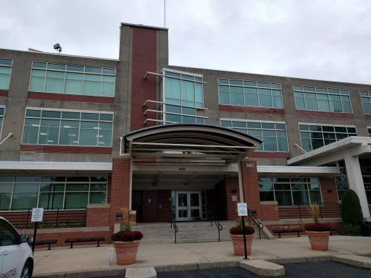

Prepared by:
Massachusetts Department of Public Health
Bureau of Environmental Health
Indoor Air Quality Program
December 2016

Background
Building: | Massachusetts Teachers’ Retirement System (MTRS)
Address: | 500 Rutherford Avenue, Charlestown, MA
Assessment Requested by: | Paul Burke, Senior Project Manager, Division of Capital Asset Management and Maintenance (DCAMM)
Reason for Request: | Post-occupancy indoor air quality (IAQ) assessment
Date of Assessment: | November 17, 2016
Massachusetts Department of Public Health/Bureau of Environmental Health (MDPH/BEH) Staff Conducting Assessment: | Ruth Alfasso, Environmental Engineer/Inspector, IAQ Program
Building Description: | This office suite is a part of “Hood Park” on the location of the former H.P. Hood and Sons Milk factory. It is now an office park containing other office tenants. The building also includes a fitness center and restaurant.
Building Population: | Approximately 100
Windows: | Not openable

Methods
Please refer to the IAQ Manual for methods, sampling procedures, and interpretation of results (MDPH, 2015).

IAQ Testing Results
The following is a summary of indoor air testing results (Table 1).
- Carbon dioxide levels were below 800 parts per million (ppm) in all areas assessed, indicating adequate fresh air in the space.
- Temperature was within the recommended range of 70°F to 78°F in all areas assessed.
- Relative humidity was below the recommended range of 40% to 60% in all areas assessed.
- Carbon monoxide levels were non-detectable in all indoor areas assessed.
- Total volatile organic compounds (TVOCs) were either not detected or below background in the building at the time of assessment.
- Fine particulate matter (PM2.5) concentrations measured were below the National Ambient Air Quality Standard (NAAQS) level of 35 micrograms per cubic meter (μg/m³) in all areas assessed.

Ventilation
A heating, ventilating, and air conditioning (HVAC) system has several functions. First, it provides heating and, if equipped, cooling. Second, it is a source of fresh air. Finally, an HVAC system will dilute and remove normally occurring indoor environmental pollutants by not only introducing fresh air, but also filtering the airstream and ejecting stale air to the outdoors via exhaust ventilation. Even if an HVAC system is operating as designed, point sources of respiratory irritation may exist and affect symptoms in sensitive individuals. The following analysis examines and identifies components of the HVAC system and likely sources of respiratory irritant/allergen exposure due to water damage, aerosolized dust, and/or chemicals found in the indoor environment.
Fresh air is provided by rooftop air handling units (AHU) that draw fresh air from intakes on the roof. The space utilizes a ducted supply system and ceiling-mounted supply vents (Picture 1). Return vents draw air back into the AHU. The HVAC system was reportedly recently balanced prior to the pre-occupancy assessment.
The assessment results indicate that the ventilation system is providing adequate fresh air for the occupancy in the building. In the conference room, what appeared to be carbon dioxide sensors were located next to the thermostats (Picture 2) to direct the ventilation system to provide more fresh air during periods of high occupancy. These should be calibrated or replaced in accordance with manufacturer’s recommendations.

Microbial/Moisture Concerns
Plants were observed in a few areas (Picture 3; Table 1). Plants can be a source of pollen and mold, which can be respiratory irritants to some individuals. Plants should be properly maintained and equipped with drip pans and should be located away from air diffusers to prevent the aerosolization of dirt, pollen, and mold.
Water dispensers were observed on carpets, where leaks can damage carpet and lead to microbial growth (Picture 4). Drinking water for these units is produced by a reverse osmosis system, the machinery for which is located in a utility room (Pictures 5 and 6). Note that this system has an active drain for the wastewater from the operation of the system. This system should be regularly maintained in accordance with manufacturer’s instructions and should be monitored regularly to ensure the drain has not clogged. This room should not be used for storage due to the moist environment and potential for leaks.
The cabinet under the sink in the large conference room was constructed without a bottom shelf, and carpeting had been placed in the area underneath (Picture 7). This condition will allow the carpeting to become moistened from leaks and condensation and likely lead to microbial growth. The carpeting under this sink should be removed and replaced with tile. Note that this is a punch-list item identified during the pre-occupancy visit that still needs completion.

Other IAQ Evaluations
Exposure to low levels of total volatile organic compounds (TVOCs) may produce eye, nose, throat, and/or respiratory irritation in some sensitive individuals. In addition to testing, BEH/IAQ staff examined spaces for products containing VOCs. BEH/IAQ staff noted air fresheners, hand sanitizers, cleaning products, and dry erase materials in a number of areas throughout the office space (Table 1). All of these products have the potential to be irritants to the eyes, nose, throat, and respiratory system of sensitive individuals.
As indicated in the pre-occupancy report, a skylight was installed over a portion of this space after the staff had moved in (Picture 8). The skylight was installed on the weekend prior to this visit. Occupants reported some “chemical” odors that may relate to the installation, but also said the odors were less prominent later in the day as well as lessening over the week since the installation. No odors were detected during the visit and no TVOC readings above background were measured. Until the odors are completely dissipated, it is recommended that the supply and exhaust ventilation be operated earlier in the morning than usual so that odors can be removed before staff are in the office.
Plastic odors were detected in the Interview rooms, which have reportedly been used very little if at all since the MTRS office was occupied (Table 1). Although it was reported that none of the furniture or items in this room are new, plastic odors may linger on items that are stored without ventilation. It is recommended that any plastic wrapping be removed and stored/discarded and that the doors to the Interview rooms be left open overnight and during occupied periods for a few days to allow these odors to dissipate.
The HVAC systems on the roof were not available to be examined during this visit, so it was unknown if the recommendation in the pre-occupancy report to upgrade the filters from Minimum Efficiency Reporting Value (MERV) 7 to MERV 8 or 9 had been followed.
The offices were mostly carpeted. Carpets should be cleaned annually (or semi-annually in soiled/high traffic areas) in accordance with Institute of Inspection, Cleaning and Restoration Certification (IICRC) recommendations, (IICRC, 2012).
In some areas, stored materials and accumulated items make it more difficult for custodial staff to clean. Items should be stored neatly and moved periodically to allow for wet wiping and vacuuming of surfaces.

Conclusions/Recommendations
Based on observations at the time of assessment, the following is recommended:
- Operate supply and exhaust ventilation continuously in all areas during occupied periods. Ensure all HVAC equipment is maintained and supply and return vents are cleaned periodically to prevent dust re-aerosolization.
- Ensure thermostats are programed to allow fan “on” when the building is occupied.
- As mentioned in the pre-occupancy report, consider upgrading the filters in the AHU from MERV 7 to MERV 8 or higher, if this has not been done already. Change filters in accordance with manufacturer’s recommendations.
- If the item next to the thermostat shown in Picture 2 is a carbon dioxide sensor, ensure these are calibrated or replaced in accordance with manufacturer’s recommendations.
- Keep plants in good condition, avoid overwatering, and remove from the airstream of heating and ventilation equipment.
- Consider moving water dispensers to areas with non-carpeted floors or use a waterproof mat underneath.
- Ensure the reverse osmosis system is maintained by the manufacturer. Inspect the drain periodically to ensure proper function. Avoid storing anything in this room that is not part of the reverse osmosis system.
- Replace the carpet underneath the sink in Picture 7 with water-resistant flooring.
- Reduce the use of cleaning products, sanitizers, and other items that contain VOCs.
- Ensure the ventilation system is running prior to occupancy each day until the odors related to the skylight installation and in the Interview rooms have dissipated.
- Remove plastic wrapping from items in the Interview rooms and leave the doors open overnight and during occupied periods to allow these odors to dissipate.
- Clean carpeting in accordance with IICRC recommendations (IICRC, 2012).
- Reduce accumulated materials on flat surfaces and store in an organized manner to allow for thorough cleaning.
- Refer to resource manual and other related IAQ documents located on the MDPH’s website for further building-wide evaluations and advice on maintaining public buildings. These documents are available at: http://mass.gov/dph/iaq.

References
IICRC. 2012. Institute of Inspection, Cleaning and Restoration Certification. Carpet Cleaning: FAQ. Retrieved from http://www.iicrc.org/consumers/care/carpet-cleaning.
MDPH. 2015. Massachusetts Department of Public Health. Indoor Air Quality Manual: Chapters I-III. Available at: http://www.mass.gov/eohhs/gov/departments/dph/programs/environmental-health/exposure-topics/iaq/iaq-manual/.
Picture 1
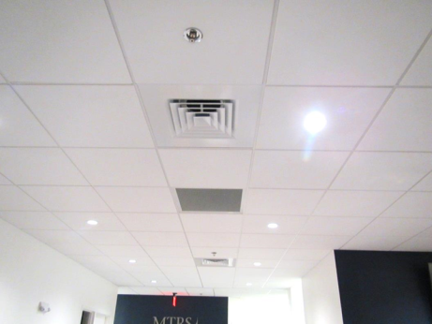
Two supply and one return vent
Picture 2
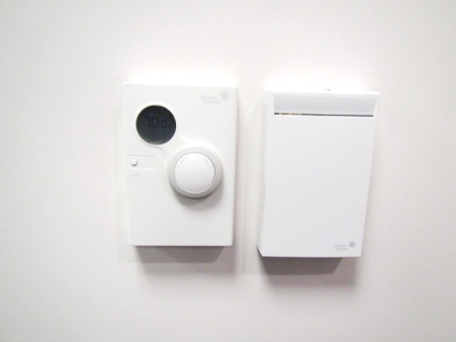
Thermostat in meeting room (on left) with what appears to be carbon dioxide sensor
Picture 3
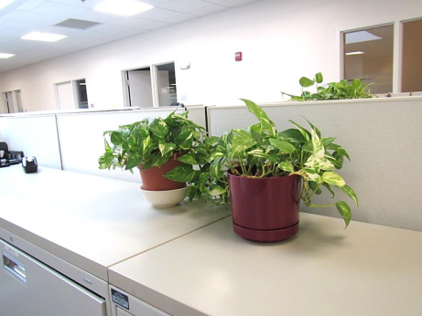
Plants on a cabinet
Picture 4
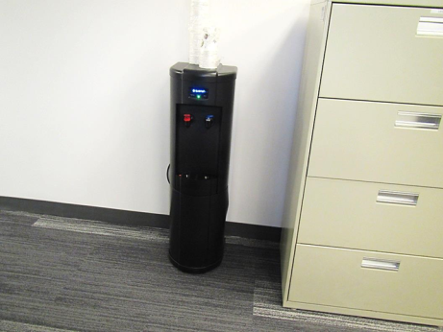
Water dispenser on carpet
Picture 5
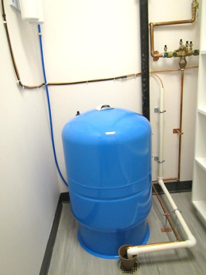
Reverse osmosis system in utility room
Picture 6
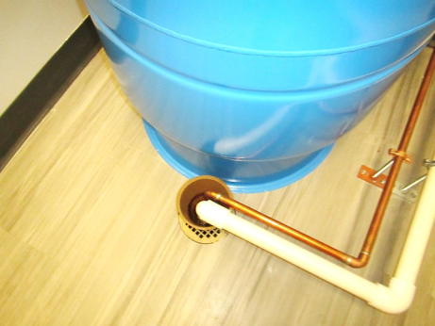
Drain for reverse osmosis system
Picture 7
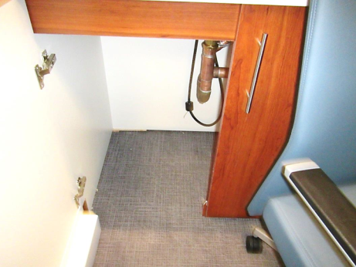
Carpet underneath sink
Picture 8
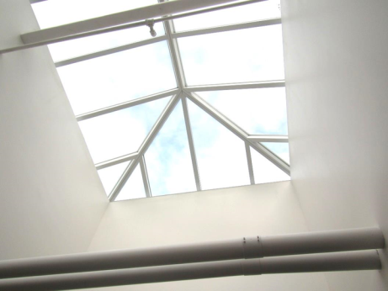
New skylight
Location | Carbon  Dioxide  (ppm) | Carbon Monoxide  (ppm) | Temp  (°F) | Relative  Humidity  (%) | PM2.5  (µg/m³) | Occupants  in Room | Windows  Openable | Ventilation |  | Remarks
 |  |  |  |  |  |  |  | Supply | Exhaust
Background | 343 | ND | 68 | 35 | 6 |  |  |  |  | Mostly sunny
Presentation Room | 414 | ND | 72 | 35 | 5 | 0 | N | Y | Y | Carpet under sink (punch-list item), carbon dioxide sensors
Computer Training | 388 | ND | 72 | 34 | 6 | 0 | N | Y | Y | DEM
Kitchen | 445 | ND | 73 | 35 | 6 | 4 | N | Y | Y | DO, kitchen equipment
Files | 438 | ND | 71 | 34 | 5 | 0 | N | Y | Y | Cardboard odor
Salvie (office) | 731 | ND | 72 | 38 | 6 | 0 | N | Y | Y | Coffee
Du (cubes) | 724 | ND | 72 | 37 | 6 | 1 | N | Y | Y | Heater, WC on carpet
Morgan (office) | 747 | ND | 73 | 37 | 7 | 1 | N | Y | Y | DEM
Neeland (office) | 767 | ND | 73 | 36 | 7 | 1 | N | Y | Y | DO
Kwan (cubes) | 640 | ND | 73 | 36 | 6 | 1 | N | Y | Y | Display items
Zizza (cubes) | 663 | ND | 73 | 36 | 6 | 2 | N | Y | Y
Porcoco (office) | 773 | ND | 73 | 37 | 6 | 1 | N | Y | Y | HS
George (office) | 772 | ND | 74 | 38 | 6 | 2 | N | Y | Y | Plush items
Ling Liang (cubes) | 793 | ND | 74 | 35 | 6 | 0 | N | Y | Y | HS/CP
Malone (office) | 758 | ND | 74 | 35 | 6 | 1 | N | Y | Y | DEM, fridge on carpet, DO
Ligon (cubes) | 715 | ND | 74 | 35 | 6 | 1 | N | Y | Y | Plant
105 vacant office | 576 | ND | 73 | 34 | 6 | 0 | N | Y | Y
Sarah (office) | 748 | ND | 73 | 36 | 6 | 1 | N | Y | Y | Food, PF
Keefe (office) | 716 | ND | 73 | 36 | 6 | 1 | N | Y | Y | DO, plant
Snow-Branch (cubes) | 749 | ND | 74 | 36 | 6 | 0 | N | Y | Y | Plant, food
Coco (office) | 721 | ND | 73 | 36 | 6 | 1 | N | Y | Y | DO, plant
Legal files | 752 | ND | 73 | 33 | 5 | 0 | N | Y | Y | Files and paper
O’Leary (office) | 768 | ND | 73 | 36 | 6 | 0 | N | Y | Y | DO
Vacant office | 506 | ND | 73 | 34 | 5 | 0 | N | Y | Y
Fabino (office) | 609 | ND | 73 | 35 | 5 | 0 | N | Y | Y | PF/heater, DEM
Ford (cubes) | 700 | ND | 73 | 36 | 7 | 2 | N | Y | Y
Office | 705 | ND | 74 | 36 | 6 | 1 | N | Y | Y
Rai (cubes) | 704 | ND | 74 | 35 | 6 | 1 | N | Y | Y | DEM
Vacant office | 709 | ND | 74 | 35 | 6 | 0 | N | Y | Y | Nice storage area
Wright | 662 | ND | 74 | 35 | 5 | 2 | N | Y | Y
IT storage | 593 | ND | 73 | 33 | 5 | 0 | N | Y | Y
Reverse Osmosis room |  |  |  |  |  |  | N | Y | Y | Reverse osmosis equipment including drain
Scanning | 650 | ND | 73 | 35 | 6 | 0 | N | Y | Y
Cullity (office) | 659 | ND | 73 | 35 | 6 | 2 | N | Y | Y | PF
Mosley (office) | 659 | ND | 74 | 35 | 6 | 0 | N | Y | Y
Tierney (cubes) | 674 | ND | 74 | 35 | 6 | 0 | N | Y | Y
Lapriore | 640 | ND | 74 | 34 | 6 | 2 | N | Y | Y
Grzembski | 683 | ND | 74 | 35 | 7 | 1 | N | Y | Y
Ionell (cubes) | 654 | ND | 74 | 34 | 6 | 5 | N | Y | Y | Plants, fridge, coffee
Lavesque (cubes) | 684 | ND | 74 | 35 | 6 | 3 | N | Y | Y
Percoc (cubes) | 698 | ND | 74 | 35 | 6 | 4 | N | Y | Y
Willkins (office) | 628 | ND | 74 | 33 | 6 | 0 | N | Y | Y | Fridge, bullet-blender
Ferreira (cubes) | 541 | ND | 74 | 33 | 6 | 2 | N | Y | Y
Ria (cubes) | 591 | ND | 74 | 34 | 6 | 1 | N | Y | Y | Coffee
Osimo (office) | 611 | ND | 74 | 34 | 7 | 1 | N | Y | Y
Thiell (office) | 597 | ND | 73 | 34 | 6 | 0 | N | Y | Y | DEM, plants, HS
Glaster (office) | 590 | ND | 73 | 34 | 6 | 2 | N | Y | Y
Petruziello (cubes) | 594 | ND | 73 | 34 | 7 | 1 | N | Y | Y
Lovett (cubes) | 576 | ND | 73 | 34 | 7 | 2 | N | Y | Y
LaPine (cubes) | 649 | ND | 74 | 34 | 7 | 3 | N | Y | Y
Office | 602 | ND | 74 | 35 | 7 | 1 | N | Y | Y | DEM, boxes
Mail | 607 | ND | 74 | 34 | 7 | 0 | N | Y | Y | Mail items and machines
Interview | 495 | ND | 73 | 32 | 6 | 0 | N | Y | Y | Plastic odor
Interview | 473 | ND | 73 | 33 | 6 | 0 | N | Y | Y | Plastic odor
Waiting/reception | 603 | ND | 73 | 35 | 7 | 2 | N | Y | Y

