# MAC Brainstorming Sessions

Meeting 1: April 26, 2024

## Welcome and Introductions

Heather Johnson, the meeting facilitator, walked the group through the agenda and meeting guidelines. Participants suggested the following additions to the guidelines:

* Remove any barriers when speaking, such as a mask, to assist with lip reading
* Announce who you are when speaking
* Recognize that trust building is an active process that occurs over time

The meeting included participants from diverse locations across Massachusetts with experience using MassHealth services, supporting someone to use these services, or running advisory councils. Participants shared their names and pronouns. As an ice breaker, participants also shared something they were feeling thankful for. Haylee Denham, Project Manager with Collective Insight, used the participants’ answers to the icebreaker to create a world cloud visual shared at the end of the meeting.

Haylee also reviewed meeting logistics. This included Zoom features as well as the note taking and follow up process. Following the meeting, participants will share with Haylee how they prefer to be listed in meeting notes.

## Brainstorming Session Overview

Heather, Keith Jones, and the MassHealth staff provided an overview of the Brainstorming Session purpose and goals.

As noted in the [Brainstorming Sessions Invitation,](https://drive.google.com/file/d/1JuRMB65Ei76wX6dUs9bSU07AtHKwQIwd/view?usp=sharing) this group will meet six times to inform the development of a MassHealth Member Advisory Committee (MAC). The group reviewed the purpose of the MAC and why MassHealth wants to develop a MAC.

### What is a Member Advisory Committee (MAC)?

* Formal committee gathered by a state Medicaid office after a selection process​
* A MAC is made up of Medicaid beneficiaries and state Medicaid staff​
* The goal of a MAC is to improve member experience with Medicaid and ultimately improve health care​

### Why does MassHealth want to develop a MAC?

MassHealth team members highlighted the need to collaborate with and hear directly from MassHealth members to:

* Learn about their experiences with MassHealth programs
* Share information and improve transparency around MassHealth programs
* Create a space to discuss MassHealth and members’ priorities for programs
* To improve quality and access to care for MassHealth members

## Group Discussion on Previous Experiences with Advisory Groups Application Processes

The group opened the floor to discussion about participants’ experiences with various application processes in the past, including what they found challenging or helpful about these processes. Participants identified key elements that impact their application experiences, including:

* Methods Used
  + Participants noted that certain methods are more successful than others for different reasons
    - For instance, in-person meetings may allow some members to feel more heard, while virtual meetings may allow other members to feel safer or allow for more accommodations
  + Participants recommended creating processes that allow for multiple methods
* Accommodations Available
  + Participants noted that some people may need support to complete an application process
  + Participants also highlighted that they would need to know if the advisory group they were applying for would make accommodations available, such as childcare, food, and transportation
* Clear and Consistent Communication
  + Participants underscored the need for up front communication in the application process about the type of applicants being sought out
    - Participants also noted the importance of following up with those applicants not selected. Being transparent can improve everyone’s experience with an applicant process and dispel feelings that a program may have a culture of exclusion
  + Participants stressed the importance of communication with potential and actual applicants throughout a process. A participant noted that it is frustrating to not hear back when you take the time to put yourself out there
* Building a Safe Space
  + Participants noted that it is critical to intentionally build trust and ensure applicants understand how sharing information about themselves might impact them
    - For instance, the application process should specify that the things an applicant shares will not be held against them
  + Participants also highlighted the importance of choosing trusted facilitators for meetings
* Community Allies
  + Participants shared how working with community allies can improve an application process in numerous ways
    - Community allies may improve outreach and encourage people to apply
    - Community allies already trusted by marginalized communities can help identify the methods and accommodations needed to reach and support those communities
    - Community allies may collaborate on communication throughout the process and be trusted to share honest information about what the applicant should expect

The group also discussed what should be considered when thinking about an application and selection process. Participants identified key elements to consider, including:

* MassHealth Experiences
  + Participants noted that potential applicants’ previous experiences with MassHealth will impact how they interact with the application process. One participant shared their experiences with MassHealth alongside other services and supports. This participant noted that many experiences of marginalization build on each other.
  + A participant also noted that while their experiences talking with MassHealth employees over the phone have been empowering and pleasant, they have found the website intimidating to use, describing it as “like a fortress”
* Accommodations Available
  + Participants recommended MassHealth make various accommodations available in the MAC and communicate the availability of these accommodations clearly in the application process, such as:
    - Offering many methods for engaging in MAC meetings, including in-person
    - Providing childcare
    - Providing food, depending on the timing and length of meetings
    - Providing compensation
    - Providing technical assistance with Zoom and any technology required for meetings
* Building a Safe Space
  + Participants highlighted the importance of clarifying the group culture to ensure potential applicants understand they would be empowered to speak up and will not experience backlash
  + Participants also noted the importance of applicants knowing that what they contribute to the MAC will make a real difference
  + Participants also stressed the importance of communicating how any information shared in the application process or MAC meetings will be used and safely stored
* Clear Messaging
  + Participants noted that all information should be clear and readily available
    - For instance, a potential applicant should not necessarily need to apply in order to get more information
  + Participants highlighted the importance that the logistics of the MAC are clearly communicated, including expectations of member time commitment, compensation, decision making power, and potential discussion topics
  + Participants recommended that any collection of demographic data or disability information is accompanied by an explanation as to why the information is being collected and how it will be used

Participants also shared their thoughts on what they want to know about potential applicants to inform the selection process. Participants highlighted the following information:

* An applicant’s experiences with MassHealth, such as their experiences applying to programs
* Length of time an applicant has been involved with MassHealth
* The complexity of an applicant’s involvement with MassHealth
  + - For instance, enrollment in multiple programs or use of disability services
  + Demographic and disability information, to the extent needed or appropriate

The group discussed the importance of reaching underserved communities that are often left out of conversations that may inform MassHealth programs. One participant expressed how their job helps them stay connected to new information. Even if someone’s day to day experiences are the same, one person may be left out of information sharing due to lack of connection to places where it is shared. The group discussed outreach strategies for reaching communities that are often left out and participants shared the following recommendations:

* Participants suggested working with trusted community allies that these communities have been successful with in the past, such as places of worship, school-based health centers, and community centers. Participants shared examples of community allies they trust, including:
  + Grandparents Raising Grandchildren
  + Independent Living Centers
  + LGBTQ+ community centers
  + Organizations run by fellow college students
* Participants recommended providing support and accommodations
  + Those who are underserved are often facing many logistical challenges and systematic barriers that may make it challenging to engage
* Participants suggested prioritizing thoughtful representation. Participants noted that certain communities live at the intersection of multiple marginalized identities and may bring a multitude of experience to the table, such as:
  + Individuals with multiple disabilities
  + Individuals who use sign language
  + Individuals who speak English as a second language

Participants also shared several tips for the MassHealth MAC outreach:

* Participants suggested tapping people in this group to partner in sharing information about the MAC
* Participants recommended using outreach language that is exciting and centers the power of a MAC to make change
* Participants highlighted that outreach language should identify what potential members will get out of the experience and what opportunities they will have to make a difference

## Wrap Up and Closing

To close the meeting, Heather reiterated key points made throughout the discussion and asked participants to fill out the meeting survey. Additionally, Haylee shared the word cloud visual capturing what participants shared they were grateful for, pictured on the next page.

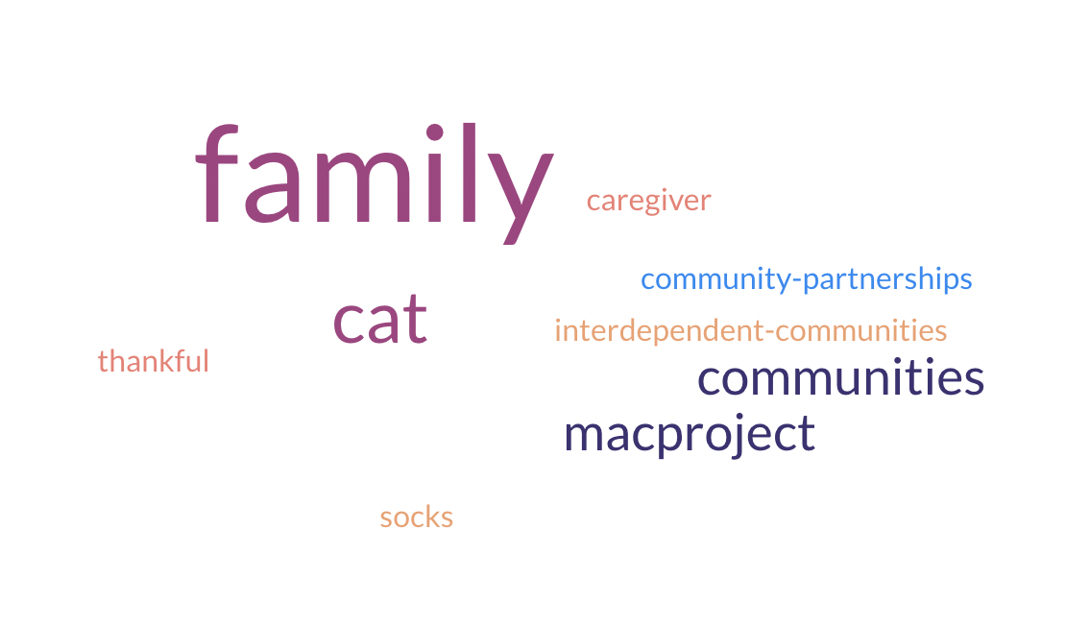

The meeting resulted in the following next steps:

* Participants will share how they prefer to be listed in meeting notes
* Participants will fill out the end of Post-Meeting Reflection
* Haylee will share meeting recording and notes with the group