# MAC Brainstorming Sessions

Meeting 3: May 8, 2024

## Welcome and Introductions

Erin McGaffigan (Collective Insight) reintroduced herself to the group as today’s facilitator. Erin welcomed the group and went through the Meeting Guidelines.

Haylee (Collective Insight) took some time to reflect on feedback provided through the Post-Meeting Survey, which included:

-Consider break out groups

-Clarify if people know what words mean by raising hands (physical or virtual)

-Type in chat if people need to temporarily move off camera

-Reshare the Google Drive link to access materials ahead of meetings

-Consider ideas for specific facilitation questions

Haylee shared with the group that this feedback will inform our addition of a new meeting guideline, which will be to check in with the group around understanding certain concepts before moving ahead. Haylee and Erin also shared that we have not used Break Out Groups due to the size of the group and the ability to create a space within this size to share freely. Erin invited participants to share where they think conversations would be better suited to host Break Out Groups as we walk through meeting discussions.

Participants shared their names and pronouns. Participants also shared their answer to the question “What does engagement mean to you?” Haylee used the participants’ answers to create a world cloud visual, which was shared at the end of the meeting.

## Confirming What We Heard in the Last Meeting

Erin reviewed the purpose of the Brainstorming Sessions, which is to engage communities to develop strategies for getting diverse MassHealth members to apply for the MAC.

The group has had many fruitful conversations over the past 2 meetings about the MAC approach and potential MAC representation. So far, we have learned that the MAC approach should encourage diverse experiences and recognize intersectionality. The focus of Meeting 3 is to take our learnings from Meetings 1 and 2 and apply them to outreach. We are looking to understand “who” to outreach to and “how” to outreach to them.

Last week, Heather offered an overview of potential perspectives to consider, including MassHealth Members and guardians and family members of current or previous Members, who reflect the diverse ages, cultural, linguistic, community, racial, ethnic, health, disability, sexual orientation and gender identities, experiences, geographical communities, and program participation of the MassHealth population. During Meeting 2, participants also highlighted that MAC Members should include the following experiences:

* Community and facility settings
* Various MassHealth programs
* Various points of transition
* Caregiving status
* Neurodiversity

Erin asked the group to indicate who we are still missing in this list. Participants shared various examples, including:

* People who are covered by MassHealth, but not yet represented
* Unhoused communities
* Previously incarcerated individuals
* People who do not have long-term Massachusetts residence
* Dual Eligible (eligible for both MassHealth and Medicare) individuals
* Individuals dually eligible for more than one service program (e.g., Mental Health and Aging)
* Veterans
* Individuals with foster care experience, including group adult foster care, youth foster care, and aging out of foster care
* Individuals with various geographic locations along the state border
* Individuals turning 65 years old transitioning into aging programs
* Individuals accessing rural providers
* Individuals from Indigenous Nations
* Individuals with Intellectual Disabilities and Developmental Disabilities
* Individuals with non-apparent disabilities
* Individuals accessing dental care
* Individuals accessing assisted living

## MAC Outreach Strategy Discussion

The group discussed MAC outreach, including the obstacles to successful outreach, lessons learned from previous outreach experiences, and potential solutions and partnerships to make outreach work. Participants provided the following points:

### Obstacles to effective engagement

* Participants noted several ways technology may challenge successful engagement, such as:
  + Excluding people who don’t have access to the internet or a device
  + Excluding people who don’t have the technological literacy to effectively access the internet or use their device
  + Excluding people who can’t or don’t regularly check their emails
* Participants highlighted that outreach may fall flat for people because they don’t feel like the right person or do not believe that MassHealth or advisory councils, generally, are for them. Eligible people may self-select out of outreach before they learn more.
* Participants emphasized that there is stigma attached to the image and reputation of MassHealth, which may create a barrier for people to benefit from outreach. MassHealth must tackle these issues head on, such as:
  + Perception that MassHealth is difficult to reach by phone
    - Participants noted that phone calls can only be made on weekdays during business hours, which increases difficulty
  + Perception that MassHealth website is difficult to navigate
  + Perception that MassHealth and its advisory structures are all red tape and bureaucracy
* Participants noted that maintaining consistent and continual outreach can be difficult as people’s contact information may change
* Participants noted that many MassHealth members cannot travel or leave the house, which poses a barrier to reaching them through traditional outreach methods
* Participants emphasized existing accessibility issues with current MassHealth outreach, such as:
  + Connecting with assistance over the phone can be difficult for Deaf and hard of hearing people when call center staff have accents or when calls use artificial intelligence (AI) bots to answer phone calls as these bots often do not recognize deaf people’s voices

### Solutions to make outreach work well

* Participants suggested meeting people where they already are through strategies such as:
  + Collaborating with navigators to share outreach information during in person and virtual medical encounters
  + Joining community events, such as street festivals or business fairs
  + Outreaching at places of worship
  + Tabling at pride parades to reach LGBTQ+ communities
* Participants recommended regular outreach through multiple modalities, including:
  + Public forums
  + Community centers
  + Digital ads, including on the MassHealth website
  + The side of buses
  + Radio commercials
  + TV commercials
  + Free Streaming services ads
* Participants stressed the need to prioritize accessibility by:
  + Making calls possible through the website
  + Providing closed captioning for remote calls (for example, Zoom meetings)
  + Providing support at all in person outreach, such as helping folks navigate to the room where a meeting is being hosted
  + Providing outreach in multiple languages
  + Using the fewest technical options possible to avoid alienating people with lower technological literacy or access
* Participants highlighted continuous outreach, which is made easier by collecting information about multiple ways to contact people
* Participants suggested designing flexible programs that may be less intimidating to people during outreach, such as:
  + Creating an additional, compensated committee that provides recommendations but does not require live meetings
  + Engaging a group of partners that can bridge the gap between MAC brainstorming and implementation
* Participants recommended continued collaboration with partners to improve outreach and address obstacles
  + Participants noted that working with a wide range of partners ensures outreach is informed by and benefits from an array of lived experiences
  + Participants noted that ‘word of mouth’ is a critical part of outreach that can be initiated by community partners
    - Participants also noted that community partners are often well versed in accessible outreach and will use culturally reflective language to discuss the MAC
  + Participants pointed out that MassHealth already has numerous partnerships that can help reach people whose contact information may have changed, such as the Department of Transportation, Department of Housing and Urban Development, and the Social Security Administration

### Partners to engage to improve outreach

* Participants recommended tapping existing partners in the outreach process, including:
  + MassHealth help lines, such as 211, 511, and 988 (the substance abuse helpline)
  + Health plans, such as Mass General Brigham, WellSense, and Tufts
  + Partners that assist with the MassHealth renewal process
  + Existing committees, like consumer advisory boards
* Participants suggested additional community partners for outreach, including:
  + The Assistive Technology Center
  + Non-profits
  + Hiring agencies
  + Housing companies and apartment complexes
  + Tour guides
  + Local history groups
  + Food pantries
  + Travel agencies
  + Senior centers/aging centers
  + Disability advocacy groups & centers
  + Community Service Organizations (CSOs)
  + Town governments
  + Town newspapers
  + Accountable Care Organizations (ACOs)
  + Behavioral Health Community Partners (CP) Program
  + Independent living centers
  + Domestic violence shelters
  + Sexual health clinics
  + Charities that help people gain US citizenship
  + Community centers

### Strategies for effective messaging

* Participants recommended using outreach messaging that centers the MAC in the broader context of improving health within the state to address stigma
* Participants noted that engaging communities often left out, such as indigenous peoples, may demonstrate MassHealth’s commitment to an effective and just group
* Participants suggested creating fun and catchy hooks to grab people’s attention, such as the example of “a big MAC”
* Participants suggested looking to successful messaging from other outreach campaigns
  + A participant highlighted outreach from the Massachusetts Commission on Discrimination as a good example of outreach and messaging that made them feel comfortable

### Essential elements to include in outreach content

* Emphasize the opportunities to make change by joining the MAC
* Detail how members feedback will be used
* Emphasize the availability of accommodations, including support for translational and interpretation services
* Provide logistical information, such as
  + In person, hybrid, or virtual meeting status
  + Time commitment requirements
  + Amount of human interactivity
  + Compensation details
* Ensure accessing information or application is easy. For instance, use QR codes

## Wrap Up and Closing

To close the meeting, Erin thanked the group and Haylee reviewed themes shared. Erin reviewed the purpose of the next meeting, which is to finish the outreach discussion. Additionally, Haylee shared the word cloud capturing “what engagement means to me:”

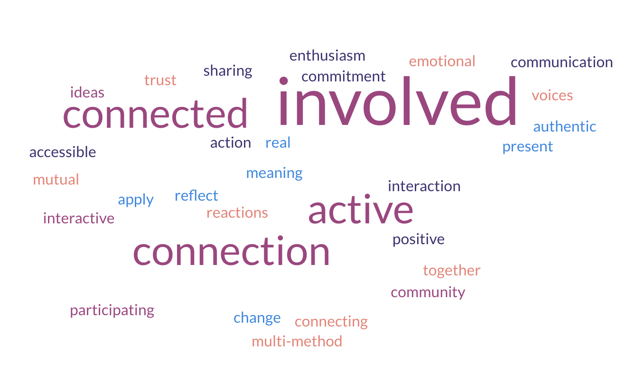

The meeting resulted in the following next steps:

* Participants will fill out the Post-Meeting Survey
* Haylee will share the meeting notes
* Haylee will follow up with Marc about accessibility questions for the Assistive Technology Center