# Meeting 1: Introduction, MAC Purpose and Considerations​

# Friday, April 26th, 2024​

Brainstorming Sessions

MassHealth Member Advisory Committee (MAC)​

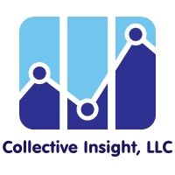

## Welcome!

## Agenda

1. Welcome and Introductions​
2. Brainstorming Sessions Overview​
3. Break
4. Group Discussion​
5. Wrap Up and Closing​

## Meeting Guidelines

* Provide the information and support needed for all to engage.​
* Ensure space for all to contribute.​
* Avoid jargon and acronyms (or spell them out first).​
* Recognize all opinions matter and there are no right or wrong answers.​
* Actively listen and limit outside distractions.
* Arrive on time and keep cameras on as much as possible.​
* Provide space for breaks and take breaks when needed.​
* Share your thoughts while also leaving time for others’ ideas.​
* Adhere to meeting agendas and try to stay on topic.​
* Protect everyone’s personal information and shared experiences.

Meet the GroupA map of Massachusetts with red pins to represent where Brainstorming Session participants live in the state


## Tell Us About Yourself

* Name
* Pronouns
* What Are You Most Thankful For?

## Meeting Logistics

* Note Taking Practice​
* Meeting Etiquette​
* Zoom Tutorial​
* Any Questions?

## Overview

### What is a Member Advisory Committee?

* Advisory committee formed by the state Medicaid office after a formal selection process
* Consists of Medicaid beneficiaries with a wide range of Medicaid experiences
* Partners with Medicaid state agency staff to improve members’ access to and experience with Medicaid
* Goal is to ultimately improve health care

## Overview

### MassHealth MAC Formation

* To improve quality and access to care for MassHealth members
* Desire to understand MassHealth member experiences with the program
* Address inequities
* Eliminate disparities in health and healthcare
* Core value of the agency

## Overview

### What are Brainstorming Sessions?​

* Informal short-term meetings to guide development of the MAC​
* Consists of diverse Massachusetts residents who expressed interest in getting involved with development of the MAC​
* To engage Massachusetts communities in sharing their ideas for the development of the MAC based on their own unique life experiences

## Overview

### What Are We Doing Together?

* About 5 to 6 meetings, 60 to 120 minutes through the months of April and May 2024​
* Consists of respondents who expressed interest in creating and reviewing materials and who have lived experience related to MassHealth as well as facilitators from Collective Insight and MassHealth staff​
* To learn about best practices to ensure that MAC materials that are accessible, understandable, culturally relevant, person-centered

## Overview

### You Will Be Working On

* Accessible, understandable, and culturally relevant materials ​
* MAC Approach (such as ideas for number, location, time of meetings; frequency of meeting; accommodations)​
* MAC Outreach Materials​
* MAC Outreach Materials Messaging

## Meeting Calendar

* Meeting 1
  + Focus: Introduction, MAC Purpose and Considerations​
  + Date: Friday, April 26th, 2024
  + Time: 11:00-1:00pm
* Meeting 2
  + Focus: MAC Approach
  + Date: Wednesday, May 1st, 2024
  + Time: 12:00-2:00pm
* Meeting 3
  + Focus: Outreach Materials
  + Date: Wednesday, May 8th
  + Time: 12:00-2:00pm
* Meeting 4
  + Focus: MAC Outreach Planning
  + Date: Wednesday, May 15th
  + Time: 12:00-2:00pm
* Meeting 5
  + Focus: Bringing It All Together
  + Date: Wednesday, May 22nd
  + Time: 12:00-2:00pm
* Meeting 6
  + Focus: Recap and Next Steps
  + Date: Wednesday, May 29th
  + Time: 12:00-2:00pm

## Meeting Calendar

### Insight on Meeting 6

* Celebrate our progress​
* Discuss additional insights​
* Hear about next steps

## Think About a Time You Applied for Something

* What do you remember about the process?​
* What was challenging?​
* What would have made it easier?

## FIVE MINUTE BREAK

## Group Discussion

* What is important to know about a MAC to apply?​
* What is important to learn about members who apply?​
* How do we make the process accessible to all communities?

## Wrap Up and Closing

* Summary of Key Learnings​
* Expectations for Next Meeting​
* Questions?

## What are you thankful for?

* Family
* Cat
* For being thankful
* Caregiver
* Community partnerships
* Interdependent communities
* This MAC project
* Communities
* My child putting on socks today

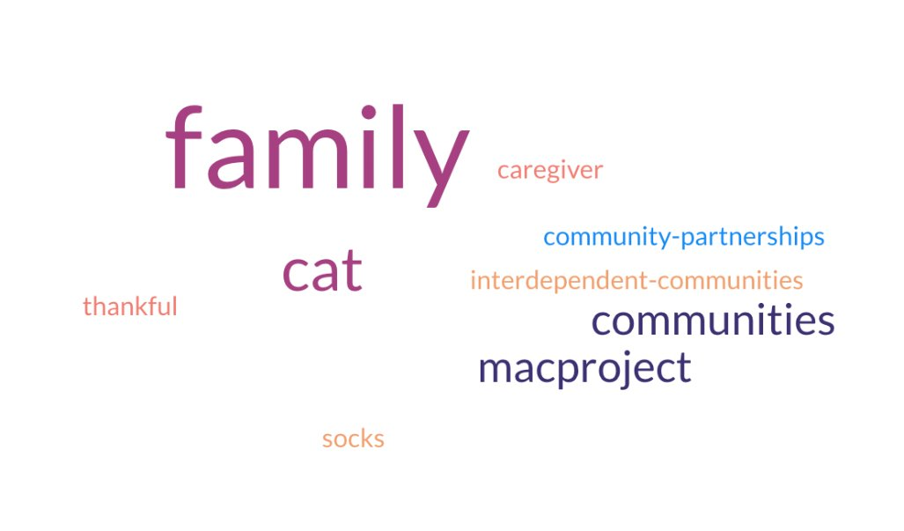

## Thank you!​

## See you on May 1st!

## Post Meeting Survey

4 questions