## Meeting 4: Outreach Continued​

## Wednesday, May 15th, 2024​

Brainstorming Sessions

MassHealth Member Advisory Committee (MAC)​



## Welcome!

## Agenda

1. Welcome, Check In, Recap​
2. Outreach Continued
3. Break
4. Interactive Activity ​
5. Wrap Up and Closing​

## Meeting Guidelines

* Provide the information and support needed for all to engage.​
* ​Ensure space for all to contribute.​
* ​Avoid jargon and acronyms (or spell them out first).​
* ​Recognize all opinions matter and there are no right or wrong answers.​
* ​Actively listen and limit outside distractions.​
* ​Build trust in increments.
* Arrive on time and keep cameras on as much as possible.​
* ​Provide space for breaks and take breaks when needed.​
* ​Share your thoughts while also leaving time for others’ ideas.​
* ​Adhere to meeting agendas and try to stay on topic.​
* Protect everyone’s personal information and shared experiences.
* Check in with the group about their understanding of concepts with a show of hands.

## Feedback Provided

* Add more slide subtitles​
* Consider interactive activity​
* ​Peel back the "onion" of outreach and engagement

## Checking In!

* Name
* Pronouns
* What does “cultural relevance” mean to you?

## Last Week We Talked About

* Desired MAC Participation​
* Outreach Obstacles​
* Outreach Lessons Learned​
* Outreach Partnerships for Success​
* Messaging Strategies and Content

## Where We Started

### Various Programs​

* Standard MassHealth​
* Integrated Care​
* Senior Care Options​
* OneCare​
* Personal Care Attendant Program​
* Frail Elder Waiver​
* Limited MassHealth​
* Traumatic Brain Injury Programs

### Community & Facility Settings​

* home with supports​
* supportive living​
* long-term care facilities​
* K-12 schools​
* college campuses​
* hospitals​
* memory care

### Geography​

* county​
* urban​
* rural​
* data-driven

## Where We Went

### Various Programs​

* Standard MassHealth​
* Integrated Care​
* Senior Care Options​
* OneCare​
* Personal Care Attendant Program​
* Frail Elder Waiver​
* Limited MassHealth​
* Traumatic Brain Injury Programs ​
* Covered but not represented​
* Dual Eligible

### Community & Facility Settings​

* home with supports​
* supportive living​
* long-term care facilities​
* K-12 schools​
* college campuses​
* hospitals​
* memory care​
* assisted living​
* group adult foster care

## Where We Went

### Geography​

* county​
* urban​
* rural​
* data-driven​
* along state borders​
* non-permanent Massachusetts residence

### Older Adults​

* 65+ transitioning programs​
* Veterans​

### Youth/Young Adults​

* foster care

## Partnerships For Success

* Assistive Technology Center
* Non-profits
* Disability Advocacy Orgs
* Community Service Organizations​
* Behavioral Health Community Partners Program
* Independent Living Centers
* Community Centers
* Hiring Agencies​
* Local History Groups
* Food Pantries
* Senior Centers/Aging Centers
* Accountable Care Organizations
* Sexual Health Clinics​
* Domestic Violence Shelters
* Housing & Apartment Complexes​
* Tour Guides
* Travel Agencies​
* Town Government​
* Town Newspaper
* Charities for US Citizenship​

## Think About Your Community Allies

* Who are they?​
* How can we reach them?​
* Where are they?​

## Outreach at the Edges of the State

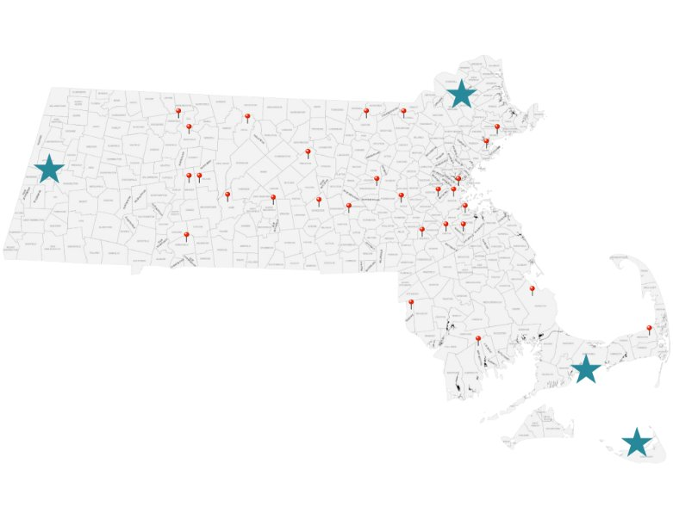

What locations must we reach?​

​How can we reach the starred areas of the state?

## LET’S BREAK

## Messaging

* Think about how you would develop messaging for the MAC​
* ​Group activity to develop a sample of MAC Outreach media​
* ​To access the Jamboard, go to <https://jamboard.google.com/d/17zPkWw6TONP-wcQ7MIIhXwEvMx6mX4iKG9fRTwvjRQo/edit?usp=sharing>.

### Activity Instructions​

* **​**Go over "Jamboard" features​
* Use the link in the chat to see the "Jamboard"​
* Auto-assign to a Zoom Break Out Room Make sure to note your group number! ​
* Work together for 15 minutes to brainstorm outreach media on the slide with your group ​
* Select one group member to share your brainstorming with the whole group​
* Haylee will share her screen to show what you created

## Implementing the MAC

* What needs to be communicated to ensure potential members and MAC members feel supported?​
* What would make you feel informed and confident?

## Wrap Up and Closing

* Plan for Next Meeting​
* Any Questions?

## Thank you!​

## See you on May 22nd

## Post Meeting Survey

4 questions