# Meeting 3: Outreach Materials​

# Wednesday, May 8th, 2024​

Brainstorming Sessions

MassHealth Member Advisory Committee (MAC)​



## Welcome!

## Agenda

1. Welcome, Check In, Recap​
2. Outreach Communities ​
3. BREAK​
4. Outreach Challenges & Solutions​
5. Wrap Up and Closing​

## Meeting Guidelines

* Provide the information and support needed for all to engage.​
* Ensure space for all to contribute.​
* Avoid jargon and acronyms (or spell them out first).​
* Recognize all opinions matter and there are no right or wrong answers.​
* Actively listen and limit outside distractions.​
* Build trust in increments.
* Arrive on time and keep cameras on as much as possible.​
* Provide space for breaks and take breaks when needed.​
* Share your thoughts while also leaving time for others’ ideas.​
* Adhere to meeting agendas and try to stay on topic.​
* Protect everyone’s personal information and shared experiences.

## Feedback Provided

* Consider break out groups
* Clarify if people know what words mean by raising hands (physical or virtual) ​
* Type in chat if people need to temporarily move off camera​
* Reshare the Google Drive link to access materials ahead of meetings​
* Consider ideas for specific facilitation questions

## Checking In!

* Name
* Pronouns
* What Does Engagement Mean to You?

## What Are We Learning?

### MAC Approach

* MAC Meetings
* MAC Members

## Outreach Focus Areas

* Who
* How

## What experiences and perspectives are needed for a meaningful MAC?

We heard the goal is diverse experiences and recognition of intersectionality.​

## Where We Started

* age​
* culture​
* language spoken​
* racial and ethnic identity​
* health status​
* disability​
* sexuality​
* gender identity

## What We Heard

* community and facility settings​
* various MassHealth programs​
* various points of transition​
* caregiving status​
* neuro-​diversity

Can you think of two more?

Why those two?

## And We Heard This

### Various Programs​

* Standard MassHealth​
* Integrated Care​
* Senior Care Options​
* OneCare​
* Personal Care Attendant Program​
* Frail Elder Waiver​
* Limited MassHealth​
* Traumatic Brain Injury Programs

### Community & Facility Settings​

* home with supports​
* supportive living​
* long-term care facilities​
* K-12 schools​
* college campuses​
* hospitals​
* memory care

### Geography​

* county​
* urban​
* rural​
* data-driven

Can you think of two more?​

​

Why those two?

## Let’s Break

## MAC Outreach: The “How”

* Obstacles​
* Lessons Learned​
* Solutions​
* Partners​

## MAC Outreach: The “How”

* Messaging​
* Content​
* Accessibility​

How would you want to hear about the MAC?

Where would you want to hear about it?

## What Does Engagement Mean to You?

* Connection/Connection
* Involved
* Active
* Ideas
* Accessible
* Mutual
* Interactive/Interaction
* Apply
* Reflect
* Reactions
* Sharing
* Trust
* Enthusiasm
* Commitment
* Emotional
* Communication
* Voices
* Authentic
* Present
* Action
* Real
* Participating
* Change
* Multi-method
* Positive
* Community
* Together

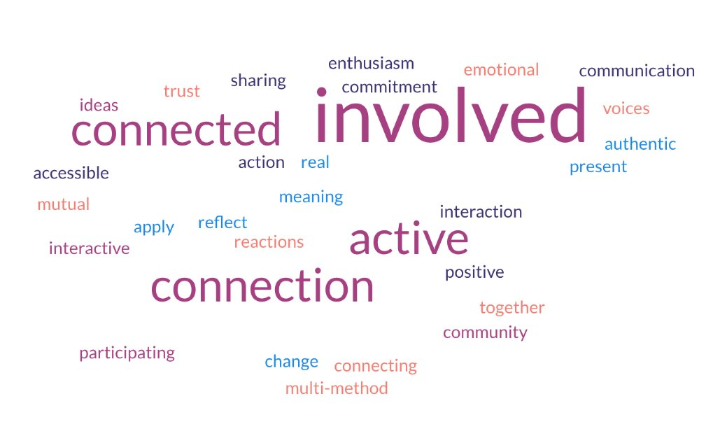

## Wrap Up and Closing

* Key Learnings​
* ​Plans for Next Meeting​
* ​Any Questions?​

## Thank you!​

## See you on May 15th!

## Post Meeting Survey

4 questions