# MAC Brainstorming Sessions

Activity 2

Meeting 1: May 2, 2024 Afternoon Session

## Welcome and Introductions

Heather Johnson, the meeting facilitator, walked the group through the agenda and meeting guidelines.

The meeting included participants from diverse locations across Massachusetts with experience using MassHealth services, supporting someone to use these services, or providing health care services. Participants shared their names and pronouns. As an ice breaker, participants also shared something they were feeling thankful for. Haylee Denham, Project Manager with Collective Insight, used the participants’ answers to the icebreaker to create a world cloud visual shared at the end of the meeting.

Haylee also reviewed meeting logistics. This included Zoom features as well as the note taking and follow up process. Following the meeting, participants will share how they prefer to be listed in meeting notes with Haylee.

## Brainstorming Session Overview

Heather, Keith Jones, and the MassHealth staff provided an overview of the Brainstorming Session purpose and goals.

As noted in the [Brainstorming Sessions Invitation,](https://drive.google.com/file/d/1JuRMB65Ei76wX6dUs9bSU07AtHKwQIwd/view?usp=sharing) this group will meet four times to inform the development of a MassHealth Member Advisory Committee (MAC). The group reviewed the purpose of the MAC and why MassHealth wants to develop a MAC.

### What is a Member Advisory Committee (MAC)?

* Formal committee gathered by a state Medicaid office after a selection process​
* A MAC is made up of Medicaid beneficiaries and state Medicaid staff​
* The goal of a MAC is to improve member experience with Medicaid and ultimately improve health care​

### Why does MassHealth want to develop a MAC?

MassHealth team members highlighted the need to collaborate with and hear directly from MassHealth members to:

* Learn about their experiences with MassHealth programs
* Share information and improve transparency around MassHealth programs
* Create a space to discuss MassHealth and members’ priorities for programs
* To improve quality and access to care for MassHealth members

### Goals for Brainstorming Workgroup

The workgroup brings together members with diverse lenses and unique life experiences into discussion to:

* Identify communities commonly left out of outreach and ways to effectively reach communities to share MAC Application
* Identifying common pitfalls and share lessons learned
* Map existing community assets
* Inform development of an Outreach Plan

## Group Discussion About Outreach and Recruitment

The group discussed the experiences and perspectives necessary to build a meaningful MAC. Heather offered an overview of potential perspectives to consider, including guardians, family members or caregivers of current or previous Members, who reflect the diverse ages, cultural, linguistic, community, racial, ethnic, health, disability, sexual orientation and gender identities, experiences, geographical communities, and program participation of the MassHealth population. Participants highlighted the following perspectives to include:

* Participants highlighted the importance of intentional representation that focuses less on checking boxes or filling certain categories and more on including a diverse range of perspectives
  + Participants noted that people who may identify similarly in one sense, such as their racial or ethnic identity, may have vastly different experiences in other ways
  + Participants stressed prioritizing intersectionality
* Participants recommended reaching members that already fall through the cracks and do not receive care regularly
  + Participants also highlighted members that are afraid to seek care
* Participants identified several underserved lenses that are important to hear from, including
  + Children and adults with mental health needs
  + People with past or current experiences with homelessness
  + People who don’t have access to computers or cannot use them
  + People who are struggling to access internet and PCP
  + People with low literacy levels
  + People with different kinds of communication needs
    - A participant noted that this may include deaf and hard of hearing members, members that need less text and more visual info, and members whose primary language is not English
* A participant recommended including members that use MassHealth as a primary source of health care as well as those who use it in a secondary capacity

The group also discussed pitfalls and lessons learned from outreach that should be accounted for in this process, including:

* Participants identified accommodation barriers that prevent participation, such as
  + Financial barriers
  + Technological barriers, including to video calls as well as dialing into meetings due to limited data plans and the expense
  + Transportation barriers
    - A participant pointed out that PT1, the system for MassHealth members to request transportation to medical appointments often hinders rather than helps transportation access
  + Fear and hesitancy around health care
    - Participants noted that fear and hesitancy can arise due to a member's immigration status, struggles with addiction, history with incarceration. These fears can be exacerbated when health care situations ask for unnecessary personal information such as their home address or social security number
    - Participants also noted that fear of being labeled as difficult also contributes
    - A participant highlighted the fear that medications or treatments will be pushed onto patients leading to avoidance
    - A participant noted the need for training for providers to improve these issues and create a safer space in healthcare settings
* Participants also highlighted pitfalls within the existing MassHealth communication channels, including:
  + Extremely long phone calls and wait times
  + Overly complex paperwork
  + Lack of communication about where to access help with paperwork
  + The process of being shunted to provider to provider to get the info or care needed
  + Disconnect between different types of healthcare systems and failure to share records between them

The group also discussed examples of successful outreach strategies, such as:

* Participants noted the need to create safe spaces and highlighted strategies for doing so, including:
  + Ensuring members understand meeting norms, including that their opinions and experience will be met with respect
  + Taking a person-centered approach that understands that each member is different, even if they share identities with other members
  + Account for lessons learned during the COVID-19 pandemic, including collaborating with trusted doctors and healthcare workers from hesitant communities, recognizing community fears and historical harm, and avoiding asking for unnecessary information
* Participants recommended providing a range of meaningful accommodations
  + For instance, a participant highlighted how providing resources in text form to those who use American Sign Language (ASL) may not be sufficient as ASL may not translate directly to English
* Participants suggested strategies for collaborating with community partners, including:
  + Working with already trusted community partners to further reach communities
    - Consider how community leaders can advocate for people who may not have enough information to understand the benefits of receiving care or engaging with MassHealth
  + Introducing community partners to resources and organizations already in place to assist with MassHealth that may not yet be well known
* Participants stressed the need to work with family units and communities as a whole and meeting those communities where they already are, such as:
  + Schools
  + Pediatrician offices
  + Churches and places of worship
    - A participant noted that these spaces may be particularly useful for reaching non-English speakers and immigrants
  + Medical fairs
  + YMCA programs, such as those for families at risk
  + Laundromats
  + Bodegas
  + Corner stores
  + Aging service access points
  + Community centers
  + Senior centers
  + Working with community health workers
  + Mobile care clinics, such as that exemplified by the organization, Bridge Over Troubled Water, in Boston
* Participants recommended taking a multi-pronged approach that is both top-down and bottom-up

## Wrap Up and Closing

To close the meeting, Heather highlighted the opportunity for continued conversation at upcoming meetings. Additionally, Haylee shared the word cloud visual capturing what participants shared they were grateful for, pictured here:

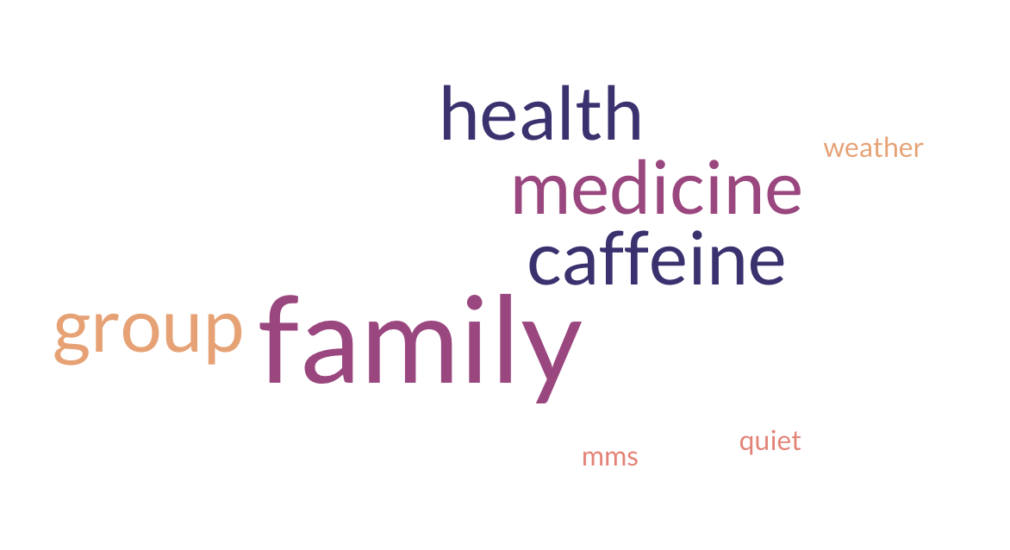

The meeting resulted in the following next steps:

* Participants will share their preferred meeting time with Haylee
* Participants will share their preference for how their name is listed in the notes with Haylee
* Participants will share their preferences for gift cards with Haylee
* Participants will fill out the meeting evaluation survey
* Haylee will share the meeting notes