# MAC Brainstorming Sessions

Activity 2

Meeting 2 May 9th: Afternoon Session

## Welcome and Introductions

Heather walked the group through the agenda and meeting guidelines. Heather highlighted feedback from participants to improve the Brainstorming sessions, such as utilizing breakout groups and/or increasing session length. Heather also shared participants’ responses to what they learned including the importance of communication and the collective vision the group has for working towards solutions together.

Participants shared their names and pronouns. As an ice breaker, participants also shared what engagement means to them. Haylee used the participants’ answers to the icebreaker question to create a world cloud visual shared at the end of the meeting.

Haylee also reviewed meeting logistics. This included Zoom features as well as the note taking and follow up process. Following the meeting, participants will share how they prefer to be listed in meeting notes with Haylee.

## Overview of Asset Mapping

Heather provided an overview of Asset Mapping, a process which uses brainstorming discussions to identify the following key elements or “assets:”

* Engagement already happening​
* Communities at risk of being left out​
* Obstacles to engagement ​
* Solutions and partners for success​

The Asset Mapping process allows these assets to be displayed visually so the group may confirm and build upon it further. Keith also noted that Asset Mapping may help us translate our thinking around outreach into language that makes sense for the communities we need to reach. It can also help us identify individuals with on the ground connections to those communities.

## Building Upon the Asset Map

The group reviewed an initial Asset Map, which was developed based upon input shared in the previous meeting. The Map includes several pages outlining participant feedback for MAC outreach, including experiences and perspectives critical to include in the MAC, obstacles and lessons learned for outreach, and target communities and partners for outreach.

## Experiences and Perspectives to Include in the MAC

The group reviewed the first page of the Map, which includes three sections:

* Services, such as mental health services
* Programs, such as members who have MassHealth as Secondary insurance
* Geography, such as urban and rural spaces

Participants provided potential additions and updates to this page of the Map, including:

* Adding the following programs
  + Prescriptions/medications
  + Dental care
  + Vision
* Adding the following services
  + Food services
  + Housing services
  + Other social determinants of health-related services
  + Home and Community-Based Services (HCBS)
  + Nursing facilities
* Moving Personal Care Attendants (PCA) into the service category
* Making note of additional waiver programs beyond those listed
* Highlighting integrated care generally

## Outreach Obstacles and Lessons Learned

Participants provided additional details around outreach obstacles, such as:

* Burdens around MassHealth and healthcare generally may create an obstacle to outreach. For instance:
  + Many MassHealth members experience a high care coordination burden, making it difficult for members and/or parents or caregivers of members to engage in the MAC
  + In the autism community, there are a lack of providers for essential services that accept MassHealth, which creates an additional burden
  + Many people, especially Black communities, experience racism within the healthcare system. This must be accounted for in outreach.
* Reputation of MassHealth may pose a barrier to successful outreach
  + Insurance coverage can be easy to lose, which may create distrust or worsen burdens and burnout
  + People associate calling MassHealth with long hold times, which may prevent people from reaching out
    - Partner organizations may feel uncomfortable sharing outreach materials with MassHealth numbers if they know hold times will be too long
    - Long hold times may disproportionally impact people with pay-as-they-go phone plans
  + Healthcare is generally not fun or engaging
* Communication and literacy barriers related to disability or cultural needs
  + A participant highlighted how many people who speak a language cannot read in that language, which must be accounted for in outreach
* Varying comfortability with technology may create challenges to outreach
  + A participant noted that [COMMBUYS](https://www.bing.com/ck/a?!&&p=2caf8902ba333b1fJmltdHM9MTcxNTgxNzYwMCZpZ3VpZD0xZTU3Y2I2My00M2I2LTZmOTQtMjQ5Mi1kODVlNDI2ZTZlNWMmaW5zaWQ9NTIxMQ&ptn=3&ver=2&hsh=3&fclid=1e57cb63-43b6-6f94-2492-d85e426e6e5c&psq=commbuys&u=a1aHR0cHM6Ly93d3cuY29tbWJ1eXMuY29tL2Jzby8&ntb=1) is challenging to navigate and often uses more words than are necessary
  + Participants discussed the need to take a multi-pronged approach to technology by balancing use of Facebook and other social medias with on the ground tactics

Participants also provided additional outreach lessons learned, such as:

* Utilize “boots on the ground” outreach tactics including mobile health vans and community-based organizations already embedded in the community
* Make messaging around health care more fun by providing toys or snacks to children or providing swag with consistent messaging
* Prioritize equitable funding and payment for frontline workers
* Support partners helping to spread the word
  + A participant recommended reducing any workload associated with MAC outreach by making materials simple and accessible as well as providing any training on how to conduct outreach
  + A participant recommended providing partners with the resources to build upon existing outreach and update materials to match the needs of the communities they serve
* Use local tv and radio stations, including those in languages other than English, to reach immigrant communities
* Add QR codes to flyers and other materials

## Partnerships for Successful Outreach

The group reviewed several asset map pages which provided an overview of target populations and the potential partners identified in previous meetings that may aid in reaching the communities. Heather asked the group to consider additional partners that may still be missing from the Map, including trusted community partners that connect directly with MassHealth Members. Participants provided the following suggestions:

Additional Partners for Reaching the Disability community:

* Special Education Parent Advisory Councils (SEPACs)
* The Federation for Children with Special Needs (FCSN)
* Mass Advocates for Children
* Special education departments in local schools
* Black Autism Coalition
* Somali Parents Advocacy Center for Education (SPACE)
* National Parents Union

Additional Partners for Reaching Older Adults:

* Elder Stakeholders’ Group, a group convened by AARP, which includes partners in nursing homes, assisted living, and home and community-based services

Additional Partners for Reaching Immigrant Communities:

* Local social clubs
* The Embassy
* Local celebrations
* School resource fairs
* International exchange student hosts
* English as a second language classes
* Citizenship classes

Participants also highlighted types of partners that may be useful in reaching a range of target communities, including:

* Alcoholics Anonymous
* School nurse offices
* Mobile Bus for care in community settings
* Health Care for All
* Legal services and advocates
* Mutual aid groups
* Advocates
* Pharmacies
* MBTA (bus system)
* Childrens Behavioral Health Initiative providers
* Churches
* Housing department offices
* After school programs
* Hospitals
* Nail salons
* Local Chamber of Commerce offices
* Primary care offices
* Organized shopping caravans that bring groups to stores during special discount times (by age or veteran status)
* United States Postal Service
* Technical schools
* College internship programs

Additionally, participants noted specific community organizations known to conduct community events, workshops, or canvasing. These organizations are attuned to community needs and connected to boots on the ground outreach strategies:

* Brockton Worker's Alliance
* Men of Color Health Awareness (MOCHA)
* The Oral Health Progress & Equity Network (OPEN Network)
* YMCA
* Boys and Girls Clubs
* Greater Boston Food Bank and other similar food banks
* A participant suggested asking the food banks to add outreach materials to the meal boxes that they distribute

A participant recommended adding people at transitional ages as an additional target community.

## Wrap Up and Closing

To close the meeting, Heather and Haylee highlighted key learnings from the discussion and noted that these will be reflected in the Asset Map. Haylee shared the word cloud visual capturing what participants shared they were grateful for, pictured here:

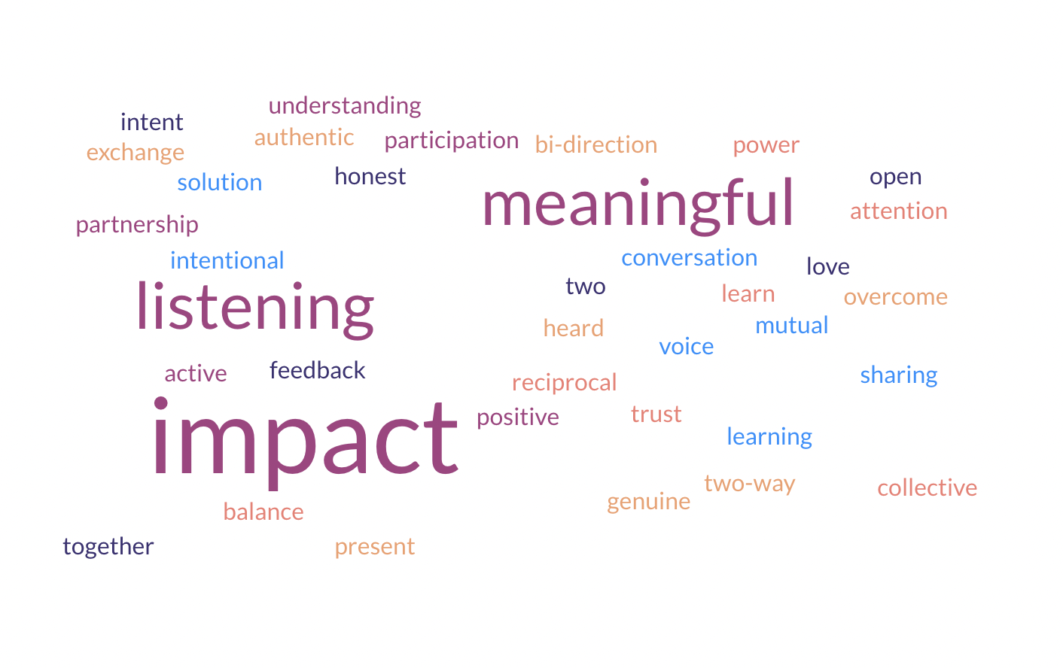

The meeting resulted in the following next steps:

* Participants will fill out the post-meeting survey
* Haylee will incorporate key learnings into the Asset Map
* Haylee will share the meeting notes