# MAC Brainstorming Sessions

Activity 2

Meeting 1: May 2, 2024 Morning Session

## Welcome and Introductions

Heather Johnson, the meeting facilitator, walked the group through the agenda and meeting guidelines.

The meeting included participants from diverse locations across Massachusetts with experience using MassHealth services, supporting someone to use these services, or working within services, such as human services, community health centers, or health law. Participants shared their names and pronouns. As an ice breaker, participants also shared something they were feeling thankful for. Haylee Denham, Project Manager with Collective Insight, used the participants’ answers to the icebreaker to create a world cloud visual shared at the end of the meeting.

Haylee also reviewed meeting logistics. This included Zoom features as well as the note taking and follow up processes. Following the meeting, participants will share how they prefer to be listed in meeting notes with Haylee.

## Brainstorming Session Overview

Heather, Keith Jones, and the MassHealth staff provided an overview of the Brainstorming Session purpose and goals.

As noted in the [Brainstorming Sessions Invitation,](https://drive.google.com/file/d/1JuRMB65Ei76wX6dUs9bSU07AtHKwQIwd/view?usp=sharing) this group will meet four times to inform the development of a MassHealth Member Advisory Committee (MAC). The group reviewed the purpose of the MAC and why MassHealth wants to develop a MAC.

### What is a Member Advisory Committee (MAC)?

* Formal committee gathered by a state Medicaid office after a selection process​
* A MAC is made up of Medicaid beneficiaries and state Medicaid staff​
* The goal of a MAC is to improve member experience with Medicaid and ultimately improve health care​

### Why does MassHealth want to develop a MAC?

MassHealth team members highlighted the need to collaborate with and hear directly from MassHealth members to:

* Learn about their experiences with MassHealth programs
* Share information and improve transparency around MassHealth programs
* Create a space to discuss MassHealth and members’ priorities for programs
* To improve quality and access to care for MassHealth members

#### Goals for Brainstorming Workgroup

The workgroup brings together members with diverse lenses and unique life experiences into the discussion to:

* Identify communities commonly left out of outreach and ways to effectively reach communities to share MAC Application
* Identifying common pitfalls and share lessons learned
* Map existing community assets
* Inform development of an Outreach Plan

## Group Discussion About Outreach and Recruitment

The group discussed the experiences and perspectives necessary to build a meaningful MAC. Heather offered an overview of potential perspectives to consider, including guardians, family members or caregivers of current or previous Members who reflect the diverse ages, cultural, linguistic, community, racial, ethnic, health, disability, sexual orientation and gender identities, experiences, geographical communities, and program participation of the MassHealth population. Participants then highlighted the following perspectives to include:

* Participants suggested including caregivers and family members
  + Participants noted that these individuals bring important perspectives to the table, but that the MAC should be intentional about representation and facilitation to ensure they do not speak over MassHealth members themselves
* Participants highlighted the importance of engaging people with experiences using various MassHealth programs, such as CommonHealth, MassHealth Standard, MassHealth Limited, and Children's Medical Security Plan
* Participants stressed the various challenges associated with accessing and effectively using different MassHealth programs. Participants noted the importance of members bringing a range of experiences with these challenges, such as:
  + Challenges seeking mental health care, particularly for people with cognitive disabilities
  + Challenges receiving necessary care due to limited benefits
* Participants recommended including people that use languages other than English, including American Sign Language (ASL)
* A participant recommended engaging people with previous or current experiences of homelessness
* Participants highlighted the importance of engaging people with various immigration statuses
* A participant suggested including people who need Durable Medical Equipment (DME)
  + DME can be challenging to procure and individuals needing DME represent important perspectives
* Participants also noted the importance of geographical diversity
  + A participant highlighted important gaps experienced in western Massachusetts
  + A participant noted the privileges of some locations, such as Marlborough, due to the easier access to services within a reasonable time frame
* A participant noted the importance of reaching at risk youth, including those aging out of foster care and with complex medical needs

Participants also provided suggestions for reaching underserved populations whose voices are often left out of the engagement process. Participants highlighted an array of community partners to tap as well as key strategies for reaching these groups:

* Participants noted the importance of collaborating with community partners and key community hubs to reach underserved communities, such as
  + Hospitals
  + Schools, including school health programs and school nurses
  + Churches and other places of worship
  + Community and congregate settings
  + Shelters
  + Adult day health programs
  + Meals on Wheels
  + Community health centers and the advocates connected with these organizations
  + Home health workers
  + Rural nurses
  + Municipal health departments, many of which have already done the groundwork to reach people in their region
* Participants also noted specific partners within Massachusetts, including
  + The Personal Care Attendant (PCA) union
  + The statewide network of providers
  + The Office of New Bostonians

The group discussed lessons learned from previous outreach strategies and participants identified important gaps and pitfalls to remain aware of, including:

* Participants noted an outreach gap reaching families with young children with disabilities
  + Participants noted that many families learn about important MassHealth programs when their child is older (10-12 years old).
* Participants cautioned against the overly complex processes for outreach used elsewhere in MassHealth
  + Participants pointed out the complex procurement process being used to reach formerly incarcerated people. Alongside difficulties with the MassHealth website, this process can prevent successful recruitment
  + A participant noted that MassHealth paperwork is generally overwhelming

Participants also highlighted successful outreach strategies to look to, including:

* Participants stressed aligning outreach strategies with target audiences
  + For instance, a participant highlighted how age may impact outreach. Younger folks are more likely to be reached through social media rather than landline lists
  + Participants also highlighted using a range of outreach methods, such as phone, email, and different social media platforms
  + A participant also noted that, in their experience, mail and email surveys still receive a high response rate
  + A participant highlighted the importance of duplicating outreach. For instance, sharing information with people at multiple points of contact
* A participant highlighted the benefits of collaborating with families to conduct outreach. They noted the success of webinars and social media campaigns run by family members that used the [Arc of Indiana](https://www.arcind.org/)
* Participants recommended prioritizing accessibility, including consulting plain language experts and accounting for folks that cannot read or read at a lower level
* A participant noted that outreach must highlight the benefits and opportunity to make a difference by joining a MAC
  + Outreach must overcome feelings of hopelessness, disinterest, and fear of getting involved, feelings which may be common among target communities, including caregivers

## Wrap Up and Closing

To close the meeting, Heather highlighted the opportunity for continued conversation about encouraging people to join a MAC. Additionally, Haylee shared the word cloud visual capturing what participants shared they were grateful for, pictured here:

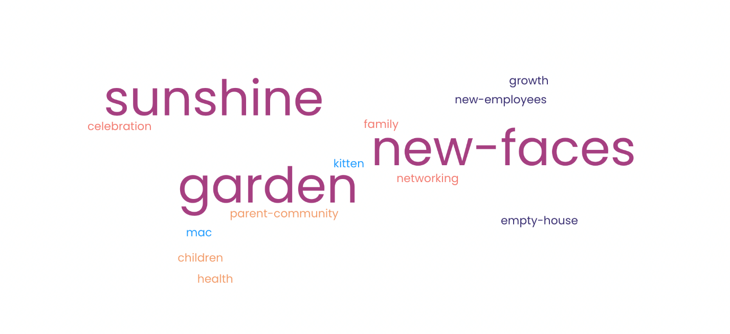

The meeting resulted in the following next steps:

* Participants will share their preference for if and how their names are listed in the notes with Haylee
* Haylee will share meeting notes with participants
* Participants will fill out the Post-Meeting Reflection