# MAC Brainstorming Sessions

Activity 2

Meeting 2 May 9th: Morning Session

## Welcome and Introductions

Heather walked the group through the agenda and meeting guidelines. Heather highlighted feedback from participants to improve the Brainstorming sessions, such as utilizing breakout groups and/or increasing session length. Heather also shared participants’ responses to what they learned including the importance of communication and the collective vision the group has for working towards solutions together.

Participants shared their names and pronouns. As an ice breaker, participants also shared what engagement means to them. Haylee used the participants’ answers to the icebreaker question to create a world cloud visual shared at the end of the meeting.

Heather also provided an overview of what the group has learned through meetings thus far, including:

* Importance of diversity in perspectives and experiences
  + Participants particularly highlighted the importance of intersectionality
* Importance of outreaching to a diverse range of places
  + Participants recommended going beyond typical partners to reach communities often left out of engagement

## Overview of Asset Mapping

Heather provided an overview of Asset Mapping, a process which uses brainstorming discussions to identify the following key elements or “assets:”

* Engagement already happening​
* Communities at risk of being left out​
* Obstacles to engagement ​
* Solutions and partners for success​

The Asset Mapping process allows these assets to be displayed visually so the group may confirm and build upon it further.

## Building Upon the Asset Map

The group reviewed an initial Asset Map, which was developed based upon input shared in the previous meeting. The Map includes several pages outlining participant feedback for MAC outreach, including experiences and perspectives critical to include in the MAC, obstacles and lessons learned for outreach, and target communities and partners for outreach.

### Experiences and Perspectives to Include in the MAC

The group reviewed this first page of the Map, which includes three sections:

* Services, such as mental health services
* Programs, such as members with MassHealth as secondary
* Geography, such as urban and rural spaces

Keith emphasized the need to translate our jargon while reviewing the Asset Map to ensure we are meeting our target communities where they are.

### Outreach Obstacles and Lessons Learned

Participants provided additional details and insights to fill out the Map, such as:

Obstacles to Effective Outreach:

* Lack of knowledge about MassHealth programs, including due to lack of access to or savviness with technology
* Competing priorities, worsened by lack of support for caregivers
* Technological and cost barriers associated with paperwork, such as faxing
* Timing of meetings overlapping with work that cannot be missed
* Reaching Deaf and hard of hearing communities that do not use ASL

Lessons Learned for Effective Outreach:

* Provide translation and interpretation that is culturally relevant
  + This is sometimes called “transcreation”
* Ensure outreach and messaging priorities making members feel valued and heard
* Meet communities where they are
* Ensure outreach and messaging communicates mutual benefits, rather than focusing only on how people will give information to the process
* Consider surveying existing members

### Partnerships for Successful Outreach

The group reviewed several Asset Map pages overviewing target populations and the potential partners identified in previous meetings that will help in reaching communities. Heather asked the group to consider additional partners that may still be missing from the Map, including trusted community partners that connect directly with MassHealth Members. Participants provided the following suggestions:

Additional Partners for Reaching the Disability Community:

* Transportation services, such as school bus drivers
* Community-based day programs and day-habilitation programs
* Medical providers
* Durable Medical Equipment (DME) providers
* Local and chain pharmacies
* Deaf and hard of hearing service providers, such as Deaf, Inc.
* Mass Commission for the Deaf and Hard of Hearing
* Boston Disability Commission
* Department of Mental Health (DMH) Clubhouses
* Independent living centers
* Private Facebook support groups
  + A participant noted that these groups are of utmost importance, but are often difficult to access

Additional Partners for Reaching Older Adults:

* Senior day care centers
* Nursing home resident and family councils
* Ombudsman

Additional Partners for Reaching Rural Communities:

* Rural libraries
* Laundromats
* Community action centers
* Schools
* Grocery stores
* Behavioral health network
* Metro West Nonprofit Network

Additional Partners for Reaching Immigrant Communities:

* Community health centers
* Farms employing seasonal farm workers
* Soccer leagues and other recreational sports leagues

Additional Partners for Reaching Children, Youth, and Families:

* Day care centers
* Homeschooling organizations
* Youth sports leagues and recreation departments

**Participants also identified additional partnerships that may be useful for reaching all target communities, including:**

* Grocery stores
* Shopping malls
* Medical interpreters
* Community based health center
* Peer support specialists
* Farmers markets
* Churches

Participants also highlighted the following outreach strategies:

* Prioritizing word-of-mouth
* Spreading the word through radio states and local cable channels, including those in languages other than English

## Wrap Up and Closing

To close the meeting, Heather and Haylee highlighted key learnings from the discussion and noted that these will be reflected in the Asset Map. Haylee shared the word cloud visual capturing what engagement means to participants, pictured here:

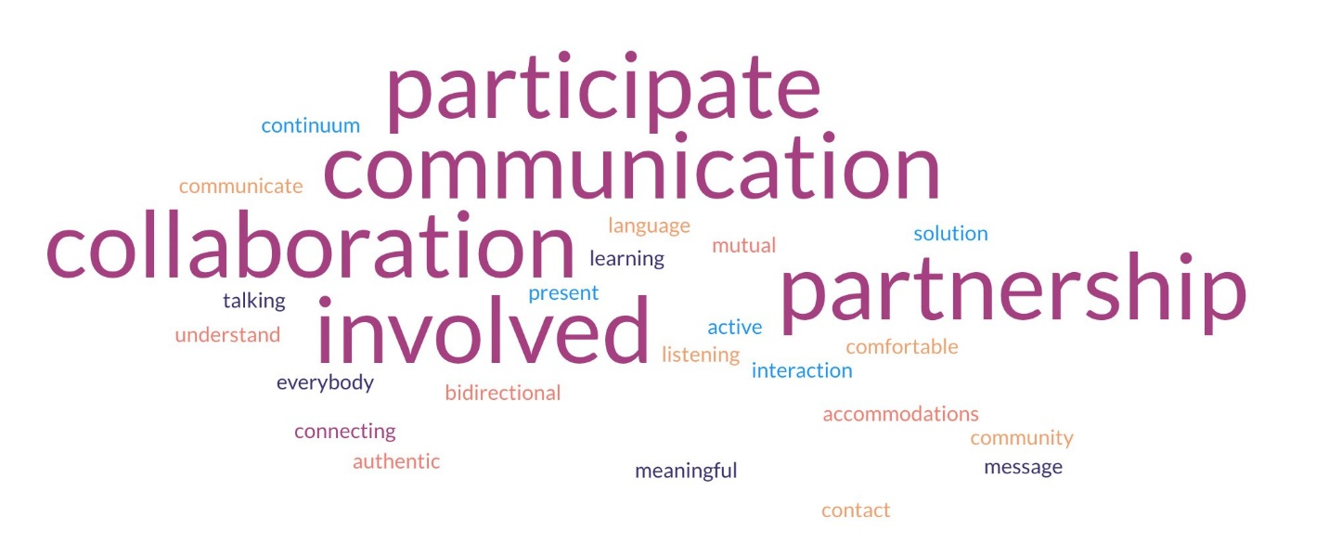

The meeting resulted in the following next steps:

* Participants will fill out the meeting evaluations survey
* Haylee will incorporate key learnings into the Asset Map
* Haylee will share the meeting notes