# Meeting 1: Project Introduction & Initial Brainstorming​

# Thursday, May 2nd, 2024

Brainstorming Sessions

MassHealth Member Advisory Committee (MAC)



Welcome!

## Agenda

1. Welcome and Introductions
2. Brainstorming Sessions Overview
3. BREAK
4. Group Discussion
5. Wrap Up and Closing

## Meeting Guidelines

* Provide the information and support needed for all to engage.
* Ensure space for all to contribute.
* Avoid jargon and acronyms (or spell them out first).
* Recognize all opinions matter and there are no right or wrong answers.
* Actively listen and limit outside distractions.
* Arrive on time and keep cameras on as much as possible.
* Provide space for breaks and take breaks when needed.
* Share your thoughts while also leaving time for others’ ideas.
* Adhere to meeting agendas and try to stay on topic.
* Protect everyone’s personal information and shared experiences.

A map of Massachusetts with red pins to represent where Brainstorming Session participants live in the state. Participants are located in Athol, Beverly, Boston, Greenfield, Hanover, Lowell, Marlborough, Natick, North Brookfield, Pelham, Plymouth, Princeton, Springfield, Ware, Westborough, and Worcester.


## Tell Us About Yourself

* Name
* Pronouns
* What Are You Most Thankful For?

## Meeting Logistics

* Note Taking Practice
* Zoom Tutorial
* Any Questions?

## Overview

## What is a Member Advisory Committee?

* Advisory committee formed by the state Medicaid office after a formal selection process
* Consists of Medicaid beneficiaries with a wide range of Medicaid experiences
* Partners with Medicaid state agency staff to improve members’ access to and experience with Medicaid
* Goal is to ultimately improve health care



## Overview

### MassHealth MAC Formation

* To improve quality and access to care for MassHealth members
* Desire to understand MassHealth member experiences with the program
* Address inequities
* Eliminate disparities in health and healthcare
* Core value of the agency

## A picture containing stationary, writing implement

## Overview

Our Goal for Brainstorming: Meaningful Outreach

* About 4 meetings, 90 minutes, (May 2024)
* Identify strategies so MAC materials reach historically marginalized populations in the Commonwealth
* We want you to bring diverse lenses and your unique life experiences to meetings
* Collective Insight team will facilitate in partnership with MassHealth staff



### Our Focus Areas for Discussion

* Identify communities commonly left out of outreach and ways to effectively reach communities to share MAC Application
* Identifying common pitfalls and share lessons learned
* Map existing community assets
* Develop an Outreach Plan

## Meeting Calendar

|  |  |
| --- | --- |
| **Meeting Focus** | **Meeting Date** |
| **Meeting 1**  Project Introduction & Initial Brainstorming | Thursday, May 2nd  9:30-11am or 4-5:30pm |
| **Meeting 2** Mapping our Assets/ Partnerships | Thursday, May 9th  9:30-11am or 4-5:30pm |
| **Meeting 3**  Review and Refine Outreach Plan | Thursday, May 23rd  9:30-11am or 4-5:30pm |
| **Meeting 4**  Celebrate Progress with Other  Brainstorming Participants, Share Insights,  & Review Next Steps | Wednesday, May 29th  12-2pm |

## FIVE MINUTE BREAK

## Initial Brainstorming

* What experiences and perspectives are needed for a meaningful MAC?

## Initial Brainstorming

* Common outreach pitfalls and lessons learned you would like to share?

## Initial Brainstorming

* Partnerships for Success?

## What We’re Learning

* What is important to know about a MAC to apply?
* What is important to learn about members who apply?
* How do we make the process accessible to all communities?

## Wrap Up and Closing

* Summary of Key Learnings
* Expectations for Next Meeting
* Questions?

## What are you thankful for?

* Family
* Cat
* For being thankful
* Caregiver
* Community partnerships
* Interdependent communities
* This MAC project
* Communities
* My child putting on socks today

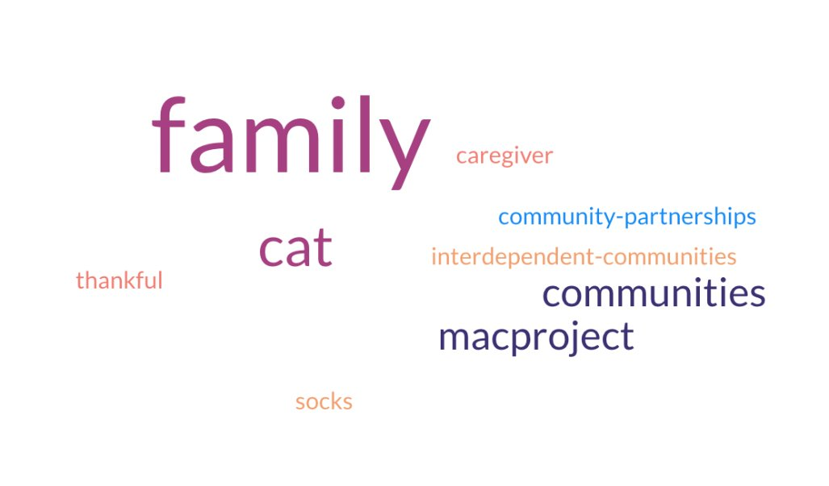

## Thank you!

## See you on May 9th!

## Post Meeting Survey

4 questions