# Final Meeting: Celebration, Sharing & Next Steps

# Wednesday, May 29th, 2024​

Brainstorming Sessions

MassHealth Member Advisory Committee (MAC)​

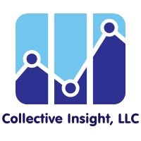

## Welcome!

## Agenda

1. Welcome and Introductions​
2. Brainstorming Sessions’ Key Findings ​
3. Break
4. Group Reflections ​
5. MassHealth Reflections and Q&A ​
6. Closing ​

## Meeting Guidelines

* Provide the information and support needed for all to engage.​
* Ensure space for all to contribute.​
* Avoid jargon and acronyms (or spell them out first).​
* Recognize all opinions matter and there are no right or wrong answers.​
* ​Actively listen and limit outside distractions.​
* ​Build trust in increments.​
* ​Arrive on time and keep cameras on as much as possible.
* Provide space for breaks and take breaks when needed.​
* ​Share your thoughts while also leaving time for others’ ideas.​
* ​Adhere to meeting agendas and try to stay on topic.​
* ​Protect everyone’s personal information and shared experiences.​
* ​Check in with the group about their understanding of concepts with a show of hands.

## Brainstorming Sessions Feedback

* We need to meet groups where they are at and give value in order to have participation.
* People genuinely care.
* There are diverse stakeholders all interested in the same pursuit of equitable access to care.
* Even when you think you’ve got everything, a new perspective opens news doors and identifies new gaps.
* It was really nice to meet so many people that are invested in the same topic as I am. Strength in numbers!
* I’m hoping that an intentionally evolutionary consciousness can progress MassHealth and the whole Commonwealth.
* There is always something that I learn from brainstorming sessions.
* I continue to be blown away by honestly, how hard MassHealth works to constantly try to make the member experience as good as possible. Seeking feedback – on multiple fronts!
* I am filled with hope because of the caring illustrated here.
* We make a great team.

## A group of words and symbols that describe what people liked about the brainstorming sessions

## Brainstorming Investment

11 Meetings total

Activity 1​

* 5 meetings​
* 7 participants​
* 70 hours

Activity 2​

* 3 meetings​
* 20 participants​
* 90 hours

Backgrounds: MassHealth Members, Providers, Caregivers, Community-Based and Advocacy Organizations, Students

## Brainstorming Purpose

### To Engage:

Diverse Massachusetts communities in the initial planning phase of the first ever MassHealth Member Advisory Committee

### To Learn From:

Various perspectives on how to design a MAC and outreach for a MAC that encourages diversity and represents the unique experiences of MassHealth members

## Getting to Know Each Other!

* Place your name in the chat and which Activity you participated in.
* Share one thing you would like everyone to know about you in the chat.

## Activity 1

## Focus Areas

### Activity 1

* Develop accessible, understandable, and culturally relevant materials ​
* Understand the MAC Approach​
* Inform MAC Outreach Materials and ​
* Design MAC Outreach Messaging

## Overarching Theme

The MAC should represent diverse experiences and recognize intersectionality.

## Intersection of Identities

* Age​
* Culture​
* Language​
* Geography​
* Race ​
* Ethnicity​
* Health​
* Disability/ Neurodiversity​
* Sexuality​
* Gender Identity​
* Program ​
* Setting

Age, Geography, Disability/Neurodiversity, and Program are broken down into more detail on the next slides

Setting was an identity added by the group that is also broken down into more detail on the next slides.

## Breaking it Down

### Geography​

* county​
* urban​
* rural​
* data-driven​
* along state borders​
* non-permanent MA resident

### Older Adults​

* 65+ transitioning programs​
* Veterans

## Breaking it Down

### Various Programs​

* Standard MassHealth​
* Integrated Care​
* Senior Care Options​
* OneCare​
* Personal Care Attendant Program​
* Frail Elder Waiver​
* Limited MassHealth​
* Traumatic Brain Injury Programs ​
* Covered but not represented​
* Dual Eligible

### Disability Status​

* developmental disability​
* intellectual disability​
* non-apparent disability​
* physical disability​
* sensory disability

## Additional Perspectives

* Living Settings​
* home with supports​
* supportive living​
* long-term care facilities​
* K-12 schools​
* college campuses​
* hospitals​
* memory care​
* assisted living​
* group adult foster care​
* prisons​
* homeless shelters​
* unhoused​
* long term half-way houses​
* sober houses​
* detoxes

## Takeaway for MAC Approach

### MAC Members​

* 10-15 members​
* Range of term limits​
* Renewal process​
* Represents geographic diversity of MassHealth members​
* Intersecting identities

### MAC Meetings​

* Shorter meetings, meet more often and vice versa​
* Hybrid with two facilitators​
* Person-centered onboarding and training​
* Financial and non-financial incentives​
* Accommodations

## Progress

* Messaging​
* Accessibility​
* Partnerships for Success​
* Strategies

## Messaging

* Emphasize the opportunity to make a change ​
* Include logistics about the MAC​
* Explain that accommodations will be available​
* Describe the MAC’s role in the context of health care​
* Show a commitment to change at MassHealth

## Accessibility​

* Highlight the availability of translation and interpretation services among other accommodations​
* Use many methods for engaging​
* Describe compensation options​
* Use clear communication​
* Practice plain language

## Strategies​

* Many Methods​
* Digital (video, television, ads)​
* Physical (flyers, QR codes, word of mouth)​
* Meet Communities Where They Are (events, festivals, parks)​
* Ongoing Communication​
* Low Tech​

## Partnerships For Success

### List from Last Week

* Assistive Technology Center
* Non-profits
* Disability Advocacy Orgs
* Community Service Organizations​
* Behavioral Health Community Partners Program
* Community Centers
* Independent Living Centers
* Hiring Agencies
* Local History Groups
* Food Pantries
* Senior Centers/Aging Centers
* Accountable Care Organizations
* Sexual Health Clinics​
* Domestic Violence Shelters
* Housing & Apartment Complexes
* Tour Guides
* Travel Agencies
* Town Government
* Town Newspaper
* Charities for US Citizenship

### What We Added

* Community Events
* Mental Health Vendors
* Wildflower Alliance
* Local Recovery Learning Centers
* Peer Respite

## Activity 2

## Focus Areas

### Activity 2

* Identify communities commonly left out of outreach and ways to effectively reach communities to share MAC Application ​
* Identify common pitfalls and share lessons learned​
* Map existing community assets ​
* Inform an Outreach Plan

## Perspectives and ​Experiences

### Services​

* Durable Medical Equipment​
* Mental Health​
* Lack of Primary Care Provider​
* Food​
* Housing​
* Home and Community Based​
* Personal Care Attendant​
* Social Determinants of Health ​
* Facility-based services​

### Geography​

* rural​
* proximity to Boston​
* urban

### Various Programs​

* MassHealth Secondary​
* Standard MassHealth​
* Integrated Care​
* Senior Care Options​
* OneCare​
* State Waivers​
* Limited MassHealth​
* Traumatic Brain Injury Programs ​
* Dental​
* Vision​
* Prescriptions​
* PACE

## Perspectives and Experiences

### Target Communities​

* caregivers​
* mixed literacy​
* complex medical needs​
* foster care​
* family members​
* disability​
* mental health ​
* unhoused​
* mixed immigration status​
* at risk youth​
* transitional ages​
* older adults

## Outreach ​Obstacles

### Obstacles​

* Financial barriers​
* Technology barriers​
* Transportation barriers​
* Lack of recognition of historical mistrust in health care​
* Traditional outreach assumptions​
* Competing priorities​
* Oppressive Practices​
* Long hold times associated with MassHealth​
* Perception of healthcare ​
* Communication and literacy differences​

​

## Outreach Lessons Learned

Lessons Learned​

* Align outreach strategy with target audience​
* Collaborate with community allies​
* Prioritize accessibility​
* Highlight the benefits of the opportunity ​
* Create a safe space​
* Bottom-up and top-down approaches​
* Multi-prong approach​
* Fun Messaging​
* Use Many Languages​
* Meet Communities Where They Are​
* Mutual Benefits​
* Success with surveys​

## Disability Community ​

* Aging Service Access Points (ASAPs)​
* Schools​
* Provider Network​
* Senior Centers​
* Personal Care Attendant Union​
* Special Education Parent Advisory Councils​
* Federation for Children with Special Needs​
* Mass Advocates for Children​
* Special education departments​
* Black Autism Coalition​
* National Parents Union​
* Transportation Services​
* Community-Based Day Programs​
* Durable Medical Equipment Providers​
* Deaf Inc.​
* State Commission for the Deaf and Hard of Hearing​
* Boston Disability Commission​
* Somali Parents Advocacy Center for Education​
* Department of Mental Health Clubhouses​
* Independent Living Centers​
* Facebook Support Groups​

## Older Adults

* Aging Service Access Points (ASAPs)​
* Senior Centers​
* Home Health Workers​
* Personal Care Attendant Union​
* Hospitals ​
* Senior Day Care Centers​
* Nursing Homes​
* My Ombudsman​
* Elder Stakeholders’ Group​
* Ombudsman for Nursing Facilities​

## Rural Community

* Municipal Health Departments​
* Rural Nurses​
* Provider Network​
* School Nurses​
* Mobile Health Clinics​
* Libraries​
* Laundromats​
* Community Action Centers​
* Schools​
* Grocery Stores​
* Behavioral Health Network​
* Metro West Nonprofit Network

## Children, Youth, Families (including at risk youth)​

* Schools​
* YMCA​
* Pediatricians​
* School Nurses​
* Mobile Health Clinics​
* Day Care Centers​
* Homeschooling Organizations​
* Mobile Bus Care​
* MBTA​
* Children’s Behavioral Health Initiative​
* Primary Care Offices​
* Hospitals​
* Shelters​
* Provider Network​
* Recreation Departments​
* Colleges​
* Mutual Aid Groups​
* Health Care for All ​
* Foster Care​
* Nail Salons​
* Boys and Girls Club​
* PPAL

## Unhoused Community​

* Shelters​
* Bodegas​
* Corner Stores​
* Laundromats​
* Grocery Stores​
* Meal Caravans​
* United State Postal Services​
* MBTA​
* Mutual Aid Groups​
* Legal Advocates​
* Health Care For All​
* Food Banks​

## Young and Middle-Aged Adults​

* Alcoholics Anonymous​
* Heath Care For All​
* Legal Services​
* Mutual Aid​
* MBTA​
* Places of Worship​
* Housing Departments​
* Hospitals​
* Chamber of Commerce​
* Primary Care Providers​
* Meal Caravans​
* United States Postal Service​
* Schools​
* Brockton Worker’s Alliance​
* Men of Color Health Awareness​
* Oral Health Progress and Equity Network​
* YMCA​
* Greater Boston Food Bank​
* Shopping Malls​
* Medical Interpreters​
* Farmers Markets​
* Peer Support

## Mixed Literacy​

* Medical Interpreters​
* Peer Support Specialists​
* Places of Worship​
* Schools​
* Grocery Stores​
* Laundromats​
* Libraries​
* Legal Advocates

## Let’s Break

## Group Reflections

1. Based on today’s group sharing, describe the outreach strategy that you believe is important. What does that strategy look like in your own words? ​
2. What do you believe will be the biggest hurdles to achieving real MassHealth member engagement? What suggestions do you have for overcoming these hurdles?

## MassHealth Reflections

* Purpose​
* Outreach & Relationship Building​
* Decision Making ​
* Accommodations ​
* Accountability

## Q & A

## What Does Engagement Mean to You?

* Accommodations
* Language
* Change
* Positive
* Interactions
* Continuum
* Participate
* Collaboration
* Communicate
* Understand
* Action
* Ideas
* Bidirectional
* Intent
* Together
* Reactions
* Emotional
* Accessible
* Authentic
* Everybody
* Voices
* Enthusiasm
* Partnership
* Meaningful
* Solution
* Impact
* Comfortable
* Message
* Multi-method
* Exchange
* Real
* Present
* Commitment
* Contact
* Reflect
* Sharing
* Participating
* Feedback

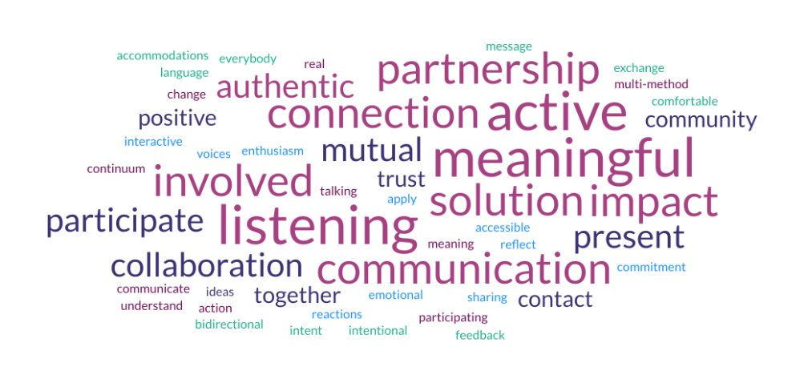

## Post Meeting Survey

4 questions