INDOOR AIR QUALITY ASSESSMENT

Ralph C. Mahar Regional School
507 South Main Street
Orange, Massachusetts

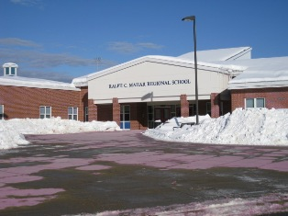

Prepared by:
Massachusetts Department of Public Health
Bureau of Environmental Health
Indoor Air Quality Program
July 2011

Background/Introduction
At the request of Mr. Thomas Bates, Director of Facilities for Ralph C. Mahar Regional School, the Massachusetts Department of Public Health (MDPH), Bureau of Environmental Health (BEH) conducted an indoor air quality (IAQ) assessment at the Ralph C. Mahar Regional School (MRS) located at 507 South Main Street, Orange, Massachusetts. Lisa Hébert, an Environmental Analyst/Regional Inspector for BEH’s Indoor Air Quality (IAQ) Program, originally visited the building on February 4, 2011. On February 11, 2011, Ms. Hébert returned to the MRS with Michael Feeney, Director of BEH’s IAQ Program to conduct further evaluations. A letter was issued in response to chemical storage concerns discovered during the assessment, which is attached as Appendix A. The purpose of this report is to address general indoor air quality concerns.
The MRS is a one-story brick building constructed in 1956. A major renovation of the building took place as a phased, two-year project (from 2002 to 2004). The portions of the building that remained from the original 1956 construction (i.e., auditorium, cafeteria, high school gym), were stripped down to the steel supports and concrete floors prior to renovation.

Methods
Air tests for carbon monoxide, carbon dioxide, temperature and relative humidity were conducted with the TSI, Q-Trak, IAQ Monitor, Model 7565. Air tests for airborne particle matter with a diameter less than 2.5 micrometers were taken with the TSI, DUSTTRAK™ Aerosol Monitor Model 8520. BEH staff also performed visual inspection of building materials for water damage and/or microbial growth.

Results
The school houses approximately 800 students in grades 7 through 12 and a staff of approximately 100. The school is visited by approximately 30 individuals daily. Tests were taken during normal operations and results appear in Tables 1 and 2.

Discussion

Ventilation
It can be seen from Table 1 that carbon dioxide levels were below 800 parts per million (ppm) in 64 of 82 areas surveyed on February 4, 2001 and on February 11, 2011(Table 2) carbon dioxide levels were below 800 parts per million in 37 of 41 areas surveyed. These results indicate adequate air exchange throughout the majority of rooms in the building at the time of testing.
Fresh air in classrooms is supplied by unit ventilator (univent) systems (Figure 1). A univent draws air from the outdoors through a fresh air intake located on the exterior wall of the building and returns air through an air intake located at the base of the unit. Fresh and return air are mixed, filtered, heated and provided to classrooms through an air diffuser located in the top of the unit (Picture 1). Obstructions to airflow on top of univents and in front of univent returns was seen in a number of classrooms (Picture 2).
Exhaust ventilation in classrooms is provided by a mechanical exhaust system. The exhaust vents are located on the classroom ceilings and ducted to rooftop vents. Some of the exhaust vents were also partially obstructed with stored classroom materials (Picture 3). Ventilation equipment must remain free and clear of obstructions in order to perform optimally.
To maximize air exchange, the MDPH recommends that both supply and exhaust ventilation operate continuously during periods of occupancy. In order to have proper ventilation with a mechanical supply and exhaust system, the systems must be balanced to provide an adequate amount of fresh air to the interior of a room while removing stale air from the room. It is recommended that HVAC systems be re-balanced every five years to ensure adequate air systems function (SMACNA, 1994). The system was last balanced upon installation in 2004.
The Massachusetts Building Code requires that each room have a minimum ventilation rate of 15 cubic feet per minute (cfm) per occupant of fresh outside air or openable windows (SBBRS, 1997; BOCA, 1993). The ventilation must be on at all times that the room is occupied. Providing adequate fresh air ventilation with open windows and maintaining the temperature in the comfort range during the cold weather season is impractical. Mechanical ventilation is usually required to provide adequate fresh air ventilation.
Carbon dioxide is not a problem in and of itself. It is used as an indicator of the adequacy of the fresh air ventilation. As carbon dioxide levels rise, it indicates that the ventilating system is malfunctioning or the design occupancy of the room is being exceeded. When this happens, a buildup of common indoor air pollutants can occur, leading to discomfort or health complaints. The Occupational Safety and Health Administration (OSHA) standard for carbon dioxide is 5,000 parts per million parts of air (ppm). Workers may be exposed to this level for 40 hours/week, based on a time-weighted average (OSHA, 1997).
The MDPH uses a guideline of 800 ppm for publicly occupied buildings. A guideline of 600 ppm or less is preferred in schools due to the fact that the majority of occupants are young and considered to be a more sensitive population in the evaluation of environmental health status. Inadequate ventilation and/or elevated temperatures are major causes of complaints such as respiratory, eye, nose and throat irritation, lethargy and headaches. For more information concerning carbon dioxide, consult Appendix B.
Indoor temperatures ranged from 69º F to 75º F, on February 4, 2011, which were within or very close to the lower end of the MDPH recommended comfort range (Table 1). Indoor temperatures ranged from 64º F to 74º F, on February 11, 2011, which were below the MDPH recommended comfort range in a number of areas (Table 2). The MDPH recommends that indoor air temperatures be maintained in a range of 70º F to 78º F in order to provide for the comfort of building occupants. In many cases concerning indoor air quality, fluctuations of temperature in occupied spaces are typically experienced, even in a building with an adequate fresh air supply.
The relative humidity measured in the building on February 4, 2011 ranged from 6 to 15 percent (Table 1). The relative humidity measured in the building on February 11, 2011 ranged from 5 to 11 percent (Table 2). Relative humidity levels were below the MDPH recommended comfort range in all areas surveyed on both days of the assessment. The MDPH recommends a comfort range of 40 to 60 percent for indoor air relative humidity. The sensation of dryness and irritation is common in a low relative humidity environment. Low relative humidity is a very common problem during the heating season in the northeast part of the United States. For buildings in New England, periods of low relative humidity during the winter are often unavoidable. Therefore, scrupulous cleaning practices should be adopted to minimize common indoor air contaminants whose irritant effects can be enhanced when the relative humidity is low.

Microbial/Moisture Concerns
Several classrooms and hallways had water-damaged ceiling tiles, some of which had been painted over. Water-damaged ceiling tiles can indicate sources of water penetration/leaks from either the building envelope or plumbing system (Picture 4). Water-damaged ceiling tiles can provide a source of mold and should be replaced after a water leak is discovered and repaired.
The US Environmental Protection Agency (US EPA) and the American Conference of Governmental Industrial Hygienists (ACGIH) recommend that porous materials be dried with fans and heating within 24 to 48 hours of becoming wet (US EPA, 2001; ACGIH, 1989). If not dried within this time frame, mold growth may occur. Once mold has colonized porous materials, they are difficult to clean and should be removed and discarded.
Plants were noted in several classrooms. Plants can be a source of pollen and mold which can be respiratory irritants to some individuals. Plants should be properly maintained and equipped with drip pans and should be located away from univents to prevent the aerosolization of dirt, pollen and mold.

Other IAQ Evaluations
Indoor air quality can be negatively influenced by the presence of respiratory irritants, such as products of combustion. The process of combustion produces a number of pollutants. Common combustion emissions include carbon monoxide, carbon dioxide, water vapor, and smoke (fine airborne particle material). Of these materials, exposure to carbon monoxide and particulate matter with a diameter of 2.5 micrometers (μm) or less (PM2.5) can produce immediate, acute health effects upon exposure. To determine whether combustion products were present in the building environment, BEH staff obtained measurements for carbon monoxide and PM2.5.

Carbon Monoxide
Carbon monoxide is a by-product of incomplete combustion of organic matter (e.g., gasoline, wood and tobacco). Exposure to carbon monoxide can produce immediate and acute health effects. Several air quality standards have been established to address carbon monoxide and prevent symptoms from exposure to these substances. The MDPH established a corrective action level concerning carbon monoxide in ice skating rinks that use fossil-fueled ice resurfacing equipment. If an operator of an indoor ice rink measures a carbon monoxide level over 30 ppm, taken 20 minutes after resurfacing within a rink, that operator must take actions to reduce carbon monoxide levels (MDPH, 1997).
The American Society of Heating Refrigeration and Air-Conditioning Engineers (ASHRAE) has adopted the National Ambient Air Quality Standards (NAAQS) as one set of criteria for assessing indoor air quality and monitoring of fresh air introduced by HVAC systems (ASHRAE, 1989). The NAAQS are standards established by the US EPA to protect the public health from six criteria pollutants, including carbon monoxide and particulate matter (US EPA, 2006). As recommended by ASHRAE, pollutant levels of fresh air introduced to a building should not exceed the NAAQS levels (ASHRAE, 1989). The NAAQS were adopted by reference in the Building Officials & Code Administrators (BOCA) National Mechanical Code of 1993 (BOCA, 1993), which is now an HVAC standard included in the Massachusetts State Building Code (SBBRS, 1997). According to the NAAQS, carbon monoxide levels in outdoor air should not exceed 9 ppm in an eight-hour average (US EPA, 2006).
Carbon monoxide should not be present in a typical, indoor environment. If it is present, indoor carbon monoxide levels should be less than or equal to outdoor levels. Outdoor carbon monoxide concentrations were non-detect (ND) on both days of the assessment (Tables 1 and 2). No measureable levels of carbon monoxide were detected in the building during the assessment conducted on February 4, 2011 with the exception of the maintenance/facilities room, which had a slight measurement of 0.3 ppm. This room contains a door to the loading dock and it was reported that vehicles were operating outside the loading dock earlier in the day. Subsequent carbon monoxide measurements were ND. No measureable levels of carbon monoxide were detected in the building during the assessment conducted on February 11, 2011 (Table 2).

Particulate Matter
The US EPA has established NAAQS limits for exposure to particulate matter. Particulate matter is airborne solids that can be irritating to the eyes, nose and throat. The NAAQS originally established exposure limits to particulate matter with a diameter of 10 μm or less (PM10). According to the NAAQS, PM10 levels should not exceed 150 micrograms per cubic meter (μg/m³) in a 24-hour average (US EPA, 2006). These standards were adopted by both ASHRAE and BOCA. Since the issuance of the ASHRAE standard and BOCA Code, US EPA established a more protective standard for fine airborne particles. This more stringent PM2.5 standard requires outdoor air particle levels be maintained below 35 μg/m³ over a 24-hour average (US EPA, 2006). Although both the ASHRAE standard and BOCA Code adopted the PM10 standard for evaluating air quality, MDPH uses the more protective PM2.5 standard for evaluating airborne particulate matter concentrations in the indoor environment.
Outdoor PM2.5 concentrations measured 13 μg/m³ on February 4, 2001 and 22 μg/m³ on February 11, 2011 (Tables 1 and 2). PM2.5 levels measured indoors on February 4, 2011 ranged from 1 to 63 μg/m³, which were below the NAAQS PM2.5 level of 35 μg/m³ in all areas with the exception of the woodshop (63 μg/m³) due to wood cutting and clean-up activities. PM2.5 levels measured indoors on February 11, 2011 ranged from 5 to 43 μg/m³ (Table 2), which were below the NAAQS PM2.5 level of 35 μg/m³ in 31 of 41 areas surveyed. Elevated levels of PM2.5 appeared to be the result of classroom activities. Frequently, indoor air levels of particulates (including PM2.5) can be at higher levels than those measured outdoors. A number of activities that occur indoors and/or mechanical devices can generate particulate during normal operations. Sources of indoor airborne particulates may include but are not limited to particles generated during the operation of fan belts in the HVAC system, use of stoves and/or microwave ovens in kitchen areas; use of photocopiers, fax machines and computer printing devices; operation of an ordinary vacuum cleaner and heavy foot traffic indoors.

Volatile Organic Compounds
Indoor air concentrations can be greatly impacted by the use of products containing volatile organic compounds (VOCs). VOCs are carbon-containing substances that have the ability to evaporate at room temperature. Frequently, exposure to low levels of total VOCs (TVOCs) may produce eye, nose, throat and/or respiratory irritation in some sensitive individuals. For example, chemicals evaporating from a paint can stored at room temperature would most likely contain VOCs. In an effort to identify materials that can potentially increase VOC concentrations, BEH staff examined classrooms for products that may contain these respiratory irritants.
Cleaning products were observed in some classrooms (Picture 5). These items contain chemicals that can be irritating to the eyes, nose and throat and should be kept out of reach of students. Additionally, a Material Safety Data Sheet (MSDS) should be available at a central location for each product in the event of an emergency.
BEH staff observed tennis balls which had been sliced open and placed on chair and/or table legs (Picture 6). Tennis balls are made of a number of materials that are a source of respiratory irritants. Constant wearing of tennis balls can produce fibers and cause VOCs to off-gas. Tennis balls are made with a natural rubber latex bladder, which becomes abraded when used as a chair leg pad. Use of tennis balls in this manner may introduce latex dust into the school environment. Some individuals are highly allergic to latex (e.g., spina bifida patients) (SBAA, 2001). It is recommended that the use of materials containing latex be limited in buildings to reduce the likelihood of symptoms in sensitive individuals (NIOSH, 1997).
Photocopiers and lamination machines were observed at the MRS. Lamination machines melt plastic and give off odors and VOCs. VOCs and ozone can be produced by photocopiers, particularly if the equipment is older and in frequent use. Ozone is a respiratory irritant (Schmidt Etkin, 1992).

Woodshop and Drafting Room
Several conditions were noted in the woodshop that may impact indoor air quality. A noticeable wood dust odor was detected in the hallway outside of the woodshop. A gasket was missing/in disrepair on the woodshop door, which can allow dusts/odors to migrate into adjacent areas of the school (Picture 7). In the woodshop, the wood cutting/sanding machines are connected to a ducted wood dust collection system, which is located indoors in a room adjacent to the woodshop. A gap was observed at the base of the door to this room, which may allow fine wood dust to re-enter the woodshop. A heavy accumulation of wood dust was observed on the woodshop floor and numerous horizontal surfaces (Picture 8). Wood dust is a fine particulate, which can be easily aerosolized and become irritating to the eyes, nose, throat and respiratory system. Therefore, the practice of cleaning wood dust from equipment using compressed air should be discontinued, as should sweeping due to the fact that both practices can cause fine wood dust to become air borne and to potentially be breathed in by students and staff. Under certain conditions, wood dust is also a fire hazard.
The woodshop has a room that is used for painting/staining projects. The room contains a spray booth that is vented to the outdoors (Pictures 9 and 10). The roof adjacent to the exhaust duct for the spray booth was not properly sealed, therefore one could see through to the outdoors. This condition could allow paint fume exhaust and unconditioned air to enter the room. A gap was also observed in the exterior door at the rear of the woodshop. Unconditioned outside air has the potential to create condensation on surfaces under certain conditions. Condensation on porous surfaces can promote mold colonization. These breaches can allow drafts, moisture, insects and rodents to enter the building.
The door between the woodshop and the drafting room was observed to be open, likely one reason the odor of wood dust was present in that room. Although the woodworking tools in the drafting room are reportedly not frequently used, they lack a wood dust collection system. Finally, BEH staff was informed that the woodshop and drafting room share an AHU, which may also contribute to wood dust odors.

Science/Chemistry Area
BEH staff conducted a limited chemical inventory in the science/chemistry storage room. The focus of this examination was to observe the conditions of flammable materials, acids, alkaline and other chemicals that may pose a problem for emergency responders if an incident occurs in this location. Tables 3 and 4 provide a partial listing of chemicals stored in the chemical storage cabinet as observed by BEH staff. Substances in Tables 3 and 4 marked with an asterisk (*) are chemicals that in the opinion of the safe practices subcommittee of the American Chemical Society “should not be found in a secondary school chemical inventory…” (ACS, unknown). It is important to note that these substances appear to have been purchased several decades prior to this assessment. Due to the particular hazards posed by each of the chemicals highlighted (Pictures 11 and 12); it is recommended that these materials be removed by a licensed hazardous waste disposal contractor.
Numerous flammable chemicals were observed in this cabinet. The cabinet is of a vintage/design that has minimal fire containment capabilities. Further, it was not readily identifiable as a flammables cabinet from the exterior. Flammable materials should be stored in a cabinet that meets the requirements of the National Fire Prevention Association (NFPA, 1996). Of note are containers in the flammables storage cabinet that are corroded, which can indicate exposure to off-gassing materials that can interact with metal.
Chemical containers appear to be re-used in some cases (Picture 13). The practice of re-use of chemical storage containers should be discontinued. Chemicals should remain in their original containers or be placed in a properly labeled container. Some hand-written labels on chemicals have also begun to deteriorate with age.
Metal shelving did not have a lip, which can cause chemicals to easily fall off storage shelves. Oxidation was observed on many metal surfaces, including but not limited to shelving, cabinet components and chemical containers (Pictures 14 through 16). Chemical residues were observed on shelving as well as on glass bottles (Pictures 17 through 19). These conditions occur as a result of chemicals off-gassing into the environment. Related exposure to such vapors may cause irritation to the eyes, nose and respiratory system. Several corrosive and moisture sensitive chemicals were also observed, each of which have their own specific storage requirements. It is highly recommended that a thorough inventory of chemicals in the science department be done to assess chemical storage practices and to ensure disposal of materials is done in an appropriate manner consistent with Massachusetts hazardous waste laws.

Other Conditions
Other conditions that can affect indoor air quality were observed during the assessment. A hole was observed in the exhaust duct leading from the kiln. This condition can allow heat and fumes to exhaust into the kiln room, and may be responsible for the rusted shelving observed in the kiln room (Picture 20).
Numerous sinks that appeared to be infrequently used were observed to have dry drain traps. The purpose of a drain trap is to prevent drainage system gases and odors from entering the occupied space. When water is poured into a trap, an airtight seal is created by the water in the U-bend section of the pipe. These drains must have water poured into the traps at least twice a week to maintain the integrity of the seal. Without water, the dry trap opens the room to the drainage system. If a mechanical device (e.g., the fan) depressurizes the room, air, gas and odors can be drawn from the drainage system into the room. The effect of this phenomenon can be increased if heavy rains cause an air backup in the drainage system.
Pencil shavings and food particles were observed in the interior of one univent (Picture 21). Another univent, lacking a properly sized filter, was observed to have a large filter folded over to fit into the unit. This excess filter media is not conducive to proper operation of the univent (Picture 22).
In several classrooms, items were observed on the floor, windowsills, tabletops, counters, bookcases and desks. The large number of items stored in classrooms provides a source for dusts to accumulate. These items (e.g., papers, folders, boxes) make it difficult for custodial staff to clean. Items should be relocated and/or be cleaned periodically to avoid excessive dust build up. In addition, these materials can accumulate on flat surfaces (e.g., desktops, shelving and carpets) in occupied areas and subsequently be re-aerosolized causing further irritation.
Stuffed pillows/toys, blankets and upholstered furniture were noted in some classrooms (Picture 23). Stuffed toys used by an individual child should be washed on a weekly basis to prevent disease (Hale and Polder, 1996). Furthermore, stuffed pillows/toys can be a point for dust collection. Close contact with such items can leave oils, perspiration, hair and skin cells. Dust mites feed upon human skin cells and excrete waste products that contain allergens. As discussed, dust can be irritating to the eyes, nose and respiratory system.
A number of univents, exhaust vents and personal fans were observed to have accumulated dust/debris (Picture 24). These diffusers, vents and fans should be cleaned in order to prevent dust/debris from being aerosolized and redistributed throughout the room.

Conclusions/Recommendations
The conditions related to indoor air quality at the MRS raise a number of issues. Some of these conditions can be remedied by actions of building occupants. Other remediation efforts will require alteration to the building structure and equipment. For these reasons, a two-phase approach is required for remediation. The first consists of short-term measures to improve air quality and the second consists of long-term measures that will require planning and resources to adequately address the overall indoor air quality concerns.

Short-Term Recommendations
- Continue to implement previous recommendations listed in MDPH letter issued in February 2011.
- Operate all ventilation systems throughout the building continuously during periods of occupancy independent of thermostat control to maximize air exchange.
- In order to optimize air exchange in MRS, remove obstructions in front and on top of unit ventilators and relocate stored classroom materials located directly below exhaust vents.
- Routinely maintain univents, ensuring the interiors are clean and free from dust and debris (e.g., pencil shavings).
- Ensure univent filters are properly sized for optimal univent function.
- Use openable windows in conjunction with mechanical ventilation to facilitate air exchange. Care should be taken to ensure windows are properly closed at night and weekends to avoid the freezing of pipes and potential flooding.
- Consider adopting a balancing schedule of every 5 years for all mechanical ventilation systems, as recommended by ventilation industrial standards (SMACNA, 1994).
- For buildings in New England, periods of low relative humidity during the winter are often unavoidable. Therefore, scrupulous cleaning practices should be adopted to minimize common indoor air contaminants whose irritant effects can be enhanced when the relative humidity is low. To control dusts, a high efficiency particulate arrestance (HEPA) filter equipped vacuum cleaner in conjunction with wet wiping of all surfaces is recommended. Avoid the use of feather dusters. Drinking water during the day can help ease some symptoms associated with a dry environment (throat and sinus irritations).
- Repair any existing water leaks and replace any remaining water-damaged ceiling tiles.
- Encourage staff to monitor their respective areas for active leaks/water damage and report to building maintenance for prompt remediation.
- Ensure plants are equipped with drip pans. Examine drip pans periodically for mold growth and disinfect with an appropriate antimicrobial, as needed. Move plants away from fresh air supply sources.
- Store cleaning products properly and out of reach of students. All cleaning products used at the facility should be approved by the school department with MSDS’ available at a central location.
- Consider replacing tennis balls with latex-free tennis balls or glides.
- Consider opening a window and operating a fan in a manner that removes odors and waste heat when operating the laminator.
- Repair gasket on woodshop hallway door.
- Repair gaps in exterior door to woodshop. Repair gaps at bottom of paint room and wood dust collection room.
- Ensure roof of paint room is repaired and is weathertight.
- Clean wood dust from woodshop surfaces and equipment using a vacuum cleaner equipped with a high efficiency particle arrestance (HEPA) filter.
- Close door between woodshop and drafting classroom to reduce wood dust migration into classroom.
- Have a chemical inventory done in all storage areas and classrooms. Properly store flammable materials in a manner consistent with environmental statutes and regulations (NFPA, 1996). Label chemical containers with the chemical name of its contents. Follow proper procedures for storing and securing hazardous materials. Consider purchasing storage shelving with a lip to ensure chemicals do not accidentally fall off shelving.
- Ensure ducts to kilns are properly sealed.
- Pour water into unused drains twice a week (or as needed) to maintain an airtight seal.
- Relocate or consider reducing the amount of materials stored in classrooms to allow for more thorough cleaning of classrooms. Clean items regularly with a wet cloth or sponge to prevent excessive dust build-up.
- Clean accumulated dust and debris periodically from the surface of air diffusers, exhaust vents and blades of personal and ceiling fans.
- Clean blankets, sheets, pillows/pillow cases weekly.
- Upholstered furniture should be cleaned annually.
- Consider adopting the US EPA (2000) document, “Tools for Schools”, as an instrument for maintaining a good indoor air quality environment in the building. This document is available at: http://www.epa.gov/iaq/schools/index.html.
- Refer to resource manual and other related indoor air quality documents located on the MDPH’s website for further building-wide evaluations and advice on maintaining public buildings. These documents are available at: http://mass.gov/dph/iaq.

Long-Term Recommendations
- Consider providing dedicated exhaust for laminator area.
- Consider moving wood dust collection operation to the outdoors.
- Consider installing an AHU for drafting class that is not tied into woodshop AHU.

References
ACGIH. 1989. Guidelines for the Assessment of Bioaerosols in the Indoor Environment. American Conference of Governmental Industrial Hygienists, Cincinnati, OH.
ACS. Unknown. Reducing Risks to Students and Educators from Hazardous Chemicals in a Secondary School Chemical Inventory. American Chemical Society’s Joint Board-Council Committee on Chemical Safety. Available at: http://portal.acs.org/portal/acs/corg/content?_nfpb=true&_pageLabel=PP_SUPERARTICLE&node_id=2230&use_sec=false&sec_url_var=region1&__uuid=cd4137ef-1297-416e-b9cf-579888514556
Arundel et al. 1986. Indirect Health Effects of Relative humidity on Indoor Environments. Env. Health Perspectives 65:351-361.
ASHRAE. 1989. Ventilation for Acceptable Indoor Air Quality. American Society of Heating, Refrigeration and Air Conditioning Engineers. ANSI/ASHRAE 62-1989
Bayer, C. W. et al. 1999. Causes of Indoor air Quality Problems in Schools. US Department of Energy, Oak Ridge National Laboratory, Energy Division, Oak Ridge, TN.
BOCA. 1993. The BOCA National Mechanical Code/1993. 8th ed. Building Officials and Code Administrators International, Inc., Country Club Hill, IL.
Hale, C.M., Polder, J.A. 1996. The ABC’s of Safe and Healthy Child Care a Handbook for Child Care Providers, Department of Health and Human Services. United States Public Health Service, Centers for Disease Control
MDPH. 1997. Requirements to Maintain Air Quality in Indoor Skating Rinks (State Sanitary Code, Chapter XI). 105 CMR 675.000. Massachusetts Department of Public Health, Boston, MA.
NFPA. 1996. Flammable and Combustible Liquids Code. 1996 ed. National Fire Prevention Association, Quincy, MA. NFPA 30.
NIOSH. 1997. NIOSH Alert: Preventing Allergic Reactions to Natural Rubber Latex in the Workplace. National Institute for Occupational Safety and Health, Atlanta, GA.
OSHA. 1997. Limits for Air Contaminants. Occupational Safety and Health Administration. Code of Federal Regulations. 29 C.F.R 1910.1000 Table Z-1-A.
SBAA. 2001. Latex In the Home And Community Updated Spring 2001. Spina Bifida Association of America, Washington, DC.
SBBRS. 1997. Mechanical Ventilation. State Board of Building Regulations and Standards. Code of Massachusetts Regulations. 780 CMR 1209.0
Schmidt Etkin, D. 1992. Office Furnishings/Equipment & IAQ Health Impacts, Prevention & Mitigation. Cutter Information Corporation, Indoor Air Quality Update, Arlington, MA.
SMACNA. 1994. HVAC Systems Commissioning Manual. 1st ed. Sheet Metal and Air Conditioning Contractors’ National Association, Inc., Chantilly, VA.
US EPA. 2000. Tools for Schools. Office of Air and Radiation, Office of Radiation and Indoor Air, Indoor Environments Division (6609J). EPA 402-K-95-001, Second Edition. http://www.epa.gov/iaq/schools/tools4s2.html.
US EPA. 2001. “Mold Remediation in Schools and Commercial Buildings”. Office of Air and Radiation, Indoor Environments Division, Washington, DC. EPA 402-K-01-001. March 2001. Available at: http://www.epa.gov/iaq/molds/mold_remediation.html
US EPA. 2006. National Ambient Air Quality Standards (NAAQS). US Environmental Protection Agency, Office of Air Quality Planning and Standards, Washington, DC. http://www.epa.gov/air/criteria.html.
Picture 1

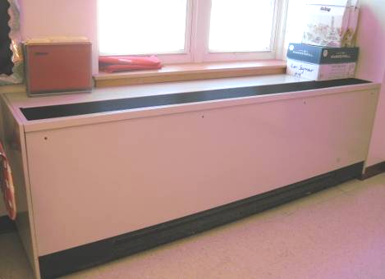

Unit Ventilator (Univent)

Picture 2

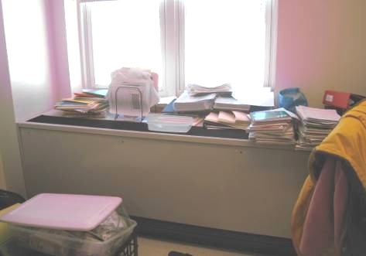

Univent Partially Obstructed with Classroom Materials

Picture 3

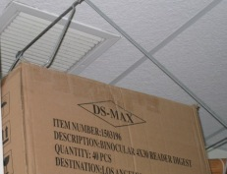

Ceiling Exhaust Vent Partially Obstructed

Picture 4

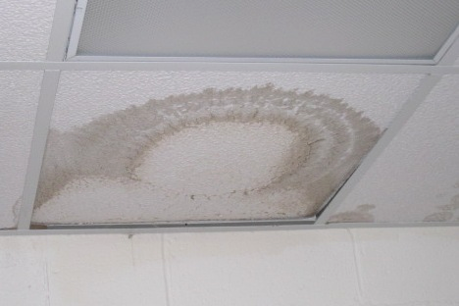

Water-Damaged Ceiling Tiles

Picture 5

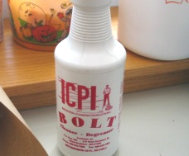

Cleaner/Degreaser Stored on Classroom Shelf

Picture 6

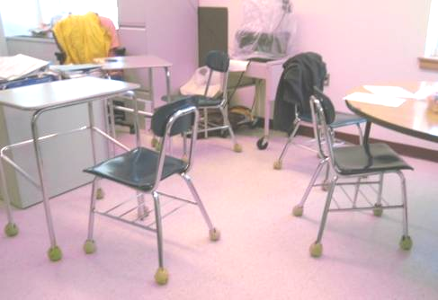

Tennis Balls used as Glides on Legs of Chairs and Desks

Picture 7

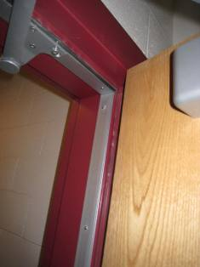

Missing Gasket on Woodshop Door

Picture 8

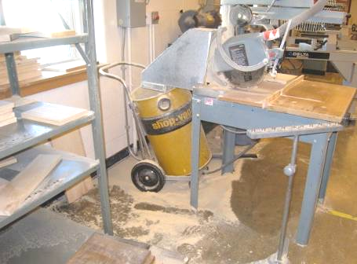

Wood Dust Deposition on Floors
Note Wood Dust on Adjacent Shelves
Picture 9

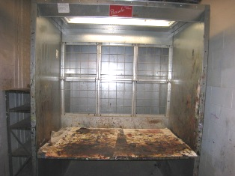

Spray Booth in Paint Room in Woodshop

Picture 10

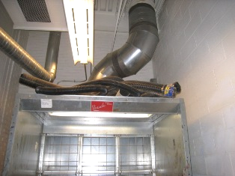

Open Penetration around Exhaust Duct through Roof (Arrow)

Picture 11

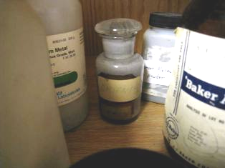

Arsenic in Chemical Storage Area (Arrow)

Picture 12

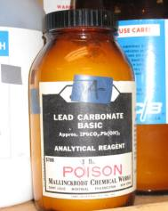

Bottle of Lead Carbonate

Picture 13

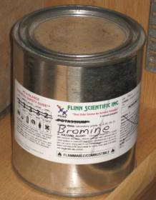

Apparent Re-Use of Chemical Storage Container

Picture 14

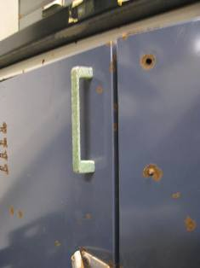

Oxidation of Metal Cabinet

Picture 15

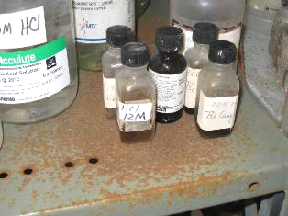

Rusted Metal Storage Shelves

Picture 16

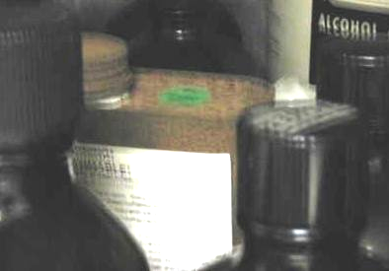

Rusted Container of Flammable Liquid

Picture 17

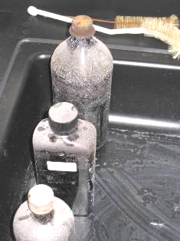

Chemical Residue on Glass Bottles

Picture 18

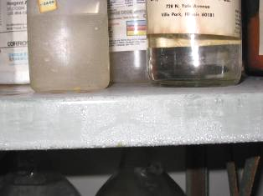

Residue on Storage Shelves

Picture 19

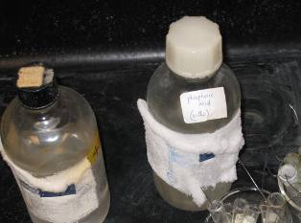

Crystallized Chemicals on Exterior of Bottles

Picture 20

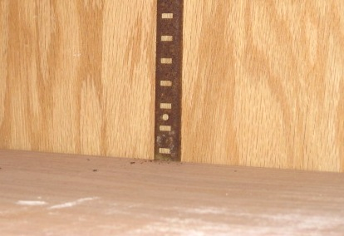

Oxidized Metal Shelving Brackets in Kiln Room

Picture 21

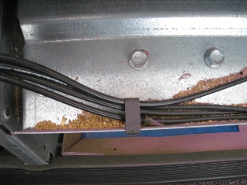

Debris in Univent

Picture 22

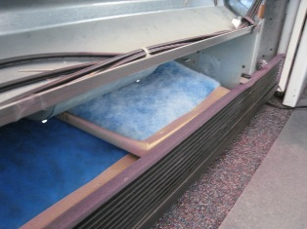

Oversized Univent Filter Folded Over inside Univent

Picture 23

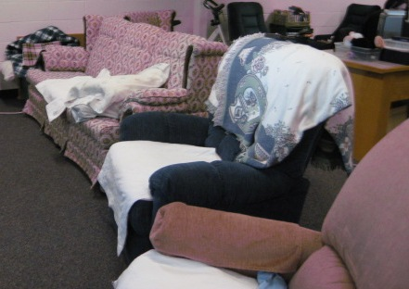

Upholstered Furniture, Blankets and Pillows

Picture 24

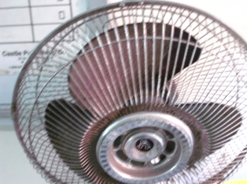

Heavy Dust Accumulation on Fan Blades
Location/ Room | Occupants  in Room | Temp  (°F) | Relative  Humidity  (%) | Carbon  Dioxide  (ppm) | Carbon Monoxide  (ppm) | PM2.5  (µg/m3) | Windows  Openable | Ventilation |  | Remarks
 |  |  |  |  |  |  |  | Supply | Exhaust | Remarks
background | - | 33 | 12 | 354 | ND | 13 | - | - | - | Clear, sunny, brisk, wind speed 2mph (SW), visibility 9 miles (Weather Underground)
Boiler Room | 2 | 75 | 7 | 469 | ND | 12 | N | Y | N
Break Area | 2 | 69 | 8 | 447 | ND | 1 | N | Y | Y | Microwave, refrigerator and toaster oven
Breakroom | 0 | 72 | 7 | 373 | ND | 2 | N | Y | N | Copier
Breakroom/  copy room | 0 | 70 | 8 | 381 | ND | 1 | N | Y | N | DO, microwave, refrigerator, toaster oven
C10 | 3 | 73 | 10 | 608 | ND | 13 | Y | Y | Y | DEM, PF
C11 | 7 | 72 | 9 | 659 | ND | 3 | Y | Y | Y | DO, DEM
C16 | 1 | 70 | 9 | 534 | ND | 14 | N | Y | Y | WD CT
C4 | 11 | 72 | 10 | 607 | ND | 4 | Y | Y | Y | WD CTs, UF
C6  (wood shop) | 15 | 71 | 13 | 607 | ND | 63 | Y | Y | Y | Students were sweeping and had just completed “cleaning” wood working equipment with compressed air
C9 | 16 | 73 | 11 | 806 | ND | 10 | Y | Y | Y | DO, DEM
Com. Police | 0 | 70 | 8 | 435 | ND | 2 | N | Y | Y | DO
Conf. room | 0 | 73 | 10 | 581 | ND | 1 | N | Y | Y | DO
Conference Room | 0 | 69 | 8 | 421 | ND | 1 | N | Y | Y | DO
Curriculum Coordinator | 0 | 70 | 8 | 481 | ND | 1 | N | Y | Y | DO
Dean of Students | 0 | 70 | 8 | 457 | ND | 2 | N | Y | Y | DO
H1 | 2 | 75 | 9 | 777 | ND | 7 | Y | Y | Y | DC, DEM
H10 | 9 | 70 | 10 | 551 | ND | 5 | Y | Y | Y | DEM, terrarium, aquarium, plants, dry trap, hood
H11 | 4 | 75 | 9 | 645 | ND | 4 | Y | Y | Y | DO, DEM
H12 | 1 | 69 | 8 | 467 | ND | 4 | Y | Y | Y | DO, DEM, sinks
H14 | 16 | 71 | 13 | 1018 | ND | 5 | Y | Y | Y | DO, DEM, exhaust obstructed
H15 | 0 | 73 | 12 | 1012 | ND | 4 | Y | Y | Y | DEM
H2 | 3 | 74 | 8 | 577 | ND | 4 | Y | Y | Y | DEM
H3 | 3 | 73 | 8 | 511 | ND | 3 | N | Y | Y | DEM, 23 computers
H4 | 1 | 73 | 8 | 476 | ND | 3 | Y | Y | Y | DEM
H5 | 17 | 74 | 12 | 954 | ND | 11 | Y | Y | Y | DO, DEM, univent obstructed
H6 | 22 | 75 | 11 | 901 | ND | 5 | Y | Y | Y | DEM, sinks rarely used; dry drain traps
H7 | 17 | 74 | 11 | 831 | ND | 6 | Y | Y | Y | DEM
H8 | 10 | 72 | 8 | 535 | ND | 4 | Y | `Y | Y | DEM
H9 | 24 | 74 | 13 | 1024 | ND | 3 | Y | Y | Y | DO, DEM, PF
High School conf. room | 0 | 71 | 7 | 431 | ND | 3 | Y | Y | Y | DO, DEM
High School Dean of Students | 1 | 70 | 8 | 442 | ND | 3 | Y | Y | Y | DO
High School Office (front) | 2 | 70 | 7 | 433 | ND | 2 | Y | Y | Y | Plants
M1 | 0 | 69 | 6 | 406 | ND | 6 | Y | Y | Y | DEM, PF
M10 | 7 | 69 | 10 | 629 | ND | 5 | Y | Y | Y | DEM, plants
M11 | 25 | 72 | 15 | 926 | ND | 11 | Y | Y | Y | DEM
M12 | 18 | 70 | 12 | 952 | ND | 16 | Y | Y | Y | DEM, TB
M13 | 20 | 70 | 13 | 1156 | ND | 16 | Y | Y | Y | DEM, plants
M14 | 24 | 70 | 11 | 862 | ND | 14 | Y | Y | Y | DEM, PF
M15 | 17 | 69 | 10 | 978 | ND | 19 | Y | Y | Y | DEM, TB
M16 | 19 | 70 | 11 | 907 | ND | 24 | Y | Y | Y
M17 | 0 | 69 | 8 | 424 | ND | 4 | Y | Y | Y | DEM, dust on exhaust vent
M18 | 16 | 71 | 11 | 1164 | ND | 27 | Y | Y | Y | TB, DEM, univent obstructed with books
M19 | 19 | 70 | 10 | 863 | ND | 27 | Y | Y | Y | DEM, TB, degreaser, univent obstructed, dust accumulation on exhaust vent
M2 | 15 | 71 | 7 | 566 | ND | 4 | Y | Y | Y | DEM, TB
M20 | 0 | 71 | 8 | 556 | ND | 30 | Y | Y | Y | DEM, computers
M21 | 11 | 72 | 9 | 678 | ND | 25 | Y | Y | Y | DO, DEM
M3 | 14 | 72 | 9 | 671 | ND | 7 | Y | Y | Y | TB, univent obstructed
M4 | 19 | 72 | 10 | 687 | ND | 8 | Y | Y | Y | DEM
M5 | 16 | 72 | 10 | 823 | ND | 5 | Y | Y | Y | DEM, PF
M6 | 13 | 72 | 9 | 730 | ND | 8 | Y | Y | Y | DEM, PF, AF/perfume odor
M7 | 15 | 71 | 11 | 911 | ND | 6 | Y | Y | Y | DEM
M8 | 14 | 71 | 10 | 827 | ND | 8 | Y | Y | Y | Sinks
M9 | 17 | 71 | 10 | 765 | ND | 5 | Y | Y | Y | DEM, WD CT, TB, exhaust obstructed
Men’s Room |  |  |  |  |  |  | N | N | Y | WD CT
Middle School Office (front desk) | 2 | 70 | 8 | 527 | ND | 2 | Y | Y | Y | Stuffed animals
Middle School Office Waiting Room | 3 | 70 | 8 | 527 | ND | 4 | Y | Y | Y
Nurse | 1 | 72 | 9 | 460 | ND | 2 | Y | Y | Y | DO
Nurse  (Exam 1) | 0 | 73 | 9 | 466 | ND | 4 | N | Y | Y | Sink has dry trap
Nurse  (Exam 2) | 0 | 73 | 9 | 448 | ND | 3 | N | Y | Y | DO, sink has dry trap
Office  (Stacy) | 1 | 71 | 8 | 410 | ND | 1 | Y | Y | Y | DO
Office  (Robin) | 0 | 71 | 7 | 373 | ND | 1 | Y | Y | Y | DO
Office  (McKenna) | 1 | 73 | 8 | 439 | ND | 1 | Y | Y | Y
Office  (Swenson) | 0 | 73 | 9 | 462 | ND | 1 | Y | Y | Y | Dust accumulation on exhaust vent
Office  (Storm) | 1 | 72 | 9 | 536 | ND | 3 | N | Y | Y | Nurse
Office  (Page) | 1 | 73 | 8 | 412 | ND | 2 | Y | Y | Y | DO, univent obstructed
Office  (Ramon) | 0 | 72 | 8 | 414 | ND | 3 | Y | Y | Y | DO, DEM
Office  (Elliot) | 0 | 72 | 8 | 433 | ND | 3 | Y | Y | Y | UF
Office  (Dr. Conway) | 1 | 71 | 8 | 443 | ND | 3 | Y | Y | Y
Office  (Eklund) | 1 | 72 | 9 | 629 | ND | 2 | N | Y | Y | DO
Office (SO1) -Front room | 1 | 73 | 9 | 535 | ND | 2 | N | Y | Y | PF
Office/  storage | 0 | 69 | 8 | 377 | ND | 1 | N | Y | Y
Principal | 1 | 69 | 8 | 553 | ND | 3 | Y | Y | Y | DO, plants
Reception | 0 | 72 | 7 | 374 | ND | 1 | N | Y | Y | DO
School Psych.  (Dougherty) | 1 | 72 | 10 | 438 | ND | 6 | Y | Y | Y | DO
SO2 | 7 | 72 | 10 | 773 | ND | 4 | Y | Y | Y | DO, DEM
SO3 | 0 | 72 | 8 | 476 | ND | 5 | Y | N | Y | Ripped window screen
Student services | 4 | 73 | 10 | 556 | ND | 3 | N | Y | Y
Student Services  (Hoyle) | 0 | 71 | 10 | 454 | ND | 3 | N | Y | Y
Student services file room | 0 | 72 | 9 | 492 | ND | 2 | Y | Y | Y | DO
Supt. Baldassarre | 0 | 71 | 7 | 350 | ND | 1 | Y | Y | Y | DO, plants
Supt. conf room | 0 | 70 | 8 | 468 | ND | 1 | Y | Y | Y
Teachers’ Work Room (Middle School) | 3  (left room ~ 1 minute earlier) | 71 | 10 | 683 | ND | 7 | Y | Y | Y | DO, laminator
Tom Bates/ Facilities | 2 | 72 | 11 | 793 | ND-0.3 | 22 | N | Y | Y
Women’s Room |  |  |  |  |  |  | N | N | Y

Location/ Room | Occupants  in Room | Temp  (°F) | Relative  Humidity  (%) | Carbon  Dioxide  (ppm) | Carbon Monoxide  (ppm) | PM2.5  (µg/m3) | Windows  Openable | Ventilation |  | Remarks
 |  |  |  |  |  |  |  | Supply | Exhaust | Remarks
background | - | 47 | 6 | 282 | ND | 22 | - | - | -
Athletic Dir. | 2 | 67 | 8 | 688 | ND | 36 | Y | Y | Y | DO, accumulation of paper
Auditorium | 0 | 68 | 6 | 320 | ND | 27 | N | Y | Y
C1 | 12 | 73 | 6 | 529 | ND | 14 | Y | Y | Y | DO, DEM
C13 (computer lab) | 0 | 71 | 9 | 765 | ND | 7 | N | Y | Y | DEM, 30 computers
C14 | 1 | 71 | 8 | 788 | ND | 6 | N | Y | Y | DO, DEM, 25 computers
C15 | 6 | 69 | 7 | 589 | ND | 5 | N | Y | Y | DO, DEM
C2 | 11 | 73 | 11 | 833 | ND | 22 | Y | Y | Y | DEM, glazes
C3 | 16 | 72 | 9 | 812 | ND | 13 | Y | Y | Y | DEM, rubber cement
C5  (drafting) | 14 | 74 | 9 | 683 | ND | 18 | N | Y | Y | Odor of wood; door to wood shop open
CAPS room | 9 | 70 | 7 | 674 | ND | 30 | N | Y | Y | Electric stove
Chorale theater | 0 | 69 | 6 | 511 | ND | 24 | N | Y | Y
Coach (Men’s Locker room) | 0 | 69 | 6 | 510 | ND | 37 | N | Y | Y
Coach (Women’s Locker room) | 0 | 69 | 7 | 458 | ND | 35 | N | Y | Y
Gym Lobby | 0 | 66 | 7 | 629 | ND | 39 | N | Y | N
H13 | 2 | 72 | 6 | 612 | ND | 17 | Y | Y | Y | DO, DEM, hood
H14 | 19 | 73 | 8 | 868 | ND | 10 | Y | Y | Y | DO, DEM
H15 | 18 | 73 | 7 | 612 | ND | 11 | Y | Y | Y | DO
H16 | 18 | 73 | 9 | 962 | ND | 13 | Y | Y | Y | DO, DEM, exhaust obstructed
H17 | 18 | 73 | 7 | 690 | ND | 11 | Y | Y | Y | Exhaust obstructed
H18 | 18 | 73 | 8 | 739 | ND | 10 | Y | Y | Y | DO, DEM, PFs (2)
H19 | 9 | 72 | 7 | 587 | ND | 10 | Y | Y | Y | DO, PF, DEM, plants, exhaust obstructed
H20 | 16 | 72 | 7 | 707 | ND | 10 | Y | Y | Y | DEM
H22 | 16 (less than 1 minute earlier) | 72 | 8 | 764 | ND | 12 | Y | Y | Y | DEM, dust accumulation on exhaust vent
H23 | 5 | 71 | 7 | 579 | ND | 9 | Y | Y | Y | DO, DEM
H24 | 7 | 72 | 6 | 534 | ND | 10 | Y | Y | Y | DO, DEM
High School Girls’ Locker room | 0 | 68 | 6 | 482 | ND | 36 | N | Y | Y
High School Gym | 19 | 66 | 7 | 440 | ND | 43 | N | Y | Y | Students playing soccer
High School Teachers’ room | 5 | 72 | 9 | 607 | ND | 20 | N | Y | Y | Dust accumulation on air diffuser
Kitchen | 5 | 72 | 9 | 661 | ND | 23 | N | Y | Y | DO, hood
Library | 22 | 69 | 7 | 541 | ND | 15 | N | Y | Y
Library class | 2 | 70 | 8 | 402 | ND | 15 | N | Y | Y | PF, DEM
Library office | 0 | 70 | 6 | 418 | ND | 14 | N | Y | Y | DO, DEM, plant food, cleaning products
Lunch room | ~150 | 72 | 8 | 615 | ND | 22 | N | Y | Y | DO
Middle School Girls’ Locker room | 0 | 68 | 6 | 500 | ND | 36 | N | Y | Y
Middle School Gym | 0 | 64 | 10 | 430 | ND | 34 | N | Y | Y
Music Room | 11 | 69 | 5 | 376 | ND | 12 | N | Y | N | Dust accumulation on air diffuser, exhaust in back office
Teacher dining room | 0 | 68 | 6 | 343 | ND | 23 | Y | Y | Y
Technology Coordinator | 1 | 69 | 8 | 665 | ND | 36 | N | Y | Y | PF
Training room | 2 | 66 | 10 | 736 | ND | 43 | Y | Y | Y | DO, DEM, equipment in use
Weight room | 5 | 66 | 8 | 456 | ND | 42 | Y | Y | Y | WD CTs, treadmill in use
Wood shop | 1 | 73 | 7 | 623 | ND | 19 | Y | Y | Y | DO, gap at bottom of exterior door

Chemical | quantity
1,1,1-trichloroethane | 1 pt
1-propanol | 500 ml
2,4-pentadione | 1 pt
2-methyl-1-propanol | 1 pt
2-propanol | 1 pt
3-amino-5-diethylaminopentane | 1 small bottle
Acetone | 1 pt
Acetone | 4 l
Acetyl aldehyde | 1 pt
Acetyl anhydride | 1 pt
Adipoyl chloride * | ½ pt
Benzene * | 1 pt.
Benzene * | 1 pt
Benzyl alcohol | 1 pt
Benzyl aldehyde | 1 pt
Butyl alcohol | 500 ml corroded container
Chlorobenzene | 1 pt
Chromatography solvent (petroleum ether/alcohol) | 1 pt
Cyclohexane | 1 pt
cyclohexane | 1 pt
Dichloromethane | 1 pt
Dimethylsulfoxide * | 1 pt
Ethanol | 1 qt
Ethyl acetate | 1 pt
Ethyl acetate | 1 pt
Ethyl alcohol | 1 pt
Ethyl alcohol | 1 pt
Ethyl alcohol | 500 ml
Ethyl alcohol | 4 l
Ethyl alcohol 1M | 1 pt
Ethylene dichloride * | 1 pt
Ethylene glycol | 1 qt
Ethylhexadecane | 1 pt
Hexane | 500 ml
Isoamyl alcohol | 1 pt
Isopropyl alcohol | 4 l
Isopropyl alcohol | 4 l
Lauryl alcohol | 1 pt
Ligroine | 2 kg
Methyl alcohol | 1 pt
Methyl alcohol | 1 l
Methyl alcohol | 4 l
Methyl ethyl ketone * | 1 pt
Methylene chloride * | 1 pt
n-amyl acetate | 1 pt
n-amyl acetate | 1 pt
n-amyl alcohol | 1 pt
n-amyl alcohol | 1 pt
n-butyl acetate | 1 pt
Nitrobenzene * | 1 pt
Nitrobenzene * | 1 pt.
n-octyl acid | 1 pt
n-propanol | 1 pt
Petroleum ether | 1 qt
pH 7 standard buffer solution | 1 pt
Pyridoline reagent | 1 pt
Pyridine | 1 pt
Sec-butyl alcohol | 1 pt
Tert-amyl alcohol | 1 pt
Toluene | 1 pt. rusted metal cap
Toluene | 1 pt
Trichloroethylene | 1 pt
Xylene | 1 pt
Xylol | 1 pt

*Chemicals that “should not be found in a secondary school chemical inventory” in the opinion of the safe practices subcommittee of the American Chemical Society.

Chemical
Antimony *
Cadmium *
Arsenic *
Lead compounds *
Bromine *

*Chemicals that “should not be found in a secondary school chemical inventory” in the opinion of the safe practices subcommittee of the American Chemical Society.


Appendix A

The Commonwealth of Massachusetts
Executive Office of Health and Human Services
Department of Public Health
Bureau of Environmental Health
250 Washington Street, Boston, MA 02108
DEVAL L. PATRICK
GOVERNOR
TIMOTHY P. MURRAY
LIEUTENANT GOVERNOR
JUDYANN BIGBY, MD
SECRETARY
JOHN AUERBACH
COMMISSIONER

February 24, 2011

Mr. Thomas Bates, Director of Facilities
Ralph C. Mahar Regional School District
507 South Main Street
Orange, MA 01364

Dear Mr. Bates,
As you know, in response to your request for assistance, the Massachusetts Department of Public Health (MDPH) Bureau of Environmental Health’s (BEH) Indoor Air Quality (IAQ) Program conducted an assessment at the Ralph C. Mahar Regional School (MRS) located at 507 South Main Street, Orange, Massachusetts on February 4 and 11, 2011. On February 4, 2011, the building was visited by Lisa Hébert, an Environmental Analyst/Regional Inspector for BEH’s IAQ Program. On February 11, 2011, Ms. Hébert returned to the building with Michael Feeney, Director of BEH’s IAQ Program. The purpose of this letter is to provide additional written guidance concerning chemical storage issues reviewed verbally between BEH staff and you on February 11, 2011. A follow-up written report will provide results of the general indoor air quality assessment conducted by MDPH.

Summary of Critical Findings
During the February 11, 2011 visit BEH staff observed a vented metal cabinet in the Art Department that was used to store a variety of chemicals, including but not limited to copper etching solution, furniture stripper, cans of spray paint and a variety of art supplies (Picture 1). Of greatest concern was a metal can of paint stripper that had deteriorated to the point that a portion of the contents leaked and solidified, forming a solid “plug” at the bottom of the container (Picture 2). The Material Data Safety Sheet (MSDS) for this product clearly states that contents of the metal can includes a number of hazardous materials as defined by the Occupational Safety & Health Administration (OSHA) (Attachment A). Since the can was adhered to the board on top of the metal shelf, any attempt to remove the can itself would likely disturb the “plug” and cause the product to leak. At the time of the assessment, it was recommended that the Orange Fire Department be contacted for further instruction.
During the February 11, 2011 assessment, BEH staff observed two different types of glazes in the kiln room and in the art room - some labeled “Lead Free” and others that did not specifically state that they were lead-free (Picture 3). From the provisions of M.G.L. c. 111, § 196 [105 CMR 460.300(B)], use of lead-containing products is prohibited from settings with children under 18 years of age. Glaze products not identified as lead free should be prohibited from use until they can be properly disposed of during a school-wide chemical cleanout. At this time, efforts to organize a school-wide chemical cleanout are in the planning phase for the current school year.
In view of the findings at the time of the assessment, the following recommendations are made:
- In consultation with local fire department, safely remove metal can containing paint stripper from the school in accordance with MSDS guidelines. Since removal of this material will likely require disassembly of the cabinet and shelves that may result in spillage, remediation activities should be conducted after school hours.
- Dispose of stripper as required by MSDS guidelines and all applicable state and federal regulations.
- Discontinue use of glazes that are not labeled as “Lead Free.”
- Dispose of lead-containing glazes in accordance with MSDS guidelines and all applicable state and federal regulations.
- In consultation with local fire department, determine and acquire the correct storage facilities (e.g., flame proof cabinet) for the chemicals in use within the building.
- Continue to obtain/ maintain MSDSs for chemicals from manufacturers or suppliers. Maintain these MSDS’ and train individuals in the proper use, storage and protective measures for each material in a manner consistent with the Massachusetts Right-To-Know Law, M.G.L. c. 111F (M.G.L., 1983).
- If one is not available, consider developing a Chemical Spill Response Plan: Schools should have a chemical inventory and emergency response plan to ensure the safety of building occupants and emergency responders. The elements of an emergency response plan should include the following topics:
  - Procedures for evacuation of the building in the case of a spill that may result in exposure to building occupants (e.g., closing of doors, deactivating the ventilation system, routing evacuation away from the spill location).
  - Contact numbers for emergency responders to a chemical spill (911) and school/health emergency officials.
  - Emergency procedures to contain the material in the location of the spill.
  - Contact information for remediation services.
  - Procedures for proper disposal of hazardous material in compliance with Massachusetts hazardous waste disposal laws.
  - Completed Chemical Spill Response Plan should be maintained and routinely drilled in order for all parties to become familiar with the duties and responsibilities of the Plan.

If you have any questions or if we can be of further assistance in this matter, please feel free to call us at (617) 624-5747.

Sincerely,

Suzanne K. Condon, Associate Commissioner
Director, Bureau of Environmental Health

CC:
Michael R. Baldassarre, Superintendent, Ralph C. Mahar Regional School District
Scott Hemlin, Principal, Ralph C. Mahar Regional School
Hon. Senator Stephen M. Brewer
Hon. Representative Denise Andrews
Michael A. Feeney, Director, Indoor Air Quality Program, BEH

References
MGL. 1983. Hazardous Substances Disclosure by Employers. Massachusetts General Laws. M.G.L. c. 111F.
Picture 1

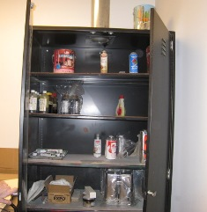

Chemical Storage Cabinet in Art Department

Picture 2

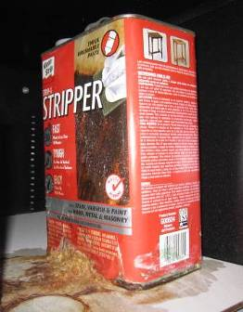

Leaking Can of Stripper; Note Area of Solidified
Chemical from Container to Board on top of Metal Shelf
Picture 3

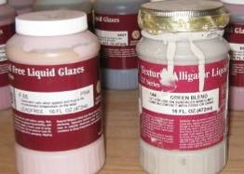

Containers of Glazes; Note Container on Right Lacks “Lead Free” Label

Klean-Strip Strip-X Material Safety Data Sheet (MSDS)

