ODOR INVESTIGATION FOLLOW-UP

Major Edwards Elementary School
70 Crescent Street
West Boylston, Massachusetts

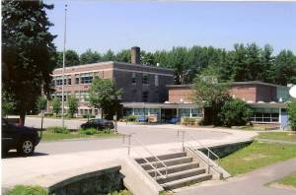

Prepared by:
Massachusetts Department of Public Health
Bureau of Environmental Health
Indoor Air Quality Program
April 2008

Background/Discussion/Odor Investigation
At the request of Principal Thomas Caruso and the West Boylston Public School Department (WBPSD), the Massachusetts Department of Public Health (MDPH), Bureau of Environmental Health (BEH) provided assistance and consultation regarding continued odor complaints at the Major Edwards Elementary School (MEES), 70 Crescent Street, West Boylston, Massachusetts. The request was prompted by concerns related to septic odors in basement classrooms.
MDPH originally visited the building in 2004 and issued a report detailing environmental conditions observed at the time (MDPH, 2004). On December 21, 2007, an odor investigation/indoor air quality (IAQ) assessment was conducted at the MEES by Cory Holmes, an Environmental Analyst in BEH’s IAQ Program. A report was released in February 2008 identifying several potential sources and pathways for odors to migrate into occupied areas.
Since the December 21, 2007 visit, odors of increased intensity were reported in classrooms in the lowest level of the building. Principal Caruso requested that BEH return to the school to assist in the locating the source of these odors since the frequency and intensity of the odors appear to have increased sine the prior BEH visit. Mr. Holmes returned to the MEES on February 8, 2008 accompanied by Michael Feeney, Director of BEH’s IAQ Program to investigate the lower level of the building.
During the course of this visit, it was revealed that two of the classrooms and restrooms on this level were created by renovating former locker rooms. This type of classroom conversion would necessitate the a proper sealing abandoned shower water supplies, toilet water supply and drains as well as floor drains.
Concurrent with BEH follow up visit, the WBPSD had contracted a plumbing company (Eagan Plumbing) to identify the source of the odor and make repairs. On the day of the BEH follow up visit, Eagan Plumbing work had already begun. Eagan Plumbing had removed gypsum wallboard and bored holes into cement block to open a wall cavity that contained a significant amount of abandoned plumbing. According to Eagan Plumbing, floor drains had been sealed with construction debris (Picture 1). With the increased rain during the 2007-2008 winter, combined with the school using a septic system, it is likely that water forced air back up the drain lines subsequently forcing sewage odor through the construction debris and into the wall cavity. From that point the schools heating, ventilating, and air-conditioning system would draw this odor into the classrooms.
These newly discovered open drains were capped by Eagan (Pictures 2 and 3) which resulted in the immediate dissipation of odors. In a telephone conversation with Principal Caruso after this visit, he reported that Eagan Plumbing had located and capped 14 different pipes, drains, and vents in this area of the school. The local plumbing inspector had also inspected and approved the sealing of these open drains. Principal Caruso reported that no further odors had been reported and that occupants would be relocated back to their respective rooms.

Conclusions/Recommendations
The discovery and subsequent sealing of abandoned floor drains/plumbing fixtures by the WBPSD’s plumbing contractor have eliminated the most likely pollutant sources/pathways. In view of the findings at the time of the visit, the following recommendations are made:
- In the event of future odors/concerns, continue working with plumbing contractor to identify/eliminate any additional abandoned plumbing fixtures that serve as sources/pathways for odors.
- Continue to implement all applicable recommendations listed in previous MDPH reports.
References
MDPH. 2004. Indoor Air Quality Assessment. Major Edwards Elementary School, West Boylston, MA. Massachusetts Department of Public Health, Bureau of Environmental Health Assessment, Boston, MA. March, 2004.

MDPH. 2008. Odor Investigation/Indoor Air Quality Assessment. Major Edwards Elementary School, West Boylston, MA. Massachusetts Department of Public Health, Bureau of Environmental Health, Boston, MA. February 2008.
Picture 1

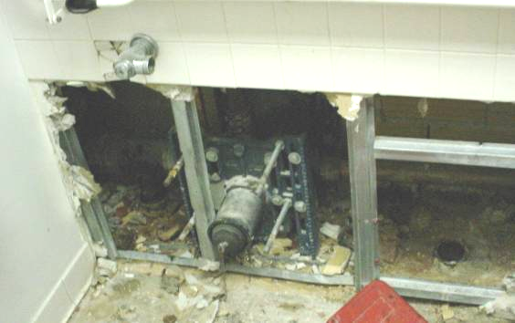

Abandoned Floor Drains in Basement Wall Cavity between Restrooms

Picture 2

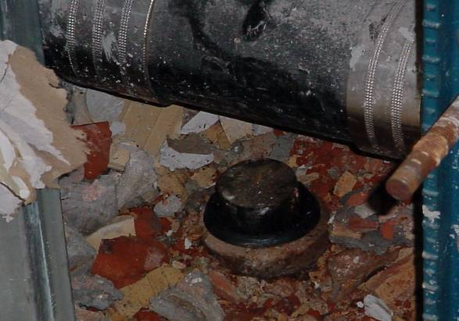

Close-Up of Capped Floor Drain in Basement Wall Cavity between Restrooms

Picture 3

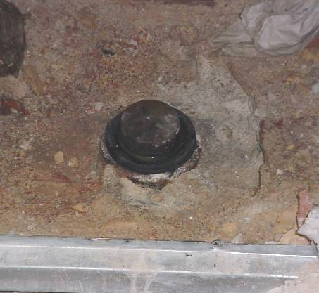

Close-Up of Capped Floor Drain in Basement Wall Cavity between Restrooms

