ODOR INVESTIGATION/INDOOR AIR QUALITY ASSESSMENT

Major Edwards Elementary School
70 Crescent Street
West Boylston, Massachusetts

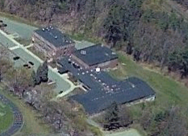

Prepared by:
Massachusetts Department of Public Health
Bureau of Environmental Health
Indoor Air Quality Program
February 2008

Background/Introduction
At the request of Principal Thomas Caruso, and the West Boylston Public School Department (WBPSD), the Massachusetts Department of Public Health (MDPH), Bureau of Environmental Health (BEH) provided assistance and consultation regarding indoor air quality at the Major Edwards Elementary School (MEES), 70 Crescent Street, West Boylston, Massachusetts. The request was prompted by concerns related to septic odors in basement classrooms. On December 21, 2007, a visit to conduct an indoor air quality assessment with a focus on odors was made to this school by Cory Holmes, an Environmental Analyst in BEH’s Indoor Air Quality (IAQ) Program. The investigation focused on basement classrooms and surrounding areas. Mr. Holmes was accompanied by Rick Watson, District Maintenance Coordinator, WBPSD during the assessment.
As described by Principal Caruso, periodic “septic/ sewer-like” odors were reported by staff that occupy basement classrooms, primarily in the occupational therapy (OT) room. The odors reportedly follow no particular pattern related to time, weather or other conditions and usually dissipate after a day or so. Previous to the BEH assessment the WBPS hired Diversified Environmental Corp. (Diversified), an environmental consultant to conduct an indoor air quality investigation. The Diversified report recommended: 1) providing continuous exhaust in the men’s restroom, 2) replacing water damaged ceiling tiles and repairing sources of moisture to prevent further damage, and 3) examining the univent in the Music Room to ensure proper function (Diversified, 2007).
Shortly after the BEH assessment, the WBPSD also contacted a licensed plumber to conduct smoke-tests over Christmas vacation at the MEES to detect possible leaks in the plumbing/drainage systems. In a subsequent conversation with Principal Caruso he stated that the plumbing contractor identified several possible sources of odors including vent pipes on the roof and a leak within a wall cavity. Principal Caruso assured that measures were being taken to address these issues.

Methods
BEH staff performed a visual inspection for potential sources of sewer-gas odors as well as any pathways that could provide a means of migration of odors into occupied areas. In addition, general indoor air quality tests for carbon monoxide, carbon dioxide, temperature and relative humidity were conducted with the TSI, Q-Trak, IAQ Monitor, Model 8551. Air tests for airborne particle matter with a diameter less than 2.5 micrometers were taken with the TSI, DUSTTRAK™ Aerosol Monitor Model 8520. Screening for total volatile organic compounds (TVOCs) was conducted using a Thermo Environmental Instruments Inc., Model 580 Series Photo Ionization Detector (PID).

Results
The school houses a student population of approximately 390 and a staff of approximately 80. The tests were taken during normal operations at the school and results appear in Table 1.

Discussion
Ventilation
It can be seen from Table 1 that carbon dioxide levels were above 800 parts per million (ppm) each of the occupied areas in the basement surveyed, indicating inadequate air exchange in these areas at the time of the assessment. These measurements were likely due to the deactivation, condition and/or removal of mechanical ventilation components. Several classrooms were unoccupied during the assessment, which can greatly reduce carbon dioxide levels. Carbon dioxide levels would be expected to be higher with full occupancy.
Fresh air in basement classrooms is supplied by ceiling-mounted unit ventilator (univent) systems (Picture 1). A univent draws air from outdoors through a fresh air intake located on the exterior wall of the building (Picture 2) and returns air through an air intake located at the base of the unit (Figure 1). Fresh and return air are mixed, filtered, heated and provided to classrooms through an air diffuser located in the top of the unit. Mechanical exhaust ventilation is provided by wall-mounted vents (Picture 3) powered by rooftop motors. Univents are reportedly original equipment from the 1950’s. Univents of this age can be difficult to maintain because replacement parts are often unavailable. The univent in the music room was extremely loud and in need of repair. The univent in the life skills room was reportedly deactivated due to lack of heat control (i.e., overheating).
Also having a negative effect on air exchange was the subdivision of basement classrooms. A large room in the basement was subdivided, which placed the univent in the music room and the exhaust vent in the OT room (Picture 3). This subdivision essentially places the music room under positive pressure and the OT room under negative pressure. It is common practice to adjust mechanical ventilation systems so that classrooms will be slightly pressurized. Areas that are depressurized can draw air/odors from surrounding areas, which may account for the odor complaints in the OT room.
To maximize air exchange, the MDPH recommends that both supply and exhaust ventilation operate continuously during periods of school occupancy. In order to have proper ventilation with a mechanical supply and exhaust system, the systems must be balanced to provide an adequate amount of fresh air to the interior of a room while removing stale air from the room. It is recommended that HVAC systems be re-balanced every five years to ensure adequate air systems function (SMACNA, 1994). The date of the last balancing of these systems was not available at the time of the assessment. Please note that several components of the mechanical ventilation system cannot be balanced in their current condition.
The Massachusetts Building Code requires a minimum ventilation rate of 15 cubic feet per minute (cfm) per occupant of fresh outside air or have openable windows in each room (SBBRS, 1997; BOCA, 1993). The ventilation must be on at all times that the room is occupied. Providing adequate fresh air ventilation with open windows and maintaining the temperature in the comfort range during the cold weather season is impractical. Mechanical ventilation is usually required to provide adequate fresh air ventilation.
Carbon dioxide is not a problem in and of itself. It is used as an indicator of the adequacy of the fresh air ventilation. As carbon dioxide levels rise, it indicates that the ventilating system is malfunctioning or the design occupancy of the room is being exceeded. When this happens, a buildup of common indoor air pollutants can occur, leading to discomfort or health complaints. The Occupational Safety and Health Administration (OSHA) standard for carbon dioxide is 5,000 parts per million parts of air (ppm). Workers may be exposed to this level for 40 hours/week, based on a time-weighted average (OSHA, 1997).
The MDPH uses a guideline of 800 ppm for publicly occupied buildings. A guideline of 600 ppm or less is preferred in schools due to the fact that the majority of occupants are young and considered to be a more sensitive population in the evaluation of environmental health status. Inadequate ventilation and/or elevated temperatures are major causes of complaints such as respiratory, eye, nose and throat irritation, lethargy and headaches. For more information concerning carbon dioxide, consult Appendix A.
Temperature measurements the day of the assessment ranged from 70º F to 75º F, which were within the MDPH recommended comfort range. The MDPH recommends that indoor air temperatures be maintained in a range of 70º F to 78º F in order to provide for the comfort of building occupants. In many cases concerning indoor air quality, fluctuations of temperature in occupied spaces are typically experienced, even in a building with an adequate fresh air supply. As previously mentioned the univent in the life skills classroom was deactivated due to lack of heat control, which may indicate that the thermostatic controls are malfunctioning or in need of calibration. In addition, it is difficult to control temperature and maintain comfort without operating the ventilation equipment as designed (e.g., univents deactivated, room configuration altered).
The relative humidity ranged from 21 to 27 percent, which was below the BEH recommended comfort range in all areas surveyed during the assessment. The BEH recommends a comfort range of 40 to 60 percent for indoor air relative humidity. Relative humidity would be expected to drop below comfort levels during the heating season. The sensation of dryness and irritation is common in a low relative humidity environment. Low relative humidity is a very common problem during the heating season in the northeast part of the United States.

Microbial/Moisture Concerns
The MEES has a history of condensation and mold growth in basement classrooms during periods of elevated relative humidity (>70%). Introduction of uncontrolled hot, moist air via univents and/or windows likely generates condensation on chilled non-porous surfaces (e.g., floor tiles, windows). In order to decrease humidity in classrooms, floor model portable dehumidifiers are utilized. Dehumidifiers should be cleaned/maintained as per the manufacturer’s instructions to prevent mold/bacterial growth and associated odors.
The US Environmental Protection Agency (US EPA) and the American Conference of Governmental Industrial Hygienists (ACGIH) recommend that porous materials be dried with fans and heating within 24 to 48 hours of becoming wet (US EPA, 2001; ACGIH, 1989). If not dried within this time frame, mold growth may occur. Once mold has colonized porous materials, they are difficult to clean and should be removed/discarded.

Odor Investigation

As mentioned previously the reported odors were described as “septic” or “sewer-like”. Mr. Watson detected a previous odor that he described as decomposing rodents. The odors appear to have no obvious pattern related to outdoor weather conditions, time of day/week or particular indoor activities. No unusual odors were detected the day of the BEH assessment, therefore the investigation focused on identifying potential sources and/or pathways for odors to enter occupied areas. BEH staff identified several sources and/or pathways; these included:
- Floor drains in the boiler room (Picture 4) and a clogged drain in an exterior stairwell outside the OT room (Picture 5). Drains are usually designed with traps in order to prevent sewer odors/gases from penetrating into occupied spaces. When water enters a drain, the trap fills and forms a watertight seal. Without a periodic input of water (e.g., every other day), traps can dry, breaking the watertight seal. Without a watertight seal, odors or other material can travel up the drain and enter the occupied space.
- Open utility pipes in the boiler room and a decommissioned heating system in the basement hallway (Pictures 6 and 7);
- Spaces in the basement boy’s restroom wall around sink pipes (Picture 8);
- An abandoned chase way for pipes beneath the floor of the OT room (Picture 9); and
- Spaces beneath exterior doors to the emergency generator room (off the boiler room) (Pictures 10 and 11) and rear exterior wall (Picture 12), which could provide access to pests/rodents into the building.
Each of these is a potential source/pathway for odors/drafts to migrate into occupied areas. Of particular interested was the abandoned chase way located beneath a metal floor plate in the OT room. Although no unusual odors were detected during the assessment, significant airflow was detected around the access plate indicating a potential pathway for drafts/odors to migrate into the OT room. Since the OT room is depressurized, (due to the subdivision of the room putting the supply vent in one room and exhaust in the other), it would tend to entrain (draw-in) odors from adjacent areas including the chase way beneath the floor. Mr. Watson suggested sealing the abandoned chase way with cement; BEH staff agreed that this may eliminate a potential (and most likely) source/pathway of odors/drafts into the OT room.

Other IAQ Evaluations
Indoor air quality can be negatively influenced by the presence of respiratory irritants, such as products of combustion. The process of combustion produces a number of pollutants. Common combustion emissions include carbon monoxide, carbon dioxide, water vapor and smoke (fine airborne particle material). Of these materials, exposure to carbon monoxide and particulate matter with a diameter of 2.5 micrometers (μm) or less (PM2.5) can produce immediate and acute health effects upon exposure. To determine whether combustion products were present in the school environment, BEH staff obtained measurements for carbon monoxide and PM2.5.
Carbon monoxide is a by-product of incomplete combustion of organic matter (e.g., gasoline, wood and tobacco). Exposure to carbon monoxide can produce immediate and acute health affects. Several air quality standards have been established to address carbon monoxide and prevent symptoms from exposure to these substances. The MDPH established a corrective action level concerning carbon monoxide in ice skating rinks that use fossil-fueled ice resurfacing equipment. An operator of an indoor ice must take actions to reduce carbon monoxide levels, if those levels exceed 30 ppm, 20 minutes after resurfacing within a rink (MDPH, 1997).
The American Society of Heating Refrigeration and Air-Conditioning Engineers (ASHRAE) has adopted the National Ambient Air Quality Standards (NAAQS) as one set of criteria for assessing indoor air quality and monitoring of fresh air introduced by HVAC systems (ASHRAE, 1989). The NAAQS are standards established by the US EPA to protect the public health from six criteria pollutants, including carbon monoxide and particulate matter (US EPA, 2006). As recommended by ASHRAE, pollutant levels of fresh air introduced to a building should not exceed the NAAQS levels (ASHRAE, 1989). The NAAQS were adopted by reference in the Building Officials & Code Administrators (BOCA) National Mechanical Code of 1993 (BOCA, 1993), which is now an HVAC standard included in the Massachusetts State Building Code (SBBRS, 1997). According to the NAAQS, carbon monoxide levels in outdoor air should not exceed 9 ppm in an eight-hour average (US EPA, 2006).
Carbon monoxide should not be present in a typical, indoor environment. If it is present, indoor carbon monoxide levels should be less than or equal to outdoor levels. Outdoor carbon monoxide concentrations were non-detect (ND) (Table 1). Carbon monoxide levels measured in the school were also ND during the assessment.
The US EPA has established NAAQS limits for exposure to particulate matter. Particulate matter is airborne solids that can be irritating to the eyes, nose and throat. The NAAQS originally established exposure limits to particulate matter with a diameter of 10 μm or less (PM10). According to the NAAQS, PM10 levels should not exceed 150 microgram per cubic meter (μg/m³) in a 24-hour average (US EPA, 2006). These standards were adopted by both ASHRAE and BOCA. Since the issuance of the ASHRAE standard and BOCA Code, US EPA established a more protective standard for fine airborne particles. This more stringent PM2.5 standard requires outdoor air particle levels be maintained below 35 μg/m³ over a 24-hour average (US EPA, 2006). Although both the ASHRAE standard and BOCA Code adopted the PM10 standard for evaluating air quality, MDPH uses the more protective PM2.5 standard for evaluating airborne particulate matter concentrations in the indoor environment.
Outdoor PM2.5 concentrations the day of the assessment were measured at 17 μg/m³. PM2.5 levels measured in the school ranged from 13 to 18 μg/m³ (Table 1), which were below the NAAQS PM2.5 level of 35 μg/m³. Frequently, indoor air levels of particulates (including PM2.5) can be at higher levels than those measured outdoors. A number of mechanical devices and/or activities that occur in schools can generate particulate during normal operations. Sources of indoor airborne particulates may include but are not limited to particles generated during the operation of fan belts in the HVAC system, cooking in the cafeteria stoves and microwave ovens; use of photocopiers, fax machines and computer printing devices; operation of an ordinary vacuum cleaner and heavy foot traffic indoors.
Indoor air quality can also be negatively influenced by the presence of materials containing volatile organic compounds (VOCs). VOCs are carbon-containing substances that have the ability to evaporate at room temperature. Frequently, exposure to low levels of total VOCs (TVOCs) may produce eye, nose, throat and/or respiratory irritation in some sensitive individuals. For example, chemicals evaporating from a paint can stored at room temperature would most likely contain VOCs. In an effort to determine whether VOCs were present in the building, air monitoring for TVOCs was conducted. An outdoor air sample was taken for comparison. Outdoor TVOC concentrations were ND (Table 1). Indoor TVOC concentrations were also ND during the assessment (Table 1).
Please note, TVOC air measurements are only reflective of the indoor air concentrations present at the time of sampling. Indoor air concentrations can be greatly impacted by the use of TVOC containing products. In an effort to identify materials that can potentially increase indoor TVOC concentrations, BEH staff examined classrooms for products containing these respiratory irritants. Several classrooms contained dry erase boards and dry erase board markers. Materials such as dry erase markers and dry erase board cleaners may contain VOCs, such as methyl isobutyl ketone, n-butyl acetate and butyl-cellusolve (Sanford, 1999), which can be irritating to the eyes, nose and throat.
Finally, the art room has a kiln equipped with local exhaust ventilation (Picture 13). Pottery kilns can produce carbon monoxide and sulfur dioxide, which can cause respiratory symptoms in exposed individuals (McCann, 1985). The terminus of the exhaust vent releases kiln exhaust approximately 4-feet below the univent fresh air intake (Picture 14). The building code requires that pollutant sources must be ten feet away from and two feet above fresh air intakes (BOCA, 1993, SBBRS, 1997). An extension several feet above the fresh air intake may be needed to prevent entrainment of kiln exhaust.

Conclusions/Recommendations
Although no unusual odors were detected the day of the assessment, a number of potential sources and/or pathways for odors to enter occupied areas were identified. Sealing/elimination of these pollutant sources/pathways in addition to actions recommended by the plumbing contractor should be implemented to eliminate the migration of odors into occupied areas. In view of the findings at the time of the visit, the following recommendations are made:
- Continue with plans to seal abandoned pipe chase way beneath floor of OT room (as well as in any other occupied areas of the basement).
- Seal or remove open pipes to decommissioned heating system in the basement.
- Ensure drain at bottom of exterior stairwell outside of basement classrooms is clear and draining properly. Inspect/maintain on a regular basis.
- Seal around pipes/wall in basement restroom.
- Take measures to tighten exterior doors (e.g., weather-stripping) to the emergency generator room to prevent pest/rodent entry. Ensure tightness of doors by monitoring for light penetration and drafts around doorframes.
- Seal open utility holes/breaches in exterior walls (Picture 12).
- Examine each univent for function, replace parts and make repairs as necessary. Survey classrooms for univent function to ascertain if an adequate air supply exists for each room; an increase of fresh air intake may be necessary. Operate univents while classrooms are occupied.
- Operate both supply and exhaust ventilation continuously during periods of school occupancy, independent of classroom thermostat control to maximize air exchange.
- Repair and/or replace thermostats as necessary to maintain control of comfort.
- Contact an HVAC engineering firm for a ventilation systems assessment. Based on the age, physical deterioration and availability of parts for ventilation components, such an evaluation is necessary to determine the operability and feasibility of repairing/replacing the equipment.
- Work with HVAC firm to examine methods to provide mechanical supply ventilation to the OT room and exhaust ventilation to the music room. As noted in the report, classrooms should be slightly pressurized to avoid the entrainment of odors/particulates from adjacent areas.
- Change filters for air-handling equipment as per the manufacturer’s instructions or more frequently if needed. Vacuum interior of units prior to activation to prevent the aerosolization of dirt, dust and particulates. Ensure filters fit flush in their racks with no spaces in between allowing bypass of unfiltered air into the unit.
- Close classroom doors to maximize air exchange.
- Consider adopting a balancing schedule of every 5 years for all mechanical ventilation systems, as recommended by ventilation industrial standards (SMACNA, 1994).
- For buildings in New England, periods of low relative humidity during the winter are often unavoidable. Therefore, scrupulous cleaning practices should be adopted to minimize common indoor air contaminants whose irritant effects can be enhanced when the relative humidity is low. To control for dusts, a high efficiency particulate arrestance (HEPA) filter equipped vacuum cleaner in conjunction with wet wiping of all surfaces is recommended. Avoid the use of feather dusters. Drinking water during the day can help ease some symptoms associated with a dry environment (throat and sinus irritations).
- Use windows to introduce fresh air and supplement the mechanical ventilation system, particulary in the OT room. However, staff should ensure windows are closed during hot, humid weather to limit moisture intrusion and avoid condensation problems.
- Utilize ACs and/or dehumidifiers to reduce relative humidity during periods of excessive relative humidity (e.g., over 70% for extended periods of time).
- Ensure dehumidifiers are cleaned/maintained as per the manufacturer’s instructions to prevent mold/bacterial growth.
- Consider stationing dehumidifiers on countertops so they drain directly into sinks (where available) to prevent overflow and reduce maintenance.
- Extend local exhaust vent pipe for kiln in close proximity to univent air intake several feet above the fresh air intake to prevent entrainment. The building code requires that pollutant sources must be ten feet away from and two feet above fresh air intakes (BOCA, 1993; SBBRS, 1997).
- Consider adopting the US EPA (2000) document, “Tools for Schools”, as an instrument for maintaining a good indoor air quality environment in the building. This document is available at: http://www.epa.gov/iaq/schools/index.html.
- Refer to resource manual and other related indoor air quality documents located on the MDPH’s website for further building-wide evaluations and advice on maintaining public buildings. These documents are available at: http://www.state.ma.us/dph/MDPH/iaq/iaqhome.htm.

References
ACGIH. 1989. Guidelines for the Assessment of Bioaerosols in the Indoor Environment. American Conference of Governmental Industrial Hygienists, Cincinnati, OH.

ASHRAE. 1989. Ventilation for Acceptable Indoor Air Quality. American Society of Heating, Refrigeration and Air Conditioning Engineers. ANSI/ASHRAE 62-1989
BOCA. 1993. The BOCA National Mechanical Code/1993. 8th ed. Building Officials & Code Administrators International, Inc., Country Club Hills, IL.

Diversified. 2007. Diversified Environmental Corp. Air Quality Investigation: West Boylston Public Schools, Major Edwards Elementary School. Project #07-Various. December 19, 2007.

McCann, M. 1985. Health Hazards Manual for Artists. 3rd rev. ed. Lyons & Burford, Publishers, New York, NY.
MDPH. 1997. Requirements to Maintain Air Quality in Indoor Skating Rinks (State Sanitary Code, Chapter XI). 105 CMR 675.000. Massachusetts Department of Public Health, Boston, MA.
OSHA. 1997. Limits for Air Contaminants. Occupational Safety and Health Administration. Code of Federal Regulations. 29 C.F.R 1910.1000 Table Z-1-A.

Sanford. 1999. Material Safety Data Sheet (MSDS No: 198-17). Expo® Dry Erase Markers Bullet, Chisel, and Ultra Fine Tip. Sanford Corporation. Bellwood, IL.

SBBRS. 1997. Mechanical Ventilation. State Board of Building Regulations and Standards. Code of Massachusetts Regulations. 780 CMR 1209.0

SMACNA. 1994. HVAC Systems Commissioning Manual. 1st ed. Sheet Metal and Air Conditioning Contractors’ National Association, Inc., Chantilly, VA.

US EPA. 2000. Tools for Schools. Office of Air and Radiation, Office of Radiation and Indoor Air, Indoor Environments Division (6609J). EPA 402-K-95-001, Second Edition. http://www.epa.gov/iaq/schools/tools4s2.html

US EPA. 2001. “Mold Remediation in Schools and Commercial Buildings”. Office of Air and Radiation, Indoor Environments Division, Washington, DC. EPA 402-K-01-001. March 2001. Available at: http://www.epa.gov/iaq/molds/mold_remediation.html

US EPA. 2006. National Ambient Air Quality Standards (NAAQS). US Environmental Protection Agency, Office of Air Quality Planning and Standards, Washington, DC. http://www.epa.gov/air/criteria.html.
Picture 1

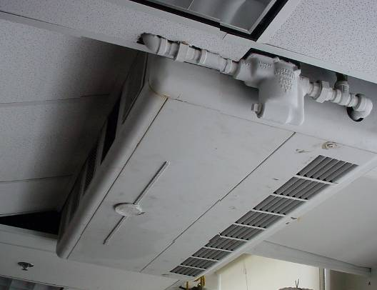

Ceiling-Mounted Univent (1950s Vintage) in Classroom

Picture 2

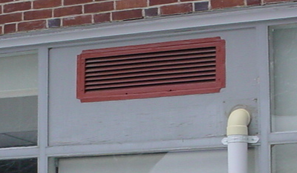

Univent Fresh Air Intake Vent
Picture 3

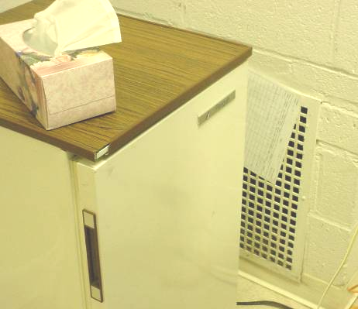

Wall-Mounted Exhaust Vent in OT Room, Suspended Paper Indicates Draw of Air

Picture 4

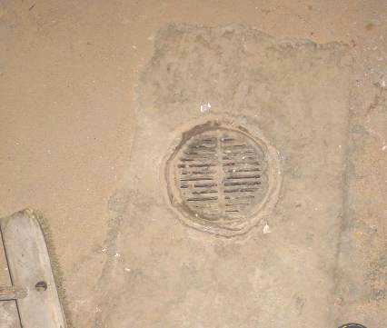

Floor Drain Located in Boiler Room
Picture 5

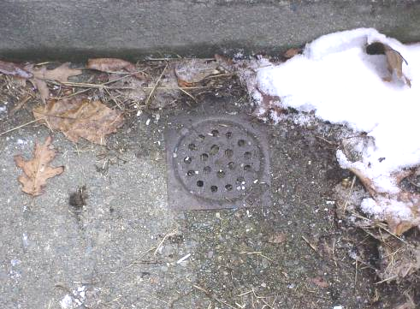

Clogged Exterior Stairwell Drain outside of OT Room

Picture 6

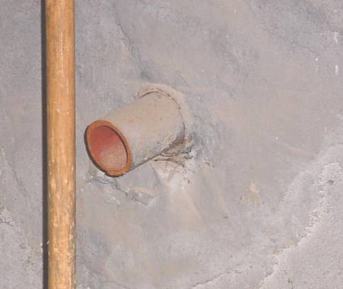

Open Pipe in Boiler Room to Abandoned Heating System in Basement Hallway
Picture 7

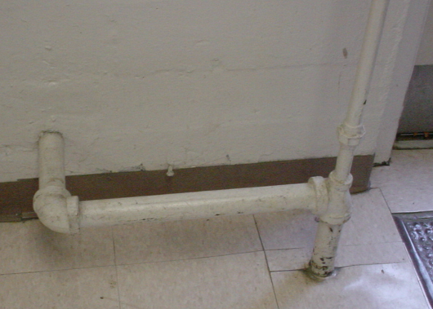

Pipes in Basement Hallway to Abandoned Heating System

Picture 8

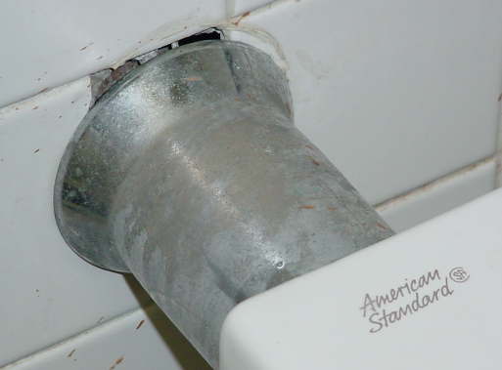

Spaces around Pipes in Basement Restroom Where Drafts were Detected
Picture 9

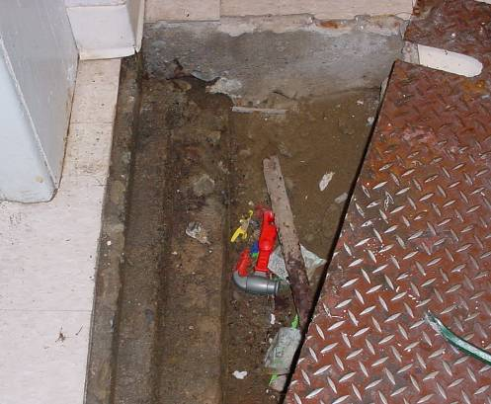

Chaseway beneath Metal Floor Panel in OT Room, Arrow Indicates Open Utility Hole for Pipe Passage

Picture 10

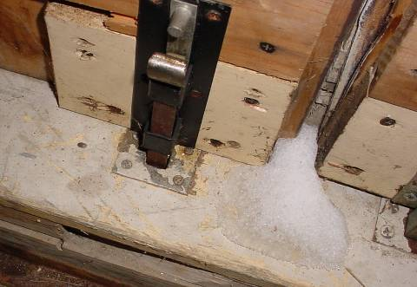

Spaces around Emergency Generator Room, Note Snow Penetration
Picture 11

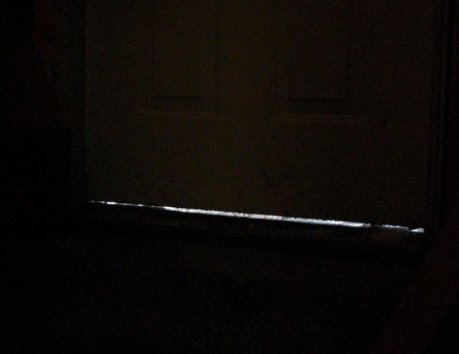

Light Penetrating beneath Emergency Generator Room off Boiler Room

Picture 12

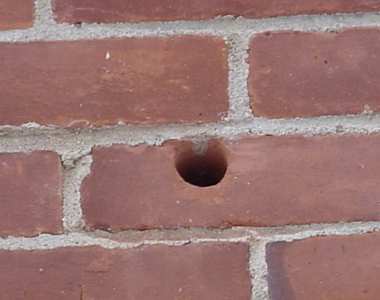

Open Utility Hole in Rear Exterior Wall
Picture 13

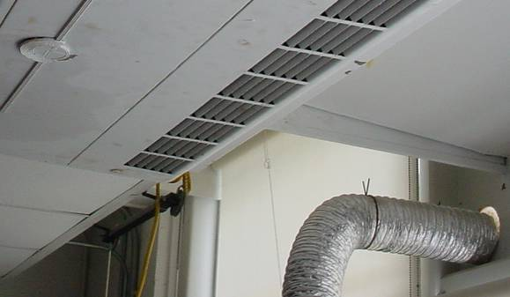

Art Room Univent and Local Exhaust Duct Exiting Exterior Wall

Picture 14

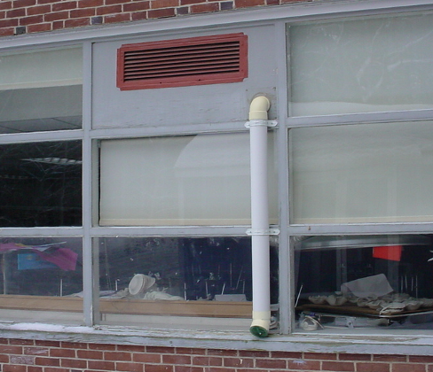

Art Room Univent Air Intake, Note Proximity to Local Kiln Exhaust
(as Indicated by Arrow)
Location/ Room | Occupants  in Room | Temp  (°F) | Relative  Humidity  (%) | Carbon  Dioxide  (ppm) | Carbon Monoxide  (ppm) | TVOCs  (ppm) | PM2.5  (µg/m3) | Windows  Openable | Ventilation |  | Remarks
 |  |  |  |  |  |  |  |  | Supply | Exhaust | Remarks
background |  | 36 | 35 | 339 | ND | ND | 17 |  |  |  | Overcast, cols, light snow winds: 6-13 MPH, gusts up to 20
Boiler Room | 2 | 75 | 27 | 489 | ND | ND | 18 | N | Y  Passive | N | Floor drains, open utility hole-wall, spaces under doors to outside in generator room-rodent access
Basement Hallway (near boiler room) |  |  |  |  |  |  |  |  |  |  | Decommissioned pipes
OT | 10 | 73 | 25 | 1183 | ND | ND | 15 | Y | N | Y | Area where strongest odors reported-no odors detected during assessment, access plate in floor-pipe chase-drafts detected, room ÷in half (supply in Music room/exhaust in OT room), room depressurized, exterior drain outside in stairwell-clogged
Music | 0 | 70 | 22 | 569 | ND | ND | 14 | Y | Y | N | room ÷in half (supply in Music room/exhaust in OT room), room pressurized, univent extremely noisy-needs repair
Art | 0 | 70 | 21 | 580 | ND | ND | 13 | Y | Y | Y
Life Skills | 6 | 73 | 24 | 1063 | ND | ND | 16 | Y | Y | Y | Univent off-heat control issues
Boy’s Room basement |  |  |  |  |  |  |  |  |  | Y | Spaces around sink pipes-drafts

