Quick Meal? Your Choice Calories count. Use this guide to help you make better choices.

High Calorie Calories Lower Calorie Calories
Breakfast Food
Sausage egg and cheese on a croissant 690 Ham, egg and cheese on an English Muffin 360
Medium mocha latte with whip cream 330 Medium non-fat latte without whip cream 120
TOTAL 1,020 TOTAL 480

Sandwich
12 inch meatball sub 1160 6 inch turkey sub 260
Bag of regular potato chips 230 Bag of baked potato chips 130
Medium regular soft drink 255 Water or diet soft drink 0
Chocolate chip cookie 200 Apple slices with caramel dip 85
TOTAL 1845 TOTAL 475

Chicken
3 piece dark meat with skin 555 3 piece dark meat without skin 350
Mashed potatoes with gravy 225 Mashed potatoes without gravy 180
Coleslaw 295 Sweet corn 135
Medium sweetened ice tea 160 Water 0
TOTAL 1235 TOTAL 665

Mexican
Burrito 1050 Two soft tacos with cheese and sauce 500
Chips with cheese 970 Mexican rice 120
Medium soft drink 255 Water 0
TOTAL 2275 TOTAL 620

Pizza
2 slices regular crush sausage pizza 900 2 slices regular crush veggie pizza 720
Medium soft drink 255 Water 0
TOTAL 1155 TOTAL 720

Burger
Double cheeseburger 597 Cheeseburger 330
Large fry 530 Side salad with low-fat Italian dressing 80
Medium soft drink 255 Water 0
TOTAL 1382 TOTAL 410


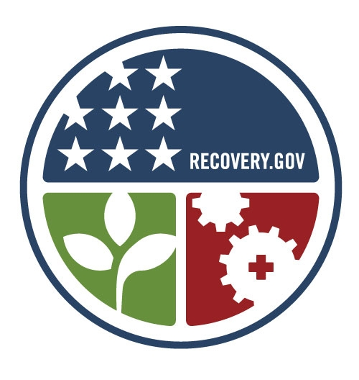
2000 calories per day is what most adults need to control their weight. Learn more at mass.gov/massinmotion

