INDOOR AIR QUALITY ASSESSMENT

Malcolm L. Bell Lower School
40-42 Baldwin Road
Marblehead, MA 01945

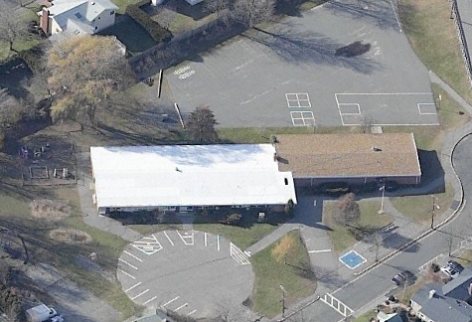

Prepared by:
Massachusetts Department of Public Health
Bureau of Environmental Health
Emergency Response/Indoor Air Quality Program
July 2007

Background/Introduction
At the request a parent, the Massachusetts Department of Public Health (MDPH), Bureau of Environmental Health (BEH) conducted an indoor air quality assessment at the lower building of the Malcolm L. Bell School (MBS), 42 Baldwin Road, Marblehead, Massachusetts. The assessment was prompted by concerns of mold growth and associated odors in the school. On February 12, 2007, a visit to conduct an indoor air quality investigation was made to the MBS by Sharon Lee, an Environmental Analyst in BEH’s Emergency Response/Indoor Air Quality (ER/IAQ) Program. During the assessment Ms. Lee was accompanied by David Dunkley, Facilities Director, Marblehead Public Schools.
The lower building of the MBS is a single-story, red brick building constructed in 1958. The school consists of pre-kindergarten and kindergarten classrooms, as well as a main office, nurse’s office and gymnasium.

Methods
Air tests for carbon monoxide, carbon dioxide, temperature and relative humidity were conducted with the TSI, Q-Trak, IAQ Monitor, Model 8551. Air tests for airborne particle matter with a diameter less than 2.5 micrometers were taken with the TSI, DUSTTRAK™ Aerosol Monitor Model 8520. Screening for total volatile organic compounds (TVOCs) was conducted using an HNu, Model 102 Snap-on Photo Ionization Detector (PID). BEH staff also performed a visual inspection of building materials for water damage and/or microbial growth.
Results
The school houses approximately 120 pre-kindergarten and kindergarten students, as well as approximately 30 staff members. Tests were taken during normal operations at the school and results appear in Table 1.
Discussion

Ventilation
It can be seen from Table 1 that carbon dioxide levels were elevated above 800 parts per million (ppm) in three of nine areas, indicating adequate ventilation in two-thirds of the areas surveyed the day of the assessment. Fresh air in classrooms is supplied by unit ventilator (univent) systems (Picture 1). A univent draws air from the outdoors through a fresh air intake located on the exterior wall of the building and returns air through an air intake located at the base of the unit (Figure 1, Picture 2). Fresh and return air are mixed, filtered, heated and provided to classrooms through an air diffuser located in the top of the unit. One univent was found deactivated, reportedly by the room occupant. Obstructions to airflow, such as papers and books stored on univents and bookcases and carts and desks located in front of univent returns, were also observed in a few classrooms (Picture 3). In order for univents to provide fresh air as designed, these units must remain activated and allowed to operate while rooms are occupied. In addition, univent intakes and diffusers must remain free of obstructions.
Exhaust ventilation is provided by a mechanical exhaust vent box located in the closet. Air is drawn into the closet via undercut doors and removed from the building (Picture 4). The exhaust fan was not operating in one classroom at the time of assessment. The location of these exhausts allows them to be easily blocked by stored materials. Without sufficient supply and exhaust ventilation, indoor air pollutants can build up, leading to indoor air quality/comfort complaints.
To maximize air exchange, the MDPH recommends that both supply and exhaust ventilation operate continuously during periods of occupancy. In order to have proper ventilation with a mechanical supply and exhaust system, the systems must be balanced to provide an adequate amount of fresh air to the interior of a room while removing stale air from the room. It is recommended that HVAC systems be re-balanced every five years to ensure adequate air systems function (SMACNA, 1994).
The Massachusetts Building Code requires a minimum ventilation rate of 15 cubic feet per minute (cfm) per occupant of fresh outside air or have openable windows in each room (SBBRS, 1997; BOCA, 1993). The ventilation must be on at all times that the room is occupied. Providing adequate fresh air ventilation with open windows and maintaining the temperature in the comfort range during the cold weather season is impractical. Mechanical ventilation is usually required to provide adequate fresh air ventilation.
Carbon dioxide is not a problem in and of itself. It is used as an indicator of the adequacy of the fresh air ventilation. As carbon dioxide levels rise, it indicates that the ventilating system is malfunctioning or the design occupancy of the room is being exceeded. When this happens, a buildup of common indoor air pollutants can occur, leading to discomfort or health complaints. The Occupational Safety and Health Administration (OSHA) standard for carbon dioxide is 5,000 parts per million parts of air (ppm). Workers may be exposed to this level for 40 hours/week, based on a time-weighted average (OSHA, 1997).
The MPDH uses a guideline of 800 ppm for publicly occupied buildings. A guideline of 600 ppm or less is preferred in schools due to the fact that the majority of occupants are young and considered to be a more sensitive population in the evaluation of environmental health status. Inadequate ventilation and/or elevated temperatures are major causes of complaints such as respiratory, eye, nose and throat irritation, lethargy and headaches. For more information concerning carbon dioxide, consult Appendix A.
Temperature measurements the day of the assessment ranged from 68º F to 74º F, which were within or close to the lower end of the MDPH recommended comfort range. The MDPH recommends that indoor air temperatures be maintained in a range of 70º F to 78º F in order to provide for the comfort of building occupants. Although temperatures were within the recommended comfort range in most areas assessed, occupants expressed temperature control complaints to BEH staff during the assessment. In many cases concerning indoor air quality, fluctuations of temperature in occupied spaces are typically experienced, even in a building with an adequate fresh air supply.
The relative humidity measured in the building during the assessment ranged from 10 to 17 percent, which was below the MDPH recommended comfort range. The MDPH recommends a comfort range of 40 to 60 percent for indoor air relative humidity. Relative humidity levels in the building would be expected to drop during the winter months due to heating. The sensation of dryness and irritation is common in a low relative humidity environment. Low relative humidity is a very common problem during the heating season in the northeast part of the United States.

Microbial/Moisture Concerns
As previously mentioned, the assessment was prompted by concerns of mold growth and the detection of odors by a parent. According to Mr. Dunkley, the gymnasium is prone to periodic moisture problems due to a high water table. Approximately 2-3 years ago, related to groundwater flooding occurred in the gym. Following the flood, the gym was reportedly cleaned and disinfected, while damaged materials were removed and replaced. At the time of the assessment, no current damage or odors were noted. However, due to the increased moisture that may be experienced in the gym, especially during high humidity and prolonged periods of precipitation, BEH staff recommended vacuuming cracks/crevices (i.e., between wood work) and duct work periodically with a high efficiency particle arrestance (HEPA) filtered vacuum, removing plastic baseboard coving to prevent trapping of moisture behind the coving and operating a dehumidifier during periods of high humidity (> 70%).
More recently during the spring of 2006, flooding was experienced in the boiler room, which is below grade. Mr. Dunkley reported that a sump pump that normally operates in the boiler room had failed. As a result, three feet of water accumulated in the boiler room. Damaged equipment and materials were reportedly removed and replaced. The sump pump was restored and has since been operating with no other flooding reported.
The US Environmental Protection Agency (US EPA) and the American Conference of Governmental Industrial Hygienists (ACGIH) recommends that porous materials (carpeting, ceiling tiles, etc.) be dried with fans and heating within 24 to 48 hours of becoming wet (US EPA, 2001; ACGIH, 1989). If porous materials are not dried within this time frame, mold growth may occur. Water-damaged porous materials cannot be adequately cleaned to remove mold growth. The application of a mildewcide to moldy porous materials is not recommended.
Several classrooms had a number of plants. Moistened plant soil and drip pans can be a source of mold growth. Plants should be equipped with drip pans; the lack of drip pans can lead to water pooling and mold growth on windowsills. Plants are also a source of pollen. Plants should be located away from the air stream of ventilation sources to prevent the aerosolization of mold, pollen or particulate matter throughout the classroom (Picture 1).
Shrubbery and other plants were also observed to be growing in cracks and crevices in close proximity to the foundation walls (Picture 2). The growth of roots against the exterior walls can bring moisture in contact with wall brick and eventually lead to cracks and/or fissures in the foundation below ground level. Similarly, clinging plants were observed growing against the building exterior (Picture 5). Clinging plants can cause damage to brickwork through the insertion of tendrils into brick and mortar. Water can penetrate into the brick along the tendrils, which can subsequently freeze and thaw during the winter. This freezing/thawing action can weaken bricks and mortar, resulting in damage.
A damaged downspout was observed on the exterior of the building (Picture 6). Excessive exposure of exterior brickwork to water can result in structural damage. Over time, these conditions can undermine the integrity of the building envelope and provide a means of water entry into the building through capillary action through foundation concrete and masonry (Lstiburek & Brennan, 2001).

Other IAQ Evaluations
Indoor air quality can be negatively influenced by the presence of respiratory irritants, such as products of combustion. The process of combustion produces a number of pollutants. Common combustion emissions include carbon monoxide, carbon dioxide, water vapor and smoke (fine airborne particle material). Of these materials, exposure to carbon monoxide and particulate matter with a diameter of 2.5 micrometers (μm) or less (PM2.5) can produce immediate, acute health effects upon exposure. To determine whether combustion products were present in the school environment, BEH staff obtained measurements for carbon monoxide and PM2.5.
Carbon monoxide is a by-product of incomplete combustion of organic matter (e.g., gasoline, wood and tobacco). Exposure to carbon monoxide can produce immediate and acute health affects. Several air quality standards have been established to address carbon monoxide and prevent symptoms from exposure to these substances. The MDPH established a corrective action level concerning carbon monoxide in ice skating rinks that use fossil-fueled ice resurfacing equipment. If an operator of an indoor ice rink measures a carbon monoxide level over 30 ppm, taken 20 minutes after resurfacing within a rink, that operator must take actions to reduce carbon monoxide levels (MDPH, 1997).
The American Society of Heating Refrigeration and Air-Conditioning Engineers (ASHRAE) has adopted the National Ambient Air Quality Standards (NAAQS) as one set of criteria for assessing indoor air quality and monitoring of fresh air introduced by HVAC systems (ASHRAE, 1989). The NAAQS are standards established by the US EPA to protect the public health from six criteria pollutants, including carbon monoxide and particulate matter (US EPA, 2006). As recommended by ASHRAE, pollutant levels of fresh air introduced to a building should not exceed the NAAQS levels (ASHRAE, 1989). The NAAQS were adopted by reference in the Building Officials & Code Administrators (BOCA) National Mechanical Code of 1993 (BOCA, 1993), which is now an HVAC standard included in the Massachusetts State Building Code (SBBRS, 1997). According to the NAAQS, carbon monoxide levels in outdoor air should not exceed 9 ppm in an eight-hour average (US EPA, 2006).
Carbon monoxide should not be present in a typical, indoor environment. If it is present, indoor carbon monoxide levels should be less than or equal to outdoor levels. On the day of assessment, outdoor carbon monoxide concentrations were non-detect (ND) (Table 1). Carbon monoxide levels measured in the school were ND (Table 1). Although no carbon monoxide or associated combustion odors were detected during the assessment, BEH staff observed spaces beneath the boiler room door. If the boiler room becomes pressurized, odors and particulates can be forced around the door and into the hallway. Consideration should be given to installing a door sweep to the boiler room door to prevent movement of boiler room odors and products of combustion to occupied areas of the school.
The US EPA has established NAAQS limits for exposure to particulate matter. Particulate matter is airborne solids that can be irritating to the eyes, nose and throat. The NAAQS originally established exposure limits to particulate matter with a diameter of 10 μm or less (PM10). According to the NAAQS, PM10 levels should not exceed 150 microgram per cubic meter (μg/m³) in a 24-hour average (US EPA, 2006). These standards were adopted by both ASHRAE and BOCA. Since the issuance of the ASHRAE standard and BOCA Code, the US EPA established a more protective standard for fine airborne particles. This more stringent PM2.5 standard requires outdoor air particle levels be maintained below 35 μg/m³ over a 24-hour average (US EPA, 2006). Although both the ASHRAE standard and BOCA Code adopted the PM10 standard for evaluating air quality, MDPH uses the more protective PM2.5 standard for evaluating airborne particulate matter concentrations in the indoor environment.
Outdoor PM2.5 concentrations were measured at 19 μg/m³ (Table 1). PM2.5 levels within the school ranged from 13 to 15 μg/m³, which were below the NAAQS of 35 μg/m³ (Table 1). Frequently, indoor air levels of particulates can be at higher levels than those measured outdoors. A number of mechanical devices and/or activities that occur in schools can generate particulates during normal operation. Sources of indoor airborne particulate may include but are not limited to particles generated during the operation of fan belts in the HVAC system, cooking in the cafeteria stoves and microwave ovens; use of photocopiers, fax machines and computer printing devices, operating an ordinary vacuum cleaner and heavy foot traffic indoors.
Indoor air quality can also be negatively influenced by the presence of materials containing volatile organic compounds (VOCs). VOCs are carbon-containing substances that have the ability to evaporate at room temperature. Frequently, exposure to low levels of total VOCs (TVOCs) may produce eye, nose, throat and/or respiratory irritation in some sensitive individuals. For example, chemicals evaporating from a paint can stored at room temperature would most likely contain VOCs. In an effort to determine whether VOCs were present in the building, air monitoring for TVOCs was conducted during the assessment. An outdoor air sample was taken for comparison. Outdoor TVOC concentrations were ND (Table 1). Indoor TVOC concentrations were ND in all areas surveyed (Table 1).
In an effort to identify materials that can potentially increase indoor TVOC concentrations, BEH staff examined classrooms for products containing these respiratory irritants. The majority of classrooms contained dry erase boards and dry erase board markers. Materials such as dry erase markers and dry erase board cleaners may contain VOCs, such as methyl isobutyl ketone, n-butyl acetate and butyl-cellusolve (Sanford, 1999), which can be irritating to the eyes, nose and throat.
Cleaning products were found on countertops and in unlocked cabinets beneath sinks in some classrooms (Picture 7). Like dry erase materials, cleaning products contain VOCs and other chemicals that can be irritating to the eyes, nose and throat of sensitive individuals.
Lamination machines can give off waste heat and odors. As reported by Mr. Dunkley, the school experienced an instance where a laminator had remained ‘on’ for an extended period of time. As a result, a strong burning plastic odor was produced. These odors migrated from the teachers’ room, where the laminator is located (Picture 8), to the front hallway of the building. The teacher’s room does not have mechanical exhaust ventilation to help remove excess heat and odors. According to Mr. Dunkley, the window immediately behind the laminator was opened following the incident; however, the odors from the machine lingered for some time.
Finally of note was the amount of materials stored inside classrooms. In some classrooms items were observed on windowsills, tabletops, counters, univents, bookcases and desks. The stored materials in classrooms provide surfaces for dust to accumulate. Accumulation of these items (e.g., papers, folders, boxes) makes cleaning difficult for custodial staff.
Conclusions/Recommendations
In view of the findings, the following recommendations are made:
- Operate both supply and exhaust ventilation continuously during periods of school occupancy, independent of classroom thermostat control to maximize air exchange. Consult the school’s heating, ventilation and air conditioning (HVAC) engineer concerning an increase in the introduction of outside air.
- Ensure supply and exhaust vents are free of obstructions to facilitate airflow.
- Consider having the ventilation system balanced by an HVAC engineer every five years (SMACNA, 1994).
- Change filters for HVAC equipment as per manufacturer’s instructions or more frequently if needed.
- For buildings in New England, periods of low relative humidity during the winter are often unavoidable. Therefore, scrupulous cleaning practices should be adopted to minimize common indoor air contaminants whose irritant effects can be enhanced when the relative humidity is low. To control for dusts, a high efficiency particulate arrestance (HEPA) filter equipped vacuum cleaner in conjunction with wet wiping of all surfaces is recommended. Avoid the use of feather dusters. Drinking water during the day can help ease some symptoms associated with a dry environment (throat and sinus irritations).
- Vacuum cracks/crevices (i.e., between wood work) and duct work in the gymnasium periodically with a high efficiency particle arrestance (HEPA) filtered vacuum
- Remove plastic baseboard coving in the gymnasium to prevent accumulation of moisture and materials behind the coving
- Consider operating a dehumidifier in the gymnasium during periods of high humidity
- Ensure plants have drip pans. Examine drip pans periodically for mold growth and disinfect with an appropriate antimicrobial where necessary. Remove plants from the air stream of mechanical ventilation.
- Remove shrubs, plants and clinging plant growth from the building exterior and perimeter to prevent damage to masonry
- Repair/replace elbow extensions on downspouts to direct rain water away from the building.
- Store cleaning products properly and out of reach of students. Ensure spray bottles are properly labeled. All cleaning products used at the facility should be approved by the school department with MSDS’ available at a central location.
- Relocate or consider reducing the amount of materials stored in classrooms to allow for more thorough cleaning. Clean items regularly with a wet cloth or sponge to prevent excessive dust build-up.
- Ensure laminator is deactivated after use. Open windows to create air exchange and reduce odors during operation. Consider installing a local exhaust fan in the teachers’ lounge.
- Install door sweep on boiler room door to prevent the migration of odors and particulates.
- Consider adopting the US EPA (2000) document, “Tools for Schools”, as an instrument for maintaining a good indoor air quality environment in the building. This document is available at: http://www.epa.gov/iaq/schools/index.html.
- For more information on mold, Consult “Mold Remediation in Schools and Commercial Buildings” published by the US Environmental Protection Agency (US EPA, 2001) for more information on mold. This document can be downloaded from the US EPA website at: http://www.epa.gov/iaq/molds/mold_remediation.html.
- Refer to resource manual and other related indoor air quality documents located on the MDPH’s website for further building-wide evaluations and advice on maintaining public buildings. These documents are available at: http://www.state.ma.us/dph/MDPH/iaq/iaqhome.htm.

References
ACGIH. 1989. Guidelines for the Assessment of Bioaerosols in the Indoor Environment. American Conference of Governmental Industrial Hygienists, Cincinnati, OH.
ASHRAE. 1989. Ventilation for Acceptable Indoor Air Quality. American Society of Heating, Refrigeration and Air Conditioning Engineers. ANSI/ASHRAE 62-1989

BOCA. 1993. The BOCA National Mechanical Code/1993. 8th ed. Building Officials & Code Administrators International, Inc., Country Club Hills, IL.

Lstiburek, J. & Brennan, T. 2001. Read This Before You Design, Build or Renovate. Building Science Corporation, Westford, MA. U.S. Department of Housing and Urban Development, Region I, Boston, MA
MDPH. 1997. Requirements to Maintain Air Quality in Indoor Skating Rinks (State Sanitary Code, Chapter XI). 105 CMR 675.000. Massachusetts Department of Public Health, Boston, MA.
OSHA. 1997. Limits for Air Contaminants. Occupational Safety and Health Administration. Code of Federal Regulations. 29 C.F.R 1910.1000 Table Z-1-A.

Sanford. 1999. Material Safety Data Sheet (MSDS No: 198-17). Expo® Dry Erase Markers Bullet, Chisel, and Ultra Fine Tip. Sanford Corporation. Bellwood, IL.
SBBRS. 1997. Mechanical Ventilation. State Board of Building Regulations and Standards. Code of Massachusetts Regulations. 780 CMR 1209.0.

SMACNA. 1994. HVAC Systems Commissioning Manual. 1st ed. Sheet Metal and Air Conditioning Contractors’ National Association, Inc., Chantilly, VA.

US EPA. 2000. Tools for Schools. Office of Air and Radiation, Office of Radiation and Indoor Air, Indoor Environments Division (6609J). EPA 402-K-95-001, Second Edition. http://www.epa.gov/iaq/schools/tools4s2.html
US EPA. 2001. “Mold Remediation in Schools and Commercial Buildings”. Office of Air and Radiation, Indoor Environments Division, Washington, DC. EPA 402-K-01-001. March 2001. Available at: http://www.epa.gov/iaq/molds/mold_remediation.html
US EPA. 2006. National Ambient Air Quality Standards (NAAQS). US Environmental Protection Agency, Office of Air Quality Planning and Standards, Washington, DC. http://www.epa.gov/air/criteria.html.
Picture 1

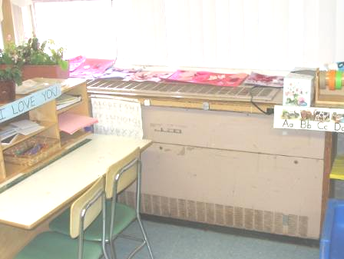

Classroom univent, note plant near air diffuser

Picture 2

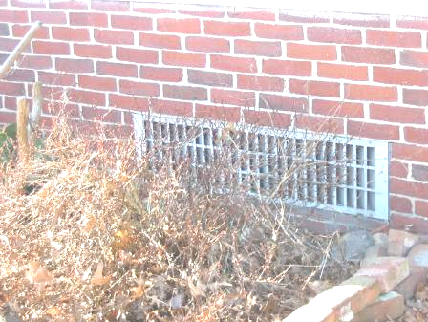

Fresh air intake, note plant growth in close proximity

Picture 3



Classroom univent partially obstructed

Picture 4

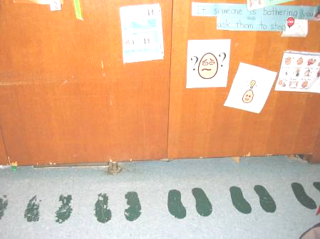

Undercut closet for exhaust

Picture 5
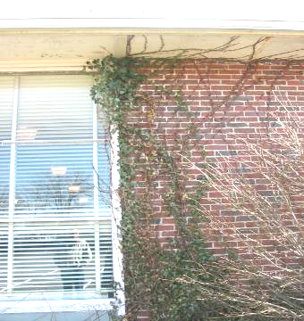

Clinging plant growth on building exterior

Picture 6
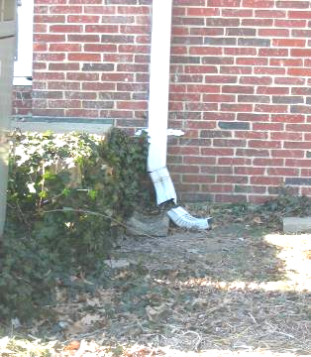

Damaged downspout
Picture 7

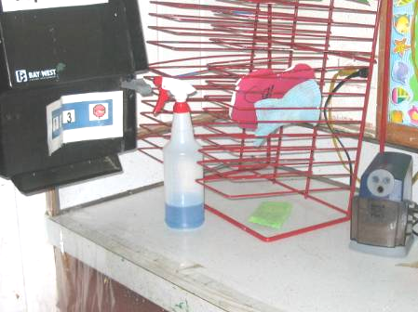

Unlabelled cleaning bottle

Picture 8

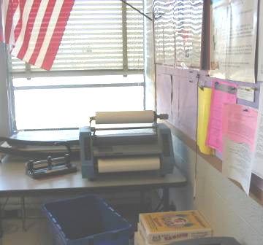

Laminator in teachers’ room
Location/ Room | Occupants  in Room | Temp  (°F) | Relative  Humidity  (%) | Carbon  Dioxide  (ppm) | Carbon Monoxide  (ppm) | TVOCs  (ppm) | PM2.5  (µg/m3) | Windows  Openable | Ventilation |  | Remarks
 |  |  |  |  |  |  |  |  | Supply | Exhaust | Remarks
background |  | 46 | 24 | 438 | 0 | 0 | 19 |  |  |  | Sunny, clear
1 | 0 | 67 | 18 | 783 | 0 | 0 | 13 | Y  # open: 0  # total: 2 | Y  univent | Y  closet  Off | Hallway DO, window-mounted AC, plants
2 | 2 | 68 | 14 | 602 | 0 | 0 | 13 | Y  # open: 0  # total: 3 | Y  univent  off | Y  closet | Univent turned off by occupant; plants
4 | 16 | 68 | 17 | 922 | 0 | 0 | 14 | Y  # open: 0  # total: 3 | Y  univent | Y  closet | Window-mounted AC, DEM, cleaners, plants
3 | 14 | 74 | 16 | 844 | 0 | 0 | 14 | Y  # open: 0  # total: 3 | Y  univent | Y  closet | Cleaners, plants
5 | 0 | 72 | 11 | 567 | 0 | 0 | 14 | Y  # open: 0  # total: 3 | Y  univent | Y  closet | Hallway DO
6 | 1 | 71 | 10 | 515 | 0 | 0 | 14 | Y  # open: 0  # total: 3 | Y  univent | Y  closet | Window-mounted AC, clutter
Nurse’s office | 0 | 72 | 14 | 762 | 0 | 0 | 14 | Y  # open: 0  # total: 3 | N | N | Hallway DO
Gym | 0 | 69 | 14 | 553 | 0 | 0 | 13 | Y | Y  Wall | Y  Wall
Kindergarten | 18 | 74 | 16 | 906 | 0 | 0 | 15 | Y  # open: 0  # total: 4 | Y  Univent | Y  Closet  Off | Exterior door open; items  Exhaust broken

