INDOOR AIR QUALITY ASSESSMENT

Malden District Court
89 Summer Street
Malden, Massachusetts



Prepared by:
Massachusetts Department of Public Health
Bureau of Environmental Health
Indoor Air Quality Program
June 2013

Background/Introduction
At the request of Mike Lane, Environmental Coordinator, Administrative Office of the Trial Court, the Massachusetts Department of Public Health (MDPH), Bureau of Environmental Health (BEH) conducted an indoor air quality (IAQ) assessment at Malden District Court (MDC), 89 Summer Street, Malden, Massachusetts. Concerns about water damage and general IAQ prompted this assessment. On April 17, 2013 Sharon Lee, Environmental Analyst/Inspector, and Ruth Alfasso, Environmental Engineer/Inspector, from BEH’s IAQ Program visited this building.
The BEH/IAQ Program previously visited the MDC in December 2000. A report regarding conditions observed at that time and recommendations for improving IAQ was issued in February 2001 (MDPH, 2001). Appendix A shows the actions that have since been taken in response to report recommendations.
The MDC is a two-story brick and concrete building constructed in 1929. The building contains three courtrooms, clerks’ offices, judges lobby, criminal/civil and probation departments, hearing rooms, jury rooms and records storage. Hallways in the first and second floor are used as waiting areas. A lockup, maintenance area, and several offices are located in the basement/lower level. Windows are openable in most areas of the building.

Methods
Air tests for carbon monoxide, carbon dioxide, temperature and relative humidity were conducted with the TSI, Q-Trak, IAQ Monitor, Model 7565. Air tests for airborne particle matter with a diameter less than 2.5 micrometers were taken with the TSI, DUSTTRAK™ Aerosol Monitor Model 8520. BEH/IAQ staff also performed visual inspection of building materials for water damage and/or microbial growth.

Results
The MDC houses approximately 30 employees and can be visited by several hundred people daily. Tests were taken during normal operations and are provided in Table 1.

Discussion

Ventilation
It can be seen from Table 1 that carbon dioxide levels were above 800 parts per million (ppm) in 12 out of 41 areas sampled throughout the MDC. These carbon dioxide levels are indicative of adequate fresh air supply in about three quarters of the areas tested; however, several areas had open windows or were empty/sparsely populated at the time measurements were taken, which can greatly reduce carbon dioxide levels. Carbon dioxide levels would be expected to increase with windows closed and greater occupancy.
Ventilation for the maintenance offices and the lockup on the lower level is provided by an air-handling unit (AHU). Fresh air mixed with air returned by exhaust vents is supplied to these areas via ceiling-mounted supply vents (Picture 1). The upper two floors of the MDC have no mechanical ventilation. Windows are the only source for introducing fresh air. Heat and cooling to these areas is provided by fan coil units (FCUs) that recirculate air inside the room (Picture 2).
Most restrooms are equipped with exhaust vents, but at the time of assessment the fans were not functioning or deactivated. It was reported to BEH/IAQ staff that these fans are turned off due to excessive noise in adjacent areas. Without functioning exhaust ventilation in restrooms, normally-occurring pollutants, odors and moisture cannot be removed from the building.
To maximize air exchange, the MDPH recommends that both supply and exhaust ventilation operate continuously during periods of occupancy. In order to have proper ventilation with a mechanical supply and exhaust system, the systems must be balanced to provide an adequate amount of fresh air to the interior of a room while removing stale air from the room. It is recommended that HVAC systems be re-balanced every five years to ensure adequate air systems function (SMACNA, 1994).
Minimum design ventilation rates are mandated by the Massachusetts State Building Code (MSBC). Until 2011, the minimum ventilation rate in Massachusetts was higher for both occupied office spaces and general classrooms, with similar requirements for other occupied spaces (BOCA, 1993). The current version of the MSBC, promulgated in 2011 by the State Board of Building Regulations and Standards (SBBRS), adopted the 2009 International Mechanical Code (IMC) to set minimum ventilation rates. Please note that the MSBC is a minimum standard that is not health-based. At lower rates of cubic feet per minute (cfm) per occupant of fresh air, carbon dioxide levels would be expected to rise significantly. A ventilation rate of 20 cfm per occupant of fresh air provides optimal air exchange resulting in carbon dioxide levels at or below 800 ppm in the indoor environment in each area measured. MDPH recommends that carbon dioxide levels be maintained at 800 ppm or below. This is because most environmental and occupational health scientists involved with research on IAQ and health effects have documented significant increases in indoor air quality complaints and/or health effects when carbon dioxide levels rise above the MDPH guidelines of 800 ppm for schools, office buildings and other occupied spaces (Sundell et al., 2011). The ventilation must be on at all times that the room is occupied. Providing adequate fresh air ventilation with open windows and maintaining the temperature in the comfort range during the cold weather season is impractical. Mechanical ventilation is usually required to provide adequate fresh air ventilation.
Carbon dioxide is not a problem in and of itself. It is used as an indicator of the adequacy of the fresh air ventilation. As carbon dioxide levels rise, it indicates that the ventilating system is malfunctioning or the design occupancy of the room is being exceeded. When this happens, a buildup of common indoor air pollutants can occur, leading to discomfort or health complaints. The Occupational Safety and Health Administration (OSHA) standard for carbon dioxide is 5,000 parts per million parts of air (ppm). Workers may be exposed to this level for 40 hours/week, based on a time-weighted average (OSHA, 1997).
The MDPH uses a guideline of 800 ppm for publicly occupied buildings. A guideline of 600 ppm or less is preferred in schools due to the fact that the majority of occupants are young and considered to be a more sensitive population in the evaluation of environmental health status. Inadequate ventilation and/or elevated temperatures are major causes of complaints such as respiratory, eye, nose and throat irritation, lethargy and headaches. For more information concerning carbon dioxide, please see Appendix B.
Temperature readings ranged from 72°F to 77°F, which were within the MDPH recommended comfort guidelines at the time of assessment. The MDPH recommends that indoor air temperatures be maintained in a range of 70°F to 78°F in order to provide for the comfort of building occupants. In many cases concerning indoor air quality, fluctuations of temperature in occupied spaces are typically experienced, even in a building with an adequate fresh air supply.
The relative humidity measured in the MDC ranged from 25 to 36 percent, which was below the MDPH recommended comfort range in all areas surveyed. The MDPH recommends a comfort range of 40 to 60 percent for indoor air relative humidity. Relative humidity levels in the building would be expected to drop during the winter months due to heating. The sensation of dryness and irritation is common in a low relative humidity environment. Low relative humidity is a very common problem during the heating season in the northeast part of the United States.

Microbial/Moisture Concerns
Water-damaged plaster and ceiling tiles were noted in some locations (Table 1). Of particular note were water stains on the acoustic cloth ceiling panels in the Session 1 courtroom (Picture 3). Water damage to ceiling materials in this location is most likely the result of historic roof leaks. The roof has reportedly been repaired recently and no new leaks have been detected since repairs were complete. Since the fabric is reportedly very difficult to remove for cleaning, vacuuming and mild scrubbing of the affected area while the fabric is in place should be performed. Given the age of panels, it is likely that dust and other allergens are collected in the material. As funds allow, priority should be given to replacing these acoustic panels to prevent aerosolization of particles accumulated in the panels.
Water damage reportedly occurred in the basement file storage room of the probation department at some point prior to the BEH/IAQ visit. Water from condensation that formed on FCU cooling pipes dripped onto files, causing damage. The damaged files have reportedly been removed for professional restoration. No remaining signs of water damage or musty odors were observed in this area at the time of assessment. The aforementioned pipes were also observed to be reinsulated to prevent additional condensation from forming.
Water-damaged carpeting was observed in the Court Clinic area in the basement (Picture 4). This reportedly resulted during a wind-driven snow event over the 2012/2013 winter from water infiltrating under the exterior door into the hallway and into the clinic. BEH/IAQ staff recommends that carpeting not be used in below-grade areas due to the potential for water leaks and condensation that can moisten carpet. There was light visible from underneath and around the exterior door in this area (Picture 5). This and all other exterior doors should be equipped with weather-stripping to prevent the entry of unconditioned air, water and pests.
Evidence of a recent leak was found in the storeroom adjacent to the clinic. Damaged ceiling plaster was observed, and a small trash bin appeared to be placed on the shelf to catch leaking water (Pictures 6 and 7). The source of this leak/condition should be determined and repaired to prevent microbial growth.
A damaged countertop was noted in a women’s restroom. Breaches were observed between the backsplashes and sinks in this and other areas (Picture 8). Breaches between the backsplash and countertop or backsplash and wall should be sealed. If these seams are not watertight, water can penetrate through them. Water penetration and chronic exposure of porous and wood-based materials can cause these materials to swell and become damaged.
In several offices, small refrigerators and water coolers were located in carpeted areas (Table 1). Spills or leaks can moisten carpeting, potentially leading to microbial growth. Consideration should be given to placing plastic/rubber mats beneath such equipment to catch water.
It was noted that in some areas, carpeting had been removed and floor tiles were installed under and adjacent to some FCUs (Picture 2). This measure is recommended to prevent carpet damage from condensation/leaks from FCUs and make cleanup easier if a leak does occur.
The US Environmental Protection Agency (US EPA) and the American Conference of Governmental Industrial Hygienists (ACGIH) recommend that porous materials be dried with fans and heating within 24 to 48 hours of becoming wet (US EPA, 2001; ACGIH, 1989). If not dried within this time frame, mold growth may occur. Once mold has colonized porous materials, they are difficult to clean and should be removed/discarded.
Plants were noted in several areas (Table 1). Plants should be properly maintained and equipped with drip pans made of a non-porous material. Drip pans should be cleaned and inspected periodically to prevent mold growth. Plants should be located away from ventilation sources to prevent aerosolization of dirt, pollen or mold.
Aquariums were observed in several areas (Picture 9). Aquariums should be properly maintained to prevent microbial/algae growth, which can emit unpleasant odors.

Other IAQ Evaluations
Indoor air quality can be negatively influenced by the presence of respiratory irritants, such as products of combustion. The process of combustion produces a number of pollutants. Common combustion emissions include carbon monoxide, carbon dioxide, water vapor and smoke (fine airborne particle material). Of these materials, exposure to carbon monoxide and particulate matter with a diameter of 2.5 micrometers (μm) or less (PM2.5) can produce immediate, acute health effects upon exposure. To determine whether combustion products were present indoor, BEH/IAQ staff obtained measurements for carbon monoxide and PM2.5.

Carbon Monoxide
Carbon monoxide is a by-product of incomplete combustion of organic matter (e.g., gasoline, wood and tobacco). Exposure to carbon monoxide can produce immediate and acute health affects. Several air quality standards have been established to address carbon monoxide and prevent symptoms from exposure to these substances. The MDPH established a corrective action level concerning carbon monoxide in ice skating rinks that use fossil-fueled ice resurfacing equipment. If an operator of an indoor ice rink measures a carbon monoxide level over 30 ppm, taken 20 minutes after resurfacing within a rink, that operator must take actions to reduce carbon monoxide levels (MDPH, 1997).
The American Society of Heating Refrigeration and Air-Conditioning Engineers (ASHRAE) has adopted the National Ambient Air Quality Standards (NAAQS) as one set of criteria for assessing indoor air quality and monitoring of fresh air introduced by HVAC systems (ASHRAE, 1989). The NAAQS are standards established by the US EPA to protect the public health from six criteria pollutants, including carbon monoxide and particulate matter (US EPA, 2006). As recommended by ASHRAE, pollutant levels of fresh air introduced to a building should not exceed the NAAQS levels (ASHRAE, 1989). The NAAQS were adopted by reference in the Building Officials & Code Administrators (BOCA) National Mechanical Code of 1993 (BOCA, 1993), which is now an HVAC standard included in the Massachusetts State Building Code (SBBRS, 2011). According to the NAAQS, carbon monoxide levels in outdoor air should not exceed 9 ppm in an eight-hour average (US EPA, 2006).
Carbon monoxide should not be present in a typical, indoor environment. If it is present, indoor carbon monoxide levels should be less than or equal to outdoor levels. On the day of assessment, outdoor carbon monoxide concentrations were non-detect (ND). No carbon monoxide was detected inside the building during the assessment (Table 1).
BEH/IAQ staff noted a gas stove/oven unit inside the maintenance staff room (Picture 10). No exhaust ventilation was observed above or adjacent to the stove. Gas stoves can be a source of pollutants, including carbon monoxide, particulate matter and nitrogen oxides. This and other combustion equipment should be used in a ventilated area and maintained/adjusted so that the flames are as clean as possible (US EPA, 2012).

Particulate Matter (PM2.5)
The US EPA has established NAAQS limits for exposure to particulate matter. Particulate matter includes airborne solids that can be irritating to the eyes, nose and throat. The NAAQS originally established exposure limits to PM with a diameter of 10 μm or less (PM10). In 1997, US EPA established a more protective standard for fine airborne particulate matter with a diameter of 2.5 μm or less (PM2.5). The NAAQS has subsequently been revised, and PM2.5 levels were reduced. This more stringent PM2.5 standard requires outdoor air particle levels be maintained below 35 μg/m³ over a 24-hour average (US EPA, 2006). Although both the ASHRAE standard and BOCA Code adopted the PM10 standard for evaluating air quality, MDPH uses the more protective PM2.5 standard for evaluating airborne PM concentrations in the indoor environment.
Outdoor PM2.5 concentrations were measured at 10 μg/m³ (Table 1). Indoor PM2.5 levels ranged from 3 to 16 μg/m³ (Table 1), which were below the NAAQS PM2.5 level of 35 μg/m³ in all locations. Frequently, indoor air levels of particulates (including PM2.5) can be at higher levels than those measured outdoors. A number of mechanical devices and/or activities that occur indoors can generate particulate during normal operations. Sources of indoor airborne particulates may include but are not limited to: fan belts in the HVAC system; cooking and the use of microwave ovens; use of photocopiers, fax machines and computer printing devices; operation of an ordinary vacuum cleaner; and heavy foot traffic.

Volatile Organic Compounds
Indoor air concentrations can be greatly impacted by the use of products containing VOCs. VOCs are carbon-containing substances that have the ability to evaporate at room temperature. Frequently, exposure to low levels of total VOCs (TVOCs) may produce eye, nose, throat and/or respiratory irritation in some sensitive individuals. For example, chemicals evaporating from a paint can stored at room temperature would most likely contain VOCs.
Cleaning products, air fresheners and deodorizing materials were found in offices, common areas and restrooms (Table 1). Cleaning products and air deodorizers contain chemicals that can be irritating to the eyes, nose and throat of sensitive individuals. Many air fresheners contain 1,4-dichlorobenzene, a VOC which may cause reductions in lung function (NIH, 2006). Furthermore, deodorizing agents do not remove materials causing odors, but rather mask odors that may be present in the area. A strong odor of perfume was detected in the second floor lobby and an odor of disinfectant or deodorizer was detected in the Court Clinic office in the basement; these odors suggest that the lack of exhaust ventilation is impacting indoor air.
Photocopiers were observed in several areas. VOCs and ozone can be produced by photocopiers, particularly if the equipment is older and in frequent use. Ozone is a respiratory irritant (Schmidt Etkin, 1992). When possible, photocopiers should be located in a well-ventilated area or an area equipped with local exhaust ventilation.

Other Concerns
Other conditions that can affect IAQ were observed during the assessment. Dust/debris was accumulated on supply vents, as well as on the fan blades of personal fans (Table 1). Vents and fans should be cleaned periodically to prevent dust/debris from being aerosolized and redistributed throughout the room. FCUs should also be kept free of any foreign materials, which may impair function or distribute contaminants and odors throughout the room.
A dark, circular pattern was observed on the acoustic ceiling fabric panels in Session 1. The uniformity of the discoloration coupled with reports that ceiling fans were previously installed in the room suggests that the staining is the result of dust accumulation. The draw of air created by ceiling fans in operation likely resulted in dust collection on the panel surfaces (Picture 3). As discussed previously, consideration should be given to cleaning/vacuuming the fabric material if the panels cannot be replaced.
BEH/IAQ staff observed chalk/board trays containing a build-up of chalk dust (Picture 11). These materials can be aerosolized by air movement from doors opening and closing, and/or foot traffic and may present a respiratory irritant.
In several offices, items were observed on FCUs, floors, windowsills, tabletops, bookcases and desks. Large number of stored items provides a source for dusts to accumulate. These items (e.g., papers, folders, boxes) make it difficult for custodial staff to clean. Items should be relocated and/or be cleaned periodically to avoid excessive dust build up. Dust/debris from items placed on top of FCUs can become airborne through movement of the air.
Floors in some offices and other areas are covered by wall-to-wall carpeting. Area carpets were observed in several other areas, including on top of wall-to-wall carpeting. The Institute of Inspection, Cleaning and Restoration Certification (IICRC), recommends that carpeting be cleaned annually (or semi-annually in soiled high traffic areas) (IICRC, 2005). Where an excessively dusty environment exists due to outdoor conditions or indoor activities (e.g., renovations), cleaning frequency should be increased (every six months) (IICRC, 2000).
A set of pipes of unknown origin/function was observed in the storage area for the probation department (Picture 12). These pipes appeared to go outside the building envelope. Pipes that are abandoned should be capped to prevent pathways for odors, moisture and pests to migrate into occupied areas.
Ceiling tiles in the Court Clinic area were observed to be bowed out from the ceiling (Picture 13). These ceiling tiles were not uniform in appearance (i.e., two tiles placed within one tile bracket) as compared to other tiles in the room, suggesting these the bowed tiles are replacements. Ceiling tiles can bow for a number of reasons, including poor fit and air pressurization from either the ventilation system or outside air driving through breaches in the building envelope. Over-pressurization of the plenum can damage ceiling tiles and also drive particulates from the plenum area into occupied spaces.

Conclusions/Recommendations
Based on measurements and observations at the time of assessment, the following recommendations are made to improve indoor air quality.

Short-Term Recommendations
- Use openable windows as weather permits to provide fresh air to courtrooms and offices on the first and second floors of the MDC. During colder weather, windows may be operated when rooms are unoccupied for greater comfort of occupants. Ensure that all windows are closed at the end of each day to prevent freezing conditions and security concerns.
- Open the front door to the main lobby of the MDC periodically during the day to increase fresh air to the lobby and adjoining areas. These areas lack mechanical ventilation and experience elevated carbon dioxide levels with overcrowding that occurs between court sessions.
- Operate all mechanical systems serving the basement areas, including the lockup, continuously during occupied periods to provide fresh air and exhaust.
- Consider repair or replacement of exhaust fans serving restrooms so that these can be operated during occupied periods without disrupting operations. Until then, continue to use openable windows in restrooms.
- Consider balancing the mechanical ventilation systems every 5 years, as recommended by ventilation industrial standards (SMACNA, 1994).
- For buildings in New England, periods of low relative humidity during the winter are often unavoidable. Therefore, scrupulous cleaning practices should be adopted to minimize common indoor air contaminants whose irritant effects can be enhanced when the relative humidity is low. To control for dusts, a high efficiency particulate arrestance (HEPA) filter equipped vacuum cleaner in conjunction with wet wiping of all surfaces is recommended. Avoid the use of feather dusters. Drinking water during the day can help ease some symptoms associated with a dry environment (throat and sinus irritations).
- Vacuum/clean the acoustic fabric in the Session 1 courtroom shown in Picture 3 to remove both water-staining and dust.
- Determine the water source causing damage to ceiling plaster in storeroom next to the Court Clinic. Make repairs and clean as needed.
- Repair/weather-stripping on the exterior door adjacent to the Court Clinic. Monitor all exterior doors for weather-tightness by observing if light is visible beneath or around them and replace/repair weather-stripping as needed.
- Repair damaged wall and ceiling plaster as needed. Replace water-damaged ceiling tiles.
- Repair/replace the damaged countertop in the women’s restroom. Seal any breeches between sinks and backsplashes with a suitable water-resistant material.
- Ensure all plants are equipped with drip pans that are made of a non-porous material. Examine drip pans for mold growth and disinfect areas of water leaks with an appropriate antimicrobial where necessary. Move plants away from ventilation sources.
- Maintain aquariums to prevent algal growth and odors.
- Store cleaning products properly. Ensure spray bottles are properly labeled. All cleaning products used at the facility should be approved by the maintenance department with MSDS’s available at a central location.
- Avoid the use of deodorizing materials and air fresheners to prevent exposure to VOCs.
- Consider moving photocopiers away from occupied areas and to areas with better ventilation.
- Regularly clean chalk trays of dust.
- Clean vents, fans and other surfaces of dust on a regular basis.
- Clean carpeting annually or semi-annually in soiled high traffic areas as per the recommendations of the Institute of Inspection, Cleaning and Restoration Certification (IICRC). Copies of the IICRC fact sheet can be downloaded at: http://1.cleancareseminars.net/?page_id=185 (IICRC, 2005).
- Relocate or consider reducing the amount of materials stored in offices to allow for more thorough cleaning. Clean items regularly to prevent excessive dust build-up.
- Seal the pipes shown in Picture 12.
- Repair/replace bowed ceiling tiles in the Court Clinic room. Ensure current tiles are replaced with a properly fitting tiles, with one tile per bracket. Investigate pressurization of this area.
- Refer to resource manual and other related indoor air quality documents for further building-wide evaluations and advice on maintaining public buildings; these materials are located on the MDPH’s website: http://mass.gov/dph/iaq.

Long-Term Recommendations
- Consider replacing acoustic panels in the Session 1 courtroom.
- Consider installing non-porous flooring beneath refrigerators and water dispensers or relocating these appliances to a tiled area. Continue with plans to install tiled flooring beneath/around FCUs.
- Consider removing the water-damaged carpeting in the Court Clinic and replacing with a non-porous flooring material. The existing cement floor under the carpeting may not need to be covered with additional flooring.
- Consider replacing the gas stove in the maintenance staff area with an electric stove or removing the stove completely.

References
ACGIH. 1989. Guidelines for the Assessment of Bioaerosols in the Indoor Environment. American Conference of Governmental Industrial Hygienists, Cincinnati, OH.
ASHRAE. 1989. Ventilation for Acceptable Indoor Air Quality. American Society of Heating, Refrigeration and Air Conditioning Engineers. ANSI/ASHRAE 62-1989.
BOCA. 1993. The BOCA National Mechanical Code/1993. 8th ed. Building Officials and Code Administrators International, Inc., Country Club Hill, IL. Section M-308.1.1.
IICRC. 2000. IICRC S001. Reference Guideline for Professional On-Location Cleaning of Textile Floor Covering Materials. Institute of Inspection, Cleaning and Restoration Certification. Institute of Inspection Cleaning and Restoration, Vancouver, WA.
IICRC. 2005. Carpet Cleaning FAQ 4 Institute of Inspection, Cleaning and Restoration Certification. Institute of Inspection Cleaning and Restoration, Vancouver, WA.
MDPH. 1997. Requirements to Maintain Air Quality in Indoor Skating Rinks (State Sanitary Code, Chapter XI). 105 CMR 675.000. Massachusetts Department of Public Health, Boston, MA.
MDPH. 2001. Indoor Air Quality Assessment. Malden District Court. Massachusetts Department of Public Health, Bureau of Environmental Health, Boston, MA. February 2001.
NIH. 2006. Chemical in Many Air Fresheners May Reduce Lung Function. NIH News. National Institute of Health. July 27, 2006. http://www.nih.gov/news/pr/jul2006/niehs-27.html.
OSHA. 1997. Limits for Air Contaminants. Occupational Safety and Health Administration. Code of Federal Regulations. 29 C.F.R 1910.1000 Table Z-1-A.
SBBRS. 2011. Mechanical Ventilation. State Board of Building Regulations and Standards. Code of Massachusetts Regulations, 8th edition. 780 CMR 1209.0.
Schmidt Etkin, D. 1992. Office Furnishings/Equipment & IAQ Health Impacts, Prevention & Mitigation. Cutter Information Corporation, Indoor Air Quality Update, Arlington, MA.
SMACNA. 1994. HVAC Systems Commissioning Manual. 1st ed. Sheet Metal and Air Conditioning Contractors’ National Association, Inc., Chantilly, VA.
Sundell. 2011. Sundell, J., H. Levin, W. W. Nazaroff, W. S. Cain, W. J. Fisk, D. T. Grimsrud, F. Gyntelberg, Y. Li, A. K. Persily, A. C. Pickering, J. M. Samet, J. D. Spengler, S. T. Taylor, and C. J. Weschler. Ventilation rates and health: multidisciplinary review of the scientific literature. Indoor Air, Volume 21: pp 191–204.
US EPA. 2001. Mold Remediation in Schools and Commercial Buildings. US Environmental Protection Agency, Office of Air and Radiation, Indoor Environments Division, Washington, D.C. EPA 402-K-01-001. March 2001.
US EPA. 2006. National Ambient Air Quality Standards (NAAQS). US Environmental Protection Agency, Office of Air Quality Planning and Standards, Washington, DC. http://www.epa.gov/air/criteria.html.
US EPA. 2012. An Introduction to Indoor Air Quality: Sources of Combustion Products. US Environmental Protection Agency, Washington, DC. http://www.epa.gov/iaq/combust.html.
Picture 1

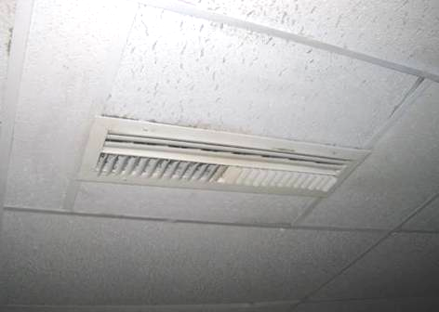

Supply vent in the basement level

Picture 2

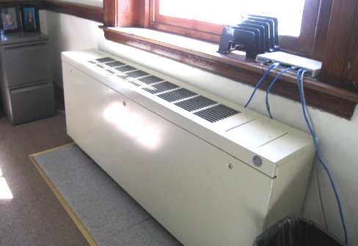

Fan coil unit; note carpet removed around unit

Picture 3

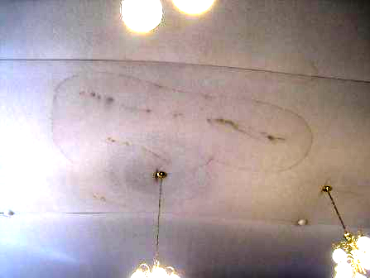

Water staining on acoustic fabric in courtroom; note dust marks from former ceiling fan

Picture 4

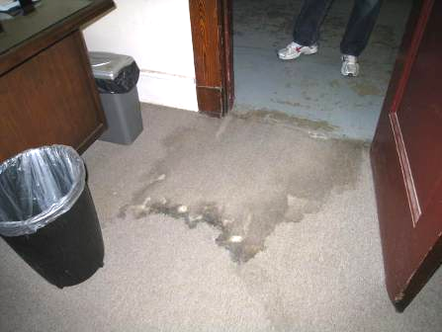

Water-stained carpet in the Court Clinic room

Picture 5

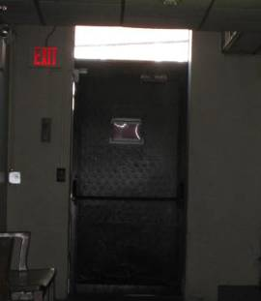

Light visible beneath and around exterior basement door adjacent to Court Clinic, likely source of water infiltration

Picture 6

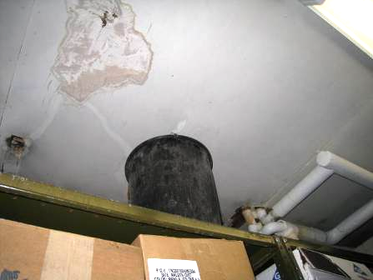

Water-stained ceiling plaster and trash can in Court Clinic storage room

Picture 7

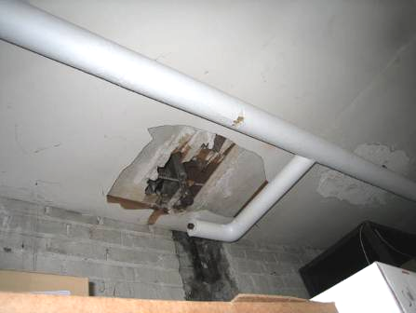

Missing/damaged plaster in Court Clinic storage room

Picture 8

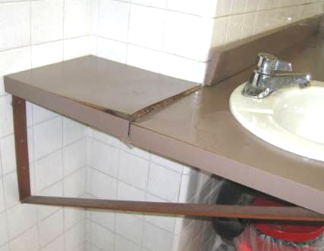

Damaged countertop in a women’s restroom, also note breach between
backsplash and sink
Picture 9

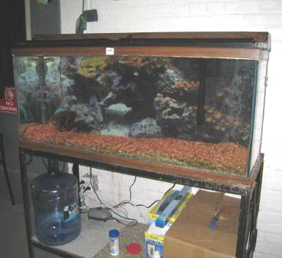

Aquarium

Picture 10

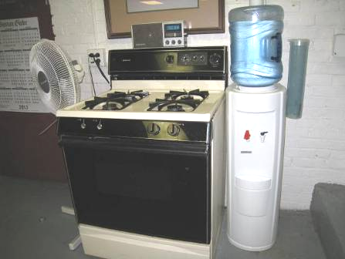

Gas stove located in the maintenance staff area

Picture 11

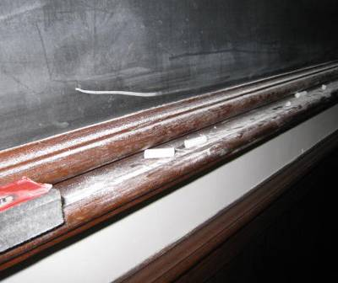

Chalk dust

Picture 12

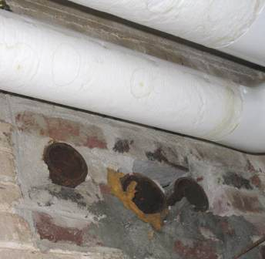

Pipes of unknown origin/function

Picture 13

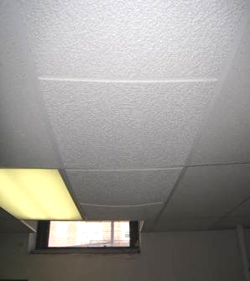

Bowed-out ceiling tiles in the Court Clinic room
Location | Carbon  Dioxide  (*ppm) | Carbon Monoxide  (ppm) | Temp  (°F) | Relative  Humidity  (%) | PM2.5  (ug/m³) | Occupants  in Room | Windows  Openable | Ventilation |  |  | Remarks
 |  |  |  |  |  |  |  | Intake | Exhaust |  | Remarks
Background | 415 | ND | 55 | 23 | 10 |  |  |  |  |  | Sunny, light breeze, some traffic
Basement Lockup kitchen | 674 | ND | 74 | 31 | 11 | 0 | Y | N |  | N
Dock (in session 1) from Lockup area | 679 | ND | 73 | 33 | 10 | 0
Basement, Probation files room | 721 | ND | 76 | 30 | 12 | 0 | N | N |  | N | Files, boxes on floor, cement floor, unknown pipes from wall, area of degraded plaster
Basement, Court Clinic | 541 | ND | 76 | 27 | 11 | 0 | Y | N |  | N | Ceiling tiles bowed, WD carpet, disinfectant/deodorizer odor
Basement storage adjacent to Clinic | 563 | ND | 72 | 28 | 8 | 0 | N | N |  | N | WD CT and plaster, bucket under ceiling (leak?)
Probation Office basement | 689 | ND | 75 | 29 | 14 | 1 | Y | N |  | N
Probation Office basement area next to spiral stairs | 621 | ND | 75 | 28 | 13 | 1 | Y | N |  | N
Basement maintenance staff area | 622 | ND | 74 | 32 | 9 | 5 | N | Y |  | Y | Stove (gas), aquarium, cement floor
1st floor Main lobby | 658 | ND | 72 | 25 | 10 | 20 | N | N |  | N | DO to exterior
1st floor Probation Office visitor area | 598 | ND | 72 | 25 | 15 | 5 | Y | N |  | N
Probation Office interview area | 694 | ND | 73 | 26 | 15 | 2 | Y | N |  | N | Rug
Probation Office main area | 624 | ND | 73 | 27 | 16 | 5 | Y 1 open | N |  | N | WD CT
Inner Probation Office | 569 | ND | 74 | 26 | 13 | 0 | Y | N |  | N
Probation Office Asst. Chief | 611 | ND | 75 | 27 | 16 | 0 | Y | N |  | N | Carpet, fridge
1st floor Judge’s Lobby | 548 | ND | 73 | 26 | 10 | 2 | Y 1 open | N |  | N | Carpet, aquarium, old books
1st floor Judge’s Office | 545 | ND | 74 | 27 | 10 | 0 | Y | N |  | N | Carpet, hanging cloth curtains, wood paneling to floor
1st floor Judge’s kitchen | 481 | ND | 74 | 25 | 9 | 0 | Y open | N |  | N | Microwave, fridge on carpet, water dispenser on carpet
1st floor Judge’s restroom |  |  |  |  |  |  |  |  |  |  | CP
First Session courtroom (near window) | 829 | ND | 74 | 31 | 14 | 5, plus ~50 just left | Y 1 open | N |  | N | Carpet slightly worn, stains on acoustic cloth ceiling (dust, WD)
First Session courtroom near front | 904 | ND | 75 | 32 | 13 | 5, ~50 just left | Y, 1 open | N |  | N
1st floor Criminal Office | 717 | ND | 73 | 28 | 12 | 3 | Y 1 of 2 open | Y |  | N | Items on FCU, CF, 3 WD CT, fridge, water cooler on carpet, plants
1st floor Criminal Magistrate | 621 | ND | 73 | 29 | 10 | 0 | Y | Y |  | N | Items on FCU, plants, CF, DO, fridge on carpet
1st floor Civil courtroom | 653 | ND | 72 | 28 | 6 | 7 | Y 2 of 4 open | Y |  | N | Items on FCU, 3 WD CT, PC, CF, plants, fridge on carpet
1st floor Civil court clerk | 562 | ND | 72 | 27 | 3 | 0 | Y open | N |  | N | PF, DO, CP
1st Session courtroom | 924 | ND | 73 | 32 | 13 |  | Y | Y |  |  | FCU
1st floor Magistrate hearing room | 980 | ND | 75 | 32 | 7 | 2 | Y open |  |  | N | FCU
2nd floor hall | 826 | ND | 77 | 30 | 12 | 8 | N | N |  | N
2nd floor staff lunchroom | 949 | ND | 76 | 31 | 10 | 2 | Y | N |  | N | Stove, fridge, plant, tile floor
2nd floor ladies restroom | 1022 | ND | 76 | 33 | 10 | 1 | Y | N |  | N | No exhaust found
2nd floor Judges Office | 805 | ND | 74 | 33 | 6 | 1 | Y | Y |  | Y | DO, FCU
2nd floor Probation main | 727 | ND | 75 | 33 | 6 | 0 | Y | Y |  |  | FCU, food, water cooler, PC, microwave, fridge, carpet
2nd floor lobby | 708 | ND | 77 | 31 | 15 | 12 | N | N |  | N | Strong perfume odor
2nd floor Jury Deliberation room | 605 | ND | 75 | 26 | 10 | 0 | Y 1 of 2 open | N |  | N | DO
3rd floor main hall | 937 | ND | 74 | 34 | 13 | 0 | N | N |  | N | Tile floor
3rd floor Clerks Office | 920 | ND | 74 | 33 | 8 | 0 | Y | N |  | N | FCU, area rug and carpeted floor
3rd floor courtroom 3 | 1055 | ND | 73 | 35 | 14 | 7 | Y | N |  | N | Rug, CD
3rd floor Judge’s Office | 799 | ND | 73 | 35 | 8 | 0 | Y | N |  | N | Solar gain/window shades down
3rd floor Probation |  | ND
3rd floor office Guidoboni | 708 | ND | 76 | 33 | 10 | 0 | Y | N |  | N
3rd floor office Garrity | 691 | ND | 76 | 33 | 9 | 0 | Y | N |  | N | CP, deodorizer
3rd floor office Russell | 714 | ND | 76 | 33 | 8 | 1 | Y | N |  | N | Fridge on carpet, microwave
3rd floor restroom |  |  |  |  |  |  | Y open |  |  | Y off | Exhaust off due to noise in adjacent courtroom
3rd floor Judges Lobby | 1274 | ND | 74 | 36 | 6 | 5 |  |  |  |  | WD ceiling plaster, PC
3rd floor Judges restroom | 675 | ND | 73 | 32 | 5 | 0 | Y 2 open | N |  | N | DO

Actions on MDPH Recommendations, Malden District Court, Malden, MA

The following is a status report of action(s) taken on MDPH recommendations made in the 2001 MDPH report (in bold) based on reports from maintenance staff, documents, and MDPH staff observations.
- Seal spaces around prisoner holding cell stairwell door with weather stripping/insulation material to prevent the egress of drafts, dirt, dust and particulates.
- Action: According to court staff, this door had been sealed following the 2001 report; however since that time the new weather-stripping had deteriorated and the door remains slightly ajar due to poor fit. BEH/IAQ staff observed the deterioration of weather-stripping and door. Court staff report that weather-stripping will be installed at the basement security door, which is kept locked at all times for security.
- For buildings in New England, periods of low relative humidity during the winter are often unavoidable. Therefore, scrupulous cleaning practices should be adopted to minimize common indoor air contaminants whose irritant effects can be enhanced when the relative humidity is low. To control for dusts, a high efficiency particulate arrestance (HEPA) filter equipped vacuum cleaner in conjunction with wet wiping of all surfaces is recommended. Avoid the use of feather dusters. Drinking water during the day can help ease some symptoms associated with a dry environment (throat and sinus irritations).
- Action: Court staff report that only HEPA-filtered vacuums are used in the facility and that daily dusting is performed with microfiber cloths.
- Repair holes/damaged wall plaster.
- Action: Court staff report that they maintain and repair damaged plaster on an as-needed basis. They also report plans to perform repairs to the building envelope exterior, including re-pointing of masonry and window sealing this summer, with bids being sought this spring.
- Clean window grates of dirt, dust and cobwebs. This should be done on a regular basis to prevent build-up. The configuration of the window grates render them difficult to clean, therefore consideration should be given to replace grating with a material which is easier to maintain.
- Action: As stated previously, court staff report that HEPA-filtered vacuuming and wiping with microfiber cloths is performed daily, including window grates.
- Clean ceiling fans on a regular basis to prevent dust buildup.
- Action: The ceiling fans have been removed.
- Change filters in air handling equipment and fan coil units as per the manufacturer’s instructions or more frequently if needed.
- Action: Court staff report that regular maintenance items such as filter changes are now reported and tracked in the DCAM CAMIS system which automatically generates work orders.
- Consider ducting the passive intake vent in the prisoner holding cell stairwell directly to the AHU.
- Action: Court staff investigated this measure and reported that the location of the AHU and vent would expose the AHU to outside temperatures which would be subject to freezing in the winter if it were retrofitted to take in outside air.
- Examine the filters in the unit ventilator. Univents should be equipped with filters that strain particulates from airflow. In order to decrease aerosolized particulates, disposable filters with an increased dust spot efficiency can be installed in the heat pumps. The dust spot efficiency is the ability of a filter to remove particulates of a certain diameter from air passing through the filter. Filters that have been determined by ASHRAE to meet its standard for a dust spot efficiency of a minimum of 40 % would be sufficient to reduce airborne particulates (Thornburg, D., 2000; MEHRC, 1997; ASHRAE, 1992). Note that increased filtration can reduce airflow produced by the heat pump by increased resistance. Prior to any increase of filtration, piece of air handling equipment should be evaluated by a ventilation engineer to ascertain whether it can maintain function with more efficient filters.
- Action: Court staff report that disposable filters of a pleated type with more efficient removal of particulates have been installed in all fan coil units/univents.

