Commonwealth of Massachusetts
Executive Office of Health and Human Services

Office of Medicaid
www.mass.gov/masshealth

MassHealth
Managed Care Entity Bulletin 11
April 2019

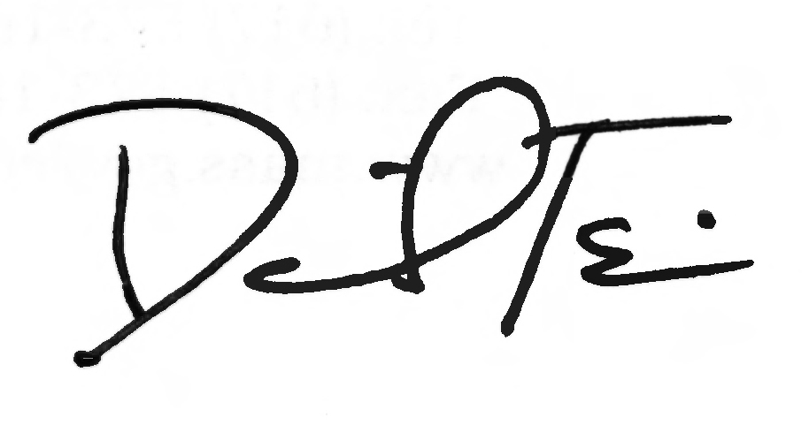
TO: MassHealth Accountable Care Partnership Plans and Managed Care Organizations

FROM: Daniel Tsai, Assistant Secretary for MassHealth

RE: Pharmacy Benefits Manager Pricing Report for Accountable Care Partnership Plans and Managed Care Organizations
Background
MassHealth is establishing new policy measures intended to provide insights into drivers of rising health care costs, as well as transparency with regard to prescription drug pricing. Recent events in other states’ Medicaid programs have highlighted pharmacy benefits manager (PBM) pricing patterns that do not always deliver the best value for Medicaid programs.
PBM Pricing Report Requirement
As part of this effort, MassHealth is directing its Accountable Care Partnership Plans and Managed Care Organizations (each, a “Plan”) to obtain certain data from each Plan’s PBM and subsequently submit a PBM Pricing Report to MassHealth. The PBM Pricing Report must include, but is not limited to, the following information for the period from January 1, 2018, to December 31, 2018.
- At the Claim level:
  - Payments to each dispensing pharmacy by the PBM
  - Payments to the PBM by the Plan
- At the National Drug Code level:
  - Volume of drugs
  - Rebate dollar amounts received by PBM from any manufacturer
  - Rebate dollar amounts paid to the Plan by the PBM
- At the aggregate level:
  - Any administrative payments made to the Plan by any PBM or to any PBM by the Plan
  - Any administrative payments made to a dispensing pharmacy contracted with the Plan by any PBM contracted with the Plan or to any PBM contracted with the Plan from any dispensing pharmacy contracted with the Plan.
This report is due July 1, 2019, and must be in a form and format specified by MassHealth. Please note that MassHealth intends to implement an ongoing periodic reporting requirement for similar information at a later date. These data requirements will allow MassHealth to take measures, if necessary, to limit excessive PBM spread and deliver value to the Commonwealth.
MassHealth Website
This bulletin is available on the MassHealth website at www.mass.gov/masshealth-provider-bulletins.
To sign up to receive email alerts when MassHealth issues new bulletins and transmittal letters, send a blank email to join-masshealth-provider-pubs@listserv.state.ma.us. No text in the body or subject line is needed.
Questions
If you have any questions about the information in this bulletin, please contact the MassHealth Customer Service Center at (800) 841-2900, email your inquiry to providersupport@mahealth.net, or fax your inquiry to (617) 988-8974.

