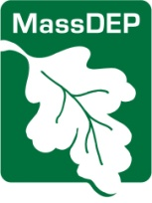 | Massachusetts Department of Environmental Protection  Bureau of Water Resources – Drinking Water Program  Public Health Advisory: Manganese  Levels greater than 300 µg/L
 | CERTIFICATION
 | Make sure to send your MassDEP regional office Drinking Water Program and local board of health a copy of each type of notice and a certification that you have met all the public notice requirements within ten days after issuing the notice (310 CMR 22.15(3)(b)). When you certify, you are also stating that you will meet future requirements for notifying new units of the manganese public health advisory.
Important: When filling out forms on the computer, use only the tab key to move your cursor - do not use the return key.  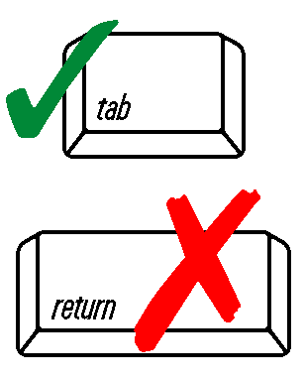 | PWS ID# | City/Town
 | PWS Name |  |  | Community Non-community
 | Date(s) water level exceeded 300 µg/L for manganese: |  |  |  | Date
 | The public water system indicated above hereby affirms that public notice has been provided to local health officials and consumers in accordance with 310 CMR 22.16 including: delivery, content, format requirements, notification deadlines, and that the public water system will meet future requirements for notifying new billing units and new customers of the exceedance.
 | Date of MassDEP notification: |  | Date
 | Notice to local health official distributed by |  |  | Method
 | on  Date |  |  | Name of health official
 | Notice to consumers distributed by |  |  | Method(s)
on
Date(s)
 | I certify under penalty of law that I am the person authorized to fill out this form and the information contained herein is true, accurate, and complete to the best of my knowledge and belief.
 | Signature of owner or operator |  |  |  |  | Date
 | Printed name of owner or operator

