# Manuel F. Correllus State Forest Project Fact Sheet and FAQ – Updated August 2025

As part of DCR’s ongoing work to engage with our stakeholders, the agency collected additional public comment on the Manuel Correllus State Forest (MCSF) Plantation Removal and Restoration Project from March 12, 2025, to March 26, 2025, following the March 12 Martha’s Vineyard Commission’s MCSF Task Force Public Meeting. In response, DCR has compiled the following fact and FAQ sheet to provide the public with additional information on the restoration project and its scientific rationale. DCR updated this fact sheet in August 2025. The original fact sheet (posted on April 29, 2025) can be found [here](https://www.mass.gov/doc/manuel-f-correllus-state-forest-project-fact-sheet-and-faq/download).

**Project Overview:**

* This project is a restoration of a native plant habitat that will support state-listed and other rare species by removing non-native conifer plantations within a 175-acre project area. DCR is required to remove 175 acres of conifer plantations within MCSF and restore conditions to pitch pine scrub oak barren, and/or oak woodland (collectively, barrens-oak woodland communities) by a 2001 Conservation Permit issued by the Massachusetts Division of Fisheries and Wildlife’s Natural Heritage and Endangered Species Program (NHESP), under the Massachusetts Endangered Species Act, for fire break management and maintenance, and by a 2021 Permit Amendment for retention and maintenance of new pedestrian trails.
  + DCR received credit under the 2021 permit amendment for removing dead and dying red pine plantations for previous work in the state forest to arrive at the required 175-acre restoration.
* The goals of the project are to: 1) remove and restore the white pine plantations to high-quality native barrens-oak woodland communities; and 2) reduce the fuel load, thereby reducing the wildfire danger and increasing public safety, and providing safe access for firefighters and fire apparatus.
  + These barrens-oak woodland communities, which comprise much of the State Forest, cannot occur just anywhere. These natural communities are globally rare, fire dependent communities occurring on dry, nutrient poor, usually sandy soils. They support a broad array of state- and federally-listed, as well as other rare plant and wildlife species that are dependent on these unique vegetation types. Unfortunately, over 90 percent of these globally rare sandplain communities have already been lost to development, making restoration and maintenance of our remaining sandplain habitats even more essential.
* This project will increase the resilience of the State Forest to future climate impacts by restoring a diversity of native trees and understory plant species that are not currently present due to the plantations. This biodiversity is important, as it is a major component of both resiliency and the adaptive capacity of this ecosystem to climate change.
* Manuel Correllus State Forest is one of the state’s most important properties for state- and federally-listed, as well as other rare species in Massachusetts. Once this project is complete, it will have re-established a rare native barrens-oak woodland ecosystem that is home to 33 state-listed species, two state- and federally-listed species, and many otherwise rare and common species.
* DCR is initially concentrating on 52 acres of this total area, partially removing and restoring two white pine plantations to a native grassland and pine barren community.
* Work in the first plantation will consist of four 3-acre patch cuts (12 acres total).
* A second plantation of 40-acres will include overstory removal of white pine but leave the existing oak trees and other native shrubs.
* These areas will be monitored post-harvest, with results used to inform later forest management.
* **This project is not a “clear-cut”** but rather a targeted removal of selected white pine plantations to restore a globally rare, native natural community that will support rare species.

**Recommendations for Climate-oriented Forest Management Guidelines:**

* There was consensus by the Climate Forestry Committee that plantations should be converted to more compositionally diverse forests via harvesting. Conversion of plantations aligns with many climate-smart forestry practices highlighted in the [Climate Forestry Committee report](https://www.mass.gov/doc/forests-as-climate-solutions-climate-forestry-committee-report-final/download?_ga=2.199015151.1558406781.1744646600-148635884.1733783191&_gl=1*94glul*_ga*MTQ4NjM1ODg0LjE3MzM3ODMxOTE.*_ga_MCLPEGW7WM*MTc0NDc2NTQyNC45MS4wLjE3NDQ3NjU0MjQuMC4wLjA.), such as: improving resistance to pests and pathogens, increasing resiliency by promoting a diversity of plant species, providing age class/structural diversity, improving conditions for a wide variety of local wildlife through the creation of temporary young forest habitat, and promoting future-adapted tree species in the regeneration mix.

**Public Process to Date:**

* Per regulations, the project at Manuel Correllus State Forest was proposed in 2022 and opened for public comments at that time. The comments that were submitted can be found on the DCR [website](https://www.mass.gov/guides/forest-management-projects#-forest-management-projects-proposed-2022-).
* DCR held two virtual public meetings on forestry projects in 2022 on October 18 and 20, followed by a 45-day comment period. Any comments that were made at that time are reflected in the link above. Resources from those public meetings can be found here:
  + [DCR Forest Management Project Proposals Public Meeting 10/20/2022 | Mass.gov](https://www.mass.gov/event/dcr-forest-management-project-proposals-public-meeting-10202022-10-20-2022)
  + [DCR Forest Management Project Proposals Public Meeting 10/18/2022 | Mass.gov](https://www.mass.gov/event/dcr-forest-management-project-proposals-public-meeting-10182022-2022-10-18t160000-0400-2022-10-18t173000-0400)
* The public process for this project was then postponed in 2022 during the pause of forest management projects as DCR awaited the recommendations from the [Forests as Climate Solutions Initiative](https://www.mass.gov/info-details/forests-as-climate-solutions?_gl=1*1xf4qbf*_ga*MTQ4NjM1ODg0LjE3MzM3ODMxOTE.*_ga_MCLPEGW7WM*MTc0NDc2NTQyNC45MS4xLjE3NDQ3NjU1NzYuMC4wLjA.) and the Climate Forestry Committee. The project was then evaluated under these [recommendations](https://www.mass.gov/doc/forests-as-climate-solutions-climate-forestry-committee-report-final/download?_ga=2.199015151.1558406781.1744646600-148635884.1733783191&_gl=1*94glul*_ga*MTQ4NjM1ODg0LjE3MzM3ODMxOTE.*_ga_MCLPEGW7WM*MTc0NDc2NTQyNC45MS4wLjE3NDQ3NjU0MjQuMC4wLjA.) and found to be in alignment, as it converts the plantation into a more compositionally diverse forest through harvesting. The project also aligns with many climate-smart forestry practices.
* DCR held a [public listening session](https://www.mass.gov/event/dcrs-manuel-f-correllus-state-forest-public-listening-session-10102024-10-10-2024?_gl=1*srffjs*_ga*MTA0OTEyOTU0OC4xNzA2ODkzNzE4*_ga_MCLPEGW7WM*MTc0MTEwNTQ1NC4yNDEuMS4xNzQxMTA3MTcyLjAuMC4w) on October 10, 2024, regarding the management of the State Forest.
* DCR held a public [pre-harvest tour](https://www.mass.gov/event/manuel-correllus-state-forest-pre-harvest-tour-notice-november-2024-11-07-2024?_gl=1*1qulw09*_ga*MTA0OTEyOTU0OC4xNzA2ODkzNzE4*_ga_MCLPEGW7WM*MTc0MTEwNTQ1NC4yNDEuMS4xNzQxMTA3NDU0LjAuMC4w) on November 7, 2024, that provided attendees with an opportunity to ask questions and learn more about the project.
* On March 4, 2025, DCR briefed the legislative delegation on the project, and on March 6, DCR met with the Edgartown Town Administrator, the Chairs of the Board of Selectmen and the Conservation Commission as well as the Town's Conservation Agent.
* Task Force: Since November, DCR Forestry and Public Affairs staff have attended the Martha's Vineyard Commission's Manuel Correllus State Forest Task Force (MVC MCSF Task Force) monthly public meetings to discuss and answer questions about the plantation removal and restoration project. The project has the [support](https://www.mvtimes.com/2025/02/20/task-force-position-clearing-white-pine/) of all of the members of the Task Force, which includes the Friends of the State Forest, Edgartown Fire Department, West Tisbury Fire Department, The Nature Conservancy, Vineyard Conservation Society, BiodiversityWorks, Polly Hill Arboretum, and Village and Wilderness. Additionally, the project is supported by all six of Martha's Vineyard's fire chiefs.
* The State Forest's plantation removal and restoration project team presented on the project at the Task Force's March 12, 2025 [public meeting.](https://www.youtube.com/watch?v=2IAwtOKpLMI&t=443s) DCR collected additional public comment on the project from March12 through March 26. During this period, DCR collected more than 120 comments that are listed below in this fact sheet.
* The Project Team presented the submitted cutting plan to the Task Force and the public at the Task Force’s June 10.

**Project Status**

* DCR submitted the forest cutting plan for the project to DCR’s State Service Forester for review on Friday, June 6.
* The Service Forester then forwarded the plan to MassWildlife's Natural Heritage & Endangered Species Program (NHESP).
* Additionally, DCR provided a copy of the plan to the Edgartown Conservation Commission. The forest cutting plan was discussed at the Conservation Commission’s June 11 meeting and the Commission did not provide any further comment on the plan. The Commission is not an approving authority.
* A copy of the plan was also provided to direct abutters and the Board of Selectmen.
* The State Service Forester approved the cutting plan on July 2, following the submission of comments from NHSEP.
* Both the approved cutting plan and the comment letter from Natural Heritage can also be accessed [[here].](https://www.mass.gov/guides/southeast-forest-management-projects)
* DCR is currently working with the MVC MCSF Task Force to explore ways to repurpose harvested wood products locally, when possible, and to meet state procurement guidelines.
* DCR anticipates bid documents will be finalized and publicly advertised by fall/early winter of 2025.
* DCR intends to begin and conduct the plantation removal during the months of November through April.
* 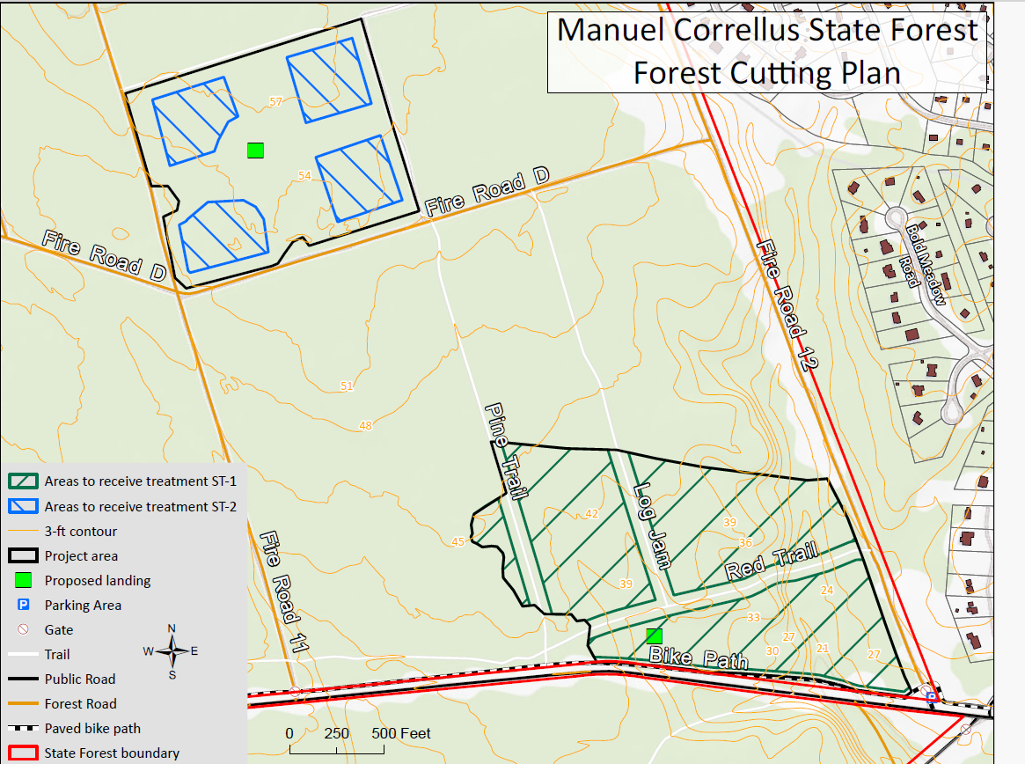

Map of Manuel Correllus State Forest Cutting Plan Phase 1

**Existing conditions photos and post-treatment photo examples:**

Photo 1: Existing MCSF pine plantation

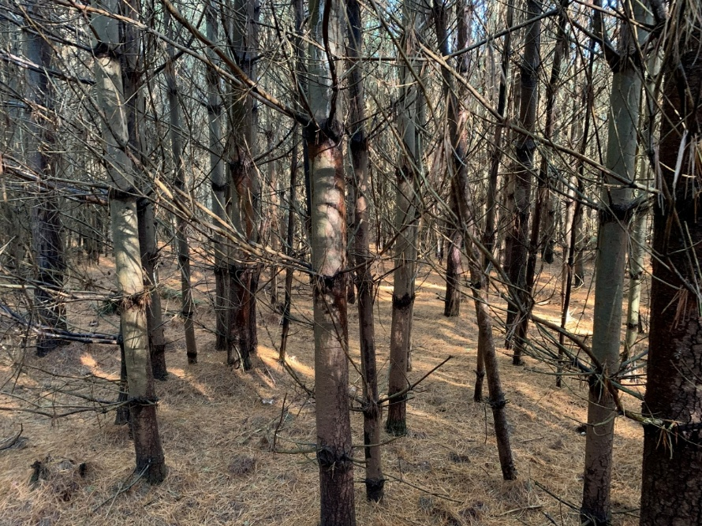

Photo 2: Existing MCSF pine plantation

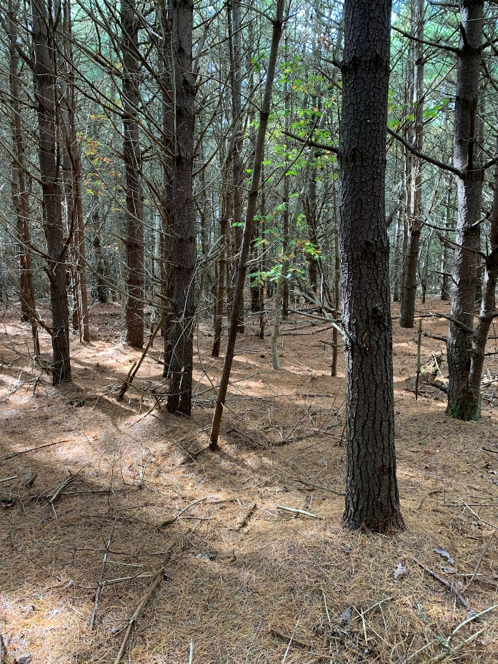

Photo 3: 0-1 year, post-treatment example, Myles Standish State Forest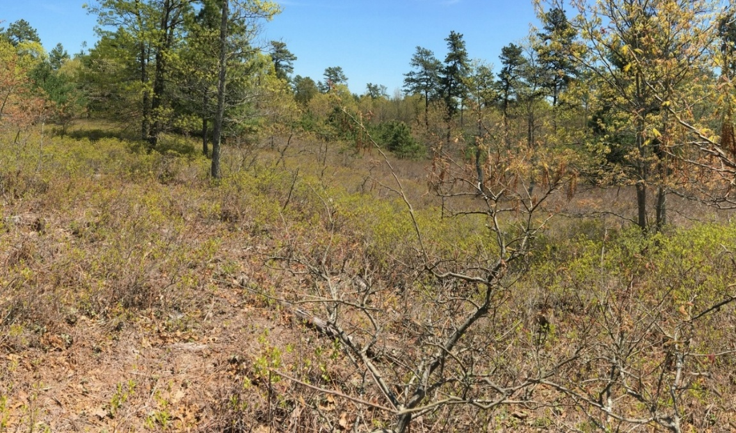

Photo 4: 2-year post-treatment example, Myles Standish State Forest

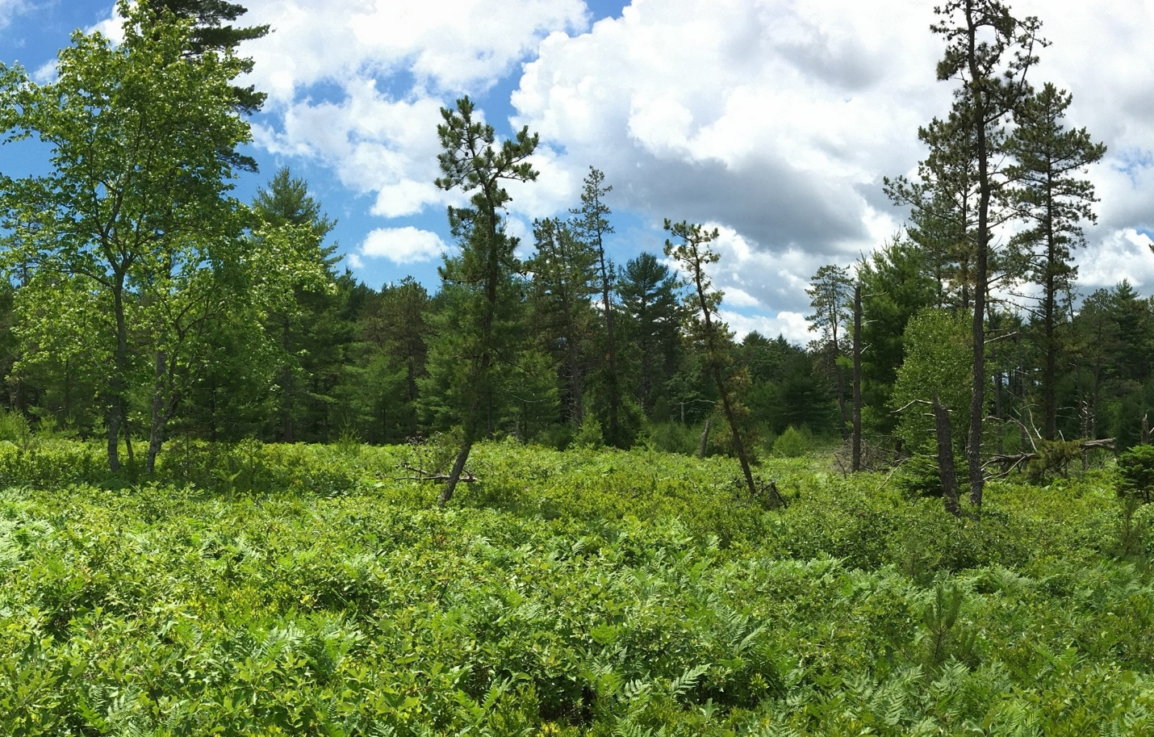

**Additional Clarifying Questions:**

Q: Will the pitch pine that is now being attacked by the southern pine beetle need to be removed to reduce fire risk and if so, at what cost?

* + DCR anticipates cyclical outbreaks of southern pine beetle and periodic pitch pine mortality events. Active management to promote resilience to stressors such as the southern pine beetle and extreme weather will help to retain pitch pine and the barrens-oak woodland community ecosystem. Removing pitch pines will depend on several factors: density; where they are located; and how fast the beetle moves across the forest. In previous efforts, DCR foresters have cut and left in place several infested trees within the interior of the State Forest. These efforts were conducted at no cost, as DCR used its Forest Health Tree crews. DCR will continue to utilize its Forest Health teams to monitor and manage the state forest to help promote resilience to

these stressors.

Q: Would widening several key fire lanes give the fire departments an upper hand in the event of a fast-moving fire?

* + The main concern regarding wildfire danger is that if a wildfire were to get into the crown of the plantations, embers could be transported up to a half mile away.  Widening the fire lanes will not necessarily reduce this risk.

Q: Could tree encroachment on the fire lanes be managed to reduce crowning or jumping of a rapidly moving fire?

* + The fire lanes are mowed every one to three years.  While this does reduce the intensity of a wildfire, it does not necessarily reduce the risk of a wildfire from moving across the fire lanes and into adjacent vegetation.

Q: Can an immediate and sustained effort be made to remove all of the proliferating pine saplings by employing island workers in the off season?

* + The concern with this approach is that the plantations will continue to produce seeds and spread the seeds into native habitats outside the plantations, as well as into areas that would be in the process of being restored.  This restoration project will reduce the seed source.

Q: Can the largest stands of pine be allowed to fully mature into a marketable size to maximize productivity and carbon sequestration? Can a local harvest plan be drawn up around this effort?

* + Allowing the pine to mature to marketable size will take a considerable amount of time given the site conditions (sandy soils) and will not reduce the fire danger. DCR is working with the MVC Task Force to identify local markets that may be interested in utilizing the raw material, preferably in long-lived wood products, to reduce carbon emissions.

Q: Could the understory of these remaining pines be cleared to 30' to reduce the laddering effect and limit the risk of a crown fire?

* + While this may reduce the risk of a crown fire, it does not address the regulatory requirement from the Natural Heritage and Endangered Species Program to remove and restore 175 acres of conifer plantations to native barrens-oak woodland communities for the benefit of state-listed rare species.

Q: Can DCR reprioritize its restoration efforts in the areas where the pine trees are in poor health?

* + Many parts of the plantations that will be removed are currently in poor health and highly susceptible to insects and diseases. DCR has also worked with the MVC MCSF Task Force on identifying the first phase of this project:
    - DCR is initially concentrating on 52 acres of this total area, partially removing and restoring two white pine plantations to a native grassland and pine barren community.
    - Work in the first plantation will consist of four 3-acre patch cuts (12 acres total).
    - A second plantation of 40-acres will include overstory removal of white pine but leave the existing oak trees and other native shrubs.
    - These areas will be monitored post-harvest, with results used to inform later forest management.

Q: Can there be a carbon solution for the biomass being removed that keeps it local and minimizes carbon losses into the atmosphere?

* + As mentioned above, DCR is working with the Martha’s Vineyard Commission and others to supply local markets with raw materials.

Q: Could some means be employed to make biochar and compost out of the chips and duff so that it can be recycled back into our soils?

* + As part of the MVC Task Force conversations, MVC did receive a grant to explore uses of biochar, and DCR is working in coordination with MVC on biochar implementation for this restoration project.

Q: Will there be a long-term commitment to complete restorations of the entire forest? How does the current plan affect that?

* + DCR plans on starting a comprehensive forest management plan in the coming year for Manuel Correllus State Forest. The plan will detail future restoration efforts.

Q: Will herbicides be used in the restoration project?

* + DCR does not foresee using herbicides for this restoration project.  No non-native invasive plants were observed in the plantations during our sampling procedures.

Q: Can we invest in more firefighting equipment and man the fire tower regularly during dry spells?

* + To support ongoing forest management, the DCR Martha’s Vineyard and Nantucket team includes a full-time Field Operations Team Leader, a newly added full-time Forest and Park Supervisor—hired as part of DCR’s October 2024 staffing commitment—and three seasonal staff. Additional support is provided by rangers from the mainland. DCR Forest Fire Control also assigns one full-time firefighter to the island, with mainland fire personnel available as needed. Recent investments in equipment—including chippers, a new work truck, and other machinery—have supported ongoing operations, including mowing and prescribed burns.

Q: Have the local Wampanoag tribal members been consulted on this plan? Do they have representation?

The Wampanoag Tribe of Gay Head (Aquinnah) has been invited to participate in the MVC Task Force, and DCR includes the tribe in its ongoing efforts and communications regarding MCSF.