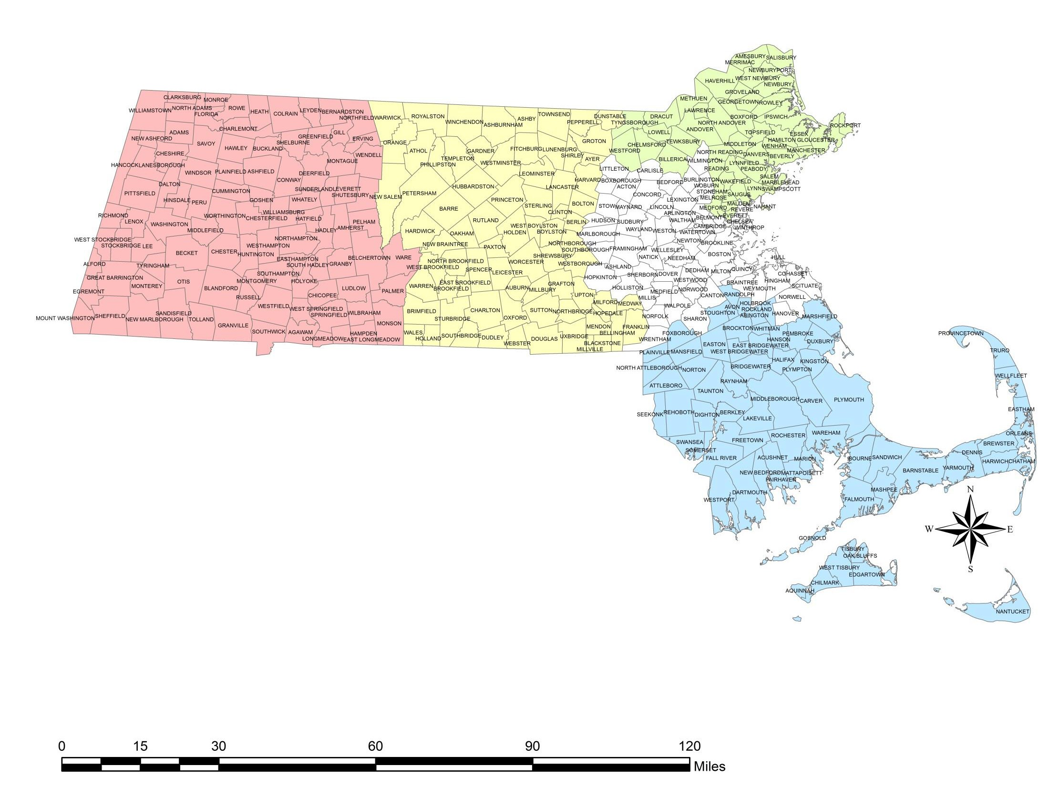
Massachusetts Emergency Medical Service (EMS) Regions and
American College of Surgeons (ACS) Verified Trauma Centers Anna Jaques
Lawrence
General

Berkshire Medical Center

Region 1 Region 2
Lowell
General

Lahey Hospital

Region 4

Region 3
Beverly
Hospital
North
Shore

DPH-Approved Regional Point of Entry Hospital Destinations for Trauma

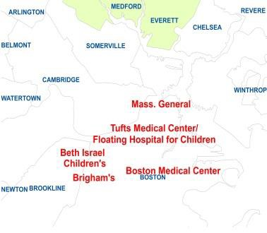

Baystate
UMass Memorial
Medical Center

South Shore

Steward Good Samaritan

DPH-Approved Regional Point of Entry Hospital Destinations for Trauma
ACS Verified Trauma Center Levels by EMS Region

Region 5

Statewide Statistics

Massachusetts 2010 Census Population = 6,547,629
Massachusetts 2016 Census Population Estimate = 6,811,779
State Total Square Miles, Land and Water = 10, 544
Legend 2016 Census
Population Estimate
Land Area Sq. Miles Density per Sq. Mile
EMS Region 1 2,588.51 329

EMS Region 2 1,851.18 509

EMS Region 3 710.15 1,894

EMS Region 4 911.47 2,550

EMS Region 5 1,742.70 761
Region 1
- Baystate Medical Center, Adult I, Pediatric II
- Berkshire Medical Center, Adult III
Region 2
- UMass Memorial Medical Center, Adult I, Pediatric I
Region 3
- Anna Jacques Hospital, Adult III
- Lawrence General Hospital, Adult III
- Beverly Hospital, Adult III
- Lowell General Hospital, Adult III
- North Shore Medical Center Salem Hospital, Adult III
Region 4
- Beth Israel Deaconess Medical Center, Adult I
- Boston Children’s Hospital, Pediatric I
- Boston Medical Center, Adult I, Pediatric II
- Brigham & Women’s Hospital, Adult I
- Lahey Hospital and Medical Center, Adult I
- Massachusetts General Hospital, Adult I, Pediatric II
- South Shore Hospital, Adult II
- Tufts Medical Center/Floating Hospital for Children, Adult I, Pediatric I
Region 5
- Steward Good Samaritan Medical Center, Adult III

Map Updated August 9, 2019
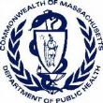
Data Sources: MDPH, CHIA, and MassGIS

