Massachusetts Department of Public Health
Division of Sexual and Domestic Violence Prevention and Services (DSDVPS)

Emergency Shelter (ES) Services

Elizabeth Freeman Center
YWCA NEMA
LAWRENCE

Alternative House
LOWELL

HAWC

Respond
SOMERVILLE
Transition House
CAMBRIDGE
HarborCOV

PITTSFIELD

Womanshelter/Compañeras
HOLYOKE

Safe Passage
NORTHAMPTON

YWCA Central MA
WORCESTER
REACH
WALTHAM

SMOC/VAV
FRAMINGHAM
SALEM

DOVE
QUINCY
CHELSEA
Asian Task Force Against DV
BOSTON
Casa Myrna
BOSTON
UU Urban Ministry
ROXBURY
Elizabeth Stone House
ROXBURY

YWCA of Western MA
SPRINGFIELD
FINEX House
JAMAICA PLAIN

ES Agencies
Alternative House (Women in Transition) Asian Task Force Against Domestic Violence

The (New Bedford) Women's Center New Hope

New Hope
ATTLEBORO
Health Imperatives
BROCKTON

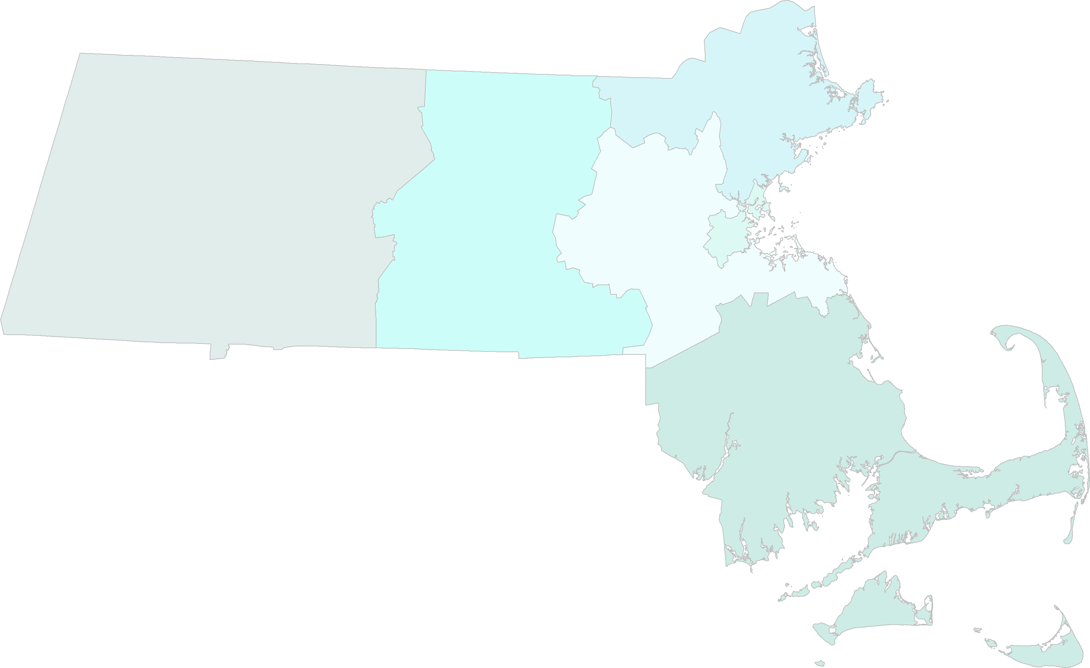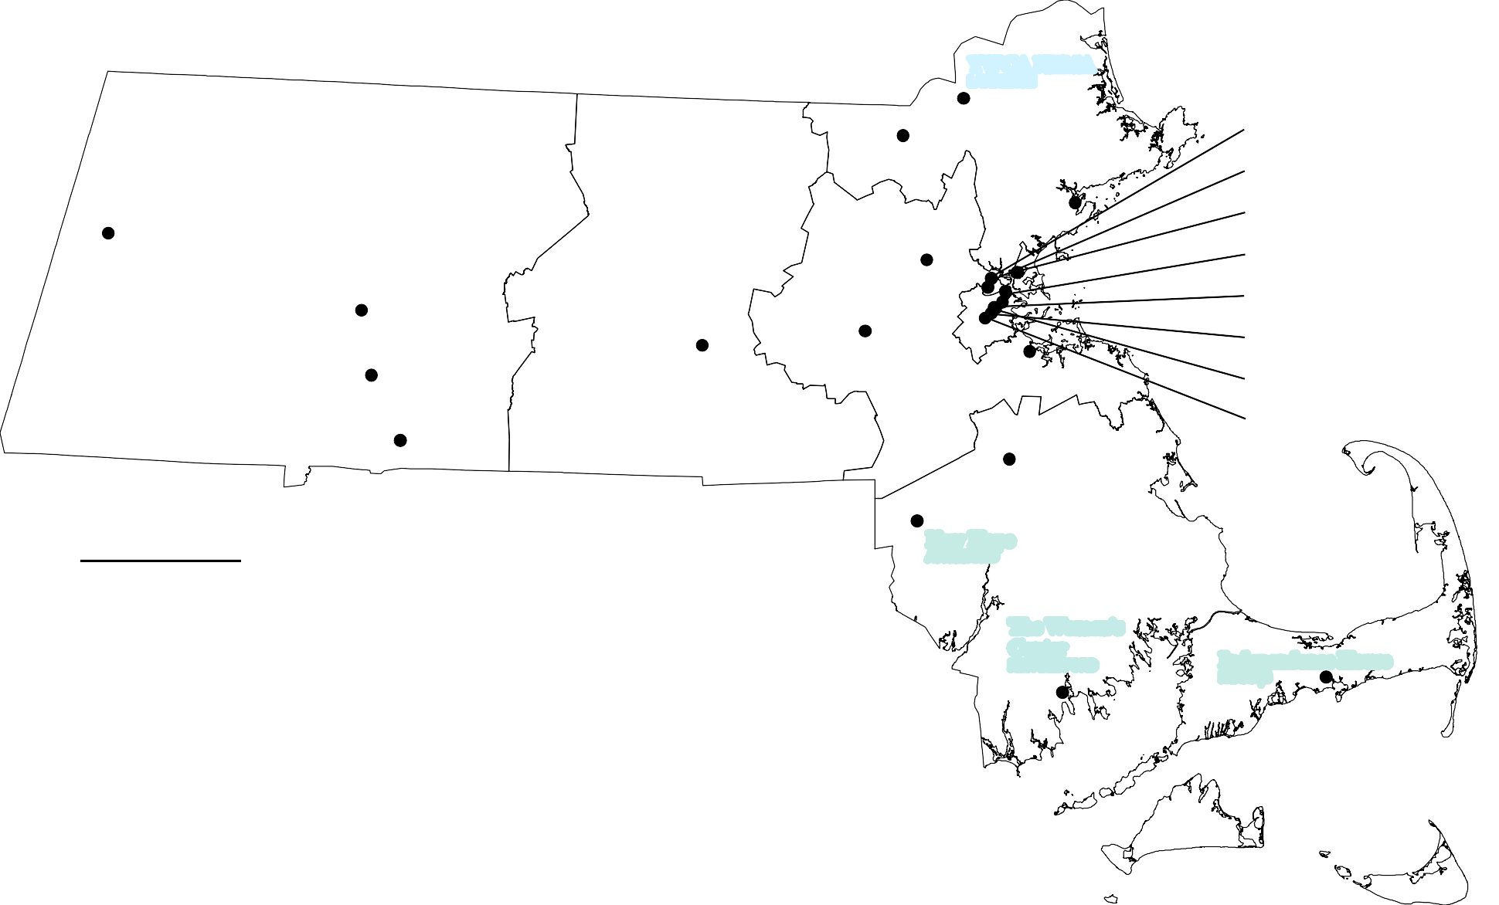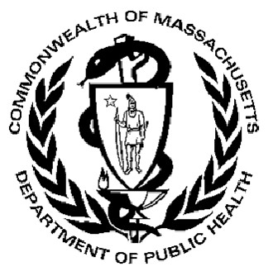(ATASK)
Unitarian Universalist Urban Ministry Casa Myrna Vazquez
DOVE
Elizabeth Freeman Center Elizabeth Stone House FINEX House HarborCOV
Healing Abused Working for Change (HAWC) Health Imperatives
Independence House
REACH Beyond Domestic Violence Respond, Inc.
Safe Passage, Inc.
South Middlesex of County/Voices Against Violence (SMOC/VAV)
Transition House Womanshelter/Compañeras
YWCA Northeastern Massachusetts (NEMA) YWCA Central MA
YWCA Northeastern MA YWCA of Western MA
The Women's
Center
NEW BEDFORD

Independence House
HYANNIS

Massachusetts Department of Public Health
Division of Sexual and Domestic Violence Prevention and Services (DSDVPS)

Housing Stabilization (HS) Services

YWCA NEMA
LAWRENCE

Way Finders
SPRINGFIELD

Second Step
NEWTONVILLE

SMOC/VAV
FRAMINGHAM

HarborCOV
CHELSEA

The Network/La Red
BOSTON

Elizabeth Stone House
ROXBURY

FINEX House
ROXBURY

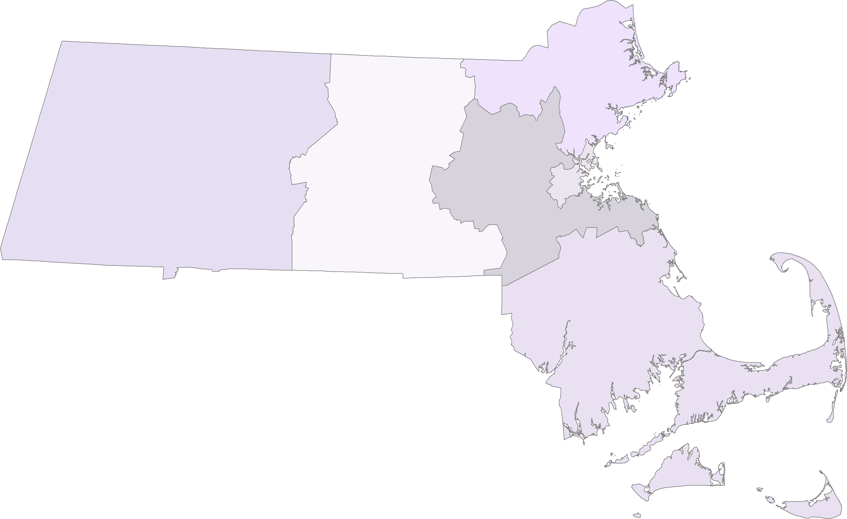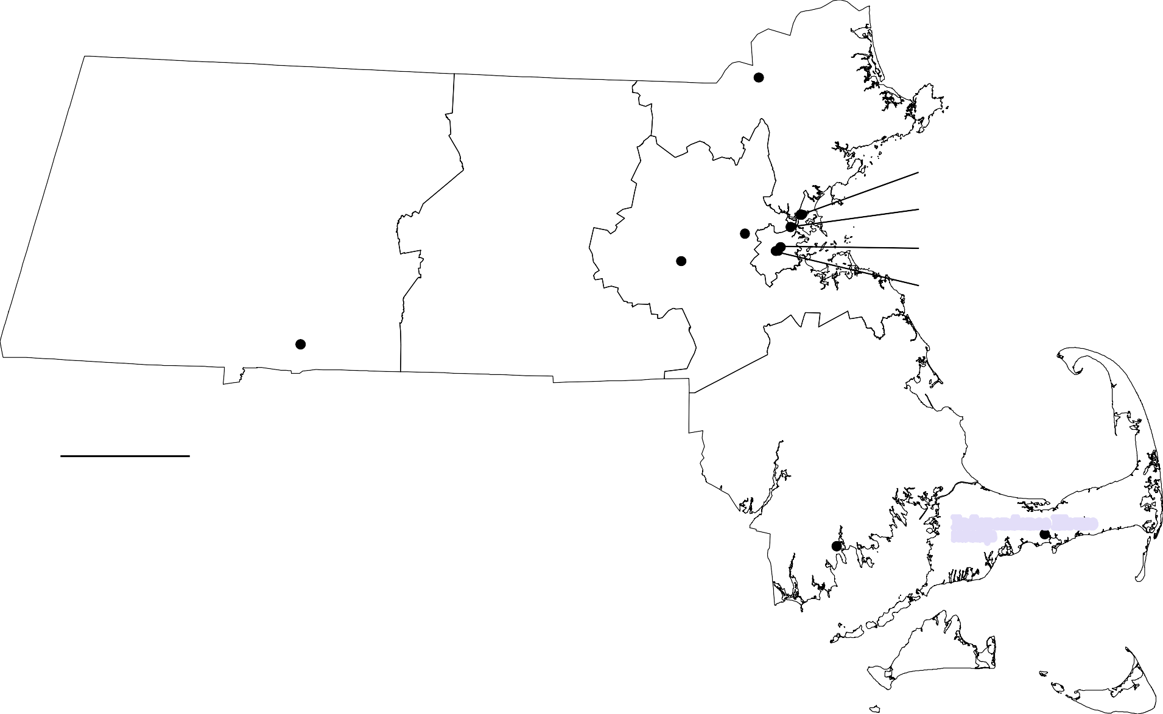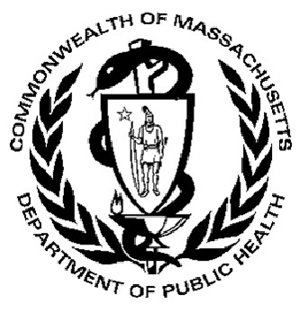HS Agencies
Elizabeth Stone House FINEX House HarborCOV Independence House Second Step
South Middlesex Opportunity Council/Voices Against Violence (SMOC/VAV) The Network/La Red
The (New Bedford) Women's Center Way Finders
YWCA Northeastern Massachusetts (NEMA)

The Women's Center
NEW BEDFORD

Independence House
HYANNIS

Massachusetts Department of Public Health
Division of Sexual and Domestic Violence Prevention and Services (DSDVPS)
Domestic Violence, Substance Misuse, and Trauma Shelter (DVSMT) Services

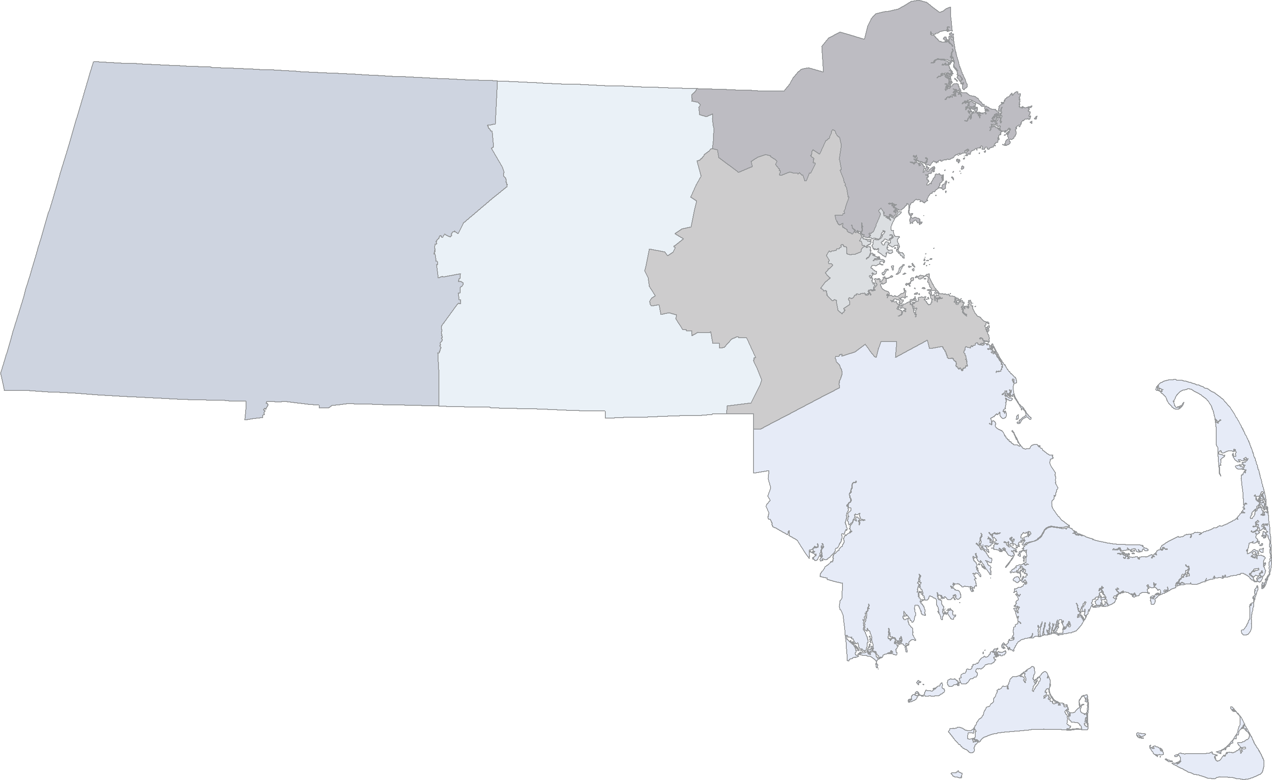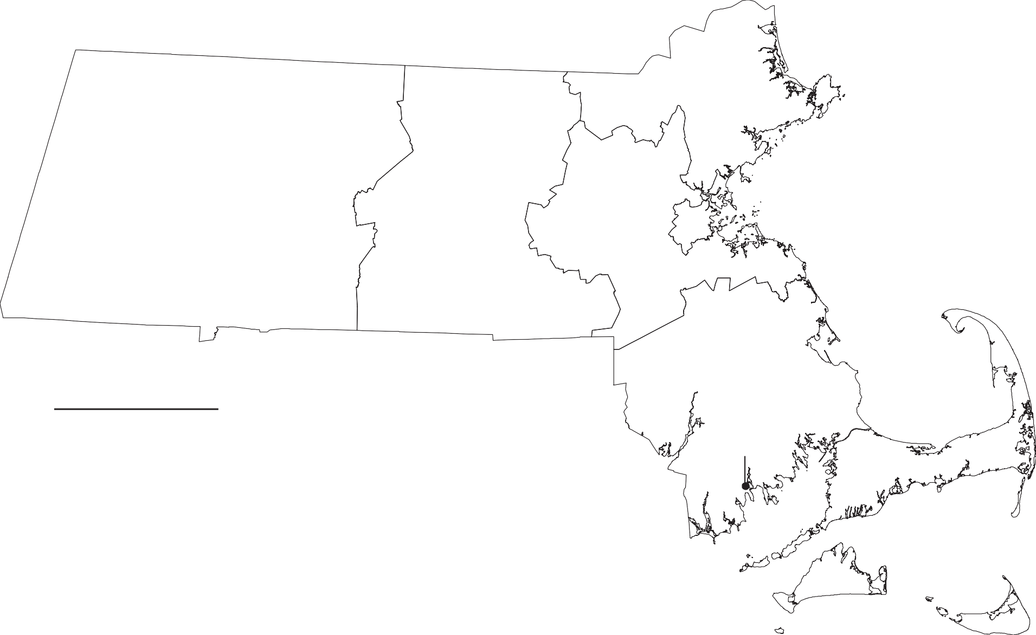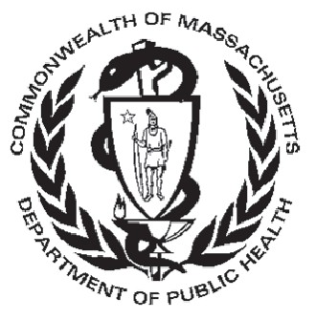DVSMT Agencies
The (New Bedford) Women's Center

The Women's Center
NEW BEDFORD

Massachusetts Department of Public Health
Division of Sexual and Domestic Violence Prevention and Services (DSDVPS)

Rape Crisis Center (RCC) Services

YWCA NEMA
LAWRENCE

Elizabeth Freeman Center
PITTSFIELD

NELCWIT
GREENFIELD

Center for Women and Community
AMHERST

Center for Hope and Healing
LOWELL

Pathways for
Change
WORCESTER

SMOC/VAV
FRAMINGHAM

Boston Area Rape Crisis Center
CAMBRIDGE

YWCA Western MA
SPRINGFIELD

RCC Agencies
A New Day, a program of Health Imperatives A Safe Place
Boston Area Rape Crisis Center (BARCC)

Wayside Youth and Family Support Network
MILFORD

New Hope
ATTLEBORO

Health Imperatives
BROCKTON

The Women's Center

Center for Women and Community, University of Massachusetts Amherst Elizabeth Freeman Center
Independence House
Martha's Vineyard Community Services (MCVS): CONNECT to End Violence New England Learning Center for Women in Transition (NELCWIT)
New Hope
Pathways for Change
South Middlesex Opportunity Council/Voices Against Violence (SMOC/VAV) The Center for Hope and Healing
The (New Bedford) Women's Center
Wayside Trauma Intervention Services/Valley Rape Crisis Program YWCA Northeastern Massachusetts (NEMA)
YWCA of Western Massachusetts
NEW BEDFORD

Independence House
HYANNIS

MV Community Services
VINEYARD HAVEN

A Safe Place
NANTUCKET

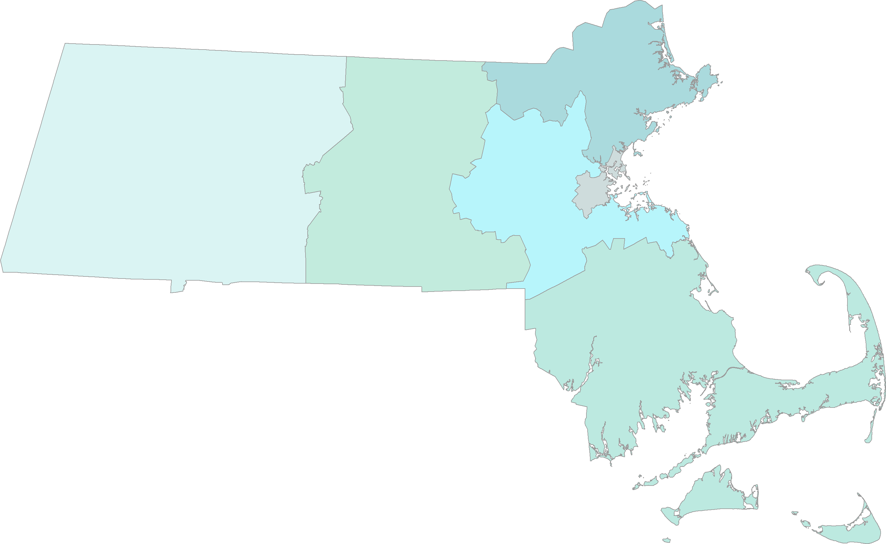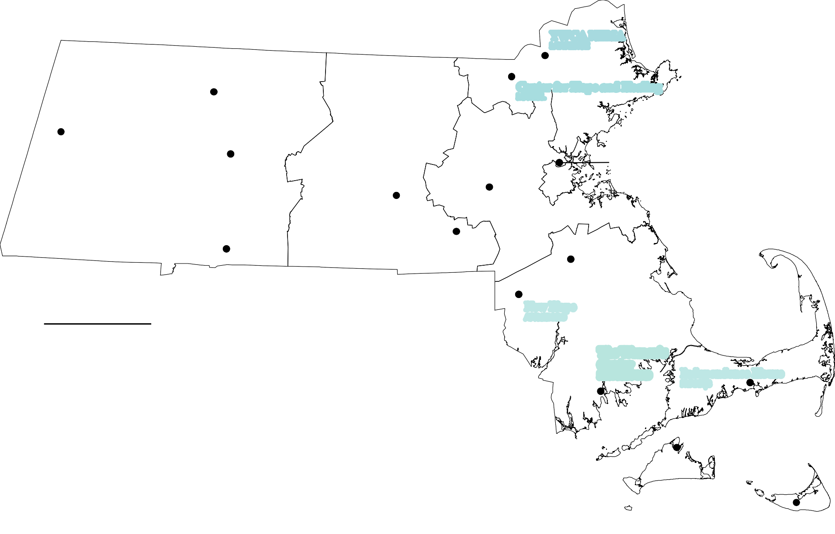
1 in = 19 miles Note: Satellite locations are not depicted.

Massachusetts Department of Public Health
Division of Sexual and Domestic Violence Prevention and Services (DSDVPS)

General Community Based Domestic Violence (GCBDV) Services

Jeanne Geiger Crisis Center
NEWBURYPORT

NELCWIT
GREENFIELD

Alternative House
LOWELL

YWCA NEMA
LAWRENCE

HAWC

HarborCOV
CHELSEA

Elizabeth Freeman Center
PITTSFIELD

Womanshelter/Compañeras
Salasin Project
GREENFIELD

Safe Passage
NORTHAMPTON

Spanish American
Center
LEOMINSTER

REACH
WALTHAM

Second Step
NEWTONVILLE

SMOC/VAV
Saheli
BURLINGTON
SALEM

Respond
SOMERVILLE

On the Rise
CAMBRIDGE

Asian Task Force Against DV
BOSTON

The Network/La Red
BOSTON

HOLYOKE

Behavioral Health Network
SPRINGFIELD

YWCA
Central MA
WORCESTER

YWCA of Western MA
SPRINGFIELD

FRAMINGHAM

Brookview
House
DORCHESTER

Family and
Casa Myrna
BOSTON

Elizabeth Stone House
ROXBURY

DOVE

GCBDV Agencies
A Safe Place

REACH Beyond Domestic Violence

New Hope
ATTLEBORO

Community Resources
BROCKTON
QUINCY

Alternative House (Women in Transition) Asian Task Force against Domestic Violence
Respond Safe Passage

Stanley St. Treatment and Resources

(ATASK)
Behavioral Health Network Brookview House
Casa Myrna Vazquez DOVE
Elizabeth Freeman Center
Saheli, Support and Friendship for South Asian Women and Families
Second Step
South Middlesex Opportunity Council/Voices Against Violence (SMOC/VAV)
Southeast Family Services, South Shore Women's
FALL RIVER

The Women's
Center
NEW BEDFORD

South Shore Women's
Resource Center
NEW BEDFORD

Independence House
HYANNIS

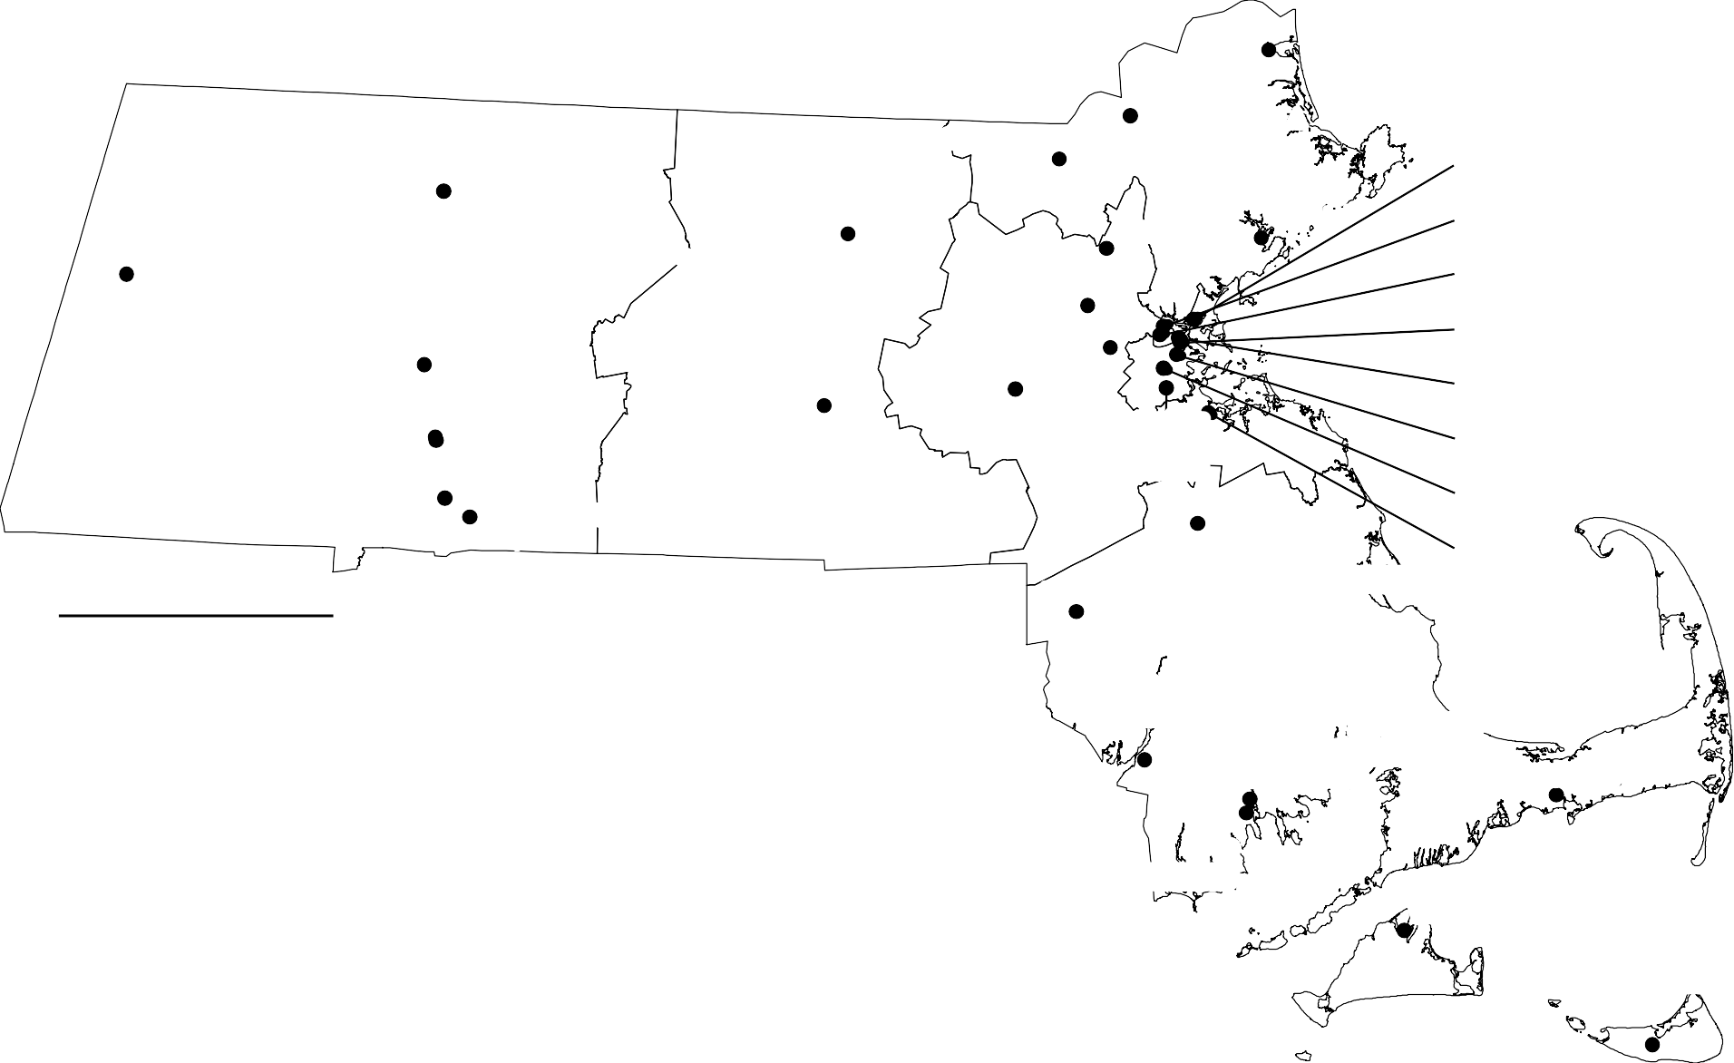Elizabeth Stone House
Family and Community Resources HarborCOV
Healing Abused Working for Change (HAWC) Independence House
Jeanne Geiger Crisis Center
Martha's Vineyard Community Services (MVCS) New England Learning Center for Women in Transition (NELWCIT)
New Hope On the Rise
Resource Center
Spanish American Center
Stanley Street Treatment and Resources The Network/La Red
The (New Bedford) Women's Center Salasin Project Womanshelter/Compañeras
YWCA Central Massachusetts
YWCA Northeastern Massachusetts (NEMA) YWCA of Western Massachusetts

MV Community Services
VINEYARD HAVEN

A Safe Place
NANTUCKET

Massachusetts Department of Public Health
Division of Sexual and Domestic Violence Prevention and Services (DSDVPS)

Intimate Partner Abuser Education (IPAE) Programs

Office of Community Corrections
PITTSFIELD

Spectrum Health Systems
LEOMINSTER

Emerge
Jeanne Geiger Crisis Center
NEWBURYPORT

Eliot CHS
LYNN

MA Alliance of Portuguese Speakers

Gándara Mental Health Center
SPRINGFIELD

IPAE Agencies

Behavioral Health Network
SPRINGFIELD
CAMBRIDGE

New Hope
ATTLEBORO

Family and Community Resources
BROCKTON
CAMBRIDGE

Common Purpose
JAMAICA PLAIN

Bay State Community Services
QUINCY

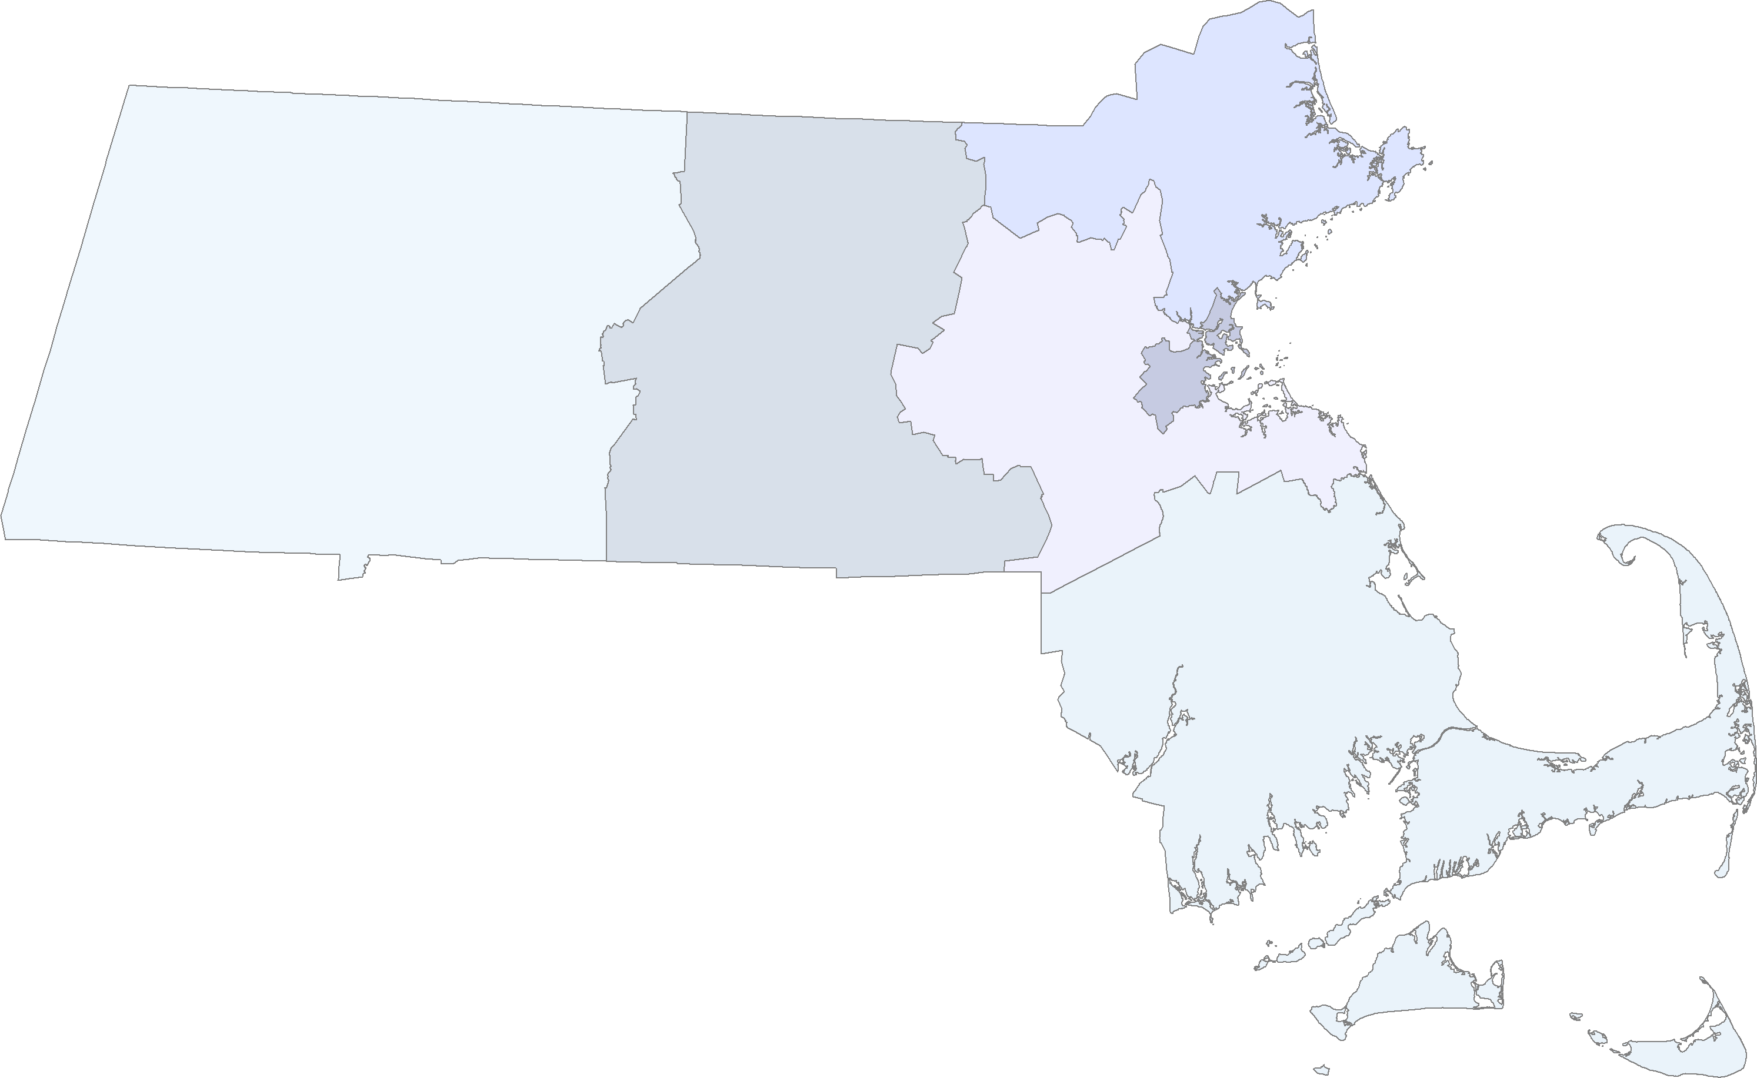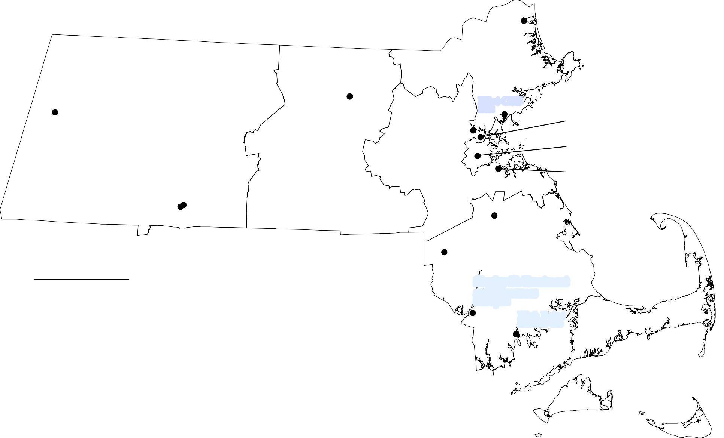
Bay State Community Services Behavioral Health Network Common Purpose
Eliot Community Human Services Emerge
Family and Community Resources Gándara Mental Health Center High Point Treatment Center Jeanne Geiger Crisis Center
Massachusetts Alliance of Portuguese Speakers (MAPS) New Hope
Office of Community Corrections Spectrum Health Systems
Stanley Street Treatment and Resources

Stanley St. Treatment and Resources
FALL RIVER

High Point
NEW BEDFORD

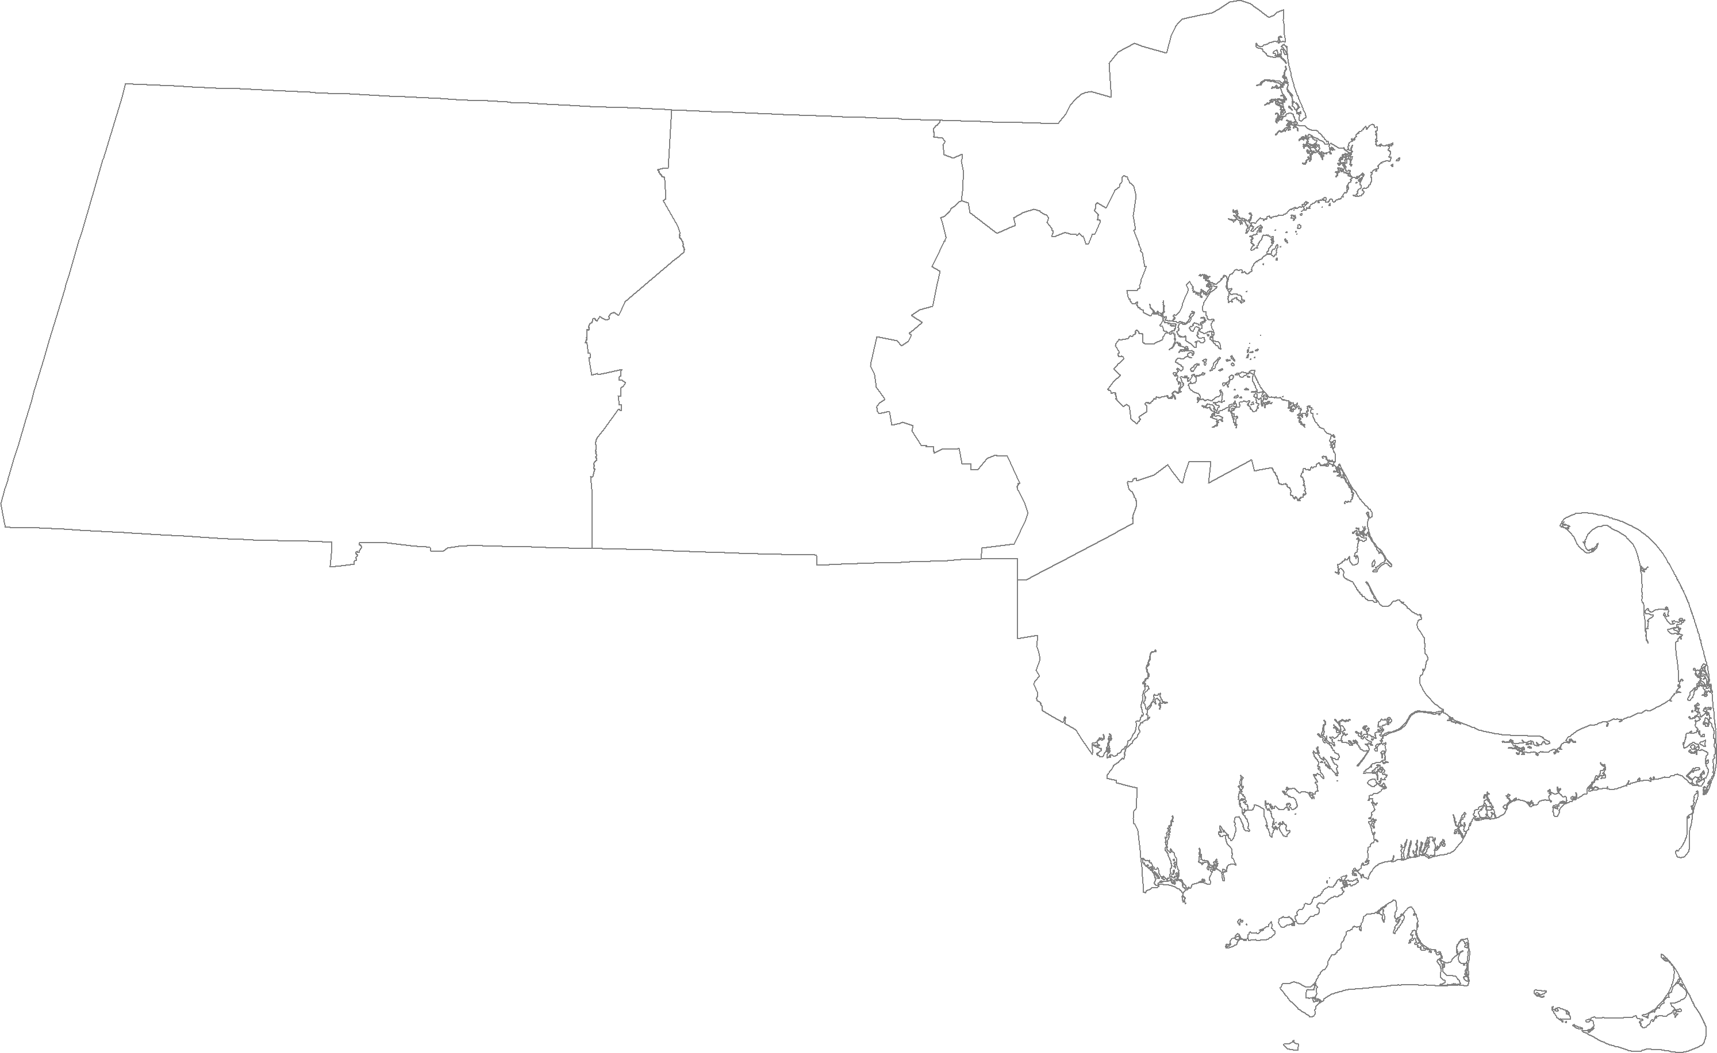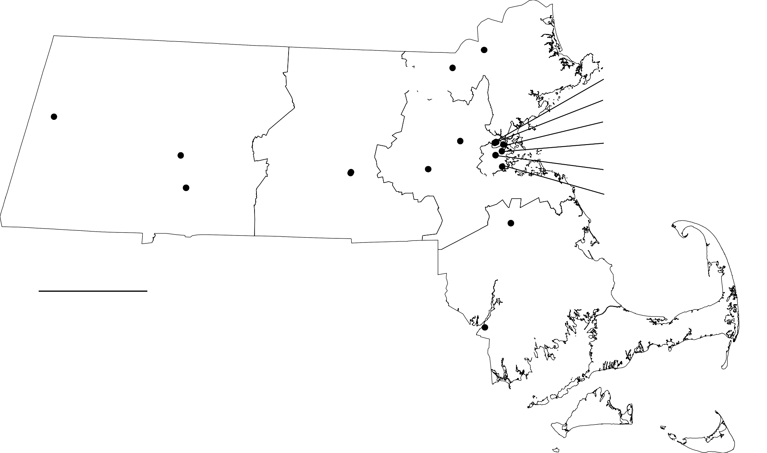Massachusetts Department of Public Health
Division of Sexual and Domestic Violence Prevention and Services (DSDVPS)

Sexual and Domestic Violence Services for Communities Experiencing Inequities (SDVEI)

Elizabeth Freeman Center
PITTSFIELD

Safe Passage
NORTHAMPTON

The Center for Hope
and Healing
LOWELL

Journey to
Safety
WALTHAM

Pathways for Change
WORCESTER
Northeast Legal Aid
LAWRENCE

MA Alliance of Portuguese Speakers
CAMBRIDGE

On the Rise
CAMBRIDGE
Greater Boston Legal Services
BOSTON

Casa Myrna
BOSTON

Refugee and Immigration Assistance Center

Womanshelter/Compañeras
HOLYOKE
Community Legal Aid
WORCESTER
Metrowest Legal Services
FRAMINGHAM
JAMAICA PLAIN

Assoc. of Haitian Women in Boston
DORCHESTER

SDVEI Agencies
Association of Haitian Women in Boston Casa Myrna Vazquez
The Center for Hope and Healing Community Legal Aid* Elizabeth Freeman Center
Family and Community Resources Greater Boston Legal Services*
Journey to Safety, Jewish Family & Children's Services
Massachusetts Alliance of Portuguese Speakers (MAPS)

Metrowest Legal Services* Northeast Legal Aid*
On the Rise Pathways for Change
Refugee and Immigration Assistance Center (RIAC)
Safe Passage
South Coastal Counties Legal Services* Womanshelter/Compañeras

Family and Community Resources
BROCKTON

South Coastal Counties Legal Services
FALL RIVER

1 in = 19 miles *Agencies providing legal services through the SDVEI contract are depicted on the map in blue.

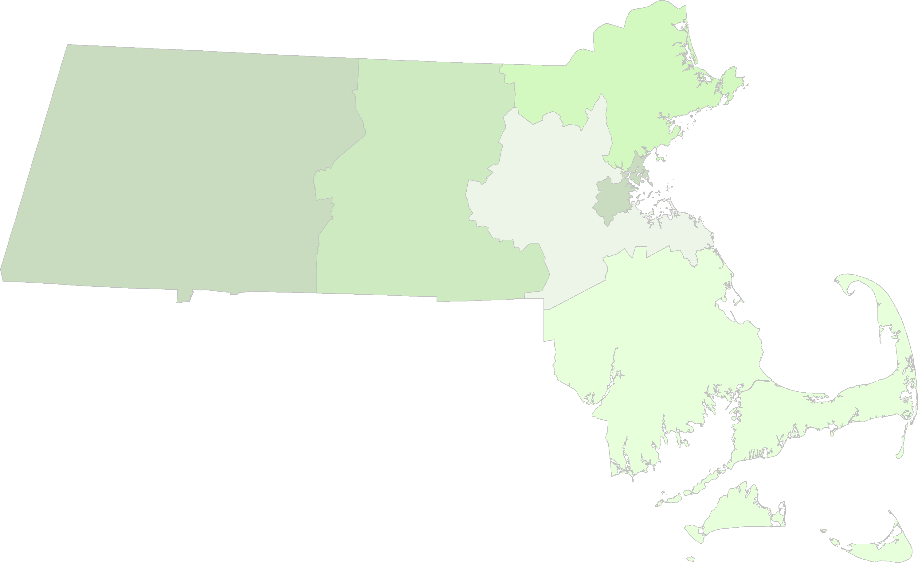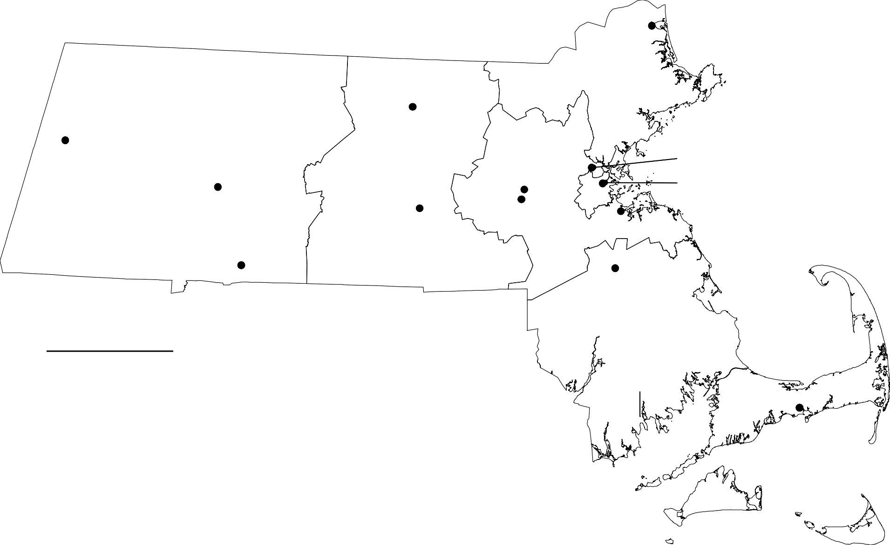Massachusetts Department of Public Health
Division of Sexual and Domestic Violence Prevention and Services (DSDVPS)

Children Exposed to Domestic Vioelnce (CEDV) Services

Jeanne Geiger Crisis Center
NEWBURYPORT

LUK
FITCHBURG

Elizabeth Freeman Center
PITTSFIELD

Safe Passage
NORTHAMPTON

Children's Charter
FRAMINGHAM

Riverside Community Care
CAMBRIDGE
Boston Medical Center Corp.
BOSTON

YWCA of Western MA
SPRINGFIELD

CEDV Agencies

Boston Medical Center Corporation

Community Health Link
WORCESTER
SMOC/VAV
FRAMINGHAM

DOVE
QUINCY

Family and Community Resources
BROCKTON

Children's Charter, A Division of The Key Program Community Health Link
DOVE
Elizabeth Freeman Center Family & Community Resources Independence House
Jeanne Geiger Crisis Center
L.U.K. Crisis Center Riverside Community Care Safe Passage
South Middlesex Opportunity Council/Voices Against Violence YWCA of Western Massachusetts

Independence House
HYANNIS

1 in = 19 miles

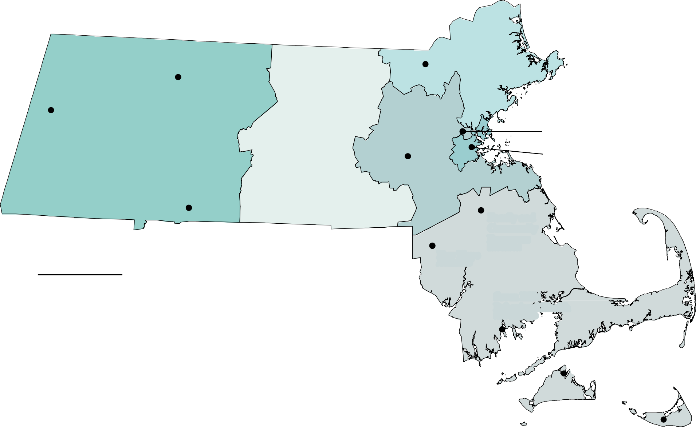Massachusetts Department of Public Health
Division of Sexual and Domestic Violence Prevention and Services (DSDVPS)

Supervised Visitation Services (SVS)

NELCWIT
GREENFIELD

Alternative House
LOWELL

Elizabeth Freeman Center
PITTSFIELD

SMOC/VAV
FRAMINGHAM

Riverside Community Care
CAMBRIDGE

Children’s Services of Roxbury
BOSTON

YWCA of Western MA
SPRINGFIELD

SVS Agencies
A Safe Place Alternative House
Children's Services of Roxbury Elizabeth Freeman Center
Family and Community Resources Martha's Vineyard Community Services
New England Learning Center for Women in Transition (NELCWIT) New Hope
Riverside Community Care Seven Hills Behavioral Health
South Middlesex Opportunity Council/Voices Against Violence (SMOC/VAV) YWCA of Western Massachusetts

New Hope
ATTLEBORO

Family and Community Resources
BROCKTON

Seven Hills Behavioral Health
NEW BEDFORD

MV Community Services
VINEYARD HAVEN

A Safe Place
NANTUCKET

1 in = 19 miles

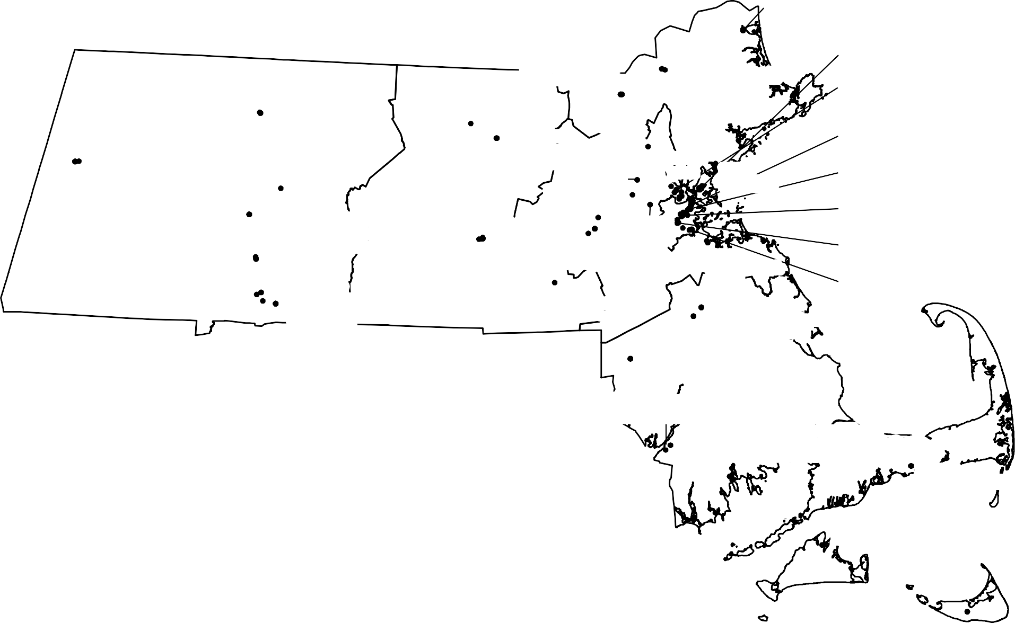Massachusetts Department of Public Health
Division of Sexual and Domestic Violence Prevention and Services (DSDVPS)

NEWBURYPORT
Jeanne Geiger Crisis Center

PITTSFIELD

GREENFIELD
NELCWIT
Salasin Project
LOWELL
Alternative House The Center for Hope and Healing

FITCHBURG
LUK
BURLINGTON

LAWRENCE
Northeast Legal Aid YWCA NEMA

SALEM
HAWC
CHELSEA
HarborCOV
CAMBRIDGE
BARCC, Emerge, MAPS, On the Rise, Riverside Community Care, Transition House
BOSTON
Asian Task Force Against DV,

Elizabeth Freeman Center
Office of Community Corrections

AMHERST
Center for Women and Community
LEOMINSTER
Spanish American Center Spectrum Health Services
Saheli

WALTHAM
REACH

SOMERVILLE
Respond

LYNN
Eliot CHS
Greater Boston Legal Services, The Network/La Red
SOUTH END
Boston Medical Center Corp., Casa Myrna

NORTHAMPTON
Safe Passage

WORCESTER
Journey To Safety
ROXBURY
Children's Services of Roxbury, Elizabeth

HOLYOKE
Community Health Link
Community Legal Aid
FRAMINGHAM
SMOC/VAV
NEWTONVILLE
Second Step
Stone House, UU Urban Ministry
JAMAICA PLAIN

Womanshelter/Compañeras

SPRINGFIELD
Pathways for Change
YWCA Central MA
Children's Charter MetroWest Legal Services

MILFORD
QUINCY
Bay State C. S. DOVE
Common Purpose, FINEX House, RIAC
DORCHESTER
Assoc. of Haitian Women in Boston, Brookview House

Behavioral Health Network
Gándara Mental Health Center Way Finders
YWCA of Western MA

Sixty-nine Massachusetts agencies provide sexual and domestic
Wayside Youth and Family Services Network

ATTLEBORO
New Hope

FALL RIVER
South Coastal Counties Legal Services Stanley St. Treatment and Resources
BROCKTON
Family Community Resources Health Imperatives

NEW BEDFORD
High Point
Seven Hills Behavioral Health

violence prevention and services through the following FY20 MDPH contract models:
South Shore Women's Resource Center The Women's Center

Children Exposed to Domestic Violence (13)
Domestic Violence, Substance Misuse, and Trauma Shelter (1) Emergency Shelter (23)

VINEYARD HAVEN
HYANNIS
Independence House

General Community-based Domestic Violence Services (35)
Housing Stabilization (10)
Intimate Partner Abuse Education Program Services (14)
Sexual and Domestic Violence Services for Communities Experiencing Inequities (17) Supervised Visitation Services (12)
Rape Crisis Centers (16)
MV Community Services

NANTUCKET
A Safe Place

1 in = 19 miles Note: Satellite office locations are not depicted.

