INDOOR AIR QUALITY ASSESSMENT

Marblehead High School
2 Humphrey Street
Marblehead, Massachusetts

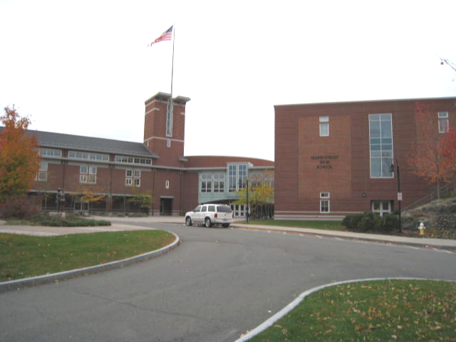

Prepared by:
Massachusetts Department of Public Health
Bureau of Environmental Health
Indoor Air Quality Program
September 2009

Background/Introduction
At the request of Richard Matthews, Facilities Director, Marblehead Public Schools, the Massachusetts Department of Public Health (MDPH), Bureau of Environmental Health (BEH) provided assistance and consultation regarding indoor air quality concerns at Marblehead High School (MHS), 2 Humphrey Street, Marblehead, Massachusetts. The request was prompted by mold concerns, odors, and water damage in Room B-215, from a roof leak that occurred on October 15, 2008.
On November 3, 2008, a visit to conduct an assessment was made to the MHS by Susan Koszalka, an Environmental Analyst/Inspector in BEH’s Indoor Air Quality (IAQ) Program. Ms. Koszalka was accompanied by Ronald Comeau, Marblehead Public Schools Facilities Department and Mr. Matthews during the assessment.

Methods
MDPH staff performed a visual inspection of building materials for water damage and/or microbial growth. Moisture content of porous building materials (gypsum wallboard [GW], and fiberglass insulation) was measured with a Delmhorst, BD-2000 Model, Moisture Detector equipped with a Delmhorst Standard Probe.

Discussion
Microbial/Moisture Concerns
As mentioned, room B-215 became water damaged as a result of a roof leak in October of 2008. The leak caused water damage and moistening of walls and insulation (Picture 1). At the time of the DPH assessment, historic water damage from an air conditioning leak in 2006 in the plenum of the adjacent hallway that houses an air handling unit (AHU) was also evaluated (Picture 2). The AHU leak resulted in the moistening of insulation surrounding the unit and adjacent pipes (Pictures 2 and 3). In addition, water stains were seen emanating down the wall from the plenum area (Picture 4). This area was reportedly disinfected with an appropriate anti-microbial and the insulation dried.
In order for building materials to support mold growth, a source of moisture is necessary. Identification and elimination of water moistening building materials is necessary to control mold growth. Building materials with increased moisture content over normal concentrations may indicate the possible presence of mold growth. Identification of the location of materials with increased moisture levels can also provide clues concerning the source of water supporting mold growth.
In an effort to determine moisture content of water-damaged ceiling materials in room B-215, moisture content was measured with a Delmhorst Moisture Detector equipped with a Delmhorst Standard Probe. The Delmhorst probe is equipped with three lights that function as visual aids that indicate moisture level. Readings that activate the green light indicate a sufficiently dry or low moisture level, those that activate the yellow light indicate borderline conditions, and those that activate the red light indicate elevated moisture content. No elevated moisture readings were measured in the remaining insulation or in the wall behind the insulation during the assessment. Nor were any mold growth or associated odors detected.
The US Environmental Protection Agency (US EPA) and the American Conference of Governmental Industrial Hygienists (ACGIH) recommend that porous materials (e.g., ceiling tiles, GW) be dried with fans and heating within 24 to 48 hours of becoming wet (US EPA, 2001; ACGIH, 1989). If not dried within this time frame, mold growth may occur. Once mold has colonized porous materials, they are difficult to clean and should be removed.

Conclusions/Recommendations
In view of the findings at the time of the assessment, the following recommendations are made:
- Ensure leaks are repaired and replace any remaining water damaged materials (e.g., ceiling tiles, insulation).
- Continue to monitor both Room B-215 and the AHU in the adjacent hallway for prompt action if leaks recur.
- If leaks recur in the AHU, the unit should be examined by an HVAC engineering firm for proper function.
- Consult “Mold Remediation in Schools and Commercial Buildings’ published by the U.S. Environmental Protection Agency (U.S. EPA, 2001) for more information on mold. This document can be downloaded from the U.S. EPA website at: http://www.epa.gov/iaq/molds/mold_remediation.html.
- Refer to resource manual and other related indoor air quality documents located on the MDPH’s website for further building-wide evaluations and advice on maintaining public buildings. These documents are available at: http://mass.gov/dph/iaq.

References

ACGIH. 1989. Guidelines for the Assessment of Bioaerosols in the Indoor Environment. American Conference of Governmental Industrial Hygienists, Cincinnati, OH.

US EPA. 2001. Mold Remediation in Schools and Commercial Buildings. US Environmental Protection Agency, Office of Air and Radiation, Indoor Environments Division, Washington, DC. EPA 402-K-01-001. March 2001.
Picture 1

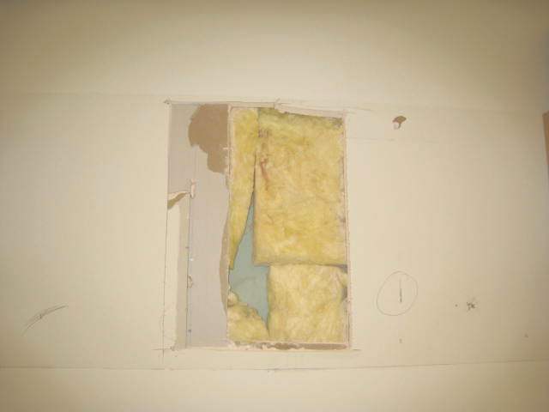

Insulation in Room B-215

Picture 2

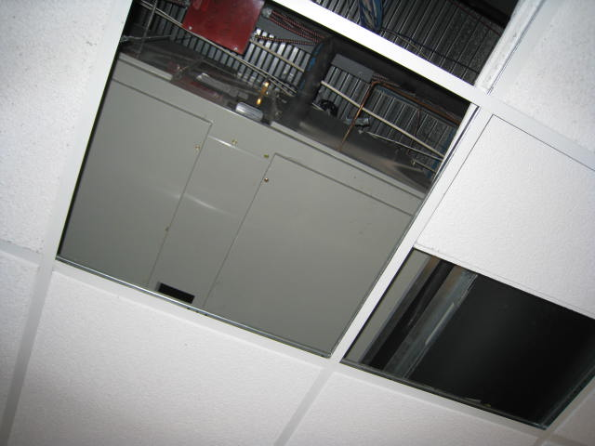

Hallway AHU Adjacent to Room B-215

Picture 3

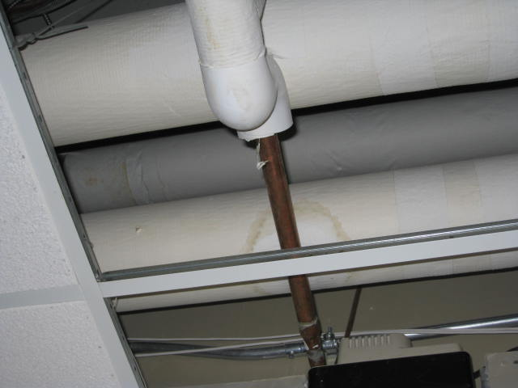

Plenum above Hallway AHU (note water staining on pipe)

Picture 4

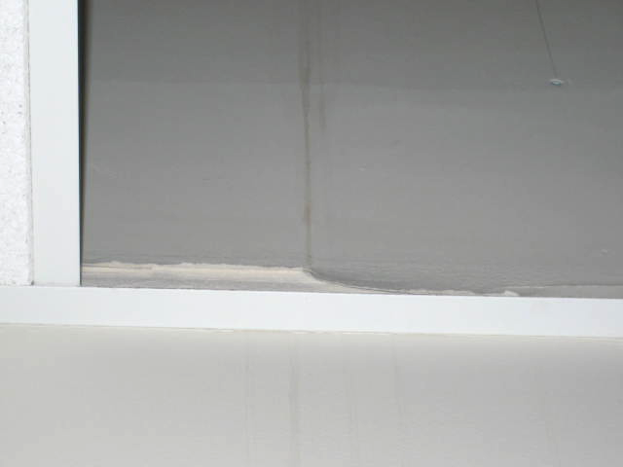

Plenum in room B-215 (note water stains)

