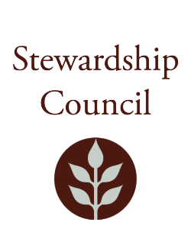

Stewardship Council Meeting
Thursday, March 12, 2026 | 1:00PM to 3:00PM
Lawrence Heritage State Park
1 Jackson St, Lawrence, MA 01840

Agenda

TOPIC | SEGMENT
Welcome and Chair’s Update – Dicken Crane, Chair | 1:00 – 1:10 PM
DCR Report – Nicole LaChapelle, Commissioner | 1:10 – 1:30 PM
Regular Business I  - Mass Parks For All Presentation, Doug Pizzi, Executive Director  - Approve Minutes: February 12, 2026  - Public Comment | 1:30 – 2:45 PM
Regular Business II  - Committee Updates  - Councilor Comments | 2:45 – 3:00 PM
Adjourn | 3:00 PM

Zoom Meeting Information

You are invited to register for a Zoom webinar!

When: Mar 12, 2026 01:00 PM Eastern Time (US and Canada)
Topic: March 12, 2026 Stewardship Council Meeting

Register in advance for this webinar.

After registering, you will receive a confirmation email containing information about joining the webinar.

Please contact Matt Perry at matthew.s.perry1@mass.gov for accessibility information.
3/5/2026 10:20 AM

