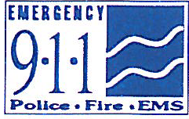
The Commonwealth of Massachusetts
EXECUTIVE OFFICE OF PUBLIC SAFETY AND SECURITY
State 911 DEPARTMENT
151 Campanelli Drive, Suite A ~ Middleborough, MA 02346
Tel: 508-828-2911 ~ TTY: 508-947-1455
www.mass.gov/e911

Maura T. Healey Terrence M. Reidy
Governor Secretary

Kimberley Driscoll Frank Pozniak
Lieutenant Governor Executive Director

AGENDA
State 911 Commission
Standards Committee Meeting
State 911 Department, 151 Campanelli Drive, Suite A, Middleborough, MA 02346
March 30, 2023, 11:00 a.m.

- Call to Order and Introductions (Chairperson Stephan Hooke)

- Approval of the January 10, 2023 Meeting Minutes (Chairperson Stephan Hooke)

- Consideration of the Draft Appendix A Standards (Dennis Kirwan/Shari Moin/Charlie Ashworth/Joe Hickey)

- Draft changes to 560 CMR 5.00 (Dennis Kirwan)

- Other Business

- Next Meeting Date – TBD

- Adjournment

