INDOOR AIR QUALITY ASSESSMENT

Maria Hastings Elementary School
2618 Massachusetts Avenue
Lexington, MA 02421

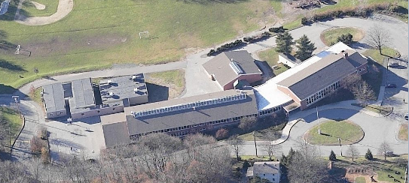

Prepared by:
Massachusetts Department of Public Health
Center for Environmental Health
Emergency Response/Indoor Air Quality Program
March 2007

Background/Introduction
At the request of William J. Hartigan, Director of Facilities for Lexington Public Schools (LPS), the Massachusetts Department of Public Health (MDPH), Center for Environmental Health (CEH) provided assistance and consultation regarding indoor air quality concerns at the Maria Hastings Elementary School (HES), 2618 Massachusetts Avenue, Lexington, Massachusetts. The request was prompted by concerns about general indoor air quality and musty odors in a ground floor classroom.
On December 13, 2006, a visit to conduct an indoor air quality assessment at the HES was made by Sharon Lee, an Environmental Analyst in CEH’s ER/IAQ Program. The HES is a two-story, red brick building constructed in 1955. An addition was made to the school in 1960. Two modular units each holding four classrooms were reportedly added within the past 15 years. These modular units are connected to the school via a hallway. The school is built on a hill with portions of the original building below grade. The ground floor consists of general classrooms and a cafeteria. The main floor contains general classrooms, an auditorium/gymnasium, library and offices. A small crawlspace exists beneath the 1960 addition. Windows throughout the building are openable.

Methods
Air tests for carbon dioxide, carbon monoxide, temperature and relative humidity were conducted with the TSI, Q-TRAK™ IAQ Monitor, Model 8551. Air tests for airborne particle matter with a diameter less than 2.5 micrometers were taken with the TSI, DUSTTRAK™ Aerosol Monitor Model 8520. Screening for total volatile organic compounds (TVOCs) was conducted using an HNu, Model 102 Snap-on Photo Ionization Detector (PID). CEH staff also performed a visual inspection of building materials for water damage and/or microbial growth.

Results
This school houses approximately 450 kindergarten through fifth grade students, as well as approximately 90 staff members. Tests were taken during normal operations at the school. Results appear in Table 1.

Discussion

Ventilation
It can be seen from Table 1 that carbon dioxide levels were elevated above 800 parts per million (ppm) in 17 of 40 areas surveyed, indicating poor air exchange in almost half of the areas surveyed. It is important to note that several areas were empty or sparsely populated at the time of the assessment, which can greatly reduce carbon dioxide levels. Carbon dioxide levels would be expected to be higher with increased occupancy. Of note were carbon dioxide levels in classrooms in the modular buildings, which ranged from 1,101 ppm to 2,328 ppm, further indicating a lack of adequate air exchange.
Fresh air for classrooms in the original building and 1960 addition is supplied by unit ventilator (univent) systems (Figure 1, Picture 1). A univent draws air from outdoors through a fresh air intake located on the exterior wall of the building (Picture 2) and returns air through an air intake located at the base of the unit. Fresh and return air are mixed, filtered, heated and provided to classrooms through a diffuser located on the top of the unit. Obstructions to airflow, such as furniture located in front of and/or materials stored on univents, were observed in many areas (Pictures 3 and 4). Some univents were not operating at the time of the assessment. In order for univents to provide fresh air as designed, intakes and returns must be free of obstructions and importantly, these units must be operating while rooms are occupied.
Please note, the univent for classroom 4 was adjusted to minimize noise. The univent were reportedly fresh air dampers adjusted to 10 percent capacity, which results in minimal fresh air provided to the classroom. This adjustment is reflected in the carbon dioxide level of 1,081 ppm measured in the classroom. Consideration should be given to supplementing fresh air supply through the use of windows or operating window-mounted air-conditioners (ACs) in the fan only setting. Operating the ACs in this setting increases air circulation through the provision of fresh, unconditioned (i.e., outside temperature) air.
Mechanical exhaust ventilation for classrooms in the original building and the 1960 addition is provided by closet or wall-mounted exhaust vents (Pictures 5 and 6) ducted to rooftop exhaust fans. Some exhaust vents did not appear to be operating at the time of the assessment. It is important to note that the location of some exhaust vents can limit exhaust efficiency. In some classrooms, exhaust vents are located behind hallway doors (Picture 6). When classroom doors are open, exhaust vents are blocked. In addition, other blockages to exhaust (i.e., furniture or items placed in front) were noted. The effectiveness of exhaust vents to remove common environmental pollutants from classrooms becomes reduced when vents are blocked. As with univents, exhaust vents must be activated and remain free of obstructions in order to operate as designed.
Exhaust ventilation for the music room is provided by a unit exhaust ventilator (Picture 7). A unit exhaust ventilator appears similar to a univent, but removes air from the classroom and exhausts it out of the building. This unit was operating weakly at the time of assessment. Without sufficient supply and exhaust ventilation, normally occurring environmental pollutants can build-up and lead to indoor air quality/comfort complaints.
Mechanical ventilation for classrooms in both modular units is provided by air-handling units (AHUs). The AHUs for the modular building containing classrooms 31 to 34 are located on the roof (Picture 8). The AHUs for the modular building containing classrooms 41 to 44 are located on the exterior wall (Picture 9). Fresh, tempered air is supplied to each room by ceiling- or wall-mounted vents and ducted back to the AHUs via ceiling or wall-mounted return vents (Pictures 10 to 12). Each of the AHUs is controlled by a thermostat, which has fan settings of “on” and “automatic”. Thermostats were set to the “automatic” setting in a number of classrooms. The automatic setting on the thermostat activates the HVAC system at a preset temperature. Once the preset temperature is reached, the HVAC system is deactivated. Therefore, no mechanical ventilation is provided until the thermostat re-activates the system.
It appears that multiple rooms in the guidance/speech area near the cafeteria share a single univent. This ceiling-mounted univent (Picture 13) is ducted to ceiling-mounted diffusers. Passive vents were installed in shared walls to increase air flow between rooms. Consideration should be given to increasing the capacity of this univent to supply fresh air to these rooms. Consideration should also be given to increasing the size of the passive air vents between these areas to aid ventilation.
To maximize air exchange, the MDPH recommends that both supply and exhaust ventilation operate continuously during periods of school occupancy. In order to have proper ventilation with a mechanical supply and exhaust system, the systems must be balanced to provide an adequate amount of fresh air to the interior of a room, while removing stale air from the room. It is recommended that HVAC systems be re-balanced every five years to ensure adequate air systems function (SMACNA, 1994). The date of the last balancing was unknown at the time of the assessment.
The Massachusetts Building Code requires that each room have a minimum ventilation rate of 15 cubic feet per minute (cfm) per occupant of fresh outside air or openable windows (SBBRS, 1997; BOCA, 1993). The ventilation must be on at all times that the room is occupied. Providing adequate fresh air ventilation with open windows and maintaining the temperature in the comfort range during the cold weather season is impractical. Mechanical ventilation is usually required to provide adequate fresh air ventilation.
Carbon dioxide is not a problem in and of itself. It is used as an indicator of the adequacy of the fresh air ventilation. As carbon dioxide levels rise, it indicates that the ventilating system is malfunctioning or the design occupancy of the room is being exceeded. When this happens, a buildup of common indoor air pollutants can occur, leading to discomfort or health complaints. The Occupational Safety and Health Administration (OSHA) standard for carbon dioxide is 5,000 parts per million parts of air (ppm). Workers may be exposed to this level for 40 hours/week, based on a time-weighted average (OSHA, 1997).
The MDPH uses a guideline of 800 ppm for publicly occupied buildings. A guideline of 600 ppm or less is preferred in schools due to the fact that the majority of occupants are young and considered to be a more sensitive population in the evaluation of environmental health status. Inadequate ventilation and/or elevated temperatures are major causes of complaints such as respiratory, eye, nose and throat irritation, lethargy and headaches. For more information concerning carbon dioxide, see Appendix A.
Temperature measurements the day of the assessment ranged from 69º F to 75º F, which were within or very close to the lower end of the MDPH recommended comfort range. The MDPH recommends that indoor air temperatures be maintained in a range of 70º F to 78º F in order to provide for the comfort of building occupants. A number of occupants voiced temperature concerns. In many cases concerning indoor air quality, fluctuations of temperature in occupied spaces are typically experienced, even in a building with an adequate fresh air supply. It is also difficult to control temperature without the mechanical ventilation system functioning as designed (e.g., univents/exhausts not operating/obstructed).
The relative humidity measured in the building during the assessment ranged from 32 to 47 percent, which was below the MDPH recommended comfort range in the majority of areas surveyed. The MDPH recommends a comfort range of 40 to 60 percent for indoor air relative humidity. Relative humidity levels in the building would be expected to drop during the winter months due to heating. The sensation of dryness and irritation is common in a low relative humidity environment. Low relative humidity is a very common problem during the heating season in the northeast part of the United States.

Microbial/Moisture Concerns

1955/1960 Building
As previously discussed, the assessment was prompted in part by concerns of a musty odor in a ground level classroom. According to School Principal Steven Adler, the occupant of classroom 4 initially reported musty odors in early fall. Since the odor complaint, LPS maintenance and custodial staff have reportedly worked to examine, clean and replace materials in the room. CEH staff inspected the room for water damage and sources of water penetration.
In order for building materials to support mold growth, a source of moisture is necessary. Identification and elimination of water moistening building materials is necessary to control mold growth. At the time of the assessment, CEH staff did not observe any visible mold growth or detect associated odors in classroom 4. Please note this and other classrooms along this side of the building are downhill from a tree lined area. Due to the proximity of trees, it is likely that leaves and other debris may collect against the exterior wall. Univent fresh air intakes for this side of the building are also low to the ground (Picture 14). As a result, these units are prone to entrainment of debris and related odors from materials that gather at the base of the building. These odors would subsequently be distributed to classrooms. Over time and with the aid of airflow, the odors would decrease as the decomposition process is completed (or if materials are removed). As discussed, the amount of fresh air to classroom 4 was minimized. Therefore, odors within the classroom would tend to linger due to reduced dilution (e.g., amount dispersed in volume of air).
In addition, some rooms in the guidance/speech area that abut the crawlspace and hillside have been prone to moisture problems in the past. In certain instances, condensation that formed on the floor reportedly caused damage to gypsum wallboard (GW). According to HES staff, damaged GW was dried or replaced, where necessary. CEH staff did not observe any related damage at the time of the assessment; however, these areas should be monitored during periods of high humidity (i.e., when outdoor relative humidity is greater than 70 percent). Dehumidifiers were observed in these areas for moisture removal during periods of increased relative humidity. Occupants and custodial staff should periodically examine, clean and disinfect these units as per the manufacture’s instructions to prevent growth and odors.
While mold growth was not observed in the building, some potential sources for mold growth were observed. Spaces between the sink countertop and backsplash were seen in several areas (Picture 15). Improper drainage or sink overflow can lead to water penetration into the countertop, cabinet interior and areas behind cabinets. If these materials become wet repeatedly they can provide a medium for mold growth. The US Environmental Protection Agency (US EPA) and the American Conference of Governmental Industrial Hygienists (ACGIH) recommend that porous materials be dried with fans and heating within 24 to 48 hours of becoming wet (US EPA, 2001; ACGIH, 1989). If porous materials are not dried within this time frame, mold growth may occur.
Plants were noted in several areas. Plants, soil and drip pans can serve as sources of mold growth, and thus should be properly maintained. Plants should have drip pans to prevent wetting and subsequent mold colonization of window frames. A number of pine cones and decaying produce items (i.e., squash) were observed on top of a univent (Picture 16). Plants and related materials should be located away from univents and ventilation sources to prevent aerosolization of dirt, pollen or mold.
Aquariums and/or terrariums were seen in some classrooms. Aquariums should be properly maintained to prevent microbial/algae growth, which can emit unpleasant odors. Similarly, terrariums should be properly maintained to ensure soil does not become a source for mold growth/odors.
During an assessment of the exterior of the original building and 1960 addition, CEH staff observed damage to the foundation (Picture 17). Breaches, cracks and holes in the foundation can serve as points for water entry into the building. Continued freezing and thawing of water during cooler months will serve only to further damage the foundation. In addition, breaches can serve as points of entry or shelter for pests.
Small trees and other plants were also observed growing against the foundation (Pictures 18 and 19). The growth of roots against the exterior of foundation walls, as well as spaces between the tarmac, can bring moisture in contact with brick and foundation, which may eventually lead to moisture penetration below ground level areas of the building.

Modular Buildings
As previously discussed, two modular buildings of different ages were added to the HES. Upon entering the first modular building, which houses classrooms 31 to 34, CEH staff noted a slight musty odor. A number of water-damaged ceiling tiles were observed in these classrooms. Water-damaged ceiling tiles are typically an indication of roof or plumbing leaks (Picture 20). According to school personnel, this modular building has had a history of roof leaks. CEH staff examined the classrooms, but did not observe any additional water-damaged materials. However, a number of conditions concerning this modular building’s exterior could serve as sources for moisture intrusion.
CEH staff examined the building exterior of the modular building housing classrooms 31 to 34, based on guidance released by The Modular Building Institute (Stewart, 2002). The guidance provides methods for improving a building’s structure to prevent microbial growth; the guidance can also be used as an aid to identifying sources contributing to mold growth. The following is a summary of the guidance:
- Ensure structures are constructed with a sloped roof with a properly installed gutter and downspout system to drain rainwater.
- Site modular structures on well-drained surfaces.
- Direct surface water run-off away from the structure.
- Ventilate the crawlspace under the structure.
- Examine all caulking and/or flashing around windows and service posts, especially after moving a structure.
- Maintain ventilation according to American Society for Heating, Refrigerating and Air-conditioning Engineers (Stewart, 2002).
CEH staff observed breaches/conditions that could provide a source for water to penetrate the building.
Many of the wood panels on the exterior of the modular unit were bowing and no longer attached to the building’s frame (Picture 21). As a result, insulation is exposed to moisture (Picture 22). Insulation can act as a wick, drawing moisture towards the interior of the building, potentially moistening the interior wall. If moistened insulation is not dried, it can become a source for mold growth. At the time of the assessment, insulation appeared to be wet. However, no evidence of water damage was observed in the classrooms.
It appears that attempts were made to repair a previously damaged section of the enclosed crawlspace (Picture 23). However, CEH staff observed breaches in this area of the modular building. Holes, breaches, and seams are points through which water can penetrate the building, particularly under driving rain conditions.
A number of downspouts were not configured in a manner that drains water away from the base of the modular building. Over time, repeated wetting of materials can cause damage, as evidenced by staining (Picture 24).
Plant growth was observed growing against the crawlspace/base of the modular buildings (Picture 25), indicating that the area below is retaining moisture and nutrients. The growth of plants against the exterior walls of a building can bring moisture in contact with building materials causing water damage and subsequent microbial growth.
It is worthy to point out that musty odors were stronger in the three classrooms where thermostats were set to fan ‘on’ position. As mentioned previously, the MDPH typically recommends operating AHUs in the fan ‘on’ mode to provide continuous ventilation. In this case, the positive pressure created by the operation of AHUs may be serving to magnify odors. Since modular buildings are constructed to prevent moisture intrusion, moisture and related odors can also become trapped within the building envelope. As a result, moistened materials cannot dry, resulting in the potential for mold growth and proliferation of odors. Odors can penetrate the occupied areas through breaches (i.e., seams between floor and walls). Additionally, since the AHU creates an air current, air may consistently be passing over materials that are sources of odor. As a result, odors are aerosolized and distributed/recirculated by the HVAC system.
No odors were detected in the modular building housing classrooms 41 to 44; however, some moisture related issues were observed. Plant growth was observed growing into AHUs. In addition to the potential for damaging the building envelope, such growth can also damage motors and other mechanical components of the HVAC system. Furthermore, damaged flashing along the side of the building was causing water damage to the crawlspace enclosure (Pictures 26 and 27).

Other Concerns
Indoor air quality can be adversely impacted by the presence of respiratory irritants, such as products of combustion. The process of combustion produces a number of pollutants. Common combustion products include carbon monoxide, carbon dioxide, water vapor and smoke (fine airborne particle material). Of these materials, exposure to carbon monoxide and particulate matter with a diameter of 2.5 micrometers (μm) or less (PM2.5) can produce immediate, acute health effects upon exposure. To determine whether combustion products were present in the school environment, CEH staff obtained measurements for carbon monoxide and PM2.5.
Carbon monoxide is a by-product of incomplete combustion of organic matter (e.g., gasoline, wood and tobacco). Exposure to carbon monoxide can produce immediate and acute health affects. Several air quality standards have been established to address carbon monoxide pollution and prevent symptoms from exposure to these substances. The MDPH established a corrective action level concerning carbon monoxide in ice skating rinks that use fossil-fueled ice resurfacing equipment. If an operator of an indoor ice rink measures a carbon monoxide level over 30 ppm, taken 20 minutes after resurfacing within a rink, that operator must take actions to reduce carbon monoxide levels (MDPH, 1997).
ASHRAE has adopted the National Ambient Air Quality Standards (NAAQS) as one set of criteria for assessing indoor air quality and monitoring of fresh air introduced by HVAC systems (ASHRAE, 1989). The NAAQS are standards established by the US EPA to protect the public health from 6 criteria pollutants, including carbon monoxide and particulate matter (US EPA, 2000a). As recommended by ASHRAE, pollutant levels of fresh air introduced to a building should not exceed the NAAQS (ASHRAE, 1989). The NAAQS were adopted by reference in the Building Officials & Code Administrators (BOCA) National Mechanical Code of 1993 (BOCA, 1993), which is now an HVAC standard included in the Massachusetts State Building Code (SBBRS, 1997). According to the NAAQS established by the US EPA, carbon monoxide levels in outdoor air should not exceed 9 ppm in an eight-hour average (US EPA, 2006).
Carbon monoxide should not be present in a typical, indoor environment. If it is present, indoor carbon monoxide levels should be less than or equal to outdoor levels. The outdoor carbon monoxide concentration was non-detect (ND) (Table 1). Carbon monoxide levels measured in the school were also ND.
As previously mentioned, the US EPA also established NAAQS for exposure to particulate matter. Particulate matter is airborne solids that can be irritating to the eyes, nose and throat. According to the NAAQS, PM10 levels should not exceed 150 micrograms per cubic meter (μg/m³) in a 24-hour average (US EPA, 2006). This standard was adopted by both ASHRAE and BOCA. Since the issuance of the ASHRAE standard and BOCA Code, US EPA proposed a more protective standard for fine airborne particles. This more stringent, PM2.5 standard requires outdoor air particulate levels be maintained below 35 μg/m³ over a 24-hour average (US EPA, 2006). Although both the ASHRAE standard and BOCA Code adopted the PM10 standard for evaluating air quality, MDPH uses the more protective proposed PM2.5 standard for evaluating airborne particulate matter concentrations in the indoor environment.
Outdoor PM2.5 concentrations were measured at 7 μg/m³ (Table 1). PM2.5 levels measured indoors ranged from 2 to 24 μg/m³, which were below the NAAQS PM2.5 level of 35 μg/m³. Frequently, indoor air levels of particulates (including PM2.5) can be at higher levels than those measured outdoors. A number of mechanical devices and/or activities that occur in schools can generate particulate during normal operations. Sources of indoor airborne particulates may include but are not limited to particles generated during the operation of fan belts in the HVAC system, cooking in the cafeteria stoves and microwave ovens; use of photocopiers, fax machines and computer printing devices; operation of an ordinary vacuum cleaner and heavy foot traffic indoors.
Indoor air quality can also be impacted by the presence of materials containing volatile organic compounds (VOCs). VOCs are substances that have the ability to evaporate at room temperature. Frequently, exposure to low levels of total VOCs (TVOCs) may produce eye, nose, throat and/or respiratory irritation in some sensitive individuals. For example, chemicals evaporating from a paint can stored at room temperature would most likely contain VOCs. In an effort to determine whether VOCs were present in the building, air monitoring for TVOCs was conducted. Outdoor air samples were taken for comparison. Outdoor TVOC concentrations were ND (Table 1). Indoor TVOC measurements throughout the building were also ND.
Please note, TVOC air measurements are only reflective of the indoor air concentrations present at the time of sampling. Indoor air concentrations can be greatly impacted by the use of TVOC-containing products. While no measurable TVOC levels were detected in the indoor environment, VOC-containing materials were noted. Several classrooms contained dry erase boards and dry erase board markers. Materials such as dry erase markers and dry erase board cleaners may contain VOCs, such as methyl isobutyl ketone, n-butyl acetate and butyl-cellusolve (Sanford, 1999), which can be irritating to the eyes, nose and throat.
Cleaning products were found on tables, countertops and beneath sinks in a number of classrooms (Picture 28). Cleaning products contain VOCs and other chemicals, which can be irritating to the eyes, nose and throat and should be stored properly and kept out of reach of students. Consideration should be given to storing products in cabinets inaccessible to children. If cleaning products are stored in lower cabinets, consider using childproof looks on cabinet doors.
Photocopiers produce VOCs and ozone, particularly if the equipment is older and in frequent use. Ozone is a respiratory irritant (Schmidt Etkin, 1992). This type of equipment should be located in a well-ventilated area or location with local exhaust ventilation to help reduce excess heat and odors.
Several other conditions that can affect indoor air quality were noted during the assessment. In a number of classrooms, items were observed on windowsills, tabletops, counters, bookcases and desks. The large number of items stored in classrooms provides a source for dusts to accumulate. These items (e.g., papers, folders, boxes) make it difficult for custodial staff to clean. Items should be relocated and/or be cleaned periodically to avoid excessive dust build up.
A number of exhaust/return vents, univent supply vents and personal fans were observed to have accumulated dust. If exhaust vents are not functioning, backdrafting can occur, which can re-aerosolize accumulated dust particles. Re-activated univents and fans can also aerosolize dust accumulated on vents/fan blades (Picture 29).
Missing and ajar ceiling tiles were observed in a number of areas, primarily in the guidance/speech area (Picture 30). Missing/ajar ceiling tiles can provide a pathway for materials (e.g., odors, dust, particulates) to move from unoccupied areas to occupied areas. Ceiling tiles should be flush with the ceiling system to prevent such movement. Similarly, utility holes and breaches should be sealed to prevent movement of materials.
Large throw pillows and upholstered furniture (i.e., couches) were seen in a few classrooms. These upholstered items are covered with fabric that comes in contact with human skin. This type of contact can leave oils, perspiration, hair and skin cells. Dust mites feed upon human skin cells and excrete waste products that contain allergens. Further, increased relative humidity levels above 60 percent can perpetuate dust mite proliferation (US EPA, 1992). In order to remove dust mites and other pollutants, frequent vacuuming of upholstered furniture is recommended (Berry, 1994). It is also recommended that if upholstered furniture is present in schools, it should be professionally cleaned on an annual basis or every six months if dusty conditions exist (IICRC, 2000).
In an effort to reduce noise from sliding chairs, tennis balls had been sliced open and placed on chair legs in several classrooms (Picture 31). Tennis balls are made of a number of materials that are a source of respiratory irritants. Constant wearing of tennis balls can produce fibers and cause TVOCs to off-gas. Tennis balls are made with a natural rubber latex bladder, which becomes abraded when used as a chair leg pad. Use of tennis balls in this manner may introduce latex dust into the school environment. Some individuals are highly allergic to latex (e.g., spina bifida patients) (SBAA, 2001). It is recommended that the use of materials containing latex be limited in buildings to reduce the likelihood of symptoms in sensitive individuals (NIOSH, 1997). A question and answer sheet concerning latex allergy is attached as Appendix B (NIOSH, 1998).
Lastly, inactive insect nests were observed in classrooms (Picture 32). Nests can contain bacteria and may also be a source of allergenic material. Nests should be placed in resealable bags to prevent aerosolization of allergenic material. These items should also be located away from univents fresh air diffusers.

Conclusions/Recommendations
In view of the findings at the time of the assessment, the following recommendations are made:
- Examine each univent for function. Survey classrooms for univent function to ascertain if an adequate air supply exists for each room. Consider consulting a heating, ventilation and air conditioning (HVAC) engineer concerning the calibration of univent fresh air control dampers.
- Remove all blockages from univents and exhaust vents.
- Operate both supply and exhaust ventilation continuously during periods of school occupancy.
- Operate thermostats for modular classrooms in the fan “on” setting during occupancy to provide continuous air circulation.
- Consider adopting a balancing schedule of every 5 years for mechanical ventilation systems, as recommended by ventilation industrial standards (SMACNA, 1994).
- Use openable windows in conjunction with classroom mechanical ventilation to increase air exchange. Care should be taken to ensure windows are properly closed at night and weekends to avoid the freezing of pipes and potential flooding.
- For buildings in New England, periods of low relative humidity during the winter are often unavoidable. Therefore, scrupulous cleaning practices should be adopted to minimize common indoor air contaminants whose irritant effects can be enhanced when the relative humidity is low. To control for dusts, a high efficiency particulate arrestance (HEPA) filter equipped vacuum cleaner in conjunction with wet wiping of all surfaces is recommended. Drinking water during the day can help ease some symptoms associated with a dry environment (throat and sinus irritations).
- Seal breaches between sink countertops and backsplashes with an appropriate sealant to prevent water damage and potential mold growth.
- Move plants away from univents in classrooms. Ensure all plants are equipped with drip pans. Examine drip pans for mold growth and disinfect areas of water leaks with an appropriate antimicrobial where necessary.
- Repair damage to building foundation. Consider contacting a building envelope specialist for an evaluation of the building exterior.
- Remove plant growth around the main building as well as around both modular buildings. Examine exterior of modular buildings to assess damage to the building envelope and make repairs where needed.
- Examine extent of damaged insulation on the exterior of the modular building and replace where necessary.
- Repair breaches in the modular building envelope, including missing damaged siding, missing/damaged flashing, and spaces around windows and doors and roofs to prevent further water intrusion drafts and/or pest entry.
- Repair/replace existing gutters and downspouts that are damaged/missing.
- Ensure the gutter/downspout systems to the modular buildings are draining properly to prevent leaks and water accumulation against the buildings. Examine the roof membrane to ensure it is intact.
- Replace water-stained or missing ceiling tiles. Examine the area above and around these areas for mold growth. Disinfect areas of water leaks with an appropriate antimicrobial.
- Remove mold-contaminated materials in a manner consistent with recommendations found in “Mold Remediation in Schools and Commercial Buildings” published by the US EPA (2001). Copies of this document can be downloaded from the US EPA website at: http://www.epa.gov/iaq/molds/mold_remediation.html.
- Store cleaning products properly and out of reach of students. Consider storing cleaning products in cabinets with childproof locks.
- Refrain from using strongly scented items, such as air deodorizers.
- Clean univent air diffusers, fan blades and exhaust vents periodically of accumulated dust.
- Clean filters for window-mounted air conditioners as per manufacturer’s recommendation.
- Relocate or consider reducing the amount of materials stored in classrooms to allow for more thorough cleaning. Clean items regularly with a wet cloth or sponge to prevent excessive dust build-up.
- Replace missing ceiling tiles, and ensure all ceiling tiles are flush with suspended system.
- Seal utility holes and breaches to prevent movement of materials to occupied areas.
- Consider discontinuing use of tennis balls on chair legs and replacing tennis balls with alternative glides.
- Place insect nests in resealable bags or containers to prevent aerosolization of allergens.
- Consider adopting the US EPA (2000) document, “Tools for Schools”, to maintain a good indoor air quality environment in the building. This document can be downloaded from the Internet at http://www.epa.gov/iaq/schools/index.html.
- Refer to resource manuals and other related indoor air quality documents for additional building-wide evaluations and advice on maintaining public buildings. These materials are located on the MDPH’s website: http://mass.gov/dph/indoor_air.
References
ACGIH. 1989. Guidelines for the Assessment of Bioaerosols in the Indoor Environment. American Conference of Governmental Industrial Hygienists, Cincinnati, OH.
ASHRAE. 1989. Ventilation for Acceptable Indoor Air Quality. American Society of Heating, Refrigeration and Air Conditioning Engineers. ANSI/ASHRAE 62-1989
Berry, M.A. 1994. Protecting the Built Environment: Cleaning for Health, Michael A. Berry, Chapel Hill, NC.
BOCA. 1993. The BOCA National Mechanical Code/1993. 8th ed. Building Officials and Code Administrators International, Inc., Country Club Hill, IL
IICRC. 2000. IICR S001 Reference Guideline for Professional On-Location Cleaning of Textile Floor Covering Materials Institute of Inspection, Cleaning and Restoration Certification. Institute of Inspection Cleaning and Restoration, Vancouver, WA.
MDPH. 1997. Requirements to Maintain Air Quality in Indoor Skating Rinks (State Sanitary Code, Chapter XI). 105 CMR 675.000. Massachusetts Department of Public Health, Boston, MA.
NIOSH. 1997. NIOSH Alert Preventing Allergic Reactions to Natural Rubber latex in the Workplace. National Institute for Occupational Safety and Health, Atlanta, GA.
NIOSH. 1998. Latex Allergy A Prevention. National Institute for Occupational Safety and Health, Atlanta, GA.
OSHA. 1997. Limits for Air Contaminants. Occupational Safety and Health Administration. Code of Federal Regulations. 29 C.F.R 1910.1000 Table Z-1-A.
Sanford. 1999. Material Safety Data Sheet (MSDS No: 198-17). Expo® Dry Erase Markers Bullet, Chisel, and Ultra Fine Tip. Sanford Corporation. Bellwood, IL.
SBAA. 2001. Latex In the Home And Community Updated Spring 2001. Spina Bifida Association of America, Washington, DC.
SBBRS. 1997. Mechanical Ventilation. State Board of Building Regulations and Standards. Code of Massachusetts Regulations. 780 CMR 1209.0.
Schmidt Etkin, D. 1992. Office Furnishings/Equipment & IAQ Health Impacts, Prevention & Mitigation. Cutter Information Corporation, Indoor Air Quality Update, Arlington, MA.
SMACNA. 1994. HVAC Systems Commissioning Manual. 1st ed. Sheet Metal and Air Conditioning
Stewart, B. 2002. Preventing Mold Growth in Temporary School Structures. Modular Building Institute, Charlottesville, VA. March 2002. http://www.mbinet.org/web/magazine/mold01_02.html?style=printable .
US EPA. 1992. Indoor Biological Pollutants. US Environmental Protection Agency, Environmental Criteria and Assessment Office, Office of Health and Environmental Assessment, Research Triangle Park, NC. ECAO-R-0315. January 1992.
US EPA. 2000. Tools for Schools. Office of Air and Radiation, Office of Radiation and Indoor Air, Indoor Environments Division (6609J). EPA 402-K-95-001, Second Edition. http://www.epa.gov/iaq/schools/tools4s2.html
US EPA. 2001. “Mold Remediation in Schools and Commercial Buildings”. Office of Air and Radiation, Indoor Environments Division, Washington, DC. EPA 402-K-01-001. March 2001. Available at: http://www.epa.gov/iaq/molds/mold_remediation.html
US EPA. 2006. National Ambient Air Quality Standards (NAAQS). US Environmental Protection Agency, Office of Air Quality Planning and Standards, Washington, DC. http://www.epa.gov/air/criteria.html.
Picture 1

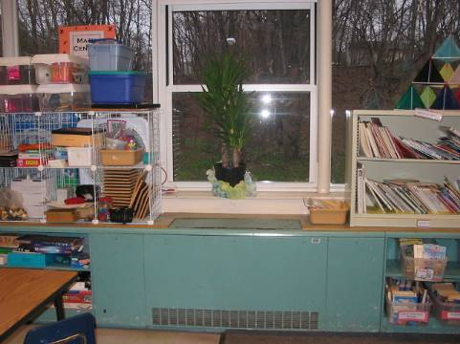

Classroom univent

Picture 2

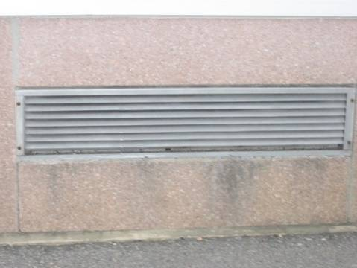

Univent fresh air intake on building exterior
Picture 3



Items placed on top of univent

Picture 4

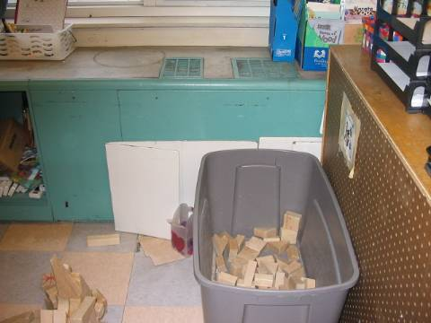

Items placed in front of univent
Picture 5

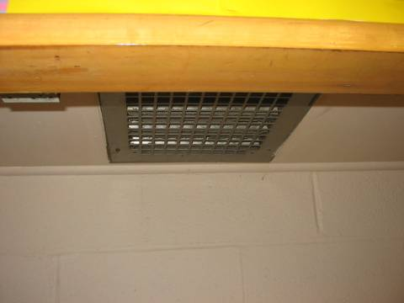

Closet exhaust in 1955 classroom

Picture 6

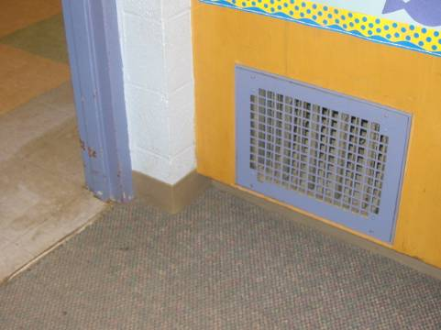

Wall exhaust typical of 1955 and 1960 classrooms
Picture 7
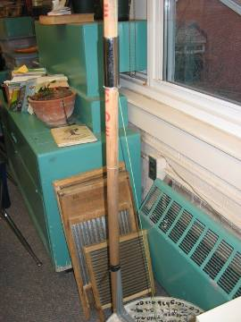

Unit exhaust ventilator in music room

Picture 8

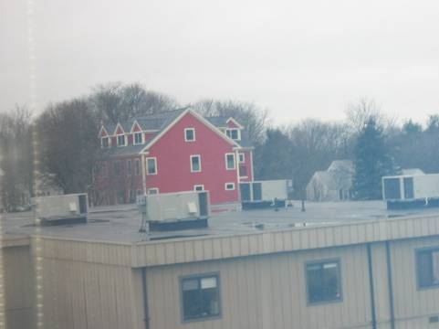

AHUs for modular building, which houses classrooms 31 to 34

Picture 9

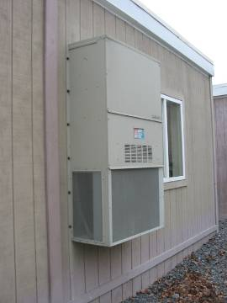

AHU for a classroom in modular building, which houses classrooms 41 to 44

Picture 10

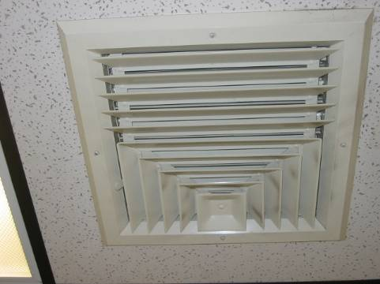

Supply vent in modular building, which houses classrooms 31 to 34
Picture 11

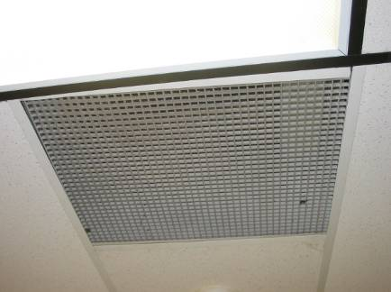

Return vent in modular building, which houses classrooms 31 to 34

Picture 12

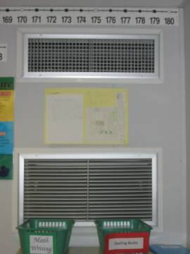

Supply vent (top) and return vent (bottom) for modular building, which houses classrooms 41 to 44

Picture 13

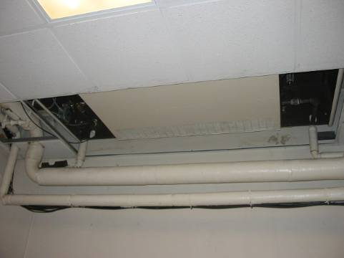

Shared univent in guidance/speech area

Picture 14

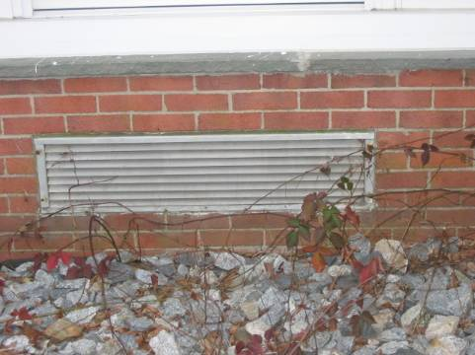

Fresh air intake for classroom 4, note debris in front of intake
Picture 15

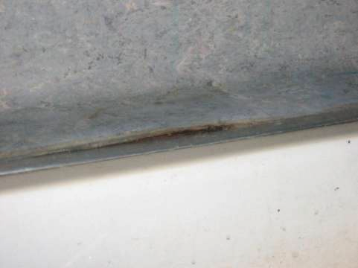

Breach between in sink countertop
Picture 16

Plant near univent, pine cones and expiring produce on univent fresh air intake

Picture 17

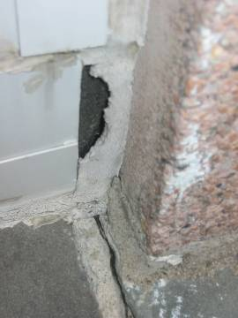

Breaches in building exterior

Picture 18

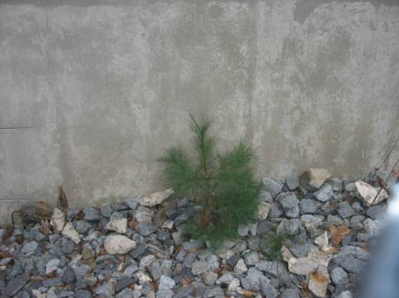

Sapling growing in close proximity to building
Picture 19

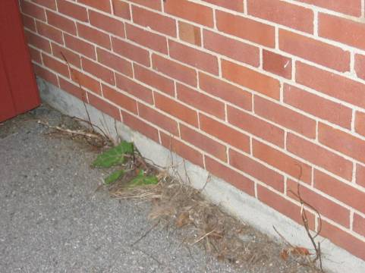

Plants growing against building foundation

Picture 20

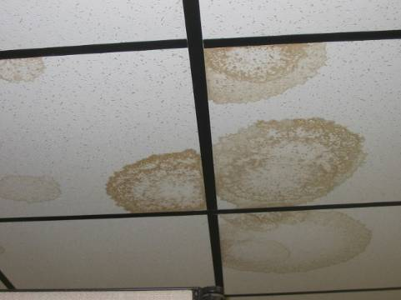

Water-damaged ceiling tiles in older modular building
Picture 21

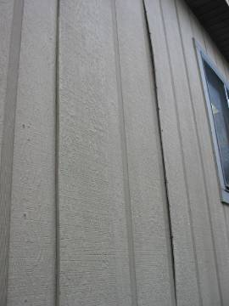

Exterior wallboards no longer adhering to building frame

Picture 22

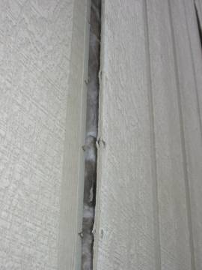

Exposed insulation
Picture 23

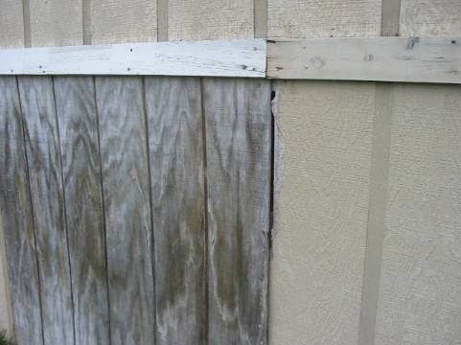

Breaches in crawlspace wall

Picture 24

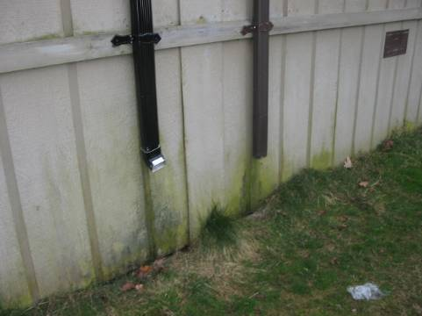

Improperly installed downspouts
Picture 25

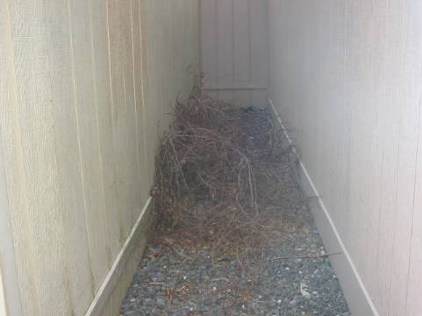

Thorny weeds growing against modular buildings

Picture 26

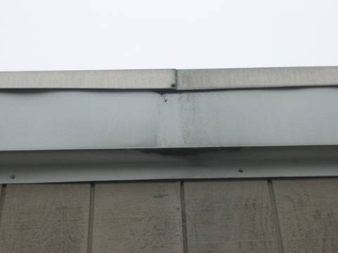

Damaged flashing on newer modular building
Picture 27

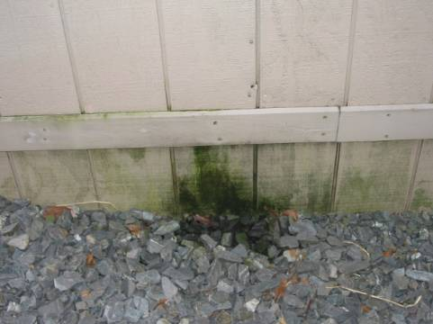

Area below damaged flashing depicted in Picture 26

Picture 28

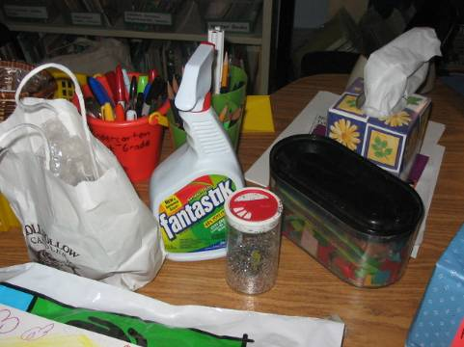

Cleaners on table
Picture 29

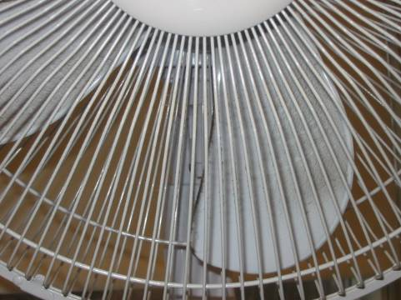

Dust accumulation of personal fan

Picture 30

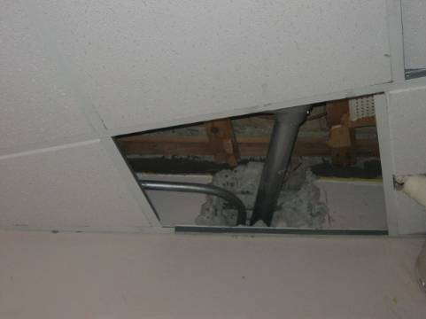

Missing ceiling tile
Picture 31

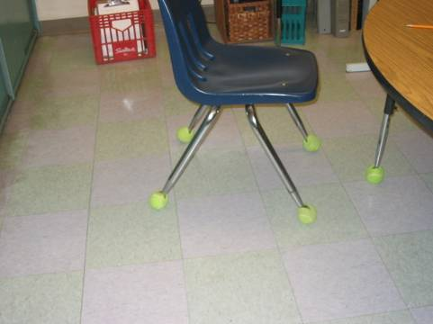

Tennis balls on chair legs

Picture 32

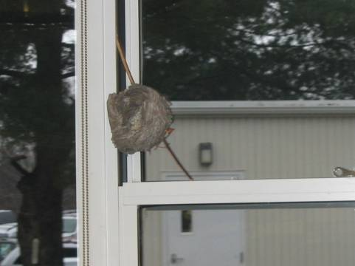

Insect nest in classroom
Location/ Room | Occupants  in Room | Temp  (°F) | Relative  Humidity  (%) | Carbon  Dioxide  (ppm) | Carbon Monoxide  (ppm) | TVOCs  (ppm) | PM2.5  (µg/m3) | Windows  Openable | Ventilation |  | Remarks
 |  |  |  |  |  |  |  |  | Supply | Exhaust | Remarks
background |  | 59 | 46 | 411 | ND | ND | 7 |  |  |  | Overcast, slight wind
4 | 21 | 69 | 37 | 1081 | ND | ND | 9 | Y  # open: 0  # total: 5 | Y  univent | Y  closet | 2 window-mounted ACs with fan only setting, CD, dust/cobwebs, plants
2 | 17 | 74 | 37 | 704 | ND | ND | 12 | Y  # open: 0  # total: 5 | Y  univent | Y  wall  VL | 2 WD-CT, Aqua/terra, items, plants
3 | 20 | 72 | 34 | 715 | ND | ND | 12 | Y  # open: 0  # total: 5 | Y  univent | Y  wall  VL | 1 MT/AT, items
34 | 22 | 70 | 47 | 1684 | ND | ND | 6 | Y  # open: 0  # total: 2 | Y  ceiling | Y  ceiling | AHU on, 3 WD-CT, slight odor, DEM
31 | 0 | 69 | 40 | 1079 | ND | ND | 6 | Y  # open: 0  # total: 2 | Y  ceiling | Y  ceiling  debris | AHU on, 8 WD-CT, slight odor, cleaners
32 | 5 | 70 | 42 | 1101 | ND | ND | 4 | Y  # open: 0  # total: 2 | Y  ceiling | Y  ceiling | AHU on, 4 WD-CT, 1 MT/AT, slight odor, cleaners
33 | 25 | 71 | 44 | 2140 | ND | ND | 22 | Y  # open: 0  # total: 2 | Y  ceiling  off | Y  ceiling  off | AHU auto, 4 WD-CT, 1 MT/AT, DEM, cleaners
41 | 27 | 69 | 46 | 1915 | ND | ND | 17 | Y  # open: 0  # total: 3 | Y  wall  off | Y  wall  off | AHU auto, cleaners, clutter
42 | 25 | 69 | 48 | 2034 | ND | ND | 19 | Y  # open: 0  # total: 3 | Y  wall  off | Y  wall  off | AHU auto, DEM, items hanging from CT
43 | 0 | 69 | 45 | 2328 | ND | ND | 11 | Y  # open: 0  # total: 4 | Y  wall  off | Y  wall  off | AHU auto, DEM
44 | 27 | 69 | 47 | 1938 | ND | ND | 6 | Y  # open: 0  # total: 5 | Y  wall | Y  wall | AHU on, DEM, plants
5 | 21 | 73 | 41 | 994 | ND | ND | 12 | Y  # open: 0  # total: 3 | Y  univent  clutter | Y  closet  debris | Clutter, items hanging from ceiling
6 | 1 | 73 | 35 | 986 | ND | ND | 16 | Y  # open: 0  # total: 5 | Y  univent  clutter | Y  closet | 20 students left about 5 minutes prior to assessment, AHU on, DEM, plants
7 | 8 | 71 | 43 | 966 | ND | ND | 11 | Y  # open: 0  # total: 5 | Y  univent  clutter | Y  closet  Dirt/debris | 4 WD-CT, cleaners, plants
9 | 2 | 73 | 36 | 913 | ND | ND | 24 | Y  # open: 0  # total: 5 | Y  univent  off  Boxes, clutter | Y  closet  Dirt/debris | 2 MT/AT, cleaners
Computer lab | 0 | 73 | 33 | 743 | ND | ND | 5 | N | N | N | Hallway DO, air-conditioning unit, 3 MT/AT, 25 computers in room
11 | 0 | 73 | 32 | 518 | ND | ND | 7 | Y  # open: 0  # total: 5 | Y  univent  off  clutter | Y  closet  Dirt/debris | Hallway DO , cleaners
10 | 2 | 73 | 32 | 489 | ND | ND | 2 | N | Y  Univent | Passive door vent | 1 WD-CT, 3 MT/AT
25 | 17 | 70 | 33 | 712 | ND | ND | 4 | Y  # open: 0  # total: 5 | Y  univent  clutter | N | UF, cleaners, nests, plants
22 | 0 | 70 | 32 | 387 | ND | ND | 2 | Y  # open: 0  # total: 5 | Y  univent  clutter | N | CD, DEM, PF
24 | 0 | 70 | 33 | 476 | ND | ND | 3 | Y  # open: 0  # total: 5 | Y  univent  boxes  clutter | Y  Wall  Off | Hallway DO, DEM, plants
23 | 3 | 70 | 34 | 590 | ND | ND | 13 | Y  # open: 0  # total: 5 | Y  univent  Boxes  Furniture | Y  Wall  Off | Hallway DO, 1 MT/AT, DEM, TB, clutter
Cafeteria | 80 | 73 | 38 | 849 | ND | ND | 17 | N | Y  wall  Weak/off | Y  wall  Weak/off
Guidance (Freeman/ Kline) | 0 | 72 | 34 | 825 | ND | ND | 13 | N | Y  univent | Y  ceiling  Off | Dehumidifier
Speech | 0 | 71 | 34 | 776 | ND | ND | 6 | N | Y  Ceiling | Y  Ceiling  Off | Inter-room DO,
Chrowder | 0 | 70 | 33 | 520 | ND | ND | 3 | N | Y  Ceiling  VL | Passive Wall
Resource | 0 | 71 | 34 | 622 | ND | ND | 4 | Y | Y  Ceiling | Y  Ceiling  Off | Hallway DO, Inter-room DO
Library | 2 | 70 | 36 | 415 | ND | ND | 3 | Y  # open: 0  # total: 8 | Y  univent | Y  Wall  Off  VL, furniture | Hallway DO
Gym | 24 | 71 | 36 | 669 | ND | ND | 7 | Y  # open: 0  # total: 8 | Y  Wall | Y  Wall | 14 MT/AT
Office | 2 | 71 | 37 | 630 | ND | ND | 6 | Y  # open: 0  # total: 2 | N | N | Hallway DO, Inter-office DO
Teachers room | 8 | 75 | 38 | 949 | ND | ND | 10 | Y  # open: 0  # total: 4 | N | N
Health | 3 | 71 | 34 | 643 | ND | ND | 10 | Y  # open: 1  # total: 1 | N | N | 1 WD-CT, 2 MT/AT
14 | 20 | 74 | 36 | 746 | ND | ND | 10 | Y  # open: 1  # total: 5 | Y  univent | Y  Wall  furniture | DEM
12 | 0 | 72 | 33 | 436 | ND | ND | 3 | Y  # open: 0  # total: 5 | Y  univent | Y  Wall | Hallway DO, DEM, plants
19 | 22 | 72 | 39 | 763 | ND | ND | 10 | Y  # open: 0  # total: 5 | Y  univent  weak | Y  Wall  Weak dirt/debris | Breach sink/counter, CD, DEM
21 | 0 | 72 | 34 | 453 | ND | ND | 5 | Y  # open: 0  # total: 5 | Y  univent | Y  Wall  weak  Dirt/debris
15 | 21 | 71 | 39 | 842 | ND | ND | 10 | Y  # open: 0  # total: 5 | Y  univent | Y  Wall  Dirt/debris | DEM, UF, plants
17 | 21 | 71 | 40 | 785 | ND | ND | 16 | Y  # open: 0  # total: 5 | Y  univent | Y  Wall  furniture | DEM, PF, plants
Main office | 1 | 70 | 35 | 494 | ND | ND | 5 | Y  # open: 0  # total: 1 | N | N | Copier
Principal’s office | 0 | 71 | 35 | 587 | ND | ND | 4 | Y  # open: 0  # total: 2 | N | N | 1 MT/AT

