ORIGINAL ARTICLE

Treatment of Persistent Pain Associated With Osteoarthritis With Controlled-Release Oxycodone Tablets in a Randomized Controlled Clinical Trial
Joseph A. Markenson, MD,* Joseph Croft, MD,† P. G. Zhang, PhD,‡ and Patricia Richards, MD, PhD‡

Objective: This study, lasting up to 90 days, was undertaken in patients with osteoarthritis with persistent moderate to severe pain uncontrolled by standard therapy (nonsteroidal anti-inflammatory drugs, acetaminophen, and/or short-acting opioids) to evaluate func- tional outcomes, as well as efficacy and safety, of controlled-release oxycodone versus placebo.
Methods: One hundred seven patients received either controlled- release oxycodone or placebo every 12 hours in this double blind, randomized, placebo-controlled, parallel-group study. Stable previous regimens of acetaminophen or nonsteroidal anti-inflammatory agents were allowed to continue. Primary efficacy variables included Brief Pain Inventory average pain intensity scores at completion of initial titration, Western Ontario and McMaster Universities Osteoarthritis Index scores at days 30 and 60, and the percentage of patients dis- continuing due to inadequate pain control.
Results: Controlled-release oxycodone was significantly superior to placebo in decreasing average pain intensity and in reducing pain- induced interference with general activity, walking ability (except at day 30), and normal work, as well as mood, sleep, relations with peo- ple (at days 60 and 90), and enjoyment in life. Daily functioning, as measured by the Western Ontario and McMaster Universities Osteo- arthritis Index, was also significantly improved in the controlled- release oxycodone group. In the placebo group, a significantly greater percentage of patients discontinued due to inadequate pain control. Adverse events were consistent with opioid adverse events, and no safety concerns were noted.
Discussion: Treatment with controlled-release oxycodone of patients
with osteoarthritis with persistent moderate to severe pain uncon- trolled by standard therapy resulted in significant pain control and improvements in physical functioning.
Key Words: Osteoarthritis, controlled-release oxycodone, random- ized clinical trial, pain
(Clin J Pain 2005;21:524–535)

steoarthritis (OA) is defined as a heterogeneous group of conditions leading to signs and symptoms associated
O
with defects in the integrity of the articular cartilage and under- lying bone in joints and joint margins; hence, patients seek treatment due to joint pain and loss of function.1,2 The prev- alence of OA is increasing as the population ages.2,3 Preva- lence rates for hip and knee OA vary depending upon whether diagnosis is made clinically or radiographically, and there is often discordance between radiographic evidence and patient reports of joint pain.1,4 It has been suggested that the origins of pain may be due to deterioration within the joint capsule, ligaments and insertions, periosteum and subchondral bone, and synovium.4,5 Although it has been shown that inflamed synovium contains an upregulated expression of opioid recep- tors, the exact source of OA pain is often unclear in the indi- vidual patient.5–7 Nonetheless, it has been shown that pain in patients with OA is a better predictor of disability and impact on daily life than the diagnostic radiographic grade.5,8,9
Most treatments of OA are not disease modifying and are directed at reducing pain, maintaining and/or improving

joint mobility, and limiting functional impairment.10 It is gener-

Received for publication April 28, 2003; revised June 19, 2004, second
revision September 11, 2004; accepted September 13, 2004.
From the *Hospital for Special Surgery, New York, NY; †Arthritis Center, P.C., Chevy Chase, MD; and ‡Purdue Pharma L.P., Stamford, CT.
Dr. Croft and Dr. Markenson received financial support from Purdue Pharma
P.L. as investigators for this clinical study. Dr. Richards and Dr Zhang are employees of Purdue Pharma, L.P., the manufacturer of OxyContin®.
Presented and published in part in abstract form: 19th Annual Scientific Meeting of the American Pain Society; Atlanta, GA; November 2–5, 2000 (Abstract 610); 3rd Congress of the European Federation of IASP Chapters; Nice, France; September 26–29, 2000 (Abstract PS1/165); Annual Scientific Meeting of the American College of Rheumatology, Philadelphia, PA, October 28–November 2, 2000 (Abstract 1622) (Arthritis Rheum 2000;43:S337).
Reprints: Patricia Richards, MD, PhD, 500 Plaza Drive, 2nd Floor, Secaucus, NY 07094 (e-mail: ptrichards@algorx.com).
Copyright © 2005 by Lippincott Williams & Wilkins
ally agreed that nonpharmacologic methods (eg, physical and occupational therapy, patient education) constitute the primary treatment, to be followed or accompanied by the use of drug therapy as needed. Additional interventions include the admin- istration of intra-articular injections of hyaluronan (hyaluronic acid) or glucocorticoids.10,11 Initial analgesic therapy consists of acetaminophen (APAP), salicylates, and nonsteroidal anti- inflammatory drugs (NSAIDs), including the recently avail- able specific cyclo-oxygenase-2 (COX-2) inhibitors, or the weak opioids propoxyphene and tramadol, followed by the use of stronger opioids when other treatments are no longer effective.11,12 Acetaminophen and NSAIDs are known to be characterized by 2 types of dosing limitations: first, they exhibit a ceiling effect for analgesia; second, at higher doses, they have

524 Clin J Pain • Volume 21, Number 6, November/December 2005

shown the potential for gastric, renal, and hepatic toxicities— complications that are of particular concern to the elderly, the population most likely to receive these analgesics.13–20 In addition, a recent randomized placebo-controlled study found APAP to be ineffective in treating OA of the knee.21
Effective analgesia for osteoarthritis pain has been dem- onstrated in recent short-term controlled clinical studies of codeine and oxycodone,22–24 and the use of potent opioids has been endorsed by the American Pain Society (APS) and the American Academy of Pain Medicine (AAPM) for the treat- ment of chronic nonmalignant pain when other strategies no longer provide adequate relief.25,26 The objective of this 90-day study was to investigate the analgesic effi y and safety, together with the impact on functional outcomes, of controlled- release (CR) oxycodone versus placebo in patients with OA with uncontrolled persistent pain who were receiving or could not tolerate standard therapy for NSAIDS, APAP, or short- acting opioids.

MATERIALS AND METHODS
Study Design and Patient Selection
This was a double blind, randomized, placebo-controlled, parallel-group study conducted in the United States in accor- dance with Good Clinical Practice and the Declaration of Helsinki. The study was approved by the Institutional Review Boards of the 9 participating centers (Appendix 1), where it was conducted from June 1997 through August 1998. Each patient signed an informed consent form before enrollment in the study.
To be eligible for the study, patients had to have OA, as defined by the American College of Rheumatology guide- lines.27 Patients selected were experiencing moderate to severe pain in the most affected joint or region, as characterized by:
- complaints of pain for at least 1 month before day 0 (baseline) or after the patient had discontinued their as necessary opioid; and 2) pain during the week before day 0 that was moderate to severe, defined as an average score of 5 or greater (3 or greater if receiving as necessary opioids) on a scale from 0 (no pain) to 10 (pain as bad as you can imagine). Eligible patients: 1) had been taking NSAIDs or APAP at a therapeutic and/or tolerated (but not as necessary) dose for at least 2 weeks before day 0;
- were not taking NSAIDs because they were NSAID- intolerant or at high risk for toxicity or complications; or
- were receiving as necessary oral opioid therapy that was equivalent to #60 mg of oxycodone per day (with or without NSAIDs or APAP for analgesia).
Patients were excluded if they were allergic to opioids, were scheduled to have surgery during the study period, had unstable coexisting disease or active dysfunction, had active cancer, were pregnant or nursing, had a past or present history of substance abuse, were involved in litigation related to their pain, or had received intra-articular or intramuscular steroid injections involving the joint or site under evaluation within 6 weeks prior to baseline.
At the screening visit, demographic information, medi- cal history, and information on baseline medications were ob- tained; an OA assessment, a physical examination with a vital
signs evaluation, and pregnancy test (if applicable) were per- formed. Patients who met the entry criteria were randomly
assigned in double blind fashion to receive either 10-mg tablets of CR oxycodone (OxyContin®, Purdue Pharma L.P.,
Stamford, CT) or matching placebo every 12 hours. The computer-generated randomization code and study drug bottles labeled with randomization numbers were supplied by the sponsor. Patients were permitted to continue their stable NSAID (or APAP) regimen during the study; the dose could be decreased but could not be increased. Patients were not permitted to continue receiving prestudy short- or long-acting opioids. Initial titration to stable dosing was defined as the point at which the patient achieved an average pain intensity score of #4 throughout a 48-hour period on the same dose of study drug. Dose adjustments of study drug were allowed at
$24-hour intervals at any time during the study (including after the initial titration was complete). Asymmetric morning and evening dosing was allowed. Doses could be increased (to a maximum of 6 tablets [60 mg] every 12 hours [120 mg per day]) or decreased depending on pain intensity or adverse events.
The first office visit was held after initial titration of the study drug was completed or on day 15, whichever came first; subsequent visits occurred on days 30, 45, 60, and 90. During each visit, patients completed the Brief Pain Inventory (BPI), the patient generated index (PGI), and the Western Ontario and McMaster University Osteoarthritis Index (WOMAC), and pro- vided a record of the measure of acceptability of pain medi- cation from their daily diaries, in which they entered ratings of average pain, current pain, and acceptability of pain medica- tion. Adverse events, concomitant medications, and compli- ance were also assessed at these visits. At the baseline and final visit, patients completed satisfaction scores in addition to the other standard assessments.

Assessment Instruments
The instruments used to measure pain were the BPI, patient-reported acceptability of and satisfaction with medi- cation, the WOMAC, and the PGI. These outcome measures were chosen to characterize the impact of CR oxycodone on multiple outcome domains, including pain reduction, physical functioning, and patient disposition, which are 3 of the core domains for clinical trials of chronic pain treatment mentioned in the Initiative on methods, measurement and pain assessment in clinical trials (IMMPACT).28
The BPI is a standardized and validated instrument widely used to assess pain intensity and the interference of pain in the patient’s life, measured on a scale from 0 to 10. Patients were asked to evaluate their pain on average, ‘‘right now,’’ and the interference of their pain with general activity and quality of life items, such as mood, walking, and sleep over the past 24 hours. The BPI, a multidimensional instrument that also in- corporates questions about pain relief, has been extensively used to measure the effectiveness of analgesic treatments.29
Patient-reported satisfaction with pain medication was assessed on a numerical scale from 0 (not at all) to 10 (totally satisfied). Patient-reported acceptability of pain medication was assessed on a numerical scale from 1 (not acceptable) to 6 (totally acceptable).

The WOMAC is an established and validated measure of symptoms and physical disability of patients with OA of the knee and/or hip.30,31 The WOMAC has also been used as an outcome measure for populations with pain and/or injury to areas other than the knee or hip, including individuals with lower back pain, ankle arthritis, and meniscal tear.32–34 The instrument was developed specifically to evaluate clinically important, patient-relevant changes in pain and dysfunction in patients with OA as a result of treatment intervention. The WOMAC is a self-administered questionnaire evaluating 3 dimensions—pain, stiffness, and physical function over the past 48 hours—on a visual analog scale (VAS) of 0 to 100, with lower scores indicating fewer symptoms or less disability.
The PGI is a validated, self-administered questionnaire that attempts to assess satisfaction with activities selected by the patient as important to improve. The assessment tool has been shown to be a reliable means of quantifying the effect of a medical condition on patients’ quality of life. In completing the PGI, the patients were asked at baseline to assign a total of 60 points across 6 areas or activities in their lives that they would like to see improved, with more points implying a greater desire for improvement. At each postbaseline visit, patients rated the 6 areas using a scale from 0 (worst you can imagine) to 100 (exactly as you would like to be). The instrument has been shown to have a high correlation with the widely used and accepted Short-Form 36-Item Health Survey, or SF-36.35

Efficacy and Safety Variables
The primary efficacy variables were BPI average pain intensity at stable dosing, WOMAC scores at days 30 and 60, and the number and percentage of patients who discontinued the study due to inadequate pain control.
Secondary efficacy variables included BPI (pain, inter- ference, and function), WOMAC, and PGI (primary activity) scores at each visit throughout the study; time to stable dosing; percentage of patients achieving stable dosing within 30 days; average daily dose at completion of initial titration; average daily dose throughout the study; medication acceptability at each visit; patient satisfaction with pain medication at baseline and the final visit; and ratings of average and current pain intensity from patient diaries.
Safety was evaluated by vital signs and physical exami- nations, reports of adverse events, and the number and per- centage of patients who discontinued from the study due to adverse events.

Statistical Analysis
All variables were evaluated by intent-to-treat (ITT) analysis (ie, including all randomized patients who received at least 1 dose of study drug) in which the last observation was carried forward (LOCF). The sample size calculation was based on the primary comparison of the average pain score between the 2 treatments, using a 2-sample t test. Based on data from previous studies (data on file, Purdue Pharma L.P.), it was assumed that the standard deviation (SD) for the BPI average pain intensity would be 2. Therefore, to obtain a significance level of a = 0.05 to detect a difference of D = 1.25 with 80% power, a minimum of 82 total patients, or 41 patients per group, was needed.
Demographic and other baseline variables were com- pared between treatment groups using the Student t test for continuous variables and the Fisher exact test for categorical variables. The primary analysis of average pain at stable dos- ing was based on BPI average pain scores at visit 2 (stable dosing or day 15) for those patients who achieved stable dosing, at visit 3 (day 30) for patients who did not achieve stable dos- ing or achieved stable dosing on a date later than visit 2, or at the final visit for those patients who discontinued at visit 2 or 3. The composite BPI physical function scores were calculated by averaging the BPI interference scores for general activity, walking ability, and normal work; the composite BPI inter- ference scores were obtained by averaging all of the BPI interference subscale scores.29 Composite WOMAC scores were calculated by averaging the scores from all 3 subscales: pain, stiffness, and physical function.30 One primary activity was selected from among the 5 areas or activities that patients rated most important on the PGI for analysis prior to unblind- ing the data.
Treatment effects on average pain intensity at stable dos- ing and patient satisfaction at the end of the study, as well as WOMAC, BPI, and patients’ diary variables at each scheduled visit, were compared using analysis of covariance (ANCOVA). Study center effect, treatment effect, and treatment-by-center interaction were included in the ANCOVA model. Covariates included baseline data, age group, and gender. The Student t test was used to analyze changes from baseline in patient satisfaction and in the BPI within treatment groups. A repeated- measures ANCOVA was applied to compare WOMAC scores between groups after 30 and 60 days of treatment (baseline data, study center, age group, gender, treatment, treatment-by- center interaction, and visit were included in the model) and to investigate the relationship between the pain scores and the acceptability of treatment. The repeated-measures ANCOVA comparing WOMAC scores between groups after 30 and 60 days of treatment was also performed on a subset of ITT popu- lation: those patients with OA of the hip, knee, lower back, and lower extremities. The Fisher exact test was used to compare the percentage of patients in each group who discontinued due to treatment failure or adverse events. The number of patients who achieved stable dosing within 30 days was compared between treatment groups using the Fisher exact test. The Kaplan-Meier analysis was employed to estimate the distri- bution of time to stable dosing; distributions between groups were compared using a log-rank test. Treatment effects were tested with a 2-sided hypothesis at a = 0.05. Data are presented as least squares (LS) means 6 standard error (SE) except where otherwise indicated.
Adverse events (AEs) were summarized using Coding Symbols for Thesaurus of Adverse Reaction Terms (COSTART®).36

RESULTS
Patient Demographics
Of 109 patients enrolled, 107 were included in the ITT and safety populations (Fig. 1). Two patients were randomized to placebo, but withdrew from the study prior to receiving the placebo study drug.

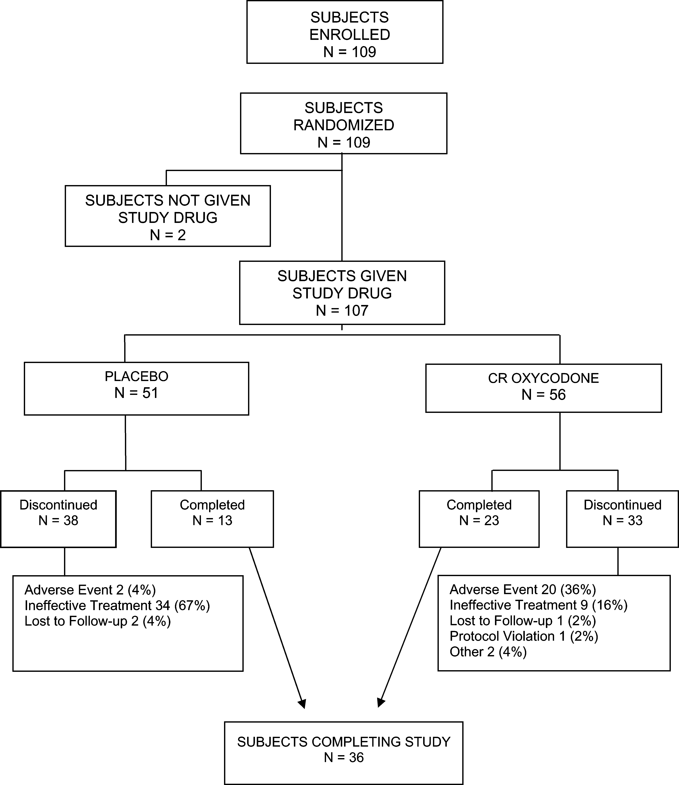FIGURE 1. Patient disposition. Two pa- tients randomized to the placebo group withdrew consent before dosing (the reason was listed as ‘‘other’’).

Demographic and baseline characteristics of the 107 patients included in the ITT and safety populations are summa- rized in Table 1. The patient population was predominantly female and white with an average age of 63 years. No statis- tically significant differences were found between the CR oxy- codone group and the placebo group for any demographic or baseline characteristic. Mean BPI scores and WOMAC mea- surements at baseline were also similar in both treatment groups. Within both treatment groups, approximately 40% were not opioid exposed at study entry. A total of 37% were taking ‘‘weak’’ opioids (tramadol 15%, propoxyphene 14%, and co- deine 8%), and 22% were taking short-acting opioids. At base- line, more than 80% of the patients in each treatment group were receiving stable NSAIDs and/or APAP therapy, either as single entities or as combination agents.

Primary Efficacy Variables
Significantly lower average pain scores at stable dosing, as measured by the BPI average pain intensity subscale, were observed in the CR oxycodone group (5.1 6 0.3 vs. 6.0 6 0.3; P = 0.042) compared with the placebo group.
The results of the WOMAC subscales and composite scores on days 30 and 60 also indicated a treatment effect of CR oxycodone compared with the results for placebo (Table 2). The WOMAC analysis was repeated using a subset of the ITT population, yielding similar results (Table 2); this subset included patients with hip, knee, lower back, or lower extrem- ity OA. The differences between treatment groups were statis- tically significant for pain, stiffness, and difficulty in physical function, as well as for the composite score.
The adjusted mean changes (mm) in scores from base- line at days 30 and 60 in the CR oxycodone group were as follows: for pain, 213.0 and 217.8; for stiffness, 215.8 and 221.7; for physical function, 212.4 and 217.1; and for the composite score, 213.8 and 218.9, respectively. These changes were significantly greater than those of the placebo group at days 30 and 60, in which the changes (mm) observed in scores from baseline were as follows: for pain, 24.1 and 22.4; for stiffness, 0.3 and 0.1; for physical function, 23.2 and 23.8; and for the composite, 22.4 and 22.1, respectively.
The number and percentage of patients who discontinued due to inadequate pain control were statistically significantly

TABLE 1. Basic Characteristics of Patients With Osteoarthritic Pain: ITT Cohort

Patient Characteristics | Placebo (N = 51) | CR Oxycodone (N = 56) | P
Gender |  |  | 0.278*
Male, no. (%) | 11 (22) | 18 (32)
Female, no. (%) | 40 (78) | 38 (68)
Race |  |  | 0.547*
White, no. (%) | 48 (94) | 52 (93)
Black, no. (%) | 2 (4) | 4 (7)
Hispanic, no. (%) | 1 (2) | 0 (0)
Age (yrs), mean (min, max) | 64 (41, 89) | 62 (38, 88) | 0.588†
,65 yrs, no. (%) | 27 (53) | 31 (55) | 0.541*
65–74 yrs, no. (%) | 17 (33) | 14 (25)
$75 yrs, no. (%) | 7 (14) | 11 (20)
Prior opioid use,‡ no. (%) | 33 (65) | 30 (54) | 0.325*
Baseline average pain intensity from Brief Pain Inventory,§ mean (SE) | 6.3 (0.2) | 6.9 (0.2) | 0.083†
Baseline worst pain intensity from Brief Pain Inventory,§ mean (SE) | 7.9 (0.2) | 8.0 (0.2) | 0.525†
Baseline composite score from WOMAC Osteoarthritis Index,k mean (SE) | 63.8 (2.1) | 64.7 (2.1) | 0.749†
Pain location
Hip | 12 (22.6%) | 7 (12.5%)
Knee | 15 (26.3%) | 18 (32.1%)
Spine | 21 (39.6%) | 27 (48.2%)
Other | 5 (9.4%) | 4 (7.1%)
*Fishers exact test.
†Student t test.
‡For this study, tramadol and propoxyphene were considered opioids because of cross-tolerance.
§From 0 (no pain) to 10 (pain as bad as you can imagine).
kComposite score calculated from pain, stiffness, and difficulty in physical function scores; assessments made using a 100-mm visual analogue scale ranging from 0 (no pain/stiffness/difficulty) to 100 (extreme pain/stiffness/difficulty).

lower for the CR oxycodone group (9 patients, 16%) compared to the placebo group (34 patients, 67%; P , 0.001).

Secondary Efficacy Variables
Pain
Brief Pain Inventory scores for patients receiving CR oxycodone treatment were significantly lower for pain intensity and interference with function and higher for pain relief, compared to scores for patients receiving placebo at all of the treatment visits. Differences in average pain intensity scores between the 2 treatment groups ranged from 0.9 to 1.4 (Fig. 2). During treatment, mean scores for average pain, pain right now, and worst pain were significantly lower in the CR oxycodone group compared to the placebo group at all visits (days 15 and 90 are presented in Table 3). In addition, scores for least pain (days 30, 60, and 90) were significantly lower in the CR oxycodone group, whereas scores for pain relief (all treatment visits) were significantly higher in the CR oxy- codone group compared with the placebo group (Table 3). The WOMAC pain subscale scores corroborated the treatment effect observed on the BPI average pain intensity subscale (Fig. 2).
Nearly 38% of the patients in the CR oxycodone treatment group achieved at least 30% pain relief at the end of 90 days, as compared to 17.6% of the patients in the placebo group (P = 0.031). Nearly 20% of the patients in the CR oxycodone treatment group achieved at least 50% pain relief at
the end of 90 days, as compared to 5.9% of the patients in the placebo group (P = 0.045).
The number of patients that would need to be given treatment with CR oxycodone for one of them to achieve at least a 30% improvement in average pain (number of patients needed to treat, NNT) equals 5.0 at the day 90 study visit. The NNT for a 50% improvement in average pain at the day 90 visit equals 7.3 patients.

Physical Functioning
The same maintenance of effect observed on the WOMAC pain subscale was seen on the other WOMAC subscales (stiffness and difficulty in physical function) and the composite scale. These WOMAC scores were significantly reduced in the CR oxycodone group at all treatment visits. At day 90, significantly reduced scores for stiffness and difficulty in physical function and in the composite score were observed in the CR oxycodone group (48.7 6 3.2, 45.4 6 2.6, and
46.6 6 2.7, respectively, vs. 68.9 6 3.5, 58.6 6 2.9, and
62.2 6 3.0, respectively, for placebo; P , 0.001 for all scales). Controlled-release oxycodone statistically significantly reduced interference caused by pain with various daily activ- ities as measured on the BPI interference subscales (Table 4). At all treatment visits, the mean scores for interference were statistically significantly lower in the CR oxycodone group than in the placebo group for general activity, mood, normal work, sleep, and enjoyment of life. For walking ability, the

TABLE 2. Least Squares Mean (6SE) WOMAC Scores: ITT Cohort and ITT Subanalysis

Population: ITT Patients (Hip, Knee, Lower Back, Lower Extremity, Upper Body Osteoarthritis) Placebo (N = 51) CR Oxycodone (N = 56)
Item | Visit 3 | Visit 5 |  | Visit 3 | Visit 5 | P*
Pain† | 57.2 (3.1) | 59.7 (3.1) |  | 47.8 (2.8) | 44.8 (2.8) | 0.001
Stiffness† | 68.7 (3.5) | 69.8 (3.5) |  | 52.4 (3.2) | 48.3 (3.2) | ,0.001
Physical function† | 58.0 (2.9) | 59.1 (2.9) |  | 48.6 (2.6) | 46.1 (2.6) | ,0.001
Composite score | 61.3 (3.0) | 62.9 (3.0) |  | 49.5 (2.7) | 46.3 (2.7) | ,0.001
Population: ITT Patients With Hip, Knee, Lower Back, or Lower Extremity OA Placebo (N = 42) CR Oxycodone (N = 47)
 | Visit 3 | Visit 5 |  | Visit 3 | Visit 5 | P*
Pain† | 58.2 (3.7) | 60.9 (3.7) |  | 49.1 (3.4) | 46.1 (3.4) | 0.005
Stiffness† | 70.6 (4.0) | 71.3 (4.0) |  | 53.2 (3.8) | 48.9 (3.8) | ,0.001
Physical function† | 59.7 (3.3) | 60.7 (3.3) |  | 50.5 (3.1) | 48.1 (3.1) | 0.005
Composite score | 62.9 (3.5) | 64.4 (3.5) |  | 50.9 (3.2) | 47.7 (3.2) | ,0.001
*Treatment comparison using repeated measures analysis with effects for center, treatment, treatment by center, and visit and with patient as random effect. Covariates included baseline data, age group, and gender.
†Pain, stiffness, and physical function scores from 0 (no pain/stiffness/difficulty) to 100 (extreme pain/stiffness/difficulty).

differences were statistically significant between the CR oxy- codone and the placebo groups at all treatment visits except at day 30; for relations with others, the differences were sta- tistically significant at days 60 and 90. For the composite BPI interference scale and the composite BPI physical function scale, the scores were statistically significantly lower in the CR oxycodone group than in the placebo group at all treatment visits (Fig. 3, Table 4).
The PGI scores reflected improvement in the primary activity (chosen by the sponsor prior to unblinding the data) among patients taking CR oxycodone during the study. At
days 30 and 45, the PGI scores were 46.4 6 2.9 and 51.2 6
3.1, respectively, for CR oxycodone versus 37.6 6 3.3 and
39.7 6 3.5, respectively, for placebo (for day 30, P = 0.027; for day 45, P = 0.007).

Dosing
The time to achieve stable dosing was significantly shorter in the CR oxycodone group (12 days) compared to greater than 30 days in the placebo group (P # 0.001). More patients achieved stable dosing within 30 days in the CR oxycodone group (68%) than in the placebo group (31%). The

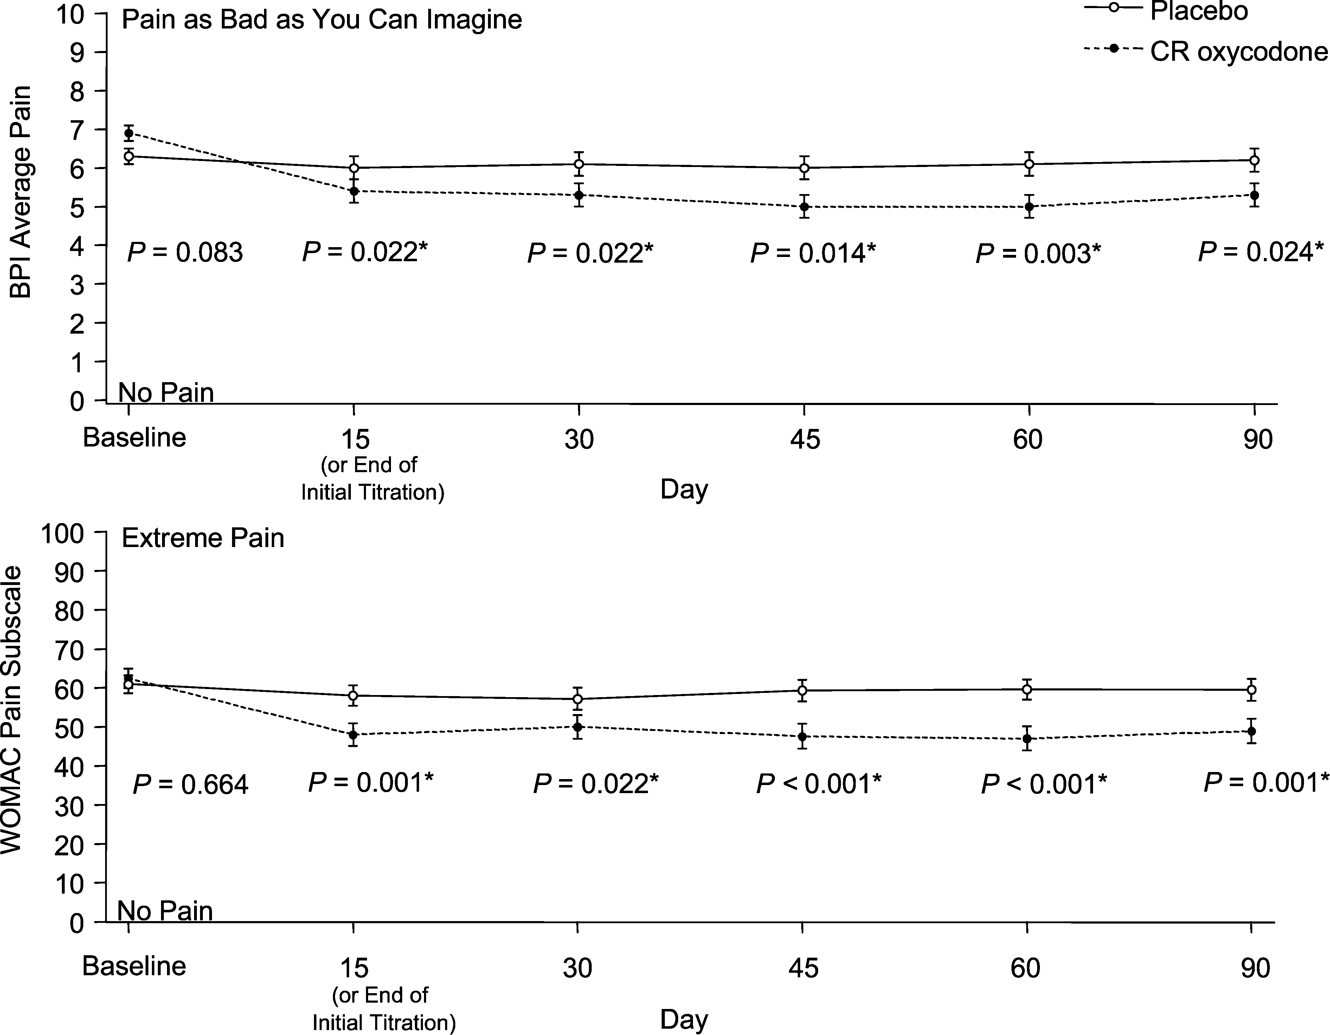FIGURE 2. Average pain intensity on the BPI (upper panel, scale from 0 [no pain] to 10 [pain as bad as you can imagine], mean 6 SE) and WOMAC pain subscales (lower panel, scale from 0 [no pain] to 100 [extreme pain]) from baseline to day 90 for placebo-treated versus CR oxycodone-treated patients (N = 107; 51 placebo, 56 CR oxy- codone). Baseline scores are arithmetic means 6 SE, and postbaseline scores are LS means 6 SE. *Statistically signif- icant at a# 0.05 (Student t test was used at baseline; ANCOVA, postbaseline).

TABLE 3. Least Squares Mean (6SE) Brief Pain Inventory Scores for Average Pain, Pain Right Now, and Worst Pain, Least Pain, and Pain Relief: ITT Cohort

Placebo (N = 51) CR Oxycodone (N = 56)

Item | n | Observed Value | Change from Baseline |  | n | Observed Value | Change from Baseline | P*
Average pain intensity† Visit 2‡ | 51 | 6.0 (0.3) | 20.6 (0.3) |  | 55 | 5.1 (0.3) | 21.5 (0.3) | 0.022
Day 90  Pain right now† Visit 2‡ | 51  51 | 6.0 (0.4)  5.8 (0.4) | 20.6 (0.4)  20.3 (0.4) |  | 55  55 | 4.9 (0.3)  4.8 (0.4) | 21.7 (0.3)  21.3 (0.4) | 0.024  0.028
Day 90 Worst pain†  Visit 2‡ | 51  51 | 5.7 (0.4)  6.9 (0.4) | 20.4 (0.4)  21.0 (0.4) |  | 55  55 | 4.4 (0.4)  6.0 (0.3) | 21.7 (0.4)  21.9 (0.3) | 0.008  0.034
Day 90 | 51 | 6.6 (0.4) | 21.3 (0.4) |  | 55 | 5.5 (0.4) | 22.4 (0.4) | 0.020
Least pain intensity†
Visit 2‡ | 51 | 4.6 (0.4) | 20.3 (0.4) |  | 55 | 3.7 (0.3) | 21.2 (0.3) | 0.053
Day 90  Pain relief now† Visit 2‡ | 51  50 | 4.7 (0.4)  35.8 (4.8) | 20.2 (0.4)  21.9 (4.8) |  | 55  56§ | 3.7 (0.4)  56.2 (4.4) | 21.3 (0.4)  18.5 (4.4) | 0.027  0.001
Day 90 | 50 | 34.7 (4.9) | 23.1 (4.9) |  | 55§ | 51.8 (4.5) | 14.0 (4.5) | 0.005
*Treatment comparison using ANCOVA with effects for center, treatment, and treatment by center. Covariates included baseline data, age group, and gender.
†For all subscales except pain relief, 0 denotes ‘‘no pain’’ and 10, ‘‘pain as bad as you can imagine.’’ For pain relief, 0 denotes ‘‘no relief’’ and 100, ‘‘complete relief.’’
‡Denotes score at time stable pain control was achieved, or on day 15, whichever occurred first.
§For visit 2, n = 55 for change from baseline. For day 90, n = 54 for change from baseline.

daily average dosage of study drug at the time of stable dosing was 4.4 6 0.5 tablets (44 6 5 mg) for the CR oxycodone group, compared to 5.3 6 0.6 tablets for the placebo group. The number of tablets taken per day plateaued in both treatment groups after visit 3, and the average CR oxycodone dose was 57 mg per day for the remainder of the study.

Acceptability and Satisfaction
Scores for patient acceptability of pain medication and satisfaction with pain medication were significantly higher for patients receiving CR oxycodone. Patients’ self-reports of the
acceptability of pain medication showed significantly in- creased ratings for those in the CR oxycodone group at all study visits. At the end of the 90-day treatment period, the CR oxycodone and the placebo groups registered statistically significant differences in scores for acceptability of pain medication (P = 0.002) and satisfaction with pain medication (P , 0.001) (Fig. 4).

Daily Measurements
The daily reports in the patient diaries corroborated instrument measurements demonstrating greater decreases in

TABLE 4. Least Squares Mean (6SE) Brief Pain Inventory Interference Scores at Day 90: ITT Cohort

Placebo (N = 51) CR Oxycodone (N = 56)

Item | n | Observed Value | Change from Baseline |  | n | Observed Value | Change from Baseline | P*
General activity† | 51 | 6.4 (0.4) | 20.2 (0.4) |  | 55 | 4.7 (0.4) | 22.0 (0.4) | ,0.001
Mood† | 51 | 5.2 (0.4) | 20.6 (0.4) |  | 56 | 4.1 (0.4) | 21.8 (0.4) | 0.018
Walking ability† | 51 | 5.8 (0.4) | 20.8 (0.4) |  | 56 | 4.6 (0.4) | 22.0 (0.4) | 0.020
Normal work† | 50 | 6.2 (0.4) | 20.6 (0.4) |  | 56 | 4.9 (0.4) | 21.9 (0.4) | 0.006
Relations with people† | 51 | 3.8 (0.4) | 20.2 (0.4) |  | 56 | 2.9 (0.3) | 21.1 (0.3) | 0.045
Sleep† | 51 | 5.1 (0.4) | 20.9 (0.4) |  | 56 | 3.3 (0.4) | 22.8 (0.4) | ,0.001
Enjoyment of life† | 51 | 5.5 (0.4) | 20.9 (0.4) |  | 56 | 4.1 (0.4) | 22.2 (0.4) | 0.012
Interference composite‡ | 51 | 5.4 (0.3) | 20.6 (0.3) |  | 56 | 4.1 (0.3) | 21.9 (0.3) | 0.001
Function composite§ | 51 | 6.2 (0.4) | 20.4 (0.4) |  | 56 | 4.7 (0.3) | 21.9 (0.3) | 0.001
*Treatment comparison using ANCOVA with effects for center, treatment, and treatment by center. Covariates included baseline data, age group, and gender.
†From 0 (does not interfere) to 10 (completely interferes).
‡The interference composite score was calculated by averaging all of the interference subscale scores.
§The physical function composite score was calculated by averaging interference with general activity, walking ability, and normal work scores.

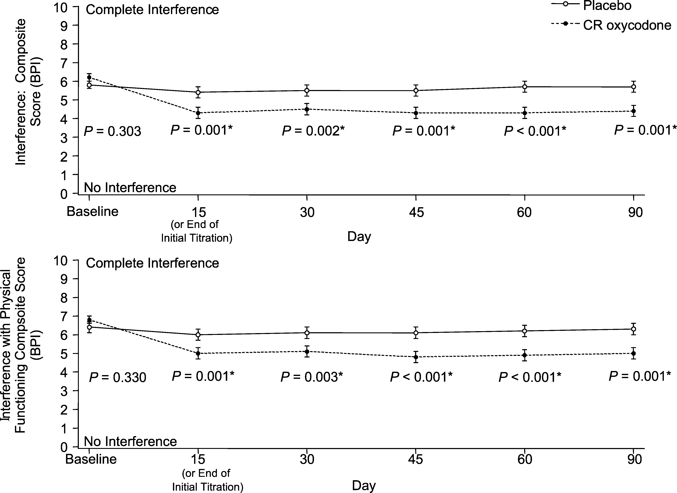FIGURE 3. Brief Pain Inventory inter- ference composite scores (upper panel, scale from 0 [does not interfere] to 10 [completely interferes], mean 6 SE) and interference with physical func- tioning composite scores (lower panel, same scale, mean 6 SE) from baseline to day 90 in placebo versus CR oxycodone-treated patients (N = 107; 51 placebo, 56 CR oxycodone). Base- line scores are arithmetic means 6 SE, and postbaseline scores are LS means 6 SE. *Statistically significant at a# 0.05 (Student t test was used at baseline; ANCOVA, postbaseline).

average pain intensity and ‘‘pain right now’’ for the CR oxy- codone group, together with increased acceptability of therapy associated with CR oxycodone treatment versus administra- tion of placebo.

Safety
The common AEs (incidence $10% of patients) ob- served in the CR oxycodone were those typical of an oral opioid analgesic (Table 5). A total of 28 (55%) patients in the placebo group and 52 (93%) of patients in the CR oxycodone group reported adverse events. Most AEs in both treatment groups were mild or moderate in intensity, had resolved by termination of the study, and did not require a change in study drug dose or other treatment. The number of patients needed to harm (NNH) equals 2.3 patients. The NNH was computed by examining those patients with 1 or more of the following adverse events (constipation, somnolence, dizziness, pruritus, headache, diarrhea, vomiting, or sweating) over the study period. The NNH for AEs leading to study discontinuation is 3.15.
No serious AEs were reported in the placebo group. Three patients in the CR oxycodone group had serious AEs: dizziness and difficulty with speech in the first patient; phlebitis in the second; and influenza, difficulty in swallowing, gastric dysmotility, and dehydration in the third patient. De- hydration, swallowing difficulty, and gastric dysmotility were considered to be related to the study drug.
Twenty patients (36%) discontinued from the study due to adverse events in the CR oxycodone group compared to 2 patients (4%) in the placebo group (P , 0.001). Consti- pation, nausea, somnolence, and dizziness were the most common AEs leading to discontinuation in the CR oxycodone group. There were no deaths.

DISCUSSION
This study was conducted in a well-defined population who met the criteria for OA as defined by the American College of Rheumatology guidelines.27 The primary outcome measures of this study demonstrated that CR oxycodone was superior to placebo in reducing average pain in the joint or other region most affected by OA. These results are consistent with previous placebo-controlled trials that have demonstrated that CR oxycodone is an effective treatment of moderate to severe OA pain.22,24 The recent American Pain Society Guide- lines specifically advise use of mu-agonist opioids, either as single agents or combined with an NSAID or APAP, for treat- ment of moderate to severe osteoarthritis and rheumatoid arthritis (RA) pain when other treatments have failed to pro- vide adequate relief.26
The study was powered appropriately and used a randomized double blind design to limit possible confounding or bias. A potential source of bias in this study was that no measures were taken to blind investigators and patients when patients reported AEs. However, an examination of the data shows that the difference between the treatment groups for the day 90 BPI and WOMAC measurements was similar in mag- nitude for both the opioid naive and opioid experienced cohorts. This study also documented improvements in phys- ical function, in addition to reduced pain levels, as measured by the WOMAC subscales and composite scores. Improve- ments in WOMAC scores achieved by day 90 ranged from
13.5 mm to 17.9 mm across scales and are comparable or supe- rior to the results from other studies of analgesics with estab- lished efficacy in OA treatment, such as ibuprofen (2400 mg per day), meloxicam (15 mg per day), and diclofenac (50 mg twice daily).37–39 The data from one of these studies sug- gest that mean changes of approximately 9 to 12 mm on the

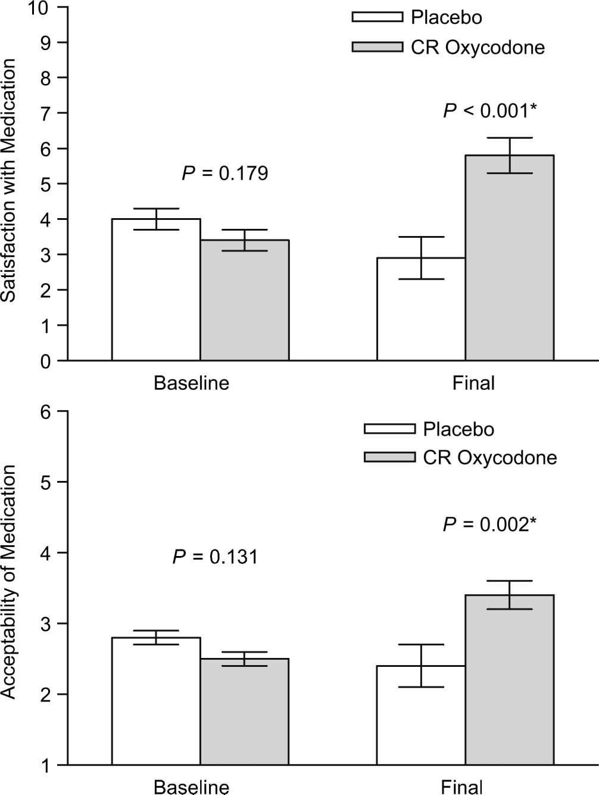TABLE 5. Common Adverse Events ($10% of Patients in Any Treatment Group)

Adverse Event*
Placebo (N = 51)
No. (%) Patients
CR Oxycodone (N = 56)
No. (%) Patients

Constipation 5 (9.8) 27 (48.2)
Nausea 7 (13.7) 23 (41.1)
Somnolence 5 (9.8) 18 (32.1)
Dizziness 3 (5.9) 18 (32.1)
Pruritus 0 (0.0) 12 (21.4)
Headache 10 (19.6) 11 (19.6)
Diarrhea 4 (7.8) 7 (12.5)
Vomiting 1 (2.0) 7 (12.5)
Sweat 2 (3.9) 6 (10.7)

*Adverse events were classified into standardized terminology from the verbatim description (investigator term) according to Coding Symbols for Thesaurus of Reaction Terms, 5th edition (COSTART®).

FIGURE 4. Satisfaction with pain medication scores (upper panel, scale from 0 [not at all satisfied] to 10 [totally satisfied], mean 6 SE) and acceptability of pain medication scores (lower panel, scale from 1 [not acceptable] to 6 [totally acceptable]) at baseline and final visit in placebo versus CR oxycodone-treated patients (N = 107; 51 placebo, 56 CR oxycodone). Baseline scores are arithmetic means 6 SE, and postbaseline scores are LS means 6 SE. *Statistically significant at a # 0.05 (Student t test was used at baseline; ANCOVA, postbaseline).

- mm WOMAC scales reflect clinically relevant improve- ments among patients with hip and knee OA.37 A limitation of this study is that the WOMAC OA Index was validated for individuals with OA of the hip or knee, whereas approximately 52% (56 out of 107) of the study patients had OA other than of the hip and knee. However, the WOMAC scales have been
patients with OA.40 In this study, at baseline, the BPI score for ‘‘worst pain’’ was approximately 8, an intensity level at which it has been shown that pain begins to interfere with and significantly affect relations with others, in addition to normal activities.29 In this study, CR oxycodone treatment signifi- cantly reduced interference of pain with relations with others from high baseline levels. Equally important, the statistically significant level of reduction found with CR oxycodone treatment was also observed in patients for whom pain resulted in mild interference with relations with others, with a reported score of 4.0 at baseline: by 60 days, the adjusted score was 2.8, a significant reduction; and at 90 days, 2.9. Moreover, CR oxycodone treatment also produced improvements in the pri- mary activity measurement of the PGI, which reflects im- provement in activities chosen by the patients, compared to placebo administration, also corroborating the results ob- served in both the BPI and the WOMAC. Significant pain control across all outcome scales was associated, for patients in the CR oxycodone group, with higher ratings of accept- ability of pain medication compared to patients in the placebo group. The significant pain control and higher acceptability ratings were substantiated by several findings: fewer CR oxycodone patients discontinued from the study due to in- adequate pain control compared to patients in the placebo group; patients taking CR oxycodone stabilized their dose level early and took less study drug overall throughout the

used in previous studies of individuals with OA of the lower

back and lower extremities.32,33 A subsequent analysis in- cluding the 89 patients (83%) with OA of the hip, knee, lower back, or lower extremities showed a treatment effect for CR oxycodone on all of the WOMAC scales.
The results of the primary and secondary efficacy variables were consistent across measurements for both treat- ment groups. The WOMAC scores were observed to decrease, as did scores for pain-associated interference in all areas of daily activities, as measured by the BPI, for patients treated with CR oxycodone compared to those treated with placebo. The correlations between the pain and function dimensions on the BPI and WOMAC scales have been recently reported in
TABLE 6. Mean (6SE) Day 90 Brief Pain Inventory Interference Scores Among Completers and Noncompleters: ITT Cohort

Placebo CR Oxycodone BPI Measurements N Mean SE N Mean SE

Day 90
13 | 4.6 | 0.5 | 23 | 4.0 | 0.4
38 | 6.7 | 0.3 | 32 | 6.2 | 0.4

BPI average pain—completers BPI average pain—noncompleters
Day 90
13 | 4.7 | 0.6 | 23 | 3.5 | 0.4
38 | 6.0 | 0.3 | 33 | 5.0 | 0.4

BPI interference—completers BPI interference—noncompleters

TABLE 7. Mean (6SE) Day 90 WOMAC Scores Among Completers and Noncompleters: ITT Cohort
CR
In this study, constipation was to be treated pro- phylactically with stimulant laxatives and stool softeners, and persistent nausea was to be treated with antiemetics. The most

Placebo
Oxycodone
frequent AEs reported in the CR oxycodone group in this
study were constipation and nausea, consistent with use of

Day 90
WOMAC Measurements N Mean SE N Mean SE
opioid analgesics. More than one-third of patients taking CR oxycodone discontinued because of adverse events, suggest-

WOMAC pain—completers 13 48.0 5.4 23 38.2 4.7
WOMAC pain—noncompleters 38 63.4 3.0 33 56.4 3.5
Day 90
WOMAC stiffness—completers 13 57.2 5.5 23 45.1 5.1
WOMAC stiffness—noncompleters 38 73.7 3.2 33 56.5 3.5
Day 90
WOMAC physical function—completers 13 51.6 5.7 23 40.8 4.8
WOMAC physical function—noncompleters 38 62.9 2.9 33 53.9 3.3
Day 90
WOMAC composite score—completers 13 52.2 5.4 23 41.4 4.8
WOMAC composite score—noncompleters 38 66.6 2.7 33 55.6 3.2

study compared to patients taking placebo; and patients taking CR oxycodone reported significant satisfaction with their pain therapy in contrast to patients receiving placebo.
Approximately two-thirds of the patients did not complete participation in the study, with pain scores higher, as expected, among those patients that discontinued from the study. The results show that the treatment effects between the CR oxycodone and the placebo groups were similar between both the completer and noncompleter cohorts. Table 6 shows the mean day 90 BPI average pain and interference mea- surement scores for completed patients and those that did not complete the study. Table 7 shows the mean day 90 WOMAC pain, stiffness, physical function, and composite scores for completed patients and those that did not complete the study. The magnitude of the differences in favor of the CR oxy- codone treatment group was comparable when examining the completer, noncompleter, or the total ITT cohorts.
In this study, at the baseline assessment, the majority of patients (greater than 80%) were taking stable doses of NSAIDs or APAP either alone or in a combination product containing an opioid and yet were experiencing moderate to severe pain. Pain reduction was observed when NSAIDs or APAP were used concomitantly with CR oxycodone, suggesting that CR oxycodone provided additional benefit when added to NSAIDs or APAP. In this study, a majority approximately 60% of the patients had a history of prior use of opioids, which was permitted by the protocol, suggesting that an appropriate population for the use of CR opioids was enrolled in the study. The use of placebo as a comparator could be a potential limitation of the study; however, the patients who enrolled in the study were required to be taking NSAID or APAP at a maximally tolerated dose or were intolerant of or at high risk for this therapy and/or taking short-acting opioids. Patients were permitted to continue their stable NSAID/APAP therapy, thus the placebo group is representative of a usual care group. It is of interest that the placebo group titrated their average dose of study drug to approximately 5.4 tablets per day (compared to 4.4 tablets for the CR oxycodone group), possibly due to a placebo effect.
ing that more aggressive treatment of constipation and nausea might improve the discontinuation rate. Effective opioid ther- apy should be accompanied by early recognition and ag- gressive treatment of these events. Constipation should be anticipated and treated prophylactically with a stimulant lax- ative and/or stool softener.41
The potential for tolerance is a concern among both patients and health-care providers. In this study, daily doses of CR oxycodone averaged 57 mg. Doses thus remained relatively low despite allowable increases of more than 3 times the stabilized dose (120 mg per day), which suggests that patients were not developing tolerance. This finding is similar to dose levels in another study in which the average daily dose at the end of titration was approximately 40 mg per day.22 (The average placebo ‘‘dose’’ also plateaued below the maximum permitted dose of 12 tablets per day, but at a higher level [approximately 7.4 tablets per day] than with CR oxycodone.)
This 90-day study demonstrated that treatment with CR oxycodone of patients with OA who had persistent moderate to severe pain uncontrolled by standard therapy resulted in significant pain control and improvements in physical func- tioning. These data suggest that CR oxycodone provided an additional benefit beyond the improvements observed with NSAIDs or APAP alone. Controlled-release oxycodone treat- ment produced adverse events typically seen with the use of an opioid analgesic and was not associated with any significant safety concerns. Data from this study support current treat- ment recommendations from pain specialists that selected groups of patients would benefit from treatment with opioid analgesics.26 Among patients with OA, opioid analgesics would benefit those with moderate to severe persistent pain who are unresponsive or intolerant to nonopioid medications such as APAP, NSAIDs, or COX-2 inhibitors or for whom monotherapy is insufficient. The large number of patients that discontinued in this study could have influenced the results. However, the patients that completed the study displayed a similar degree of treatment difference in favor of the CR oxycodone treatment, as did those patients that discontinued from the study.

ACKNOWLEDGMENTS
The authors gratefully acknowledge Pinggao Zhang, PhD, and Phyllis Clark for contributions to this study.

REFERENCES
  - Silman AJ, Hochberg MC. Osteoarthritis. In: Silman AJ, Hochberg MC, eds. Epidemiology of the Rheumatic Diseases. Oxford: Oxford University Press; 1993:257–288.
  - CDC. Arthritis prevalence and activity limitations—United States, 1990.
MMWR Morb Mortal Wkly Report. 1994;43:433–438.

  - Lawrence RC, Helmick CG, Arnett FC, et al. Estimates of the prevalence of arthritis and selected musculoskeletal disorders in the United States. Arthritis Rheum. 1998;41:778–799.
  - Creamer P, Lethbridge-Cejku M, Hochberg MC. Where does it hurt? Pain localization in osteoarthritis of the knee. Osteoarthritis Cartilage. 1998;6: 318–323.
  - Peloso PM. Opioid therapy for osteoarthritis of the hip and knee: use it or lose it? J Rheumatol. 2001;28:6–11.
  - Creamer P, Hochberg MC. Why does osteoarthritis of the knee hurt—sometimes? Br J Rheumatol. 1995;36:726–728.
  - Stein C, Pflu¨ ger M, Yassouridis A, et al. No tolerance to peripheral morphine analgesia in presence of opioid expression in inflamed synovia. J Clin Invest. 1996;98:793–799.
  - Jordan J, Luta G, Renner J, et al. Knee pain and knee osteoarthritis severity in self-reported task-specific disability: the Johnston County Osteoarthri- tis Project. J Rheumatol. 1997;24:1344–1349.
  - Creamer P, Lethbridge-Cejku M, Hochberg MC. Factors associated with functional impairment in symptomatic knee osteoarthritis. Rheumatology (Oxford). 2000;39:490–496.
  - American College of Rheumatology Subcommittee on Osteoarthritis Guidelines. Recommendations for the medical management of osteoar- thritis of the hip and knee: 2000 update. Arthritis Rheum. 2000;43:1905– 1915.
  - Wollheim FA. Current pharmacological treatment of osteoarthritis. Drugs. 1996;52(suppl 3):27–38.
  - Beaver WT. Impact of non-narcotic oral analgesics on pain management.
Am J Med. 1988;84(suppl 5A):3–15.
  - Blantz RC. Acetaminophen: acute and chronic effects on renal function.
Am J Kidney Dis. 1996;28(suppl 1):S3–S6.
  - Salgia ADT, Kosnik SD. When acetaminophen use becomes toxic: treating acute accidental and intentional overdose. Postgrad Med. 1999;105:81–90.
  - Carson JL, Willett LR. Toxicity of nonsteroidal anti-inflammatory drugs: an overview of the epidemiological evidence. Drugs. 1993;46(suppl 1): 243–248.
  - Smalley WE, Ray WA, Daugherty JR, et al. Nonsteroidal anti- inflammatory drugs and the incidence of hospitalizations for peptic ulcer disease in elderly persons. Am J Epidemiol. 1995;141:539–545.
  - Johnson AG, Seidemann P, Day RO. NSAID-related adverse drug interactions with clinical relevance: an update. Int J Clin Pharmacol Ther. 1994;32:509–532.
  - Kirchner JT. Nonsteroidal anti-inflammatory drug use in the elderly: issues of compliance and safety. J Am Osteopath Assoc. 1994;94:300–304.
  - Creamer P, Flores R, Hochberg MC. Management of osteoarthritis in older adults. Clin Geriatr Med. 1998;14:435–454.
  - Hersh EV, Moore PA, Ross GL. Over-the-counter analgesics and antipyretics: a critical assessment. Clin Ther. 2000;22:500–548.
  - Case JP, Baliunas AJ, Block JA. Lack of efficacy of acetaminophen in treating symptomatic knee osteoarthritis. Arch Intern Med. 2003;163: 169–178.
  - Caldwell JR, Hale ME, Boyd RE, et al. Treatment of osteoarthritis pain with controlled release oxycodone or fixed combination oxycodone plus acetaminophen added to nonsteroidal anti-inflammatory drugs: a double blind, randomized, multicenter, placebo controlled trial. J Rheumatol. 1999;26:862–869.
  - Peloso PM, Bellamy N, Bensen W, et al. Double blind randomized placebo control trial of controlled release codeine in the treatment of osteoarthritis of the hip or knee. J Rheumatol. 2000;27:764–771.
  - Roth SH, Fleischmann RM, Burch FX, et al. Around-the-clock, controlled-release oxycodone therapy for osteoarthritis-related pain: placebo-controlled trial and long-term evaluation. Arch Intern Med. 2000; 160:853–860.
  - The use of opioids for the treatment of chronic pain: a consensus state- ment from the American Academy of Pain Medicine and the American Pain Society. Clin J Pain. 1997;13:6–8.
  - American Pain Society. Guideline for the Management of Pain in Osteoarthritis, Rheumatoid Arthritis, and Juvenile Chronic Arthritis. Glenview, IL: American Pain Society; 2002.
  - American College of Rheumatology Ad Hoc Committee on Clinical Guidelines. Guidelines for the initial evaluation of the adult patient with acute musculoskeletal symptoms. Arthritis Rheum. 1996;39:1–8.
  - Turk D, Dworkin RH, Allen RR, et al. Core outcome domains for chronic pain clinical trials: IMMPACT recommendations. Pain. 2003;106:337–345.
  - Cleeland CS, Ryan KM. Pain assessment: global use of the Brief Pain Inventory. Ann Acad Med Singapore. 1994;23:129–138.
  - Bellamy N, Buchanan WW, Goldsmith CH, et al. Validation study of WOMAC: a health status instrument for measuring clinically important patient relevant outcomes to antirheumatic drug therapy in patients with osteoarthritis of the hip or knee. J Rheumatol. 1988;15:1833–1840.
  - McConnell S, Kolopack P, Davis AM. The Western Ontario and McMaster Universities Osteoarthritis Index (WOMAC): a review of its utility and measurement properties. Arthritis Care Res. 2001;45:453–461.
  - Wolfe F. Determinants of WOMAC function, pain and stiffness scores: evidence for the role of low back pain, symptom counts, fatigue and depression in osteoarthritis, rheumatoid arthritis and fibromyalgia. Rheumatology (Oxford). 1999;38:355–361.
  - Domsic RT, Saltzman CL. Ankle osteoarthritis scale. Foot Ankle Int. 1998;19:466–471.
  - McConnell S, Kolopack P, Davis AM. The Western Ontario and McMaster Universities Osteoarthritis Index (WOMAC): a review of its utility and measurement properties. Arthritis Care Res. 2001;45:453–461.
  - Ruta DA, Garratt AM, Leng M, et al. A new approach to the measurement of quality of life: the Patient-Generated Index. Med Care. 1994;32:1109– 1126.
  - US Food and Drug Administration, Center for Drug Evaluation and Research. Coding Symbols for Thesaurus of Adverse Reaction Terms. 5th ed. Rockville, MD: US Food and Drug Administration.
  - Ehrich EW, Davies GM, Watson DJ, et al. Minimal perceptible clinical improvement with the Western Ontario and McMaster Universities Osteoarthritis Index questionnaire and global assessments in patients with osteoarthritis. J Rheumatol. 2000;27:2635–2641.
  - Davies GM, Watson DJ, Bellamy N. Comparison of the responsiveness and relative effect size of the Western Ontario and McMaster Universities Osteoarthritis Index and the Short-Form Medical Outcomes Study Survey in a randomized, clinical trial of osteoarthritis patients. Arthritis Care Res. 1999;12:172–179.
  - Yocum D, Fleischmann R, Dalgin P, et al, for the Meloxicam Arthritis Investigators. Safety and efficacy of meloxicam in the treatment of osteoarthritis: a 12-week, double-blind, multiple-dose, placebo-controlled trial. Arch Intern Med. 2000;160:2947–2954.
  - Hoffman DL, Friedman M, Colucci S, et al. Validation of the Brief Pain Inventory for patients with osteoarthritis [abstract]. J Pain. 2002;3(suppl 1):3.
  - OxyContin® (package insert). Stamford, CT: Purdue Pharma, L.P.; 2002.

APPENDIX 1. PROVIDERS PARTICIPATING IN THE STUDY
David Allan, MD Arthritis Associates, P.C.
Medical Arts Building, Suite 107 39th and Market Streets Philadelphia, PA 19104
Jacques R. Caldwell, MD
Halifax Clinical Research Institute
311 North Clyde Morris Boulevard, Suite 520 Daytona Beach, FL 32114
Andrew Chubick, MD
Arthritis Centers of Texas, Research Associates of North Texas 712 North Washington, Suites 200 and 120
Dallas, TX 75246
David Cooley, MD
Mid-America Rheumatology Consultants 5701 West 119th Street, Suite 209 Overland Park, KS 66209
Joseph Croft, MD Arthritis Center, P.C.
5454 Wisconsin Avenue, Suite 835 Chevy Chase, MD 20815

Joseph Gimbel, MD
Arizona Research Center L.L.C.
2525 Greenway Road, Suites 100 and 114
Phoenix, AZ 85023
John M. Hague, MD Rheumatology Associates P.C.
8802 North Meridian Street, Suite 108
Indianapolis, IN 46260
Bob G. Lanier, MD
993-D Johnson Ferry Road, Suite 370
Atlanta, GA 30342
Joseph A. Markenson, MD Hospital for Special Surgery 535 East 70th Street
New York, NY 10021

