INDOOR AIR QUALITY ASSESSMENT

Marsh Grammar School
309 Pelham Street
Methuen, MA 01844

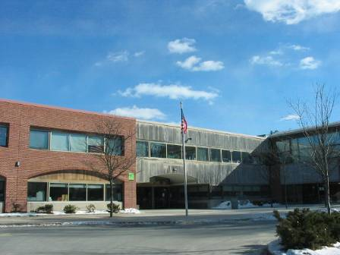

Prepared by:
Massachusetts Department of Public Health
Center for Environmental Health
Emergency Response/Indoor Air Quality Program
March 2007

Background/Introduction
At the request of a parent, the Massachusetts Department of Public Health (MDPH), Center for Environmental Health (CEH) provided assistance and consultation regarding indoor air quality at the Marsh Grammar School (MGS) located at 309 Pelham Street, Methuen, Massachusetts. On February 7, 2007, a visit to conduct an assessment of the MGS was made by Cory Holmes and Sharon Lee, Environmental Analysts in CEH’s Emergency Response/Indoor Air Quality (ER/IAQ) Program.
The MGS is a two-story red brick building originally constructed in 1969. The building underwent complete renovations in 1996-1997. The building contains general classrooms, music room, library, art rooms, office space, kitchen, cafeteria, gymnasium and an auditorium. Windows are openable throughout the building.

Methods
Air tests for carbon monoxide, carbon dioxide, temperature and relative humidity were taken with the TSI, Q-Trak, IAQ Monitor, Model 8551. Air tests for airborne particle matter with a diameter less than 2.5 micrometers were taken with the TSI, DUSTTRAK™ Aerosol Monitor Model 8520. Screening for total volatile organic compounds (TVOCs) was conducted using a Hnu, Model 102 Snap-on Photo Ionization Detector (PID). Moisture content of gypsum wallboard (GW) was measured with a Delmhorst, BD-2000 Model, Moisture Detector equipped with a Delmhorst Standard Probe. CEH staff also performed a visual inspection of building materials for water damage and/or microbial growth.

Results
The MGS houses approximately 1,425 students in grades pre-K through 8 and has a staff of approximately 165. Tests were taken under normal operating conditions. Test results appear in Table 1.

Discussion

Ventilation
It can be seen from Table 1 that carbon dioxide levels were elevated above 800 parts per million (ppm) in 11 of 63 areas surveyed, indicating adequate air exchange in most areas surveyed on the day of the assessment. Fresh air in classrooms is supplied by computerized unit ventilator (univent) systems. A univent draws air from the outdoors through a fresh air intake located on the exterior wall of the building (Picture 1) and returns air through an air intake located at the base of the unit (Figure 1). Fresh and return air are mixed, filtered, heated/cooled and provided to classrooms through an air diffuser located in the top of the unit.
The majority of univents were operating during the assessment. Two classroom univents were deactivated, reportedly due to overheating. Obstructions to airflow, such as papers and books stored on univents and items placed in front of univent returns, were seen in a number of classrooms (Picture 2). In order for univents to provide fresh air as designed, these units must be activated and allowed to operate while rooms are occupied. Univent return vents and diffusers must also remain free of obstructions.
Exhaust ventilation is provided by ceiling-mounted vents ducted to rooftop motors (Pictures 3 and 4). Exhaust vents were operating in all but one area (room 101) surveyed during the assessment (Table 1). In some areas, exhaust vents are located above classroom doors (Picture 5). When a classroom door is open, exhaust vents will tend to draw air from both the hallway and the classroom. The open hallway door reduces the effectiveness of the exhaust vent to remove common environmental pollutants from classrooms.
Mechanical ventilation for interior rooms and common areas (e.g., offices, library, gym) is provided by rooftop air-handling units (AHUs) (Picture 6). Fresh air is ducted to classrooms via ceiling-mounted fresh air diffusers (Picture 7). Exhaust air is drawn through ceiling-mounted vents and ducted back to the AHUs (Picture 7). These systems were functioning during the assessment.
To maximize air exchange, the MDPH recommends that both supply and exhaust ventilation operate continuously during periods of occupancy. In order to have proper ventilation with a mechanical ventilation system, the systems must be balanced subsequent to installation to provide an adequate amount of fresh air to the interior of a room while removing stale air from the room. It is recommended that HVAC systems be re-balanced every five years to ensure adequate air systems function (SMACNA, 1994).
The Massachusetts Building Code requires that each room have a minimum ventilation rate of 15 cubic feet per minute (cfm) per occupant of fresh outside air or have openable windows (SBBRS, 1997; BOCA, 1993). The ventilation must be on at all times that the room is occupied. Providing adequate fresh air ventilation with open windows and maintaining the temperature in the comfort range during the cold weather season is impractical. Mechanical ventilation is usually required to provide adequate fresh air ventilation.
Carbon dioxide is not a problem in and of itself. It is used as an indicator of the adequacy of the fresh air ventilation. As carbon dioxide levels rise, it indicates that the ventilating system is malfunctioning or the design occupancy of the room is being exceeded. When this happens, a buildup of common indoor air pollutants can occur, leading to discomfort or health complaints. The Occupational Safety and Health Administration (OSHA) standard for carbon dioxide is 5,000 parts per million parts of air (ppm). Workers may be exposed to this level for 40 hours/week, based on a time-weighted average (OSHA, 1997).
The MDPH uses a guideline of 800 ppm for publicly occupied buildings. A guideline of 600 ppm or less is preferred in schools due to the fact that the majority of occupants are young and considered to be a more sensitive population in the evaluation of environmental health status. Inadequate ventilation and/or elevated temperatures are major causes of complaints such as respiratory, eye, nose and throat irritation, lethargy and headaches. For more information concerning carbon dioxide, see Appendix A.
Temperature readings ranged from 69º F to 78 º F, which were within or very close to the lower end of the MDPH comfort guidelines on the day of the assessment. The MDPH recommends that indoor air temperatures be maintained in a range of 70 º F to 78 º F in order to provide for the comfort of building occupants. As indicated previously, univents were deactivated in two classrooms (231 and 233), reportedly due to overheating. An occupant in room 107 where the univent was operating also reported overheating, which may indicate a problem with the thermostat. In many cases concerning indoor air quality, fluctuations of temperature in occupied spaces are typically experienced, even in a building with an adequate fresh air supply.
The relative humidity measurements ranged from 8 to 20 percent, which were below the MDPH recommended comfort range in all areas surveyed the day of the assessment. The MDPH recommends a comfort range of 40 to 60 percent for indoor air relative humidity. Relative humidity levels in the building would be expected to drop during the winter months due to heating. The sensation of dryness and irritation is common in a low relative humidity environment. Low relative humidity is a very common problem during the heating season in the northeast part of the United States.

Microbial/Moisture Concerns
It was reported that a leak occurred two years prior to the MDPH assessment due to a frozen pipe between classrooms 106 and 107. To prevent a reoccurrence, pipes were replaced and the wall cavity was insulated with fiberglass (Picture 8). Moisture measurements were taken in this area and it was determined that GW had low (i.e., normal) moisture content at the time of the assessment. However, vinyl base coving was removed and a dark staining which appeared to be mold was identified along GW baseboard (Picture 9). GW is a porous material that absorbs moisture; the vinyl coving acts as a barrier and “traps” moisture behind it, which can create conditions for mold growth. At the time of the assessment it was recommended by CEH staff that the section of GW be replaced (At the time of this report preparation it is unknown whether this action was taken).
The US Environmental Protection Agency (US EPA) and the American Conference of Governmental Industrial Hygienists (ACGIH) recommends that porous materials be dried with fans and heating within 24 to 48 hours of becoming wet (US EPA, 2001; ACGIH, 1989). If porous materials are not dried within this time frame, mold growth may occur. Water-damaged porous materials cannot be adequately cleaned to remove mold growth. The application of a mildewcide to moldy porous materials is not recommended.
Breaches were observed between the counter and sink backsplashes in some classrooms (Picture 10). If not watertight, water can penetrate through these seams. Water penetration and chronic exposure of porous and wood-based materials can cause these materials to swell and show signs of water damage, which can subsequently lead to mold growth.
Plants were noted in several classrooms. Some plants were observed on univents (Picture 11) Plants can be a source of pollen and mold, which can be respiratory irritants for some individuals. Plants should be properly maintained and equipped with drip pans. Plants should also be located away from ventilation sources (e.g., univent air diffusers) to prevent the entrainment and/or aerosolization of dirt, pollen or mold.
Lastly, aquariums were observed in some classrooms. Aquariums should be properly maintained to prevent microbial/algae growth, which can emit unpleasant odors.

Other IAQ Evaluations
Indoor air quality can be negatively influenced by the presence of respiratory irritants, such as products of combustion. The process of combustion produces a number of pollutants. Common combustion emissions include carbon monoxide, carbon dioxide, water vapor and smoke (fine airborne particle material). Of these materials, exposure to carbon monoxide and particulate matter with a diameter of 2.5 micrometers (μm) or less (PM2.5) can produce immediate, acute health effects upon exposure. To determine whether combustion products were present in the school environment, CEH staff obtained measurements for carbon monoxide and PM2.5.
Carbon monoxide is a by-product of incomplete combustion of organic matter (e.g., gasoline, wood and tobacco). Exposure to carbon monoxide can produce immediate and acute health affects. Several air quality standards have been established to address carbon monoxide and prevent symptoms from exposure to these substances. The MDPH established a corrective action level concerning carbon monoxide in ice skating rinks that use fossil-fueled ice resurfacing equipment. If an operator of an indoor ice rink measures a carbon monoxide level over 30 ppm, taken 20 minutes after resurfacing within a rink, that operator must take actions to reduce carbon monoxide levels (MDPH, 1997).
The American Society of Heating Refrigeration and Air-Conditioning Engineers (ASHRAE) has adopted the National Ambient Air Quality Standards (NAAQS) as one set of criteria for assessing indoor air quality and monitoring of fresh air introduced by HVAC systems (ASHRAE, 1989). The NAAQS are standards established by the US EPA to protect the public health from six criteria pollutants, including carbon monoxide and particulate matter (US EPA, 2006). As recommended by ASHRAE, pollutant levels of fresh air introduced to a building should not exceed the NAAQS levels (ASHRAE, 1989). The NAAQS were adopted by reference in the Building Officials & Code Administrators (BOCA) National Mechanical Code of 1993 (BOCA, 1993), which is now an HVAC standard included in the Massachusetts State Building Code (SBBRS, 1997). According to the NAAQS, carbon monoxide levels in outdoor air should not exceed 9 ppm in an eight-hour average (US EPA, 2006).
Carbon monoxide should not be present in a typical, indoor environment. If it is present, indoor carbon monoxide levels should be less than or equal to outdoor levels. On the day of assessment, outdoor carbon monoxide concentrations were non-detect (ND) (Table 1). Carbon monoxide levels measured in the school were ND (Table 1).
The US EPA has established NAAQS limits for exposure to particulate matter. Particulate matter is airborne solids that can be irritating to the eyes, nose and throat. The NAAQS originally established exposure limits to particulate matter with a diameter of 10 μm or less (PM10). According to the NAAQS, PM10 levels should not exceed 150 microgram per cubic meter (μg/m³) in a 24-hour average (US EPA, 2006). These standards were adopted by both ASHRAE and BOCA. Since the issuance of the ASHRAE standard and BOCA Code, US EPA proposed a more protective standard for fine airborne particles. This more stringent PM2.5 standard requires outdoor air particle levels be maintained below 35 μg/m³ over a 24-hour average (US EPA, 2006). Although both the ASHRAE standard and BOCA Code adopted the PM10 standard for evaluating air quality, MDPH uses the more protective proposed PM2.5 standard for evaluating airborne particulate matter concentrations in the indoor environment.
Outdoor PM2.5 concentrations were measured at 13 μg/m³ (Table 1). PM2.5 levels within the school ranged from 3 to 16 μg/m³, which were below the NAAQS of 35 μg/m³ (Table 1). Frequently, indoor air levels of particulates can be at higher levels than those measured outdoors. A number of mechanical devices and/or activities that occur in schools can generate particulates during normal operation. Sources of indoor airborne particulate may include but are not limited to particles generated during the operation of fan belts in the HVAC system, cooking in the cafeteria stoves and microwave ovens; use of photocopiers, fax machines and computer printing devices, operating an ordinary vacuum cleaner and heavy foot traffic indoors.
Indoor air quality can also be negatively influenced by the presence of materials containing volatile organic compounds (VOCs). VOCs are carbon-containing substances that have the ability to evaporate at room temperature. Frequently, exposure to low levels of total VOCs (TVOCs) may produce eye, nose, throat and/or respiratory irritation in some sensitive individuals. For example, chemicals evaporating from a paint can stored at room temperature would most likely contain VOCs. In an effort to determine whether VOCs were present in the building, air monitoring for TVOCs was conducted during the assessment. An outdoor air sample was taken for comparison. Outdoor TVOC concentrations were ND (Table 1). Indoor TVOC concentrations were ND in all but one area surveyed (Table 1). Room 131 had a slight measurement of 0.01 ppm due to the use of dry erase markers by students and staff. [It is important to note that this level of VOCs would not be expected to impact health.]
In an effort to identify materials that can potentially increase indoor TVOC concentrations, CEH staff examined classrooms for products containing these respiratory irritants. As mentioned, classrooms contained dry erase boards and dry erase board markers. Materials such as dry erase markers and dry erase board cleaners may contain VOCs, such as methyl isobutyl ketone, n-butyl acetate and butyl-cellusolve (Sanford, 1999), which can be irritating to the eyes, nose and throat.
Cleaning products and solvents were found on countertops and in unlocked cabinets beneath sinks in some classrooms (Picture 12). Like dry erase materials, cleaning products contain VOCs and other chemicals that can be irritating to the eyes, nose and throat of sensitive individuals. Plug-in type air fresheners and spray air deodorizers were also observed in several classrooms (Pictures 13 and 14). Air fresheners and deodorizers contain chemicals that can be irritating to the eyes, nose and throat of sensitive individuals. Furthermore, air fresheners and deodorizers do not remove materials causing odors, but rather mask odors that may be present in the area.
Other conditions that can affect indoor air quality were observed during the assessment. Several personal fans and ceiling-mounted exhaust vents were occluded with dust (Pictures 15 and 16). Dust can be a source for eye and respiratory irritation. If exhaust vents are not functioning, backdrafting can occur and aerosolize dust particles. Re-activated personal fans can serve to distribute dust.
Also of note was the amount of materials stored inside classrooms (Picture 17). In some classrooms items were observed on windowsills, tabletops, counters, univents, bookcases and desks. The stored materials in classrooms provide surfaces for dust to accumulate. Accumulation of these items (e.g., papers, folders, boxes) makes cleaning difficult for custodial staff.
Exposed fiberglass insulation was observed between rooms 106 and 107 (Picture 8). As mentioned previously, this area was insulated to prevent the freezing of pipes. If work has been completed, this area should be sealed. Fiberglass insulation can provide a source of skin, eye and respiratory irritation.
Finally of note was the storage of food items and the amount of personal cooking and food storage items in classrooms (toasters, toaster ovens, microwaves, coffee makers, refrigerators). These items can serve as attractants for pests and rodents, which should be minimized to a central location.

Conclusions/Recommendations
In view of the findings at the time of the visit, the following recommendations are made:
- Repair univents/thermostats in classrooms 107, 231 and 233 to reduce heat.
- Inspect exhaust motors and belts for proper function, repair and replace as necessary.
- Continue to operate all ventilation systems throughout the building (e.g., gym, auditorium, classrooms) continuously during periods of school occupancy to maximize air exchange.
- Remove all obstructions from univents to facilitate airflow.
- Ensure classroom doors are closed to improve air exchange.
- Use openable windows in conjunction with mechanical ventilation to introduce fresh air. Care should be taken to ensure windows are properly closed at night and weekends during winter months to avoid the freezing of pipes and potential flooding.
- Consider adopting a balancing schedule for mechanical ventilation systems every 5 years, as recommended by ventilation industrial standards (SMACNA, 1994).
- For buildings in New England, periods of low relative humidity during the winter are often unavoidable. Therefore, scrupulous cleaning practices should be adopted to minimize common indoor air contaminants whose irritant effects can be enhanced when the relative humidity is low. To control for dusts, a high efficiency particulate arrestance (HEPA) filter equipped vacuum cleaner in conjunction with wet wiping of all surfaces is recommended. Drinking water during the day can help ease some symptoms associated with a dry environment (e.g., throat and sinus irritations).
- Ensure plants have drip pans. Examine drip pans periodically for mold growth and disinfect with an appropriate antimicrobial where necessary. Remove plants from the air stream of univents.
- Store cleaning products properly and out of reach of students. Ensure spray bottles are properly labeled. All cleaning products used at the facility should be approved by the school department with MSDS’ available at a central location.
- Relocate or consider reducing the amount of materials stored in classrooms to allow for more thorough cleaning. Clean items regularly with a wet cloth or sponge to prevent excessive dust build-up.
- Clean exhaust/return vents and personal fans of accumulated dust periodically to prevent the aerosolization of dirt, dust and particulates.
- Consider relocating personal cooking appliances to a central location to prevent pests/rodents.
- Seal holes between rooms 106 and 107 to prevent exposure to fiberglass insulation.
- Consider adopting the US EPA document, Tools for Schools (US EPA, 2000), as a means to maintaining a good indoor air quality environment in the building. This document can be downloaded from the Internet at http://www.epa.gov/iaq/schools/index.html.
- Refer to resource manuals and other related indoor air quality documents for further building-wide evaluations and advice on maintaining public buildings. Copies of these materials are located on the MDPH’s website: http://mass.gov/dph/indoor_air
References
ACGIH. 1989. Guidelines for the Assessment of Bioaerosols in the Indoor Environment. American Conference of Governmental Industrial Hygienists, Cincinnati, OH.

ASHRAE. 1989. ASHRAE Standard: Ventilation for Acceptable Indoor Air Quality. Sections 5.11, 5.12. American Society of Heating, Refrigerating and Air-Conditioning Engineers, Inc. Atlanta, GA.
BOCA. 1993. The BOCA National Mechanical Code/1993. 8th ed. Building Officials and Code Administrators International, Inc., Country Club Hill, IL.
MDPH. 1997. Requirements to Maintain Air Quality in Indoor Skating Rinks (State Sanitary Code, Chapter XI). 105 CMR 675.000. Massachusetts Department of Public Health, Boston, MA.
OSHA. 1997. Limits for Air Contaminants. Occupational Safety and Health Administration. Code of Federal Regulations. 29 C.F.R 1910.1000 Table Z-1-A.
SBBRS. 1997. Mechanical Ventilation. State Board of Building Regulations and Standards. Code of Massachusetts Regulations. 780 CMR 1209.0.
SMACNA. 1994. HVAC Systems Commissioning Manual. 1st ed. Sheet Metal and Air Conditioning
US EPA. 2000. Tools for Schools. Office of Air and Radiation, Office of Radiation and Indoor Air, Indoor Environments Division (6609J). EPA 402-K-95-001, Second Edition. http://www.epa.gov/iaq/schools/tools4s2.html
US EPA. 2001. “Mold Remediation in Schools and Commercial Buildings”. Office of Air and Radiation, Indoor Environments Division, Washington, DC. EPA 402-K-01-001. March 2001. Available at: http://www.epa.gov/iaq/molds/mold_remediation.html
US EPA. 2006. National Ambient Air Quality Standards (NAAQS). US Environmental Protection Agency, Office of Air Quality Planning and Standards, Washington, DC. http://www.epa.gov/air/criteria.html.

Picture 1

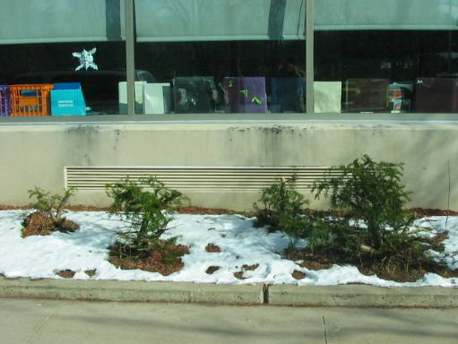

Univent Fresh Air on Building Exterior

Picture 2

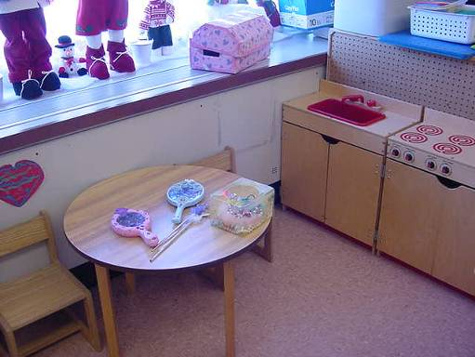

Classroom Univent, Note Furniture Partially Obstructing Return Vent (along Bottom Front)

Picture 3

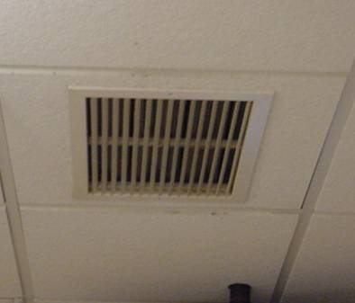

Ceiling-Mounted Exhaust/Return Vent

Picture 4

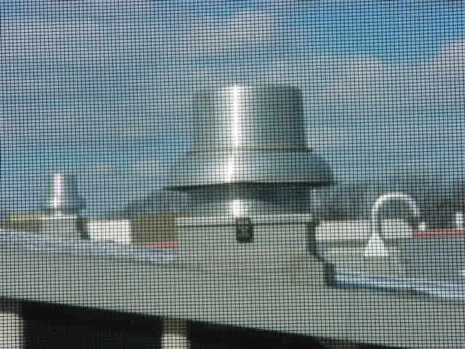

Rooftop Exhaust Motor
Picture 5

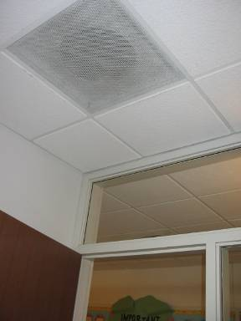

Classroom Exhaust Vent Located Above Door

Picture 6

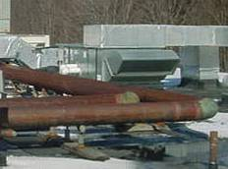

Rooftop Air Handling Unit
Picture 7

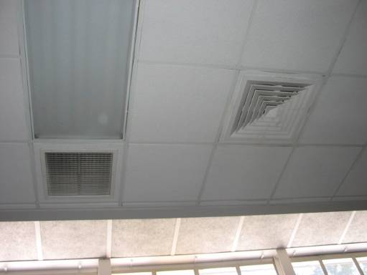

Ceiling-Mounted Supply Air Diffuser (Right) and Return Vent (Left)

Picture 8

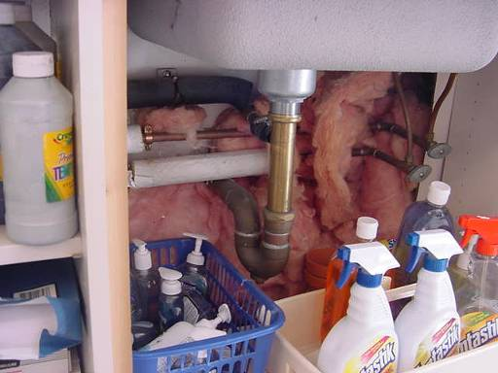

Wall Cavity between Classrooms 106 and 107 Insulated With Fiberglass
Picture 9

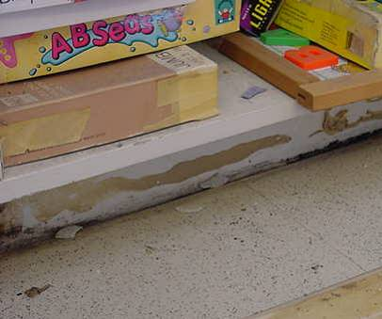

Dark Staining Indicating Possible Mold Growth along GW Baseboard in Room 106

Picture 10

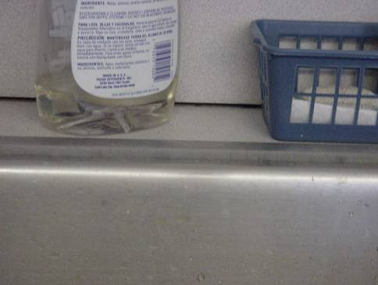

Spaces between Sink Countertop and Backsplash
Picture 11

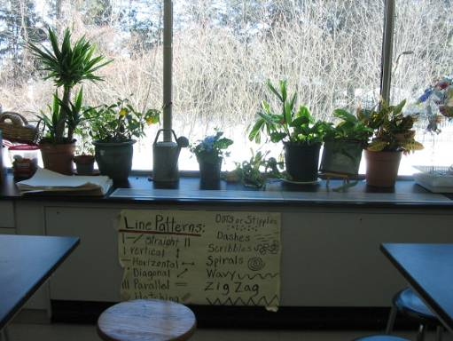

Plants Located on Univents
Picture 12

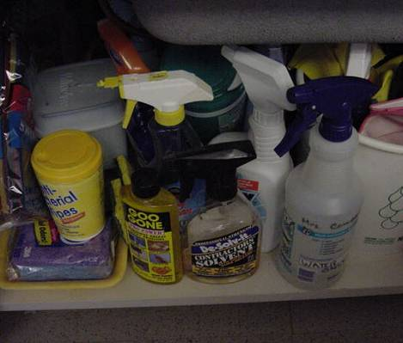

Spray Cleaning Products and Solvents under Sink in Classroom
Picture 13

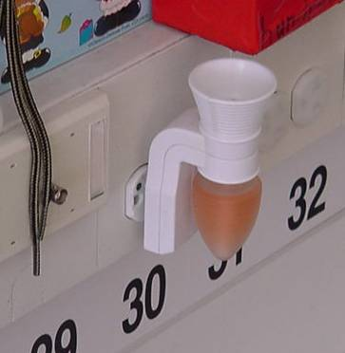

Plug-in Air Freshener in Classroom

Picture 14

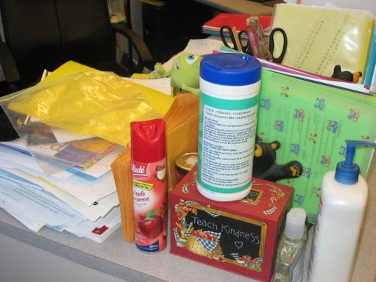

Spray Air Deodorizer

Picture 15

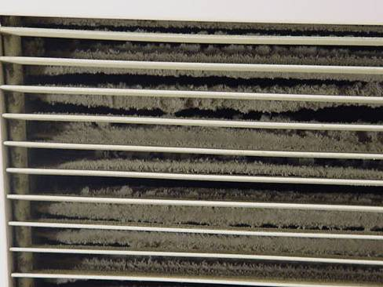

Dust Build-up on Exhaust Vent

Picture 16

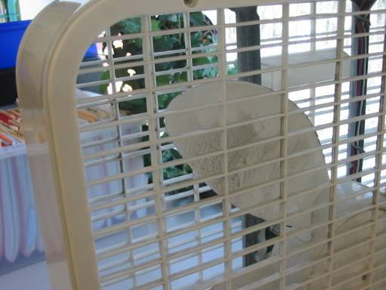

Dust Build-up on Personal Fan
Picture 17

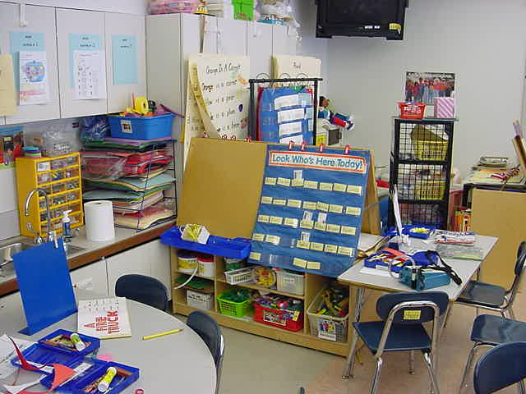

Accumulated Items in Classroom

Location/ Room | Occupants  in Room | Temp  (°F) | Relative  Humidity  (%) | Carbon  Dioxide  (ppm) | Carbon Monoxide  (ppm) | TVOCs  (ppm) | PM2.5  (µg/m3) | Windows  Openable | Ventilation |  | Remarks
 |  |  |  |  |  |  |  |  | Supply | Exhaust | Remarks
background |  | 15 | 35 | 360 | ND | ND | 13 |  |  |  | Cold and clear, winds: calm
101 | 14 | 72 | 15 | 829 | ND | ND | 11 | Y | Y  univent | Y  ceiling  off | Univent obstructed with furniture, cleaners, DEM, breach sink/countertop
102 | 12 | 71 | 12 | 696 | ND | ND | 9 | Y | Y  univent | Y  ceiling
104 | 0 | 72 | 12 | 549 | ND | ND | 9 | Y | Y  univent | Y  ceiling | Cleaners, accumulated items, breach sink/countertop
105 | 0 | 78 | 11 | 565 | ND | ND | 8 | Y | Y  univent | Y  ceiling | Dusty exhaust vent, plug-in air freshener, cleaners, accumulated items, occupants at lunch, breach sink/countertop
Auditorium | 0 | 72 | 8 | 413 | ND | ND | 7 | N | Y  ceiling | Y  ceiling  Wall
107 | 26 | 74 | 13 | 754 | ND | ND | 16 | Y | Y  univent | Y  ceiling | Univent obstructed with furniture, accumulated items, heat complaints, gypsum wallboard-low (i.e., normal) moisture, breach sink/countertop
106 | 0 | 77 | 12 | 615 | ND | ND | 8 | Y | Y  univent | Y  ceiling | Univent obstructed with furniture, gypsum wallboard-low (i.e., normal) moisture, dark staining behind vinyl coving indicating possible mold growth-rec. removal
114 Art | 26 | 71 | 11 | 678 | ND | ND | 16 | N | Y  ceiling | Y  ceiling | Hallway DO
117 | 1 | 70 | 11 | 557 | ND | ND | 8 | N | Y  ceiling | Y  ceiling | Hallway DO, DEM
Teacher’s Workroom | 3 | 71 | 11 | 533 | ND | ND | 11 | N | Y  ceiling | Y  ceiling | Photocopiers
Nurse | 6 | 72 | 13 | 723 | ND | ND | 6 | N | Y  ceiling | Y  ceiling | Hallway DO
210 | 24 | 71 | 11 | 684 | ND | ND | 10 | Y | Y  univent | Y  ceiling | DEM
211 | 5 | 72 | 12 | 708 | ND | ND | 9 | Y | Y  univent | Y  ceiling
Teacher’s Lounge | 8 | 72 | 13 | 745 | ND | ND | 11 | N | Y  ceiling | Y  ceiling
207 | 19 | 72 | 14 | 896 | ND | ND | 11 | Y | Y  univent | Y  ceiling
215 | 24 | 73 | 15 | 768 | ND | ND | 10 | Y | Y  univent | Y  ceiling | Univent obstructed by items, DEM
217 | 4 | 72 | 12 | 641 | ND | ND | 8 | Y | Y  univent | Y  ceiling | DEM, 24 occupants gone 20 mins
219 | 15 | 71 | 13 | 720 | ND | ND | 7 | Y | Y  univent |  | Plug-in air freshener, hallway DO, inter-room DO
222 | 0 | 71 | 11 | 549 | ND | ND | 8 | Y | Y  univent | Y  ceiling | Hallway DO, DEM
224 | 26 | 71 | 12 | 779 | ND | ND | 8 | Y | Y  univent | Y  ceiling | Hallway DO, DEM
Library | 4 | 75 | 10 | 445 | ND | ND | 6 | Y | Y  univent | Y  ceiling | DEM
126 | 0 | 71 | 14 | 507 | ND | ND | 4 | Y | Y  univent | Y  ceiling | DEM
127 | 0 | 71 | 15 | 517 | ND | ND | 6 | Y | Y  univent | Y  ceiling
129 | 1 | 70 | 14 | 528 | ND | ND | 4 | Y | Y  univent | Y  ceiling | Accumulated items, DEM
241 | 23 | 69 | 19 | 725 | ND | ND | 6 | Y | Y  univent | Y  ceiling | DEM
240 | 24 | 71 | 19 | 760 | ND | ND | 7 | Y | Y  univent | Y  ceiling | Plants near univent, DEM, cleaners, personal fan, air freshener, accumulated items
239 | 27 | 72 | 19 | 778 | ND | ND | 6 | Y | Y  univent | Y  ceiling | DEM
238 | 30 | 73 | 20 | 952 | ND | ND | 5 | Y | Y  univent | Y  ceiling
237 | 22 | 70 | 15 | 639 | ND | ND | 6 | Y | Y  univent | Y  ceiling | Pencil shavings, DEM
131 | 23 | 70 | 18 | 658 | ND | 0.1 | 6 | Y | Y  univent | Y  ceiling | Students with personal DEM, univent obstructed by boxes
132 | 27 | 70 | 17 | 652 | ND | ND | 7 | Y | Y  univent | Y  ceiling | Univent obstructed by boxes, DEM, accumulated items
133 | 26 | 71 | 20 | 827 | ND | ND | 7 | Y | Y  univent | Y  ceiling | Univent obstructed by items, DEM
134 Art | 1 | 73 | 16 | 568 | ND | ND | 5 | Y | Y  univent | Y  ceiling | Plants near univent, cleaners, accumulated items, DEM
135 | 36 | 72 | 17 | 827 | ND | ND | 5 | Y | Y  univent | Y  ceiling | DEM
Upper Gym | 150 | 71 | 13 | 456 | ND | ND | 6 | N | Y  ceiling | Y | 4 MT
137 | 21 | 69 | 17 | 649 | ND | ND | 3 | Y | Y  ceiling | Y  ceiling | Cleaners, accumulated items, plug-in air freshener
138 | 25 | 71 | 17 | 615 | ND | ND | 4 | Y | Y  ceiling | Y  ceiling | Unlabelled bottles
139 | 1 | 73 | 17 | 520 | ND | ND | 4 | Y | Y  ceiling | Y  ceiling | DEM, plug-in air freshener, hallway DO
Gym | 50 | 73 | 18 | 610 | ND | ND | 5 | N | Y  ceiling | Y  ceiling
141 | 1 | 73 | 14 | 503 | ND | ND | 8 | Y | Y  ceiling | Y  ceiling | DEM
140 | 1 | 73 | 15 | 518 | ND | ND | 3 | N | Y  ceiling | Y  ceiling
142 | 1 | 72 | 16 | 545 | ND | ND | 3 | Y | Y  ceiling | Y  ceiling
Consumer Science | 0 | 71 | 15 | 474 | ND | ND | 6 | Y | Y  ceiling | Y  ceiling
144 | 16 | 71 | 16 | 689 | ND | ND | 3 | Y | Y  ceiling | Y  ceiling | DEM, cleaners
145 | 26 | 73 | 18 | 868 | ND | ND | 7 | Y | Y  ceiling | Y  ceiling | DEM, accumulated items
146 | 26 | 71 | 17 | 706 | ND | ND | 4 | Y | Y  ceiling | Y  ceiling | DEM, cleaners
121 | 0 | 72 | 13 | 386 | ND | ND | 4 | N | Y  ceiling | Y  ceiling | 28 computers, DEM
122 | 2 | 71 | 14 | 423 | ND | ND | 4 | N | Y  wall | Y  ceiling
125 | 0 | 71 | 13 | 439 | ND | ND | 3 | Y | Y  univent | Y  ceiling | DEM
249 | 22 | 72 | 17 | 812 | ND | ND | 6 | Y | Y  univent | Y  ceiling | DEM, cleaners, accumulated items
248 | 22 | 71 | 19 | 849 | ND | ND | 8 | Y | Y  univent | Y  ceiling | DEM, aquarium
247 | 25 | 73 | 16 | 827 | ND | ND | 5 | Y | Y  univent | Y  ceiling | DEM, accumulated items
246 | 29 | 73 | 18 | 882 | ND | ND | 4 | Y | Y  univent | Y  ceiling | Univent obstructed by furniture, DEM
Upper Art | 0 | 71 | 14 | 439 | ND | ND | 4 | Y | Y  univent | Y  ceiling | DEM
244 | 1 | 71 | 13 | 416 | ND | ND | 4 | Y | Y  univent | Y  ceiling
243 | 25 | 71 | 14 | 813 | ND | ND | 4 | Y | Y  univent | Y  ceiling | Aquarium with standing water, DEM, cleaners
250 | 25 | 74 | 16 | 692 | ND | ND | 5 | Y | Y  univent | Y  ceiling | DEM
251 | 12 | 73 | 15 | 558 | ND | ND | 4 | Y | Y  univent | Y  ceiling | Aquarium
234 | 5 | 75 | 15 | 482 | ND | ND | 3 | Y | Y  univent | Y  ceiling | Univent obstructed by furniture, DEM, cleaners
233 | 5 | 77 | 15 | 546 | ND | ND | 4 | Y | Y  univent  off | Y  ceiling | Univent deactivated due to reports of overheating
232 | 8 | 75 | 14 | 573 | ND | ND | 5 | Y | Y  univent | Y  ceiling | Plants near univent
231 | 1 | 74 | 15 | 518 | ND | ND | 4 | Y | Y  univent  off | Y  ceiling | Univent deactivated due to reports of overheating, accumulated items, PF, DEM
200 | 2 | 73 | 13 | 501 | ND | ND | 4 | N | Y  ceiling | Y  ceiling | 30 computers

