INDOOR AIR QUALITY ASSESSMENT

**Marsh Grammar School**

309 Pelham Street

Methuen, MA

**January 2025**

Exterior view of the Marsh Grammar School
309 Pelham Street
Methuen, MA


Prepared by:

Massachusetts Department of Public Health

Bureau of Climate and Environmental Health

Division of Environmental Health Regulations and Standards

Contents

EXECUTIVE SUMMARY 3

BACKGROUND 5

RESULTS AND DISCUSSION 6

Ventilation 6

HVAC System Maintenance 7

HVAC Types and Specific Conditions 7

Water Damage and Moisture Concerns 8

Sources of Respiratory Irritants/Possible Asthma Triggers 11

Other IAQ Issues 13

CONCLUSIONS AND RECOMMENDATIONS 14

Short-term Recommendations 14

Long-term Recommendations 19

REFERENCES 20

FIGURES 22

PICTURES 23

Ventilation Pictures 23

Water Damage pictures 25

Respiratory Irritants pictures 36

Table 1 40

Table 2A 44

Table 2B 45

Table 2C 46

Table 3 47

Table 4 49

# EXECUTIVE SUMMARY

The Massachusetts Department of Public Health’s (MDPH) Division of Environmental Health, Regulations and Standards (EHRS) conducted an Indoor Air Quality (IAQ) assessment of Marsh Grammar School located at 309 Pelham Street in Methuen on December 20, 2024. This assessment was requested by a parent and coordinated through the Methuen Board of Health and Methuen City Mayor, DJ Beauregard’s Office. It is also important to note that concurrent to the MDPH assessment, the Mayor has created a School Health and Safety Task Force ([School Health and Safety Task Force | Methuen, MA](https://www.cityofmethuen.net/875/School-Health-and-Safety-Task-Force)) the goal of which is to “…*address long-standing facilities-related issues in Methuen's public schools. The goal of this page is to provide the entire community with a transparent overview of what has been done to begin addressing those problems - and what is being done to ultimately fix them”.*

Any building can have IAQ issues. These issues can be made worse through conditions common to marginalized communities (Environmental Justice communities or EJ) such as inequitable exposure to outdoor air pollution and a greater likelihood of poor building conditions leading to deterioration of IAQ resulting in higher asthma rates. Marsh Grammar School is not within an EJ community, however the town of Methuen contains a number of EJ communities (<https://matracking.ehs.state.ma.us/Environmental-Data/ej-vulnerable-health/environmental-justice.html>). Note that the pediatric asthma rate for this school as of 2023 is 8.3%. While this rate is not statistically significantly different from the statewide pediatric asthma prevalence rate, it is, however, lower than the statewide rate of 9.6% (MAEPHT, 2024).

The assessment was conducted by evaluating several key elements within the school: a visual inspection of the heating, cooling, and ventilation (HVAC) systems, water/microbial damage, cleanliness, point sources of respiratory irritants such as chemicals, and electronic measurement of carbon dioxide (CO2), carbon monoxide (CO), temperature, relative humidity (RH), and small particulate matter (PM2.5) all taken with a Qtrak XP monitor. Data is collected in this manner to identify potential asthma triggers, allergens, and other environmental factors that can cause indoor air quality symptoms. Please refer to the [Indoor Air Quality Manual](https://www.mass.gov/lists/indoor-air-quality-manual-and-appendices#indoor-air-quality-manual-) on the MDPH website for methods, sampling procedures, and interpretation of results.

It is important to note that since this school was last visited in 2007 ([Indoor air quality reports - cities and towns: M | Mass.gov](https://www.mass.gov/info-details/indoor-air-quality-reports-cities-and-towns-m#methuen-)) the Methuen Public School District has made the important commitment to improving IAQ by replacing rooftop air handling units (AHU) and HVAC control systems. However, during the assessment a number of supply and exhaust components of the mechanical ventilation system were deactivated or not operating. That limits capacity to dilute and remove typical indoor pollutants as well as outdoor pollutants, such as vehicle exhaust, pollen, mold spores, and wildfire smoke. In addition, excess water vapor during hot, humid weather may also build up in the building and lead to water damage/mold growth to building materials over summer months. Several areas with visible water damage and signs of mold growth were noted during the assessment and MDPH staff provided verbal recommendations at the time, which are reiterated in this report. (Results and Discussion).

Like many school buildings in the Commonwealth, it is also important to note that some building components, such as the windows in the original 1969 portion of the building and parts of the heating, ventilation, and air conditioning (HVAC) system are past their service life and in need of replacement.

As a result of this assessment, there are several findings typical of elementary schools of this age and type. Upon review of these findings, several primary recommendations are made to optimize existing systems and improve indoor air quality. (Conclusions and Recommendations)

* Continue with plans to bring the new electronic HVAC management system on-line. Once operating, work with staff to achieve temperature regulation and comfort control.
* Operate all supply and exhaust ventilation equipment *continuously* during occupied hours.
* Have unit ventilators and exhaust system evaluated and repaired (if necessary) by a professional HVAC engineering firm to increase air exchange, remove airborne pollutants, and lower humidity during summer months.
* Once the HVAC system is fully operational, have the system balanced every 5 years in accordance with SMACNA recommendations (SMACNA, 1994).
* Work with an HVAC engineering firm to determine the operational lifespan of existing equipment (e.g., unit ventilators) and the feasibility of repair vs. replacement.
* Use air purifiers in occupied rooms to supplement mechanical ventilation.
* Remediate water-damaged/mold-colonized items and building materials using the US EPA’s “Mold Remediation in Schools and Commercial Buildings”. Available at: <http://www.epa.gov/mold/mold-remediation-schools-and-commercial-buildings-guide>
* Replace original windows with modern energy efficient ones.
* Make repairs to the building envelope to restore watertight integrity.
* Ensure the principles of integrated pest management (IPM) are followed in accordance with state regulations.

As climate change and global warming intensifies, the urgent need for modern, energy-efficient solutions becomes clear, without significant repair of the building envelope and repair/upgrade of interior HVAC components, building conditions and indoor air quality will continue to degrade.

(Conclusions and Recommendations)

Please note: this report contains a series of recommendations that should serve as *Best Practices* that apply to most public-school buildings across the Commonwealth and should be shared amongst other buildings in the school district.

# BACKGROUND

|  |  |
| --- | --- |
| Building: | Marsh Grammar School (MGS) |
| Address: | 309 Pelham Street, Massachusetts |
| Coordinated Via: | Methuen Board of Health and Mayor’s Office |
| Reason for Request: | Water damage/mold and general indoor air quality (IAQ) concerns |
| Date of Assessment: | December 20, 2024 |
| Massachusetts Department of Public Health/Bureau of Climate and Environmental Health (MDPH/BCEH) Staff Conducting Assessment: | Cory Holmes, Senior Advisor for Indoor Air Quality Inspections, Audits, Outreach and Training  and Thomas Murphy, Environmental Analyst, Division of Environmental Health Regulations and Standards |
| Building Description: | The MGS is a two-story red brick building originally constructed in 1969. The building underwent renovations in 1996-1997. The building contains general classrooms, music room, library, art rooms, office space, kitchen, cafeteria, gymnasium, and an auditorium. |
| Windows: | Windows in the building are openable. Windows in the 1969 portion of the building are original to construction and appear to have been replaced with plywood in some cases. |

# RESULTS AND DISCUSSION

The following is a summary of indoor air testing results (Table 1)

|  |  |  |
| --- | --- | --- |
| * ***Carbon dioxide (CO2)*** | *a measure of the adequacy of ventilation* | Levels were above the MDPH guideline of 800 parts per million (ppm) in 13 of the 25 areas surveyed, indicating a lack of air exchange in some areas. This is likely due to supply and exhaust components of the HVAC system not operating at the time of assessment. |
| * ***Temperature*** | *a measure of comfort* | A few areas were below but most areas were within/close to the MDPH recommended range of 70°F to 78°F in occupied areas. |
| * ***Relative humidity*** | *a measure of comfort and, when in excess for an extended period, a way to reflect the potential for mold and fungal growth* | Was below the MDPH recommended range of 40 to 60% in areas tested. Low relative humidity is common indoors during the heating season. Relative humidity would be expected to be higher during hot, humid weather. |
| * ***Carbon monoxide***   ***(CO)*** | *a product of combustion that can result in acute and long term cardiovascular, respiratory, and neurological symptoms* | Levels were non-detect (ND) in all areas tested. |
| * ***Particulate matter (PM2.5)*** | *a way to measure inhalable particle distribution in the air* | Concentrations were below the National Ambient Air Quality Standard (NAAQS) of 35 micrograms per cubic meter (μg/m3) in all areas tested. |

## Ventilation

Ventilation refers to both the supply of fresh air and the removal of stale air from a room. The introduction of fresh air into an occupied space will dilute normally occurring pollutants that are generated by occupancy and other activities. In addition, an HVAC system will remove pollutants from a building if operating appropriately. All ventilation systems throughout the building should operate continuously during periods of occupancy.

Most classrooms are equipped with unit ventilators (univent, Picture 1). Univents bring in fresh air from a vent on the outside of the building (Picture 2), filter, heat or cool it, and supply the air through a vent on the top. Some room air is recirculated along with the fresh air through a vent at the bottom (Figure 1). The univents are reported to be controlled by a newly-installed computerized management system. During the assessment, a number of univents were in the off cycle or deactivated (Table 1), therefore no means of mechanical fresh air was being provided.

Ventilation for interior rooms and common areas is provided by rooftop air handling units (AHUs) (Picture 3). Fresh air is drawn in through air intakes and distributed to classrooms via ceiling or wall-mounted air diffusers (Picture 4). Wall or ceiling-mounted exhaust vents remove stale air from classrooms and provide air exchange (Picture 5).

Exhaust ventilation was also not operating in a number of rooms (Table 1). It was not known whether these vents were not functional or just deactivated. Without proper supply and exhaust ventilation, normally occurring environmental pollutants can build up and lead to indoor air quality/comfort complaints. In addition, without proper exhaust ventilation, excess moisture cannot be removed from the building, which can lead to mold growth conditions over the summer.

The various types of ventilation components as well as devices that can move/redirect airflow that were identified in the building are listed in Table 2A, Table 2B and Table 2C.

### HVAC System Maintenance

* MDPH recommends that filters of at least a Minimum Efficiency Rating Value (MERV) of 8 be used as these are adequate to filter out pollen, mold, and similar particulates (ASHRAE, 2012).
* It was reported that MERV 13 filters are used at MGS and replaced quarterly. MDPH recommends that filters be changed two to four times a year or as per the manufacturers’ recommendations.

**Balancing**

To have proper ventilation with a mechanical supply and exhaust system, a system must be balanced to provide an adequate amount of fresh air to the interior of a room while also removing stale air from the room. It is recommended that HVAC systems be re-balanced every five years to ensure adequate air systems function (SMACNA, 1994).

### HVAC Types and Specific Conditions

(see Ventilation pictures)

**Additional HVAC Conditions:**

* **As mentioned, a number of univents and exhaust vents appeared to be in the off-cycle or not functioning at the time of assessment** (Table 1). To maximize air exchange, BCEH recommends that both supply and exhaust ventilation operate *continuously* during periods of occupancy.
* **The system should be balanced** once the installation and programming of new electronic HVAC thermostats and controls are complete.
* **Univents may be beyond their service life.** According to the American Society of Heating, Refrigeration, and Air-Conditioning Engineering (ASHRAE), the service life of this type of unit is 15-20 years, assuming routine maintenance of the equipment (ASHRAE, 1991).

## Water Damage and Moisture Concerns

Please note that the MDPH does not recommend conducting mold testing in a typical water damage remediation. For details, please consult [Guidance Regarding Testing for Mold in Water-Damaged Public Buildings](https://www.mass.gov/info-details/guidance-regarding-testing-for-mold-in-water-damaged-public-buildings) | Mass.gov

The application of a mildewcide to moldy porous materials is not recommended.

Molds are found naturally in our environment both indoors and outdoors. Inside, mold growth may occur when items, particularly porous products such as paper or gypsum wallboard, are exposed to moisture. Typical water sources include leaks, floods, and condensation. To avoid mold growth, dry all water-damaged items and affected areas within 24-48 hours and reduce indoor humidity. Some people with chronic respiratory conditions, such as asthma, are more likely to experience health symptoms associated with molds, including allergic reactions and respiratory irritation. Controlling moisture is the key to preventing mold growth and potential health symptoms.

Hot humid summers are becoming more frequent due to climate change. Massachusetts has experienced hot, humid, and rainy summers in 2018, 2021, and 2023. July of 2021 was the wettest ever recorded in Massachusetts, and the three-month period from June through August, known as the meteorological summer, was the fourth wettest on record, according to the National Oceanic and Atmospheric Administration’s (NOAA) Centers for Environmental Information (NOAA, 2021). The summer of 2023 was also hot, and wet, being measured as the second rainiest on record (WBUR, 2023). The summer of 2024 also had significant stretches of hot, humid weather. These conditions are challenging for buildings, particularly those without central air conditioning.

During these hot and wet summers, extended periods of outdoor relative humidity above 70% occurred. Under these weather periods, public buildings experienced extended periods of water vapor exposure from high relative humidity. When exposed to these conditions, porous materials such as gypsum wallboard, cardboard, and other materials may become prone to developing mold colonization, particularly if located in areas that are prone to developing condensation on floors and walls (e.g., below grade space).

It was reported that a number of proactive actions were taken by Administrative and Custodial staff to reduce moisture/leaks, monitor conditions, and help prevent mold growth in the building. These included:

* Frequent walkthroughs of the building, particularly after rain events to note areas of water infiltration;
* The deployment of dehumidifiers in classrooms most susceptible to moisture. These dehumidifiers are stationed on countertops to allow continuous drainage into sink drains (Picture 6);
* Long-term replacement of carpeting;
* The use of MERV 13 filters in HVAC equipment;
* Making high-efficiency particulate arrestance (HEPA) air purifiers available for use. These remove up to 99% of airborne contaminants as small as 0.1 microns including airborne mold spores; and
* Plans to add new windows for the original 1969 building to a capital repair list.

In addition to these steps, the digital thermostats are part of a computerized management system. If possible, this computerized system should be utilized to monitor *real-time measurements* for temperature and relative humidity to track trends and take actions to prevent excess moisture conditions that can lead to mold growth over summer months.

All rooms examined were assessed for the presence of either mold or visible water damage and the following issues were noted.

* **Water-damaged ceiling tiles were found in some locations (Table 1),** which can indicate current/historic roof/plumbing leaks or other water infiltration. Water-damaged ceiling tiles can provide a source of mold and should be replaced after a water leak is discovered and repaired.
* **Hallway outside Room 107:** It was reported that a water-damaged ceiling tile surrounding a vent was recently painted. DPH conducted moisture measurements of the tile and examined conditions above the ceiling of this area and found the tile dry with no visible mold observed or odors detected.
* **Room 216**: Water-damaged shelving units and gypsum wallboard along the ceiling above the windows were observed in this area (Picture 7).
* **Room 107 (located directly below 216):** The leaks from room 216 traveled directly below to Room 107 causing water damage to shelving units and visible mold on the surface of wooden cabinets (Pictures 8 through 10). The wood was recommended to be removed and discarded. The shelving units in both rooms 216 and 107 were recommended to be pulled out away from the wall over the Christmas vacation to inspect and remediate any further water damage and/or mold growth that may be present.
* **Guidance Suite:** Visible mold growth was observed on the surface of metal door jambs and on the bottom of a chair (Pictures 11 and 12). These materials are non-porous and should be cleaned with a mild antimicrobial product or a wet cloth. It is likely that dust and debris (which include naturally-occurring mold spores) collected on these surfaces which got moistened during periods of elevated relative humidity, causing mold growth.
* **Restroom outside Media Center:** Visible mold was observed behind failing coving along the floor (Picture 13) due to chronic moisture or previous leaks from the toilet. This wallboard was recommended to be removed and replaced with a water-resistant material such as cement board.
* **Water-damaged wood was noted under sinks in a number of classrooms (Table 1, Picture 14).** Although this wood was dry (tested via moisture meter) at the time of assessment, in some cases the wood was severely damaged, beyond repair and should be removed and replaced. Uneven surfaces cannot be adequately cleaned, and any breaches can serve as pathways for pests and rodents into occupied areas.
* **Severely water-damaged wooden surfaces were also noted in the Media Center (Picture 15).**
* **Signs of water infiltration were noted around a skylight in the hallway outside Room 143 (Picture 16).** The gypsum wallboard was dry at the time of the assessment. Mottled (spotted) staining was noted around the skylight, which appeared to be surface mold.
* **This area was also reported to be an area of water infiltration through floor tiles during heavy rains due to a high water table (Picture 17).** Building materials in this general area are mostly non-porous materials that are not conducive to mold growth (e.g., concrete and tile). However, this area should be kept clean of dust and debris (which can grow mold) and should be monitored after heavy rains to ensure prompt clean up and drying, and avoid moisture spreading to other areas with porous building materials, which may be conducive to mold growth.
* **In one classroom missing/damaged caulking was noted between the backsplash and sink countertop (Picture 18)**, which can lead to water damage and mold growth underneath.

An exterior evaluation was also conducted to identify potential pathways for water penetration and pest entry. The following issues were noted.

* **Missing/damaged mortar around brickwork needs repointing** **(Pictures 19 through 21).**
* **Damaged wood and delaminating paint/stain were found along the roof eaves and trim around windows (Pictures 22 through 24),** which can accelerate water damage and rot allowing a pathway for drafts, moisture, and pest entry into the building.
* **Plant/tree growth was noted along the seam between the concrete foundation and tarmac surrounding the building (Pictures 24 through 26).** Plants near the building can cause water damage to brickwork and mortar. In addition, plants shading exterior walls can slow drying. Water can eventually penetrate the brick, subsequently freezing and thawing during the winter. This freezing/thawing action can weaken and damage bricks and mortar.
* **The presence of trees near the building (Picture 24) pose several hazards/issues:**
  + Leaves and other debris accumulate around roof drains, which inhibits rainwater drainage from the roof. Ineffective drains can lead to water leaks inside the building.
  + Trees prevent sunlight from drying walls and soil.
  + The trees are a possible danger due to the distance from exterior walls:
  + The recommended safe distance that any tree should be planted is the minimum of the expected maximum growth height of the species from the exterior of a building (BI, 2015).
  + Soil subsidence may also be caused by tree roots, which can undermine the structure of a building to cause wall and floor cracking and related damage. To prevent subsidence, a sufficient distance appropriate for the tree species is recommended (Williams, 2006).
  + Severe weather may result in the tree falling onto the building or the tree roots damaging the foundation. Due to the height of the trees, each is likely located closer than recommended distances.
  + In general, a tree root system will spread out in all directions from its trunk. In some cases, tree roots can extend for over 100 feet from its trunk. Any structure disrupting the root structure may make the tree unstable if subjected to high winds from a certain direction. Based on the location, the foundation walls likely disrupt the roots of several trees.
  + The Federal Emergency Management Agency (FEMA) provides several recommendations to prepare for severe thunderstorms. Of note FEMA recommends “Cut down or trim trees that may be in danger of falling on your [building]” (FEMA, 2018). Given the proximity to exterior walls, removal of trees from the exterior should be strongly considered.

These conditions represent potential water penetration sources. Over time, these conditions can undermine the integrity of the building envelope and provide a means of water entry into the building via capillary action through foundation concrete and masonry (Lstiburek & Brennan, 2001).

A list of water damage issues identified inside and outside the building is included as Table 3.

(see Water Damage Pictures)

**Mold Growth**

Porous materials (e.g., gypsum wallboard, ceiling tiles and carpeting) can be dried with fans and heating within 24 to 48 hours of becoming wet (US EPA, 2008).

If porous materials are not dried within this time frame, mold growth may occur.

## Sources of Respiratory Irritants/Possible Asthma Triggers

Asthma is a lung disease that can make breathing difficult. Without careful management of asthma, some people can have symptoms, like a tight feeling in the chest, shortness of breath, coughing, or wheezing. Although there is no cure for asthma, people with asthma can live healthy, active lives. A safe and healthy environment helps to reduce asthma symptoms.

**Comparison of Local and State-wide Asthma Rates (2024)**

8.3% of children

have asthma.

**Marsh Grammar School**

9.6% of children

have asthma.

**Massachusetts**

8.5% of children

have asthma.

**Methuen**

* **Sometimes, learning tools and personal items in a classroom can be a source of irritants.** For example, a bird or insect nest is a great learning tool for students but may harbor microbes and allergens, as does a fish tank which could be a source of odors. Similarly, food-based projects can attract pests that carry disease or trigger allergies.
* **Dust, a common respiratory and eye irritant, can collect on surfaces and items.** Although janitorial and maintenance staff perform routine cleaning in classrooms, they may not be able to clean as effectively if classroom items are not picked up or surfaces are cluttered.
* Even with a properly functioning ventilation system, it is necessary to reduce the use of materials that can be a source of respiratory irritants to prevent symptoms in individuals who have sensitivity to such pollutants. **Without operational mechanical exhaust in most areas, irritants can linger.**

For guidance on maintaining an asthma-friendly healthy school environment, please consult the MDPH Asthma Prevention and Control Program’s [Clearing the Air: An Asthma Toolkit for Healthy Schools](https://www.maasthma.org/schooltoolkit).

Possible asthma triggers and/or airborne pollutants exist in the building. These are listed below as well as in (Table 4).

(see Sources of Respiratory Irritant Pictures)

* **It was reported that rodent infestation is a concern for schools in the district.** Note that rodent infestation, because of materials present in wastes, can produce indoor air quality-related symptoms. Mouse urine contains a protein that is a known sensitizer (US EPA, 1992). A sensitizer is a material that can produce symptoms in exposed individuals (e.g. running nose or skin rashes) after repeated exposures. To reduce issues related to rodents, the animals first need to be excluded from and removed from a building. Then thorough cleaning needs to be performed to remove wastes and dander. The district has been working with a professional pest contractor to institute a pest management plan. Given the location near woodlands, removing and excluding rodents will be an ongoing process. Occupants can assist by:
* Keeping all food and food waste in tightly-closed mouse-proof containers,
* Cleaning crumbs and removing trash daily,
* Ensuring doors are closed tightly and open windows are equipped with intact screens, and
* Reporting pest sightings or new gaps in the building envelope to facility management.
* **Some areas are covered with wall-to-wall carpet that is soiled/stained and past its service life (Picture 27).** Carpeting has a service life of approximately 10-11 years (IICRC, 2002). Carpeting that is beyond its service life becomes increasingly difficult to clean and may release fibers which can be irritating if airborne. Carpets should be vacuumed regularly with a high efficiency particulate arrestance (HEPA) filter equipped vacuum cleaner and cleaned annually (or semi-annually in soiled/high traffic areas) in accordance with Institute of Inspection, Cleaning and Restoration Certification (IICRC) recommendations (IICRC, 2012).
* **Supply, exhaust, return vents and surrounding ceiling tiles had accumulations of dust and debris (Table 1, Picture 28).** This dust/debris can be aerosolized under certain conditions, and should be cleaned periodically (e.g., during regular filter changes). It is important to note that the location of these tiles *directly in the airstream* of mechanical ventilation makes them more susceptible to collecting dust due to constant airflow over the surface of the tile. If these tiles cannot be adequately cleaned, they should be replaced.
* A walkthrough of the kitchen area was conducted, and **food was noted along the floor of the walk-in refrigerator and freezer (Pictures 29 and 30).** In addition, condensation was noted dripping from the ceiling of the walk-in freezer (Picture 31).
* **Exposure to low levels of total volatile organic compounds (TVOCs)** may produce eye, nose, throat, and/or respiratory irritation in some sensitive individuals. MDPH staff examined rooms for products containing VOCs and noted hand sanitizers, air fresheners, cleaners, and dry erase materials in use within the building (Picture 32). These products have the potential to be irritants to the eyes, nose, throat, and respiratory system of sensitive individuals. Consult “[Clean Air Is Odor Free](https://www.mass.gov/doc/clean-air-is-odor-free-removing-fragrances-to-improve-indoor-air-quality-in-schools-and-offices-0/download)” for more information on fragrances in schools and other building.
* Finally, high-efficiency particulate arrestance (HEPA) air purifiers, were in use in several classrooms (Picture 33). HEPA units remove up to 99% of airborne contaminants as small as 0.1 microns including airborne mold spores. These are good choices for use in occupied areas. Air purifiers that may produce ozone should not be used (EPA, 2003). All air purifiers should be cleaned and maintained in accordance with manufacturers’ instructions.

## Other IAQ Issues

*Radon*

Radon is a naturally occurring radioactive gas that seeps into buildings from the surrounding soil and at elevated levels can increase the risk of lung cancer.

The Environmental Protection Agency (EPA) conducted a National School Radon Survey “in which it discovered nearly one in five schools has at least one schoolroom with a short-term radon level above the action level of 4pCi/L (picocuries per liter) – the level at which the EPA recommends that schools take action to reduce the level” (US EPA, 1993).

**The MDPH therefore recommends that every school be tested for radon, and that this testing be conducted during the heating season while school is in session in a manner consistent with US EPA radon testing guidelines**. Radon measurement specialists and other information can be found at [www.nrsb.org](http://www.nrsb.org) and <http://aarst-nrpp.com/wp>, with additional information at: <https://www.mass.gov/radon>.

# CONCLUSIONS AND RECOMMENDATIONS

Please note: this report contains a series of recommendations that should serve as *Best Practices* that apply to most public-school buildings across the Commonwealth and should be shared amongst other buildings in the School District. Note that activities that require removal/replacement of building materials may generate dust, debris, or odors, and should be conducted while areas are unoccupied. In subsequent conversation with Assistant Superintendent Ian Gosselin, it was reported that a number of remediation activities are being scheduled for the 2025 February break.

**Short-term recommendations** can be implemented as soon as practicable, however **long-term measures** are more complex and will require planning and resources to adequately address overall indoor air quality issues within the building.

|  |  |  |  |
| --- | --- | --- | --- |
| Short-term Recommendations | | | |
|  | **HVAC System** | | **Helpful Links** |
|  | Continue with plans to bring the new electronic HVAC management system on-line. Work with staff to determine proper temperature regulation and comfort control. |  | |
|  | Operate all supply and exhaust ventilation equipment continuously during occupied hours. |  | |
|  | Periodically check the function of all classroom and restroom exhaust vents and repair as needed. |  | |
|  | Close classroom doors for improved exhaust vent function and air exchange. |  | |
|  | Replace corroded exhaust screens as shown in Picture 5. |  | |
|  | Change HVAC filters 2-4 times a year using MERV 8 or the best MERV-rating that can work with current equipment. | [ANSI/ASHRAE Standard 52.2-2017](https://www.ashrae.org/File%20Library/Technical%20Resources/COVID-19/52_2_2017_COVID-19_20200401.pdf) | |
|  | During filter changes, clean dust and debris from the inside of univent and HVAC system cabinets. |  | |
|  | Use openable windows for additional fresh air during temperate weather when outdoor air quality is good. Tightly close windows at the end of the day and avoid opening windows when air conditioning is in use to prevent condensation and mold growth and during extreme cold to prevent freezing of pipes. | <https://www.airnow.gov/> | |
|  | Air purifiers that use HEPA filters, with or without carbon filters, are good choices for occupied areas. Units that may produce ozone should not be used. Maintain all in accordance with manufacturer’s instructions. | <https://www.epa.gov/indoor-air-quality-iaq/ozone-generators-are-sold-air-cleaners> | |
|  | Clean dust and debris from vents and surrounding ceiling tiles periodically. If ceiling tiles cannot be adequality cleaned, replace. |  | |
|  | **Water damage** | | |
|  | Remove or clean any mold-contaminated material in accordance with the US EPA’s “Mold Remediation in Schools and Commercial Buildings”.   * When performing activities that may generate large amounts of airborne dust/debris, seal off area (if possible) and deactivate HVAC system (or seal vents) and/or use *depressurization* techniques to vent away from occupied areas and out of the building (if possible). * When removing/replacing water-damaged materials items should be placed in plastic bags for transport. * Operate/flush out the HVAC system and change filters prior to reoccupancy. * Once remediation activities are concluded, clean all items and surfaces with a high efficiency particulate arrestance (HEPA) filter equipped vacuum cleaner combined with wet wiping prior to reoccupation. | <http://www.epa.gov/mold/mold-remediation-schools-and-commercial-buildings-guide> | |
|  | Ensure any roof and plumbing leaks are repaired promptly and replace any remaining water-damaged suspended ceiling tiles or other porous building materials. | <http://www.epa.gov/mold/mold-remediation-schools-and-commercial-buildings-guide> | |
|  | Monitor ceiling tiles (around vent) in hallway outside Room 107 for further water damage. |  | |
|  | If not already completed, remove water-damaged cabinets in Rooms 216, 107, the Media Center (and other affected areas) to examine conditions behind them. Clean and/or replace as necessary. |  | |
|  | Monitor the Guidance Suite during periods of elevated relative humidity. Keep doors shut to the hallway and door jambs clean of dust and debris. To reduce relative humidity levels, adjust AC and/or use dehumidifiers as needed. |  | |
|  | Remove mold-colonized gypsum wallboard in restroom outside Media Center and replace with a water-resistant material such as cement board. |  | |
|  | Remove and replace water-damaged particleboard under sinks. |  | |
|  | Ensure leaks from skylight outside Room 143 are repaired. Clean surface mold and make repairs to gypsum wallboard. |  | |
|  | Ensure floor in area outside Room 143 is kept clean of dust and debris (which can grow mold). Continue to monitor after heavy rains to ensure prompt clean up, drying, and spread to other areas with porous building materials, which may be conducive to mold growth (e.g., gypsum wallboard, carpeting). |  | |
|  | Replace missing/damaged caulking around classroom sinks. |  | |
|  | Conduct a thorough building envelope evaluation to make repairs/repointing efforts to eliminate leaks. Building occupants should ensure they report active leaks to building management for investigation and repairs. |  | |
|  | Repair/refinish delaminated wood around window frames to prevent water damage and wood rot. |  | |
|  | Remove trees and plants from away from exterior walls to allow for better drying of building materials and prevent pollen and odors from being drawn into the building. |  | |
|  | Use the computerized HVAC management system to monitor real-time measurements for temperature and relative humidity to track trends and take actions to prevent excess moisture conditions that can lead to mold growth. |  | |
|  | Do not store books, cardboard, or other porous items directly on ground-level floors or up against walls to prevent mold growth due to condensation on cool surfaces, Elevate items with pallets or store on shelving. |  | |
|  | During summer months, pull furniture away (1 to 2 inches) from walls to prevent mold growth due to lack of airflow and remove impermeable wall coverings that can trap moisture such as laminated posters. |  | |
|  | Continue to use dehumidifiers in combination with fans and AC during summer months/periods of elevated relative humidity. Clean and maintain portable dehumidifying units in accordance with manufacturers’ recommendations or drain into sinks/floor drains to reduce daily maintenance. |  | |
|  | **Respiratory Irritants/Possible Asthma Triggers** | | |
|  | Clean supply, return, exhaust vents and surrounding ceiling tiles regularly to remove accumulated dust/debris. If ceiling tiles cannot be adequately removed, replace them, particularly in Room 118. |  | |
|  | Ensure walk-in refrigerators and freezers are cleaned properly and inspected daily. |  | |
|  | Clean/wipe condensation from the ceiling of walk-in freezer, monitor for recurrence. Contact a refrigeration specialist to make repairs as needed. |  | |
|  | Reduce use of products and equipment that create irritating volatile organic compounds (VOCs) and only use in well-ventilated areas. Minimize the use of air fresheners (e.g., plug-ins), deodorizers and scented products. | <https://www.mass.gov/cleaner-greener-healthier-schools>  [Clean Air Is Odor Free](https://www.mass.gov/doc/clean-air-is-odor-free-removing-fragrances-to-improve-indoor-air-quality-in-schools-and-offices-0/download) | |
|  | Use only District-approved cleaning products. Keep spray bottles properly labeled and out of the reach of children. |  | |
|  | Reduce clutter. Periodically remove unwanted items. Store remaining items neatly and off the floor. Where rooms have a history of moisture issues, consider storing items in waterproof totes. |  | |
|  | Supplement mechanical ventilation with portable air purifiers equipped with high efficiency particulate arrestance (HEPA) filters. While these do not supply fresh air, they can remove particles including mold spores and microbes. If used, ensure filters are changed and equipment is cleaned in accordance with manufacturers’ instructions. |  | |
|  | Ensure the principles of integrated pest management (IPM) are followed in accordance with state regulations. Continue with district-wide plans to work with a professional pest contractor to address rodent infestation issues, including:   * reducing harborages inside and outside the building, * sealing breaches and pathways of entry, * centralizing food prep appliances to central location, * reducing/eliminating eating in classrooms, and * improving cleaning protocols | <https://massnrc.org/ipm/docs/ipmkitforbuildingmanagers.pdf> | |

|  |  |  |
| --- | --- | --- |
|  | **Other Recommendations to Improve Air Quality Conditions** | |
|  | Test the school for radon by a certified radon measurement specialist during the heating season when school is in session. | Radon measurement specialists and other information can be found at: [www.nrsb.org](http://www.nrsb.org), and <http://aarst-nrpp.com/wp> |
|  | To learn more about radon, review the MDPH’s Radon in Schools and Childcare Programs factsheet. | <https://www.mass.gov/info-details/radon-in-schools> |
|  | Utilize the US EPA’s (2000), “Tools for Schools” as an instrument for maintaining a good IAQ environment in the building. | <https://www.epa.gov/iaq-schools>. |
|  | For guidance on maintaining an asthma-friendly healthy school environment, please consult the MDPH Asthma Prevention and Control Program’s Clearing the Air: An Asthma Toolkit for Healthy Schools. | <https://www.maasthma.org/schooltoolkit> |
|  | Include an IAQ component in the school’s Wellness Advisory Committee program. An IAQ plan should have an IAQ liaison/teacher representative, a member of maintenance/facilities and administration that conduct regular walk-throughs to identify on-going and/or potential environmental issues. |  |
|  | Long-term Recommendations | |
|  | Continue with plans for window replacement in the original 1969 portion of the building. |  |
|  | Work with an HVAC engineering firm to determine the operational lifespan of existing equipment (e.g., univents) and the feasibility of repair vs. replacement. |  |

# REFERENCES

ASHRAE. 1991. ASHRAE Applications Handbook, Chapter 33 “Owning and Operating Costs”. American Society of Heating, Refrigeration and Air Conditioning Engineers, Atlanta, GA.

ASHRAE. 2012. American Society of Heating, Refrigeration and Air Conditioning Engineers (ASHRAE) Standard 52.2-2012 -- Method of Testing General Ventilation Air-Cleaning Devices for Removal Efficiency by Particle Size (ANSI Approved).

BI. 2015. A List of Trees and the Recommended Safe Distance from Buildings. Bickers Insurance, Littlehampton, West Sussex, UK. <https://www.bickersinsurance.co.uk/about-us/latest-news/property-owners-news/a-list-of-trees-and-the-recommended-safe-distance-from-buildings/>

FEMA. 2018. How to Stay Safe When a Thunderstorm Threatens. Federal Emergency Management Agency, Washington, DC. FEMA V-1009/May 2018.

IICRC. 2002. Institute of Inspection, Cleaning and Restoration Certification. A Life-Cycle Cost Analysis for Floor Coverings in School Facilities.

IICRC. 2012. Institute of Inspection, Cleaning and Restoration Certification. Carpet Cleaning: FAQ.

Lstiburek, J. & Brennan, T. 2001. Read This Before You Design, Build or Renovate. Building Science Corporation, Westford, MA. U.S. Department of Housing and Urban Development, Region I, Boston, MA

MAEPHT. 2024. Massachusetts Environmental Public Health Tracking. Massachusetts Department of Public Health – Bureau of Climate and Environmental Health. <https://matracking.ehs.state.ma.us/>

NOAA. 2021. Summer 2021 neck and neck with Dust Bowl summer for hottest on record. National Oceanic and Atmospheric Administration, 1401 Constitution Avenue NW, Room 5128, Washington, DC 20230 <https://www.noaa.gov/news/summer-2021-neck-and-neck-with-dust-bowl-summer-for-hottest-on-record>

SMACNA. 1994. HVAC Systems Commissioning Manual. 1st ed. Sheet Metal and Air Conditioning Contractors’ National Association, Inc., Chantilly, VA.

US EPA. 1993. Radon Measurement in Schools, Revised Edition. Office of Air and Radiation, Office of Radiation and Indoor Air, Indoor Environments Division (6609J). EPA 402-R-92-014.

US EPA. 2000. Tools for Schools. Office of Air and Radiation, Office of Radiation and Indoor Air, Indoor Environments Division (6609J). EPA 402-K-95-001, Second Edition. <https://www.epa.gov/iaq-schools>.

US EPA. 2008. Mold Remediation in Schools and Commercial Buildings. US Environmental Protection Agency, Office of Air and Radiation, Indoor Environments Division, Washington, D.C. EPA 402-K-01-001. <http://www.epa.gov/mold/mold-remediation-schools-and-commercial-buildings-guide>.

WBUR. 2023. “It’s been a summer of rain and flooding misery in Mass.” WBUR local news. September 12, 2023. <https://www.wbur.org/news/2023/09/12/summer-flooding-rain-massachusetts>

Williams. 2006. The Distance at Which Trees Can Affect a Building is Quite Significant. The Architects’ Journal. <https://www.architectsjournal.co.uk/home/the-distance-at-which-trees-can-affect-a-building-is-quite-significant/130858.article>

(Click to link back to report)

# FIGURES

**Figure 1**

**Unit Ventilator (Univent)**

Mixed Air

Air Diffuser

**Outdoors Indoors**

Fan

Heating/Cooling Coil

Air Mixing Plenum

Filter

Outdoor Return

Air Air

Air

Flow

Control

Louvers

**Air Flow**

= Fresh Air/Return Air

= Mixed Air

# PICTURES

## Ventilation Pictures

**Picture 1**

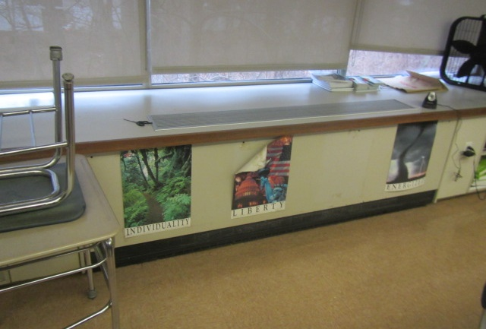

**Univent in classroom**

**Picture 2**

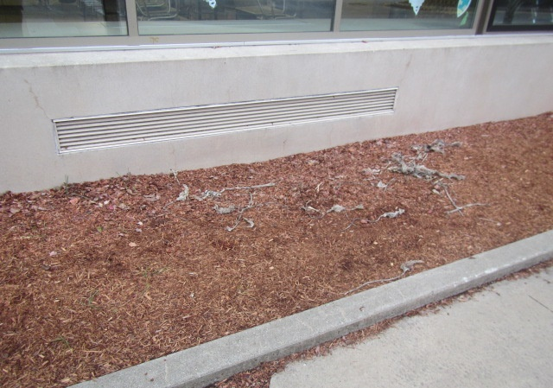

**Univent fresh air intake**

**Picture 3**

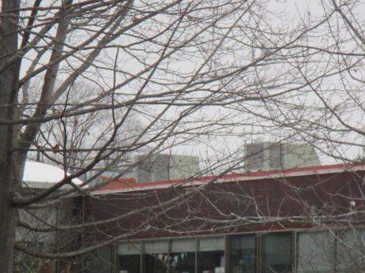

**Examples of rooftop air handling units**

**Picture 4**

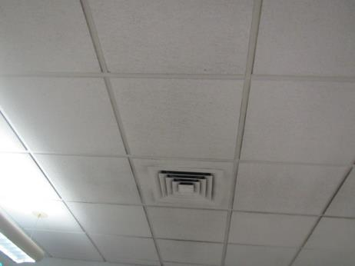

**Ceiling-mounted supply diffuser**

**Picture 5**

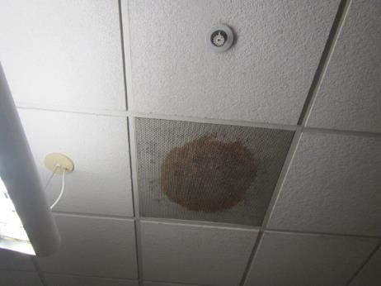

**Ceiling-mounted return vent in classroom, note corrosion/staining**

## Water Damage pictures

**Picture 6**

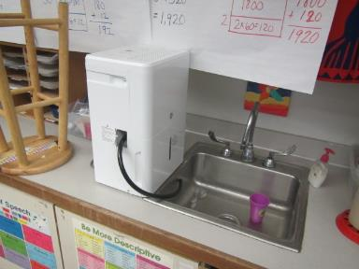

**Dehumidifier stationed on countertop to allow continuous drainage into sink drain**

**Picture 7**

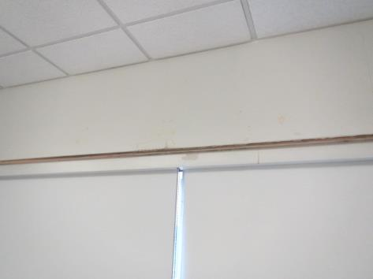

**Water-damaged gypsum wallboard above windows in Room 216**

**Picture 8**

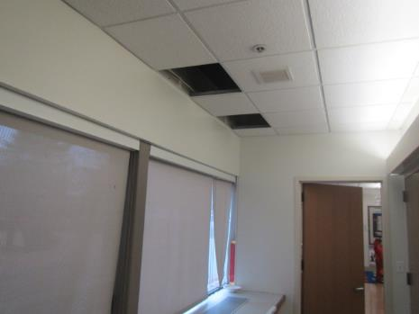

**Areas of water leaks in room 107**

**Picture 9**

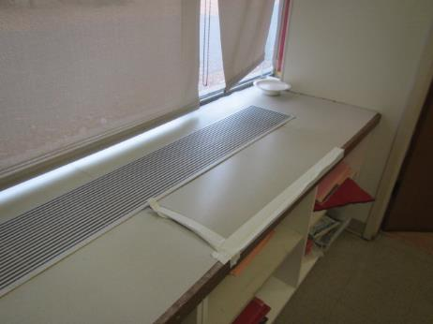

**Water-damaged countertop below water leaks (from 216) in room 107**

**Picture 10**

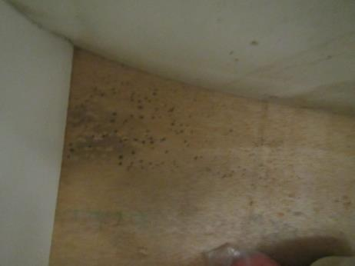

**Small dark spots indicate likely mold on plywood cabinet in Room 107**

**Picture 11**

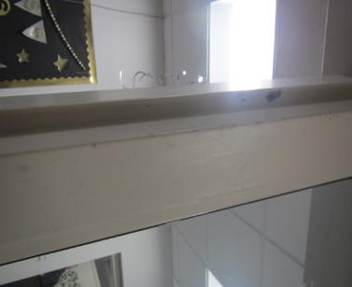

**Mold growth (spotting) on metal door jambs in Guidance Suite**

**Picture 12**

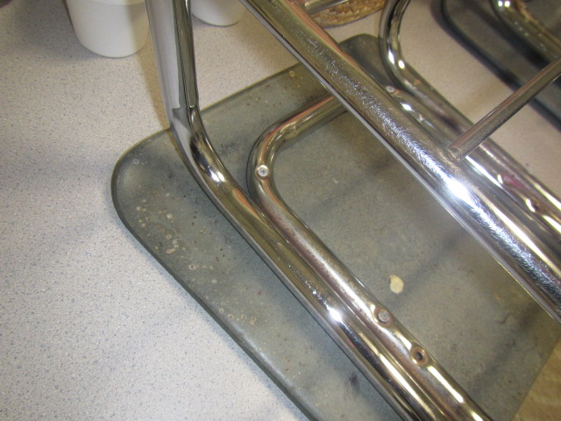

**Spots (likely mold growth) on bottom of chair in Guidance Suite**

Picture 13

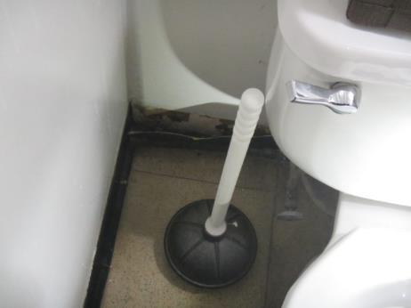

Visible mold observed behind coving in the restroom outside the Media Center

Picture 14

Water-damaged particle board under classroom sink
Note: moisture meter indicating wood was dry at time of assessment


Water-damaged particle board under classroom sink

Note: moisture meter indicating wood was dry at time of assessment

Picture 15

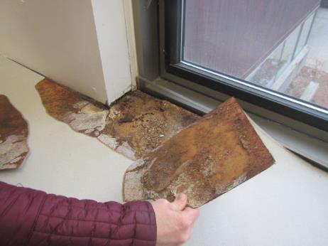

Water-damaged surfaces near windows in Media Center

Picture 16

Water-damaged gypsum wallboard around skylight
Note: light mold growth was noted on the surface around skylight (white arrows) 


Water-damaged gypsum wallboard around skylight

Note: light mold growth was noted on the surface around skylight (arrows)

Picture 17

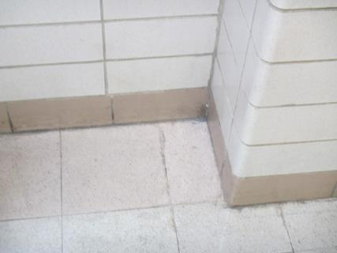

Area of water infiltration in hallway outside of Room 143

Picture 18

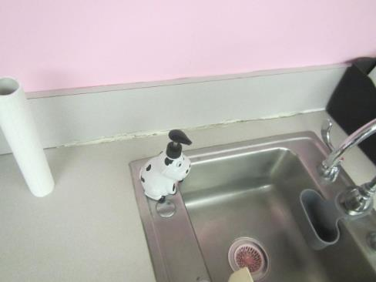

Missing/damaged caulking around classroom sink

Picture 19

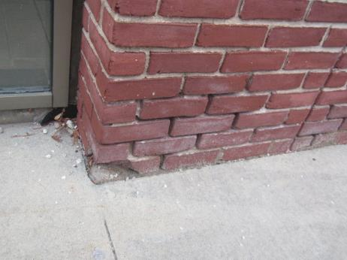

Missing/damaged mortar around exterior brick

Picture 20

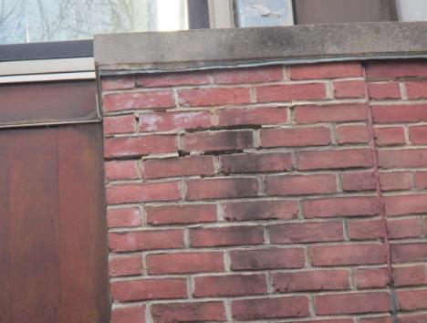

Missing/damaged mortar around exterior brick

Picture 21

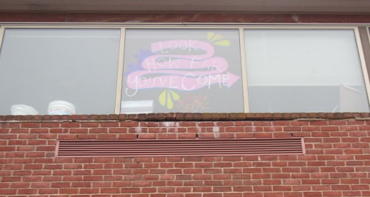

Missing/damaged mortar around exterior brick/below windows, possible source for water infiltration damaging cabinets and other interior building materials

Picture 22

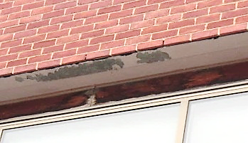

Delaminating paint/stain exposing wood around windows

Picture 23

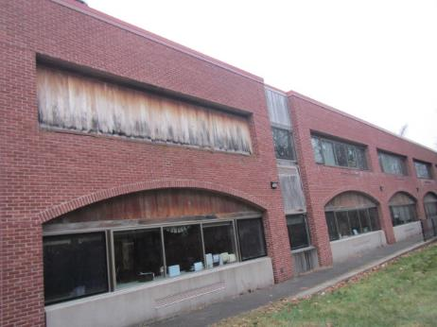

Delaminating paint/stain exposing wood covering windows in original 1969 portion of building

Picture 24

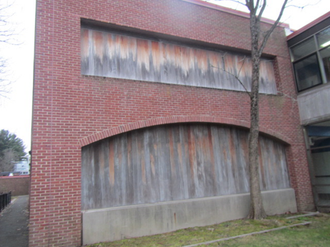

Delaminating paint/stain exposing wood covering windows in original 1969 portion of building, also note close proximity of tree to foundation/exterior wall

Picture 25

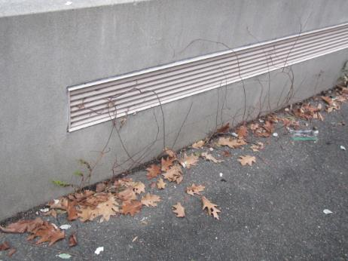

Plant growth along seam of concrete foundation and tarmac

Picture 26

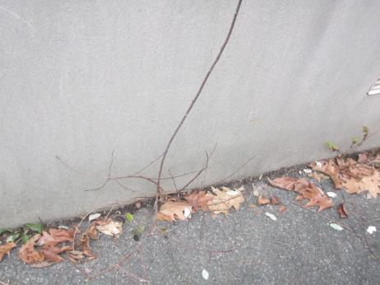

Plant growth along seam of concrete foundation and tarmac

## Respiratory Irritants pictures

**Picture 27**

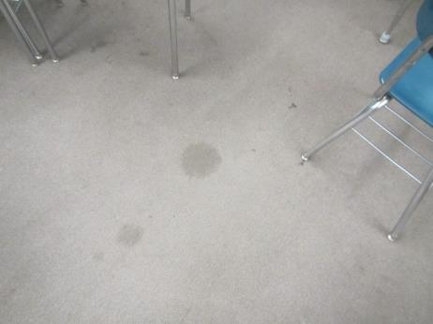

**Old/soiled carpeting in classroom**

**Picture 28**

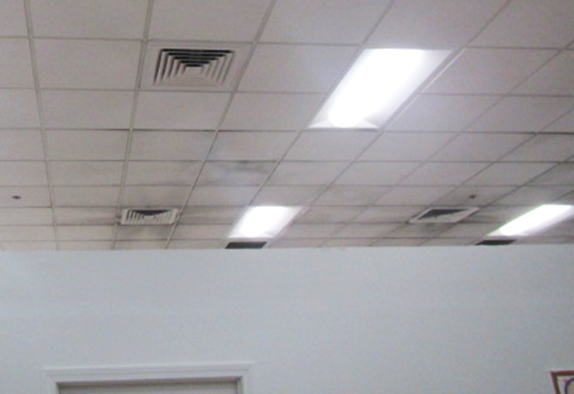

**Accumulated dust and debris on vents and surrounding ceiling tiles**

**Picture 29**

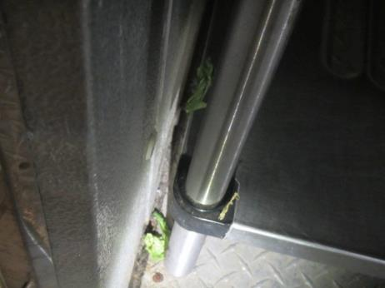

**Food (lettuce) on floor of walk-in refrigerator**

**Picture 30**

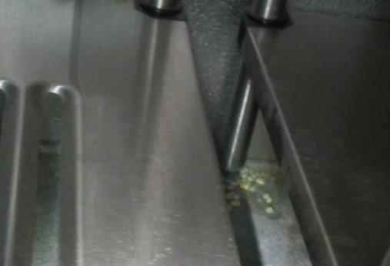

**Food (lettuce) on floor of walk-in refrigerator/freezer**

**Picture 31**

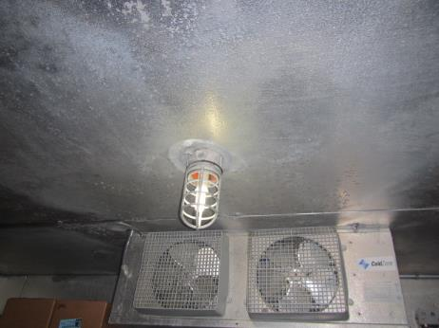

**Condensation on ceiling of walk-in freezer**

**Picture 32**

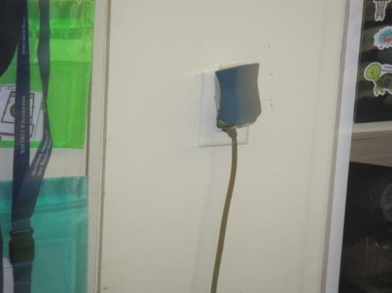

**Plug-in air freshener in classroom**

**Picture 33**

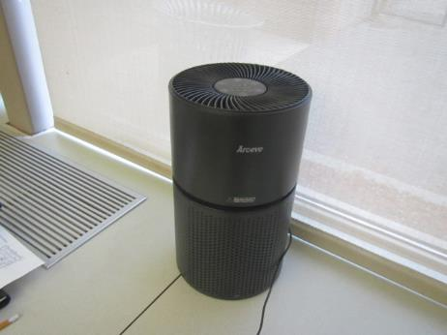

**Air purifier in classroom**

Click to link back to report

# Table 1

| **Location** | **Carbon**  **Dioxide**  **(ppm)** | **Carbon Monoxide**  **(ppm)** | **Temp**  **(°F)** | **Relative**  **Humidity**  **(%)** | **PM2.5**  **(µg/m3)** | **Occupants**  **in Room** | **Windows**  **Openable** | **Ventilation** | | **Remarks** |
| --- | --- | --- | --- | --- | --- | --- | --- | --- | --- | --- |
| **Supply** | **Exhaust** |
| Background (outside) | 471 | ND | 33 | 66 | 1 |  |  |  |  | Cloudy, light snowfall starting |
| 107 | 945 | ND | 68 | 27 | ND | 2 | Y | Y  off | Y | 15 occupants gone ~15 mins, WD cabinets from leak (room 216 above), visible mold spots on wood (back of cabinet) – rec removal |
| Hallway outside Room 107 |  |  |  |  |  |  |  |  |  | Ceiling tile around vent reportedly painted – dry, no visible mold on or above CTs in this area, WD most likely due to condensation around metal vent during summer months (humidity) |
| 118 | 644 | ND | 72 | 20 | ND | 2 | Y | Y | Y | Missing outlet cover, area rug, dust/debris along windows (high-need lift) |
| 124 | 750 | ND | 68 | 24 | ND | 3 | Y | Y  off | Y | WD CT, not carpeted, previous leak from ceiling, mini fridge, plant, dust/debris on UV |
| 126 | 810 | ND | 68 | 25 | ND | 0 | Y | Y  off | Y | Rusty exhaust vent, dust/debris on UV |
| 127 | 823 | ND | 68 | 28 | ND | 0 | Y | Y  off | Y | dust/debris on UV |
| 135 | 792 | ND | 68 | 27 | ND | 0 | Y | Y  off | Y | WD CT, dehumidifier, area carpet, dust/debris on UV |
| 137 | 870 | ND | 72 | 26 | ND | 1 | Y | Y | Y | 7 occupants gone ~5 mins, dust/debris on vents and surrounding CTs |
| 143 | 620 | ND | 74 | 23 | ND | 0 | N | Y | Y | Electrostatic dust on ceiling, reoccurring leak from ceiling, not carpeted, dust/debris on UV |
| 143 Hallway |  |  |  |  |  |  |  |  |  | WD skylight, visible mold on bottom, water infiltration through floor tiles reported (high water table) |
| 205 | 1320 | ND | 68 | 26 | ND | 20 | Y | Y  off | Y | Active leak underneath sink, mold under sink, damaged cabinet, rusty exhaust vent, wall to wall carpet |
| 216 | 710 | ND | 74 | 21 | ND | 1 | Y | Y | Y | WD ceiling/wall from leaks (inspect/remove over vacation) |
| 217 | 539 | ND | 74 | 24 | ND | 0 | Y | Y | Y | Rusty and dusty exhaust vent, WD underneath sink |
| 218 | 560 | ND | 72 | 27 | ND | 0 | N | Y | Y | Damaged particle board underneath sink, rusty exhaust vent |
| 224 | 1312 | ND | 73 | 28 | ND | 1 | Y | Y | Y | 2 WD CTs, plants |
| 229 | 1107 | ND | 72 | 24 | ND | 22 | Y | Y  Off | Y | Dust/debris on vents, area carpet, WD cabinet – dry (no visible mold or odors) |
| 232 | 775 | ND | 71 | 22 | ND | 8 | Y  Open | Y | Y | Wall to wall carpet |
| 234 | 1649 | ND | 72 | 27 | ND | 22 | Y | Y  Off | Y | Wall to wall carpet, PF, plants |
| 235 | 630 | ND | 69 | 21 | ND | 20 | Y  Open | Y | Y | Wall to wall carpet, dust/debris on vents |
| 237 | 673 | ND | 67 | 27 | ND | 0 | Y | Y  Off | Y  Off | Supply and exhaust off |
| 239 | 1299 | ND | 73 | 28 | ND | 21 | Y | Y | Y | Wall to wall carpet, dust/debris on vents, PF |
| 241 | 997 | ND | 71 | 25 | ND | 23 | Y  Open | Y | Y | Hole in CT, dust/debris on vents, exhaust vent not operating |
| 245 | 1060 | ND | 69 | 27 | ND | 22 | Y | Y | Y | Dusty UV |
| 247 | 1879 | ND | 69 | 26 | ND | 24 | Y | Y  off | Y  off | Air freshener, PF, dust along windowsill, wall to wall carpet, area carpet, supply and exhaust off |
| Cafeteria | 517 | ND | 69 | 20 | ND | 0 | Y | Y | Y |  |
| Guidance | 722 | ND | 70 | 21 | ND | 0 | N | Y | Y | Visible mold on metal door jambs and bottom of chair (rec AC adjustment, closing doors, and dehumidifiers over summer) |
| Kitchen |  |  |  |  |  | 0 |  |  |  | Food/debris along floor of refrigerator and freezer, condensation/ice formation on ceiling of freezer |
| Media Center | 900 | ND | 65 | 28 | ND | 24 | N | Y | Y | WD on carpet, WD cabinet underneath particle board counter, wall to wall carpet |
| Restroom (outside media center) |  |  |  |  |  |  |  |  |  | Visible mold under coving along floor behind toilet |

(Click to link back to report)

# Table 2A

|  |  |  |  |  |  |
| --- | --- | --- | --- | --- | --- |
| **Equipment Present in Building**  **(X = Yes)** | **Type of Heating/Cooling Ventilation**  **Equipment** | **Fresh**  **Air**  **Supply**  **(X = Yes)** | **Type of Location(s)** | **Air Filters Installed**  **MERV Rating**  **(1-15, U*)**  **(X = Yes)** | **Comments** |
| X | Univents | X | Classrooms | X, U |  |
| X | Rooftop Air Handling Units | X | Various rooms & common areas | U |  |
|  | Outdoor, Ground-Installed Air Handling Units |  |  |  |  |
|  | Attic/Crawlspace Air Handling Units |  |  |  |  |
|  | Ceiling-Mounted Air Handling Units (including inside plenum) |  |  |  |  |
|  | Basement/Crawlspace-Installed Air Handling Units |  |  |  |  |
|  | Mechanical Room-installed Air Handling Units |  |  |  |  |
|  | Fan Coil Units |  |  |  |  |
|  | Window-Mounted Air Conditioners |  |  |  |  |
|  | Portable air conditioners |  |  |  |  |
|  | Wall Louver-Controlled Gravity Air Supply |  |  |  |  |
| X | Windows | X | Most rooms |  |  |
|  | Fan in window (blowing in) |  |  |  |  |
|  | Built in wall fan (switched) |  |  |  |  |
|  | Heat recovery ventilator unit |  |  |  |  |
|  | Energy recovery ventilator unit |  |  |  |  |
|  | Chilled Beam |  |  |  |  |
|  | Passive combustion supply vent in basement/boiler room |  |  |  |  |

*U = Filter Rating underdetermined due to inaccessibility during building visit

# Table 2B

|  |  |  |  |  |
| --- | --- | --- | --- | --- |
| **Equipment Present in Building**  **(X = Yes)** | **Type of Exhaust Ventilation**  **Equipment** | **Ducted**  **To Outdoors**  **(X = Yes)** | **Type of Location(s)** | **Comments** |
| X | Rooftop Motors/Fans | X | Classrooms and common areas | Not functioning |
|  | Unit Exhaust |  |  |  |
|  | Ceiling Return Vent |  |  |  |
|  | Ceiling Return Vent, Plenum |  |  |  |
|  | Wall Return Vent |  |  |  |
|  | Kitchen Stove Hood |  |  |  |
| X | Restroom Exhaust Vent | X |  |  |
|  | Photocopier Exhaust Vent |  |  |  |
|  | Garage |  |  |  |
|  | Chemical Hood(s) |  |  |  |
|  | Locker Rooms |  |  |  |
|  | Showers |  |  |  |
|  | Clothes Dryers |  |  |  |
|  | Gas Water Heaters |  |  |  |
|  | Furnace-Flue to Chimney |  |  |  |
|  | Furnace/Boiler direct vent or power vent (no combustion air supply) |  |  |  |
|  | Kiln, Pottery |  |  |  |
|  | Dark Room |  |  |  |
|  | Generator Room |  |  |  |
|  | Wood Shop Dust Collector |  |  |  |
|  | Spray Paint Booths |  |  |  |
|  | Fan in window (blowing out) |  |  |  |

# Table 2C

|  |  |  |  |
| --- | --- | --- | --- |
| **Equipment Present in Building**  **(X = Yes)** | **Type of Equipment** | **Type of Location(s)** | **Comments** |
|  | Floor Fans, pedestal |  |  |
| X | Floor Fans, portable | Classrooms, offices |  |
| X | Air Purifier (HEPA, other) | Classrooms, offices |  |
|  | Floor heaters, portable |  |  |
| X | Refrigerators, Cold Beverage Vending Machines |  |  |
|  | Radiator, wall-mounted |  |  |
|  | Radiator, floor-mounted |  |  |
|  | Passive Vents (Wall/Door) |  |  |

(Click to link back to report)

# Table 3

| **Found in Building**  **X = Yes** | **Water-Damaged Materials, Building Components or Stored Materials** | **Location** | **Visible Microbial Growth?**  **X = Yes** | **Musty odor detected?**  **X = Yes** | **Comments** |
| --- | --- | --- | --- | --- | --- |
|  | Books-other bound materials |  |  |  |  |
| X | Brick walls – broken, missing mortar | Exterior |  |  |  |
|  | Brick walls – blocked weep holes |  |  |  |  |
|  | Cardboard boxes |  |  |  |  |
|  | Carpet tiles |  |  |  |  |
| X | Carpet - Area rugs | Various classrooms & rooms |  |  |  |
| X | Carpet wall-to-wall | Various classrooms & rooms |  |  | Media center displayed water damage |
|  | Ceiling tiles - affixed directly to ceiling surface |  |  |  |  |
|  | Ceiling tiles - bowing-in suspended ceiling |  |  |  |  |
|  | Ceiling tiles - water-stained in splined ceiling |  |  |  |  |
| X | Ceiling tiles - water-stained in suspended ceiling | Classrooms and hallways |  |  |  |
| X | Chairs - laminated | Guidance Suite | X |  | Bottom of chair |
|  | Cloth |  |  |  |  |
|  | Countertops (around sinks) |  |  |  |  |
| X | Curtains | Gym |  | X |  |
|  | Dust/debris within AHU, uninvent, HVAC, chilled beam units, etc. (WD through condensation, humidity, or leaks) |  |  |  |  |
|  | Efflorescence (i.e., mineral deposits) |  |  |  |  |
| X | Engineered woods - particleboard, plywood, Masonite | Classrooms and Media Center | X |  | Many water-damaged areas under sinks in classroom, cabinets |
|  | Flooring – loosened tiles |  |  |  |  |
|  | Flooring - wooden |  |  |  |  |
|  | Furniture - laminated |  |  |  |  |
|  | Furniture - upholstered |  |  |  |  |
| X | Gypsum wallboard - ceiling | Skylight | X |  |  |
| X | Gypsum wallboard - restroom wall | Near Media Center | X |  |  |
|  | Gypsum wallboard - interior wall |  |  |  |  |
|  | Gypsum wallboard – located on exterior wall |  |  |  |  |
|  | HVAC drain pan – lack of draining |  |  |  |  |
|  | HVAC filters |  |  |  |  |
|  | Insulation- attic (paper-backed) |  |  |  |  |
|  | Insulation - inside air handling unit |  |  |  |  |
|  | Insulation - on pipe(s) fiberglass |  |  |  |  |
|  | Insulation - on pipe(s) other/plaster-like material |  |  |  |  |
|  | Insulation - wall cavity |  |  |  |  |
|  | Insulation – ceiling plenum |  |  |  |  |
|  | Modular furniture – walls/cloth partitions |  |  |  |  |
|  | Musical instrument cases |  |  |  |  |
|  | Plaster ceilings |  |  |  |  |
|  | Records/files |  |  |  |  |
|  | Refrigerator - door gasket |  |  |  |  |
|  | Refrigerator - drip pan |  |  |  |  |
|  | Refrigerator - Interior surfaces |  |  |  |  |
|  | Room divider - ceiling-mounted, sliding |  |  |  |  |
| X | Sink backsplash | Classroom |  |  | Damaged caulking |
|  | Tables – laminated |  |  |  |  |
|  | Wallpaper |  |  |  |  |
|  | Wood - attic/roof materials |  |  |  |  |
|  | Wood - floor joists in basement ceiling |  |  |  |  |
|  | Wood - wall framing |  |  |  |  |
|  | Wood - window sills |  |  |  |  |
|  | Wood - window-mounted air conditioner framing |  |  |  |  |
| X | OTHER | Exterior trim |  |  | Delaminating |

WHAT ARE ENVIRONMENTAL ASTHMA TRIGGERS?

Asthma triggers are any chemical, pollutant, or allergen that can make your asthma worse. Asthma triggers can also be strong chemical smells, dust, or pets. Your asthma triggers may be different from those of other people. Not all asthma triggers affect people the same way. Environmental asthma triggers are found both indoors and outdoors. DPH link: [Asthma and Your Environment (mass.gov)](https://www.mass.gov/doc/asthma-and-your-environment-english/download)

(click to link back to report)

# Table 4

| **Condition Present**  **X = Yes** | **Possible asthma symptom-inducing environmental pollutant** | **Recommendation to reduce or eliminate the pollutant** |
| --- | --- | --- |
| X | Water Damage and/or Mold  (allergen) | Identify water source and repair to eliminate.  Clean non-porous materials.  Remove and replace porous materials susceptible to mold growth.  Perform regular water damage assessments as a tool to ensure timely mitigation as needed.  Use NIOSH water damage assessment protocol as a guide: [NIOSH water damage assessment guideline](https://www.cdc.gov/niosh/docs/2019-115/pdfs/2019-115.pdf?id=10.26616/NIOSHPUB2019115&inf_contact_key=241b5c2ed98c27d94b530dedc36f1623f651f238aa2edbb9c8b7cff03e0b16a0). |
|  | Moistening of building components during hot, humid weather (>2 days in length) (mold, allergen) | Remove materials not dried in <2 days in a manner consistent with [US EPA Mold Removal in Commercial Buildings guideline](https://www.epa.gov/mold/pdf-version-checklist-mold-remediation-mold-remediation-schools-and-commercial-buildings).  Use dehumidification in occupied basement areas and other areas with chronic dampness. |
| X | Vegetation against exterior of building (water damage-mold) | Remove all vegetation preventing building exterior drying.  Remove all vegetation capable of falling onto a building or depositing debris onto the roof. |
|  | Personal humidifiers (lack of proper maintenance)  (pollutant and allergen) | Clean and maintain properly.  Use distilled water to eliminate metal and water treatment odors.  Maintain hydration by increasing water consumption. |
|  | Drains: Floor drains, Sink drains (abandoned use)  Water bubblers (abandoned use) | If in use, pour water into drain at least twice a week.  If not in use, seal the drain with an appropriate material in accordance with Massachusetts Plumbing Code (248 CMR 10.00). |
|  | Live Animals (turtles, gerbils, birds, rabbits, etc.) | Ensure cleanliness or remove animals from the location. |
|  | Improperly maintained aquariums and terrariums (allergen) | Maintain such equipment properly to eliminate odor.  Discontinue use. |
| X | Plants and flowers  (allergen and mold) | Keep indoor plants well maintained and not overwatered. Monitor for signs of mold and pests.  Ensure water for cut flowers does not become stagnant.  Ensure dried plant material is free of odors, mold, and pests and handled carefully  If asthma risks are high, eliminate plants and flowers. |
| X | HVAC system moisture issues  (mold, allergen) | Consult ASHRAE’s minimum standards for HVAC maintenance and inspection of commercial HVAC systems (<https://www.ashrae.org/technical-resources/bookstore/standards-180-and-211>). |
|  | HVAC system contaminant issues (allergen) | Consult ASHRAE’s minimum standards for HVAC maintenance and inspection of commercial HVAC systems (<https://www.ashrae.org/technical-resources/bookstore/standards-180-and-211>). |
|  | Indoor swimming pool odors outside of swimming pool (mold, chemical) | Maintain and operate pool HVAC systems to vent odors from building.  Ensure locker room exhaust vents are operating during building hours.  All doors leading to pool should be rendered airtight and be closed. |
| X | Pollen (allergen) | Recommend installation of MERV 8 or better filters if HVAC engineer confirms HVAC system can be so equipped without adversely affecting function.  Cut grass after hours.  Cut grass in a pattern to direct clippings away from exterior wall.  Remove trees and shrubs from in front of windows and air intakes. |
|  | Dry air | Maintain hydration.  Avoid overheating of air. |
|  | Dust mites  (allergen) | Recommendation to remove non-official upholstered furniture, area rugs, pillows, cushions, etc.  Cleaning with use of HEPA-filtered vacuum cleaner.  Eliminating clutter, storing items in dust and moisture-proof containers, and regularly removing dust through wet wiping. |
|  | Pests, including rodents and cockroaches  (allergen) | Use of integrated pest management guidelines, including:   * Proper disposal of food containers * Proper storage of food products in airtight containers * Elimination of use of food as art projects * Remove pest harborages/clutter * Regular monitoring for pests   [EPA IPM guideline link](https://www.epa.gov/ipm/introduction-integrated-pest-management) |
|  | Latex-containing materials | Remove tennis balls from furniture legs. |
|  | Fragrances  (chemical) | Eliminate point sources, such as:   * Plug-in air fresheners * Aroma/oil reed diffusers * Scented sprays * Discontinue use of other scented materials * Consult DPH fragrance guideline: [*Clean air is odor-free*](https://www.mass.gov/doc/clean-air-is-odor-free-removing-fragrances-to-improve-indoor-air-quality-in-schools-and-0/download) |
|  | Strong smells from /use of Chemicals (such as cleaning products)  (chemical) | Use building-issued cleaning products.  Use products in accordance with manufacturer’s instructions including dilution, application, and ventilation.  Avoid using products that are stronger than needed for the situation. |
|  | Strong odors from new building materials (carpeting/furniture)  (chemical) | Use low VOC-emitting materials.  Air out materials (outside or in unoccupied area) prior to installation. |
|  | Tobacco smoke  Secondhand Smoke  (pollutant) | Eliminate tobacco smoking.  Seal all shared wall penetrations. |
|  | Products with a strong odor such as paint, perfume, hairspray, air fresheners, bug-spray, laminators, candles, wax melters, dry erase markers and other VOC-containing products  (chemical) | If essential:   * Provide proper exhaust ventilation to eject aerosolized product directly outdoors. * Avoid/reduce use during occupied hours.   If not necessary, remove and eliminate. |
|  | Vehicle exhaust  (pollutant) | Enforce anti-idling regulations and post signs to give notice.  Relocate vehicles away from fresh air intakes.  Require cars to park face-in at building walls.  [MA anti-idling law FAQs](https://www.mass.gov/files/documents/2018/02/20/idling-faq.pdf#:~:text=The%20Massachusetts%20Anti-Idling%20Law%20The%20goal%20of%20the,sometime%20wonder%20when%20idling%20might%20be%20considered%20necessary.) |
|  | Vapors and or fumes from gas, oil, or kerosene stoves  (pollutant) | Operate stove hood when stove in use.  Install stove hood if not present.  Ensure equipment is in good working order. |
|  | Ozone (pollutant) | Eliminate use of ozone generating equipment. |
|  | Window Air Conditioners (if not properly maintained) (allergen) | Equip with proper filter and clean periodically.  Clean drip pans.  Install in window with weathertight, non-mold-growth sustaining material. |
|  | Pottery (pollutant) | Do not operate kiln during occupied hours.  Operate kiln with exhaust system activated.  Seal all seams and holes in kiln vent.  Ensure kiln exhaust discharge terminates outdoors. |
| X | Carpeting (allergen) | Clean carpeting in a manner consistent with IICRC standards, including regular vacuuming with a high efficiency particulate air (HEPA) filtered vacuum in combination with annual cleaning or semi-annual cleaning in soiled high traffic areas. |
|  | Sweeping/dusting vs HEPA vacuuming/wet wiping  (allergen or pollutant) | Refrain from using feather dusters or brooms.  Utilize HEPA vacuums and wet wiping to minimize aerosolizing particulate matter. |
| X | Lack of adequate air exchange/mechanical ventilation | Make repairs as necessary and ensure all HVAC system components are operating continuously when building is occupied. |
|  | Lack of local exhaust at source of pollution (vocational shop activities, kitchen exhaust hood) (all) | Recommend installation of exhaust ventilation to direct pollutants directly outdoors. |
|  | Renovating buildings while occupied  (chemical) | Use all SMACNA guidelines for Renovation While Buildings Are Occupied. For information, visit <https://www.mass.gov/service-details/construction-and-renovation-generated-pollutants-in-occupied-buildings>. |
|  | Chemistry program chemical storage  (chemical) | Repair (if needed) and operate chemical storeroom vents appropriately.  Reduce or eliminate unneeded or overstocked chemicals.  Store all chemicals in a manner to separate incompatible chemicals.  Keep chemical storerooms clean. |
| X | Photocopiers/duplicating machines | All machines should have dedicated exhaust vents. |