INDOOR AIR QUALITY ASSESSMENT

Marshfield Town Hall
Selectmen’s Area/Hearing Rooms
870 Moraine Street
Marshfield, Massachusetts

Prepared by:
Massachusetts Department of Public Health
Bureau of Environmental Health
Indoor Air Quality Program
December 2017

Background
Building: | Marshfield Town Hall (MTH)
Address: | 870 Moraine Street
Assessment Requested by: | Peter Fallabella, Director of Public Health
Reason for Request: | General indoor air quality (IAQ)
Date of Assessment: | December 7, 2017
Massachusetts Department of Public Health/Bureau of Environmental Health (MDPH/BEH) Staff Conducting Assessment: | Cory Holmes, Environmental Analyst/Inspector, IAQ Program
Building Description: | The MTH is a two-story building that was completed in 1970; the building contains municipal offices and meeting rooms. The assessment was limited to the Selectmen’s area/hearing rooms. Building components consist of office space/open work areas with tile flooring, cinderblock and gypsum wallboard walls with dropped ceilings.
Windows: | Windows are openable in the space.

Methods
Please refer to the IAQ Manual and appendices for methods, sampling procedures, and interpretation of results (MDPH, 2015).

Results and Discussion
The following is a summary of indoor air testing results (Table 1).
- Carbon dioxide measurements were below the MDPH recommended level of 800 parts per million (ppm) in all areas surveyed, indicating adequate exchange in the spaces tested.
- Temperature was within or slightly below the MDPH recommended range of 70°F to 78°F in areas tested at the time of assessment.
- Relative humidity was below the MDPH recommended range of 40 to 60% in all areas tested and reflective of outdoor (dry) conditions.
- Carbon monoxide levels were non-detectable in all areas tested.
- Particulate matter (PM2.5) concentrations measured were below the National Ambient Air Quality (NAAQS) level of 35 μg/m³ in all areas tested.

Ventilation
A heating, ventilating and air-conditioning (HVAC) system has several functions. First it provides heating and, if equipped, cooling. Second, it is a source of fresh air. Finally, an HVAC system will dilute and remove normally-occurring indoor environmental pollutants by not only introducing fresh air, but also filtering the airstream and ejecting stale air to the outdoors via exhaust ventilation. The areas tested had no means of mechanical exhaust ventilation.
Mechanical ventilation in the areas tested is provided by a combination of unit ventilators (univents; Picture 1) and central HVAC from an air handling unit (AHU) located in the attic (Picture 2). Univents at the MTH draw air from the outdoors through a fresh air intake located on the exterior wall of the building (Picture 3) and return air through an air intake located at the base of the unit. Fresh and return air are mixed, filtered, heated or cooled and provided to rooms through an air diffuser located in the top of the unit (Figure 1). In a few cases, items were on top of univents (Picture 4), which can block air circulation, and, if heated can give off odors.
It is important to note that relative humidity levels in the building would be expected to be low during the winter months due to atmospheric conditions and heating. Low relative humidity can lead to common symptoms such as: dry skin, lips, and scalp; dry/scratchy throats and noses (nose bleeds); exacerbation of asthma, eczema, or allergies; dry/irritated eyes; and irritation of respiratory tract. This may account for some of the general IAQ symptoms described by building occupants.

Microbial/Moisture Concerns
In order for building materials to support mold growth, a source of water exposure is necessary. Historic water leaks in several places in the main hallway were reported due to HVAC issues. No current leaks or related water damage were observed during this assessment.
Plants were observed in a few areas, including one in standing water (Picture 5). Plants can be a source of pollen and mold, which can be respiratory irritants to some individuals. Plants should be properly maintained and equipped with drip pans and should be located away from air diffusers to prevent the aerosolization of dirt, pollen, and mold. Water should be changed regularly to avoid becoming stagnant and source of odors.

Other Conditions
In a number of areas, items were observed on the floor, windowsills, tabletops, counters, bookcases and desks (Pictures 4 through 7). The large number of items stored provides a source for dusts to accumulate. These items (e.g., papers, folders, boxes) make it difficult for custodial staff to clean. Items should be relocated and/or be cleaned periodically to avoid excessive dust build up. In addition, dust can accumulate on flat surfaces in occupied areas and subsequently be re-aerosolized causing further irritation.
Several ceiling-mounted vents and flat surfaces were observed to have accumulated dust/debris (Picture 8). Operation of HVAC equipment can re-aerosolize accumulated dust particles providing a source of eye and respiratory irritation.
Finally, filters examined appeared to be a medium efficiency MERV 7 type (Pictures 9 through 11). The MDPH recommends using pleated filters in AHUs with a Minimum Efficiency Reporting Value (MERV) of 8 or higher, which are adequate in filtering out pollen and mold spores (ASHRAE, 2012).

Conclusions and Recommendations
In view of the findings at the time of the visit, the following recommendations are made:
- Remove obstructions from in front of/on top of univents for proper operation.
- Continue to change univent and AHU filters 2 to 4 times per year, preferably using MERV 8 filters, which are adequate to filter out pollen and mold spores (ASHRAE, 2012).
- Have the HVAC system re-balanced, as recommended (every 5 years) in accordance with SMACNA recommendations (SMACNA, 1994).
- Continue to monitor for leaks, make repairs and replace water-damaged ceiling tiles as necessary.
- For buildings in New England, periods of low relative humidity during the winter are often unavoidable. Therefore, scrupulous cleaning practices should be adopted to minimize common indoor air contaminants whose irritant effects can be enhanced when the relative humidity is low. To control for dusts, a high efficiency particulate arrestance (HEPA) filter-equipped vacuum cleaner in conjunction with wet wiping of all surfaces is recommended. Avoid the use of feather dusters. Drinking water during the day can help ease some symptoms associated with a dry environment (throat and sinus irritation).
- Keep plants in good condition, avoid overwatering, and remove from the airstream of heating and ventilation equipment.
- Consider reducing the amount of stored materials to allow for more thorough cleaning. Clean items regularly with a wet cloth or sponge to prevent excessive dust build-up.
- Clean ceiling-mounted vents/grills periodically of accumulated dust. Use a vacuum/brush attachment or remove for soaking/cleaning as necessary.
- Consider creating a log book for staff to submit specific cleaning/maintenance requests. Make log book available for staff/management in a central location. Cleaning/Maintenance requests should include date, requester, a detailed description of where and what the issue is as well as a section for cleaning/maintenance personnel to sign off or document progress of request.
- Refer to resource manual and other related IAQ documents located on the MDPH’s website for further building-wide evaluations and advice on maintaining public buildings. These documents are available at http://mass.gov/dph/iaq.

References
ASHRAE. 2012. American Society of Heating, Refrigeration and Air Conditioning Engineers (ASHRAE) Standard 52.2-2012 -- Method of Testing General Ventilation Air-Cleaning Devices for Removal Efficiency by Particle Size (ANSI Approved). 2012.
MDPH. 2015. Massachusetts Department of Public Health. Massachusetts Department of Public Health Indoor Air Quality Manual: Chapters I-III. Available at: http://www.mass.gov/eohhs/gov/departments/dph/programs/environmental-health/exposure-topics/iaq/iaq-manual/.
SMACNA. 1994. HVAC Systems Commissioning Manual. 1st ed. Sheet Metal and Air Conditioning Contractors’ National Association, Inc., Chantilly, VA.
Picture 1
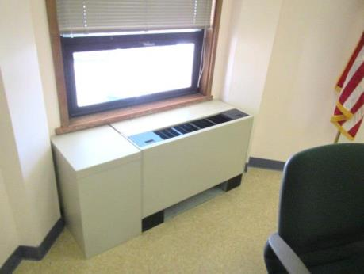
Unit ventilator (univent)
Picture 2
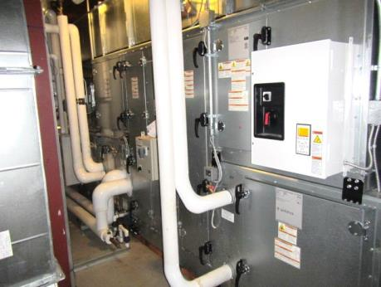
Air handling unit (AHU) located in attic
Picture 3
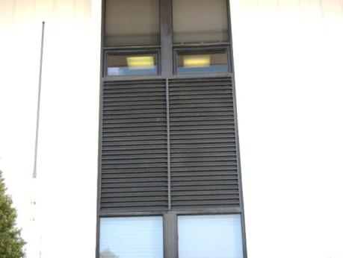
Fresh air intake
Picture 4
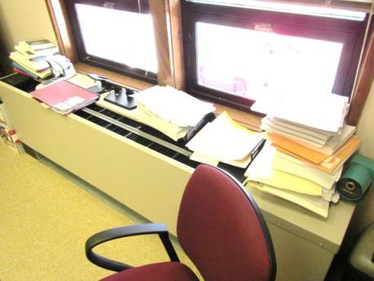
Items on univent
Picture 5
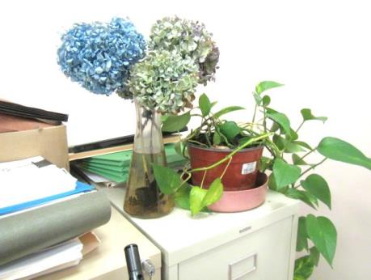
Plant in standing water
Picture 6
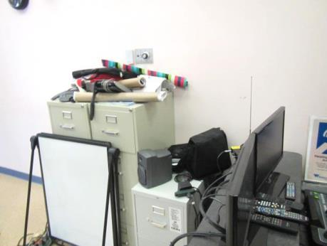
Items on flat surfaces
Picture 7
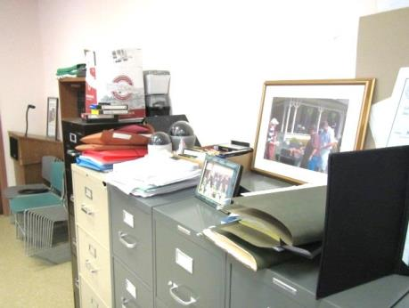
Items on flat surfaces
Picture 8
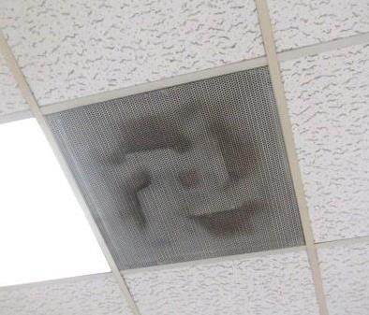
Accumulated dust/debris on ceiling vent
Picture 9
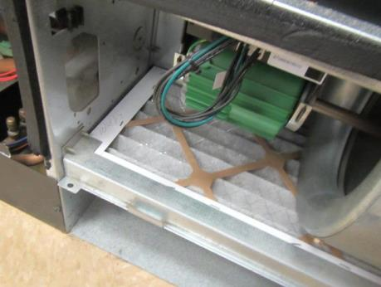
Pleated filters in univent
Picture 10
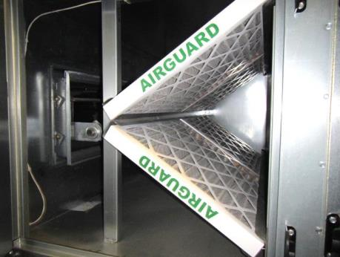
Pleated filters in AHU
Picture 11
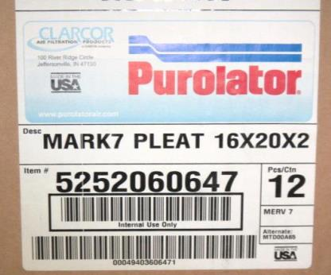
Label on box of filters indicating MERV rating of 7 (arrow)

Location | Carbon  Dioxide  (ppm) | Carbon Monoxide  (ppm) | Temp  (°F) | Relative  Humidity  (%) | PM2.5  (µg/m³) | Occupants  in Room | Windows  Openable | Ventilation |  | Remarks
 |  |  |  |  |  |  |  | Supply | Exhaust
Background | 430 | ND | 50 | 28 | 9 |  |  |  |  | Clear, sunny
Linsky Hearing Room | 502 | ND | 67 | 23 | 6 | 1 | Y | Y | Y | 3 univents, dust/debris on ceiling vents, accumulated items on flat surfaces
Selectmen’s Office Area | 645 | ND | 72 | 23 | 5 | 3 | Y | Y | N | Plants-standing water, accumulated items on flat surfaces, items on univent
Hearing Room 2 | 514 | ND | 75 | 15 | 6 | 0 | Y | Y | Y | Dust/debris on vents
Main 2nd Floor Hallway | 554 | ND | 75 | 18 | 9 | 3 | N | Y | Y | Dust/debris on vents

