INDOOR AIR QUALITY ASSESSMENT
Marshfield Town Hall
870 Moraine Street
Marshfield, Massachusetts
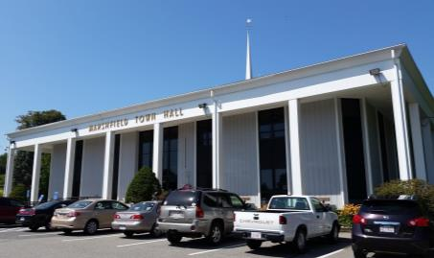
Prepared by:
Massachusetts Department of Public Health
Bureau of Environmental Health
Indoor Air Quality Program
May 2017

Background
Building: | Marshfield Town Hall (MTH)
Address: | 870 Moraine Street
Assessment Requested by: | Peter Fallabella, Director of Public Health
Reason for Request: | General indoor air quality (IAQ)
Date of Assessment: | April 24, 2017
Massachusetts Department of Public Health/Bureau of Environmental Health (MDPH/BEH) Staff Conducting Assessment: | Cory Holmes, Environmental Analyst/Inspector, IAQ Program
Building Description: | The MTH is a two-story building that was completed in 1970; the building contains municipal offices and meeting rooms. The assessment was limited to the Treasurers, Collectors and Clerks areas. Building components in these areas consist of enclosed offices and open work areas with wall-to-wall carpeting, gypsum wallboard and dropped ceilings.
Windows: | Windows are openable in the space.

Methods
Please refer to the IAQ Manual and appendices for methods, sampling procedures, and interpretation of results (MDPH, 2015).

Results and Discussion
The following is a summary of indoor air testing results (Table 1).
- Carbon dioxide measurements were below the MDPH recommended level of 800 parts per million (ppm) in all areas surveyed, indicating adequate exchange in the spaces tested.
- Temperature was within the MDPH recommended range of 70°F to 78°F in areas tested at the time of assessment.
- Relative humidity was within or slightly below the MDPH recommended range of 40 to 60% in all areas tested.
- Carbon monoxide levels were non-detectable in all areas tested.
- Particulate matter (PM2.5) concentrations measured were below the National Ambient Air Quality (NAAQS) level of 35 μg/m³ in all areas tested.

Ventilation
A heating, ventilating and air-conditioning (HVAC) system has several functions. First it provides heating and, if equipped, cooling. Second, it is a source of fresh air. Finally, an HVAC system will dilute and remove normally occurring indoor environmental pollutants by not only introducing fresh air, but also filtering the airstream and ejecting stale air to the outdoors via exhaust ventilation. The areas tested had no means of mechanical exhaust ventilation.
Mechanical ventilation in the areas tested is provided by fan coil units (FCUs; Picture 1). FCUs at the MTH draw air from the outdoors through a fresh air intake located on the exterior wall of the building (Picture 2) and returns air through an air intake located at the base of the unit. Fresh and return air are mixed, filtered, heated or cooled and provided to rooms through an air diffuser located in the top of the unit (Figure 1). In a few cases FCUs were obstructed on top as well as in front of the units (Pictures 3 and 4), which can impede airflow, effect temperature control and over a period of time, damage equipment.
It is important to note that relative humidity levels in the building would be expected to be low during the winter months due to atmospheric conditions and heating. Low relative humidity can lead to common symptoms such as: dry skin, lips, and scalp; dry/scratchy throats and noses (nose bleeds); exacerbation of asthma, eczema, or allergies; dry/irritated eyes; and irritation of respiratory tract. This may account for some of the general IAQ symptoms described among building occupants.

Microbial/Moisture Concerns
In order for building materials to support mold growth, a source of water exposure is necessary. Water-damaged ceiling tiles were seen in several areas (Table 1; Pictures 5 and 6). Water-damaged ceiling tiles indicate leaks from either the roof or plumbing system and can provide a source for mold growth. These tiles should be replaced after a water leak is discovered and repaired. It was reported that the damaged tiles in the Clerk’s office were from a heating system leak that has been repaired. At the time of the assessment, IAQ Program staff noted exposed insulation material and loose debris above the ceiling tiles and recommended in a letter (MDPH, 2017) that it be tested by a licensed inspector for possible asbestos containing materials (ACM). Marshfield Town officials contacted Vertex, an environmental consulting firm, who tested/confirmed that the material is non ACM (Vertex, 2017).
Plants were observed in a few areas, including on top of FCUs (Picture 4; Table 1). Plants can be a source of pollen and mold, which can be respiratory irritants to some individuals. Plants should be properly maintained and equipped with drip pans and should be located away from air diffusers to prevent the aerosolization of dirt, pollen, and mold.
The space contains wall to wall carpeting. It appears that the FCUs were installed at a later date over the carpeting, which could create musty odors/mold growth conditions if components from the cooling system (i.e., uninsulated pipes, condensate pumps) leak or drip condensation (Picture 7).

Other Conditions
In a number of areas, items were observed on the floor, windowsills, tabletops, counters, bookcases and desks. The large number of items stored provides a source for dusts to accumulate. These items (e.g., papers, folders, boxes) make it difficult for custodial staff to clean. Items should be relocated and/or be cleaned periodically to avoid excessive dust build up. In addition, dust can accumulate on flat surfaces (e.g., desktops, windowsills and carpets) in occupied areas and subsequently be re-aerosolized causing further irritation.
Several portable fans and flat surfaces throughout the offices were observed to have accumulated dust/debris. Operation of this equipment can re-aerosolize accumulated dust particles providing a source of eye and respiratory irritation.
As mentioned, the areas assessed contain wall to wall carpeting. The Institute of Inspection, Cleaning, and Restoration Certification (IICRC), recommends that carpeting be cleaned annually, or semi-annually in high-traffic areas (IICRC, 2012). MTH staff reported that a regular carpet cleaning program was not in place.
Finally, several areas were missing light covers (Table 1; Picture 8). Modern fluorescent bulbs contain mercury, which can be released if they are accidentally broken.

Conclusions and Recommendations
In view of the findings at the time of the visit, the following recommendations are made:
- Remove obstructions from in front of/on top of FCUs for proper operation.
- Continue to change FCU filters 2 to 4 times per year, preferably using MERV 8 filters, which are adequate to filter out pollen and mold spores (ASHRAE, 2012).
- Have the HVAC system re-balanced, as recommended (every 5 years) in accordance with SMACNA recommendations (SMACNA, 1994).
- Ensure leaks are repaired and replace water-damaged ceiling tiles.
- Consider removing carpeting from beneath FCUs.
- For buildings in New England, periods of low relative humidity during the winter are often unavoidable. Therefore, scrupulous cleaning practices should be adopted to minimize common indoor air contaminants whose irritant effects can be enhanced when the relative humidity is low. To control for dusts, a high efficiency particulate arrestance (HEPA) filter-equipped vacuum cleaner in conjunction with wet wiping of all surfaces is recommended. Avoid the use of feather dusters. Drinking water during the day can help ease some symptoms associated with a dry environment (throat and sinus irritation).
- Keep plants in good condition, avoid overwatering, and remove from the airstream of heating and ventilation equipment.
- Consider reducing the amount of stored materials to allow for more thorough cleaning. Clean items regularly with a wet cloth or sponge to prevent excessive dust build-up.
- Clean personal fans and flat surfaces periodically of accumulated dust.
- Clean carpeting annually (or semi-annually in soiled high traffic areas) as per the recommendations of the Institute of Inspection, Cleaning and Restoration Certification (IICRC).
- Replace missing light covers.
- Consider creating a log book for staff to submit specific cleaning/maintenance requests. Make log book available for staff/management in a central location. Cleaning/Maintenance requests should include date, requester, a detailed description of where and what the issue is as well as a section for cleaning/maintenance personnel to sign off or document progress of request.
- Refer to resource manual and other related IAQ documents located on the MDPH’s website for further building-wide evaluations and advice on maintaining public buildings. These documents are available at http://mass.gov/dph/iaq.
References
ASHRAE. 2012. American Society of Heating, Refrigeration and Air Conditioning Engineers (ASHRAE) Standard 52.2-2012 -- Method of Testing General Ventilation Air-Cleaning Devices for Removal Efficiency by Particle Size (ANSI Approved). 2012.
IICRC. 2012. Institute of Inspection Cleaning and Restoration Certification. Institute of Inspection, Cleaning and Restoration Certification. Carpet Cleaning: FAQ. Retrieved from http://www.iicrc.org/consumers/care/carpet-cleaning.
MDPH. 2015. Massachusetts Department of Public Health. Massachusetts Department of Public Health Indoor Air Quality Manual: Chapters I-III. Available at: http://www.mass.gov/eohhs/gov/departments/dph/programs/environmental-health/exposure-topics/iaq/iaq-manual/.
MDPH. 2017. Letter to Marshfield Health Director Peter Fallabella, Regarding Possible Asbestos Containing Material above Ceiling Tiles in Town Hall Clerk’s Office. Massachusetts Department of Public Health. Indoor Air Quality Program. Dated April 26, 2017.
SMACNA. 1994. HVAC Systems Commissioning Manual. 1st ed. Sheet Metal and Air Conditioning Contractors’ National Association, Inc., Chantilly, VA.
Vertex. 2017. Limited Asbestos Containing Materials Inspection. Town Hall, Town Clerk’s Office. The Vertex Companies, Inc. Project #42557.
Picture 1
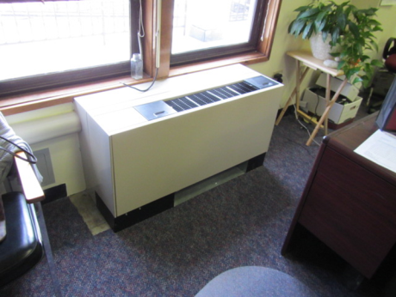
Fan coil unit (FCU)
Picture 2
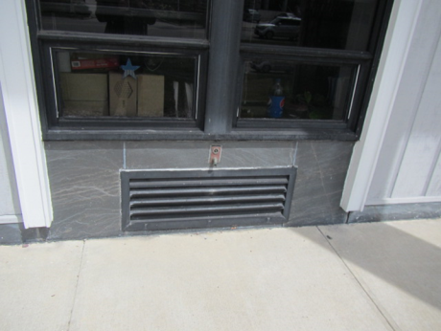
FCU air intake
Picture 3
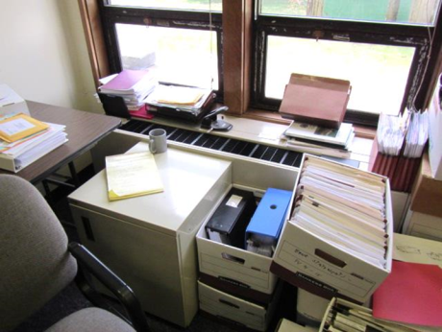
Items on/in front of FCU
Picture 4
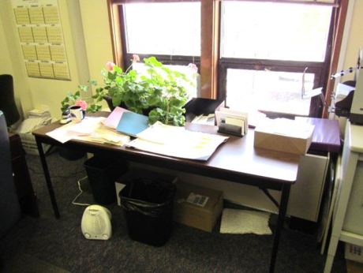
Items on/front of FCU, note plant
Picture 5
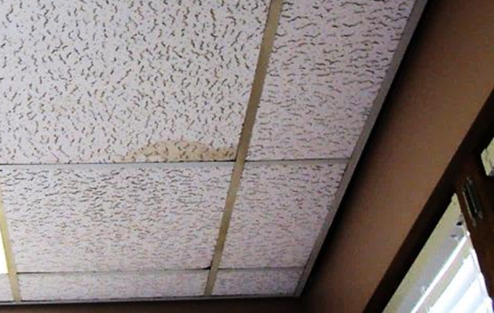
Water-damaged tile in Treasure's office
Picture 6
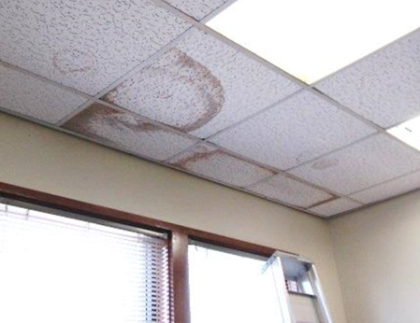
Water-damaged ceiling tiles in Clerk's office
Picture 7
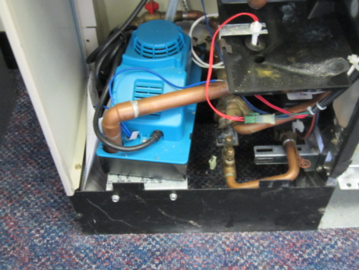
FCU cooling system components directly over carpeting
Picture 8
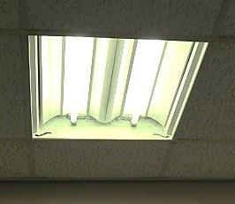
Missing light cover
Location | Carbon  Dioxide  (ppm) | Carbon Monoxide  (ppm) | Temp  (°F) | Relative  Humidity  (%) | PM2.5  (µg/m³) | Occupants  in Room | Windows  Openable | Ventilation |  |  | Remarks
 |  |  |  |  |  |  |  | Intake | Exhaust
Background | 378 | ND | 61 | 70 | 9
101 Collectors | 653 | ND | 75 | 34 | 3 | 3 | Y | Y |  | N | PF, dust-flat surfaces, items/plants on FCU, PC
102 Treasurers Main Area | 778 | ND | 72 | 40 | 3 | 4 | Y | Y |  | N | Wall to wall carpeting, 2 FCUs-one obstructed w/boxes/items
Treasurer’s Office | 638 | ND | 73 | 37 | 2 | 0 | Y | Y |  | N | PF-dusty, 1 WD CT, missing light cover
Vault | 699 | ND | 73 | 36 | 2 | 0 | N | N |  | N
103 Town Clerk Main Area | 740 | ND | 75 | 34 | 7 | 2 | Y | Y |  | N | Accumulated items, PF, missing light covers
Clerk’s Office | 579 | ND | 74 | 33 | 2 | 0 | Y | Y |  | N | 7 WD CT, missing light cover, reported heating system leak-repaired
Vault | 704 | ND | 75 | 34 | 3 | 0 | N | N |  | N

